Measuring the NHS Staff Standards
Factor Analysis of the NHS Staff Survey

Analytical Report
DHSC Social Research & Economics
February 2026

Executive Summary
This report assesses whether the six NHS Staff Standards can be reliably measured using questions from the NHS Staff Survey, and recommends how to score and compare them across trusts.
We conducted exploratory factor analysis (EFA) and confirmatory factor analysis (CFA) on trust-level data from 210 NHS trusts across four survey years (2021–2024), using 50 candidate survey questions spanning all six standards.

Key findings
- The six standards do not correspond to six separate empirical dimensions. The data supports three underlying constructs at trust level, with a possible fourth (appraisal quality).
- Three standards (Flexible Working, Effective Line Management, Supportive Environment) are empirically indistinguishable at trust level, with latent factor correlations of r = 0.91 to 0.99. Trusts that perform well on one perform well on all three.
- Violence and Sexual Safety also merge into a single ‘patient-facing harm’ dimension (r = 0.96).
- Tackling Racism is the most distinct standard, with moderate correlations to others (r = 0.58–0.87).
- Despite this, 36% of variation is standard-specific. Trusts do show meaningfully different profiles across standards, and the six-standard framework has monitoring value.

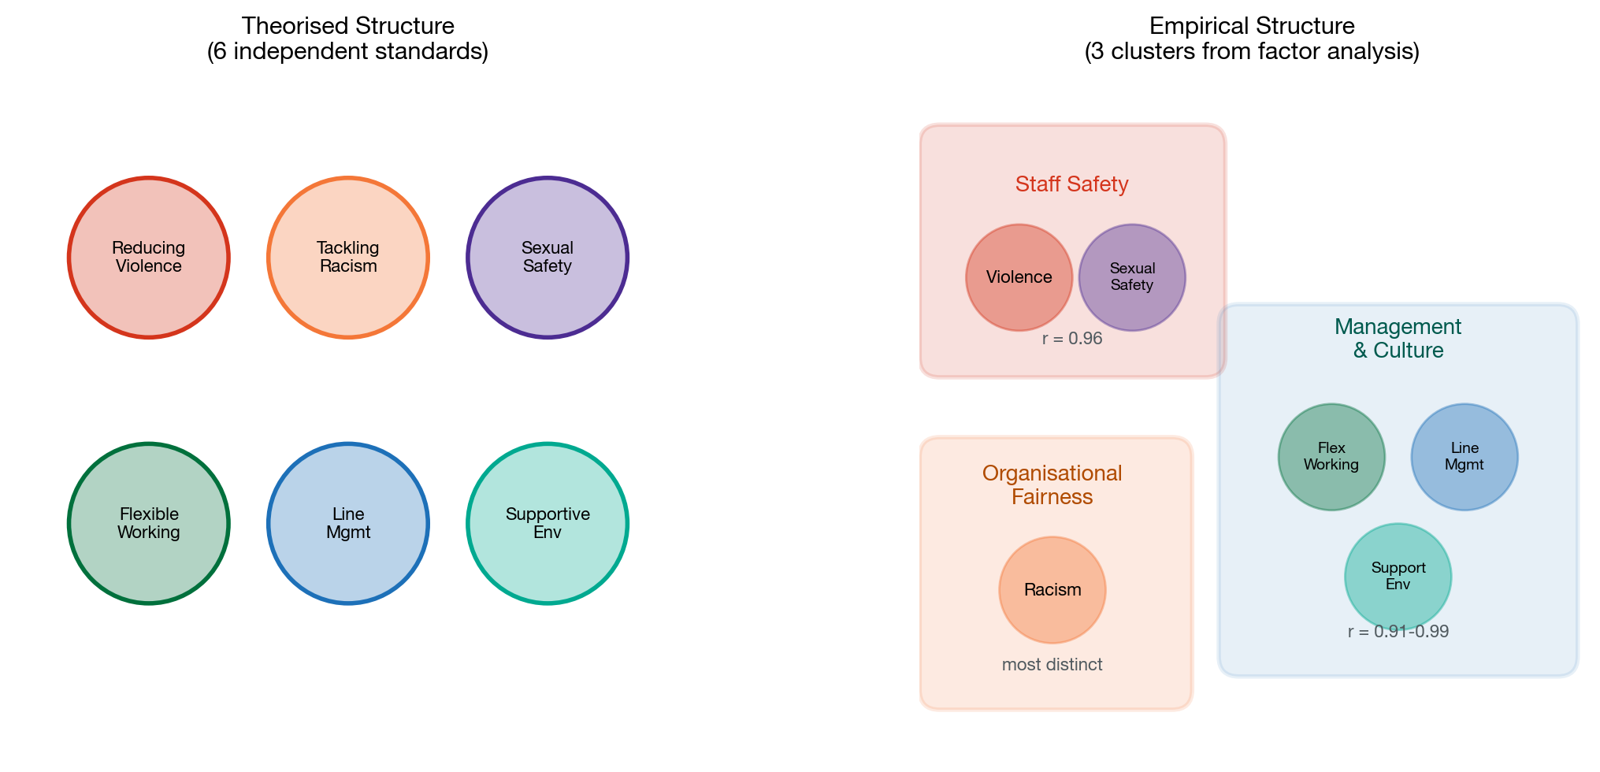
Figure 1: Theorised six-standard structure (left) vs empirical three-cluster structure (right)

Recommendations
- Use the recommended question sets per standard (Section 7).
- Score each standard as a simple average of its items after direction-correction.
- Compare trusts using z-score profiles rather than raw scores.
- Report the standards as related but complementary lenses on trust performance, not as six independent dimensions.

1. Background and Purpose
DHSC has set out six standards for NHS employers:
# | Standard | Sub-standards
1 | Reducing Violence Against Staff | —
2 | Tackling Racism | —
3 | Improving Sexual Safety | —
4 | Promoting Flexible Working | —
5 | Effective Line Management | Line management; Appraisal; Development
6 | Creating a Supportive Environment | Facilities; Support for Wellbeing

To operationalise these standards for trust-level monitoring, two questions must be answered:
A. Which NHS Staff Survey questions should measure each standard? The survey contains over 100 questions. Some map directly to standards (e.g. q13a on physical violence maps to Standard 1). Others are less clear-cut.
B. How should scores be aggregated, and can standards be meaningfully compared? This requires understanding whether the standards are empirically distinct or substantially overlapping, and what scoring methodology best captures trust-level variation.
Factor analysis is the appropriate tool for both questions. It reveals the latent structure underlying observed survey responses and tests whether the theorised six-standard structure matches the data.

2. Data

2.1 Source
NHS Staff Survey benchmark data (trust-level aggregates) for 2021, 2022, 2023 and 2024. Each observation is a trust-year, with variables representing the proportion of staff at that trust giving a particular response.

2.2 Sample
210 NHS trusts across five trust types, yielding 821 trust-year observations. For cross-sectional analysis, we averaged each variable across years per trust, producing 210 trust-level means.
Trust type | Number of trusts
Acute & Acute Community Trusts | 122
Mental Health, Learning Disability & Community Trusts | 50
Acute Specialist Trusts | 13
Community Trusts | 14
Ambulance Trusts | 11
Total | 210

2.3 Variables
We selected 50 variables with face-valid relevance to at least one standard. This is deliberately broader than any initial proposed question set to avoid the circularity of only testing pre-assigned questions. Variables are proportions bounded between 0 and 1, not individual-level Likert responses.

3. Methodology

3.1 Analytical strategy
We followed a three-phase approach:
Phase 1: Exploratory Factor Analysis (EFA) on the full 50-item pool to identify the empirical factor structure without imposing the six-standard framework.
Phase 2: Confirmatory Factor Analysis (CFA) comparing competing models: one-factor, three-factor (empirically merged), and six-factor (theory-driven).
Phase 3: Profile analysis to assess whether trusts show meaningful differentiation across standards, even where standards are highly correlated.

3.2 EFA specification
Extraction method: Minimum residual (MinRes), robust to non-normal data.
Rotation: Promax (oblique), allowing factors to correlate.
Number of factors: Determined by Horn’s parallel analysis (500 iterations, 95th percentile).
Adequacy tests: Kaiser-Meyer-Olkin (KMO) measure and Bartlett’s test of sphericity.

3.3 CFA specification
CFA models were estimated using maximum likelihood (ML) in R’s lavaan package (version 0.6-21). To address extreme multicollinearity in the manager quality items (q9a–i, which correlate at r = 0.95–0.996 at trust level), these nine items were composited into a single ‘manager quality’ variable for CFA. Similarly, three interpersonal culture items (q8b–d, r = 0.99) were composited. This reduced CFA items from 50 to 20, giving an N:p ratio of 10.5:1.

3.4 Important caveats
Ecological data. We are analysing trust-level aggregates, not individual responses. Factor structures at the aggregate level may differ from individual-level structures. Our findings describe the structure of trust-level differences, which is appropriate for trust-level monitoring but should not be interpreted as evidence about individual-level measurement properties.
Small sample. N = 210 trusts is adequate for EFA (KMO = 0.96) but marginal for complex CFA models. We focus on relative model comparisons rather than absolute fit benchmarks.
Bounded proportions. Variables are constrained to [0, 1] with floor/ceiling effects at some trusts. This can attenuate correlations and distort factor solutions.

4. Results: Exploratory Factor Analysis

4.1 Adequacy and number of factors
KMO = 0.960 (superb; above 0.90 is considered excellent). Bartlett’s test: χ² = 27,123, p < 0.001. The data is highly suitable for factor analysis.
Parallel analysis suggested four factors. The first factor is dominant, accounting for 66% of the eigenvalue sum, indicating a strong general factor underlying all items.
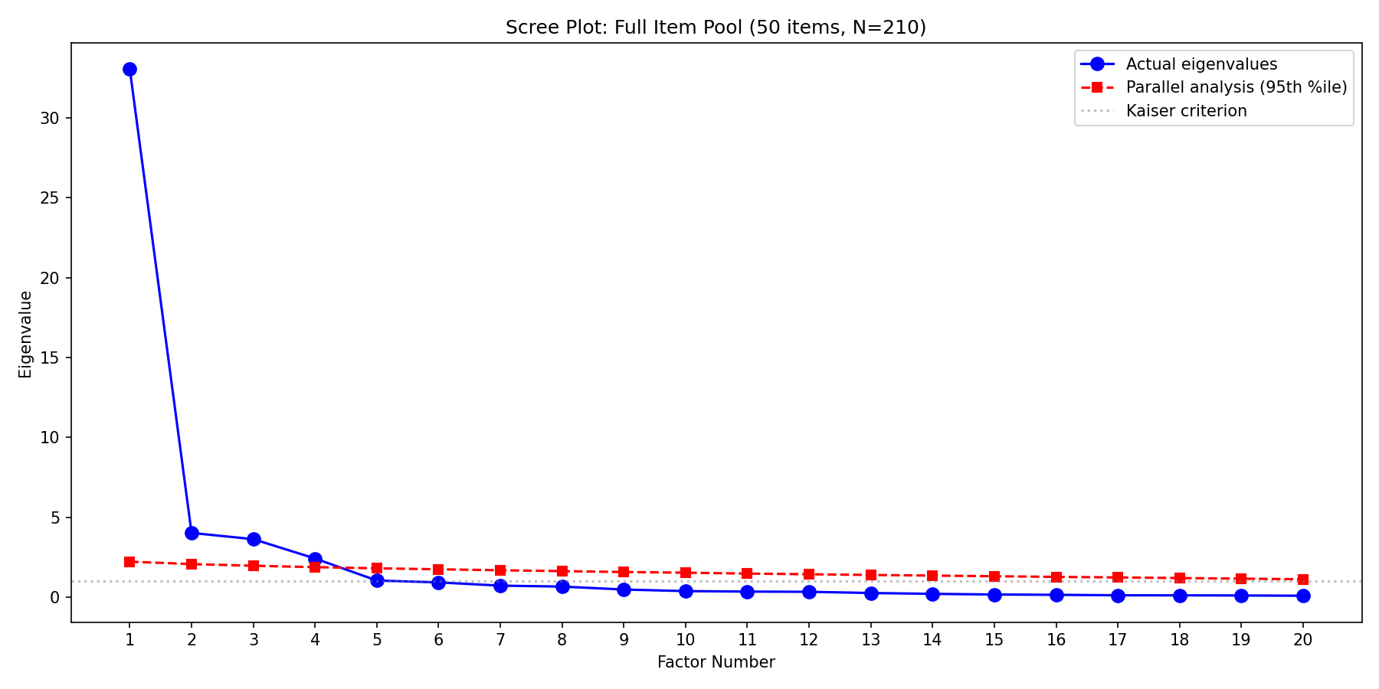
Figure 2: Scree plot with parallel analysis threshold (50 items, N = 210)

4.2 Four-factor solution
The promax-rotated four-factor solution explained 76% of total variance:
Factor | Interpretation | Key items loading
F1 | Good immediate management  and work environment | All manager items (q9a–i), flexible working (q4d, q6d), interpersonal respect (q7c, q8b–d), strained relationships (q5c)
F2 | Organisational culture  and fairness | Fair career progression (q15), respects differences (q21), safe to speak up (q25e), wellbeing action (q11a), materials/equipment (q3h), career development (q24b–e)
F3 | Patient-facing harm | Violence from patients (q13a), harassment from patients (q14a), sexual behaviour from patients (q17a) and staff (q17b)
F4 | Appraisal quality | Appraisal improved job (q23b), clear objectives (q23c), felt valued (q23d)

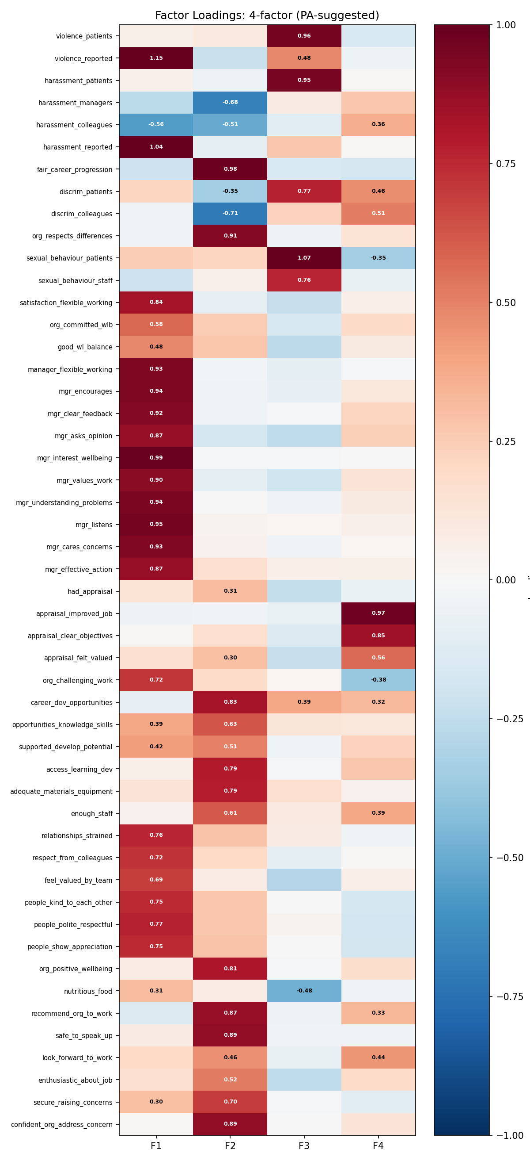
Figure 3: EFA pattern matrix heatmap (4-factor promax solution)

4.3 Mapping EFA factors to standards
EFA Factor | Standards captured
F1: Good management | Flexible Working + Line Management (line management) + Supportive Environment (culture)
F2: Org culture | Tackling Racism + Supportive Environment (wellbeing, facilities) + Line Management (development)
F3: Patient harm | Reducing Violence + Sexual Safety
F4: Appraisal | Line Management (appraisal only)

Key observation: When forced to six factors, the solution did not produce six clean factors matching the theorised standards. The additional factors were weakly defined with cross-loadings and Heywood cases (communalities exceeding 1.0).

5. Results: Confirmatory Factor Analysis

5.1 Model comparison
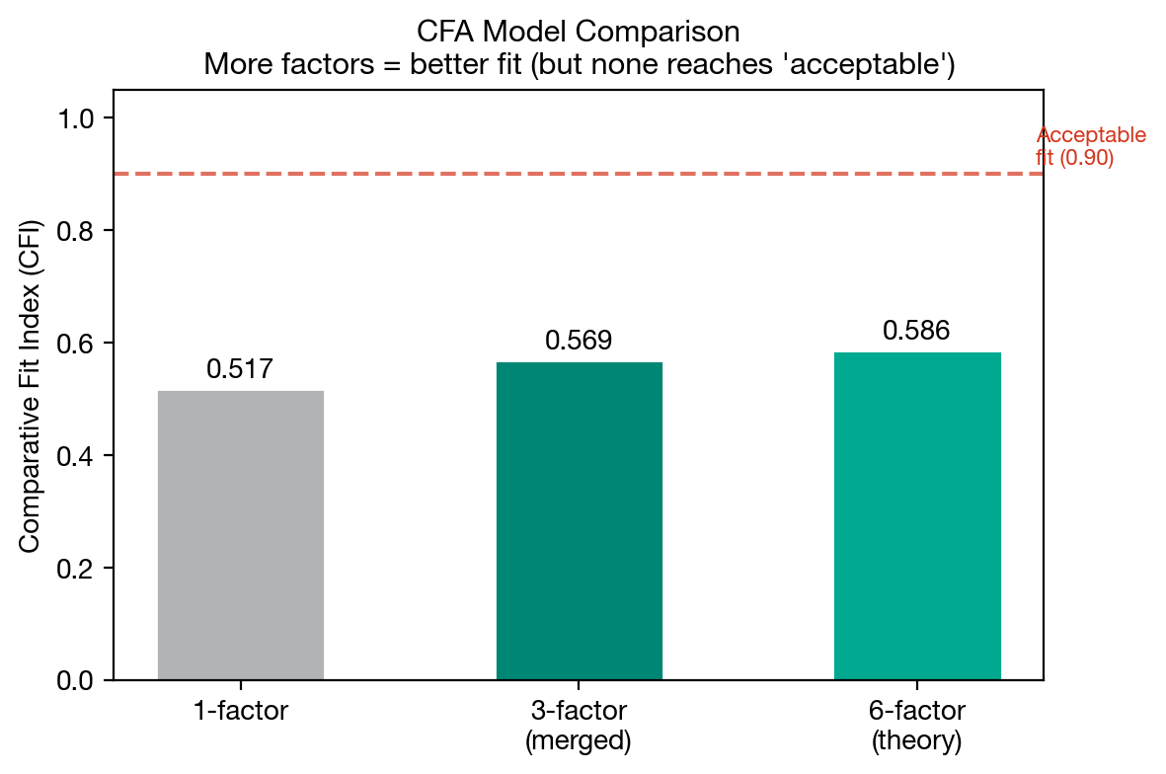
Figure 4: Comparative Fit Index (CFI) across competing CFA models

Model | χ² | df | χ²/df | CFI | TLI | RMSEA | SRMR
A. Single factor | 3,269 | 170 | 19.2 | 0.517 | 0.460 | 0.295 | 0.135
B. Three-factor (merged) | 2,928 | 167 | 17.5 | 0.569 | 0.510 | 0.281 | 0.182
D. Six-factor (theory) | 2,811 | 155 | 18.1 | 0.586 | 0.492 | 0.286 | 0.182

No model achieved conventional thresholds for acceptable fit (CFI > 0.90, RMSEA < 0.08). This is expected given ecological data, small N, and bounded proportions (see Section 3.4). However, the relative comparison is informative: the six-factor model has the lowest χ² and highest CFI, suggesting the finer-grained structure adds value beyond a single general factor.

5.2 Factor correlations (discriminant validity)
The critical finding comes from the latent factor correlations estimated by the six-factor CFA model:
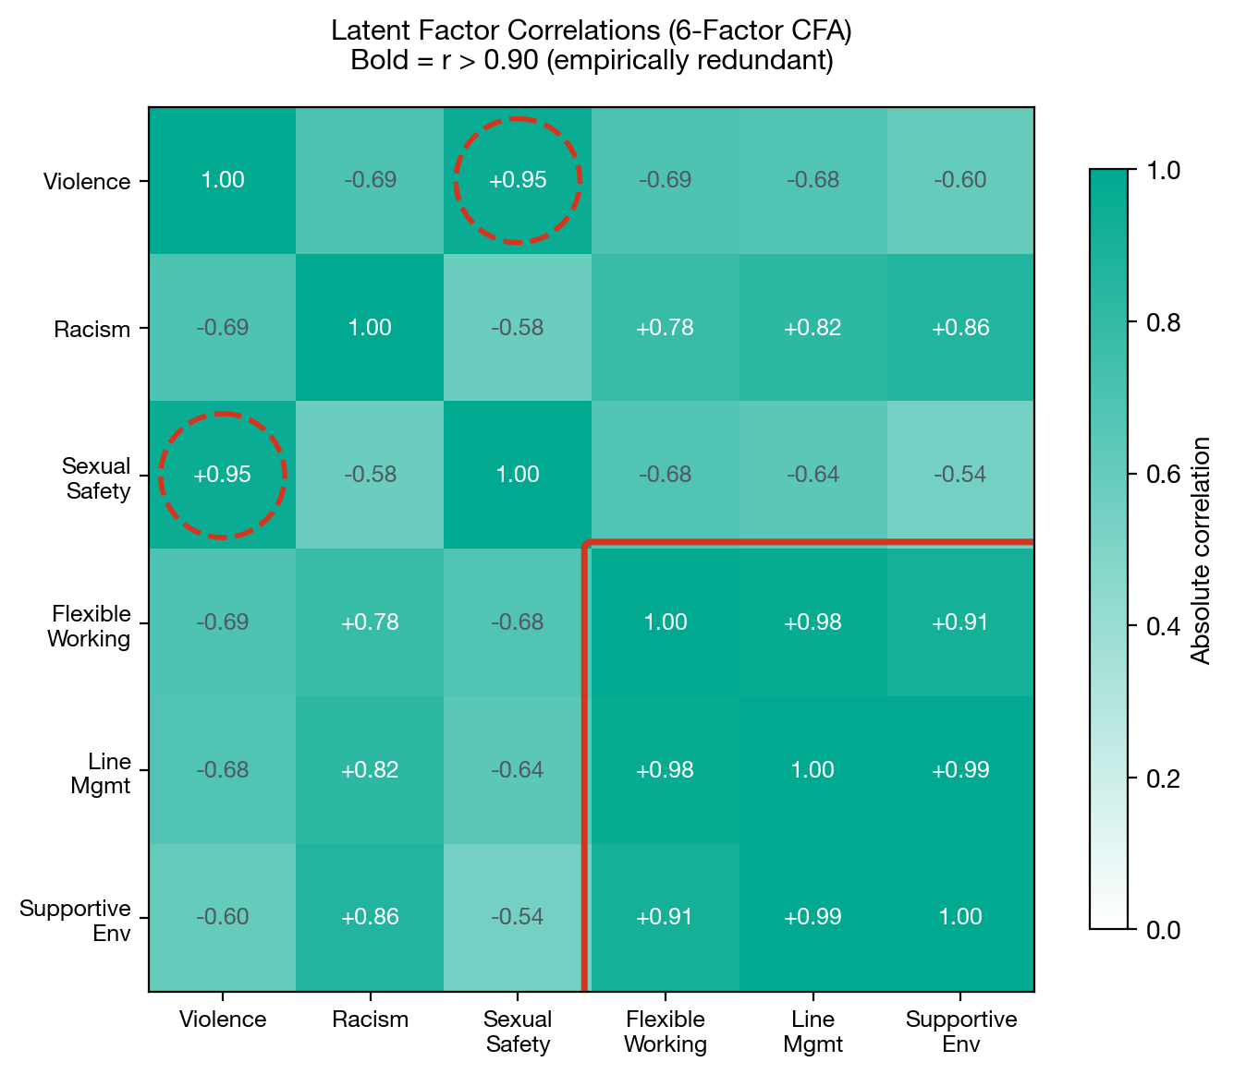
Figure 5: Latent factor correlations from 6-factor CFA. Bold values indicate r > 0.90 (empirically redundant). Red box highlights the FlexWorking/LineMgmt/SupportEnv cluster. Dashed circles highlight the Violence/SexSafety pair.

Interpretation of key pairs:
- LineMgmt ↔ SupportEnv (r = 0.989): Statistically indistinguishable. A trust’s line management score predicts its supportive environment score with near-perfect accuracy.
- FlexWorking ↔ LineMgmt (r = 0.976): Also effectively identical. Whether staff report good flexible working is almost entirely explained by whether they report good line management.
- Violence ↔ SexSafety (r = 0.955): Trusts with violence problems have sexual safety problems and vice versa.
- Racism ↔ SupportEnv (r = 0.865): High but not redundant. Discrimination is correlated with poor organisational culture but retains a meaningful unique component.
- Racism ↔ SexSafety (r = −0.582): The most distinct pair. These measure genuinely different things.
In measurement terms, correlations above 0.90 between latent factors indicate that the constructs cannot be empirically distinguished. The covariance matrix of latent variables was flagged as non-positive-definite by lavaan, confirming that the six-factor structure is empirically untenable as six separate dimensions.

5.3 Standardised factor loadings
Despite the redundancy between factors, items loaded strongly on their assigned factors:
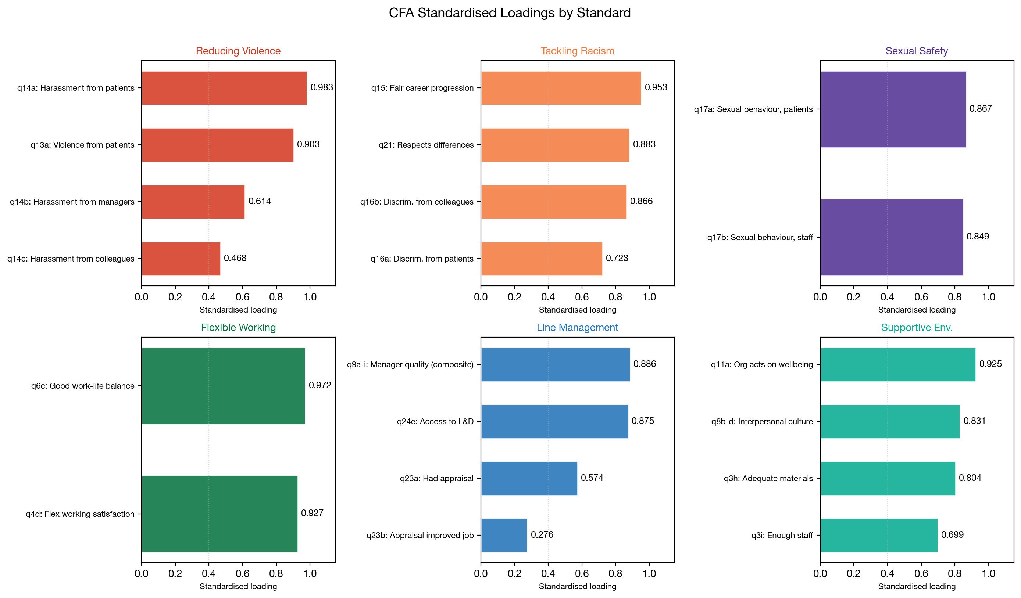
Figure 6: CFA standardised loadings by standard
All loadings are statistically significant (p < 0.001). The weakest is appraisal_improved_job (0.276), suggesting appraisal quality captures something partially distinct from broader line management.

6. Results: Profile Analysis

6.1 Variance decomposition
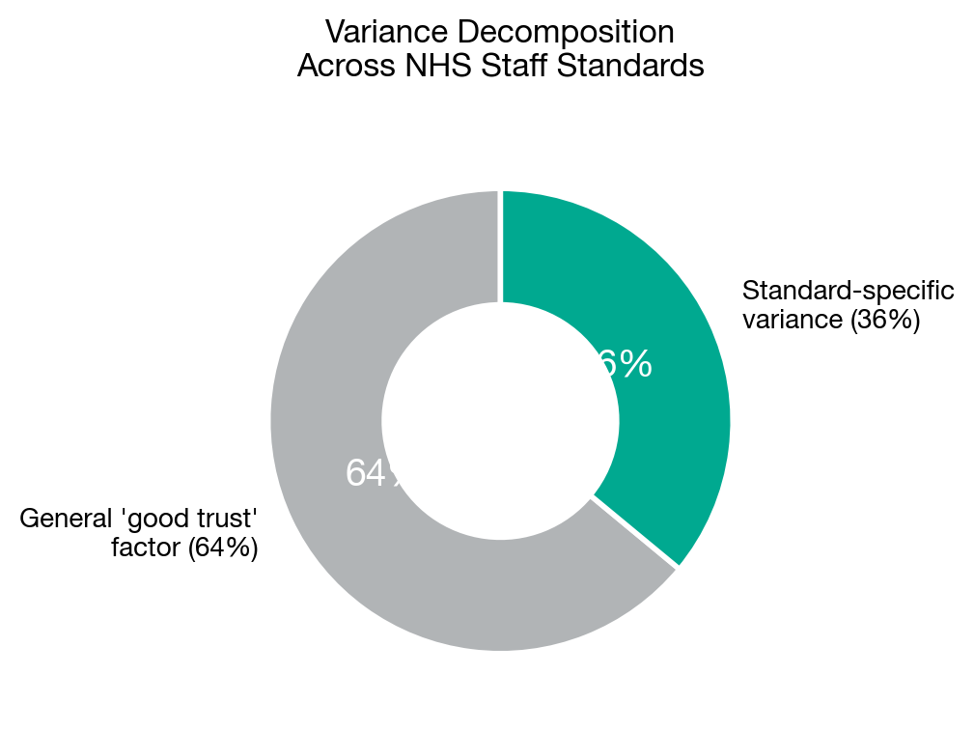
Figure 7: Decomposition of trust-level variance across standards

The mean inter-standard correlation is r = 0.80, implying that 64% of trust-level variation is a general ‘good trust’ factor and 36% is standard-specific. Most variation is shared, but a meaningful minority is not.

6.2 Trust profiles
To assess whether trusts show meaningfully different patterns (not just levels), we computed within-trust z-score profiles across the five standards. The mean profile variability was 0.40 SD, indicating meaningful differentiation.
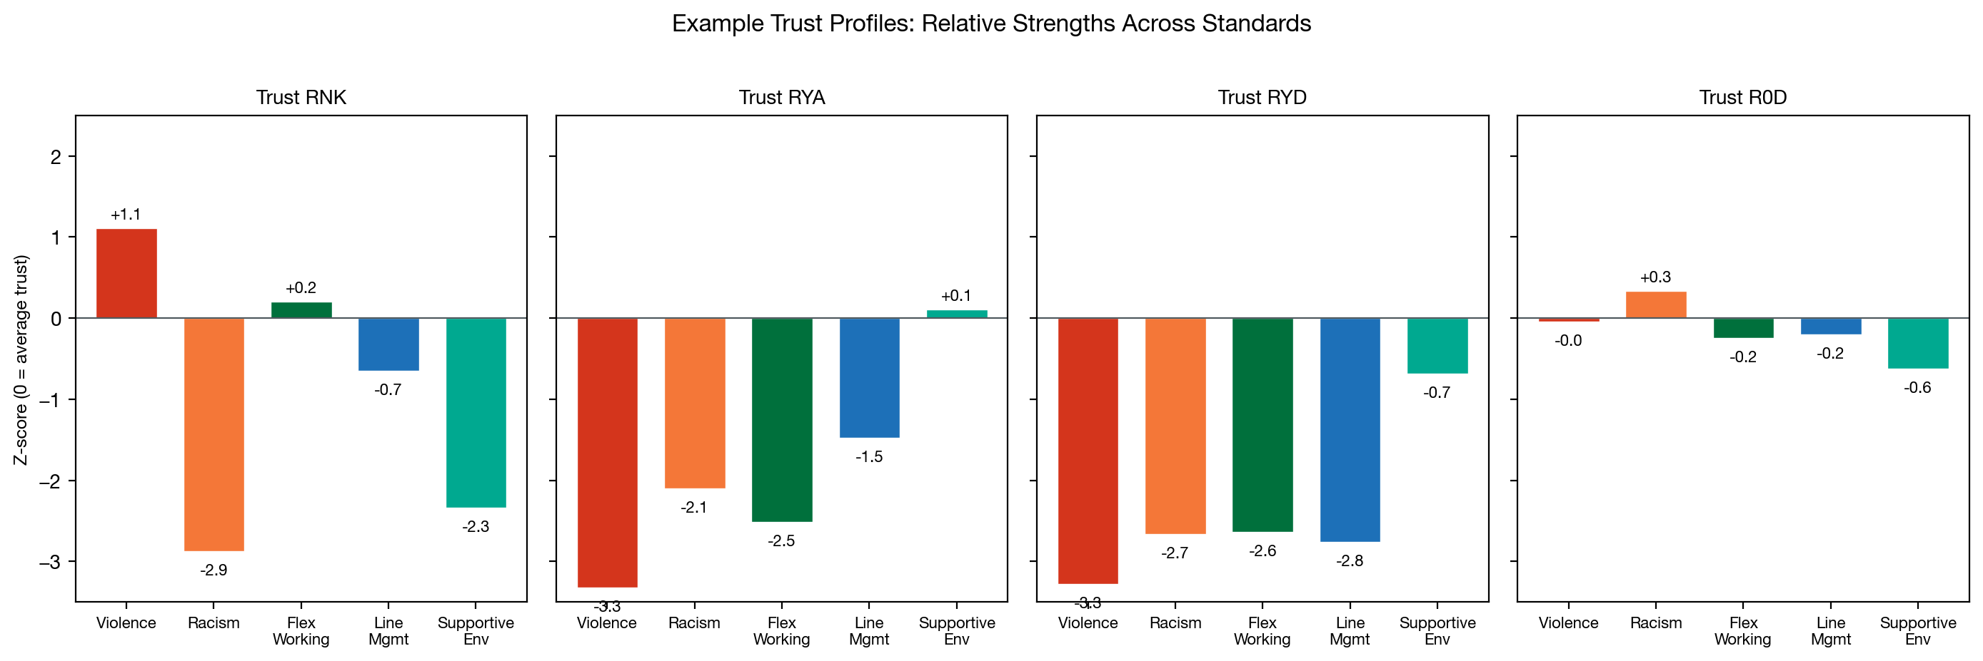
Figure 8: Example trust z-score profiles. Trust RNK, for instance, scores above average on violence (low violence) but nearly three standard deviations below average on racism.

Key implication: The six-standard framework has monitoring value because it directs attention to specific areas where a trust may underperform relative to its general level. A single composite score would mask these patterns.

6.3 Sub-standard structure
Two standards have defined sub-standards: Effective Line Management (line management, appraisal, development) and Supportive Environment (facilities, wellbeing). The factor analysis has something to say about whether these sub-groupings hold in the data.

Effective Line Management
- Line management (q9a–i). All nine manager quality items correlate at r = 0.95 to 0.996 at trust level. They are a single, undifferentiated block. There is no empirical basis for distinguishing between, say, ‘manager gives feedback’ and ‘manager shows interest in wellbeing’ at trust level.
- Appraisal (q23a–d). Emerged as a distinct sub-factor (Factor 4) in the EFA. This is one of the clearest findings: having a good line manager does not automatically translate into a useful appraisal. The sub-standard distinction is empirically validated.
- Development (q24b, q24d, q24e). In the EFA, development items loaded more strongly on the organisational culture factor (F2) than on the manager/team factor (F1). This suggests that access to learning and career development is driven more by organisational culture and investment than by individual line manager quality. The data would place development closer to Supportive Environment than to Line Management.

Supportive Environment
- Facilities (q3h, q3i). Loaded on the organisational culture factor (F2). Whether a trust has adequate materials and enough staff is an institutional-level decision, consistent with treating this as a distinct sub-standard.
- Wellbeing (q8b–d, q11a). This sub-standard is split across two empirical factors. The interpersonal culture items (q8b–d: kindness, respect, appreciation) loaded with the manager/team factor (F1), suggesting they reflect team-level culture driven by line management. The organisational wellbeing item (q11a) loaded with the organisational culture factor (F2). In other words, ‘people being kind to each other’ is a team phenomenon, while ‘the organisation takes action on wellbeing’ is an institutional one.

Summary: The appraisal sub-standard within ELM is clearly validated by the data. The development sub-standard may sit more naturally under Supportive Environment. The wellbeing sub-standard straddles two empirical factors, with interpersonal culture being team-driven and organisational wellbeing being institution-driven.

7. Recommended Question Sets
Based on the EFA loadings, CFA standardised loadings, and face validity, we recommend the following questions for each standard. Items are listed in order of loading strength.

Standard 1: Reducing Violence Against Staff
Code | Question | Loading | Direction
q14a | Harassment/bullying/abuse from patients/public | 0.983 | Lower = better
q13a | Physical violence from patients/public | 0.903 | Lower = better
q14b | Harassment/bullying/abuse from managers | 0.614 | Lower = better
q14c | Harassment/bullying/abuse from colleagues | 0.468 | Lower = better

Note: We include harassment items (q14a–c) alongside physical violence. The reporting items (q13d, q14d) should be excluded from the composite as they measure reporting culture rather than incidence. They can be reported separately. Violence from managers (q13b) and colleagues (q13c) had near-zero variance at trust level and were dropped.

Standard 2: Tackling Racism
Code | Question | Loading | Direction
q15 | Fair career progression regardless of characteristics | 0.953 | Higher = better
q21 | Organisation respects individual differences | 0.883 | Higher = better
q16b | Discrimination from managers/colleagues | 0.866 | Lower = better
q16a | Discrimination from patients/public | 0.723 | Lower = better

Note: This is the most empirically distinct standard. q21 is not exclusively about race but loads strongly here because trusts with discrimination problems also score poorly on respecting differences.

Standard 3: Improving Sexual Safety
Code | Question | Loading | Direction
q17a | Unwanted sexual behaviour from patients/public | 0.867 | Lower = better
q17b | Unwanted sexual behaviour from staff/colleagues | 0.849 | Lower = better

Note: Only two items available (introduced 2023). Empirically very close to Reducing Violence (CFA r = 0.96). Could be monitored jointly as part of a broader ‘Staff Safety’ construct.

Standard 4: Promoting Flexible Working
Code | Question | Loading | Direction
q6c | I achieve a good balance between my work life and home life | 0.972 | Higher = better
q4d | Satisfaction with opportunities for flexible working | 0.927 | Higher = better

Note: Empirically very close to Line Management (CFA r = 0.98). Trusts with good managers automatically score well on flexible working. Can be retained as a separate monitoring lens but should not be interpreted as measuring a distinct dimension.

Standard 5: Effective Line Management

5a. Line management
Code | Question | Direction
q9d | Manager takes positive interest in health/wellbeing | Higher = better
q9f | Manager works together to understand problems | Higher = better
q9i | Manager takes effective action to help | Higher = better

Note: All nine q9 items correlate at r = 0.95 to 0.996 at trust level. They measure the same thing. Either use all nine and average, or select three representative items as above. Results are identical to three decimal places.

5b. Appraisal
Code | Question | Loading | Direction
q23a | Had appraisal in last 12 months | 0.574 | Higher = better
q23b | Appraisal helped improve how I do my job | 0.276 | Higher = better
q23c | Appraisal helped agree clear objectives | — | Higher = better
q23d | Appraisal left me feeling valued | — | Higher = better

Note: Appraisal quality emerged as a distinct sub-factor in EFA. Having a good manager does not automatically translate into a useful appraisal. Track separately within this standard.

5c. Development
Code | Question | Loading | Direction
q24e | Access to right L&D opportunities | 0.875 | Higher = better
q24b | Opportunities for career development | — | Higher = better
q24d | Feel supported to develop potential | — | Higher = better

Standard 6: Creating a Supportive Environment

6a. Facilities
Code | Question | Loading | Direction
q3h | Adequate materials, supplies and equipment | 0.804 | Higher = better
q3i | Enough staff to do my job properly | 0.699 | Higher = better
q22 | Can eat nutritious affordable food at work | — | Higher = better

6b. Support for wellbeing
Code | Question | Loading | Direction
q11a | Organisation takes positive action on wellbeing | 0.925 | Higher = better
q8b | People are understanding and kind to one another | — | Higher = better
q8c | People are polite and treat each other with respect | — | Higher = better
q8d | People show appreciation to one another | — | Higher = better

Note: q8b–d are highly collinear (r = 0.99) and can be composited into a single ‘interpersonal culture’ score.

8. Cross-Validation
To test the robustness of these findings, we replicated the analysis using a temporal hold-out design: EFA on 2023 data to discover the structure, CFA on independent 2024 data to test it. Both years are post-COVID. This mirrors the methodology used for the People Promise analysis.

8.1 EFA on 2023 (exploration sample)
- N = 207 trusts. KMO = 0.961.
- Parallel analysis: 4 factors (same as main analysis).
- Same factor structure: F1 = manager/team, F2 = org culture, F3 = patient-facing harm, F4 = appraisal quality.
- Variance explained: 73.4%.

8.2 CFA on 2024 (confirmation sample)
We tested the same three models on the independent 2024 data (N = 210):
Model | χ² | df | χ²/df | CFI | TLI | RMSEA | SRMR
A. 6-factor (theory) | 2,493 | 155 | 16.1 | 0.603 | 0.513 | 0.268 | 0.178
B. 3-factor (merged) | 2,647 | 167 | 15.9 | 0.579 | 0.521 | 0.266 | 0.176
C. 1-factor | 2,997 | 170 | 17.6 | 0.520 | 0.464 | 0.281 | 0.136

8.3 Factor correlations on hold-out data
The latent factor correlations from the 6-factor CFA on independent 2024 data closely replicate the main analysis:
Factor pair | Main analysis  (all years) | 2024 hold-out | Interpretation
FlexWorking ↔ LineMgmt | 0.976 | 0.965 | Redundant
LineMgmt ↔ SupportEnv | 0.989 | 1.017* | Redundant
Violence ↔ SexSafety | 0.955 | 0.932 | Redundant
FlexWorking ↔ SupportEnv | 0.914 | 0.886 | High
Racism ↔ SexSafety | −0.582 | −0.520 | Distinct

*A correlation exceeding 1.0 is mathematically impossible and indicates that the model cannot distinguish these two factors at all. lavaan flagged the covariance matrix as non-positive-definite, confirming the redundancy.

Conclusion: All findings replicate on independent data. The three-cluster structure, the redundancy of FlexWorking/LineMgmt/SupportEnv, and the distinctiveness of Tackling Racism are not artefacts of the averaging approach or of COVID-era data.

9. Scoring Methodology

9.1 Computing standard scores
For each trust, each standard score is the simple average of its component items after direction-correction.
Direction correction: Items where ‘lower = better’ (violence, harassment, discrimination, sexual behaviour) should be reversed by subtracting from 1. After reversal, all items are on a ‘higher = better’ scale and can be averaged.

9.2 Why simple averages
We considered factor score estimation and loading-weighted averages but recommend simple averages because:
- They are transparent and reproducible without specialised software.
- With high within-standard correlations, the correlation between simple averages and factor scores is typically > 0.98.
- Weighting by loadings adds complexity without meaningful improvement in validity.

9.3 Comparing trusts: z-score profiles
Raw composite scores are not directly comparable across standards because standards have different means and variances.
Recommended approach:
- Compute the composite score for each standard for each trust.
- Convert to z-scores: z = (score − mean) / SD across all trusts.
- Present as a profile showing relative strengths and weaknesses.
A z-score of 0 means average performance. This allows meaningful statements like ‘Trust X performs 1.5 SDs above average on Racism but 0.8 SDs below average on Violence.’

9.4 Interpreting cross-standard differences
- Rankings of trusts will be broadly similar across standards. A trust ranking 10th on Line Management will typically rank in the top 20 on most other standards.
- But not identical. The 36% standard-specific variance means some trusts will show distinctive profiles.
- Do not over-interpret small differences between highly correlated standards (e.g. Flexible Working vs Line Management). Differences of less than ~0.5 SD are likely noise.
- Do interpret differences between weakly correlated standards (e.g. Racism vs Sexual Safety). A trust scoring well on one and poorly on the other is showing a genuine pattern.

10. Summary of Recommendations

On measurement (which questions)
- Use the question sets in Section 7.
- Exclude reporting items (q13d, q14d) from composites. Track them separately.
- Composite the nine manager items (q9a–i) into a single score.
- Track appraisal quality separately within Standard 5.

On structure (how many standards)
- Keep six standards for policy communication.
- Acknowledge that three empirical clusters exist: Staff Safety (Violence + Sexual Safety), Management & Culture (Flexible Working + Line Management + Supportive Environment), and Organisational Fairness (Tackling Racism, most distinct).
- Consider whether Flexible Working and Supportive Environment need to be separate standards given they are empirically indistinguishable from Line Management.

On scoring and comparison
- Use simple averages of direction-corrected items.
- Compare trusts using z-score profiles, not raw scores.
- Report the 64/36 split (general vs specific variance) to set expectations.

