* LP Tableux Writer
* Simplex solver
* Transportation problem solver
* Allocation problem solver
* All available as .g3a files for Casio Graphical calculators

Casio Decision Mathematics Suite

# Analysis

## Problem Identification

Myself and my friends in our Further Mathematics class have encountered a problem with the Decision Mathematics modules. It is difficult to check if the answers we have given to questions are correct as the questions are complicated and the algorithms in use have multiple steps involved. It is easy to make a mistake while going through the steps of these algorithms, and it causes some confusion as to what the correct answer is. This is where it would be useful to have applications available to us in the lesson that can solve these problems for us. Most of us in the class have available to us a Casio FX-CG50 graphical calculator, which can have graphical programs written for it using the SDK.

The project aim is to create a suite of applications to solve all the problems available in the Edexcel Further Mathematics Decision module. These applications can be installed onto the Casio calculators and used as any other program on the calculator would be.

## Stakeholders

The stakeholders in this project would be myself and my classmates. Each of us would be capable of checking, testing and evaluating the individual applications and I would be able to frequently get new feedback from them.

Every one of us has a use for it as an academic tool – it allows us to write our own questions for revision and also mark them ourselves.

## Research

### Simplex

It is possible to solve simplex problems on the Casio FX-CG50 manually, using a matrix and matrix row operations. However, this is not an automated solution as wanted, and so is not exactly suited to the stakeholder’s requirements.

However, it would be useful to be able to enter a simplex tableu manually rather than have it automatically generated at all times, so this is definitely something I can take away as an idea.

### Transportation Problems

Transportation problems are a special case of linear programming problems, which makes them solvable by the simplex method, but it is generally more computationally efficient to solve them by different means.

I have been unable to find an implementation of the Stepping Stone algorithm (the method used to solve these problems) for Casio calculators. Additionally it is not possible to use any of the features already available on the calculator to solve them manually.

Thusly the only available examples are online solvers such as this one:

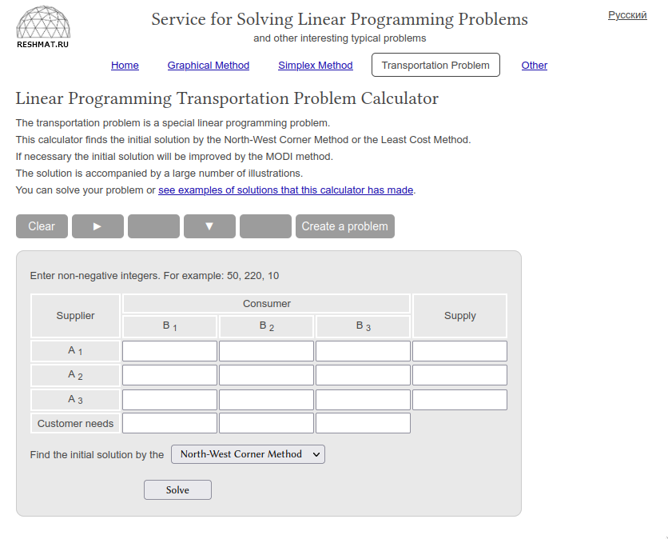(taken from <http://reshmat.ru/transportation_problem_lp.html>)

I will use a similar design for the program on the calculators – this is how the tables are laid out in the questions too, so it will be very easy to transfer the information to the calculator from the questions.

### Allocation Problems

Allocations problems are problems where there are an equal number of workers and tasks to be completed. Every worker has a number associated with every task (representing time to complete, cost, etc.) and the goal is to find a solution that uses the most optimal selection of workers for each task.

An example of this could be selection for athletes in a multi-stage swimming relay. Each athlete will swim different stokes and will take different times to complete laps in particular strokes. The table representing this problem could look as such:

| Swimmer / Stroke | Breaststroke | Front Crawl | Backstroke | Butterfly |
| --- | --- | --- | --- | --- |
| Mark | 21 | 35 | 32 | 30 |
| Nicky | 34 | 20 | 36 | 18 |
| Nigel | 25 | 38 | 15 | 40 |
| Susie | 39 | 18 | 29 | 27 |

I have also been unable to find any implementation to solve allocation problems for the Casio calculators. Like Transportation Problems, it is possible to solve allocation problems as a linear programming problem, although the set-up for the tableu is prohibitively repetitive, and it is more efficient to solve the problems by the algorithms designed exactly for them.

Because of this there is very little information I can gather about existing solutions, and so I will need to develop my own implementation without any guidance. I will likely use a similar set-up as for the Transportation Problem solver.

### Research Conclusions

Throughout the whole of my research I did not find any examples of a whole suite of applications like the one I am suggesting. I will be taking inspiration from the tools I found. However, the table layouts used in the tools are already what is standard and what is taught in the book, so not much new information can be garnered from these tools.

## Essential Features

The desired solution will be a suite of applications, including an application to solve Transportation Problems, Allocation Problems and Linear Programming problems. The users will be able to input the problem information, and the solution will be automatically generated, with the steps to attain such a solution shown if required.

## Limitations

The limitations of my solution will stem largely from the hardware they are running on. The Casio FX-CG50 has only 61 kB of RAM available, and so the calculator would be unable to solve large problems, such as those that would be encountered in industry. This, however, will not come up to be an issue, as the solution developed for the calculators would not be used in an industry circumstance. The second limitation would be the way that data is entered into the solvers. Because the screen of the calculator is relatively small, it can only display a small amount of information on it at any one time. This small screen is less suited to entering larger amounts of data for larger problems. Thankfully, as this solution is only intended for use by students studying Further Mathematics Decision, the problems entered into the calculator would be restricted in their size.

## Requirements

### Hardware Requirements

A Casio FX-CG50 calculator, or similar calculator from the same line, will be required to run the applications, as well as the appropriate cables to install the software on the calculator. The cables usually come provided with the calculator. Additionally a computer will be required to download the applications to get them onto the calculator, or use a calculator that already has the software installed and a link cable. It is preferable to install them from a computer as it is much faster than using the link cable between two calculators.

### Software Requirements

There are no additional software requirements, the calculators come with everything required to run the applications.