**A Map of the New England States**

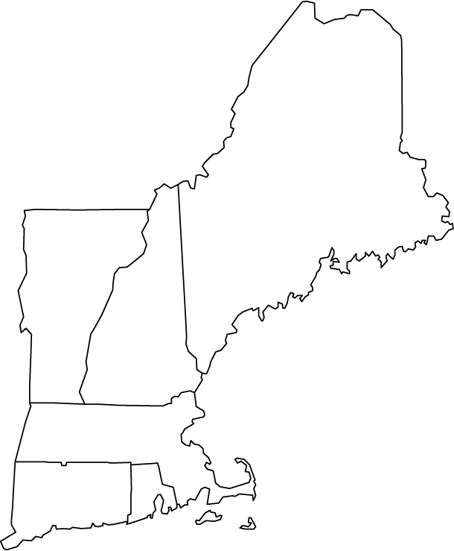

**Massachusetts**

**Connecticut**

**New Hampshire**

**Rhode Island**

**Vermont**

**Maine**

Directions: Drag the names into the correct state. Check your work on the front board. Identify the states you marked correctly.