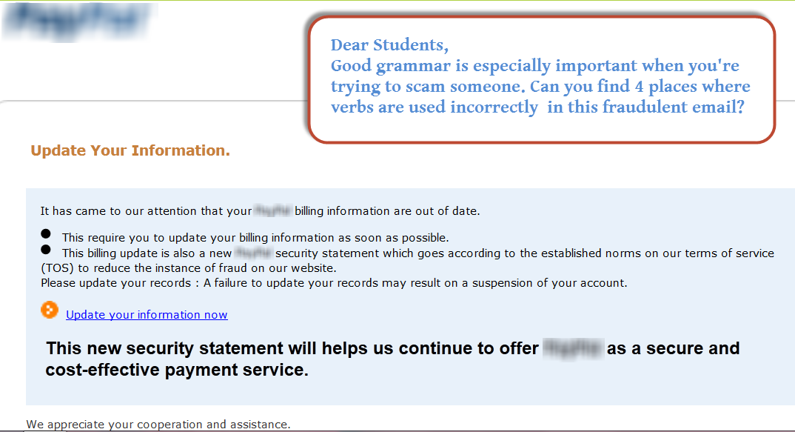

This writer used verbs incorrectly in 4 places. List them here and correct them:

Can you find other places that contain weak writing? List them and tell how you would make the writing stronger.