Advanced Image Processing

Leevi Hokkanen

050253975

# Project Report

## Multiresolution Bilateral Filtering for Image Denoising

The paper was about image denoising using multiresolution bilateral filtering. The method was proposed in the paper by taking a wavelet transformation of the image and applying bilateral filtering and wavelet thresholding to it. This method was then compared to other filtering methods via PSRN values.

Our presentation will consist of a presentation of the partial methods used in the filter and the overall filter itself. The results of this filter will then be compared to other methods.

The goal of our project was simply to implement this same filter and conduct a comparison to other filtering methods. The original goal was to try to reproduce the same results as the ones showed on paper, however, we do not have access to the same pictures and lack the understanding and time to implement the other denoising methods. Therefore, we only implemented the proposed filter and compared the results to some of the pre-made denoising filters available on Python.

We have embedded the implementation with the report. We found no packages that included this filter pre-made, so we made it ourselves. We were, however, able to find a couple of GitHub repositories with alternative implementations of this same filter.

Our filter was made with the combination of *cv2*, *pywt*, and *skimage* package functions and should work at least on Python 3.6. Once the packages have been installed, the method can be demoed with the demo.py file. The implementation was made as we understood it from the paper. The results of this filter are then compared to other filters in our demo. One of the comparison outputs is pictured below:

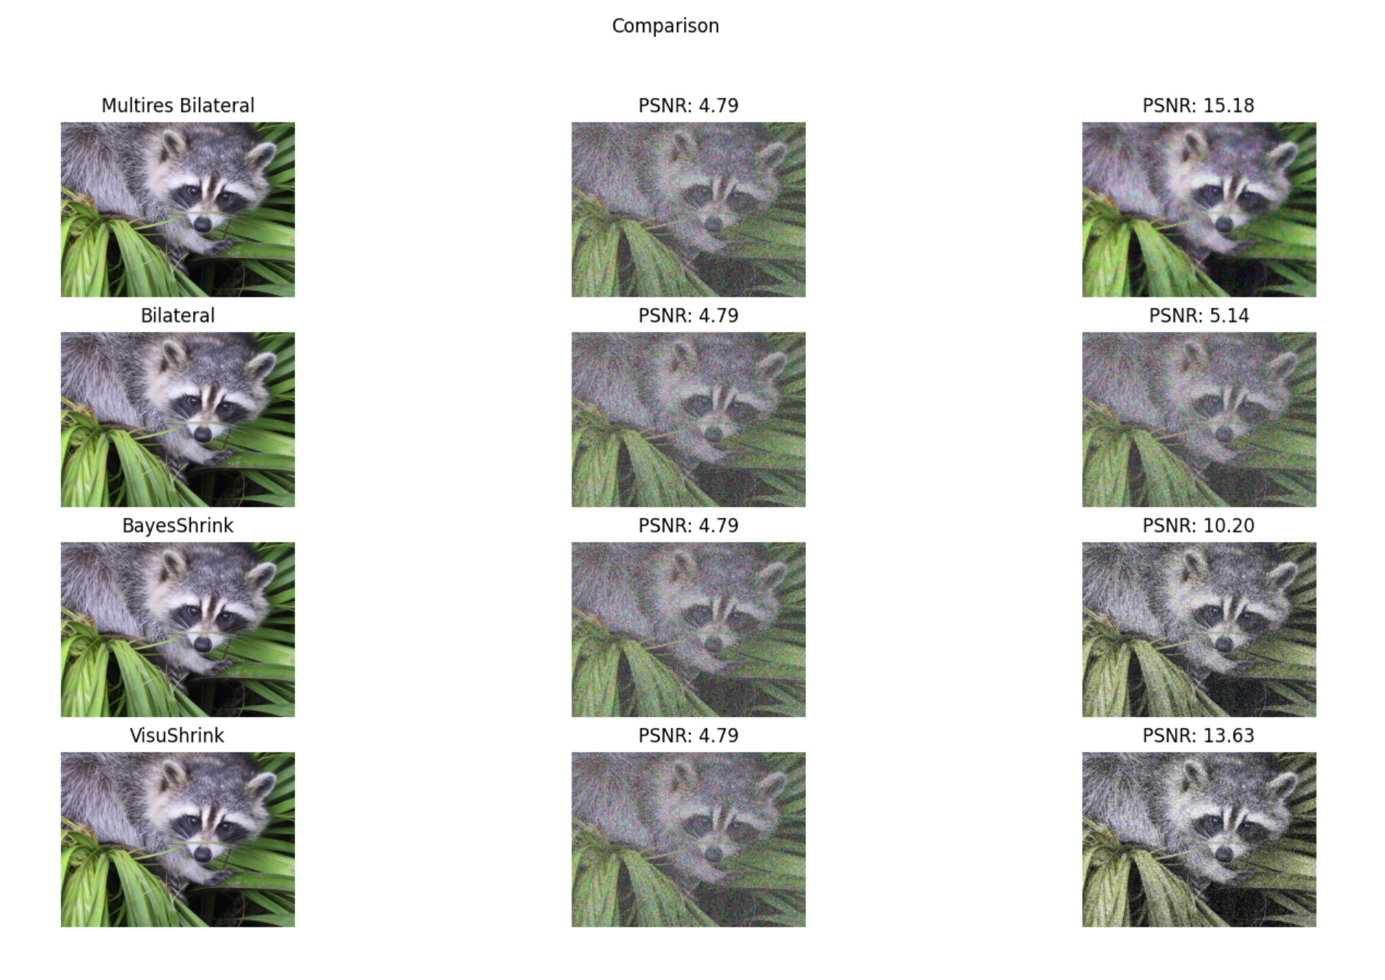

Example demo comparison output

The example results shown in this report and the ones shown in the presentation are likely to change. These results were obtained with experimentation of different parameters given to the filter, due to there being no commonly agreed upon method to choose best values for these parameters, as was already described in the paper.

## References:

*The paper studied

|  |  |
| --- | --- |
| [1] | M. Zhang, B. Z. Gunturk, Multiresolution Bilateral Filtering for Image Denoising, *IEEE Transactions On Image Processing*, 11.6 (2002): 670-684 |