Forms

# Add news post

Fields: Title, Body, Image upload

Design: Horizontal order of label/field, vertical arrangement of fields

For mobile arrange all labels and fields vertically

# Customer Sign Up Form

Fields: Forename, Surname, Email, Username, Password, Confirm password

JS: Check all fields are populated, check passwords match.

Design: Horizontal order of label/field, vertical arrangement of fields

For mobile arrange all labels and fields vertically

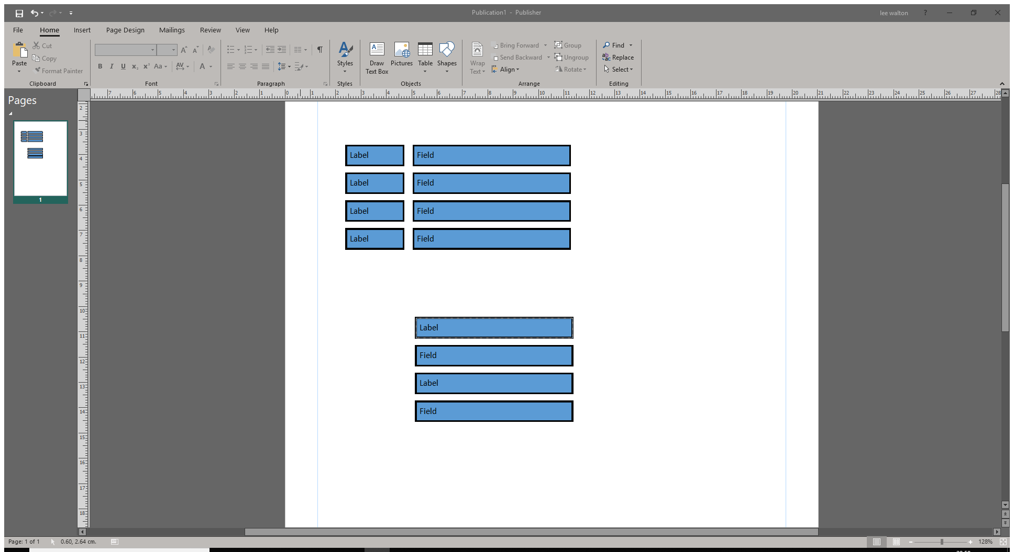Desktop:

Mobile:

# Customer Login Form

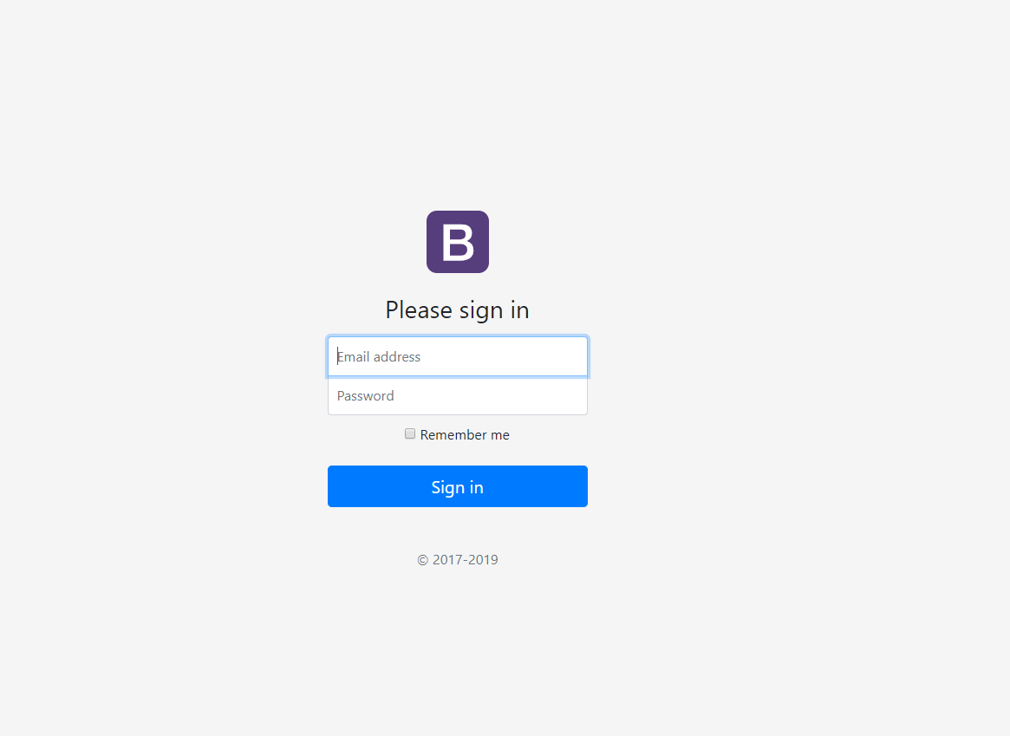Fields: Username, Password

Design: Vertical arrangement of labels and text boxes

JS: Check both fields are populated (enable/disable submit button)

# Admin Login Form

Fields: Username, Passcode

Design: Vertical arrangement of labels and text boxes

Example: