Machine Learning Engineer Nanodegree

Capstone Project
Joe Udacity
December 31st, 2050

I. Definition

Project Background (Biochemistry)
All biology depends on nucleotide and amino acid sequences which spontaneously fold to form 3D atomic biochemical structures, with the former relatively less studied. (Wan et al. 2011). However, RNA structure has increasingly been found to play a significant role in regulating cellular activities where two examples include RNA polymerase, riboswitches whose function is to make a RNA copy of DNA and sense metabolic molecules respectively (Wan et al. 2011) there is a need to study RNA structure.

The way RNA forms their structure is through physical interactions (Van der Waals interaction, hydrogen bonds, ionic pairing) (Lounnas et al. 2013), and in the cell, an RNA sequence is able to spontaneously fold to its structure. These structures can be experimentally determined if one packs them into a crystal where the determined structure is subsequently deposited into the Protein Data Bank (https://www.rcsb.org/pdb/home/home.do).

Among the 100 thousand experimental structures deposited into the Protein Data Bank, only three thousand contains RNA -- RNA is inherently flexible and difficult to resolve to a good resolution (Ke 2004). There is now a need to develop of various computational tools to predict RNA tertiary structure, where notable developments include statistical mechanics and machine translation methods (Das and Baker 2007; Popenda et al. 2012). It must be noted that RNA contains at least 20 * length atoms and the 3D space to explore when predicting an RNA structure is not a trivial task.

One area at least to my knowledge not attempted is deep learning, despite having successfully applied to a similar class of biological molecules – proteins which are largely analogous to RNA in structure and function (Wang et al. 2017). It is hoped that deep learning can be used to help predict RNA structure or least reduce the complexity of RNA structure problem for other algorithms.

Problem Statement
a. Output of model
I will be predicting pair-wise atom euclidean distances between basic building blocks of RNA, also called residues shown in matrix D (refer to formula 1). The matrix is zero-diagonal symmetric. The matrix has dimensions length * length , with length being number of residues in RNA sequence in the pair-wise distance matrix D.

Figure 1a shows exactly what distances are measured, which is the distance between two RNA phosphate atoms, while figure 1b shows an entire RNA structure with 70 residues and a complex fold for you to gain an intuition of the complexity of the problem.

To be specific about matrix D, since distance based regression may be difficult, I would predict categorical values instead of actual euclidean distances. The other reason why I used distance categorical values is that I would be able to assign probabilities on the predictions. These distance categories are short and long which are < 16Å and >16Å respectively and rationale for the 16Å distance is in the analysis. 1Å is a unit of measurement of the field, which equals 10⁻¹⁰m. The distance matrix hence is a tensor of size (Length * Length * 1 for two categories).

Formula 1, Pairwise distance matrix

Figure 1a,b : A). Two RNA residues and the distance between phosphate atoms shown in red spheres. B). Example of an RNA molecule and its complex structural fold (2cky). C). Distance matrix, (dark, light for short and long distances respectively). This RNA is the TPP riboswitch which is a potential antibiotic target.
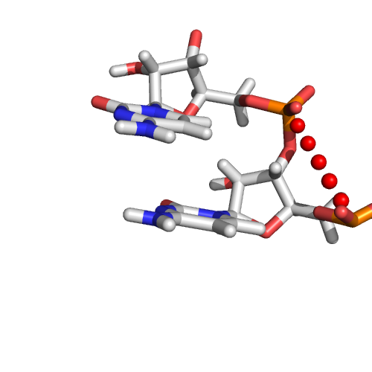A
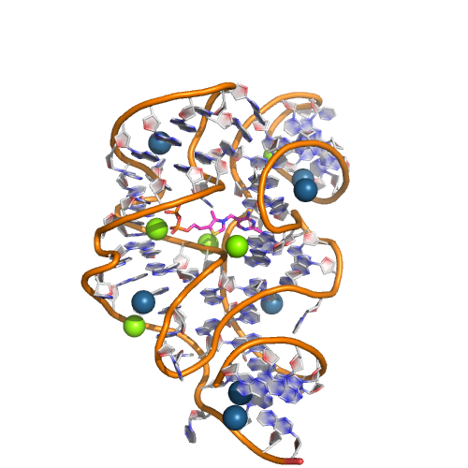B
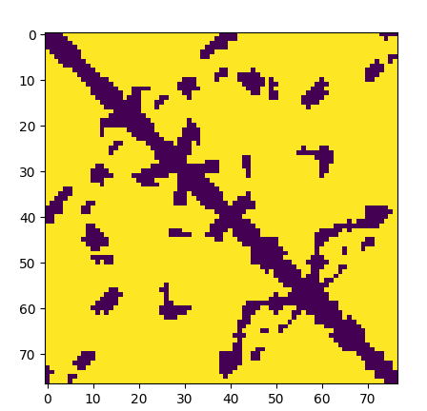C

b. Inputs of model
i. Sequence inputs
RNA sequences consist of only four different building blocks, A, U, G and C, where the sequence will be one-hot encoded into A, U, G and C in formula 2. Extra features added are using a variety of experimental and theoretical methods to further enrich the data, and help the neural network model. The input is a matrix with dimensions (Number_of_features * length , formula 2). This matrix will undergo 1D convolution along the horizontal axis and finally transformed to a (length * length * channels) tensor using inverse singular value decomposition .
The features are the following :
1. Residue A, U, G, C and others (5 features)
2. Predicted secondary structure and its associated base pair probabilities, positional entropy, mean free energy structure and positions of base pairs from ViennaRNA. (5 features)
3. Consensuses sequence and confidence of prediction from infernal. (5 features)

Formula 2 for AUGCGG
The biological and physical significance of AUGC is that sequence determines structure (quote) and thus it is possible to predict structure (and its distance matrix) from the sequence alone. Secondly, given that secondary structure predictions are rather robust (RNA composer), we use these algorithms to predict our secondary structure. Secondary structure helps to determine and simplify which residues are close and form hydrogen bonds, however this is not exhaustive
and there are other forms of structure that needs to be predicted. The final groups of features are that of the consensus sequences. RNA can be very different in sequence, yet adopt similar folds if they are from the same RNA family. This prediction will help predict related RNAs that differ very much in sequence. I have included an environment to explore the features.
ii. Pairwise inputs
There are certain features that are already (length * length) without the matrix transformation which transforms (Number_of_features * length ) to (length * length). These features include which pairs of residues form secondary structures (also known as base pairs), which can be predicted reliably by ViennaRNA. These also consist of pairwise residue from both the sequence and consensuses sequence. Figure 3 gives an example of a pairwise residues. They will give 21 (length * length) features. It is hoped this can help prediction of certain combination of residue pairs that interact strongly together.
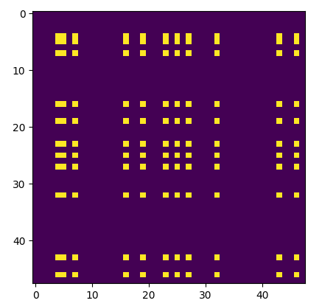
Figure 2 – Here shows presence of both A and G residues among residue pairs depicted by yellow dot.

Dataset.
There are a total of 491 structures in the train dataset, with RNAs from 35 to 500 residues long. This number is much reduced compared a total of 3000 structures due to redundancies in the protein data bank as each structure may occur multiple times. We used a manually curated list of non-redundant structures found here of version 2.141 to ensure our data is not biased by duplicates. The train data will also be augmented by subsampling 35, 50, 75, 100, 150, 200, 500 residues of the entire structure and this increases the size of the training set by 30 fold. We made a train,validation, test split of 370 : 110 : 11 structures. Model is trained only on train set, training stopped when validation performance is maxed and model finally evaluated against the 12 structures. These 12 structures were part of an RNA modeling competition and benchmarks against the best methods.

Metrics
Model predicts categorical distance matrix and the metric used to train the model will be sigmoid log loss averaged over each entry in the distance matrix. The model however will be evaluated using balanced accuracy. The formula is (TP/Positives + TN/negatives)/2. This gives a balanced metric that is unaffected by the size of the RNA. This is because the pair-wise distance categorical matrix contains mostly negatives and larger RNAs contains relatively more negatives compared to a smaller RNA since number of matrix entries scale with N², but the number of interactions scales roughly by N since and RNA residue interacts with 2-4 different residues. The balanced accuracy thus gives a metric that can be compared across RNAs of different sizes.
The probability threshold will be 0.3, where distances predicted a 30% probability will be deemed sufficient to be called a close distance. This was seen in our cross validations where a lower threshold results in a higher balanced accuracy.
Choosing a distance threshold of 16Å
I plotted all the distances between residues and found that there are three peaks in 8Å, 12Å and 18Å. I tried different models with different distances. The 8Å model was too few to have any predictive power while and 12Å model did not converge due to the class imbalance. After reweighing the minority class, the model converged, but the categorical distance matrix did not look informative which is why I settled for a 16Å model.

II. Analysis

Algorithms and Techniques
We will be using deep learning to predict the categorical distance matrix from the sequence and features generated from the sequence. Deep learning automates features and current image processing techniques are now state of the art and exceed human performance (cite). I believe a CNN is the easiest and most direct way to solve the problem because the RNA sequence varies in length in two orders of magnitude and existing machine learning methods cannot easily take in inputs of varying sizes. Furthermore, the problem is extremely complicated and almost impossible to model by ‘intuition’ . This makes is difficult to design features to model using machine learning methods. Given the extreme difficulty for a different machine learning model and the robustness of CNN in image processing, I have decided to use other methods as a benchmark instead of machine learning.
Since deep learning does automated feature selection, unimportant inputs will have little significance in the model and vice versa for important inputs. The convolution filters should pick up important features for the model which are too difficult for humans to visualize and model.

The deep learning model can be summarized in the following figure and it uses an inception style network. Residue level features were first input to followed immediately followed immediately by atwo rounds of 1D convolution. This is because the different features have no spatial correlation to each other, but different residues are correlated which is why only a 1D convolution kernel is used.

The final is a (1 * length * 64) tensor which will be applied inverse SVD across each of the 64 channels to attain a (length * length *64) tensor. The pair-wise features will then be merged into the (length * length * 64) tensor and a 2D CNN will be used with a filter sizes 3 or 5 and ‘same’ padding. Dropout was defined in model but not used while the learning rate was had a cosine decay over each epoch. The learning rate was 0.1, 0.01, 0.001 at epoch 0-150, 150-225, 225-300.

I used layer normalization since batch normalization will prove difficult with different RNA sequence lengths. The code will be shown in an environment.

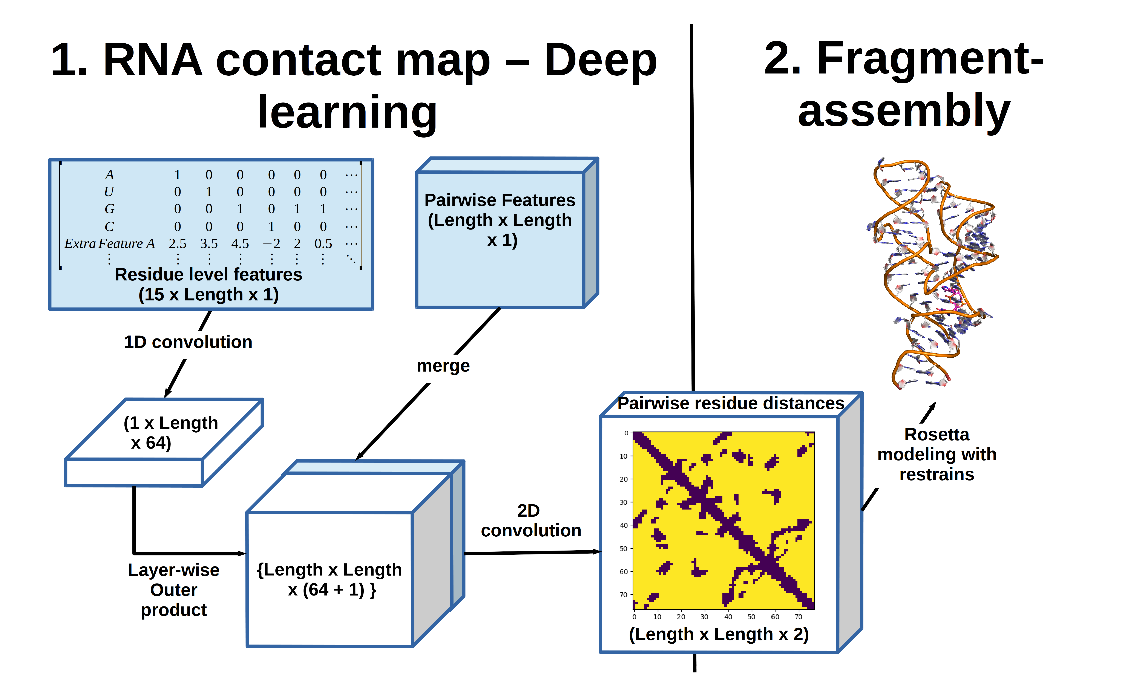

Exploratory Visualization
Provided in environment

Results and Benchmark
I have used RNA modelling competitions and converted the structures into a distance matrix for equal comparison to my deep learning method. There were 21 RNA competitions, with 16 having released results. Among these 16, one had an erroneous sequence between the predicted and modeled structure (Puzzle 5, 13), one was trivial (puzzle 1), two contained more than one RNA chain (puzzle 2 and 10) and outside the scope of our train set. We were left with 11 structures to benchmark our method against others.
I proceeded to compare the balanced accuracy of deep learning compared to other methods used in competitions. Since RNA structure exist as an ensemble in a cell, the competitions allow 10 models per competitor though the experimental structure only contain one model due to experimental constraints. I will take the mean rank of each method per competition and compare with my deep learning model.
I used ranks instead of balanced accuracy to normalize across competitions. Some competitions are inherently more difficult than others and using just balanced accuracy will be favoring methods which participate the easiest competitions. The average rank of each method will be a good metric to benchmark different methods across competitions with different difficulty levels.
Since the other methods were outside machine learning, the details will be left out in favor of a brief description.
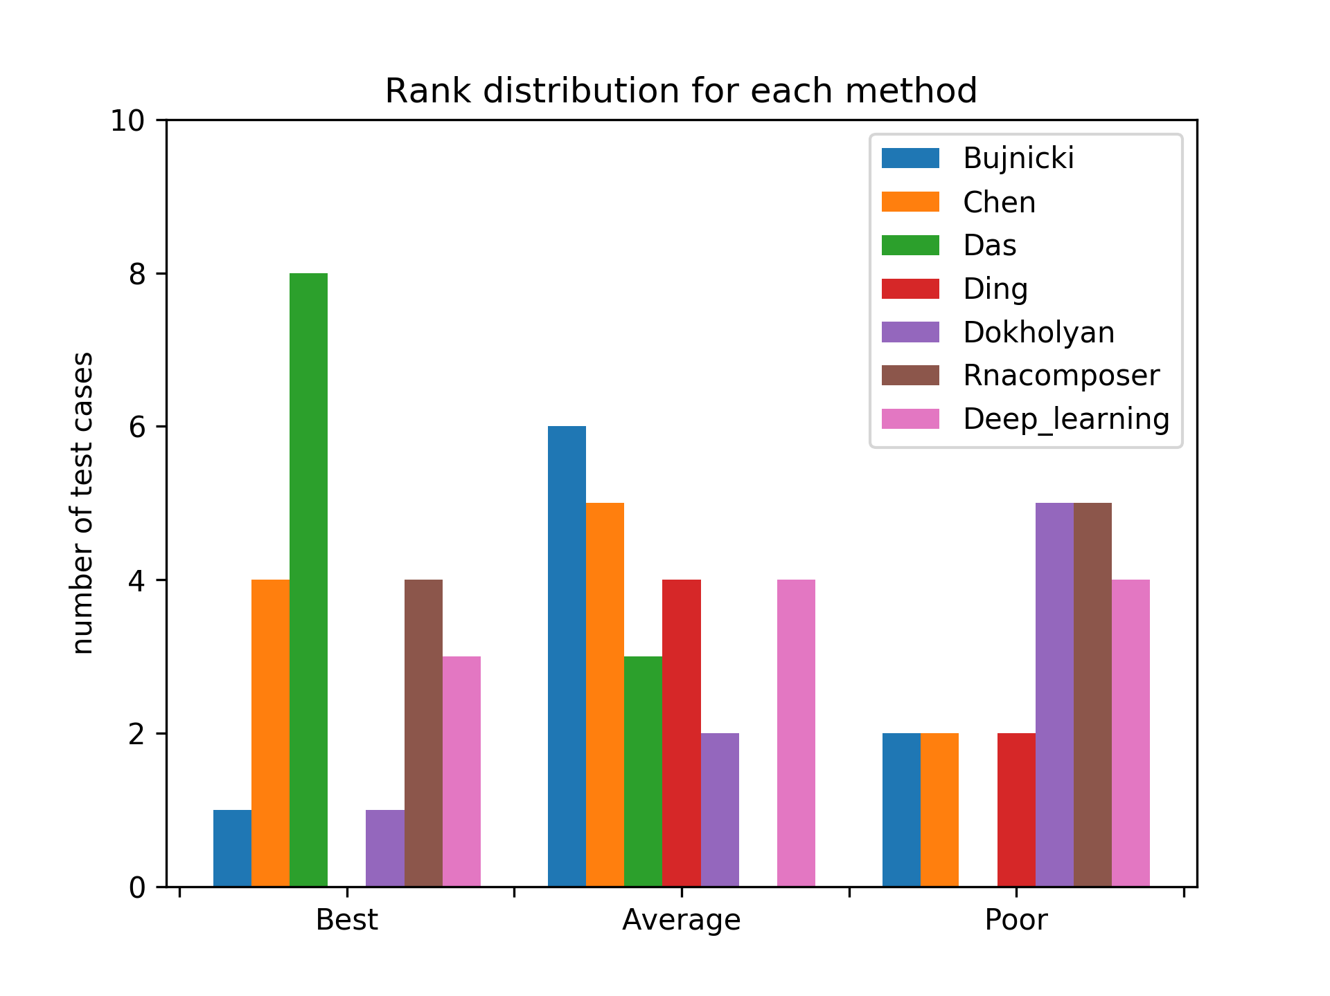
Figure X : Results
Results in figure X show the results in three histogram bis, best < 0.33 percentile, average (0.33-67 percentile) and worst ( > 0.67 percentile). I have added a figure with 11 histogram bins instead at the supplementary for a better view of the data.
The methods fom best to worst are
1. Das
2. Chen
3. Deep Learning
4. Bujnicki
5. RNAcomposer
6. Ding
7. Dokholyan
The Das and Chen, Bujnicki, Ding and Dokholyan group modeled the structures using first principles derived from statistical physics and such methods are known to be computationally expensive. Meanwhile Deep learning and RNA composer use deep learning and machine translation methods, though documentation of the latter is extremely sparse.
In conclusion deep learning appears to be fail to generalize in this case, which can be primarily attributed due to a lack of data, of which we only have 490 datapoints.

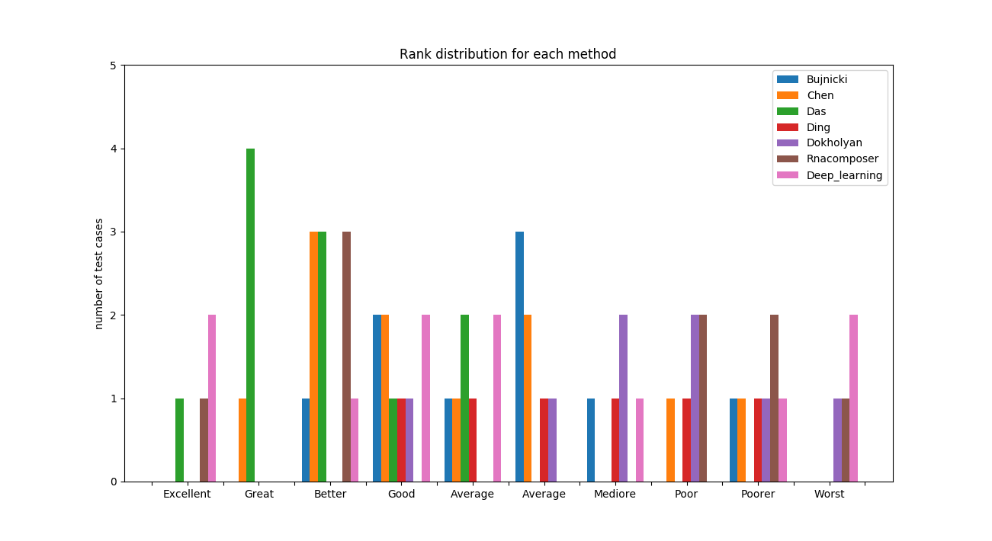Supplementary

Consensus sequence is the representative sequence of the RNA family

