# Machine Learning Engineer Nanodegree
## Capstone Proposal
Joe Udacity
December 31st, 2050

## Proposal
Modelling RNA structural interactions with deep learning
_(approx. 2-3 pages)_

### Domain Background
_(approx. 1-2 paragraphs)_
Biochemistry

All biology depends on genome sequences which spontaneously folds in the cell to form 3D atomic biochemical structures. Meanwhile RNA structure has increasingly been found to play a significant role in regulating cellular activities instead of just being a messenger molecule. Notwithstanding that, there is an increasing number of structures deposited into the protein data bank. However, among all the 100,000 structures deposited into the protein data bank, only 3000 contain RNA -- RNA is inherently flexible and difficult to resolve to a good resolution.

There is now a need to develop of various computational tools to predict RNA tertiary structure, notably physics forcefield and statistical mechanics methods. It must be noted that RNA contains at least 20 *length atoms and the 3D space to explore is huge when predicting an RNA structure.

One area at least to my knowledge not attempted is deep learning, despite having successfully applied to a similar class of biological molecules – protein which are largely analogous to RNA in structure and function. It is hoped that deep learning can be used to help predict RNA structure or least reduce the complexity of RNA folding just from the RNA sequence alone.

Automated 3D structure composition for large RNAs.

https://en.wikipedia.org/wiki/List_of_unsolved_problems_in_chemistry#Biochemistry_problems

In this section, provide brief details on the background information of the domain from which the project is proposed. Historical information relevant to the project should be included. It should be clear how or why a problem in the domain can or should be solved. Related academic research should be appropriately cited in this section, including why that research is relevant. Additionally, a discussion of your personal motivation for investigating a particular problem in the domain is encouraged but not required.

### Problem Statement
_(approx. 1 paragraph)_

I are going to be predicting pair-wise atom euclidean distances between basic building blocks of RNA, also called residues. Figure 1 shows two RNA residues, while figure two shows an entire RNA structure with 70 residues. I are interested in the distances between phosphate atoms as seen by the red spheres in figure 1. I hope to predict a pair-wise residue distance matrix D where d is the distances between phosphate atoms using the RNA sequence alone. This is physically and biologically true since sequence alone determines structure (cite)

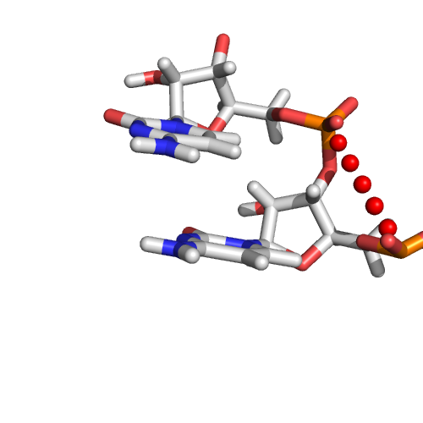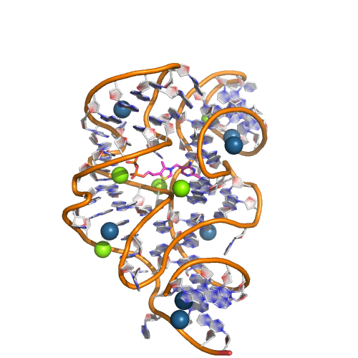
In this section, clearly describe the problem that is to be solved. The problem described should be well defined and should have at least one relevant potential solution. Additionally, describe the problem thoroughly such that it is clear that the problem is quantifiable (the problem can be expressed in mathematical or logical terms) , measurable (the problem can be measured by some metric and clearly observed), and replicable (the problem can be reproduced and occurs more than once).

### Datasets and Inputs
_(approx. 2-3 paragraphs)_

The dataset used here will be RNA structures solved through experimental means from the protein data bank. All of these structures contain the 3D ordinates for experimental atoms and the residue sequence. The input variable will be the RNA sequence, while the output variable will be the pairwise distance matrix D.

RNA sequences contain of only four difference building blocks, A, U, G and C, and a sequence of AUGCGG will have an input of the matrix below. The details of extra features will be determined by feature engineering using open sourced bioinformatic tools.

Since there are redundancies in the data as each structure may occur multiple times, we used a non-redundant list of structures found here of version 2.141. This is to ensure our data is unbiased.

I have provided a an example of a data source below.

I will give simple example of a HIV-tar RNA molecule in complex with a drug.

Webpage with RNA : http://www.rcsb.org/pdb/explore/explore.do?structureId=1QD3
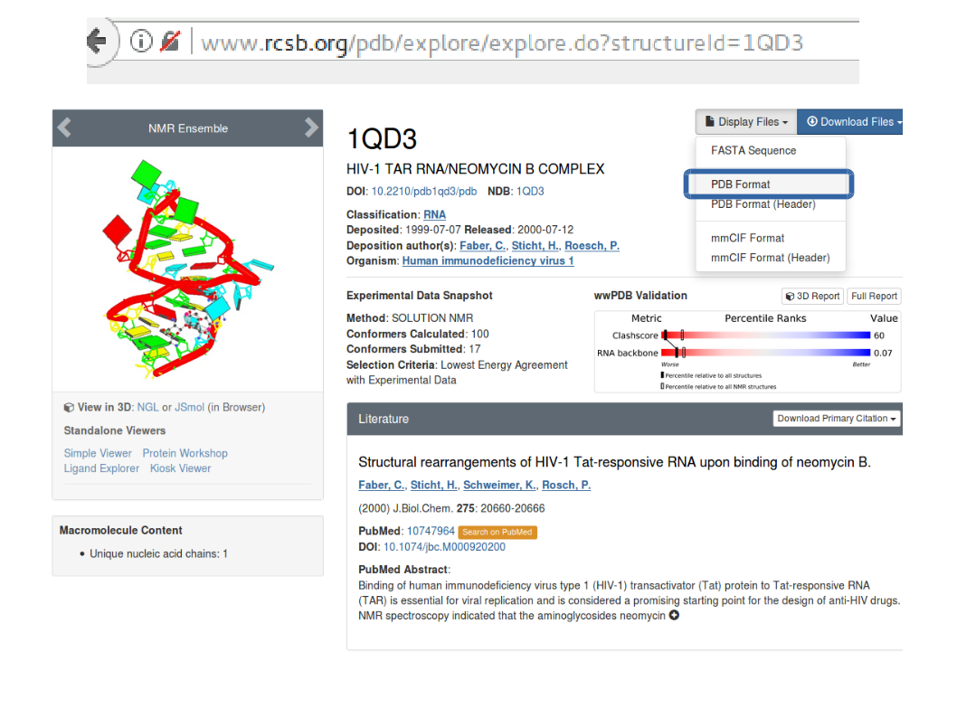
After clicking PDB format, you see a file with gibberish. Ignore that and proceed to lines with the word ATOM. Columns to pay attention are 13-16, 18-20, 21, 23-26, 31-54. These respectively gives atom type, residue type, chain, residue number and xyz coordinates. I will need these information to identify the phosphate atom of each residue and its coordinates.

### SAMPLE OF PAGE ###
ATOM 32 P C A 18 -9.580 -0.134 -9.860 1.00 0.30 P
ATOM 33 OP1 C A 18 -11.026 0.169 -9.719 1.00 0.38 O
ATOM 34 OP2 C A 18 -8.610 0.453 -8.900 1.00 0.35 O
ATOM 35 O5' C A 18 -9.405 -1.717 -9.844 1.00 0.27 O
##### End of Sample #####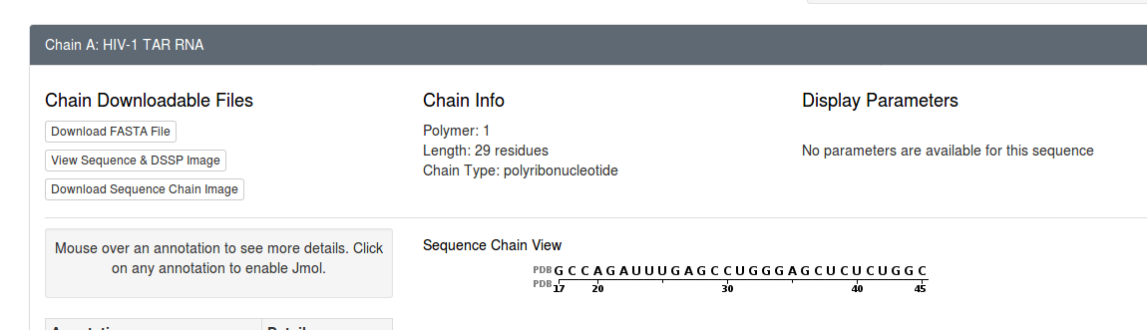
The sequence of the structure is recorded here.
I used 492 single chained RNA structures ranging for RNAs 35 to 500 residues long. The structure with the best resolution was chosen if multiple structures are available. Unfortunately you are not a biochemist and thus you have to assume that the data I propose is most suitable given the problem.

In this section, the dataset(s) and/or input(s) being considered for the project should be thoroughly described, such as how they relate to the problem and why they should be used. Information such as how the dataset or input is (was) obtained, and the characteristics of the dataset or input, should be included with relevant references and citations as necessary It should be clear how the dataset(s) or input(s) will be used in the project and whether their use is appropriate given the context of the problem.

### Solution Statement
_(approx. 1 paragraph)_
It is useful to note that the distance matrix D is very similar to an image and I will use CNN to solve the problem with a notable difference that pixel level regression will be done. This might pose some difficulties, but hey if the problem was so simple, it should be trashed.

Why I believe a CNN is suitable is that filters are invariant to input lengths. RNA differ in orders of magnitude in length, and CNN can handle such inputs. Furthermore, certain sequence patterns of RNA are correlated with certain geometries, and this can be picked up through convolution filters and proceed to predict through the distance matrix D.

In this section, clearly describe a solution to the problem. The solution should be applicable to the project domain and appropriate for the dataset(s) or input(s) given. Additionally, describe the solution thoroughly such that it is clear that the solution is quantifiable (the solution can be expressed in mathematical or logical terms) , measurable (the solution can be measured by some metric and clearly observed), and replicable (the solution can be reproduced and occurs more than once).

### Benchmark Model
_(approximately 1-2 paragraphs)_

I am sorry, but the methods here are extremely technical,
1. Modeling using fragment and knowledge based approach – RNA composer (this might not be a fair comparison since I only have access to their server and not blind test)
2. Comparison against models of various methods of RNA structure modeling competitions (http://ahsoka.u-strasbg.fr/rnapuzzlesv2/) .

In this section, provide the details for a benchmark model or result that relates to the domain, problem statement, and intended solution. Ideally, the benchmark model or result contextualizes existing methods or known information in the domain and problem given, which could then be objectively compared to the solution. Describe how the benchmark model or result is measurable (can be measured by some metric and clearly observed) with thorough detail.

### Evaluation Metrics
_(approx. 1-2 paragraphs)_
Evaluation metric would be root mean squared loss.

In this section, propose at least one evaluation metric that can be used to quantify the performance of both the benchmark model and the solution model. The evaluation metric(s) you propose should be appropriate given the context of the data, the problem statement, and the intended solution. Describe how the evaluation metric(s) are derived and provide an example of their mathematical representations (if applicable). Complex evaluation metrics should be clearly defined and quantifiable (can be expressed in mathematical or logical terms).

### Project Design
_(approx. 1 page)_

In this final section, summarize a theoretical workflow for approaching a solution given the problem. Provide thorough discussion for what strategies you may consider employing, what analysis of the data might be required before being used, or which algorithms will be considered for your implementation. The workflow and discussion that you provide should align with the qualities of the previous sections. Additionally, you are encouraged to include small visualizations, pseudocode, or diagrams to aid in describing the project design, but it is not required. The discussion should clearly outline your intended workflow of the capstone project.

-----------

**Before submitting your proposal, ask yourself. . .**

- Does the proposal you have written follow a well-organized structure similar to that of the project template?
- Is each section (particularly **Solution Statement** and **Project Design**) written in a clear, concise and specific fashion? Are there any ambiguous terms or phrases that need clarification?
- Would the intended audience of your project be able to understand your proposal?
- Have you properly proofread your proposal to assure there are minimal grammatical and spelling mistakes?
- Are all the resources used for this project correctly cited and referenced?

Capstone Proposal Overview

Please note that once your Capstone Proposal has been submitted and you have passed the evaluation, you have to submit your Capstone project using the same proposal that you submitted. We do not allow the Capstone Proposal and the Capstone project to differ in terms of dataset and approach.

In this capstone project proposal, prior to completing the following Capstone Project, you you will leverage what you’ve learned throughout the Nanodegree program to author a proposal for solving a problem of your choice by applying machine learning algorithms and techniques. A project proposal encompasses seven key points:

The project's domain background — the field of research where the project is derived;
A problem statement — a problem being investigated for which a solution will be defined;
The datasets and inputs — data or inputs being used for the problem;
A solution statement — a the solution proposed for the problem given;
A benchmark model — some simple or historical model or result to compare the defined solution to;
A set of evaluation metrics — functional representations for how the solution can be measured;
An outline of the project design — how the solution will be developed and results obtained.

Capstone Proposal Highlights

The capstone project proposal is designed to introduce you to writing proposals for major projects. Typically, before you begin working on a solution to a problem, a proposal is written to your peers, advisor, manager, etc., to outline the details of the problem, your research, and your approach to a solution.

Things you will learn by completing this project proposal:

How to research a real-world problem of interest.
How to author a technical proposal document.
How to organize a proposed workflow for designing a solution.

