Machine Learning Engineer Nanodegree

Capstone Project
LeeXA
20th December 2017

I. Definition

Project Background (Biochemistry)
All biology depends on nucleotide and amino acid sequences which spontaneously fold to form 3D atomic biochemical structures, with the former relatively less studied. (Wan et al. 2011). However, RNA structure has increasingly been found to play a significant role in regulating cellular activities where two examples include RNA polymerase, riboswitches whose function is to make a RNA copy of DNA and sense metabolic molecules respectively (Wan et al. 2011) and there is a need to study RNA structure.

The way RNA forms structure is through physical interactions (Van der Waals interaction, hydrogen bonds, ionic pairing) (Lounnas et al. 2013), an RNA sequence is able to spontaneously fold to its structure in the cell. These structures can be experimentally determined if one packs them into a crystal and subsequently resolved by X-ray diffraction. The experimental structure is subsequently deposited into the Protein Data Bank (https://www.rcsb.org/pdb/home/home.do).

Among the 100 thousand experimental structures deposited into the Protein Data Bank, only three thousand contains RNA -- RNA is inherently flexible and difficult to resolve to a good resolution (Ke 2004). There is now a need to develop of various computational tools to predict RNA tertiary structure, where notable developments include statistical mechanics and machine translation methods (Das and Baker 2007; Popenda et al. 2012). It must be noted that RNA contains at least 20 * length atoms and the 3D space to explore when predicting an RNA structure is not a trivial task.

One area at least to my knowledge not attempted is deep learning, despite having successfully applied to a similar class of biological molecules – proteins which are largely analogous to RNA in structure and function (Wang et al. 2017). It is hoped that deep learning can be used to help predict RNA structure or least reduce the complexity of RNA structure problem for other algorithms.

Problem Statement
a. Output of model
To predict the final structure of RNA, I will be predicting pair-wise atom euclidean distances between basic building blocks of RNA, also called residues. The distance matrix is shown in matrix D (refer to formula 1). The matrix is zero-diagonal symmetric. The matrix has dimensions length * length , with length being number of residues in RNA sequence in the pair-wise distance matrix D.

Figure 1a shows exactly what distances are measured, which is the distance between two RNA phosphate atoms, while figure 1b shows an entire RNA structure with 70 residues and a complex fold for you to gain an intuition of the complexity of the problem.

To be specific about matrix D, since distance based regression may be difficult, I would predict categorical values instead of actual euclidean distances. The other reason why I used distance categorical values is that I would be able to assign probabilities on the predictions. These distance categories are short and long which are < 16Å and >16Å respectively and rationale for the 16Å distance is in the analysis. 1Å is a unit of measurement of the field, which equals 10⁻¹⁰m. The distance matrix hence is a tensor of size (Length * Length * 1 for two categories) shown in figure 1C. With a good categorical distance matrix, the RNA can be very easily modeled using various chemical modeling software and thus predicting a good distance matrix is the first step to modeling RNA structure.

Formula 1, Pairwise distance matrix

Figure 1 : A). Two RNA residues and the distance between phosphate atoms shown in red spheres. B). Example of an RNA molecule and its complex structural fold (2cky). C). Categorical distance matrix, (dark, light for short and long distances respectively). This RNA is the TPP riboswitch which is a potential antibiotic target.
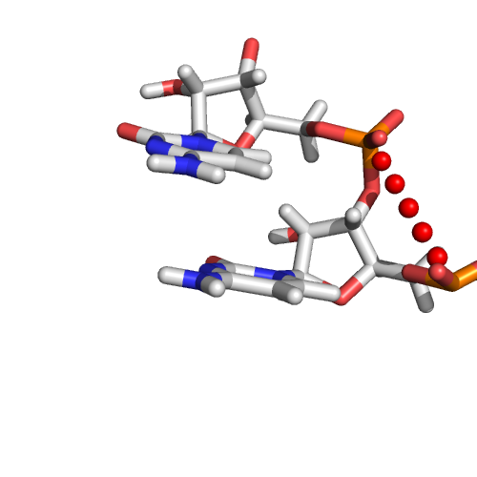A
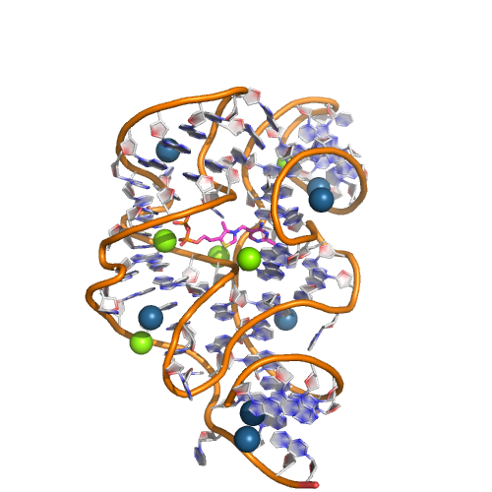B
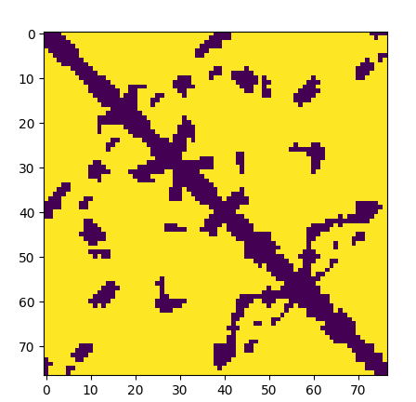C

b. Inputs of model

The model was trained in batch size of 1 and for simplicity sake, the batch axis is omitted from the report but present in the model.

i. Sequence inputs
RNA sequences consist of only four different building blocks, A, U, G and C, where the sequence will be one-hot encoded into A, U, G and C in formula 2. Extra features using a variety of experimental and theoretical methods will be added to help the neural network model. The sequence input is a matrix with dimensions (Number_of_features * length , formula 2). This matrix will undergo 1D convolution finally transformed to a (length * length * channels) tensor using inverse singular value decomposition.
The features are the following :
1. Residue A, U, G, C and others one hot encoded (5 features)
2. Predicted secondary structure and its associated base pair probabilities, positional entropy, mean free energy structure and positions of base pairs from ViennaRNA (Lorenz et al. 2011). (5 features)
3. Familial consensuses sequence and confidence of prediction from infernal (Nawrocki, Kolbe, and Eddy 2009). (5 features)

Formula 2 for RNA sequence AUGCGG
Firstly, the biological and physical significance of using the first five features (A, U, G, C, others) is that sequence determines structure (Wang et al. 2017) and thus it is possible to predict structure (and its distance matrix) from the sequence alone. Secondly, given that secondary structure predictions are rather robust with an MCC of 0.96-1.00 (Popenda et al. 2012), we use ViennaRNA to predict our secondary structure. This is because secondary structure helps to determine and simplify the problem by defining which residues are close together and form RNA basepairs, however this feature is insufficient to determine the entire fold of the RNA. Thirdly, we use features from the consensus sequences of it's RNA family. RNA can be very different in sequence, yet adopt similar structure if they are from the same RNA family. This information from the consensus sequence will help predict related RNAs that differ very much in sequence but are from the same family.
I have included an environment to explore the features.
ii. Pairwise inputs
There are certain features that are already (length * length) without the matrix transformation which transforms (Number_of_features * length ) to (length * length). These features include which pairs of residues form secondary structures (also known as base pairs), predicted reliably by ViennaRNA. The pairwise features are obtained from the sequence and consensuses sequence. Figure 3 gives an example of a pairwise residues. They will give 21 (length * length) features. It is hoped this can help prediction of certain combination of residue pairs that interact strongly together.
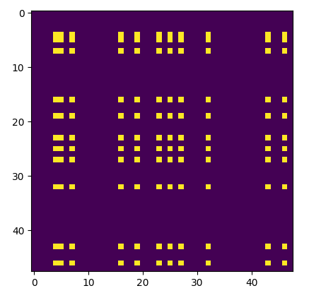
Figure 2 – Here shows presence of both A and G residues among residue pairs depicted by yellow dot.

iii) Points to note for the sequences
Much of the data is feature engineered from specific engineered bioinformatics software which require a background in biochemistry and biophysics. The way to generate requires many steps and the suitability of such software is probably not your expertise with much preprocessing done in the code and outside the code. For your reference, the preprocessed variables are listed in the table below. These will be data in it's preprocessed form to directly feed into the model.

Table 1 : Names of inputs used in code.

Dataset.
There are a total of 491 structures in the dataset, with RNAs from 35 to 1500 residues long. I removed very small <35 residues and very large RNAs due to the former being usually uninteresting and the latter too large to model. This number is much reduced compared a total of 3000 structures due to redundancies in the protein data bank as each structure may occur multiple times. We used a manually curated list of non-redundant structures found here of version 2.141 to ensure our data is not biased by duplicates. The train data will also be augmented by sub-sampling 35, 50, 75, 100, 150, 200, 500 residues of the entire structure and this increases the size of the training set by 30 fold. The 500 limit was set due to memory constraints and this means RNA >= 500 residues long are all in the train set. We made a train,validation, test split of 370 : 110 : 11 structures. Model is trained on the train set, training stopped when performance is optimized int the validation set and model finally evaluated against the 11 test structures. These 11 structures were part of an RNA modeling competition and benchmarks against the best methods.

Metrics
Model predicts the categorical distance matrix and the objective function will be the average sigmoid log loss of the distance matrix. The model however will be evaluated using balanced accuracy with formula (TP/Positives + TN/negatives)/2. This gives a balanced metric that is unaffected by the size of the RNA. This is because the pair-wise distance categorical matrix contains mostly negatives and larger RNAs contains relatively more negatives compared to a smaller RNA since number of matrix entries scale with N², but the number of interactions scales roughly by N since an RNA residue interacts with 2-4 different residues. The balanced accuracy thus gives a metric that can be compared across RNAs of different sizes.
The probability threshold will be 0.3, where distances predicted with 30% probability will be deemed sufficient to be called a close distance. This was seen in the cross validations where a lower threshold results in a higher balanced accuracy.
To obtain the predictions, I performed a sigmoid transformation on the logits using this function : tf.nn.sigmoid(out), where out is the logits. I filled the diagonals as 0 (close distances) and added its the categorical distance matrix by its transpose to obtain a symmetrical matrix and applied the 30% threshold to obtain the predictions.
Note : M + M^{T} = symmetric matrix
Choosing a distance threshold of 16Å
I plotted all the distances between residues and found that there are three peaks in 8Å, 12Å and 18Å. I tried different models with different distances. The 8Å and 12Å model suffered from severe class imbalance and the categorical distance matrix did not look informative judging from experience which is why I settled for a 16Å model.

II. Analysis

Algorithms and Techniques
I will be using deep learning to predict the categorical distance matrix from the sequence and features generated from the sequence. Deep learning automates features and current image processing techniques are now state of the art and exceed human performance in certain cases(Dodge and Karam 2017). I believe a CNN is the easiest and most direct way to solve the problem because the RNA sequence varies in length in two orders of magnitude and existing machine learning methods cannot easily take in inputs of varying sizes. Furthermore, the problem is extremely complicated and almost impossible to model by 'intuition'. This makes is difficult to design features to model using traditional machine learning methods. Given the extreme difficulty for a different machine learning model and the robustness of CNN in image processing, I have decided to use other existing modeling methods as a benchmark instead of machine learning.
One type of network which has a large filter size and saves parameters is the inception3 network(Szegedy et al. 2016), as it dissects a large convolution kernel to various smaller kernels and I will use them for my problem.
The deep learning model can be summarized in figure 3 and it contains five inception3 units. There were two types of inputs : i) residue level features and ii) pairwise features, and both types of features undergo 1D and 2D convolution respectively.

Firstly, the residue level features was followed by a two 1D inception3 networks, with the first being having filter size of (15x1) with 'valid' padding to transform the inputs from (15 * Length * 1) to (1 * length * 64) followed by 1D convolution with 'same' padding along the length axis with the final tensor to be (1 * length * 96). This is because the matrix is spatially correlated along the length axis, but not along the features axis as different features have no obvious spatial correlation to each other, but an RNA residue is very correlated to its neighboring residues being bonded by strong chemical bonds. This is the reason for a 1D convolution along the features axis followed by 1D convolution along the length. The resultant (1 * length * 96) tensor will undergo inverse SVD across each of the 96 channels to attain a (length * length * 96) tensor.

Secondly, the pair-wise features under go 2D convolution to form a (length * length * 64) tensor and merged with the output from the inverse SVD to form a (length * length * 160) tensor. A 2D CNN is subsequently used with a kernel sizes 3 or 5 and ‘same’ padding. Three inception3 units were used and the final output (length * length * 128) undergoes a linear combination to output the logits for the final pair-wise distance matrix which will be optimized with a average sigmoid loss over the entire matrix. The diagonals and missing data will be masked with 0 since they should not contribute to the loss.

Dropout was defined in model but not used while the learning rate had a cosine decay over each epoch. The cosine learning rate allows a search for both the global and local minima. The initial learning rate was 0.1, 0.01, 0.001 at epoch 0 - 150, 150 – 225, 225 - 245. Layer normalization was also used since batch normalization will prove difficult with different RNA sequence lengths. The code will be shown in an environment.

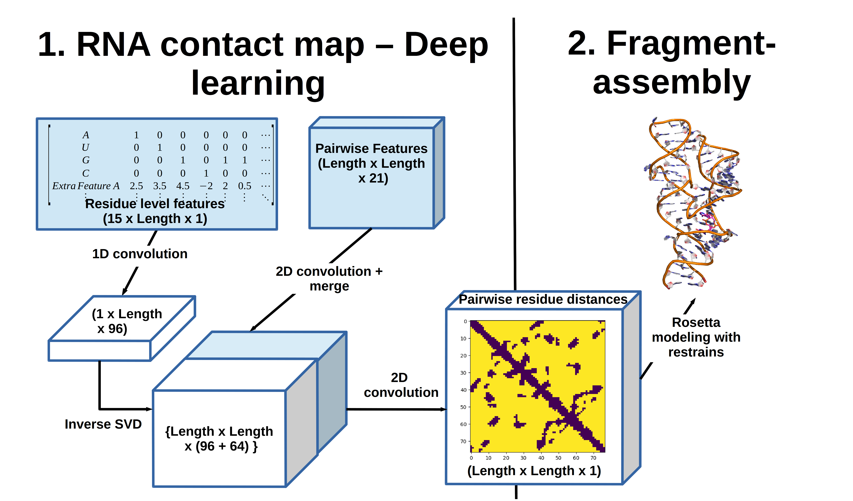
Figure 3 Architecture of model : Inputs are shown in blue, and the output is a pair-wise distance matrix. Deep learning portion only consist of part 1, part 2 is outside the scope of the project but completes modeling of the RNA structure.

Exploratory Visualization
Provided in environment

Results and Benchmark
I have used RNA modelling competitions and converted the structures into a distance matrix for equal comparison to my deep learning method(Miao et al. 2017). There were 21 RNA competitions, with 16 having released results. Among these 16, one had an erroneous sequence between the predicted and modeled structure (Puzzle 5, 13), one was trivial (puzzle 1), two contained more than one RNA chain (puzzle 2 and 10) and outside the scope of our train set. We were left with 11 structures to benchmark our method against others.
I proceeded to compare the balanced accuracy of deep learning compared to other methods used in competitions. Since RNA structure exist as an ensemble in a cell, the competitions allow 10 models per competitor though the experimental structure only contain one model due to experimental constraints. I will take the mean rank of each method per competition and compare with my deep learning model.
I used ranks instead of balanced accuracy to normalize across competitions. Some competitions are inherently more difficult than others and using just balanced accuracy will be favoring methods which participate the easiest competitions. The average rank of each method will be a good metric to benchmark different methods across competitions with different difficulty levels. Since the other methods were outside machine learning, the details will be left out in favor of a brief description.
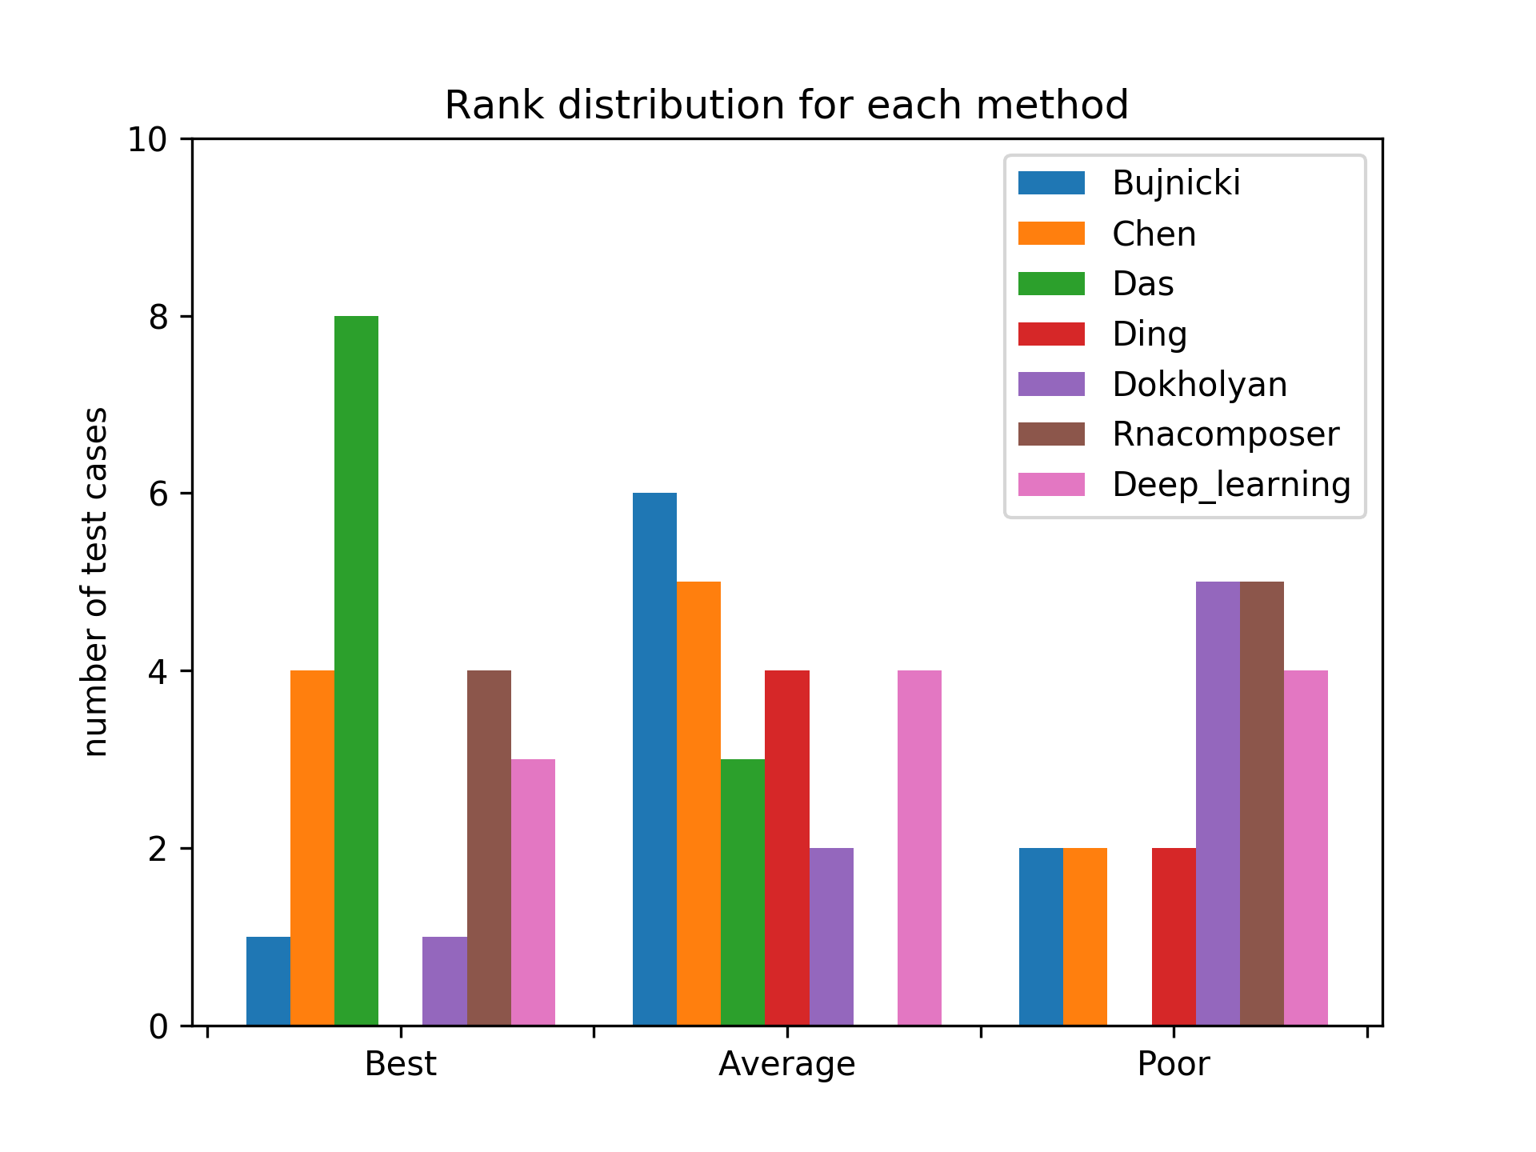
Figure 4 : Ranks of different methods over the 11 competitions. The histogram bins are best (< 0.33 percentile), average (0.33-0.67 percentile) and worst (>0.67 percentile).
Results in figure 4 show the results in three histogram bis, best < 0.33 percentile, average (0.33-67 percentile) and worst ( > 0.67 percentile). I have added a figure with 10 histogram bins at the supplementary for a better view of the data. Deep learning has a validation balanced accuracy of 80.5 percent, and test balanced accuracy of 78.4 percent. The results are also reported in table 2.

Table 2 : The average rank and balanced accuracy. The average balanced accuracy is not the best metric since only Das, Chen and Deep_learning had results for all 11 competitions and difficult competitions tend to reduce the average balanced accuracy but not the average rank.

The Das and Chen, Bujnicki, Ding and Dokholyan group modeled the structures using first principles derived from statistical physics and such methods are known to be computationally expensive(Miao et al. 2017). Meanwhile Deep learning and RNA composer use deep learning and machine translation methods, though documentation of the latter is extremely sparse(Popenda et al. 2012).
In conclusion deep learning appears to be do reasonably well, but not as well as the best method by Das, which is a method from first principles compared to statistical learning. There are possible reasons why the data fails to generalize, and mainly is the the dataset size is relatively small to fully generalize in this case, where we only have 490 data points.
Nevertheless, there is still a space for our method since it can predict contacts relatively fast and accurately compared to Das which requires thousands of CPU hours per model.
Improvements
The dataset is relatively small and a follow-up of my project is to use the predictions to model a structure using fragment assembly (figure 3 part 2), and proceed to benchmark a larger dataset. This was not included here since fragment assembly is outside the scope of the project. Currently there are also some bottlenecks in the model pipeline, namely the (15 * 1) 1D convolution and also the inverse SVD which very suddenly compresses or expands the data. Alternative methods to prevent hese bottleneck will likely help the model.
Another interesting follow-up is to apply transfer learning on my model to predict another RNA related problem, eg. Secondary structure or other properties.

Das, Rhiju, and David Baker. 2007. “Automated de Novo Prediction of Native-like RNA Tertiary Structures.” Proceedings of the National Academy of Sciences 104 (37):14664–14669.
Dodge, Samuel, and Lina Karam. 2017. “A Study and Comparison of Human and Deep Learning Recognition Performance Under Visual Distortions.” arXiv Preprint arXiv:1705.02498.
Ke, A. 2004. “Crystallization of RNA and RNA?protein Complexes.” Methods 34 (3):408–14. https://doi.org/10.1016/j.ymeth.2004.03.027.
Lorenz, Ronny, Stephan H. Bernhart, Christian Hoener Zu Siederdissen, Hakim Tafer, Christoph Flamm, Peter F. Stadler, and Ivo L. Hofacker. 2011. “ViennaRNA Package 2.0.” Algorithms for Molecular Biology 6 (1):26.
Lounnas, Valère, Tina Ritschel, Jan Kelder, Ross McGuire, Robert P. Bywater, and Nicolas Foloppe. 2013. “CURRENT PROGRESS IN STRUCTURE-BASED RATIONAL DRUG DESIGN MARKS A NEW MINDSET IN DRUG DISCOVERY.” Computational and Structural Biotechnology Journal 5 (6):1–14. https://doi.org/10.5936/csbj.201302011.
Miao, Zhichao, Ryszard W. Adamiak, Maciej Antczak, Robert T. Batey, Alexander J. Becka, Marcin Biesiada, Micha\l J. Boniecki, Janusz M. Bujnicki, Shi-Jie Chen, and Clarence Yu Cheng. 2017. “RNA-Puzzles Round III: 3D RNA Structure Prediction of Five Riboswitches and One Ribozyme.” RNA 23 (5):655–672.
Nawrocki, E. P., D. L. Kolbe, and S. R. Eddy. 2009. “Infernal 1.0: Inference of RNA Alignments.” Bioinformatics 25 (10):1335–37. https://doi.org/10.1093/bioinformatics/btp157.
Popenda, M., M. Szachniuk, M. Antczak, K. J. Purzycka, P. Lukasiak, N. Bartol, J. Blazewicz, and R. W. Adamiak. 2012. “Automated 3D Structure Composition for Large RNAs.” Nucleic Acids Research 40 (14):e112–e112. https://doi.org/10.1093/nar/gks339.
Szegedy, Christian, Vincent Vanhoucke, Sergey Ioffe, Jon Shlens, and Zbigniew Wojna. 2016. “Rethinking the Inception Architecture for Computer Vision.” In Proceedings of the IEEE Conference on Computer Vision and Pattern Recognition, 2818–2826.
Wan, Yue, Michael Kertesz, Robert C. Spitale, Eran Segal, and Howard Y. Chang. 2011. “Understanding the Transcriptome through RNA Structure.” Nature Reviews Genetics 12 (9):641–55. https://doi.org/10.1038/nrg3049.
Wang, Sheng, Siqi Sun, Zhen Li, Renyu Zhang, and Jinbo Xu. 2017. “Accurate de Novo Prediction of Protein Contact Map by Ultra-Deep Learning Model.” PLoS Computational Biology 13 (1):e1005324.
Supplementary
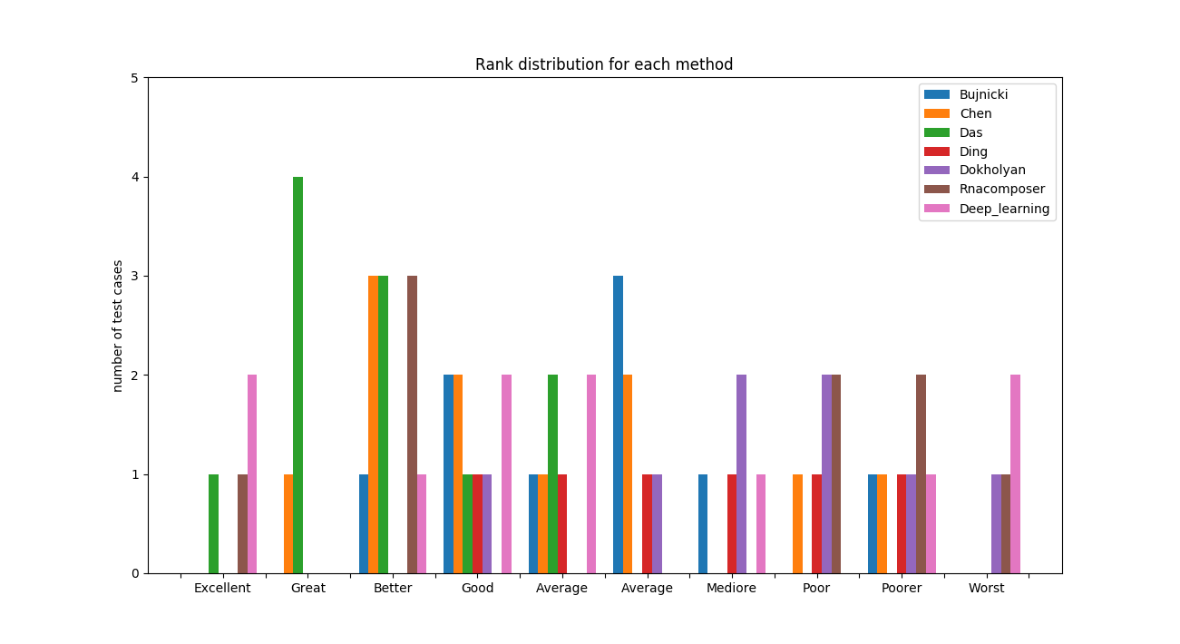
Figure 5 : Results of different methods with 10 histogram bins.

Consensus sequence is the representative sequence of the RNA family

