Genalyn Thomas

CJ-113: Review the layout to see if the website design loosely follows the style guide.

Acceptance Criteria: See if the website loosely follows the ETSU style guide

BucStop Website Design Location: wwwroot -> css -> site css

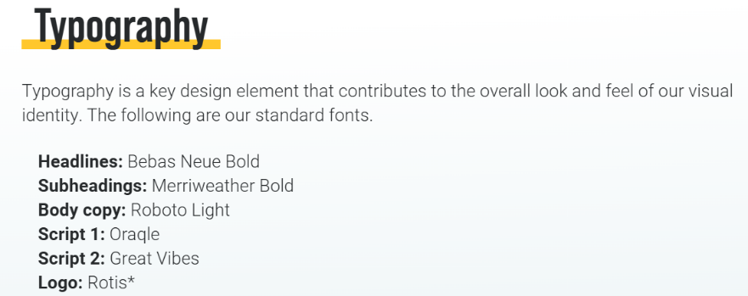

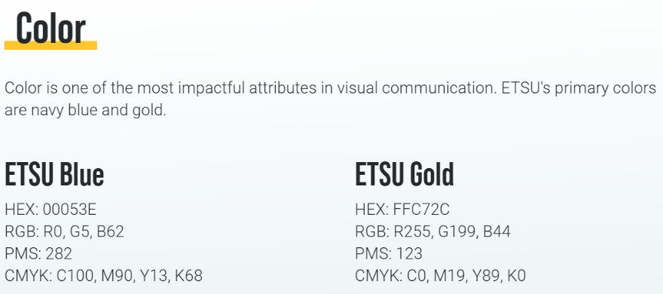

According to ETSU Website Typography, it is a critical part of layout design. I found that the BucStop website follows the ETSU Design Typography and Color guidelines. Overall, this CSS styles the website in a way that aligns loosely with ETSU’s aesthetic through colors, fonts, and other stylistic choices, while adding unique interactive elements for a gaming context.

Responsive Font Sizes:

The base font size is set to 14px but increases to 16px on devices with a width of at least 768px.

Page Layout:

The html and body elements are styled to ensure the page fills at least the full height of the viewport. The body also has a bottom margin (60px), likely for spacing elements from the bottom of the page, and a full-cover background image is applied.

Custom Fonts:

Two custom fonts, "Bebas Neue" and "Great Vibes," are added using @font-face. "Bebas Neue" is set as the default font for all elements, while "Great Vibes" can be applied selectively with the .font-great-vibes class.

Color Scheme:

Specific ETSU colors are applied:

Gold (#FFC72C) for headings.

Old Gold (#C6AA76) for links.

Navy and other shades of blue for other elements.

Text and Background Colors:

Most text is white by default, creating a clear contrast against darker or busier backgrounds.

Several utility color classes (color-etsu-navy, color-etsu-gold, etc.) are defined for consistent use of specific ETSU-inspired colors.

