VCard Import Steps

1. Go to OutLook => Option => Advanced => International options => Preferred encoding for outlook vCards => Choose UTF-8

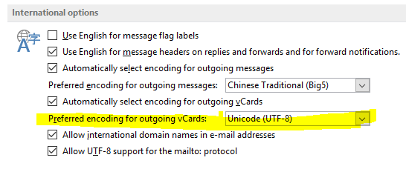

1. Check if the characters are correct.

