Jerusalem Guide: A Mobile Cloud Application

تسنيم حسن الشوبكي, 220180959, sososozo636@gmail.com

يارا فريد عبد الرحمن , 220182751,leeyuri883@gmai.com

مريم أبو مزيد, 220171110, mareamissa2000@gmail.com

Cloud Computing and its Applications

Department of Mobile Computing and Applications of Smart Devices

Faculty of Information Technology

Islamic University of Gaza

# Abstract

# Jerusalem application is an application that displays news about Jerusalem on the main screen, and a screen that displays cities and explains information about cities. We can put the news or the city in the favorites.

# Introduction

Application depends on cloud storage cities stored in Firebase Firestore and login to the application users store in authentication, Firestore, news and information from

# Method to add the city and Method to view city details and Method to add eaves and method to view details. User and MERHOD to display news

# Cloud Software Application Requirements

# 

# Software Architecture and Design

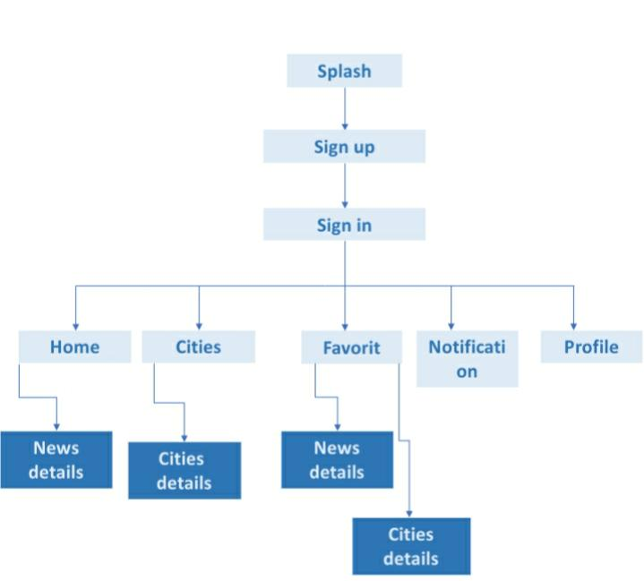

# Used Cloud Services and its Interfaces

* Firebase firestore
* Firebase Authontecation
* Firebase messages

# Implementation

* Firestore
* Authontication
* Messages
* Recycler
* PickImage

# Data

Model.

* Cities
* Users

Firebase

* Firestore

Cities

Favorit

Users

* Authonticaion
* Messages

# Architecture of the Used Cloud Platform

Firebase

* Firestore

Cities ( name , images , latitude , longtiud , details , video , area )

Favorit

Users ( email , fName , lName)

* Authonticaion
* Messages

# User Support

First, the user can sign up if he don’t have an account yet then he can browse the application pages (splash, cities, profile , …)

User can receive notification about new updates on Jerusalem city

User have his own profile that contain his information (email, name, phone, …)

User can add his favorite cities

# Conclusion

At the end we hope this application cover the main features and be a good guide to users to help them know more about Jerusalem and what's going there

# References

Wikipedia

Android developers

Stackoverflow

GitHub