**Making Competent Cell (NEB Stable *E.coli* competent cell)**

2021/09/14 Sandor method (not working)

Day 0

1. Do an overnight culture of the competent cell in 20 mL of LB broth without antibiotic, shaker incubator, 37*c

Day 1

***Preparing 100 mM Calcium Chloride solution***

|  |
| --- |
| CaCl2 111g/mol  100 mM = 0.1 mol/1L = 11.1 gm/1L of distilled RNAase-free water |

1. Mix 11.1 gm of CaCl2 in 1 L of distilled water, shake vigorously
2. Filter through the 0.22 um PES membrane in a sterile storage bottle using vacuum system

***Bacteria***

1. Grow the bacteria in the exponential phase; diluting an overnight culture 200 times in new LB broth (w/o antibiotic) and incubate it for 2-3 hours in warm room shaker

e.g. add 5 mL of overnight culture in 1 L of LB broth in 4L flask

1. Stop the bacteria proliferation by freezing the flask with ice, swirl every 2 mins to homogenize the temperature

*after this step, everything done on ice

1. Aliquot in 50 mL tube
2. Centrifuge at 3000 rpm, 4*c, 10 mins; discard supernatant
3. Wash with 5 mL cold CaCl2 solution, vortex
4. Combine 2-4 tubes depending on the amount of pellet, add CaCl2 to 50 mL, wait 20 mins
5. Centrifuge at 3000 rpm, 4*c, 10 mins; discard supernatant
6. Add 5 mL cold CaCl2 solution, vortex, add cold CaCl2 to 50 mL
7. Keep under ice in cold room overnight

Day 2

1. Centrifuge at 3000 rpm, 4*c, 10 mins; discard supernatant
2. Resuspend the competent cell with cold 10% glycerol in 100mM CaCl2 by pipetting softly, do not vortex

*Volume depending on pellet, after resuspension you should see a cloudy solution

e.g. 1 mL to 50 mL tube

1. Aliquot into Eppendorf tube
2. Snap frozen with liquid nitrogen or dry ice, store in -80*c
3. Test the competency of the cell with transfection of fresh competent cell and frozen competent cell each batch

**Daulet’s Method from iGEM**

https://jemi.microbiology.ubc.ca/sites/default/files/Chang%20et%20al%20JEMI-methods%20Vol%201%20pg%2022-25.pdf

**Preparing CaCl2 solutions**

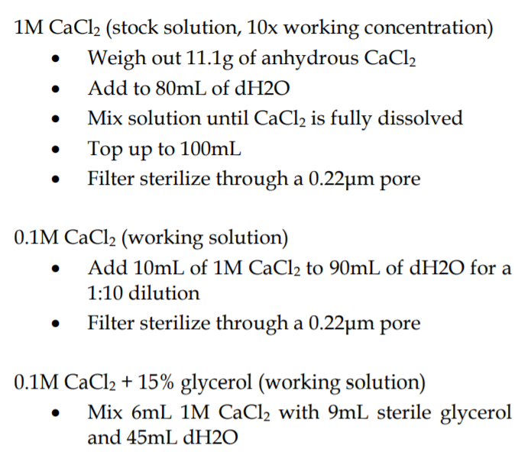

*solution can be autoclaved instead of filter

**Preparing chemically competent E.coli**

1. Prepare 100 mM CaCl2 and 100 mM CaCl2 + 15% glycerol solutions beforehand and keep them on ice before use
2. Take 1 mL of NEB Stable strain of E coli from LB overnight culture and inoculate that in 100 mL of LB media in 500 mL flask.
3. Place the flask with NEB Stable in the warm room’s shaker at 250 rpm, 37 C until OD 600 reaches 0.2-0.3 (after 1.5-2 hours, OD600 doubles every~30 mins)
4. Once the desired OD600 is achieved, place the flask on ice for 15 min.
5. Aliquot 50mL into 50 mL Falcon tube
6. Centrifuge bacteria at 4 C, 4000 rpm for 10 min, discard media, keep pellet
7. Resuspend pellet in 30 mL of 100 mM CaCl2 in Falcon tube. Put on ice for 30 min.
8. Centrifuge bacteria at 4 C, 4000 rpm for 10 min. Resuspend in 3 mL of 100 mM CaCl2 + 15% glycerol solution.
9. Prepare 500 uL aliquots of resulting solution in separate 1.5-mL Eppendorf tubes.
10. Store aliquots in -80 C freezer.