* RNA isolation phase (w/ [RNEasy Plus Mini Kit](https://www.qiagen.com/us/shop/pcr/rneasy-plus-mini-kit/#productdetails)):
  + Every step at room temperature
  + Gather sample (cell, organoid) (< 1x10^7 cells/sample).
  + Lyse directly or trypsinized and collected as a cell pellet by adding 400 uL Buffer RLT Plus and keep it in 1.5 mL tube

If organoid, use P1000 pipette tip to break up organoid and do a swirling motion “beating an egg.”

* + Homogenize the lysate by vortexing for 1 min

>> Pause point: -20oc or -80oc for several months

* + Transfer lysate to purple gDNA Eliminator Spin Column. Pipette up and down until foamy.
  + Centrifuge for 30s at 8000g. Save Flow-Through (/FT). Discard column.

*All centrifuge at 20-25*c (not cool below 20*c)

* + Add 350 uL of 70% EtOH to FT. Mix and immediately transfer 700 uL of FT to the pink RNEasy Spin Column.
  + Close lid & Centrifuge for 15s at 8000g. Discard FT. Save column.
  + Add 700 uL Buffer RW1 to the same pink column.
  + Close lid & Centrifuge for 15s at 8000g. Discard FT. Save column.
  + Add 500 uL Buffer RPE to the same pink column.
  + Close lid & Centrifuge for 15s at 8000g. Discard FT. Save column.
  + Add 500 uL Buffer RPE to the same pink column.
  + Close lid & Centrifuge for 2min at 8000g. Discard FT. Save column.
  + Dry column for 2min.
  + Place pink column in a new 1.5-mL Eppendorf tube for elution.
  + Add 35-60 uL dw directly onto the membrane
  + Close lid & Centrifuge for 1min at 8000g to elute RNA.
  + Measure [RNA] with NanoDrop.
  + Store RNA at 4 C until further use.
* RT phase:
  + Dilute RNA with dw in PCR-tube strip.
  + Make RT Master Mix.
  + Distribute RT MM into diluted RNA in PCR-tube strip.
  + On PCR machine, incubate at 42 C for 2 hours then 4 C.
  + Store cDNA RT product at 4 C until further use.
  + Formula for RNA dilution per sample:
    - Ideally, target mass of RNA = 1000 ng (max2000 ng)
    - If smallest [RNA] = 65 ng/uL, then set target mass at 65 ng/uL x 15 uL = 1000 ng
    - Calculate volume of RNA needed to reach target mass for each sample.
    - Top off with dw to reach total volume of 15 uL
    - Total volume for RNA diluted = 15 uL
  + Formula for RT Master Mix in 2-mL Eppendorf tube:
    - Multiply each volume below by (the number of reactions needed + 10% for pipetting error)
    - 2 uL 10X RT Buffer (Applied Biosystem)
    - 2 uL 10X RT Random Primers
    - 1 uL RT Enzyme (MultiScribe ReverseTranscriptase)
    - 0.5 uL dNTP
    - Total volume for RT MM per sample = 5.5 uL
  + Total volume for RT product per sample = 20.5 uL
  + Thermocycler setup for reverse transcriptase (two-step)

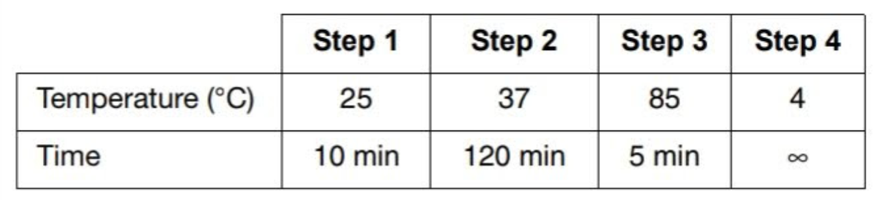

* 5RT with BioRad’s iScript 5x MM
  + Dilute RNA to 1000ng or 1500 ng in PCR strip 🡪 Total Volume 8uL
  + Add 2uL 5x MM to make it to 10uL
* qPCR phase (ddCT):
  + Formula for each well:
    - 5 uL 2X PowerSYBR Green MM
    - 0.2 uL 10uM primer mix
    - 0.2 uL RT product/template
    - 4.6 uL dw
  + Step 1: Plate Planning
    - Suppose: 5 samples, 10 genes
    - Mixtures: SYBR MM + Template; dw + primer (not waste more SYBR!)
    - Prepare 5 tubes in strip for 5 templates (dist. horizontally)
      * Each tube has enough for 10 -> 15 rxns
    - Prepare 10 tubes in strip for 10 genes (dist. vertically)
      * Each tube has enough for 5 -> 10 rxns
  + Step 2: Volume Planning
    - SYBR MM + Template Mixture:
      * SYBR MM: 5 uL x 15 rxns = 75 uL
      * Tempalte: 0.2 uL x 15 rxns = 3 uL
      * Total = 78 uL per PCR tube
      * Distributing horizontally 5.2 uL per well
    - Dw + Primer Mixture
      * Primers: 0.2 uL x 10 rxns = 2 uL
      * Dw: 4.6 uL x 10 rxns = 46 uL
      * Total = 48 uL per PCR tube
      * Distributing vertically 4.8 uL per well
  + Step 3: Doing it!
    - Distribute with the electronic multi-channel pipette
    - Each tip has a max volume of 30 uL

* qPCR phase (Nilay 2021.8.24) :
  + Make a standard
    - Tube A = Pool 3 uL cDNA from each condition to make a most concentrated standard

e.g. 6 conditions -> 3x6 = 18 uL

* + - Tube B = Dilute tube A in dw to make enough standard volume for each gene

e.g. 10 genes -> dilute to the final volume at least 10x4.5 uL = 45 uL

* + - Serial dilution of Tube B in 1:5 manner 4 times to make tube C, D, E

|  |  |
| --- | --- |
|  | Relative cDNA |
| Tube B | 1:1 (125x) |
| Tube C | 1:5(25x) |
| Tube D | 1:25(5x) |
| Tube E | 1:125(1x) |

* + Formula for each rxn (10 uL/rxn)
    - 5 uL 2X PowerSYBR Green MM
    - 0.2 uL 10uM primer mix (each)
    - 2 uL 10-fold dilution RT product/template
    - 2.8 uL dw
  + Plate planning
    - Each plate has to have 1) house keeping gene 2) standard reaction for each gene
  + Thermocycler (Bio-Rad CFX)

|  |  |  |  |
| --- | --- | --- | --- |
| Activation of enzyme | 95c | 10 min | Activate AmpliTaq Gold DNA polymerase |
| Denature | 95c | 15 sec | 40x |
| Annealing&Elongation | 60c | 60 sec |
| Plate readout |  |  |
| Melt curve analysis | 55c | 0.5c increment every 5 sec |  |
|  | 90c |  |

