**General Lipofectamine2000 Transfection**

Edited by Pornlada & Paul

**Day 0:**

1. Seed the HEK293 cells to be 70-90% confluency 24hr later before transfection in antibiotic-free media (“Transfection media”)
   1. 6-well 1.5 million cells/well

**Day 1:**

1. Prepare *two* tubes for *each* transfection:

Tube A: 4-5 uL of Lipofectamine 2000 reagent in 125 uL of Opti-Mem

Tube B: 2.5 ug DNA in 125 ul of Opti-Mem

In this case, the DNA/Lipofectamine ratio is 1:2 (ug/uL).

2) Preparing tube A:  
🡪 Using dropwise technique  
🡪 Wait at RT for 5 minutes (not more than 25 mins before mixing with tube B)

3) Preparing tube B:

|  |  |  |
| --- | --- | --- |
| Tube B |  | 6-well plate well |
| Opti-MEM |  | 125 uL |
| DNA |  | 2.5 ug |
| - Tranfection plasmid | 50% | 1.25 ug |
| - Lentivirus env+enz | 50% |  |
| - psPAX2 | 75% | 0.937 ug |
| - pMD2.G | 25% | 0.312 ug |

1. Slowly add the DNA (tube B) into the lipofectamine (Tube A) drop by drop, then vortex immediately
2. Incubate the DNA/Lipofectamine mixture for 30 minutes at room temp (up to 6 hr)
3. (optional) Remove old media, gently add **antibiotic-free media** into each well/dish.

*No need to change the media if it is already in the antibiotic-free media and not orange

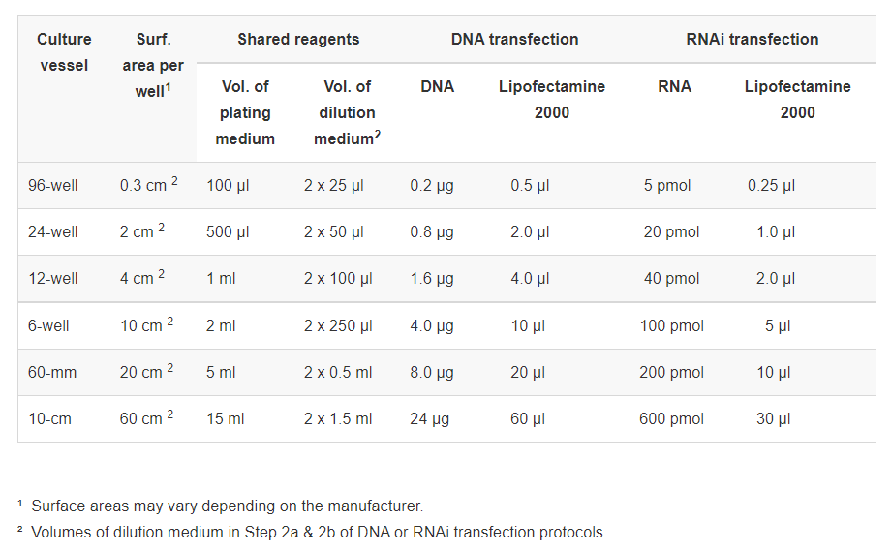

1. Add Lipofectamine/DNA mixture (250 uL total/well into 6-well plate), mix by shaking the plate forward and backward, then side to side (not swirling!)
2. Put the plates/dishes back to 37°C incubator with 5% CO2, in the lenti room, incubate for 6 hours
3. After 6 hr, replace lipofectamine-containing medium with a new transfection medium
   * 2.5 mL / well (DMEM + HEPES) bottle + 10% FBS

**Day 1 XTREMEGENE**

MM per rxn: 3 uL of XtremeGene in 100 uL of Opti-Mem

PCR Tube A: 1 ug DNA in 20 ul of Opti-Mem

In this case, the DNA/XTREMEGENE ratio is 1:3 (ug/uL).

|  |  |  |
| --- | --- | --- |
| DNA |  | 1 ug |
| - Tranfection plasmid | 50% | 0.5 ug |
| - Lentivirus env+enz | 50% |  |
| - psPAX2 | 75% | 0.375 ug |
| - pMD2.G | 25% | 0.125 ug |

Put the plates/dishes back to 37°C incubator with 5% CO2, in the lenti room

Do not replace media after addition of XtremeGene+DNA.

**Day 2,3:**

1. Incubate 24 hr in Lenti room before first harvest. Incubate 36-40 hr before second harvest.
   1. Pool
   2. Temporary storage at 4C.
   3. Long-term storage at -80C Eppendorf 1.5mL
2. Optional steps to remove cell debris:
   1. Centrifuge viral supernatant at 500 g x 5 mins to pellet any packaging cells
   2. Filter supernatant through a 0.45 um PES filter (optional)
3. Viral supernatant can be stored at 4*C for a few days but should be snap frozen in liquid nitrogen and stored at -80*C

**TRANSDUCTION into target cell**

Day 0 (24 hours before transduction):

1) Seed cancer cells in 6-well at 1,000,000 cells/well

2) Split

Day 1:

1) Aspirate old media from seeded 6-well cancer cell plate

- Seed 1,000,000 cells at -24 hours beforehand

2) Add in 500-750 uL filtered virus media

+ Polybrene (1: 1000 dilution in the media at final concentration of 8 ug/mL) at 1.50-1.75-mL per well in a 6-well plate

*Polybrene stock 8 mg/mL

3) Incubate in lenti room for 48 hours

Day 3:

1) Add in puromycin-containing media (Stock 10 mg/ mL 🡪 5 ug/mL) to start selection

Equation: 10000 ug/mL * Vi (mL)= (5 ug/mL) * Vf (mL)

e.g., 5 uL taken from stock to make 10 mL media

Day 6:

1) Change old media with new puromycin-containing media (same puro concentration 5 ug/mL)

a) HT29: wait 2-3? Days

b) HT115: wait

Day 10+:

1) Change into 6-cm dish with no-puro media to let them grow 🡪 This becomes a stable cell line

2) If enough cells, split cells for flow, RT-qPCR, Western and frozen stock