* Cell collection (6-well)

1. Wash cell with cold PBS
2. Add 200 uL solution of RIPA +PIC+phosphatase inhibitor per 1 rxn

*190 uL/ rxn of RIPA = radioimmunoprecipitation assay buffer (lysis)

*8 uL/ rxn of PIC = protease inhibitor cocktail ; stock 25x (1 tablet in 2 mL water or PBS)

*2 uL/ rxn of Phosphatase inhibitor; stock 100x

! Keep all these buffer on ice

1. Spin and rotate in cold room 30 mins

*can add buffer mix and bring the plate on the shaker in cold room and collect the cell pellet later

1. Collect cell pellets with cell scraper in 1.5 mL tubes
2. Spin 13,000 rpm 10 mins
3. Collect supernatant

*Pause point: keep supernatant in -20*c

* Cell collection without scraper 10cm
  1. Trypsinize 1.5 mL Quench 4.5 mL media
  2. Transfer 1.5 mL to Eppendorf. Passage the rest
  3. Spin down. Aspirate.
  4. Wash cells with cold PBS. (NO PHENOL RED allowed in BCA assay)
  5. Add 200 uL of RIPA +PIC+phosphatase inhibitor / rxn
  6. Spin and rotate in cold room 30 mins
     + *can add buffer mix and bring the plate on the shaker in cold room and collect the cell pellet later
  7. Collect cell pellets with cell scraper in 1.5 mL tubes
  8. Spin 13,000 rpm 10 mins
  9. Collect supernatant in PCR-strips

*Pause point: keep supernatant in -20*c

* Bradford assay (Bio-Rad)

[Bio-rad protocol](https://www.bio-rad.com/webroot/web/pdf/lsr/literature/4110065A.pdf)

*96-well flat transparent plate

*duplicate or triplicate

***Standard procedure for microtiter plate*** : 10uL sample/std + 200 uL diluted Bradford solution

Don’t use: Microassay procedure for microtiter plate : 160 uL sample/std + 40 uL dilated dye

1. Dilute Bradford dye solution like so:
   1. Biorad Protein assay concentrate : distilled water = 1:4
2. Preparing at least 5 standard BSA (Bovine serum albumin)

Stock BSA at 2 mg/mL ; *For 10 uL std + Bradford -> linear range is 0-750 ug/mL

Diluent is dw.

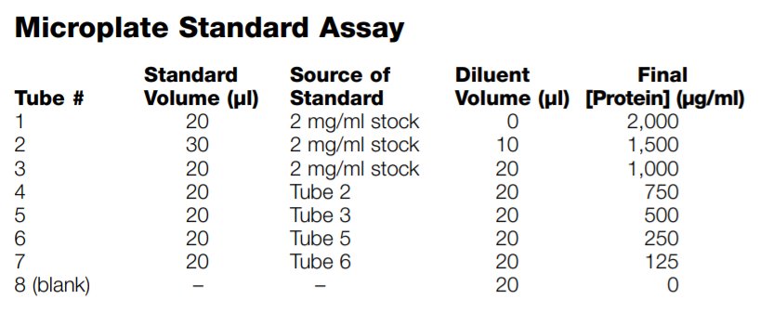

1. Load 10uL per sample or standard in the 96-well plate

*Make appropriate dilution of samples to fit within the standard range (look at the color!)

1. Add on top 200 uL Bradford solution / well using multichannel, pipetting, beware of bubbles

*the color change according to vol, time of reaction

1. Incubate at RT for at least 5 mins (<1hr)
2. Spectrophotometer at 595 nm, measure absorbance
3. Back calculate protein concentration from the standard curve

**BCA (not Gold) assay**

* + Prepare Working Solution: 10 mL Reagent A + 0.6 mL Reagent B
  + <= 5 (1-2 if too much protein in sample) uL sample/standard + 100 uL BCA mix
  + Incubate 37*C for 30 min.

**BCA** [**Rapid Gold**](https://www.thermofisher.com/order/catalog/product/A53225) **assay**

**Sample Preparation**

1. Equilibrate all reagents, unknowns and protein standards to room temperature. Mix thoroughly but gently to avoid introducing micro bubbles.

2.Prepare enough fresh working reagent (WR) for all standards and samples to be measured using a 50:1 ratio of the kit reagents A:B.

**Note:** When Rapid Gold BCA Reagent B is first added to Rapid Gold BCA Reagent A, a pale blue precipitate may be observed, but, upon vortexing or mixing for < 5 seconds, the precipitate should dissolve to yield a clear, green solution. Use fresh working reagent each time.

3.Add 100 μL of WR to each standard and sample tube/well.

4.Dilution Factor 5x 🡪 then dilute 5 Sample: 20 Water

5.Add 5 μL of standards or diluted samples to the well.

6.Incubate the standard and sample tubes at room temperature for 5 minutes.

7. Measure Absorbance.

* SDS-Gel running buffer

[SDS gel protocol-Biorad](https://www.bio-rad.com/webroot/web/pdf/lsr/literature/Bulletin_6040.pdf)

1. Choose the smallest concentration as the baseline; good range is 20-25 ug/well and dilute with RIPA buffer (with PIC + PIC added) to make all samples have equal protein

E.g.

|  |  |  |  |  |
| --- | --- | --- | --- | --- |
| Sample | Conc (ug/mL) | Vol(uL) | RIPA(uL) | Protein(ug) |
| 1 | 600 | 30 | 0 | 18 |
| 2 | 900 | 20 | 10 | 18 |
| 3 | 1630 | 11 | 19 | 18 |

1. Prepare Laemmli sample buffer by adding a reducing agent (1:9)

10 uL 2-mercaptoethanol + 90 uL 4xLaemmli

1. Dilute sample with 4xLaemmli (3:1)

E.g. 1 lane = 30 uL sample + 10uL 4x Laemmli

1. Spin down and incubate at 99*C for 10 mins
2. Choose appropriate pre-cast SDS gel concentration 4-20%, (8-16%)
3. Remove the strip on the lower end, put in the dock (the shorter plate go in front), fill the running buffer to the level, remove the comb
4. Load 30 uL sample into each well, 6-8 uL protein ladder

Don't leave empty wells; add loading buffer to prevent skew protein migration

1. Set up : 150 V for 70 mins or until the loading dye go to the end (time not really matter)

* Transfer (Dry with iBlot)

1. Keep gel in buffer at all time
2. Soak a separate membrane in a milliQ
3. Crack gel open carefully, remove stacking part, cut gel from all margins
4. Put gel on a membrane without touching the protein in order (see instruction), use roller to eliminate air bubbles

*arrange the top of the gel (higher kDa) toward the center of the membrane (higher electricity)

1. Turn the iBlot on: P0 template for 7 mins

* Antibody staining

*do not touch the blot, non-specific background

1. Cut membrane according to interested protein size
2. Blocking with 5% BSA/Milk for 30-60 mins on rocker at RT or overnight at 4oc
3. Incubate the membrane with primary Ab in blocking buffer overnight at 4oc on rocker

1* Ab can be reused

1. Wash with TBST 5 mins x3
2. Incubate the membrane with conjugated secondary Ab in blocking buffer at RT 1hr
3. Wash with TBST 5 mins x3
4. Signal development as protocol <ECL>

* ECL reacts with HRP bound to create lumniescent signal
* Mix component 1 & 2 in a 1:1 ratio, prepare just before use (hrs)
* Wait 2 mins to react

1. Image blot

* Blot -> Chemiluminescent -> adjust manual exposure not to oversaturated or too dim
* Keep all images (different exposure) in tiff file

WEBSITE to look for new antibodies: <https://www.antibodypedia.com>

Brands:

* + CellSignaling
  + AbCam
  + Thermo
  + Biolegned (iffy)