**Professional Behavior Template**

1. **Interacting Professionally with the Instructor:**

Personally, I received good advice from my instructor:

-He helped me feel encouraged and focused, even though I had to change teams at the beginning of the course.

-He also helped me by giving me good feedback with 2 issues, CSS3 using JavaScript (particularly how to improve the use of classes) and JavaScript Objects.

-I also liked the scriptures he shared during class; they were very adequate.

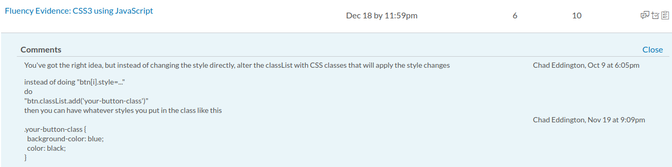

1. **Interacting Helpfully and Professionally with Other Teams:**

Unfortunately, I had little interaction with other teams, it is something that I have to improve in future opportunities. I tried to be cordial with everyone from the beginning and present myself open so that they knew me and wanted to work with me. I was always ahead of the posts on various topics and the questions asked to the instructor were very useful, these allowed me to work without getting stuck by different doubts.

1. **Supporting the Team by Teaching, etc.**

Here is a YouTube link where I am teaching my team about Audio, Video and Canvas. You can hear me teaching from minute 1:39 until minute 18 stamp in the video.

<https://www.youtube.com/watch?v=2XHZPZCzoPA&t=1m39s>

My partners were very kind with me.

1. **Self-Reflection/Meta-Cognition:**

In D&C 29:34 it says "... verily I say unto you that all things unto me are spiritual ...", I believe that the course has been a spiritual experience in my life. Sometimes I wondered why I had to have so much interaction with my classmates who spoke another language or why this course gave us so much freedom to manage our time. Recently I had a couple of job interviews in a similar format, where I had to present my knowledge in another language, which was somehow a spiritual experience for me, and I felt that this course was a personal response to my needs to improve.

1. **Professional Scheduling Group:**

Regarding the scheduled meetings, I fulfilled my responsibilities, on two occasions I had to report that the meetings were not held although I was waiting for 20 minutes and nobody else showed up, after that I had a change of team and there were no more problems.

I tried to be flexible with the schedule and adapt to the times of others in order to achieve the goals of the course.

I did my best in terms of preparing the assigned topics to be presented by me, despite my language limitations.

I tried to be interested in the applications developed by others and on a couple of occasions I could give very important help to a colleague with a storage problem.

Interacting with my classmates and working as a team was a very useful experience.

