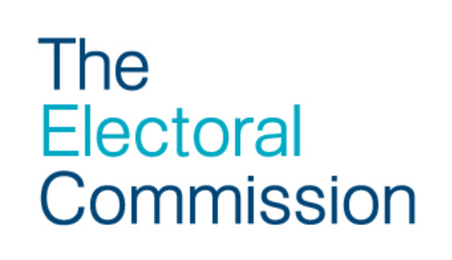

Proof-checking factsheet
This guidance is designed to help Returning Officers quality-assure the process of producing election materials and provides an overview of the key points that will need to be considered during production. Having robust proof checking processes in place could help detect any errors and avoid data breaches before they occur.
Key points
You should produce guidance notes for those members of staff checking election materials. Particular attention should be paid to checking that:
- electors’ names and addresses are accurate and match those on the electoral register / absent voting lists
- materials being sent to electors are the correct ones for them (e.g. the ballot paper is the correct one for their electoral area; postal proxies are being sent postal proxy poll cards)
- where relevant, the correct deadlines appear (for example, for postal/proxy applications on poll cards)
- where a form is prescribed, that it meets the prescribed requirements
- in addition, in relation to the ballot paper, you should check that:
  - the directions for printing have been followed precisely
  - the official mark and unique identifying mark are correctly printed
  - the ballot paper includes the details of all validly nominated candidates for that particular electoral area; as part of this you should check that:
- all candidate names (or commonly used name(s) where relevant) are correct
- where relevant, party names, descriptions and emblems are correct and as registered on the Commission’s register of political parties
- the instructions at the top of each ballot paper are the correct ones for the electoral area
- in relation to the postal voting statement, you should, in addition, check that:
  - the correct ballot paper numbers are printed
  - the correct voting instructions for the electoral area are included

You should have in place a process for checking live proofs of all forms of election material and ensure that you have a member of your staff in attendance when the election materials are being printed to check that there are no errors and that they are being printed to the required specification. In addition to the checklist above, at the live proof staff will be able to check there is no bleeding of ink and the print quality is good and consistent.

- Staff should check the beginning and end of the print runs for each polling district for accuracy. Random spot checks within polling districts should also be carried out so that a representative cross-section can be checked.
- Staff should also ensure that they carry out checks of filled postal ballot packs prior to dispatch. This is to ensure that the postal ballot pack contains all of the required stationery, printed to the agreed specification, so that voters receive the election material they are entitled to receive. At this stage staff can also ensure that postal ballot packs being sent to overseas addresses contain a reply envelope that is capable of being used overseas. As a minimum, you should check at least the first and last pack per fill. Random spot checks per fill should also be carried out, so that a representative cross-section can be checked.
- Keep a record of stationery that has been checked to provide a clear audit trail of the processes that have been undertaken and which you can refer back to should any issues subsequently arise.

If you have outsourced the printing process, discussions to facilitate these checks and how any replacements would be produced should occur at the time the contract is negotiated and reflected in it. For more information see our contract management checklist.
Managing dispatch of election material factsheet
In addition to quality-assuring the process of production of election materials, the following guidance is designed to help Returning Officers manage the delivery of materials to ensure that the material is received by voters as soon as possible so that they have the maximum amount of time to act on the information.
Key points
- Agree on delivery schedules well in advance of the poll. For example, when the dispatch of election material will commence and last date of dispatch.
- Obtain the estimated delivery window of election material based on the dispatch dates and method of delivery/postal package chosen. This will help you to manage communication channels to voters in your area and assist in early detection of any issues encountered with the delivery of election material.
- Obtain formal confirmation from contractor on the delivery schedules, making it clear that no changes should be made to the delivery schedules without prior authorisation from you as Returning Officer.
- Once dispatch has commenced, obtain postal dockets to confirm the number of documents dispatched and the dates of dispatch, for the first and any subsequent issues. This will also help to identify any possible issues that may have arisen with regards to dispatch and feed into any subsequent evaluation of contractor performance, and enable you to provide information to voters on dates that they should expect to receive material.

