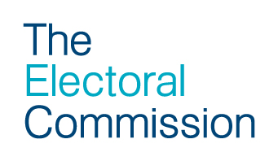

Notification of secrecy requirements – the poll

Section 66 of the Representation of the People Act 1983 (as applied by Schedule 4 of The Local Authorities (Conduct of Referendums)(England) Regulations 2012)
(1) The following persons –

- every counting officer and every presiding officer or clerk attending at a polling station,

- every polling observer so attending,

- every person so attending by virtue of any of sections 6A to 6D of the Political Parties, Elections and Referendums Act 2000

shall maintain and aid in maintaining the secrecy of voting and shall not, except for some purpose authorised by law, communicate to any person before the poll is closed any information as to –

- the name of any elector or proxy for an elector who has or has not applied for a ballot paper or voted at a polling station;

- the number on the register of electors of any elector who, or whose proxy, has or has not applied for a ballot paper or voted at a polling station; or

- the official mark.

[...]

(3) No person shall –

- interfere with or attempt to interfere with a voter when recording his vote;

- otherwise obtain or attempt to obtain in a polling station information as to the answer for which a voter in that station is about to vote or has voted;

- communicate at any time to any person any information obtained in a polling station as to the answer for which a voter in that station is about to vote or has voted, or as to the number or other unique identifying mark on the back of the ballot paper given to a voter at that station;

- directly or indirectly induce a voter to display his ballot paper after he has marked it so as to make known to any person the answer for which he has or has not voted.

[...]

(5) No person having undertaken to assist a blind voter to vote shall communicate at any time to any person any information as to the answer for which that voter intends to vote or has voted, or as to the number or other unique identifying mark on the back of the ballot paper given for the use of that voter.

(6) If a person acts in contravention of this section he shall be liable on summary conviction to a fine not exceeding level 5 on the standard scale or to imprisonment for a term not exceeding 6 months.

