获取首页菜单栏：

请求地址（POST）：http://127.0.0.1:8001/api/menuItem/list

请求参数：{"item_type":1,"item_level":1}

执行SQL：select * from tb_menu_item where item_type = 1 and item_level = 1 order by item_order

返回结果：

{"msg":"操作成功","code":200,"data":[{"did":2,"item_type":1,"item_name":"母婴","item_desc":"母婴","item_level":1,"pid":0,"goods_sum":20,"item_order":2,"remark":"母婴"},{"did":3,"item_type":1,"item_name":"儿童","item_desc":"儿童","item_level":1,"pid":0,"goods_sum":20,"item_order":3,"remark":"儿童"}]}

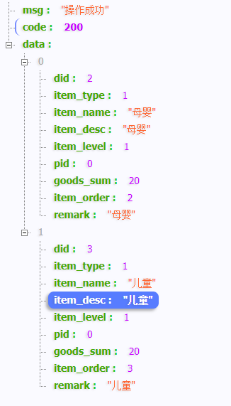

全量表分页数据：

1 发送post请求：http://127.0.0.1:8001/api/goods/coupon/page

2 发送请求json:

{"pageSize":1,"pageNo":1,"order":"price","orderType":"desc","title":"热水器"}