# [vscode如何实现react编写时tab键补全html](https://blog.csdn.net/margin_0px/article/details/81317868)

2018年07月31日 18:00:13 [潜行的Q](https://me.csdn.net/margin_0px" \t "https://blog.csdn.net/margin_0px/article/details/_blank) 阅读数：1303 标签： [vscode](http://so.csdn.net/so/search/s.do?q=vscode&t=blog" \t "https://blog.csdn.net/margin_0px/article/details/_blank)[react](http://so.csdn.net/so/search/s.do?q=react&t=blog" \t "https://blog.csdn.net/margin_0px/article/details/_blank) 更多

个人分类： [编辑器](https://blog.csdn.net/margin_0px/article/category/7901021" \t "https://blog.csdn.net/margin_0px/article/details/_blank)

 首先点击编辑器左上方的首选项(preference)－》设置(settings)

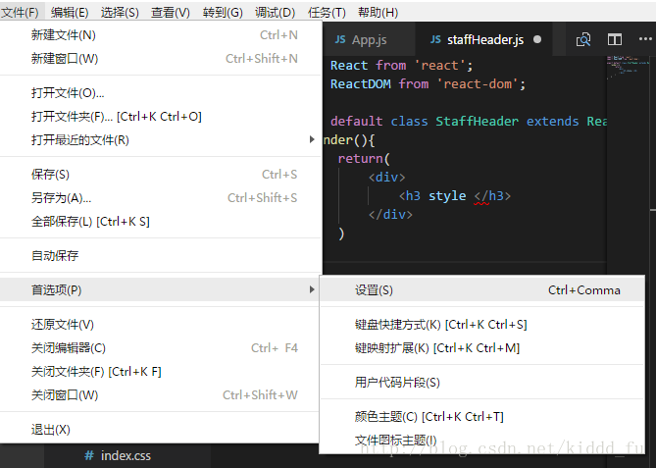

进入下面界面

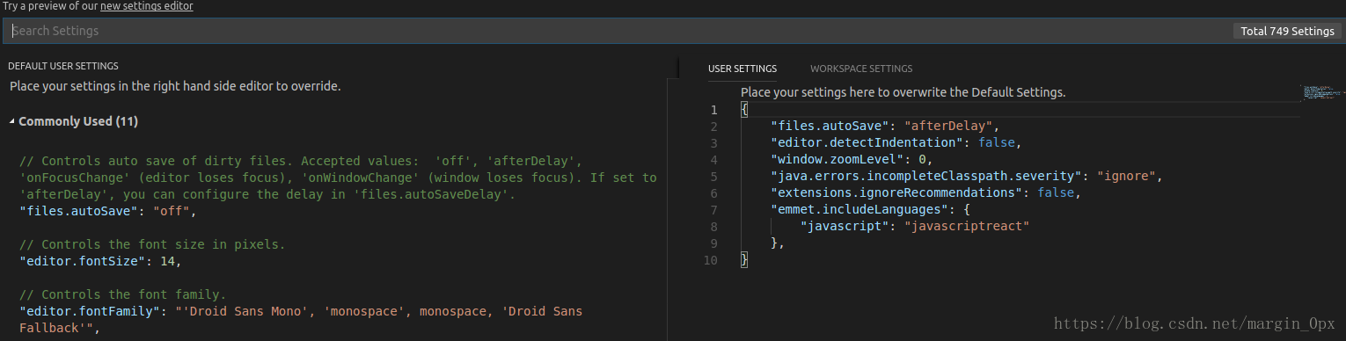

在右边添加下面属性：

"emmet.includeLanguages": {

"javascript": "javascriptreact"

},

