

A Network of Excellence forging the
Multilingual Europe Technology Alliance

D2.1 Annotated Hybrid Sample MT Corpus

Author(s): Pavel Pecina, Eleftherios Avramidis, Christian Federmann, Josef van Genabith, Maite Melero, Marta Ruiz, Josef van Genabith
Dissemination Level: Restricted
Date: January 21, 2011

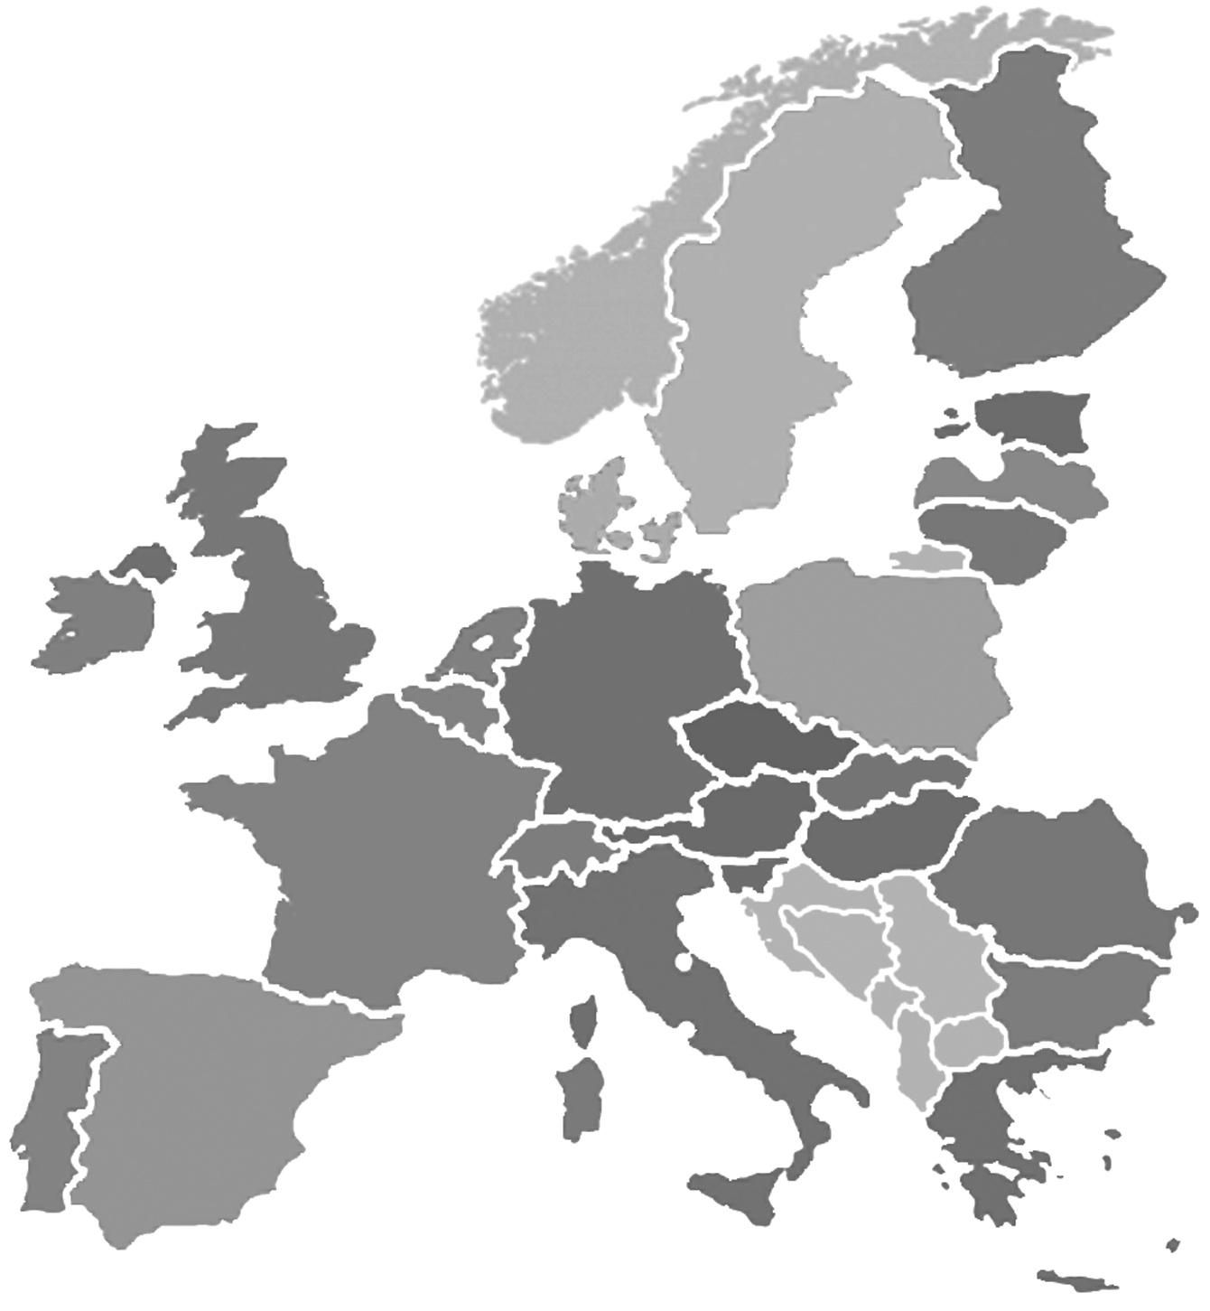

Grant agreement no. |  | 249119
Project acronym |  | T4ME Net (META-NET)
Project full title |  | Technologies for the Multilingual European Information Society
Funding scheme |  | Network of Excellence
Coordinator |  | Prof. Hans Uszkoreit (DFKI)
Start date, duration |  | 1 February 2010, 36 months
Distribution |  | Public
Contractual date of delivery |  | January 31, 2011
Actual date of delivery
Deliverable number |  | D2.1
Deliverable title |  | Annotated Hybrid Sample MT Corpus
Type |  | Report
Status and version |  | Draft
Number of pages
Contributing partners |  | DCU, DFKI, BM
WP leader |  | DCU
Task leader |  | DCU
Authors |  | Pavel Pecina, Eleftherios Avramidis, Christian Federmann, Josef van Genabith, Maite Melero, Marta Ruiz, Josef van Genabith
EC project officer |  | Hanna Klimek
The partners in META-NET are: | Deutsches Forschungszentrum für Künstliche Intelligenz (DFKI), Germany
The partners in META-NET are: | Barcelona Media (BM), Spain
The partners in META-NET are: | Consiglio Nazionale Ricerche – Istituto di Linguistica Computazionale “Antonio Zampolli” (CNR), Italy
The partners in META-NET are: | Institute for Language and Speech Processing, R.C. “Athena” (ILSP), Greece
The partners in META-NET are: | Charles University in Prague (CUP), Czech Republic
The partners in META-NET are: | Centre National de la Recherche Scientifique – Laboratoire d’Informatique pour la Mécanique et les Sciences de l’Ingénieur (CNRS), France
The partners in META-NET are: | Universiteit Utrecht (UU), Netherlands
The partners in META-NET are: | Aalto University (AALTO), Finland
The partners in META-NET are: | Fondazione Bruno Kessler (FBK), Italy
The partners in META-NET are: | Dublin City University (DCU), Ireland
The partners in META-NET are: | Rheinisch-Westfälische Technische Hochschule Aachen (RWTH), Germany
The partners in META-NET are: | Jozef Stefan Institute (JSI), Slovenia
The partners in META-NET are: | Evaluations and Language Resources Distribution Agency (ELDA), France
For copies of reports, updates on project activities and other META-NET-related information, contact:
DFKI GmbH
META-NET
Dr. Georg Rehm office@meta-net.eu
Alt-Moabit 91c Phone: +49 (30) 3949-1833
10559 Berlin, Germany Fax: +49 (30) 3949-1810
Copies of reports and other material can also be accessed via http://www.meta-net.eu
© 2010, The Individual Authors
No part of this document may be reproduced or transmitted in any form, or by any means, electronic or mechanical, including photocopy, recording, or any information storage and retrieval system, without permission from the copyright owner.
Table of Contents
Executive Summary 4
Introduction 4

Executive Summary
Lorem ipsum dolor sit amet, consetetur sadipscing elitr, sed diam nonumy eirmod tempor invidunt ut labore et dolore magna aliquyam erat, sed diam voluptua. At vero eos et accusam et justo duo dolores et ea rebum. Stet clita kasd gubergren, no sea takimata sanctus est Lorem ipsum dolor sit amet. Lorem ipsum dolor sit amet, consetetur sadipscing elitr, sed diam nonumy eirmod tempor invidunt ut labore et dolore magna aliquyam erat, sed diam voluptua. At vero eos et accusam et justo duo dolores et ea rebum. Stet clita kasd gubergren, no sea takimata sanctus est Lorem ipsum dolor sit amet.

Introduction

Data

Europarl

WMT test data

MT Systems

Lucy

Joshua

Metis

Apertium

Matrex

Corpus format

Common parts

System specific parts

Lucy

Joshua
Joshua is an open-source toolkit for statistical machine translation. It has been presented in 2009 by Johns Hopkins University, offering a full implementation of state-of-the-art techniques making use of synchronous context free grammars (SCFGs). The decoding process features algorithms such as chart-parsing, n-gram language model integration, beam-and cube-pruning and k-best extraction, whereas training includes suffix-array grammar extraction and minimum error rate training.
Data: For the purposes of the annotated corpus, we performed a fresh training of Joshua-specific translation models, according to the specifications for the constrained statistical systems of the task: Acquis and WMT News Corpus were used for the extraction of the hierarchical grammar; the development set News Corpus Dev-test 2007 was used for tuning the weights. As a result of the process, full decoder output is given for the WMT News-test 2008. All incoming corpora have been sentence-aligned (when parallel), tokenized and lowercased. Training: The training process included subsampling of the training corpus, by keeping only the data that are required for the decoding of the tuning and the test corpus. Berkeley Unsupervised Aligner (ver. 2.1) was afterwards used in order to produce word alignments from the sentence-aligned aligned training corpora. The aligner made 5 iterations using two HMM alignment models trained jointly and then decoded using the competitive thresholding heuristic.
Given these alignments, Joshua scripts built a suffix-array and extracted the required SCFG grammar. An n-gram language model of order 5 was built over the target side of the corpus, by using the SRILM toolkit (ver. 1.5.11). Finally, the training process was concluded with a Minimum Error Rate Training with the use of ZMERT script, in order to get the model weights that optimize translation quality for the development set. ZMERT weights converged after an average of 4 iterations.
Recasing: As the lowercased output of the decoder requires recasing, we trained a SCFG grammar deriving recasing rules from the lowercased to the originally cased version of the training corpus. This grammar can be used to restore uppercase characters on the decoded output. This feature will be available in a future release of the annotation set.
Annotation: As a result of the annotation process, we provide the output of the decoding process given the "test set", as processed by Joshua (SVN revision 1775) with a heap size of 2000, a span limit of 10, 40 max. items per bin and a relative threshold of 10.0. In particular, the annotation set contains:
- The globally applied model weights, as adjusted by the ZMERT process,
- the full output of each translated sentence with the highest total score, among the n-best candidates,
- the language model and translation table scores of each translated sentence
- the derivation of each translated sentence, represented by hierarchical phrases in a tree-like structure;
- each hierarchical phrase either contains one or more tokens (terminal) or points to one or more children phrases (non-terminal),
- tokens not found in the grammar are annotated with an OOV tag
- the word-alignment of each phrase to the source text, using word indices.
Joshua can provide an n-best hypotheses list, which will be integrated into a future release.

Metis

Apertium

Matrex

Conclusion

Zhifei Li et. al., Joshua: an open source toolkit for parsing-based machine translation. StatMT '09 Proceedings of the Fourth Workshop on Statistical Machine Translation

