UNIVERSITY OF CALIFORNIA

Los Angeles

Wearable Sensor for Continuously Vigilant Blood Perfusion and Oxygenation Monitoring

A thesis submitted in partial satisfaction

of the requirements for the degree Master of Science

in Electrical Engineering

By

Bijan David Mapar

2012

ABSTRACT OF THE THESIS

Wearable Sensor for Continuously Vigilant Blood Perfusion and Oxygenation Monitoring

by

Bijan David Mapar

Master of Science in Electrical Engineering

University of California, Los Angeles, 2012

Professor William J. Kaiser, Chair

The ability to directly analyze blood perfusion in tissue is essential to a wide range of applications in diagnosing wound conditions, circulatory disorders, and monitoring treatment outcomes. The speed with which these conditions can occur and worsen, combined with their high risk for those afflicted, requires a solution capable of continuously monitoring perfusion status, while remaining easy and cheap to deploy. Both of these objectives require advances in current perfusion sensing technology. The Perfusion and Oxygenation Monitor (POM) system has been developed to provide a solution to these requirements. The POM system utilizes the principles of photoplethysmographic (PPG) sensing in new ways to provide perfusion information beyond the traditionally reported oximetry values. POM introduces sensor diversity by using secondary sensors, detecting pressure and positioning, to allow measurements to be taken accurately and consistently, enabling data from continuously monitored patients or test sites to be directly compared. The development of these sensing methods and creation of the POM sensor platform enable delivery of reliable perfusion information, and experimental validation of the principles applied in its design has been conducted on several healthy subjects.

The thesis of Bijan David Mapar is approved.

Majid Sarrafzadeh

Alex Anh-Tuan Bui

William J. Kaiser, Committee Chair

University of California, Los Angeles

2012

I would like to thank Professor William J. Kaiser, Professor Majid Sarrafzadeh, and Professor Alex Bui for their advice, guidance, and financial support.

I would also like to thank Dr. Alireza Mehrnia, Frank Wang, and Yeung Lam for their guidance and advice during development.

# Table of Contents

1. Introduction 1

1.1 Background 1

1.2 Objectives and Contributions 2

2. System Design 5

2.1 Overview of Photoplethysmography in POM 5

2.2 Evolution of the POM Platform 7

2.3 Overview of Current POM Platform 8

2.4 System Architecture 11

2.4.1 Sensor Hardware 12

2.4.2 Data Acquisition and Control System 20

2.4.3 Software and Operation 22

2.4.4 Data Processing 25

3. PPG Blood Pressure Correlation 33

3.1 Overview 33

3.2 Stair Trials 33

3.2.1 Experimental Procedure 33

3.2.2 Measurement Techniques and Devices 34

3.2.3 Blood Pressure Data 35

3.2.4 POM Data Metrics 40

3.2.5 POM Metric Correlation to Blood Pressure 43

3.2.6 Stair Trial Correlation Visualization 47

3.2.7 Stair Trial Regression Analysis 57

3.2.8 Stair Trial Conclusions 62

3.3 Height Trials 63

3.3.1 Height Trial Background 63

3.3.2 Height Trial Results 64

3.3.3 Height Trial Analysis 66

4. PPG Pressure and Location Analysis 67

4.1 Initial Sensor and Location Data 67

4.2 Pressure Sensor Data 72

4.3 Wearable Perfusion Imager 74

4.3.1 Overview of Imaging Platform 74

4.3.2 Image Overlay and Interpolation System 76

4.4 Thermally Induced Vasodilation Experiment 80

6. Conclusion 82

6.1 Conclusion 82

6.2 Future Work 84

Appendix I: POM Data Processing Matlab Code 86

References 94

# List of Figures

|  |  |
| --- | --- |
| Figure 2.1 POM light path and sensor arrangement | 7 |
| Figure 2.2 POM iterations, optical side | 8 |
| Figure 2.3 POM iterations, component side | 8 |
| Figure 2.4 Block diagram overview of POM system | 9 |
| Figure 2.5 Layout and routing of POM PCB | 12 |
| Figure 2.6 Analog component side of POM PCB | 13 |
| Figure 2.7 Optical component side of POM PCB | 14 |
| Figure 2.8 LED Drive circuit schematic | 15 |
| Figure 2.9 Photodiode spectral response | 16 |
| Figure 2.10 Photodiode read circuit schematic | 17 |
| Figure 2.11 CompactRIO and Host PC | 21 |
| Figure 2.12 Configuration tab of LabVIEW interface | 23 |
| Figure 2.13 Data display tab of LabVIEW interface | 25 |
| Figure 2.14 Illustration of noise locations | 27 |
| Figure 2.15 Frequency response of heterodyning | 28 |
| Figure 2.16 Heterodyning results in PPG | 29 |
| Figure 2.17 Comparison of Wavelet and Low Pass Filter | 30 |
| Figure 3.1 Panasonic EW2122S used to measure blood pressure | 35 |
| Figure 3.2 POM sensor used to measure PPG in the trials | 35 |
| Figure 3.3 Blood pressure data from first test subject | 36 |
| Figure 3.4 Blood pressure data from second test subject | 37 |
| Figure 3.5 Blood pressure data from third test subject | 38 |
| Figure 3.6 Blood pressure data from fourth test subject | 39 |
| Figure 3.7 Blood pressure data from fifth test subject | 40 |
| Figure 3.8 Example labeled PPG waveform | 41 |
| Figure 3.9 Systolic rise time | 42 |
| Figure 3.10 Diastolic fall time | 42 |
| Figure 3.11 Diastolic secondary peak strength | 42 |
| Figure 3.12 Delay between systolic and diastolic peaks | 43 |
| Figure 3.13 Falloff time of diastolic secondary peak | 43 |
| Figure 3.14 Correlations between metrics and heart rate for first test subject | 47 |
| Figure 3.15 Correlations between metrics and systolic blood pressure for first test subject | 48 |
| Figure 3.16 Correlations between metrics and diastolic blood pressure for first test subject | 48 |
| Figure 3.17 Correlations between metrics and heart rate for second test subject | 49 |
| Figure 3.18 Correlations between metrics and systolic blood pressure for second test subject | 50 |
| Figure 3.19 Correlations between metrics and diastolic blood pressure for second test subject | 50 |
| Figure 3.20 Correlations between metrics and heart rate for third test subject | 51 |
| Figure 3.21 Correlations between metrics and systolic blood pressure for third test subject | 52 |
| Figure 3.22 Correlations between metrics and diastolic blood pressure for third test subject | 52 |
| Figure 3.23 Correlations between metrics and heart rate for fourth test subject | 53 |
| Figure 3.24 Correlations between metrics and systolic blood pressure for fourth test subject | 54 |
| Figure 3.25 Correlations between metrics and diastolic blood pressure for fourth test subject | 54 |
| Figure 3.26 Correlations between metrics and heart rate for fifth test subject | 55 |
| Figure 3.27 Correlations between metrics and systolic blood pressure for fifth test subject | 56 |
| Figure 3.28 Correlations between metrics and diastolic blood pressure for fifth test subject | 56 |
| Figure 3.29 Correlations between all metrics | 57 |
| Figure 3.30 Heart rate vs. fall time regression | 59 |
| Figure 3.31 Heart rate vs. rise time regression | 59 |
| Figure 3.32 Blood pressure vs. fall time regression | 60 |
| Figure 3.33 Blood pressure vs. rise time regression | 61 |
| Figure 3.34 Blood pressure vs. pulse amplitude regression | 61 |
| Figure 3.35 Blood pressure vs. secondary peak regression | 62 |
| Figure 3.36 Amplitude results for height trial | 64 |
| Figure 3.37 Rise time results for height trial | 65 |
| Figure 3.38 Fall time results for height trial | 65 |
| Figure 3.39 Secondary peak strength results for height trial | 66 |
| Figure 4.1 Measurements from the thumb at various sensor spacings | 68 |
| Figure 4.2 measurements from the wrist at various sensor spacings | 69 |
| Figure 4.3 Measurements from the carotid artery on the neck | 70 |
| Figure 4.4 Measurements from the forehead at various sensor spacings | 70 |
| Figure 4.5 A comparison of measurements from various locations | 71 |
| Figure 4.6 A comparison of measurements with artificial DC offset | 71 |
| Figure 4.7 Pressure comparison measurements from the thumb | 73 |
| Figure 4.8 Pressure comparison measurements from the forehead | 73 |
| Figure 4.9 Pressure comparison measurements from the neck | 74 |
| Figure 4.10 Example kriging interpolation using sensor tracking data | 77 |
| Figure 4.11 The marker pattern assumed for this test | 78 |
| Figure 4.12 A sample overlay image | 79 |
| Figure 4.13 Block diagram describing the operation of the system | 80 |
| Figure 4.14 Perfusion data resulting from the thermal experiment | 81 |

# List of Tables

|  |  |
| --- | --- |
| Table 2.1 LED and photodiode response for each wavelength | 7 |
| Table 3.1 Blood pressure data from first test subject | 36 |
| Table 3.2 Blood pressure data from second test subject | 37 |
| Table 3.3 Blood pressure data from third test subject | 37 |
| Table 3.4 Blood pressure data from fourth test subject | 38 |
| Table 3.5 Blood pressure data from fifth test subject | 39 |
| Table 3.6 Correlation coefficients for first test subject | 44 |
| Table 3.7 Correlation coefficients for second test subject | 44 |
| Table 3.8 Correlation coefficients for third test subject | 45 |
| Table 3.9 Correlation coefficients for fourth test subject | 45 |
| Table 3.10 Correlation coefficients for fifth test subject | 46 |
| Table 3.11 Averaged correlation coefficients | 46 |

# Chapter 1

# Introduction

## 1.1 Background

The growing field of wireless health has been aided by the continuous improvement in low power, low cost monitoring solutions, and advancements in sensor capabilities. This allows for new solutions to many of the critical problems in healthcare, but also enables older technologies to be improved, or even deployed for different applications. Blood perfusion serves as a key indicator for high risk circulatory disorders, wound formation, and patient recovery [1,2,3]. Over 3% of all Americans suffer from leg ulcers, which require treatment that can rise to as costly as $20,000 per patient without early diagnosis, and have recurrence rates of up to 78% [4,5,6,7]. Healthcare providers are in urgent need of a platform that can provide continuous and accurate perfusion monitoring, to aid in the diagnosis of high risk conditions that use blood perfusion as an indicator.

Traditional solutions for monitoring blood perfusion are based on the principles of laser Doppler, while newer solutions are based on laser speckle contrast analysis (LASCA) [8,9,10]. Both of these solutions lead to costly platforms that can measure only a single site, while requiring a complicated and time consuming configuration for each subject, highly trained operators, and a stationary measurement site. These characteristics make current solutions for blood perfusion incompatible with the continuously vigilant monitoring required for diagnosis of circulatory and wound conditions. Wound detection is therefore carried out by simple visual inspection by a care provider, which is difficult to standardize or quantize, leading to unreliable and poorly scheduled inspections that fail to diagnose conditions until after prevention is impossible [11,12].

Photoplethsymography (PPG) has traditionally been used in the acquisition and monitoring of patient blood oxygenation. There are several systems that utilize PPG for characterization of blood perfusion, but the development of a clinical system targeted at diagnosing wound formation or dangerous circulatory issues has not occurred. Instead, these systems target either cerebral perfusion levels in an attempt to measure brain activity, or do not have a focused application beyond measuring perfusion in response to a local stimulus [13,14,15].

## 1.2 Objectives and Contributions

This thesis aims at providing a low cost PPG based sensor platform capable of measuring blood perfusion at high risk areas for wound formation, integrating experimental results regarding the behavior and limitations of a PPG based solution in an uncontrolled environment. The system, named the Perfusion and Oxygenation Monitor (POM), is targeted at continuously monitoring the perfusion status of a patient with a minimum of configuration, intervention, or training of system operators. The platform is capable of rapid revision as more information on necessary requirements of a clinical environment becomes available. The work in this thesis contains three major contributions:

1. Development of a rapidly reconfigurable sensor platform capable of providing detailed perfusion information over a tissue region.
   1. Data processing and analysis algorithms to provide accurate perfusion information;
   2. User interface and data storage architecture to allow fast and organized collection of large amounts of perfusion data; and
   3. Development of hardware to allow rapid prototyping and revision, enabling iterative improvements and easy scaling for the system.
2. Examination of the relation between PPG signals and blood pressure and heart rate.
   1. Experiments based on elevation of blood pressure via exercise;
   2. Experiments of blood pressure elevation based on height induced hydrostatic pressure differences; and
   3. Correlation and Regression analysis to give an insight of the behavior of PPG in regards to blood pressure and heart rate.
3. The development of a more detailed understanding of the behavior of PPG measurements in non-traditional conditions suited to perfusion measurement rather than pure oximetry.
   1. Variation across a wider range of tissue regions, rather than traditional finger or head locations;
   2. Examination of the pressure dependent nature of PPG measurements;
   3. The development of a motion tracking imaging modality prototype; and
   4. Experiments to detail the perfusion response of the thermoregulatory system due to heating.

# Chapter 2

# System Design

This chapter contains information on photoplethysmography and its use in POM, followed by a high-level overview of the iterations of the POM system, and finally the system architecture details.

## 2.1 Overview of Photoplethysmography in POM

The POM system is a NIRS (Near Infrared Spectroscopy) platform, designed to use near infrared wavelengths of light to detect blood perfusion, the amount of blood flowing in tissue. POM uses three wavelengths of light, one heavily absorbed by oxygenated hemoglobin (880nm), one absorbed by deoxygenated hemoglobin (660nm), and one that provides skin surface perfusion (555nm) [16,17]. This allows it to not only detect raw perfusion and pulse waveforms, but also generate oximetry data. The pulse waveform that a PPG provides represents the change in the volume of blood being perfused through the sensed region. The resulting waveform shows a primary peak for the systolic portion of the heartbeat, followed by relaxation with a smaller, secondary peak during the diastolic action.

The principal methodology for PPG oximetry is to measure the relative concentrations of deoxyhemoglobin and oxyhemoglobin. This is achieved by introducing red and infrared light to the tissue of interest. The respective wavelengths of this light correspond to known absorption rates by deoxy and oxyhemoglobin. By measuring the ratio of absorption of the two wavelengths of light, it is possible to determine the ratio of deoxy and oxyhemoglobin, providing an absolute blood oximetry value for a patient. The necessary sample rate for generating an accurate PPG measurement is usually 50-200Hz; however, when using multiple illumination points, this necessitates sampling each illuminator’s response every 5-10 milliseconds [18]. This results in an increase in sampling requirements as a PPG array is scaled towards more illuminators and detectors.

POM uses a photodiode and LED arrangement to sample the light reflected and absorbed by hemoglobin in the blood. The sensor uses a parallel, reflective arrangement, rather than a perpendicular, transmittance one. This means that the detector and emitter are placed side by side on the target location. Figure 2.1 below shows the sensor arrangement and light path that the system uses. This orientation allows for sensor placement at any location on the body, as opposed to transmittance orientation, which limits deployment to areas such as the fingertip or earlobe. The path that detected light takes in this sensor arrangement also allows for variation of sensing depth by altering the spacing between emitter and receiver [19].

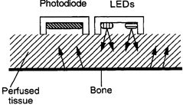

Figure 2.1: The light path (left) and sensor arrangement (right) for the POM system

In order to accurately generate comparable readings for the multiple wavelengths used in the POM system, the radiant flux of the LED and photodiode responsivity must be calibrated. Table 1 shows these metrics for each of the three wavelengths the POM system utilizes. During data processing, these values are used to calibrate measurements and provide accurate perfusion and oximetry data.

Table 1 – LED Outputs and Photodiode Response at Each Wavelength

|  |  |  |  |
| --- | --- | --- | --- |
| Wavelength | Radiant Flux (@20mA) | PD Response | PD Current resulting from full LED capture |
| 555nm | 1mW | 0.3 A/W | 300 uA |
| 660nm | 1.8mW | 0.37 A/W | 666 uA |
| 880nm | 1.5mW | 0.54 A/W | 810 uA |

## 2.2 Evolution of the POM Platform

The POM array started with a 3x3 square array (POM 1.0) of interwoven photodiodes and LEDs. The photodiodes were integrated amplifier/photodiode packages, and the LEDs were the same ones used in the current array. The lack of driver circuitry meant LED output was not current matched, and the array was bulky. The second generation of the board (POM 2.0) included almost the same sensor package as the current POM 2.5, however, it lacked the humidity sensor and thermistor, and the driver circuitry was not optimized. The current POM 2.5 array is a direct evolution of the POM 2.0 array, using lessons learned from the POM 1.0. The three iterations of the POM system can be seen from the optical array side in Figure 2.2, and the analog component side in Figure 2.3.

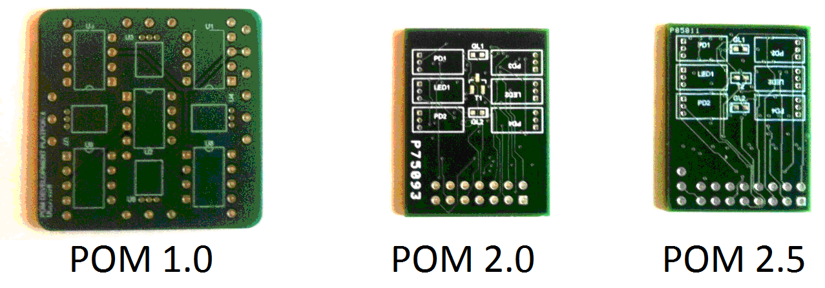

Figure 2.2: The optical array side of each iteration of POM design

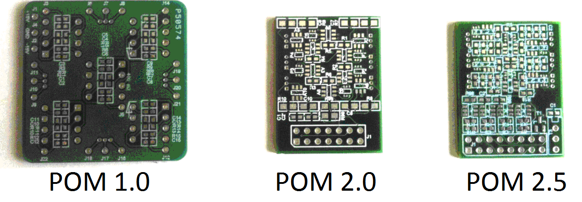

Figure 2.3: The back of the board, holding the SMD components, for each POM iteration

## 2.3 Overview of Current POM Platform

The goal of the POM development platform is to create a modular system that can accurately perform real-time blood perfusion sensing in a variety of physical configurations. The two primary applications to which this system will be applied are wound management and circulatory disorder diagnosis. The modularity and configurability of the system allows for flexibility in targeting each application. The data gained by testing the system in multiple configurations allows rapid analysis of the most effective methods for applying the sensors for each application. With this information, a more compact and wearable system can be developed for each application. Figure 2.4 below shows block diagram illustrating an overview of the full system.

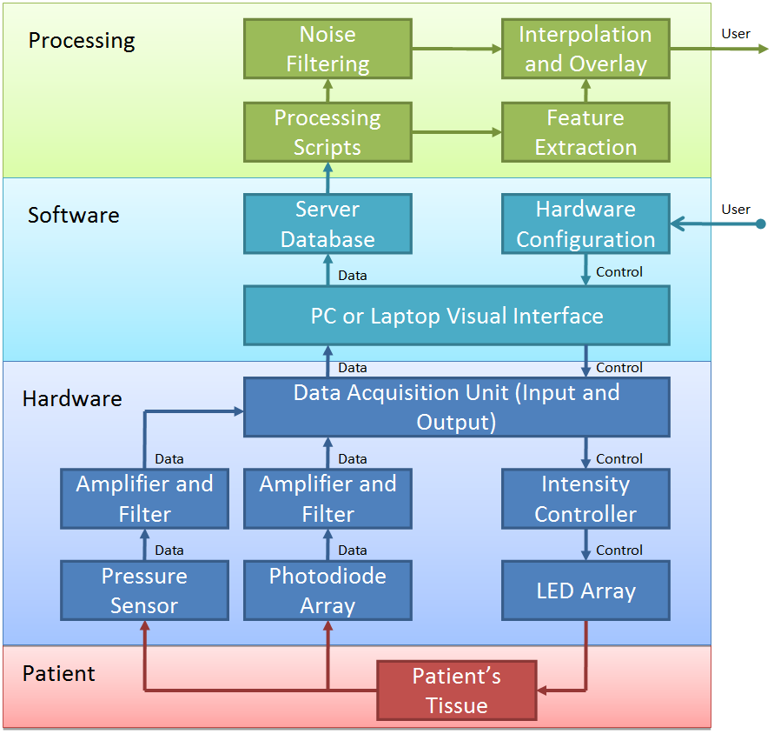

Figure 2.4: Block diagram overview of the POM system

The POM development system consists of four main components: red/infrared LED pairs, photodiodes, a data acquisition/control system and a PC for user interaction. The LEDs and photodiodes attach to the data acquisition system through cabling and can be physically configured by attaching them to a variety of bands and arrays. The data acquisition system is capable of interfacing with a large number of LEDs and photodiodes. The data acquisition system interfaces with a PC allowing a user to configure the LED pulses as well as sampling rate of the photodiodes.

The current POM system contains an expanded list of available sensors, beyond the primary PPG emitter and receiver. The inclusion of a humidity sensor and thermistor in addition to an IC temperature sensor provide additional data, while the board has maintained the same footprint as previous revisions. Size constraints are an important factor, due to the difficulty in securely applying a large sensor to different tissue regions.

The humidity sensor is ideally located to capture the humidity of the surrounding environment, and fits securely next to the main connector. The thermistor selection and placement was carefully studied and designed so that it enables capturing surface temperature of the target tissue. Hence the thermistor is located on the front side of the board where LED-photodiode array is located. The IC temperature sensor is located on the back side of the board with a proper ground design to capture relative temperature of the surrounding environment. The following is a summary of on board components for the current POM (Gen 2.5) array:

* 4 Photodiodes
  + The photodiodes comprise the sense portion of the oximeter/ photoplethysmograph system of the POM device.
* 2 Red LEDs
  + These 660nm LEDs are used to generate oximeter readings, and are contained in a dual emitter package with 1 red and 1 IR led
* 2 IR LEDs
  + These 880nm LEDs are also used to generate oximeter readings
* 2 Green LEDs
  + These 555nm LEDs are used for skin surface measurements
* 1 Thermistor on the front of the array
  + The thermistor is used to measure target location temperature
* 1 IC temperature sensor on the back of the array
  + This sensor is used to detect the board’s temperature, which is useful for calibration
* 1 Humidity sensor on the back
  + This sensor is located on the back of the array, near the header pins, and is used to monitor ambient humidity levels
* 1 Pressure sensor on the back
  + The pressure sensor is used to determine with how much force the POM array is applied, which enables calibration

## 2.4 System Architecture

We discuss here the details of the current POM system’s architecture, in terms of Sensor Hardware, Data Acquisition and Control Systems, and Processing Algorithms.

### 2.4.1 Sensor Hardware

#### 2.4.1.1 Sensor PCB Platform

The POM System uses a purpose built PCB to house the sensors and associated analog drivers and components. The PCB contains two LED pairs, four photodiodes, and two green LEDs with wavelengths keyed to skin surface perfusion. In addition, it has a temperature sensor to monitor skin surface temperature. The layout of the sensor array is shown below in Figure 2.5. This figure illustrates the compact placement of all components. The sensor array itself has a size dictated by desired emitter/receiver spacing, and the driver circuits for each sensor as well as the connector are placed to minimize the footprint of the design when placed on a test subject.

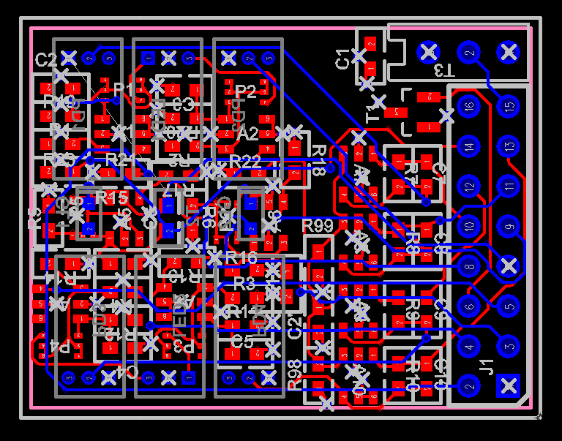

Figure 2.5: Layout and Routing of the POM PCB.

The array layout itself consists of four photodiodes, spaced around a pair of dual emitter red/infrared LEDs, pair of green LEDs, and a thermistor for skin temperature measurement. Figure 2.6 illustrates the back of the PCB where the driving circuitry is located, safely out of contact with the test subject, and the front of the PCB (right) that houses the sensor portion of the array is shown in Figure 2.7. Both of these figures show the PCB with and without the connector attached, and with the relevant sensors labeled. The layout was spaced to allow each LED output to be measured by a pair of photodiodes at both 5 and 15mm spacing, to allow comparison of measurements at different depths.

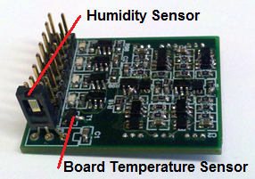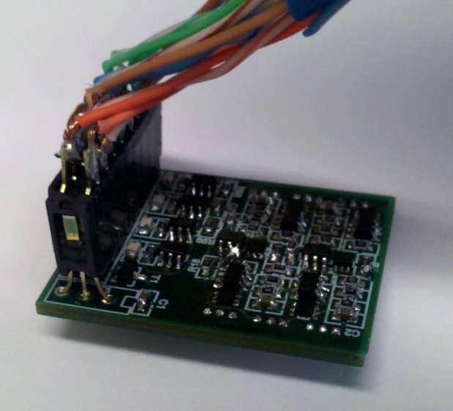

Figure 2.6: The analog component side of the populated POM PCB

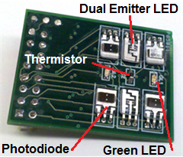 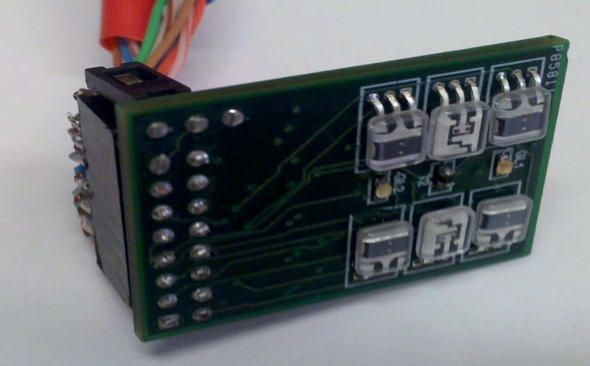

Figure 2.7: The Optical Sensor side of the populated POM PCB

#### 2.4.1.2 Optical Illumination

In order to produce the wavelengths of light corresponding to deoxy and oxyhemoglobin absorption, our system uses light emitting diodes. Specifically, our system uses the DLED-660/880-CSL-2 dual emitter combinations from OSI Optoelectronics. This dual emitter combines a red (660nm) and infrared (880nm) LED into a single package. Each red/infrared LED pair requires a 20mA current source and have a 2.4/2.0V forward voltage respectively. The system runs the LED pairs between 20mA and 40mA depending on application. As these emitters are produced specifically for PPG applications, they provide high intensity output, and are matched intensity, reducing noise resulting from calibration error.

In addition to the red/infrared LEDs, a KingBright 525nm APTD1608ZGC green LED is used to provide skin surface perfusion measurements. The 525nm green LED is able to output 780mcd at 20mA, which is intense enough to provide a response from the NIRS focused photodiodes.

The LED drive circuit, shown below in Figure 2.8, includes a current set resistor (10k), and a Maxim MAX1916 LED driver. The LED driver is capable of driving each channel at 120mA, which is more than sufficient for the 20-40mA required for the LEDs in use. The driver provides stable operation for the LEDs at periods above 3ms, with active times of 500 microseconds and higher. Below these, the driver is unable to guarantee stable operation. This provides sufficient stability for the 5 millisecond period used for the majority of measurements with POM system, with enough margin to enable experiments at faster timings if necessary. The driver operates as a current mirror, providing 230 times the current biased at the set node.

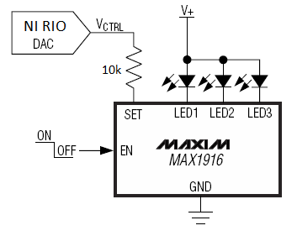

Figure 2.8: The LED drive circuit

#### 2.4.1.3 Optical PGG/Perfusion Sensing

In order to measure a photoplethysmograph, the light reflected from the LED pairs is detected by a photodiode array. The system currently uses the PIN-0.8-CSL photodiode by OSI Optoelectronics. This photodiode has a spectral range of 350-1100nm and has a responsivity to 660nm and 900nm light of .33 and .55 A/W respectively. This photodiode is manufactured to be matched to the LEDs in use, and provides a high responsivity for NIRS wavelengths when compared with more traditional commercial photodiodes. The spectral response of the photodiode is shown below in Figure 2.9, with markers placed at the responsivity for each LED in use in the POM array (555, 660, and 880nm).

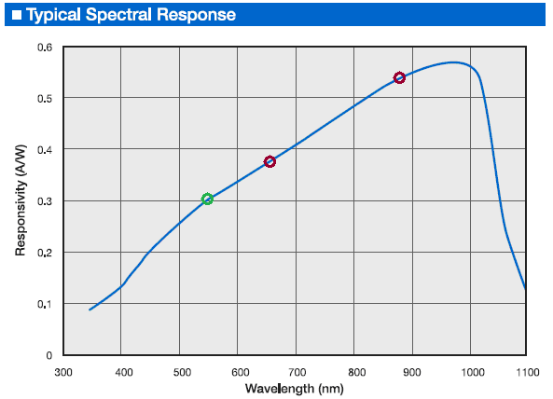

Figure 2.9: Photodiode spectral response

The photodiode read circuit operates via a virtual ground transimpedance op-amp circuit, shown below in Figure 2.10. The positive input pin of the op-amp is driven by a voltage divider, providing 2.5V (half of VDD). The negative pin is hooked up to the photodiode, which is reverse biased, and through feedback to the output of the amplifier. The feedback is controlled by a simple low pass filter with a 2.7pF capacitor and a 100 kilo-ohm resistor. The 0.1uF capacitor shown is used to decouple the voltage divider from ground. The circuit amplifies the current output of the photodiode and converts it to voltage, allowing the NI Compact-RIO to read the voltage via its voltage input module.

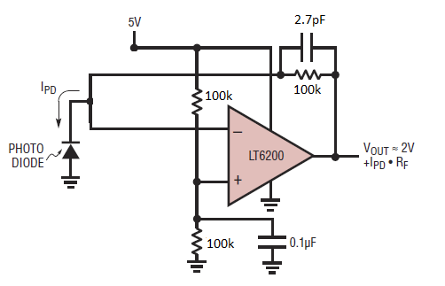

Figure 2.10: The photodiode read circuit; a virtual ground transimpedance amplifier

#### 2.4.1.4 Supporting Sensors

In addition to the primary optical sensors of the POM system that provide oximetry and perfusion data via PPG, the system also contains a number of supporting sensors to provide additional data regarding patient, ambient, or device condition. The data these sensors contribute can be used to calibrate for, or correct any variation in measurements between patients, ensuring more accurate perfusion measurements are taken.

Due to the pressure dependent nature of PPG measurements, a one pound Flexiforce pressure sensor was used to ensure consistent results. The pressure sensor is attached to the back of the POM array, and measures the pressure used in applying it to a target location. The pressure sensor is designed to deliver accurate measurements of pressure in a range from zero to one pound, which encompasses the range of pressures that can reasonably be applied when using the POM device on a patient. By keeping the applied pressure constant between measurements and test subjects, the PPG and resulting perfusion measurements can be compared more accurately.

In order to provide accurate temperature readings of tissue at the test location, a thermistor has been included on the board in middle of the optical array, as shown previously in Figure 2.7. Monitoring tissue temperature at the measurement location is necessary to generate accurate perfusion measurements. If the tissue changes temperature, the thermoregulatory response of the body will result in a vasodilation response to heating, or vasoconstriction response to cooling [20,21]. The resulting change in perfusion can skew measurements if the temperature change is not detected. With the thermistor in contact with the target tissue region, a simple divider circuit can provide the resistance of the thermistor, and from this the temperature can be determined from the following equation:

For the thermistor being used in our board, R0 is 100 kilohms, T0 is 298.15 Kelvin (25C), and B is 4100 Kelvin. No buffer is needed for reading the voltage across the thermistor because the current draw of the data acquisition sampling module in use is less than 100 picoamps. The circuit has a 1µF capacitor in parallel with the thermistor to ensure stability.

In addition to the thermistor for monitoring patient tissue, a Microchip Technologies TC1047 linear temperature to voltage integrated circuit package is included on the device. This sensor ensures the PCB ground plane temperature does not exceed acceptable levels, and induce a vasodilation effect skewing perfusion measurements, or cause the patient discomfort. It also allows calibration of other sensors based on board temperature.

A Honeywell HIH-4000 capacitive humidity sensor allows the detection of ambient humidity levels. The sensor is a three pin design, and provides a voltage output indicating humidity in the following manner:

Vout = VSupply (0.0062 * RHSensor + 0.16)

RHTrue = RHSensor (1.0546 – 0.00216 * T)-1

Where RH is Relative Humidity, RHSensor is measured RH, and RHTrue is RHSensor adjusted for the current temperature T, in degrees Celsius. The board temperature sensor is used to generate the current temperature, and verification has shown consistent measurements at both low and high humidity operation.

### 2.4.2 Data Acquisition and Control System

The POM system is built around a rapidly configurable National Instruments CompactRIO 9014 real-time controller coupled with an NI 9104 3M gate FPGA chassis. The system interfaces with the LEDs and photodiodes using three sets of modules for current output, current input, and voltage input. This allows configuration changes to be made rapidly, but also allows easy and simple user operation once the changes have been finalized. It also provides a large degree of flexibility in regards to active sensors or emitters.

#### 2.4.2.1 CompactRIO Real-Time Controller

The CompactRIO real-time controller is powered by a 400Mhz PowerPC processor and runs the VxWorks real-time operating system. It is completely programmable using the LabVIEW real-time development environment. It has 512MB of memory and 2GB flash storage. The controller also supports additional storage via USB. The controller has an Ethernet port for connection to the user interface PC.

#### 2.4.2.2 FPGA Chassis

An FPGA backplane controls communication between the CompactRIO real-time controller and I/O modules. This FPGA can itself be programmed using LabVIEW FPGA. This allows hardware implementation of high speed sampling and signal processing. The FPGA Chassis is shown below in Figure 2.11 with all of its modules connected, and hooked up to the host PC. The FPGA chassis has multiple modules connected to provide current and voltage input and output. The system currently uses the voltage input and output modules to control the LEDs and record data. The system, however, has the capability to be immediately reconfigured to use the current modules if hardware requirements change.

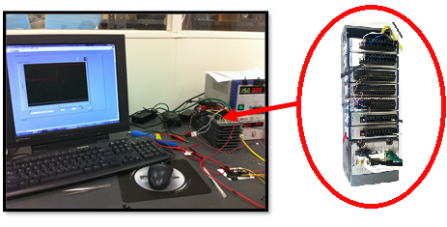

Figure 2.11: The CompactRIO (right) connected to its Host PC (left).

#### 2.4.2.3 NI 9263 Current Output Module

This module has four channels, each capable of sourcing 0-20mA. The channels can be driven at a rate of 100K updates/sec. The system supports five of these modules allowing a total of 10 red/infrared LED pairs to be operated directly from the CompactRIO if necessary.

#### 2.4.2.4 NI 9203 Current Input Module

This module has eight 16-bit analog current input channels. The module is capable of sampling at a maximum frequency of 200kS/s. The module contains one ADC multiplexed across all channels allowing simultaneous sampling rate of 25kS/sec. The system supports two of these modules allowing a total of 16 direct current output photodiodes.

#### 2.4.2.5 NI 9205 Voltage Input Module

This module has 32 16-bit analog voltage input channels. For greater accuracy, they can be used as 16 differential input channels. The channels are multiplexed to an ADC capable of sampling at 250kS/s. Each channel can be configured for a voltage range of +/-200mV, 1V, 5V, or 10V.The system supports two of these modules allowing a total of 32 voltage inputs from photodiode/amplifier modules.

#### 2.4.2.6 NO 9264 Voltage Output Module

This module has 32 16-bit analog voltage output channels. Like the NI9205 module, it is capable of operating as 16 differential output channels for increased accuracy. The module is capable of providing 25kS/s per channel output, at a configurable voltage range of up to +/-10V. The system contains one of these modules, allowing up to 16 LEDs to be controlled simultaneously.

### 2.4.3 Software and Operation

The user interacts with the data acquisition and control system through a PC running National Instruments LabVIEW. The PC communicates with the CompactRIO over an Ethernet connection. Data files generated on the CompactRIO are stored onboard and can be transferred to the PC over an FTP connection. The user interface provides a wide range of configuration options in addition to a data display and file capture manager. The configuration options, shown in Figure 2.12, enable a user to configure the timing parameters for all connected LEDs. In Figure 2.12, the LEDs are shown configured to all illuminate simultaneously.

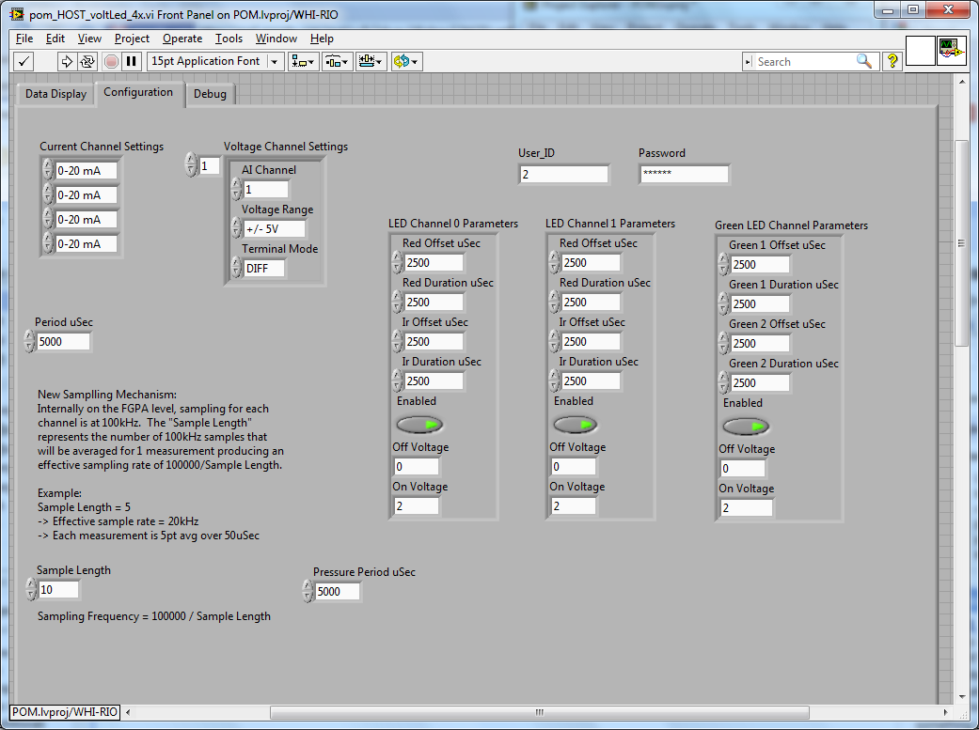

Figure 2.12: The configuration portion of the LabVIEW user interface

Each LED can have a separately controlled on time and phase shift (offset time), and the period for cycling through LEDs can also be set. The photodiode sampling rate can be configured to any level, so long as the hardware capabilities of the NI 9205 module are not exceeded. For sampling a single POM sensor array, there is an effective maximum sample rate of 60KHz, however, due to the large volume of redundant data this generates, the default rate is set to 10KHz per channel.

The LEDs are configured by default to have on times of 1ms, with both of the green LEDs illuminating simultaneously. This results in a 10 sample measurement from each photodiode for every illumination period. Additionally, the LED intensity can be controlled, with the input voltage to the MAX1916 LED driver configurable for each LED.

Once the system has been configured, the data display portion of the interface allows a user to observe and capture data. The data capture interface is shown below in Figure 2.13. Data capture period is specified in terms of illumination periods. Real time feedback is given regarding both photodiode measurements and pressure sensors measurements, while other sensors are logged for later analysis. This enables pressure to be kept constant during measurements, allowing accurate perfusion data collection.

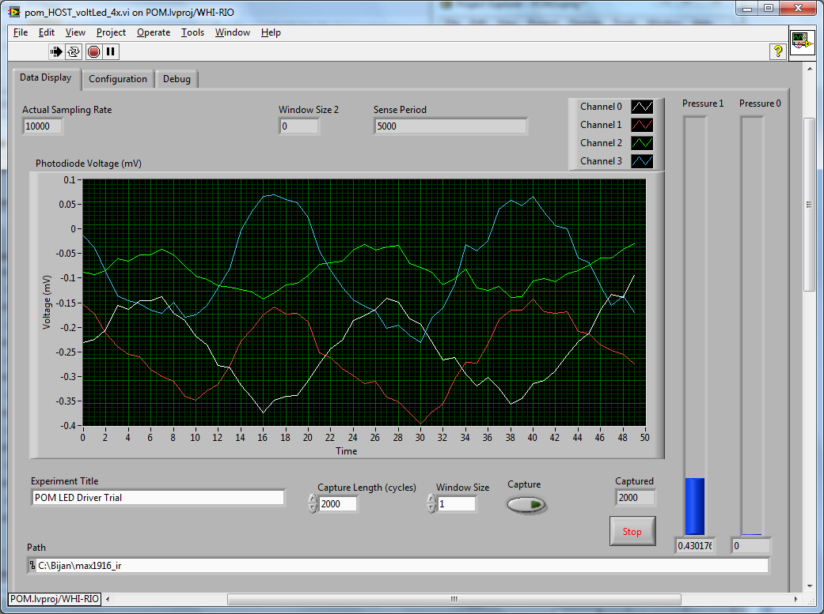

Figure 2.13: The data display and capture portion of the LabVIEW user interface

### 2.4.4 Data Processing

In order to generate useful information and metrics from the raw data recorded by the POM platform, a number of algorithms are used. The first uses the relatively simple concept of heterodyning to help eliminate in band noise. The data recorded from when the LEDs are off is subtracted from adjacent data from when the LED is on. This assumes that any measurement from when the LEDs are off will not contain PPG information, but will be a measurement of current noise levels. Although this creates high frequency noise, it removes low frequency in-band noise, which is a larger issue due to the frequencies at which motion noise occurs [22,23]. Motion noise typically occurs in the 0.5 to 35Hz range, which is the same frequency range that PPG data occupies [24]. This in-band noise can cause significant error in perfusion and oximetry calculations unless it is removed. The additional high frequency noise that is introduced by heterodyning is easily filtered out by a low pass filter or wavelet filter. Currently the algorithms are configurable, but wavelet coefficient filtering is used by default due to the preservation of high frequency information of the PPG signals it allows.

The noise subtraction procedure via heterodyning takes several steps. As shown in Figure 2.14 below, noise information from the areas marked *1* and *2* is used to attempt to calculate the noise that appears in area *3*. For the single-sided method, only the preceding noise information from area *1* is used, and the noise level is assumed to be the same. For the double-sided method, noise from areas *1* and *2* is averaged to attempt to give. Finally, interpolation of the noise at *3* is attempted via spline interpolation, using the data from all available noise periods, preceding and following the target data point (*3*). The more successful measurements averaged the data in these areas to generate a single point for each LED pulse. Each method is filtered at the end to remove high frequency noise. For the frequency response plots, the frequency is normalized to the frequency of the simulated LED drive signal, with 1 meaning the noise is the same frequency as the drive signal, 2 meaning it is double the drive frequency, and so forth.

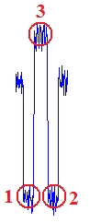

Figure 2.14: An illustration of the noise locations (1, 2) used to try and subtract noise from information points (3)

The theoretical response of the heterodyning method in relation to noise and correction frequency is shown below in Figure 2.15. It was determined by adding sinusoidal noise of a wide range of frequencies to a square wave signal, applying the correction method, and measuring the ratio of remaining noise to original noise. Measurements were averaged across all phases for a given frequency. As the noise we are targeting for removal is significantly lower than the correction frequency of 200Hz, this results in a ratio well below one, which as shown in the figure is highly attenuated by this filtering method.

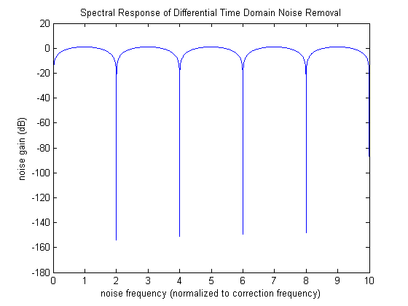

Figure 2.15: The frequency response of the heterodyning method shown on a dB scale.

When the heterodyning method was tested on actual POM system measurements that contained known segments of motion noise, reduction of motion artifacts was significantly improved. The different methods of heterodyning, however, proved to be roughly equivalent in performance, so the double-sided method is used in current implementations of the algorithm to eliminate the complication of interpolation. Figure 2.16 below shows the successful use of heterodyning to remove a motion noise artifact that occurs between t=1 and t=2 seconds. The PPG signal traces are offset to enable direct comparison in the figure.

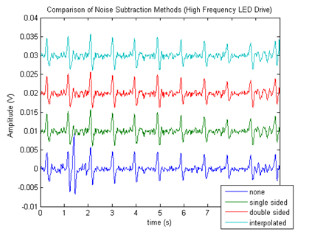

Figure 2.16: The result of employing heterodyning on POM data containing motion noise.

The noise subtraction method has been shown to be effective in removing in band noise, but the removal of high frequency noise can lead to the loss of information of the signal. Accurate measures of pulse rise time, fall time, and peak amplitude, are confounded by heavy low pass filtering. A solution to this, which allows the majority of high frequency noise to be removed but the high frequency information of the PPG signal to be retained, is using the discrete wavelet transform.

Wavelet decomposition filtering is an effective method of reducing noise while retaining high frequency information in both PPG and ECG signal analysis, and the most effective wavelet for this purpose is the Daubechies-10 (DB10) wavelet [25,26]. Figure 2.17 shows an example waveform with low pass filtering (green) and DB10 wavelet decomposition filtering (blue). Figure 2.17 below shows low pass and wavelet filtering of the same two signals, and demonstrate a clear improvement in high frequency information retention for wavelet transform. The wavelet based filter retains much more high frequency information, and the second peak of the pulse signal is much more visible. The phase shift is an artifact of the wavelet transform, but due to the small timescale does not interfere with perfusion or oximetry calculations.

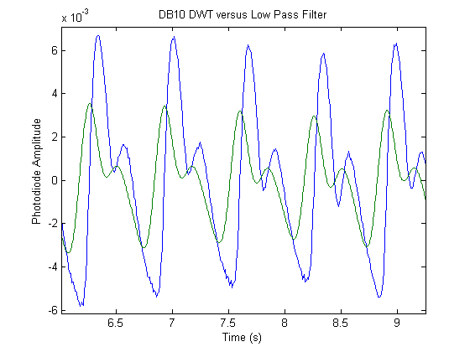

Figure 2.17: POM data showing low pass filtering (green) and DB10 wavelet decomposition filtering (blue).

Once both motion artifacts and high frequency noise have been removed, the DC level of the signal is recorded as a pseudo-perfusion measurement. This measurement must be calibrated using simultaneously recorded pressure data before it can be compared to other measurements, but offers an accurate relative measurement of perfusion. Recorded temperature data from the thermistor is also used to verify that no external stimuli created a change in temperature and resulting vasodilation effect, which would result in an erroneous flag of independent perfusion activity. During continuous monitoring, significant measurement level shifts as a result of perfusion changes can detected immediately and action taken, such as notifying a care provider.

After DC level information has been recorded, the DC offset is removed from the PPG data, and oximetry is calculated. The most commonly used method of determining oximetry via PPG is to ratio the absorption of red and infrared light according to a formula derived from the Beer-Lambert law [27, 28]:

The Beer-Lambert law states that the intensity of light transmitted through a substance, I, is dependent on the input intensity, I0, absorption coefficient of the substance, , and the distance between source and detector, d. Oximetry takes advantage of this by providing two wavelengths with different absorption coefficients for oxygenated and deoxygenated hemoglobin. The PPG data is analyzed using peak detection routines to find the peaks corresponding to the systolic portion of blood flow. The value of received intensity at these peaks is then used to calculate oximetry:

Where ACRED and ACIR correspond to the peak values of the PPG signal for red and infrared wavelengths, and DCRED and DCIR correspond to the previously measured DC levels. The result is a ratio of pulse to constant proportions at the two different wavelengths. This ratio is then used with a calibration curve to generate an oximetry value.

In addition to collecting perfusion and oximetry data, the POM system also records a number of parameters of the PPG waveform itself. The system records the systolic rise and fall times, the height of the systolic peak, and the height of the diastolic peak. These parameters allow correlation analysis between the PPG and various other metrics, such as blood pressure.

# Chapter 3

# PPG Blood Pressure Correlation

## 3.1 Overview

Blood pressure represents a valuable metric for healthcare providers, and several experiments were conducted to test the efficacy of using the existing system to measure it.

## 3.2 Stair Trials

### 3.2.1 Experimental Procedure

To test the effects of changes in blood pressure on POM sensor waveforms, the research group conducted an experiment involving exercise. Blood pressure is elevated after periods of exercise, and remains at an elevated level for a period of time after activity has stopped. This change and the recovery time are dependent on the age and physical fitness of the test subject, and the duration of activity. The POM team is currently investigating the links between photoplethysmograph timing parameters and peak heights and blood pressure. In order to characterize these relationships, we devised the following experiment:

1. Have the test subject remain at rest for a period of 5 minutes.
2. Measure baseline POM and blood pressure readings from the finger and heel.
3. Test subject runs down 5 flights of stairs, then back up 5 flights of stairs twice in the life sciences building.
4. Measure POM and blood pressure readings immediately after exercise period.
5. Continue taking POM and blood pressure readings every minute until 5 minutes after exercise.

The exercise period takes approximately three minutes, which should be sufficient to elevate blood pressure. In a similar study using exercise bikes as the method of exercise, conducted by the University of Kuopio, three minutes of exercise was sufficient to generate an average of a 30mmHg difference in systolic blood pressure [29]. Verification of the effectiveness of the planned experiment shows that this time does result in an increase in blood pressure, which tails off to normal blood pressure within roughly five minutes, but the amount of change is highly variable depending on test subject.

### 3.2.2 Measurement Techniques and Devices

In order to gather blood pressure readings, a Panasonic EW3122S Upper Arm Blood Pressure Monitor was attached to the left bicep at heart level. The arm was kept in a relaxed state, and rested on a table for every test subject. The POM sensor was then taped to the index finger on the right arm, and held at heart height for measurements. A Flexiforce 1 pound pressure sensor was attached to the back of the POM device, and used to ensure constant pressure was applied throughout the trials.

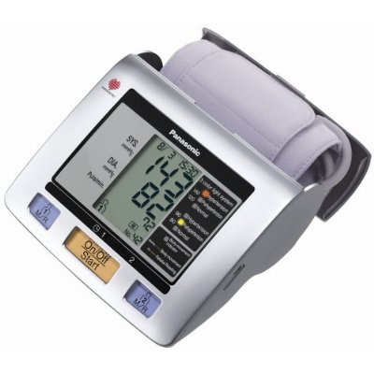

Figure 3.1: The Panasonic EW3122S used to measure blood pressure in the trials

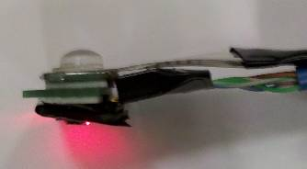

Figure 3.2: The POM sensor used to measure a plethysmograph in the trials

### 3.2.3 Blood Pressure Data

The results detailed below show blood pressure data from five test subjects of the stair blood pressure trials. Each test subject ran the trial three times, with a minimum of twenty minutes between trials to allow sufficient recover. Tables 3.1 to 3.5 show each subject’s blood pressure results for the baseline and five post-exercise period measurements, over three trials per person. All blood pressure measurements are in mmHg, with the systolic blood pressure listed first, followed by the diastolic. Figures 3.3 to 3.7 show plots of each subject’s blood pressure during the recovery time.

Table 3.1 – Blood Pressure Data from Mike Festa

|  |  |  |  |  |  |
| --- | --- | --- | --- | --- | --- |
| Mike 1 | BP | Mike 2 | BP | Mike 3 | BP |
| Baseline | 128/81 | Baseline | 130/83 | Baseline | 118/86 |
| 1 | 152/93 | 1 | 166/93 | 1 | 174/103 |
| 2 | 145/80 | 2 | 151/96 | 2 | 164/95 |
| 3 | 136/73 | 3 | 145/86 | 3 | 139/86 |
| 4 | 132/81 | 4 | 125/83 | 4 | 132/79 |
| 5 | 125/82 | 5 | 135/79 | 5 | 116/77 |

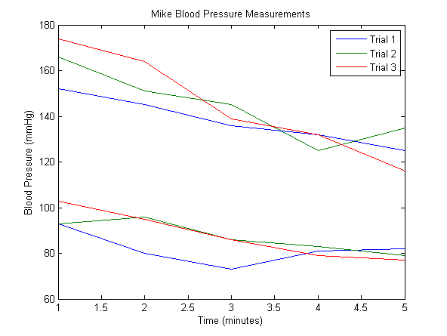

Figure 3.3: Blood pressure data from Mike. The higher cluster is systolic, the lower diastolic.

Table 3.2 – Blood Pressure Data from Bijan Mapar

|  |  |  |  |  |  |
| --- | --- | --- | --- | --- | --- |
| Bijan 1 | BP | Bijan 2 | BP | Bijan 3 | BP |
| Baseline | 117/83 | Baseline | 107/76 | Baseline | 113/79 |
| 1 | 156/70 | 1 | 147/78 | 1 | 117/70 |
| 2 | 143/79 | 2 | 125/56 | 2 | 131/77 |
| 3 | 147/74 | 3 | 153/85 | 3 | 135/82 |
| 4 | 136/78 | 4 | 139/83 | 4 | 123/77 |
| 5 | 126/83 | 5 | 141/86 | 5 | 111/75 |

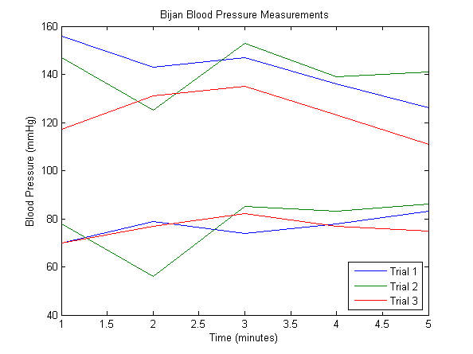

Figure 3.4: Blood pressure data from Bijan. The higher cluster is systolic, the lower diastolic.

Table 3.3 – Blood Pressure Data from Yeung Lam

|  |  |  |  |  |  |
| --- | --- | --- | --- | --- | --- |
| Yeung 1 | BP | Yeung 2 | BP | Yeung 3 | BP |
| Baseline | 123/85 | Baseline | 121/79 | Baseline | 111/81 |
| 1 | 144/96 | 1 | 153/93 | 1 | 126/81 |
| 2 | 136/93 | 2 | 150/92 | 2 | 135/83 |
| 3 | 143/90 | 3 | 141/88 | 3 | 122/89 |
| 4 | 136/93 | 4 | 138/87 | 4 | 126/83 |
| 5 | 132/88 | 5 | 129/83 | 5 | 108/79 |

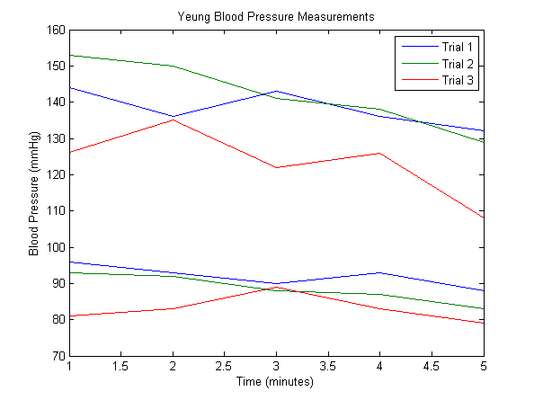

Figure 3.5: Blood pressure data from Yeung. The higher cluster is systolic, the lower diastolic.

Table 3.4 – Blood Pressure Data from Victor Chen

|  |  |  |  |  |  |
| --- | --- | --- | --- | --- | --- |
| Victor 1 | BP | Victor 2 | BP | Victor 3 | BP |
| Baseline | 119/70 | Baseline | 116/70 | Baseline | 121/71 |
| 1 | 153/85 | 1 | 152/83 | 1 | 150/78 |
| 2 | 141/81 | 2 | 140/83 | 2 | 139/77 |
| 3 | 132/74 | 3 | 138/78 | 3 | 126/74 |
| 4 | 141/76 | 4 | 127/80 | 4 | 125/72 |
| 5 | 117/71 | 5 | 125/80 | 5 | 119/67 |

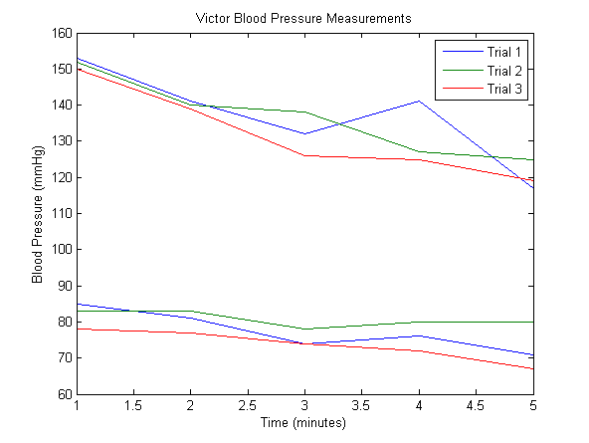

Figure 3.6: Blood pressure data from Victor. The higher cluster is systolic, the lower diastolic.

Table 3.5 – Blood Pressure Data from Henrik Borgstrom

|  |  |  |  |  |  |
| --- | --- | --- | --- | --- | --- |
| Henrik 1 | BP | Henrik 2 | BP | Henrik 3 | BP |
| Baseline | 134/87 | Baseline | 136/91 | Baseline | 136/77 |
| 1 | 172/91 | 1 | 172/85 | 1 | 144/87 |
| 2 | 160/92 | 2 | 149/87 | 2 | 143/89 |
| 3 | 153/92 | 3 | 152/83 | 3 | 141/80 |
| 4 | 160/95 | 4 | 130/79 | 4 | 126/86 |
| 5 | 152/92 | 5 | 142/85 | 5 | 143/81 |

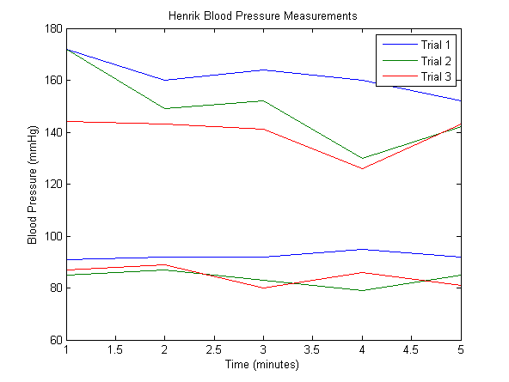

Figure 3.7: Blood pressure data from Henrik. The higher cluster is systolic, the lower diastolic.

### 3.2.4 POM Data Metrics

A total of 18 POM measurements were taken from each of five subjects, resulting in 90 total POM measurements for this experiment. A number of metrics were extracted from the POM data for the purpose of attempting to correlate to blood pressure changes, and are detailed below.

In Figure 3.8, taken from a POM measurement, the red circles represent primary peaks (the local maximum of the plethysmograph signal), the green circles represent secondary peaks (local maximum, but not largest value of the plethysmograph for that pulse), and the blue circles represent the minimum value of the signal. These points are automatically found by the data processing software for every POM measurement, and are used to generate metrics detailed below for that measurement.

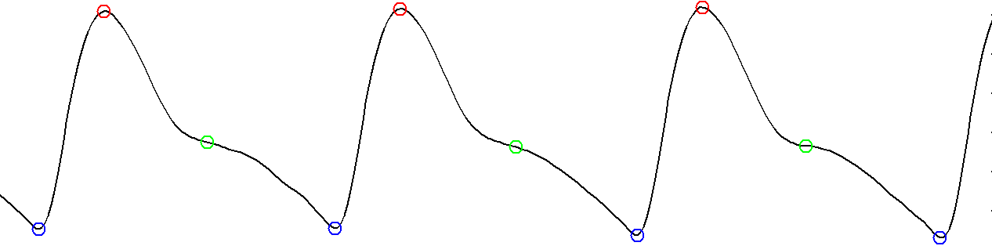

Figure 3.8: Example labeled PPG pulse waveform

Systolic rise time, shown in Figure 3.9 below, is measured in seconds from a minimum reading of the plethysmograph waveform to the next maximum reading. Diastolic fall time, measured in seconds from a maximum reading of the plethysmograph waveform to the next minimum reading, is shown in Figure 3.10 below. These two measurements have been cited as having possible correlation with blood pressure in published experiments [30]. This correlation is investigated in the further sections. Strength of the diastolic secondary peak, measured by calculating the height of the primary peak and finding what percentage of that the secondary peak reaches, is illustrated in Figure 3.11. As this metric is a function of the diastolic action of a heartbeat, it was collected to be examined for correlation with diastolic blood pressure. Delay between systolic and diastolic peaks, measured by taking the delay in seconds between the primary and secondary peaks, is shown in Figure 3.12. This metric was collected to examine whether the timing parameters of these two peaks are related to blood pressure.

Finally, Figure 3.13 shows the falloff time of diastolic secondary peak, measured by taking the time, in seconds, between a secondary peak and the next minimum reading. This metric was also collected to examine for correlation with diastolic blood pressure. These metrics encompass all of the relevant timing and magnitude characteristics of the PPG waveform in regards to blood pressure, and their correlation with actual blood pressure measurements gives a good indication of whether these metrics can be reliably used to determine blood pressure.

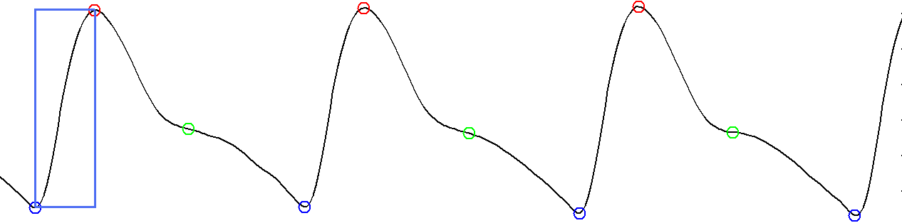

Figure 3.9: Systolic rise time

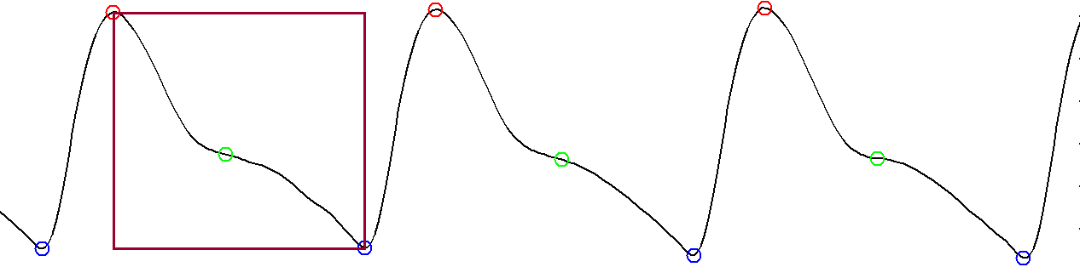

Figure 3.10: Diastolic fall time

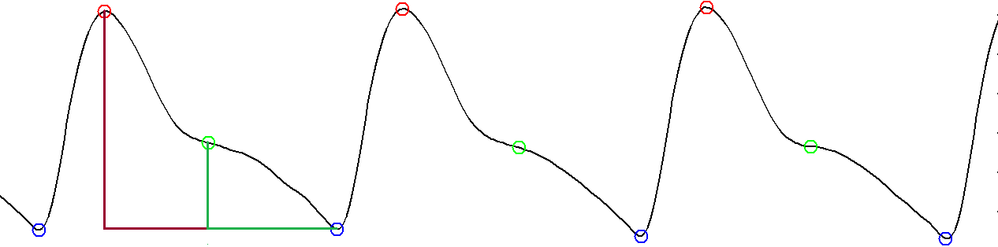

Figure 3.11: Diastolic secondary peak strength

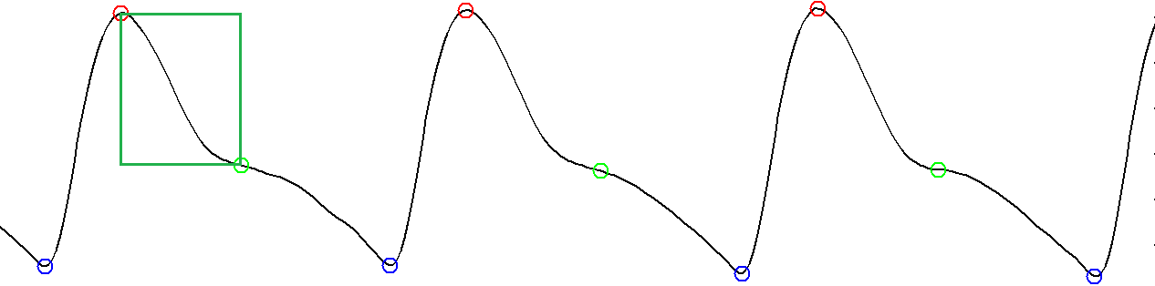

Figure 3.12: Delay between systolic and diastolic peaks

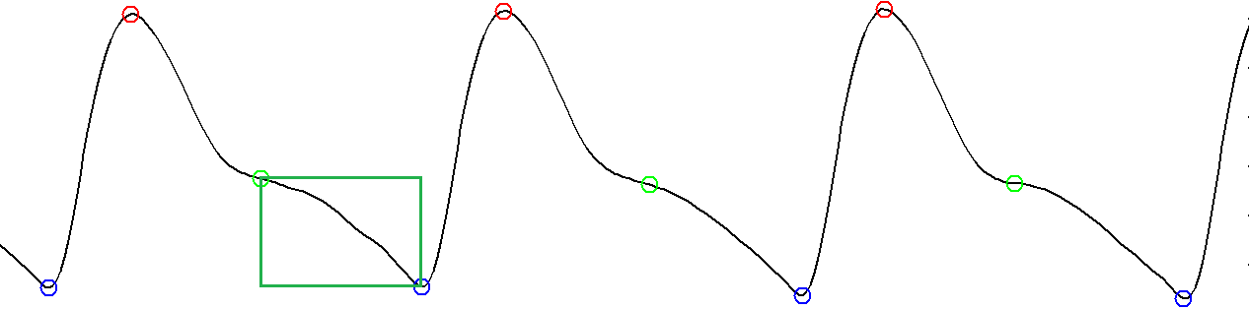

Figure 3.13: Falloff time of diastolic secondary peak

### 3.2.5 POM Metric Correlation to Blood Pressure

To characterize the accuracy of each metric in characterizing blood pressure, the correlation coefficient of each metric was taken in regards to systolic blood pressure, diastolic blood pressure, and heart rate. The data shown in Tables 3.6 to 3.10 contains the correlations of each metric to heart rate, systolic blood pressure, and diastolic blood pressure on a per trial basis for each subject. Table 3.11 contains correlation data averaged across subjects and trials, to provide an overview of the effectiveness of each metric. Results show that all PPG timing metrics are unreliable indicators of blood pressure activity, and utilizing the timing parameters in combination also failed to achieve success. However, PPG measurement of heart rate appears highly correlated to blood pressure during exercise recovery. The data is presented visually in the figures in the next section. The abbreviations used are as follows:

* FT is Diastolic Fall Time
* RT is Systolic Rise Time
* SP is Diastolic Second Peak Strength
* HR is Heart Rate
* The number represents the trial, e.g. RT1 is rise time from trial 1

Table 3.6 – Correlation Coefficients for Mike’s Measurements

|  |  |  |  |  |  |  |
| --- | --- | --- | --- | --- | --- | --- |
|  | RT1 | RT2 | RT3 | FT1 | FT2 | FT3 |
| HR | -0.502 | -0.775 | -0.934 | -0.866 | -0.969 | -0.949 |
| Systolic | -0.959 | -0.767 | -0.796 | -0.531 | -0.783 | -0.794 |
| Diastolic | -0.725 | -0.720 | -0.886 | -0.710 | -0.450 | -0.886 |
|  | SP1 | SP2 | SP3 | HR1 | HR2 | HR3 |
| HR | -0.959 | -0.738 | -0.935 | 1.000 | 1.000 | 1.000 |
| Systolic | -0.165 | -0.496 | -0.695 | 0.314 | 0.898 | 0.842 |
| Diastolic | -0.570 | -0.303 | -0.724 | 0.767 | 0.598 | 0.895 |

Table 3.7 – Correlation Coefficients for Bijan’s Measurements

|  |  |  |  |  |  |  |
| --- | --- | --- | --- | --- | --- | --- |
|  | RT1 | RT2 | RT3 | FT1 | FT2 | FT3 |
| HR | 0.453 | -0.928 | -0.325 | 0.584 | -0.868 | -0.519 |
| Systolic | -0.874 | -0.317 | -0.121 | -0.781 | 0.211 | -0.311 |
| Diastolic | 0.733 | -0.041 | 0.556 | 0.604 | 0.664 | 0.389 |
|  | SP1 | SP2 | SP3 | HR1 | HR2 | HR3 |
| HR | -0.274 | -0.940 | -0.336 | 1.000 | 1.000 | 1.000 |
| Systolic | 0.114 | -0.030 | -0.221 | -0.467 | 0.129 | 0.903 |
| Diastolic | 0.146 | 0.328 | -0.377 | 0.548 | -0.282 | 0.535 |

Table 3.8 – Correlation Coefficients for Yeung’s Measurements

|  |  |  |  |  |  |  |
| --- | --- | --- | --- | --- | --- | --- |
|  | RT1 | RT2 | RT3 | FT1 | FT2 | FT3 |
| HR | -0.719 | 0.045 | -0.783 | -0.998 | -0.985 | -0.936 |
| Systolic | -0.553 | -0.331 | -0.662 | -0.701 | -0.736 | -0.597 |
| Diastolic | -0.344 | -0.360 | -0.716 | -0.779 | -0.725 | -0.059 |
|  | SP1 | SP2 | SP3 | HR1 | HR2 | HR3 |
| HR | -0.888 | -0.135 | -0.409 | 1.000 | 1.000 | 1.000 |
| Systolic | -0.458 | 0.116 | 0.006 | 0.715 | 0.795 | 0.723 |
| Diastolic | -0.640 | 0.096 | -0.519 | 0.743 | 0.786 | 0.169 |

Table 3.9 – Correlation Coefficients for Victor’s Measurements

|  |  |  |  |  |  |  |
| --- | --- | --- | --- | --- | --- | --- |
|  | RT1 | RT2 | RT3 | FT1 | FT2 | FT3 |
| HR | -0.877 | -0.927 | -0.373 | -0.666 | -0.676 | -0.592 |
| Systolic | 0.569 | -0.689 | -0.423 | -0.115 | -0.751 | 0.452 |
| Diastolic | -0.802 | -0.224 | -0.307 | 0.100 | -0.819 | 0.588 |
|  | SP1 | SP2 | SP3 | HR1 | HR2 | HR3 |
| HR | -0.395 | 0.635 | 0.525 | 1.000 | 1.000 | 1.000 |
| Systolic | 0.703 | 0.175 | 0.449 | 0.363 | 0.848 | 0.107 |
| Diastolic | 0.403 | 0.280 | 0.181 | 0.673 | 0.547 | -0.304 |

Table 3.10 – Correlation Coefficients for Henrik’s Measurements

|  |  |  |  |  |  |  |
| --- | --- | --- | --- | --- | --- | --- |
|  | RT1 | RT2 | RT3 | FT1 | FT2 | FT3 |
| HR | -0.8234 | -0.875 | -0.7364 | -0.9678 | -0.9142 | -0.9515 |
| Systolic | -0.6841 | -0.9399 | -0.6228 | -0.5409 | -0.7563 | -0.3345 |
| Diastolic | 0.9175 | -0.5417 | -0.0599 | 0.7319 | -0.208 | -0.45 |
|  | SP1 | SP2 | SP3 | HR1 | HR2 | HR3 |
| HR | -0.8403 | -0.7589 | -0.954 | 1 | 1 | 1 |
| Systolic | -0.6437 | -0.9659 | -0.7213 | 0.4277 | 0.7857 | 0.5684 |
| Diastolic | 0.5149 | -0.6408 | -0.3504 | -0.8669 | 0.0903 | 0.3514 |

Table 3.11 – Correlation Coefficients Averaged Across Subjects and Trials

|  |  |  |  |  |
| --- | --- | --- | --- | --- |
|  | RT | FT | SP | HR |
| HR | -0.605 | -0.751 | -0.493 | 1 |
| Systolic | -0.545 | -0.471 | -0.189 | 0.530 |
| Diastolic | -0.235 | -0.134 | -0.145 | 0.350 |

### 3.2.6 Stair Trial Correlation Visualization

Figures 3.14 to 3.16 below show the correlations between all metrics and heart rate (3.14), systolic blood pressure (3.15), and diastolic blood pressure (3.16) for test subject 1 across all three trials. This data corresponds to that listed in Table 3.6 in the previous section.

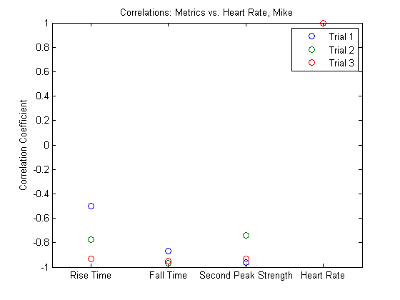

Figure 3.14: Correlations between selected metrics and heart rate from test subject 1.

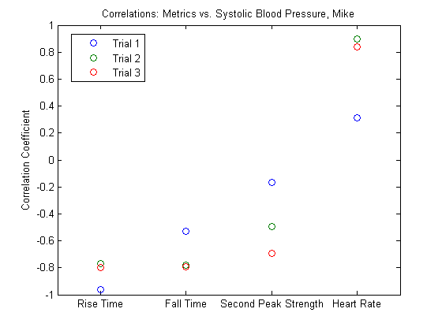

Figure 3.15: Correlations between metrics and systolic blood pressure from test subject 1.

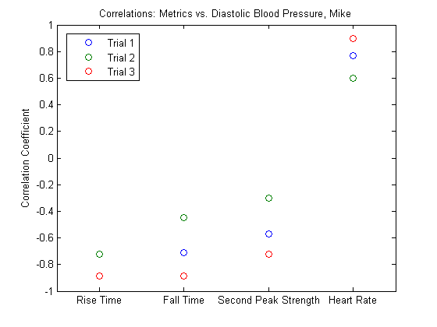

Figure 3.16: Correlations between metrics and systolic blood pressure from test subject 1.

Figures 3.17 to 3.19 below show the correlations between all metrics and heart rate (3.17), systolic blood pressure (3.18), and diastolic blood pressure (3.19) for test subject 2 across all three trials. This data corresponds to the data in Table 3.7 above.

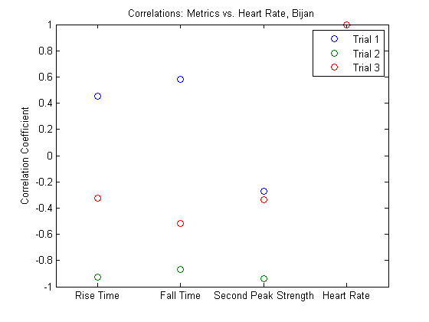

Figure 3.17: Correlations between selected metrics and heart rate from test subject 2.

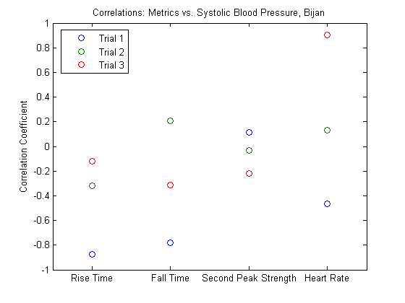

Figure 3.18: Correlations between metrics and systolic blood pressure from test subject 2.

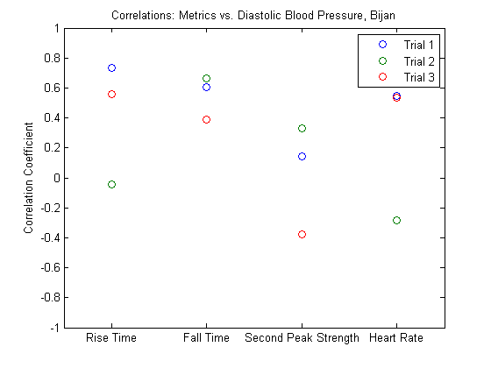

Figure 3.19: Correlations between metrics and diastolic blood pressure from test subject 2.

Figures 3.20 to 3.22 below show the correlations between all metrics and heart rate (3.20), systolic blood pressure (3.21), and diastolic blood pressure (3.22) for test subject 3 across all three trials. This data corresponds to the data in Table 3.8 above.

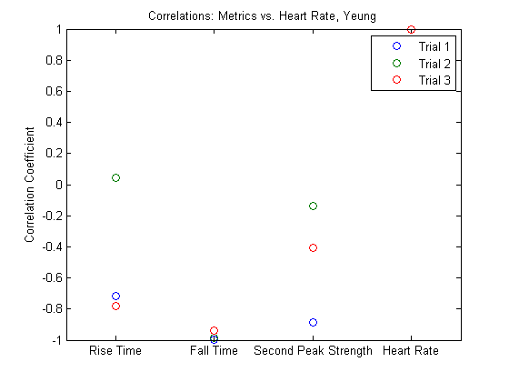

Figure 3.20: Correlations between selected metrics and heart rate from test subject 3.

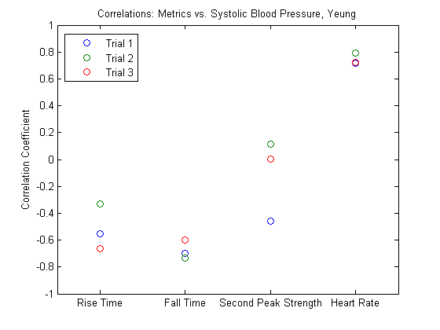

Figure 3.21: Correlations between metrics and systolic blood pressure from test subject 3.

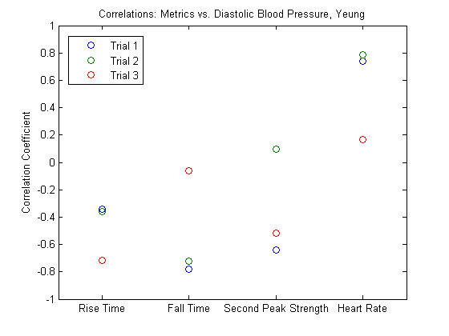

Figure 3.22: Correlations between metrics and diastolic blood pressure from test subject 3.

Figures 3.23 to 3.25 below show the correlations between all metrics and heart rate (3.23), systolic blood pressure (3.24), and diastolic blood pressure (3.25) for test subject 4 across all three trials. This data corresponds to the data in Table 3.9 above.

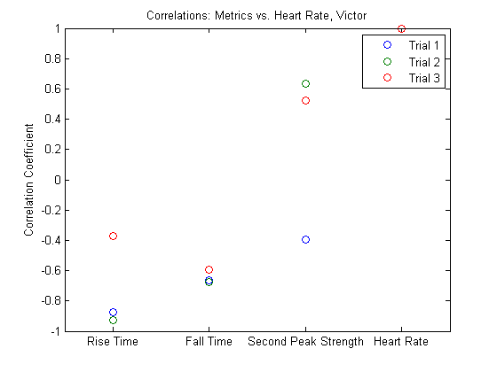

Figure 3.23: Correlations between selected metrics and heart rate from test subject 4.

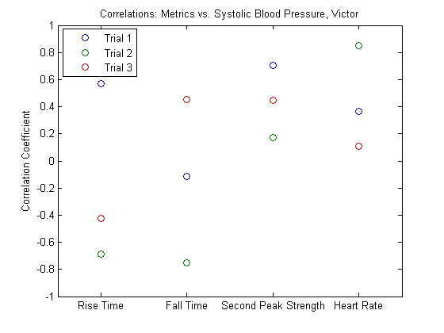

Figure 3.24: Correlations between metrics and systolic blood pressure from test subject 4.

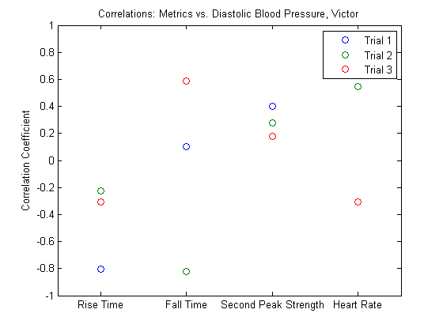

Figure 3.25: Correlations between metrics and diastolic blood pressure from test subject 4.

Figures 3.26 to 3.27 below show the correlations between all metrics and heart rate (3.26), systolic blood pressure (3.27), and diastolic blood pressure (3.28) for test subject 5 across all three trials. This data corresponds to the data in Table 3.10 above.

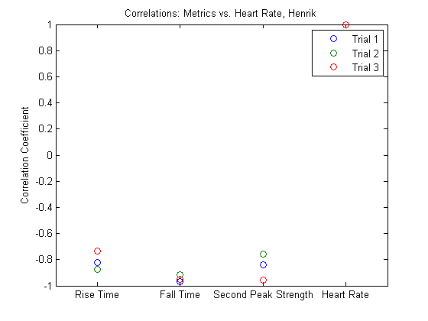

Figure 3.26: Correlations between selected metrics and heart rate from test subject 5.

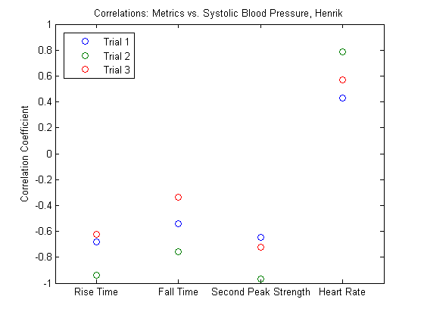

Figure 3.27: Correlations between metrics and systolic blood pressure from test subject 5.

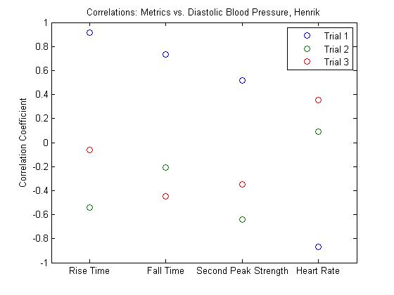

Figure 3.28: Correlations between metrics and diastolic blood pressure from test subject 5.

The averaged correlation of each metric with heart rate, systolic blood pressure, and diastolic blood pressure are shown below in Figure 3.29. This provides a general overview of the performance of each metric as an indicator of each physiological property.

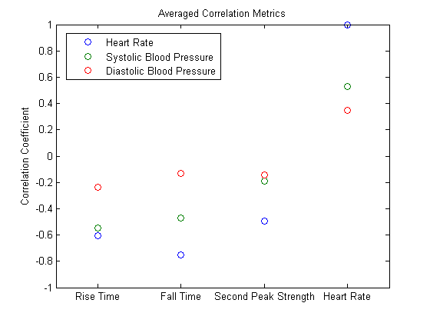

Figure 3.29: Correlations between selected metrics and heart rate, systolic blood pressure, and diastolic blood pressure averaged across all trials and subjects.

### 3.2.7 Stair Trial Regression Analysis

After compiling data from six test subjects, it is necessary to try a regression and see if any meaningful relationships can be extracted. The various metrics were all compared with blood pressure, however, no meaningful trends were found. The r-squared values for all the blood pressure regressions were very low, which indicates that better metrics are needed to extract a blood pressure measurement with our sensor system. It is important to note, however, that the previous correlation data was run on a per-subject basis, and seems to indicate that while these metrics may not provide absolute information, monitoring a metric for a single subject could still provide relative data.

Fall time is shown plotted against heart rate for all data points in Figure 3.30. As expected, the two are very strongly related, with an R2 of 0.790 for the expected rational fit. The fit was 69.27 / (0.2132 + Fall Time), which is very close to the 60 / (C + Fall Time) one would expect from perfect correlation. Rise time is shown plotted against heart rate in Figure 3.31. If there is a relationship between this timing parameter and heart rate, it should be an inverse one, in the same manner as Fall Time. However, as shown in the figure, there is almost no trend, with a very low R2 of 0.0517. This indicates that the systolic rise time portion of PPG recorded heartbeat is independent of heart rate, which is almost solely dependent on diastolic fall time.

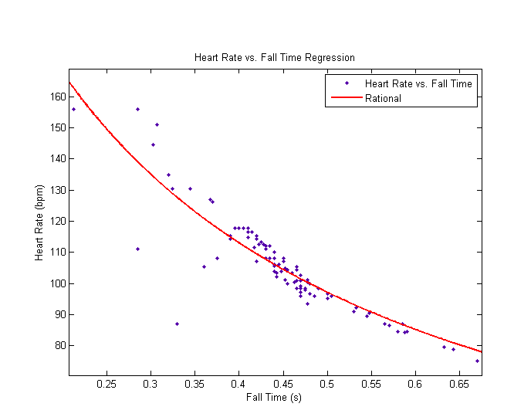

Figure 3.30: Heart Rate vs. Fall Time Regression.

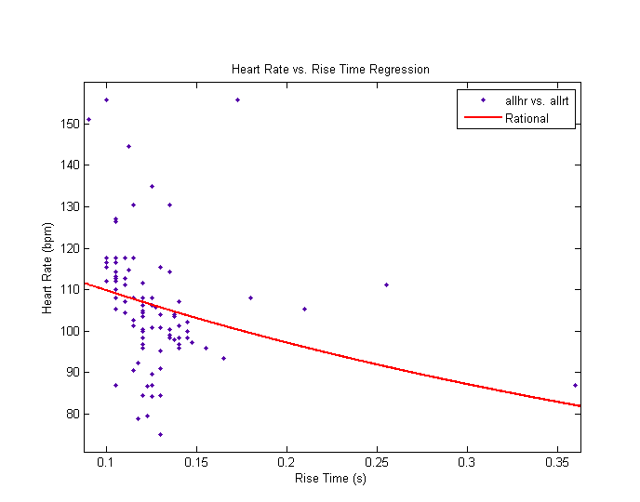

Figure 3.31: Heart Rate vs. Rise Time regression

The figures below illustrate the regression of other metrics to blood pressure. Figure 3.32 shows fall time compared to blood pressure. There is no trend shown, with R2 equal to 0.017 for linear and exponential, and 0.0208 for quadratic, indicating that fall time is a poor indicator of blood pressure. Similarly, Figure 3.33, which shows rise time compared to blood pressure, also has a very poor fit. There is no trend shown, with R2 equal to 0.000994 for linear, 0.0333 for quadratic, 0.00107 for exponential, and 0.00115 for rational. Figure 3.34, which shows blood pressure versus systolic peak amplitude, and Figure 3.35, which shows blood pressure versus diastolic secondary peak amplitude, also illustrates poor correlation.

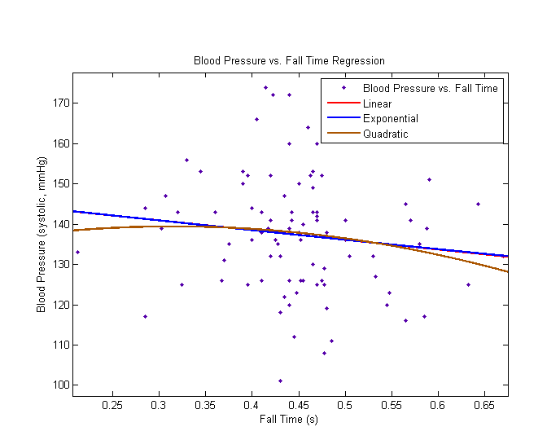

Figure 3.32: Blood Pressure vs. Fall Time Regression

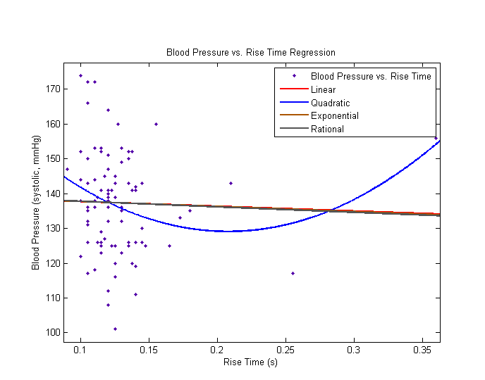

Figure 3.33: Blood Pressure vs. Rise Time Regression

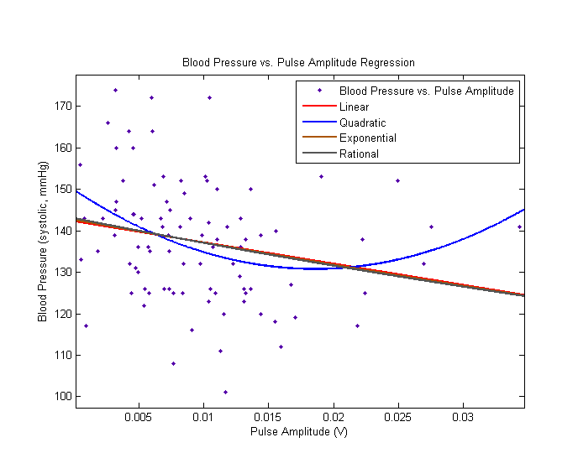

Figure 3.34: Blood Pressure vs. Pulse Amplitude Regression

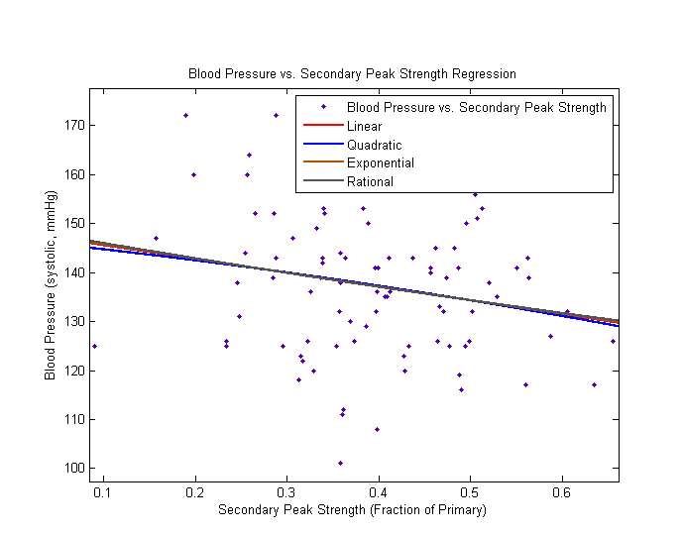

Figure 3.35: Blood Pressure vs. Secondary Peak Strength Regression

### 3.2.8 Stair Trial Conclusions

Based on analysis of current data from five test subjects, our current conclusion is that there is potential for blood pressure analysis via the POM device, however, a single senor is not capable of delivering enough information to enable this. Secondary peak strength appears to be a poor metric, and is not well correlated with anything but heart rate. The fall time metric appears to be more highly correlated with heart rate than systolic blood pressure, however, fall time appears moderately well correlated with both heart rate and blood pressure on a per subject basis. Across all subjects, no absolute fit can be found for any metrics. The trend of systolic rise time independence from heart rate, however, gives interesting insight into the waveform that a PPG measurement generates.

The rise time correlation, along with the potential for tracking changes in pulse delays from multiple sensors, makes a strong argument for multi-sensor trials. Future work could utilize sensors at the finger, foot, and possibly head, to give a large height difference. As height has an influence on local blood pressure, differences in the readings may be able to give more information. Experiments expanding on this possibility are detailed below.

## 3.3 Height Trials

### 3.3.1 Height Trial Background

Blood Pressure is known to vary as the height of measurement relative to the heart is varied. This is a result of changes in hydrostatic pressure across different heights [31,32]. This effect is the reason that most commercial blood pressure cuffs require specific locations at heart level to provide accurate readings, and can be used to generate readings at different blood pressures.

To test if this effect can be measured with the POM system, 60 trials were conducted, 30 with the sensor elevated to head level, and 30 with the sensor level with the heart. The test subject was seated and stationary for the duration of the measurements, in order to keep heart rate constant and blood pressure constant at constant height. Each measurement was taken over five seconds, and the sensor was reseated for each measurement to minimize the influence a specific sensor orientation could have on the results.

### 3.3.2 Height Trial Results

The POM system showed clear differences for overall signal amplitude when measurement height was varied. Additionally, the rise time metric shows significant changes with height shifts, but appears to become unreliable when not at heart level. Other metrics did not show positive results.

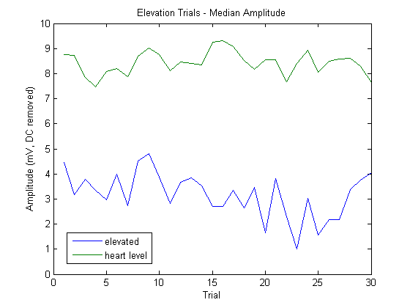

Figure 3.36: Amplitude results for elevated and level positions. There is a clear increase in amplitude when the sensor is lowered, corresponding to an increase in blood pressure.

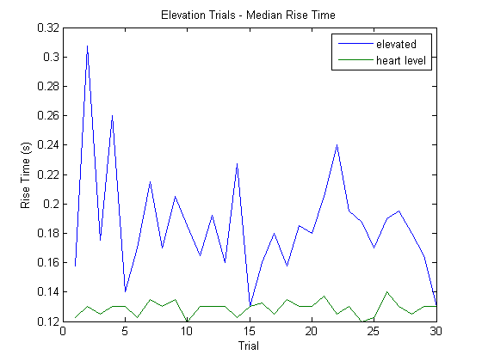

Figure 3.37: Rise time results for elevated and level positions. There is an unstable increase in rise time when the sensor is raised, corresponding to a decrease in blood pressure.

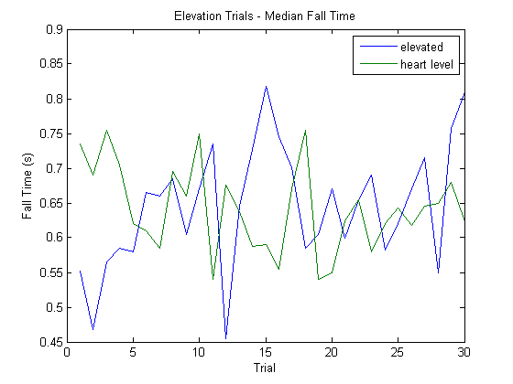

Figure 3.38: Fall time results for elevated and level positions. There no clear difference between height levels for this metric.

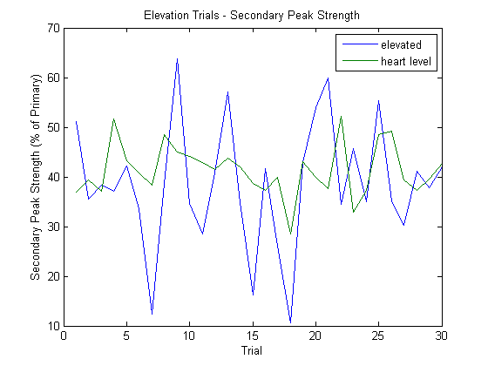

Figure 3.39: Secondary peak strength results for elevated and level positions. There no clear difference between height levels for this metric.

### 3.3.3 Height Trial Analysis

The POM system showed clear differences for overall signal amplitude when measurement height was varied. Additionally, the rise time metric shows significant changes with height shifts, but appears to become unreliable when not at heart level. Other metrics did not show positive results. This indicates that in future work, multiple POM sensors applied at locations with varying elevations from the heart could be used to determine blood pressure via systolic peak amplitude.

# Chapter 4

# PPG Pressure and Location Analysis

The location trials were done on three volunteers in the lab. For each subject, measurements were taken with the subject at rest using the POM sensor. Measurements were taken at the thumb, side of the wrist, neck, and calf. Measurements were recorded as data files via the previously discussed POM architecture.

In addition to gathering data from various locations, we also attempted to gather data at different angles of incidence between the photodiode and LED. For each location, we sampled at 5mm, 10mm, 15mm, and 20mm spacing.  Depending on the geometry of the location we were measuring at, we recorded measurements at a flat angle and either a small angle or roughly perpendicular angle, by pinching the tissue between sensor and photodiode.

## 4.1 Initial Sensor and Location Data

Our initial results showed that the plethysmograph measurement is locally very spatially dependent.  Moving the sensor’s position on the thumb by a centimeter or two, while keeping all other factors constant (spacing, angle, etc.) resulted in a large change.  This difference was repeatable between test subjects.  This illustrates that the sensor requires multiple measurement points in order to provide effective data due to local perfusion variations.

While readings varied between locations, we were generally able to get a comparable pulse signal in one or more test scenarios at each location, excluding the arm.  This is promising, as it means the sensor can be used on most of the body, and is not limited to the default position or location on the thumb.  A series of comparison graphs created using data from our experiments is shown in the figures below. Figure 4.1 shows measurements from the thumb at 15-20mm, compared to measurements at 5mm. The large change is due the difference in depth being measured during change in spacing. Figure 4.2 shows measurements from the wrist at 5-15mm, at both flat and angled orientations. Measurements above 15mm showed poor results, but measurements were still possible.

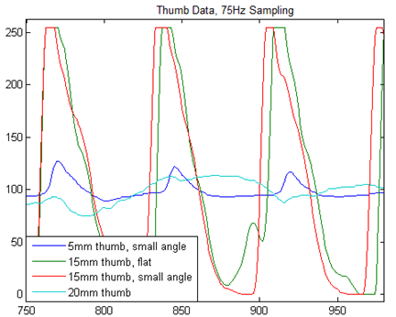

Figure 4.1: Measurements from the thumb at various sensor spacings

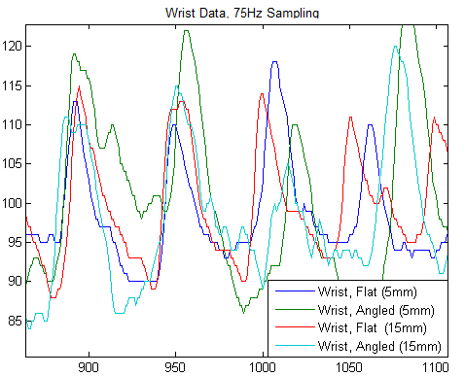

Figure 4.2: measurements from the wrist at various sensor spacings

Figure 4.3 shows measurements from 5-10mm on the neck, with both horizontal and vertical orientations on the carotid artery. One of the neck measurements shows a reversal in polarity compared to the other measurements, with the systolic portion showing as a large drop, with a maximum during diastolic periods. This is a result of that orientation and depth probing a vein rather than an artery, and therefore seeing reversed changes in blood flow during these periods. Forehead data is shown in Figure 4.4. Readings at higher spacing are very noisy, likely due to the shallow volume of perfused tissue between the bone and sensor in that region.

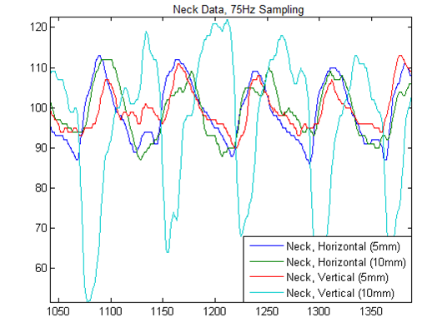

Figure 4.3: Measurements from the carotid artery on the neck at various spacings and orientations

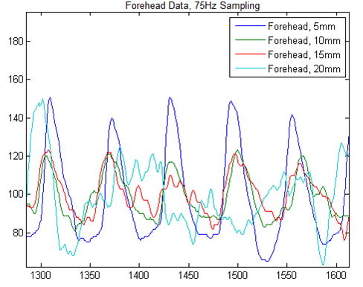

Figure 4.4: Measurements from the forehead at various sensor spacings

Figure 4.5 shows a comparison of the clearest signals at each location, superimposed. The readings are reasonably similar, regardless of where the sensor is placed on the body. All regions can provide meaningful pulse and perfusion information, however, variations in measurement depth via sensor separation are necessary to obtain the cleanest data. Figure 4.6 also shows a comparison of the clearest signals at each location, separated with artificial constant offsets.

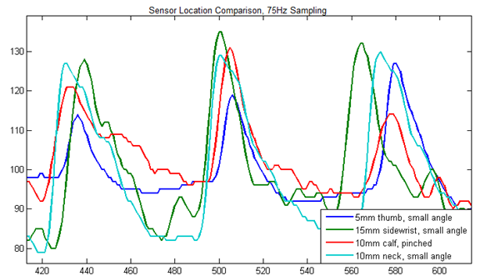

Figure 4.5: A comparison of measurements from various locations

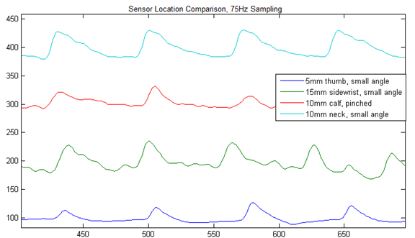

Figure 4.6: A comparison of measurements with artificial DC offset.

## 4.2 Pressure Sensor Data

A series of measurements was conducted to show that the pressure with which the sensor is applied to tissue has major impact on the sensor readings. A pressure sensor was used in the trials to quantify the differences in pressure. It appears that the neck and thumb give best results when moderate (approximately 0.5 lbs.) pressure is applied, while the wrist and forehead yield best results with low pressure (below 0.25 lbs.). High pressure (above 0.75 lbs.) generally produced poor results. This is likely due to this level of pressure disrupting perfusion by pushing blood out of the target region. The disparity in optimum pressure levels between the neck and thumb is due to softer tissue than the forehead and wrist. The figures below demonstrate the pressure dependency, with initial trials shown first, followed by trials conducted with the pressure sensor.

Figure 4.7 shows a comparison of readings from the thumb. All factors except pressure were held constant between measurements. A moderate pressure clearly results in a better waveform. Figure 4.8 shows a comparison of readings from the forehead using the POM sensor, with varying pressure and all other factors held constant. The low pressure resulted in significantly higher PPG amplitudes than higher levels, due to the thinner layer of perfused tissue above bone in this region. Figure 4.9, containing data from the neck, also shows that low pressure provides better measurements, likely due to higher pressures disrupting perfusion in this area.

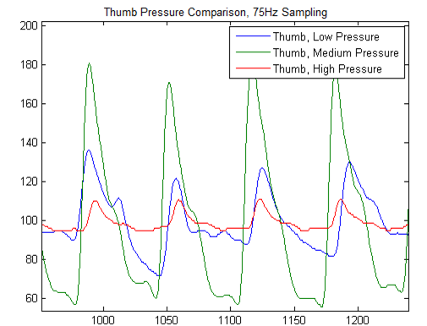

Figure 4.7: Pressure comparison measurements from the thumb

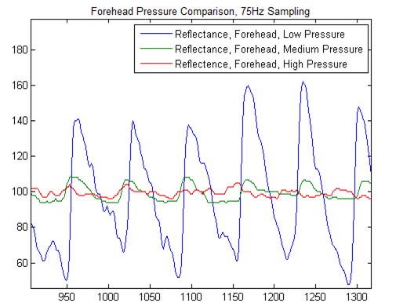

Figure 4.8: Pressure comparison measurements from the forehead

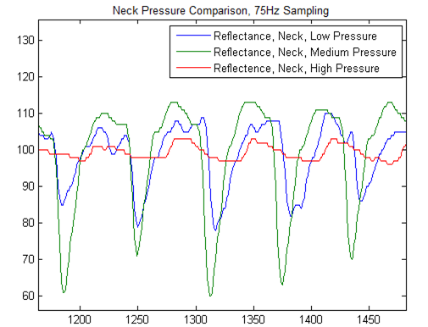

Figure 4.9: Pressure comparison measurements from the neck.

## 4.3 Wearable Perfusion Imager

### 4.3.1 Overview of Imaging Platform

To conduct preliminary analysis of a PPG imaging modality, a tracking system was devised for use with the POM PPG sensor. A laser mouse was been modified to hold the PPG sensor, and functionality was added to our imaging software to record movement the mouse registers via USB and display it to the user. The current display shows the user the absolute x and y axis movement that they have performed with the mouse, and saves a log of perfusion data matched to these coordinates. The system displays a three dimensional plot of perfusion data once scanning is completed. Due to the use of the laser mouse, rather than infrared, the mouse sensor tracks well on tissue. The results and set up are shown below.

The pressure sensor has been fixed to the mouse platform, along with the PPG sensor, in a housing in the center. The pressure sensor has a hard backing, made from cut PCB, which is mounted under the laser mouse’s PCB. The pressure sensor occupies the area that a PCB detecting mouse-wheel clicks previously occupied (this small PCB was removed). The laser tracking of the mouse was unaffected by this change. This positioning places the pressure sensor directly above, and in contact with, the PPG sensor, allowing it to detect the pressure applied directly to PPG sensor. This placement has proved significantly more effective than previous placements, and allows accurate, simultaneous measurements from all sensors.

As the system is currently rather bulky, it was easiest to take measurements from the arm, chest, stomach, and back, as these offered large continuous tissue surface area. There is generally not enough room to apply all three sensors (laser mouse, pressure, and oximeter) to regions such as the fingers and wrist. The system had difficulty maintaining an oximetry reading from the arm and other extremities. It did, however, perform well on the stomach area and extremely well on the chest area.

Note that the pressure readings are shown as a percentage value, representing the pressure applied versus the maximum that the sensor can read. A one pound pressure sensor was used in all measurements. While the chest and stomach appear sensitive to pressure, the upper and lower back were surprisingly unaffected by changes in pressure (as seen in the figures below). The interpolation shown below is performed by the GUI after data collection has been stopped, so that it does not degrade performance during live operation.

### 4.3.2 Image Overlay and Interpolation System

In order to provide a more informative map of perfusion in a local region, interpolation of blood oximeter data is conducted using sensor tracking data. Interpolation is accomplished via a kriging algorithm, and data points are mapped using a sensor on the oximeter that tracks its movement over the test area. This allows an accurate, anisotropic interpolation of the raw data, which makes the end result much easier to visualize. An example interpolation is shown below. Movement of the sensor was mostly one dimensional in this example, resulting in a linear trend across the x axis. This is due to the low variance of points in that direction (note the total displacement of approximately 40 in the X direction compared to 1400 in the Y). Figure 4.10 below shows results from interpolation of blood oximeter and mouse tracking data. Interpolation was accomplished via a kriging algorithm. Movement of the sensor was mostly one dimensional, resulting in a linear trend across the x axis. This is due to the low variance of points in that direction.

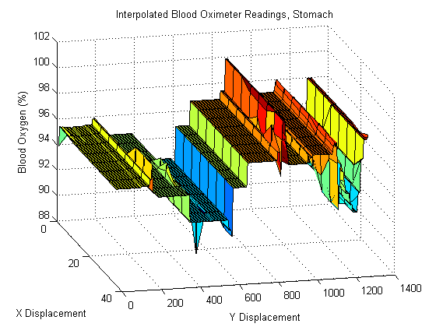

Figure 4.10: Example interpolation using sensor tracking data.

To aid in visualizing the collected blood oximetry data, we have developed software that can detect markers on a picture, and then properly align and overlay blood oximetry data. We use this system with pictures taken of the scan site, to superimpose the data directly over where it was taken from, and allow fast and accurate reading of data.

The markers used for delimiting points can be any color, but green is ideal, as it is easily distinguished from all skin tones (the same reason green screens are used in television). For a clear illustration of the software, a small plastic green box was used to mark a point, and the image was quickly edited in Photoshop to place three of them in a likely pattern. Aside from this manipulation, all other images were generated on the fly by our software. A grid was used as sample data, to more clearly illustrate what is being done by the tool. The currently assumed marker rules are shown in Figure 4.11 below. Markers 1 and 2 are used to determine the left boundary and rotation angle for the image, and marker 3 is used to determine the width of the image. Figure 4.12 shows a sample overlay aligned with markers.



Figure 4.11: The marker pattern assumed for this test.

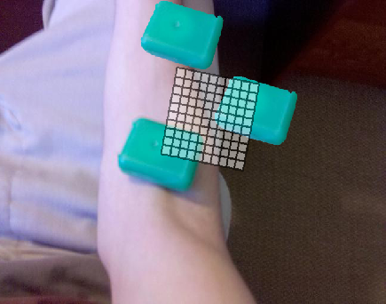

Figure 4.12: A sample overlay image

An Android application has been developed to facilitate easy capture and integration of pictures into the tool. The application allows a user to quickly take a picture with an Android Smartphone and have it automatically sent over Bluetooth and captured by the waiting client program. The picture is then integrated with the mapping system. All the user has to do is open the program, press the “Take a Picture” button, and use the Smartphone’s camera normally to take a picture. The rest is done automatically and quickly. This allows the overlay system to be easily used by someone not familiar with it.

A block diagram illustrating the steps to outputting a mapped and interpolated perfusion image is shown below in Figure 4.13. The block diagram shows a breakdown of each step in the data processing step, including extracting the location and perfusion data from each measurement point.

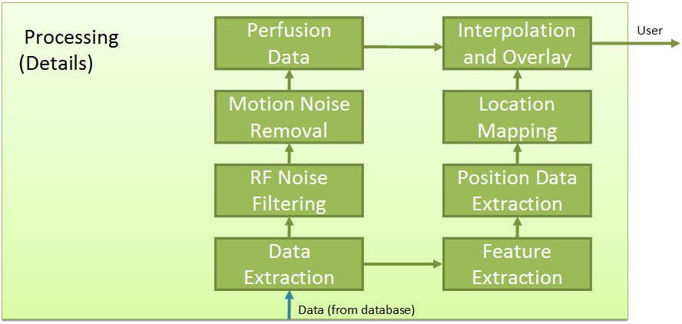

Figure 4.13: Block diagram describing the operation of the system

## 4.4 Thermally Induced Vasodilation Experiment

An experiment was performed to determine the effect of temperature induced perfusion changes on the POM PPG sensor’s readings. The control cases were performed with skin temperatures ranging from 84 to 88 degrees Fahrenheit, while the heated cases were performed with skin temperatures ranging from 103.4 to 95 degrees Fahrenheit.  The 5mm heated case was measured at higher temperature than the 10mm heated case, as the skin was beginning to become irritated after the first experiment, precluding reheating.  Temperature was rapidly cooling during measurements, but the 5mm case was taken at approximately 100F and the 10mm case was at approximately 95F.  
All results were taken from the exact same area on the volar forearm, marked with a pen to ensure distances and location remained constant. Orientation was also kept constant during the experiments.  Heating was accomplished by applying a plastic bag of heated water to the forearm for 10 minutes.  Temperatures were measured directly on the marked area using a laser thermometer. After removing the bag, skin temperature was 103.4 degrees Fahrenheit, and rapidly cooled to 95 degrees Fahrenheit.  During this cooling, the 5mm case was measured, followed by the 10mm case.

Results are detailed below, and show a clear increase in reflected LED intensity when the skin is heated, for both oxygenated and deoxygenated hemoglobin. This increase varied depending on sensor placement and wavelength, ranging from a 30% increase to an 80% increase. This increase makes sense, because according to literature over half of blood perfusion is for temperature regulation [19]. Figure 4.14 shows the perfusion levels resulting from the experiment.

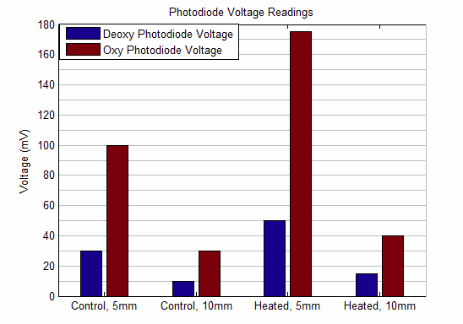

Figure 4.14: Perfusion data resulting from the thermal experiment.

# Chapter 6

# Conclusion

## 6.1 Conclusion

We first described the architecture and operation of the POM platform, in terms of sensor hardware, data acquisition hardware, control and user interface software, and data processing algorithms. An overview of the principles of PPG used in the POM platform was presented, with information on the sensor arrangement and what our chosen orientation provides. We discussed the rapidly reconfigurable nature of both the hardware and software, and how this lends the platform to analyzing the performance of a PPG platform in regard to perfusion monitoring. We also discussed the data processing algorithms, and how highly confounding motion artifacts are removed, while also attenuating higher frequency noise and preserving the high frequency elements of the PPG waveform necessary to measuring systolic and diastolic timing parameters.

An analysis of the application of PPG in measuring not only perfusion, but exercise resultant heart rate and blood pressure was provided. Extensive experimentation was carried out on multiple test subjects, and the large volume of data was analyzed for correlations with heart rate and blood pressure. Multiple metrics regarding features of the PPG waveform were used, including both diastolic and systolic sections of the recorded signal. Regressions showed interesting trends between systolic and diastolic portions of the waveform and heart rate, providing an enhanced understanding of the components of the waveform that PPG based systems provide. Blood pressure was shown to be uncorrelated with the majority of timing parameters, though heart rate was shown to be a key indicator during exercise recovery. After these results, additional trials were conducted showing the impact that hydrostatic pressure resulting from height changes relative to the heart can have. The results clarified link between direct PPG measurement and blood pressure, and provided a valuable insight to guide future work.

Finally, a series of experiments were conducted regarding the operation of PPG measurements at a wide variety of physical locations, pressure levels, and levels of thermal activity. To support this, a sensor prototype was constructed using the laser sensor from a standard computer laser mouse, and was used to track and record movement of the sensor during operation. This enabled measurements to be recorded from multiple locations, such as the wrist, neck, and calf (lower leg). These results showed that while PPG measurement is possible at all locations, the optimum level of pressure and sensor spacing depends on the location which is used. The pressure-dependent nature of PPG measurement was also explored, showing that pressure levels must kept constant in order for accurate measurements to be taken. Thermal experiments were conducted showing that the perfusion measurement methods used provide an accurate measure of perfusion levels, and verified an increase of perfusion due to the vasodilation effect that results from heating stimuli. This verification will be exploited to provide a stable and repeatable way to perform perfusion analysis trials in the future.

## 6.2 Future Work

We conclude this thesis with a discussion of potential future developments. While this thesis presents a valuable rapidly reconfigurable platform for analyzing PPG data, the system could be downsized and made mobile if configurations were finalized to optimize for perfusion measurement in a specific location using the results demonstrated so far regarding pressure and location dependence of PPG measurement. This would remove the experimentation ability of the platform in exchange for improving viability of clinical deployment.

Additionally, the results of the blood pressure data show valuable information regarding PPG waveforms, but also highlight the possibility of direct and immediate measurement of blood pressure using multiple sensors. By deploying multiple sensors at known height differences from the heart, blood pressure could be determined using the metrics analyzed in that section. Such sensors could also be used to provide perfusion data based on the information gathered regarding thermoregulatory response.

Lastly, wide scale clinical trials using the platform developed could provide valuable information regarding perfusion data if the thermoregulatory experiment were to be expanded. This would provide a much clearer demonstration of the perfusion measurement capabilities of the platform, and more comprehensive results.

# Appendix I

# POM Data Processing Matlab Code

inputfile='gen3\gen3r10';

samplingRate = 10e3; % Sampling Rate in Hz

period = 5e-3; % Period in s

duty = 2.5e-3; % Duty Cycle in s

totalTime = 10; % Total File Time in s

offsetR = 2.5e-3; % Red light offset in s

offsetIR = 0e-3; % Red light offset in s

transTime = 1.2e-4; % Rise/Fall time in s

%% Heuristics for Peak Detection & Blood Oximetry

RED_sens = 0.42; % Photodiode sensitivity @ 660nm in A/W

IR_sens = 0.61; % Photodiode sensitivity @ 880nm in A/W

MAX_HEART_RATE = 220;

MIN_SAMP = 1/((period*5)*MAX_HEART_RATE/60); % Fastest heartrate allowed

%% Read Input File into Matlab

sensorselect=3;

if sensorselect==1 %5mm

[PD1, PD2, PD3, PD4]=textread(inputfile, '%f%f%f%f%*[^\n]', 'delimiter',','); % PD1 -> central photodiode (Channel 0); PD2 -> Drive signal (Channel 1)

elseif sensorselect==2 %10mm

[PD2, PD1, PD3, PD4]=textread(inputfile, '%f%f%f%f%*[^\n]', 'delimiter',','); % PD1 -> central photodiode (Channel 0); PD2 -> Drive signal (Channel 1)

elseif sensorselect==3

[PD2, PD3, PD1, PD4]=textread(inputfile, '%f%f%f%f%*[^\n]', 'delimiter',','); % PD1 -> central photodiode (Channel 0); PD2 -> Drive signal (Channel 1)

elseif sensorselect==4

[PD2, PD3, PD4, PD1]=textread(inputfile, '%f%f%f%f%*[^\n]', 'delimiter',','); % PD1 -> central photodiode (Channel 0); PD2 -> Drive signal (Channel 1)

end

PD1=-PD1;

% if trial==3

% PD1 = PD1(length(PD1)/2+1:end);

% end

% Data=DownloadFromDB();

% PD1 = Data(1:end,1);

% PD2 = Data(1:end,2);

No_RIR_Waves = totalTime/period; % Total # of RED+IR square waves

%% Noise Cancellation

% %--------------------------------------%

% % 1. single-sided subtraction

% %--------------------------------------%

averageRed = zeros(No_RIR_Waves, 1);

averageRedStep1 = zeros(No_RIR_Waves, 1);

averageRedStep2 = zeros(No_RIR_Waves, 1);

averageIR = zeros(No_RIR_Waves, 1);

averageNoise_1 = zeros(No_RIR_Waves, 1); % 1st off portion in each period

averageNoise_2 = zeros(No_RIR_Waves, 1); % 2nd off portion

for i=0:No_RIR_Waves-1

for j=1:(duty-transTime)*samplingRate % Average every period

averageRed(i+1, 1) = averageRed(i+1, 1) + PD1(ceil(i*period*samplingRate+j+offsetR*samplingRate+transTime*samplingRate));

%averageIR(i+1, 1) = averageIR(i+1, 1) + PD1(floor(i*period*samplingRate+j+offsetIR*samplingRate+transTime*samplingRate));

end

% for j=1:(duty/2)*samplingRate % Average every period, no transition time because LED is already on, changes are very short

% averageRedStep1(i+1, 1) = averageRed(i+1, 1) + PD1(ceil(i*period*samplingRate+j+offsetR*samplingRate+transTime*samplingRate));

% averageRedStep2(i+1, 1) = averageRed(i+1, 1) + PD1(ceil(i*period*samplingRate+j+offsetR*samplingRate+transTime*samplingRate+floor((duty/2)*samplingRate)));

% %averageIR(i+1, 1) = averageIR(i+1, 1) + PD1(floor(i*period*samplingRate+j+offsetIR*samplingRate+transTime*samplingRate));

% end

for j=1:(period-duty-transTime)*samplingRate %Averaging the off portion for noise subtraction

% averageNoise_1(i+1, 1) = averageNoise_1(i+1, 1) + PD1(floor(i*period*samplingRate+j+transTime*samplingRate));

averageNoise_1(i+1, 1) = averageNoise_1(i+1, 1) + PD1(max(2,floor(i*period*samplingRate+j+transTime*samplingRate-(period-duty-offsetR-transTime)*samplingRate)));

%averageNoise_2(i+1, 1) = averageNoise_2(i+1, 1) + PD1(floor(i*period*samplingRate+j+(offsetR+duty)*samplingRate));

end

averageRed(i+1, 1) = averageRed(i+1, 1)/floor((duty-transTime)*samplingRate);

%averageIR(i+1, 1) = averageIR(i+1, 1)/((duty-transTime)*samplingRate);

% averageRedStep1(i+1, 1) = averageRedStep1(i+1, 1)/floor((duty/2)*samplingRate);

% averageRedStep2(i+1, 1) = averageRedStep2(i+1, 1)/floor((duty/2)*samplingRate);

averageNoise_1(i+1, 1) = averageNoise_1(i+1, 1)/floor((period-duty-transTime)*samplingRate); % Use period/2 when using both red and IR

%averageNoise_2(i+1, 1) = averageNoise_2(i+1, 1)/((period/2-duty-transTime)*samplingRate);

end

averageRed_1 =averageRed-averageNoise_1;

averageRed_step = averageRedStep2-averageRedStep1;

%averageIR_1 = averageIR - averageNoise_2;

averageRed_4 = zeros(No_RIR_Waves/5, 1);

averageIR_4 = zeros(No_RIR_Waves/5, 1);

for i=1:(No_RIR_Waves/5)

for j=1:5

averageRed_4(i) = averageRed_4(i)+averageRed_1((i-1)*5+j);

% averageIR_4(i) = averageIR_4(i)+averageIR_1((i-1)*5+j);

end

averageRed_4(i) = averageRed_4(i)/5;

% averageIR_4(i) = averageIR_4(i)/5;

end

% %--------------------------------------%

% %2. double-sided subtraction

% %--------------------------------------%

averageNoise_Red = (averageNoise_1 + averageNoise_2) ./ 2; % Average the off portion on two sides of one on portion

averageNoise_IR = (averageNoise_1(2:end) + averageNoise_2(1:end-1)) ./2;

averageIR_2 = zeros(No_RIR_Waves, 1);

averageRed_2 = averageRed - averageNoise_Red;

averageIR_2(1:end-1) = averageIR(1:end-1) - averageNoise_IR;

averageIR_2(end) = averageIR(end) - averageNoise_2(end); % Last period of IR uses single-sided subtraction

% %--------------------------------------%

% 3. interpolation subtraction

% %--------------------------------------%

% Noise_raw = zeros(totalTime * samplingRate, 1); % Store the low-pass-filtered off portion continously

% x_Noise = zeros(floor(offsetR*samplingRate-transTime*samplingRate)+floor(offsetIR*samplingRate-(offsetR*samplingRate + (duty+transTime)*samplingRate))*No_RIR_Waves,1); % coordinates of Noise_raw

% x_Noise_x = 0;

% Noise_raw_0 = zeros(totalTime * samplingRate, 1);

%

% for i=0:No_RIR_Waves-1

% for j=1:period*samplingRate

% if (((j<=offsetR*samplingRate)&&(j>transTime*samplingRate)) || ((j> (offsetR*samplingRate + (duty+transTime)*samplingRate)) && (j <= offsetIR*samplingRate))) % load off portion to Noise_raw

% Noise_raw_0(floor(i*period*samplingRate+j)) = PD1(floor(i*period*samplingRate+j));

% end

% end

% end

%

% order = 50; % Pre-low pass filter for spline interpolation

% cutoff = 200/samplingRate; % Cut off frequency = 100 Hz

% y1 = fir1(order, cutoff,'low');

% PD1_LPF = filtfilt(y1,1,Noise_raw_0);

%

% for i=0:No_RIR_Waves-1

% for j=1:period*samplingRate

% if (((j<=offsetR*samplingRate)&&(j>transTime*samplingRate)) || ((j> (offsetR*samplingRate + (duty+transTime)*samplingRate)) && (j <= offsetIR*samplingRate))) % load off portion to Noise_raw

% x_Noise_x = x_Noise_x + 1;

% Noise_raw(x_Noise_x) = PD1_LPF(floor(i*period*samplingRate+j));

% x_Noise(x_Noise_x) = floor(i*period*samplingRate+j);

% end

% end

% end

%

%

% Noise = interp1(x_Noise,Noise_raw(1:x_Noise_x),1:samplingRate*totalTime,'spline'); % Noise interpolation

% PD_N = PD1 - Noise';

%

%

% averageRed_3_1 = zeros(No_RIR_Waves, 1);

% averageIR_3_1 = zeros(No_RIR_Waves, 1);

% for i=0:No_RIR_Waves-1 % Average data in each square wave period

% for j=1:floor((duty-transTime)*samplingRate)

% averageRed_3_1(i+1, 1) = averageRed_3_1(i+1, 1) + PD_N(floor(i*period*samplingRate+j+offsetR*samplingRate+transTime*samplingRate));

% averageIR_3_1(i+1, 1) = averageIR_3_1(i+1, 1) + PD_N(floor(i*period*samplingRate+j+offsetIR*samplingRate+transTime*samplingRate));

% end

% averageRed_3_1(i+1, 1) = averageRed_3_1(i+1, 1)/(floor((duty-transTime)*samplingRate));

% averageIR_3_1(i+1, 1) = averageIR_3_1(i+1, 1)/(floor((duty-transTime)*samplingRate));

% end

% averageIR_3_1(end) = averageIR_3_1(end-1); % Abandon the last one of IR_3 to eliminate error caused by interpolation

%% Create a Low-pass and Filter Waveforms

averageRed = averageRed_1; % _1,_2,_3,_4 correspond to single-sided subtraction, double-sided subtraction, interpolation subtraction & average of every 5 points

averageIR = zeros(length(averageRed_1),1);

order = 100;

cutoff = 10/(1/period);

y = fir1(order, cutoff,'low');

x = filtfilt(y, 1, averageRed);

z = filtfilt(y, 1, averageIR);

[dec,lib] = wavedec(averageRed,2,'db10');

a2 = wrcoef('a',dec,lib,'db10',2);

%Perfusion(ll+1) = mean(x);

%end

%% End of Loop

% % Pre-LPF for interpolation

% % order = 100;

% % cutoff1 = 40 /(1/period);

% % y1 = fir1(order, cutoff1,'low');

% % x1 = filtfilt(y1, 1, averageRed);

% % z1 = filtfilt(y1, 1, averageIR);

%

% % freqz(y) % view filter

% %

numavg = 100;

runavg = ones(1, numavg)/numavg;

x_avg = filtfilt(runavg, 1, averageRed);

z_avg = filtfilt(runavg, 1, averageIR);

% x = x - x_avg;

% z = z - z_avg;

time = (1:No_RIR_Waves)/(No_RIR_Waves)*totalTime;

%--------------------------------------%

% Red LED

%--------------------------------------%

figure;

subplot(2, 1, 1)

hold on;

plot(time, averageRed*1E3, '-k', 'linewidth', 2);

plot(time, x*1E3, '-r', 'linewidth', 2);

plot(time, x_avg*1E3, '-b', 'linewidth', 2);

hold off;

ylabel('Recived Signal [mV]', 'fontsize', 14, 'fontweight', 'bold')

xlabel('Time [s]', 'fontsize', 14, 'fontweight', 'bold')

set(gca,'linewidth', 2, 'fontsize', 10, 'fontweight', 'bold')

legend('Red LED', 'Red LED (LPF)', 'Running Average', 'Orientation','horizontal')

title('Red LED', 'fontsize', 14, 'fontweight', 'bold')

box on;

heart_beat_RED = x-x_avg;

wavelet_RED = a2-smooth(a2,200);

%heart_beat_RED = wavelet_RED;

% % Detect Heat Beat Peaks FAIL 202C VERSION

% temp = sign(diff(heart_beat_RED));

% % temp = sign(diff(x(order+numavg/2:end-numavg/2-1)));

% temp2 = (temp(1:end-1)-temp(2:end))./2;

% loc = find(temp2 ~= 0);

% loc = [loc(1); loc(find(diff(loc) > MIN_SAMP/2)+1)];

% peaks1 = loc(find(temp2(loc) > 0))+1;

% peaks1 = peaks1(find(heart_beat_RED(peaks1) > 0));

% valleys1 = loc(find(temp2(loc) < 0))+1;

% valleys1 = valleys1(find(heart_beat_RED(valleys1) < 0));

%peak detection that actually works:

peaks=[];

widthp=50;

for j = 1:totalTime/period

if heart_beat_RED(j)==max(heart_beat_RED(max(1,j-widthp):min(totalTime/period,j+widthp)))

peaks(end+1)=j;

end

end

valleys=[];

widthv=50;

for j = 1:totalTime/period

if heart_beat_RED(j)==min(heart_beat_RED(max(1,j-widthv):min(totalTime/period,j+widthv)))

valleys(end+1)=j;

end

end

diffzs=[];

widthd=25;

diff_hb = diff(heart_beat_RED);

for j = 1:totalTime/period-1

if abs(diff_hb(j))==min(abs(diff_hb(max(1,j-widthd):min(totalTime/period-1,j+widthd))))

diffzs(end+1)=j;

end

end

killthese=[];

for j=1:numel(diffzs)

for k=1:numel(peaks)

if abs(diffzs(j)-peaks(k))<25

killthese(end+1)=j;

end

for k=1:numel(valleys)

if abs(diffzs(j)-valleys(k))<25

killthese(end+1)=j;

end

end

end

peakspacing(j) = min(abs(diffzs(j)-peaks));

valleyspacing(j) = min(abs(diffzs(j)-valleys));

end

diffzs(killthese)=[];

peakspacing(killthese)=[];

%clean up peaks/valleys to make them match 1:1

delp=[];

for i = 1:length(peaks)-1

valid=0;

for j = 1:length(valleys)

if peaks(i+1)>valleys(j) && peaks(i)<valleys(j)

valid=1;

break

end

end

if valid==0 && heart_beat_RED(peaks(i+1))<heart_beat_RED(peaks(i))

delp(end+1)=i+1;

elseif valid==0

delp(end+1)=i;

end

end

peaks(delp)=[];

delv=[];

for i = 1:length(valleys)-1

valid=0;

for j = 1:length(peaks)

if valleys(i+1)>peaks(j) && valleys(i)<peaks(j)

valid=1;

break

end

end

if valid==0 && heart_beat_RED(valleys(i+1))>heart_beat_RED(valleys(i))

delv(end+1)=i+1;

elseif valid==0

delv(end+1)=i;

end

end

valleys(delv)=[];

%finish of cleanup

mdiffzs = median(heart_beat_RED(diffzs));

mpeaks = median(heart_beat_RED(peaks));

mvalleys = median(heart_beat_RED(valleys));

secondpeak = (mdiffzs-mvalleys)/(mpeaks-mvalleys);

peakspacing = median(peakspacing);

valleyspacing = median(valleyspacing);

subplot(2, 1, 2)

hold on;

plot(time, heart_beat_RED*1E3, '-k', 'linewidth', 2);

% ylim([-1.5 1.5])

plot(time(peaks), heart_beat_RED(peaks)*1E3, 'or', 'linewidth', 2, 'markersize', 12);

plot(time(valleys), heart_beat_RED(valleys)*1E3, 'ob', 'linewidth', 2, 'markersize', 12);

plot(time(diffzs), heart_beat_RED(diffzs)*1E3, 'og', 'linewidth', 2, 'markersize', 12);

hold off;

ylabel('Heart Beat [mV]', 'fontsize', 14, 'fontweight', 'bold')

xlabel('Time [s]', 'fontsize', 14, 'fontweight', 'bold')

set(gca,'linewidth', 2, 'fontsize', 10, 'fontweight', 'bold')

box on;

Heart_Rate_RED = length(peaks)/(time(end)-time(1))*60;

# References

1. Lo T., Sample R., Moore P., and Gold P., "Prediction of Wound Healing Outcome Using Skin Perfusion Pressure & Transcutaneous Oximetry," *Wounds* 21 (2009), 310-316.
2. Abbade, L.P., and Lastória, S. 2005. Venous ulcer: epidemiology, physiopathology, diagnosis and treatment. *International Journal of Dermatology* 44 (Jun. 2005), 449–456.
3. Callam, M.J., Ruckley, C.V., Harper, D.R., Dale, J.J. 1985. Chronic ulceration of the leg: extent of the problem and provision of care. *Br. Med. J*. 290 (Jun. 1985), 1855-1856.
4. Olin, J., Beusterien, K., Childs, M., Seavey, C., McHugh, L., Griffiths, R. 1999. Medical costs of treating venous stasis ulcers: evidence from a retrospective cohort study. *J. Vasc. Med.* 4 (Feb. 1999), 1-7.
5. D. Bergqvist, C. Lindholm, and O. Nelzén. 1999. Chronic leg ulcers: the impact of venous disease. *J. Vasc. Surg.* 29 (April 1999), 752–755.
6. Evans, C.J., Fowkers F. G., Rukley, C.V., and Lee, A. J. 1999. Prevalence of varicose veins and chronic venous insufficiency in men and women in the general population. *J. Epidemiol Community Health* 53 (Mar. 1999), 149–153.
7. TenBrook, J., et al. 2004. Systematic review of outcomes after surgical management of venous disease incorporating subfascial endoscopic perforator surgery. *J. Vasc. Surg. 39* (Mar. 2004), 583-589.
8. Wardell K., Jakobsson A., and Nilsson G.E., “Laser Doppler perfusion imaging by dynamic light scattering,” *IEEE Transactions on Biomedical Engineering* 40 (1993), 309-316.
9. Humeau A., Steenbergen W., Nilsson H., and Str[ö](http://www.springerlink.com/content/?Author=Tomas+Str%c3%b6mberg)mberg T., “Laser Doppler perfusion monitoring and imaging: novel approaches,” *Medical and Biological Engineering and Computing* 45 (2007), 421-435.
10. Zhu D., Lu W., Weng Y., Cui H., and Luo Q., “Monitoring thermal-induced changes in tumor blood flow and microvessels with laser speckle contrast imaging,” *Appl Opt.* 46 (Apr. 2007), 1911-1917.
11. Hegarty, M.S., Grant, E., and L. Reid, L. 2010. An overview of technologies related to care for venous ulcers. *IEEE Transactions on Information Technology in Biomedicine* 14 (Mar. 2010), 387-393.
12. Criqui M.H., et al. 2003. Chronic venous disease in an ethnically diverse population: the San Diego Population Study. *Am. J. Epidemiol* 158 (Sept. 2003), 448-56.
13. Kuebler W., "How NIR is the future in blood flow monitoring," *J. Appl. Physiol*. 104 (Jan. 2008), 905-906.
14. Volianitis S., Krustrup P., Dawson E., and Secher N.H., "Arm blood flow and oxygenation on the transition from arm to combined arm and leg exercise in humans" *J. Physiol*. 547 (2003), 641-648.
15. Nioka S., Kime R., Sunar U., Im J., Izzetoglu M., Zhang J., Alacam B., Chance B., "A novel method to measure regional muscle blood flow continuously using NIRS kinetics information," *Dynamic Medicine* 5 (May 2006)
16. Mannheimer P., Cascini J., Fein M., Nierlich S., "Wavelength selection for low-saturation pulse oximetry," *IEEE Transactions on Biomedical Engineering* 44 (1997), 148-158.
17. Sandberg M., Zhang Q., Styf J., Gerdle B., Lindberg L.G., “Non-invasive monitoring of muscle blood perfusion by photoplethysmography: evaluation of a new application,” *Acta Physiologica Scandinavica* 183(2005), 335-343, 2005.
18. Allen J., “Photoplethysmography and its application in clinical physiological measurement,” *Physiol. Meas.* 28 (2007), 1-39.
19. Minson, C., Berry, L., Joyner, M. 2001. Nitric oxide and neurally mediated regulation of skin blood flow during local heating. *J. Appl. Physiol*. 91 (Mar. 2001), 1619-1626.
20. M. Wukitsch, M. Petterson, D. Tobler, J. Pologe, "Pulse oximetry: Analysis of theory, technology, and practice," *Journal of Clinical Monitoring and Computing*, vol. 4, pp. 290-301, 1987.
21. N. Charkoudian, "Skin blood flow in adult human thermoregulation: how it works, when it does not, and why," *Mayo Clin Proc*, vol. 78, no. 5, pp.603-612, 2003.
22. Kim, B.S.; Yoo, S.K.; , "Motion artifact reduction in photoplethysmography using independent component analysis," Biomedical Engineering, IEEE Transactions on , vol.53, no.3, pp.566-568, March 2006.
23. Reddy, K.A.; Kumar, V.J., "Motion Artifact Reduction in Photoplethysmographic Signals using Singular Value Decomposition," Instrumentation and Measurement Technology Conference Proceedings, 2007. IMTC 2007. IEEE , pp.1-4, 1-3 May 2007.
24. Larsen P.D., Thirchelvarn M., and Galletly D., "Spectral analysis of AC and DC components of the pulse photoplethysmography at rest and during induction of anesthesia," *International Journal of Clinical Monitoring and Computing* 14 (1997), 89-95.
25. Raghuram, M., Madhav, K.V., Krishna, E.H., Reddy, K.A., "On the Performance of Wavelets in Reducing Motion Artifacts from Photoplethysmographic Signals," Bioinformatics and Biomedical Engineering (iCBBE), 4th International Conference on, 1-4, June 2010
26. D. Cvetkovic, E.D. Übeyli, I. Cosic, "Wavelet transform feature extraction from human PPG, ECG, and EEG signal responses to ELF PEMF exposures: A pilot study," *Digital Signal Processing* 18 (2008), 861-874.
27. Jubran A., "Pulse Oximetry," *Crit. Care* 3 (May 1999), 11-17.
28. Ferrari, M., Mottola, L., Quaresima, V. 2004. Principles, Techniques, and Limitations of Near Infrared Spectroscopy. *Can. J. Appl. Physiol.* 29 (Aug, 2004), 463-487.
29. Kurl S., Laukkanen J.A., Rauramaa R., Sivenius J., Salonen J.T., “Systolic Blood Pressure Response to Exercise Stress Test and Risk of Stroke,” *Stroke* 32 (Sep. 2001), 2036-41.
30. Poon C.C.Y., Zhang Y.T., "Cuff-less and Noninvasive Measurements of Arterial Blood Pressure by Pulse Transit Time," Engineering in Medicine and Biology Society, 27th Annual International Conference of, 5877-5880, January 2006.
31. Shaltis P., Reisner A., and Asada H., "Cufﬂess Blood Pressure Monitoring Using Hydrostatic Pressure Changes," *IEEE Transactions on Biomedical Engineering* 55 (Jun. 2008), 1775-1777.
32. Reisner A., Asada H., "Adaptive blood pressure estimation from wearable PPG sensors using peripheral artery pulse wave velocity measurements and multi-channel blind identification of local arterial dynamics," Engineering in Medicine and Biology Society, 28th Annual Interational Conference, 3521-3524, August 2006.