Australia HBV Model Summary Results

Richard T. Gray

Latest version - July 22 2016

This document presents the summary results for the baseline scenario in the Australian HBV model.

## Summary Figures

### Total population size

**Figure 1** - Total population size over time.

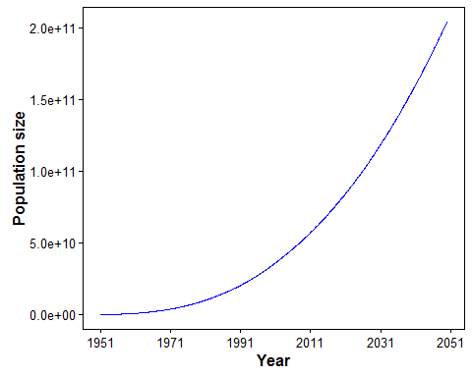

**Figure 2** - Population size by age group over time.

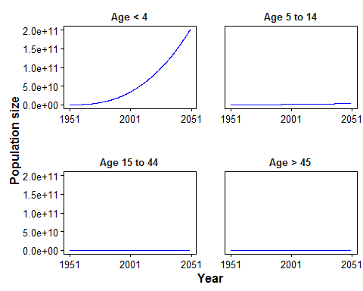

### New infections and incidence

**Figure 3** - New infections by age group.

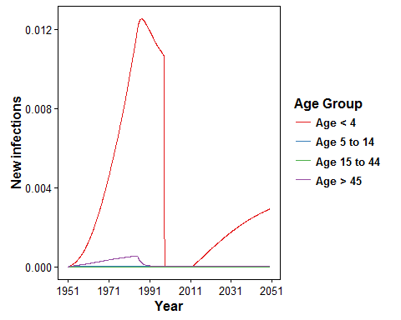

**Figure 4** - Incidence per 100,000 people by age group.

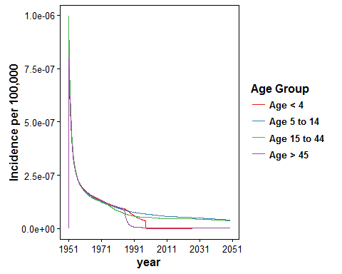

### Prevalence

**Figure 5** - Number of people in each stage of infection by age_group.

