# Comprehensive Report on SSD and YOLO Experiments

## 1. Introduction

This project and report has been created by collaboration of Mustafa Kağan CİVELEK, Mücahid Enes DENİZ and Musa Eren YAKUT.

Object detection is a crucial task in computer vision, with applications in areas such as surveillance, healthcare, and autonomous systems. This report presents the methodology, implementation, and evaluation of two popular object detection models, SSD (Single Shot MultiBox Detector) and YOLO (You Only Look Once), applied to mask classification.

## 2. Methodology

The experiments were conducted using the following methodologies:

### 2.1 Dataset

* Source: The dataset was sourced from Kaggle’s "Face Mask Detection" dataset. It includes labeled images with bounding box annotations for the three object classes.
* Exploration: The dataset structure was analyzed, and XML annotations were parsed to extract bounding box coordinates, image dimensions, and class labels.
* Preprocessing steps included resizing images and normalizing pixel values.

### 2.2 Model Descriptions

SSD is a single-shot detector that uses default boxes for object detection, while YOLO is a region-based model that predicts bounding boxes and class probabilities directly. Both models were configured with specific hyperparameters such as learning rate, batch size, and optimizer.

## 3. Implementation

The implementation was carried out using the following tools and frameworks:

- TensorFlow for SSD model.

- PyTorch and YOLOv8 for YOLO model.

The training setup included a GPU-enabled environment with batch size and learning rate adjustments for optimal convergence.

## 4. Results and Evaluation

### 4.1 SSD Results

The training and validation loss graph for the SSD model shows a steady decrease, indicating effective learning. The minimal gap between training and validation losses suggests low overfitting.

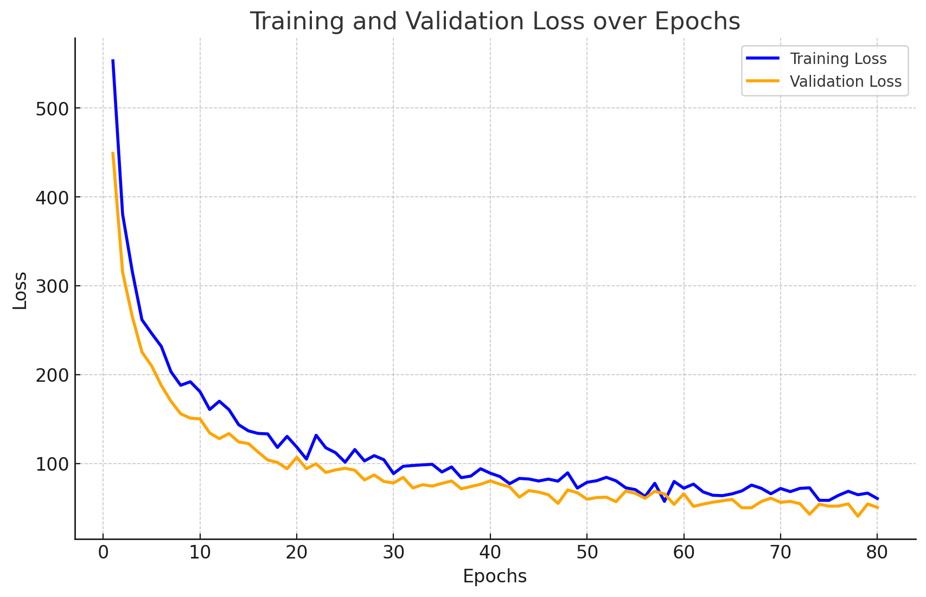

### 4.2 YOLO Results

The following results were observed for the YOLO model:

- The training and validation loss decreased consistently for box, classification, and DFL losses.

- Precision, recall, and mAP metrics improved steadily over epochs.

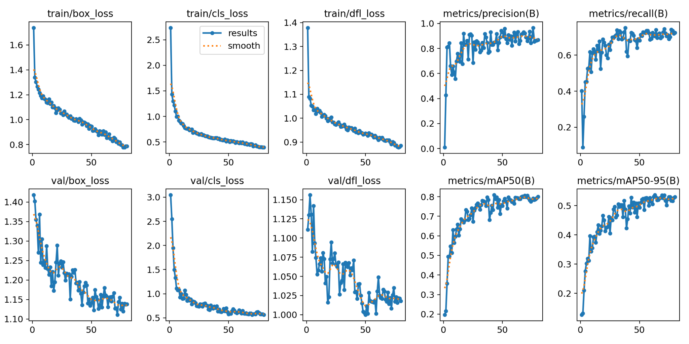

### 4.3 Confusion Matrix

The confusion matrix reveals that the 'with_mask' class has a high true positive rate, while other classes, such as 'mask_worn_incorrect' and 'without_mask', show moderate misclassifications. The 'background' class has some false positives.

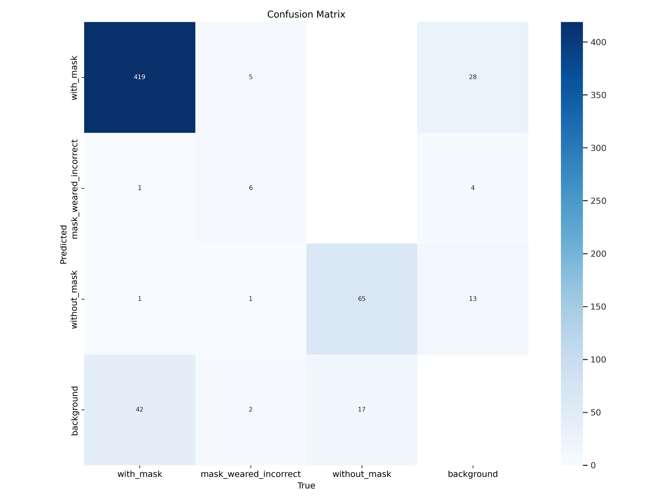

## 5. Discussion

The YOLO model outperformed the SSD model in terms of precision and recall metrics, but the SSD model was simpler to train. Challenges included imbalanced data distribution and overlapping features between classes.

Future improvements include hyperparameter tuning, advanced data augmentation techniques, and using more robust evaluation metrics.

## 6. Conclusion

This report analyzed the performance of SSD and YOLO models for mask classification. Both models showed promising results, with YOLO achieving higher precision and recall. Future work will focus on addressing challenges to enhance model performance.