

*Entebbe - Southern Queen Elizabeth National Park - Bwindi Impenetrable Forest National Park*  
*9 Days / 8 Nights*  
*2 Persons*

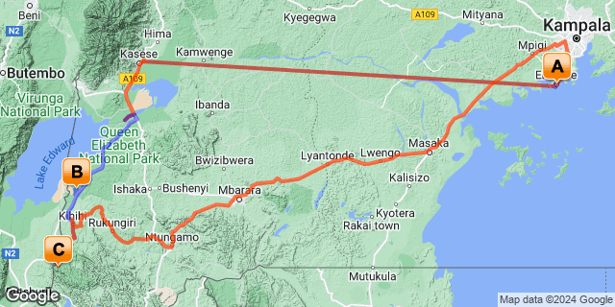

## Introduction

**This 9-day/8-night fly-in safari, is fabulous – specifically designed for those who want to see the rare and endangered Mountain Gorillas and are keen to see some game too.**

**This safari includes flights over the beautiful highlands of Uganda boasting incredible scenery to Kasese airstrip and then transfer to Mweya region for a boat trip on the Kazinga Channel and continues to Ishasha the southern sector of Queen Elizabeth National Park, where you will enjoy abundant game viewing, an area known for tree-climbing lions!  After 3nights here you will drive for approx. 2.5hrs through local villages to Bwindi Impenetrable Forest, from where you will be able to enjoy a thrilling visit with the Mountain Gorillas!  Thereafter drive to Kihihi airstrip and fly to Entebbe for the chimp integration program before your departure.**

**Uganda boasts some of the best bird watching in Africa, with over 1000 different species, including the rare shoebill and the remarkable grey-crowned crane.  Luxury accommodation, professional guides and custom-made safari vehicles – this safari will be the trip of a lifetime.**

|  |  |  |  |
| --- | --- | --- | --- |
| **Accommodation** | **Destination** | **Basis** | **Duration** |
| The Boma Hotel Entebbe | Entebbe | B&B | **1 Night** |
| [Ishasha Wilderness Camp](https://wetu.com/iBrochure/16456_61732_35622) | Southern Queen Elizabeth National Park | FB | **3 Nights** |
| [Mahogany Springs Lodge](https://wetu.com/iBrochure/16456_61732_22381) | Bwindi Impenetrable Forest National Park | FB | **3 Nights** |
| The Boma Hotel Entebbe | Entebbe | B&B | **1 Night** |

**Key**  
B&B: Bed and Breakfast  
FB: Full Board - Dinner, Bed, Breakfast and Lunch

## Price

* Please see separate quote for costing.

## Included

* Private vehicle throughout in a customised 4x4 vehicles with the services of experienced English speaking driver/guide
* All park entrance fees
* Accommodation and Full Board Meals
* House drinks at Mahogany Springs Lodge and Ishasha Wilderness Camp
* Drinking water in the vehicles
* 24 hour emergency contact

## Excluded

* Scheduled Single domestic flight between Entebbe / Kasese/ Kihihi Airstrip – USD310 Each way
* Gorilla permit - needs to be pre-booked
* Premium Drinks at Buhoma Lodge & Ishasha Wilderness Camp
* Optional Activities
* Personal expenses such as porters, drinks, tips, visas, and travel insurance

## Day 1: The Boma Hotel Entebbe, Entebbe (Sun, 1 September)

### Entebbe

Set on the shores of Lake Victoria, Entebbe is a small town that is easy to explore on foot or local boda bodas (motorbike taxis).  Explore the markets, hunt for souvenirs or crafts, meander through the Botanical Gardens or relax with a boat cruise on Lake Victoria. You’ll find a wide variety of restaurants, bars and clubs where you can sample the local beer, catch a game of football and meet the friendly locals.

### Day Itinerary

Arrive at Entebbe International Airport where you will be met by a UUJ representative and transferred to your accommodation.

Entebbe is a small, quiet town located on the shores of Lake Victoria and is easy to explore on foot or local transport on motorbikes known as “boda bodas” or local taxis.  Visit the Uganda Wildlife Education Centre where you can see and learn about Uganda’s native wildlife, local markets to buy clothes and crafts, curio shops for souvenirs, and the Botanical Gardens on Lake Victoria where you can walk among beautiful trees, watch monkeys moving through the canopy above, and spot many indigenous bird species.  Entebbe has a wide variety of restaurants serving many different cuisines as well as several bars and clubs where you can sample the local beer, catch a game of football and chat with the local Ugandans, known for their open and friendly nature.

### Overnight: The Boma Hotel Entebbe

The Boma Hotel is Entebbe’s original and most exclusive hotel, set in tropical gardens in a leafy suburb, a few minutes drive from Entebbe International Airport. Our rooms combine the modern comforts one expects today with the charm and character of the original 1940’s home. The Boma is an ideal stopover for all travellers and airline passengers, and we will arrange all your airport transfers. Our staff and management team ensure guests receive a personable service and enjoy hospitality standards which are in keeping with the tradition of this charming lakeshore town.

The residents-only bar and dining area overlooks the pool area and provides a delightful and relaxed country house experience. The main house includes a private dining veranda and living room for overnight guests. Other hotel facilities include the swimming pool, Gym, Free WiFi, 24-hour security and car parking. We offer a laundry service for overnight guests and there is a small craft shop on site. We can organise local taxi hire and day trips to the nearby attractions.

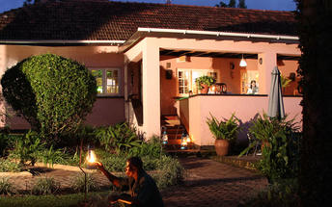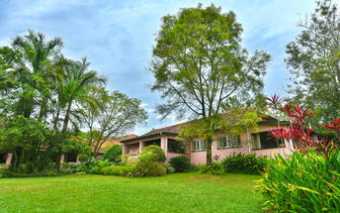

### Basis

Bed and Breakfast

### Included

Airport Transfer

### Excluded

* Drinks

## Day 2: Ishasha Wilderness Camp, Southern Queen Elizabeth National Park (Mon, 2 September)

### Southern Queen Elizabeth National Park

Surrounded by other wonderful parks in the western region of Uganda, the Queen Elizabeth National Park is known for its rich biodiversity, wildlife and history. In the southern part of the park, the remote Ishasha sector is home to tree-climbing lions who spend long lazy days dozing in the pretty fig trees. The Uganda Kob, which they watch from the branches, graze the plains, enjoy game watching - make sure to look out for elephants, topi, and perennial and migratory bird species.

### Day Itinerary

After an early breakfast, transfer back to Entebbe airport for your scheduled flight to Kasese airstrip. Meet with your guide and transfer for approx. 2hrs to Mweya sector - Queen Elizabeth National park.

The Mweya area of Queen Elizabeth National Park is rich with wildlife including warthog, water buck, bush buck, leopard, Ugandan kob, elephants, countless bird species and even the rare giant forest hog.  In the Mweya sector of the park, visitors will find vast numbers of Uganda’s unique and strange Euphorbia, or “candelabra” tree.  The many nearby crater lakes and Rwenzori mountain range provide a beautiful backdrop for your journey.

Enjoy a leisurely boat cruise along the spectacular Kazinga Channel in Queen Elizabeth National Park.  You may encounter herds of elephant, buffalos and antelopes, families of warthogs, large groups of hippos, and crocodiles basking on the shore. Kazinga’s shores are a haven for numerous birds, including many migratory species as they make their way south to warmer climates. The cruise also provides a remarkable view of the beautiful Mweya Peninsula and life in local fishing villages set along the banks.

After lunch continue to Ishasha the southern sector of Queen Elizabeth National Park, approx. 2-3 hours.  Afternoon game drives.

### Overnight: Ishasha Wilderness Camp

Ishasha Wilderness Camp is an idyllic retreat for people who truly enjoy the wilderness, coupled with superb accommodation and exceptional service.

The thatched central lounge and dining area provides a cosy and relaxed space for guests, although meals are often served ‘al fresco’ beside the river. In the evening, the outdoor fireplace beside the river is the perfect place for guests to relax over sundowners and share their day’s experiences.

Each of the ten spacious framed canvas rooms, privately nestled along the riverbank, is comfortably furnished and feature en-suite bathrooms. Wake to the delicious aroma of morning coffee served on your private verandah.

Resident troops of Black-and-White Colobus and Vervet monkeys abound and if you are lucky you’ll spot Henry, the lone hippo, wallowing lazily below our viewing deck. Game roams freely through camp, with Elephant making frequent guest appearances.

Designed to respect and complement the environment, this low impact, eco-sensitive camp is really something special, and after a few days unwinding here, you may well not want to leave.

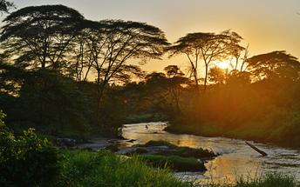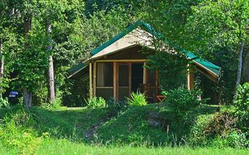

### Basis

Full Board - Dinner, Bed, Breakfast and Lunch   
All Drinks (excl Premium Brands) Included

### Included

* Game Drives
* House Drinks

### Excluded

* Premium Drinks

## Day 3-5: Ishasha Wilderness Camp, Southern Queen Elizabeth National Park (Tue, 3 September to Thu, 5 September)

### Day Itinerary

Morning and afternoon game drives in the Ishasha sector of Queen Elizabeth National Park.

 At the end of your afternoon game drive, you will be taken to a prearranged location inside the national park, where you will find a small buffet with freshly-made snacks and ice-cold drinks. This is set up with comfortable chairs, overlooking the beautiful African savannah plains. The Sundowners are held in an area where you have a combination of the beautiful African sunset, as well as having a quiet location from which to enjoy viewing the wildlife. The Sundowners last as long as you choose, so there is no pressure to return to Camp before watching the sun set fully. The selection of drinks on offer include: water, sodas, beers, house wines, as well as local gin.

Overnight at Ishasha Wilderness Camp

### Activities

|  |
| --- |
| Ishasha Game Drives |
| Ishasha Wilderness Camp Sundowner Drinks |

#### Ishasha Game Drives

Enjoy exploring this savannah wilderness in your safari vehicle, looking for the huge herds of buffalo, elephant, Uganda kob and of course, the famous tree-climbing lions. Seeing these mighty predators fast asleep up a fig tree, with their bellies hanging over the branches is a truly magnificent sight!

#### Ishasha Wilderness Camp Sundowner Drinks

Guests can enjoy late afternoon sundowners beside the Ntungwe River, or from a scenic viewing point along the ridge overlooking Ishasha. The activity includes local drinks and snacks, and also invites guests to drink in the vast vistas and atmosphere of this beautiful area of the park.

### Basis

Full Board - Dinner, Bed, Breakfast and Lunch   
All Drinks (excl Premium Brands) Included

### Included

* Premium Drinks
* Ishasha Sun downer drinks

## Day 5: Mahogany Springs Lodge, Bwindi Impenetrable Forest National Park (Thu, 5 September)

### Bwindi Impenetrable Forest National Park

The Bwindi Impenetrable National Park lies in southwestern Uganda on the edge of the Rift Valley.  Its mist-covered hillsides are blanketed by one of Uganda's oldest and most biologically diverse rainforest, which dates back over 25,000 years and contains almost 400 species of plants.  More famously, this "impenetrable forest" also protects an estimated 460 mountain gorillas - including several habituated families.   
  
This biologically diverse region also provides shelter to a further 120 species of mammal, including several primate species such as baboons and chimpanzees, as well as elephants and antelopes.  There are around 350 species of birds hosted in this forest, including 23 Albertine Rift endemics.

### Day Itinerary

Drive for approx. 2.5hrs to Bwindi Forest National Park for overnight

Bwindi National Park, located in south western Uganda on the edge of the Great Rift Valley, is considered the most diverse forest in Uganda. The area, one of the few large expanses of forest in East Africa, where lowland and montane habitats meet, contains a dense ground cover of herbs, vines, and shrubs.  Home to over 120 mammals, 345 species of birds, 200 species of butterflies, and 160 species of trees, Bwindi is one of the richest ecosystems in East Africa.  The park contains almost one half of the world’s population of the endangered Mountain Gorilla, making it an extremely valuable conservation site. Bwindi is also home to several endangered bird species with very limited ranges, and acts as an important catchment area for many rivers, supplying water for agriculture in the surrounding region.

In the afternoon, optional activities available, payable direct.  Please see below :

**Batwa Cultural Experience – Bwindi Impenetrable Forest National Park**

Embark on a three to four hour hike to a Batwa village in the midst of Bwindi Impenetrable Forest.  This amazing encounter will allow you the opportunity to meet Batwa elders and their families and learn about their daily lives.  Through the assistance of a skilled interpreter you will discover the unique traditions and practices the Batwa people including their deep attachment to the forest, the cuisine they enjoy, how they harvest their food, the style of their homes, and their burial rites.  Visitors are even given the chance to learn how to light a fire with just a stick and how to shoot a target with traditional weapons.

**Village Community Walk - Bwindi Impenetrable Forest National Park**

Embark on a community walk through the local villages surrounding Bwindi Impenetrable Forest.  Optional activities include visits to a traditional home, local orphanage or school, banana brewing demonstrations and even meeting traditional medicinal healers.  This three to four hour walk is easily tailored to your individual schedule and interests.

Overnight at Buhoma Lodge

### Overnight: Mahogany Springs Lodge

Mahogany Springs is situated in one of the most intimate, secluded, beautiful and most importantly natural settings in the world and only around 2 minutes away from the Gorilla tracking starting point.

All the rooms at Mahogany Springs are high end suites. All Suites can be twin, double or triple. There is 24/7 power in all the rooms. All rooms have large en-suite bathrooms with a gorgeously designed open terracotta shower.

All 12 luxurious suites have their own private terrace with magnificent panoramic views over the grounds, river and surrounding areas.

The main dining area is exquisitely furnished and with panoramic views beyond the lodge’s own gardens you will enjoy dining in a tranquil and unrivalled setting. The service provided is as much an art form as the food therefore, the staff are trained to very high standards. Within the main building there is a stunning bar where guests can sit all day and night trying one of the many cocktails or simply a bottle of fine wine. Most of the produce used at Mahogany Springs is grown on site to provide guests with the freshest ingredients.

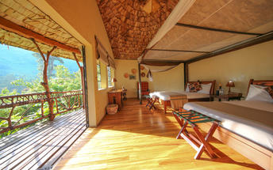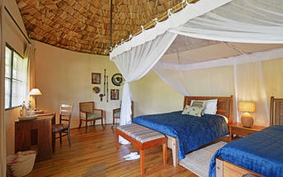

### Optional

|  |
| --- |
| Bwindi Forest Walk |
| Buhoma Community Village Walk |

#### Bwindi Forest Walk

This can be undertaken with a Uganda Wildlife Authority guide to allow you to hike along the trails and enjoy the forest flora, fauna and wildlife such as monkeys at close proximity. A popular choice is the 3–4-hour hike to the waterfall.

#### Buhoma Community Village Walk

This walk provides guests with an opportunity to support the local community whilst enjoying visiting various interesting places as you follow a walking trail through the village. Highlights include the traditional healer, banana brewery and Mukono Primary school where you may interact with the children.

### Basis

Full Board - Dinner, Bed, Breakfast and Lunch   
House Drinks Included

### Included

* House Drinks

### Excluded

* Premium Drinks
* Optional activities

## Day 6: Mahogany Springs Lodge, Bwindi Impenetrable Forest National Park (Fri, 6 September)

### Day Itinerary

Following breakfast at the lodge, travel to National Park Headquarters to meet your guides for the day and begin your gorilla tracking experience. Experienced guides and trackers will accompany your party on an early morning trek into the dense rain forest on the mountain slopes.

The journey, through dense foliage and up steep climbs, is abundantly rewarded with the lifetime experience of viewing mountain gorillas in their natural habitat.  You will have an opportunity to be within meters of these magnificent apes, sharing in their daily lives and experiencing their day-to-day activities.  Mountain gorillas are extremely rare with only an estimated 880 remaining in the wild.  This is an experience you won’t soon forget!

After your gorilla trek either spend the time relaxing at the beautiful lodge overlooking Bwindi Forest, or spend the time exploring some of the optional activities available in the area.

### Expert Tips

Wear long trousers and a long sleeved shirt with a t-shirt underneath.

Sturdy, well-worn-in walking boots with long socks.

Day bag to carry your waterproofs, water and packed lunch.

Gardening gloves can prove useful to protect your hands from thorns and stinging nettles.

Secure the services of a porter to carry your day bag and help you with the terrain.

### Activities

|  |
| --- |
| Gorilla Trekking Bwindi Impenetrable Forest |

#### Gorilla Trekking Bwindi Impenetrable Forest

Coming up close to endangered Mountain Gorillas in the forests of Uganda is a thrilling lifetime experience that surely ranks on most people’s travel bucket list. Trekking at high altitude (should we say between 1400 – 1900metres) which is much lower than Rwanda….through dense forests and up steep terrain can be challenging, especially in the African heat, but the hour you get to spend with these gentle giants is worth every step.

Only 8 guests may trek one gorilla family, at a time.  One trek per day/per family.

Trekking - is managed fully by Uganda Wildlife Authority, with a head ranger, security personnel (who are armed as a precaution against wildlife etc) and trackers , with optional porters – who walk with the guests until a family is located.  Once the gorillas are found, the rangers only take the guests closer to the gorillas – and your viewing time commences – which is one hour.

Porters – they are from the local communities, rotated for revenue sharing which goes directly to them.  Recommended at least 1 per person trekking.  Fees are usually additional to your tour, and paid directly.

### Basis

Full Board - Dinner, Bed, Breakfast and Lunch   
All Drinks (excl Premium Brands) Included

### Included

* Picnic Lunch
* House Drinks

### Excluded

* Gorilla Trekking Permit at 800 USD per permit
* Optional Activities
* Premium Drinks

## Day 7: Buhoma Lodge, Bwindi Impenetrable Forest National Park (Sat, 7 September)

### Day Itinerary

Transfer for your second gorilla Trek

### Activities

|  |
| --- |
| Gorilla Trekking Bwindi Impenetrable Forest |

#### Gorilla Trekking Bwindi Impenetrable Forest

Coming up close to endangered Mountain Gorillas in the forests of Uganda is a thrilling lifetime experience that surely ranks on most people’s travel bucket list. Trekking at high altitude (should we say between 1400 – 1900metres) which is much lower than Rwanda….through dense forests and up steep terrain can be challenging, especially in the African heat, but the hour you get to spend with these gentle giants is worth every step.

Only 8 guests may trek one gorilla family, at a time.  One trek per day/per family.

Trekking - is managed fully by Uganda Wildlife Authority, with a head ranger, security personnel (who are armed as a precaution against wildlife etc) and trackers , with optional porters – who walk with the guests until a family is located.  Once the gorillas are found, the rangers only take the guests closer to the gorillas – and your viewing time commences – which is one hour.

Porters – they are from the local communities, rotated for revenue sharing which goes directly to them.  Recommended at least 1 per person trekking.  Fees are usually additional to your tour, and paid directly.

### Basis

Full Board - Dinner, Bed, Breakfast and Lunch   
All Drinks (excl Premium Brands) Included

### Included

* Picnic Lunch
* House Drinks

### Excluded

* Gorilla Trekking Permit at 800 USD per permit
* Optional Activities
* Premium Drinks

## Day 8: The Boma Hotel Entebbe, Entebbe (Sun, 8 September)

### Entebbe

As previously described

### Day Itinerary

Transfer for approx. 2hrs to Kihihi airstrip for your scheduled flight to Entebbe. Transfer to your guest house for overnight.

### Overnight: The Boma Hotel Entebbe

The Boma Hotel is Entebbe’s original and most exclusive hotel, set in tropical gardens in a leafy suburb, a few minutes’ drive from Entebbe International Airport. Our rooms combine the modern comforts one expects today with the charm and character of the original 1940’s home. The Boma is an ideal stopover for all travellers and airline passengers, and we will arrange all your airport transfers. Our staff and management team ensure guests receive a personable service and enjoy hospitality standards which are in keeping with the tradition of this charming lakeshore town.

### Basis

Bed and Breakfast

### Included

Transfer from the airport to your hotel

### Excluded

Drinks

Scheduled flight -USD310 Each way

## Day 9: End of Itinerary (Mon, 9 September)

### Day Itinerary

After an early breakfast, transfer to UWEC for the chimp integration activity.  Transfer back to your guest house to freshen up and thereafter transfer to the airport to check-in for your international flight out.

End of services.

### Activities

|  |
| --- |
| Chimpanzee Integration Program |

#### Chimpanzee Integration Program

Taking place at the Uganda Wildlife Education Centre, Chimpanzee integration offers visitors a chance to embark on a highly moving and unique experience whereby they get close with the endangered chimpanzee species. Visitors can join the younger chimpanzees for part of their daily exercise routine in a stretch of the natural forest and be mesmerised as they interact with each other and guests. The experience offers guests a rare opportunity to bond with man's closest relative while learning about the dangers that they are currently facing in the wild.

### Basis

Bed and Breakfast

### Included

* Transfer to Entebbe airport

### Excluded

* Optional Activities
* Drinks
* Dinner