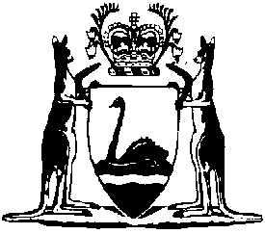
Western Australia
Dog Amendment (Stop Puppy Farming) Act 2021

Dog Amendment (Stop Puppy Farming) Act 2021 Commencement Proclamation 2024

Western Australia
Dog Amendment (Stop Puppy Farming) Act 2021 Commencement Proclamation 2024
Contents
1. Citation 1
2. Commencement 1

Dog Amendment (Stop Puppy Farming) Act 2021
Dog Amendment (Stop Puppy Farming) Act 2021 Commencement Proclamation 2024
Made under the Dog Amendment (Stop Puppy Farming) Act 2021 section 2(e) by the deputy of the Governor in Executive Council.

1. Citation
This proclamation is the Dog Amendment (Stop Puppy Farming) Act 2021 Commencement Proclamation 2024.

2. Commencement
The provisions of the Dog Amendment (Stop Puppy Farming) Act 2021 listed in the Table come into operation on the day after the day on which this proclamation is published on the WA legislation website.
Table
s. 6 | s. 8(1) to (7)
s. 9(1) | s. 10 and 11
s. 13 and 14 | s. 20(1) and (2)
s. 21 | s. 25
s. 28 and 29 | s. 31 to 36
s. 38 to 42 | s. 45

P. QUINLAN, deputy of the Governor L.S.
H. BEAZLEY, Minister for Local Government

© State of Western Australia 2024.
This work is licensed under a Creative Commons Attribution 4.0 International Licence (CC BY 4.0). To view relevant information and for a link to a copy of the licence, visit www.legislation.wa.gov.au.
Attribute work as: © State of Western Australia 2024.
By Authority: GEOFF O. LAWN, Government Printer

