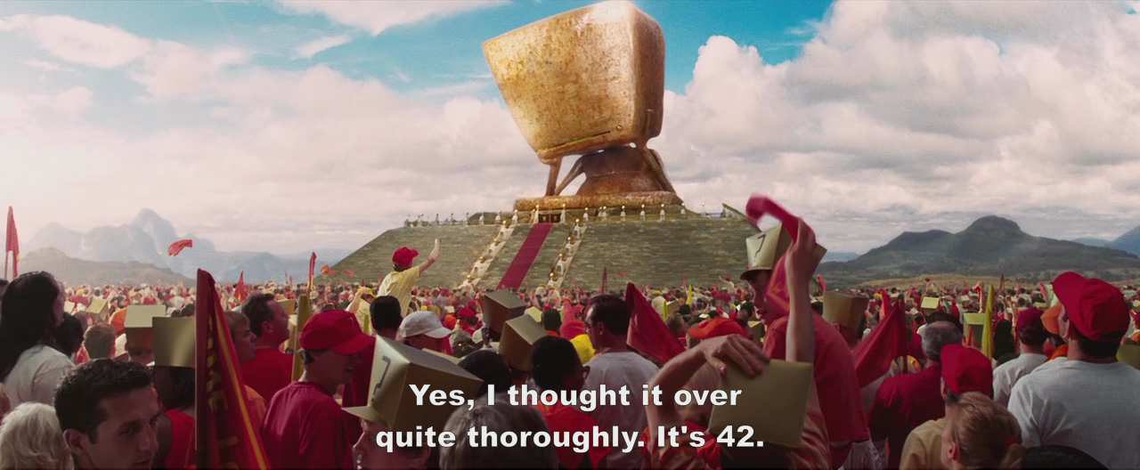
Dear {{ planet }} residents,
Hello to all {{ inhabitant_count }} of you.
Goodbye,
Your friend

