

Julia Acosta
Miguel Barrales
Elijah Davis
Mario Hernandez
Miguel Trigueros

Requirements:

Description-

Prison Escape is a 2D game top view that challenges the player to try to escape prison. The game is a one player game. The prisoner is equipped with weapons and a map to try to maneuverer its way through out the game. The challenging part is collecting the keys while running away from the security guards. Prison Escape starts with a Menu screen, the options are “Play Game” or “Quit Game”. In order to begin the game, the player clicks “Play Game” and to end the game, the player clicks “Quit Game”. The player is going to start at Prison Cell 3 and in order to move the player around the arrow keys are used to move the player up, down, left, and right. The space bar is used to shoot the guards in order to kill them.

Objective-

The objective of the game is trying to escape prison by collecting the keys that open certain doors and trying to go through the prison without getting caught by the security guards. To win the game, the player needs to open the door in the room between Tower 2 and 4.

Design:
We all decided to make the game into a grid layout so when the player enters through a door, the player is at a different part of the map. The game will only show one room at a time and we designed the game so the player has to enter/exit through the doors in order to see the other rooms.

Before-
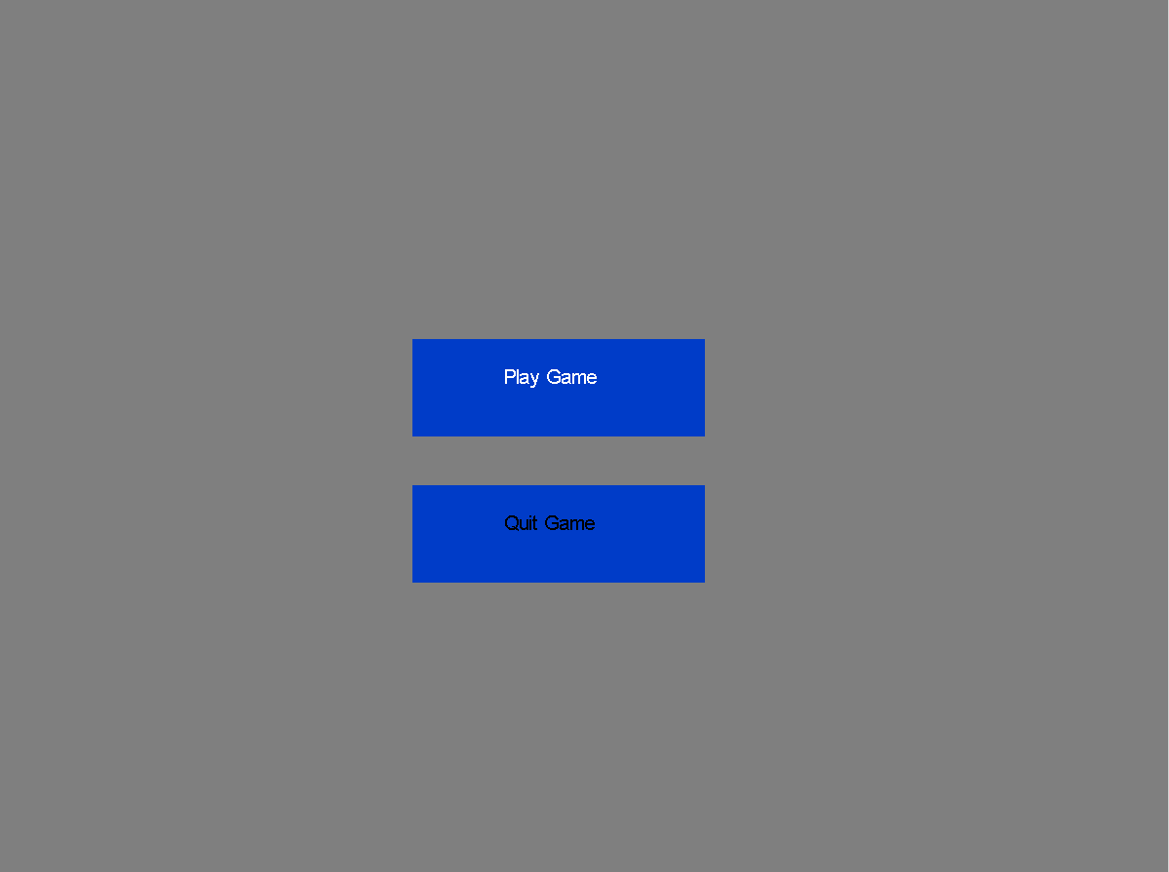
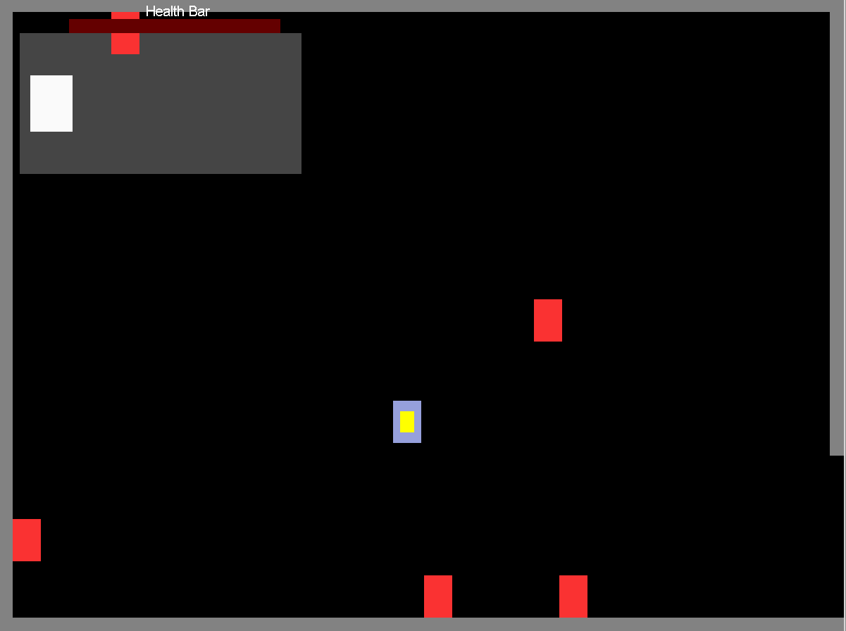
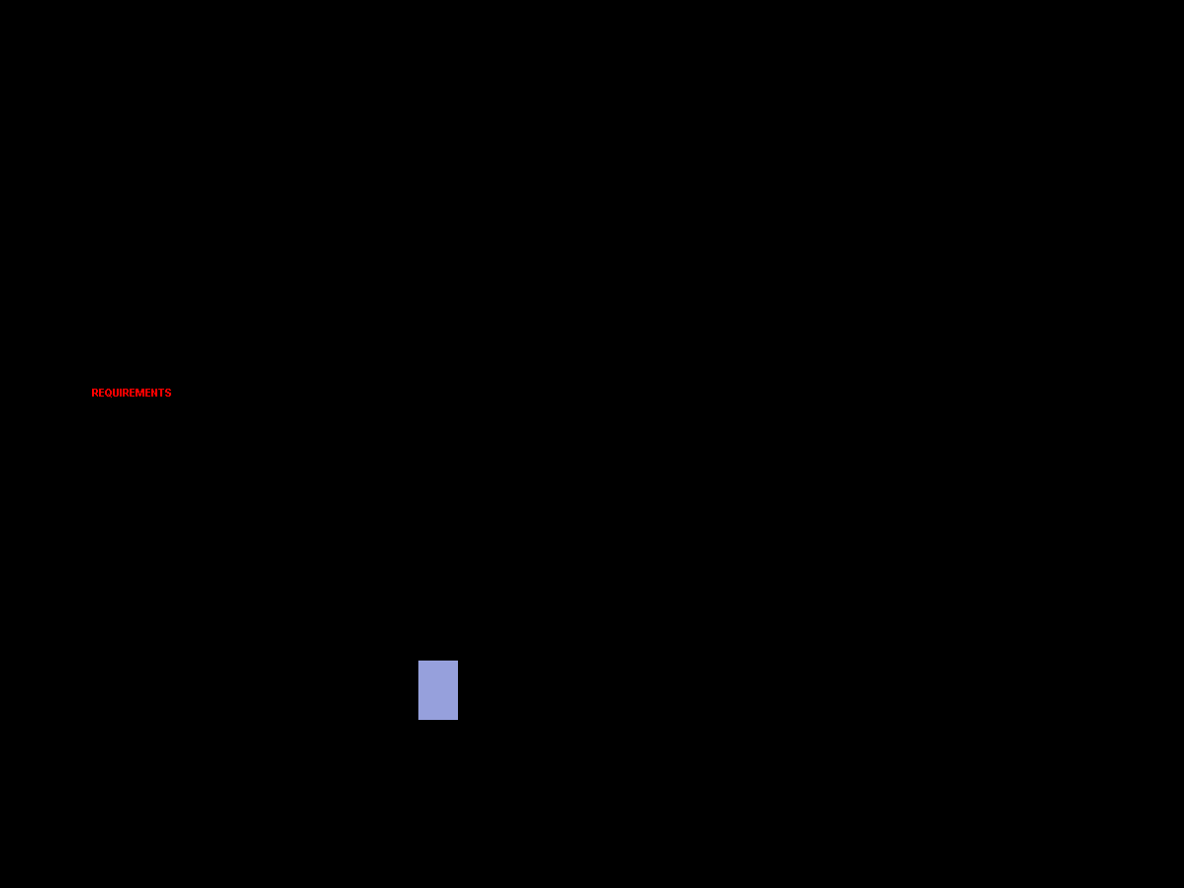

At the beginning, we only had a basic menu and for the game we used a box for the player and enemies.

After-
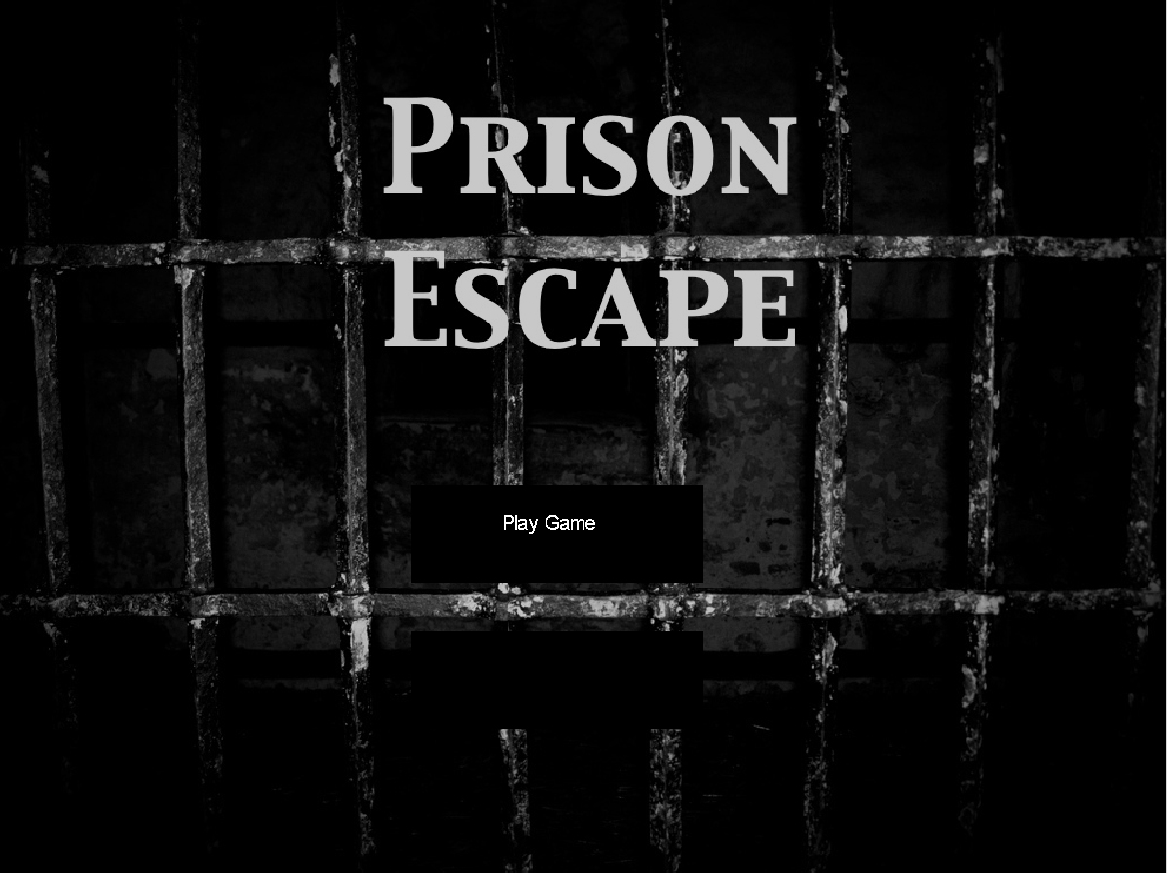
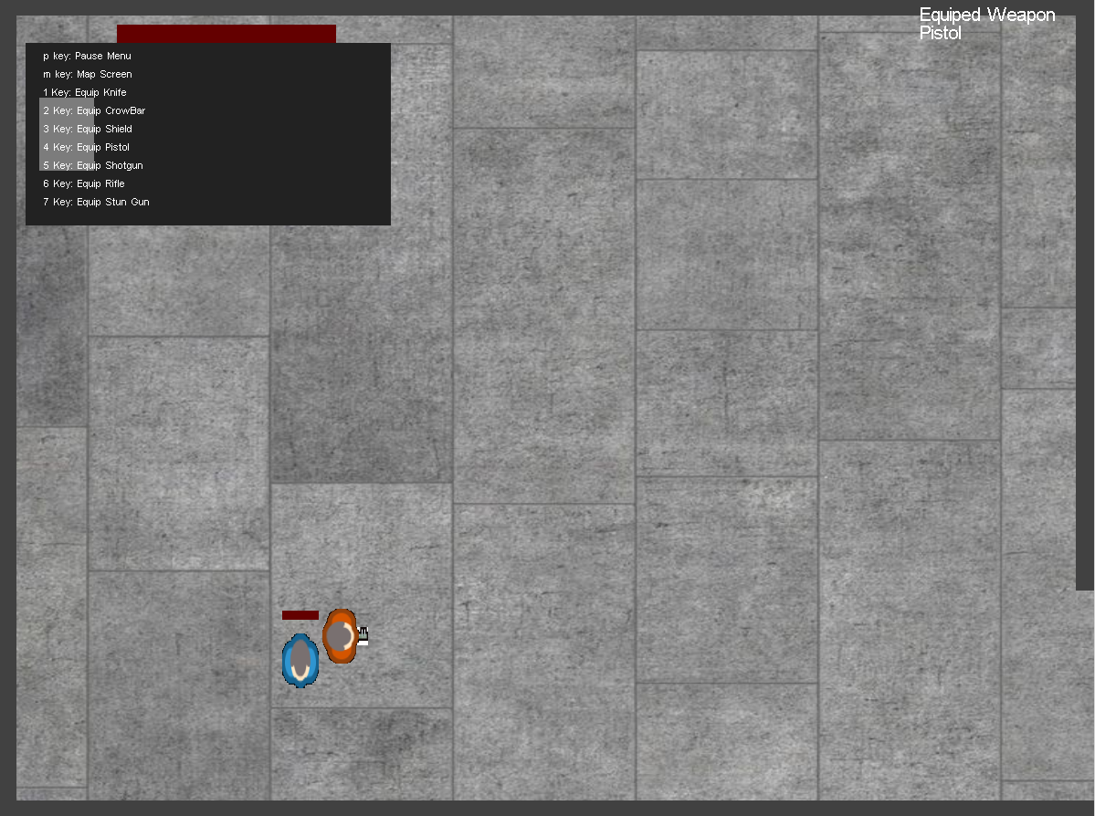
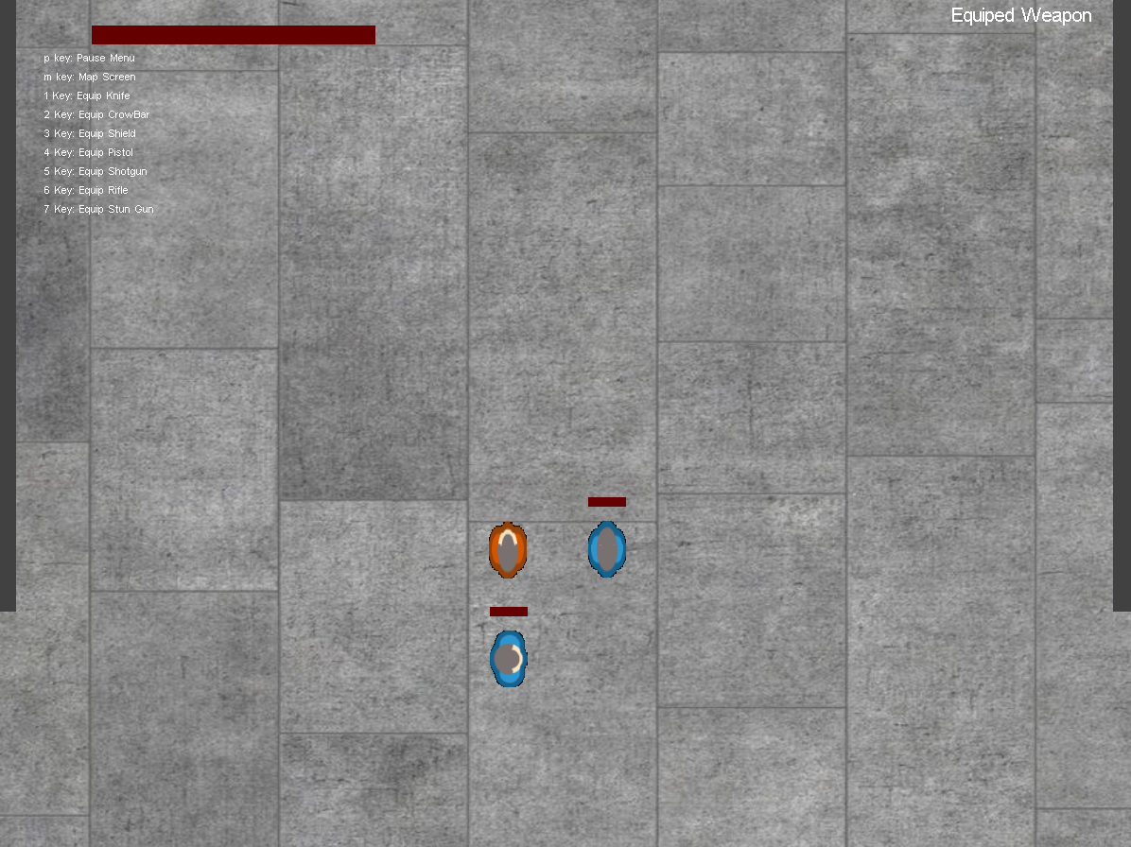

For the final project, we added a picture for the menu, a background for the floor, and images for the characters.

Components of the game-

We equipped the player with weapons and a map in order to escape prison. In order to use the weapons, the player needs to press the numbers 1-5. The player has a red heath bar at the top left of the screen and the security guards health bar are located on the top of them. When shooting the guards, their health will decrease and eventually die.

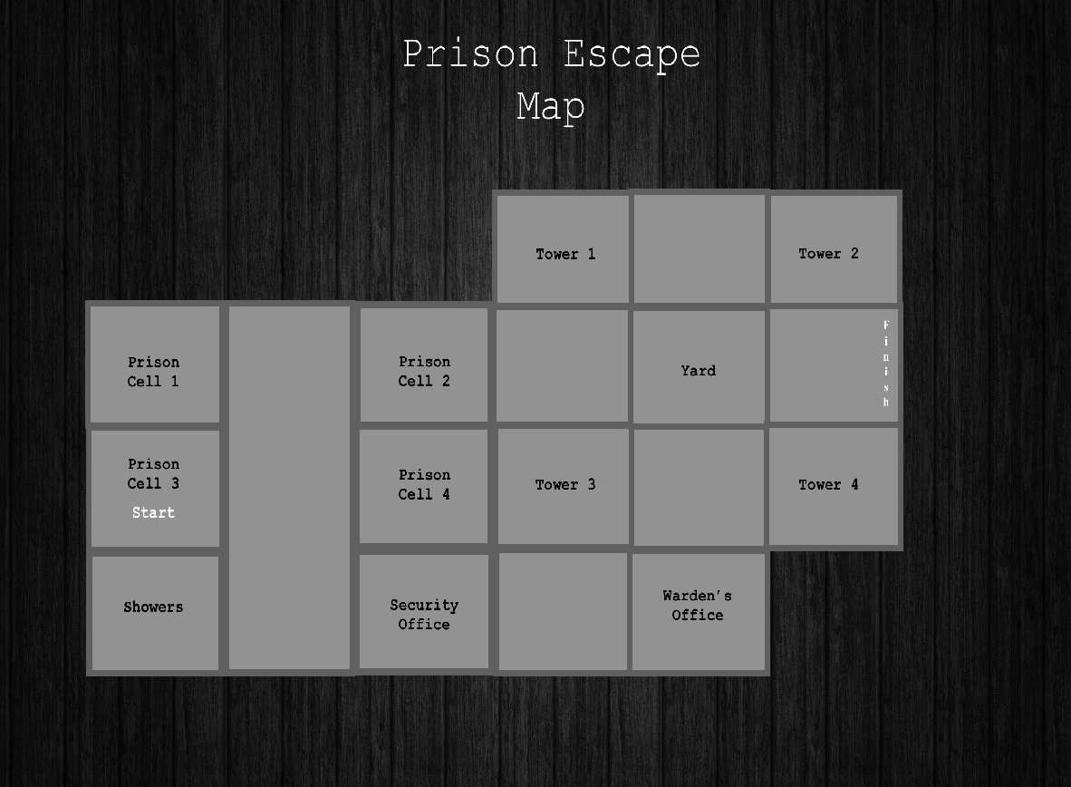

Weapons:
-knife
-Shield
-Pistol
-Shotgun
-Riffle

Game play Flow Diagram

