Instruction for running simulation code

# Overview

The simulation code comes in two folders:

* BeamSimulation: source code for simulate PSF for Gaussian, Hex and MB square lattices used in the manuscript.
* MultiBeadSimulation: source code for simulate multi-bead images and perform Fourier plane correlation.
* FIREfunctions: these are source code from Nieuwenhuizen et al(2013) to calculate Fourier plane correlation.

Code requirements:

Code has been validated to work on Matlab R2019b and requires the Signal Processing and Image Processing toolboxes.

# Beam simulation code

To run beam simulation, use one of the driving scripts named “driving_script_XXX.m”. It will open a script as shown below:

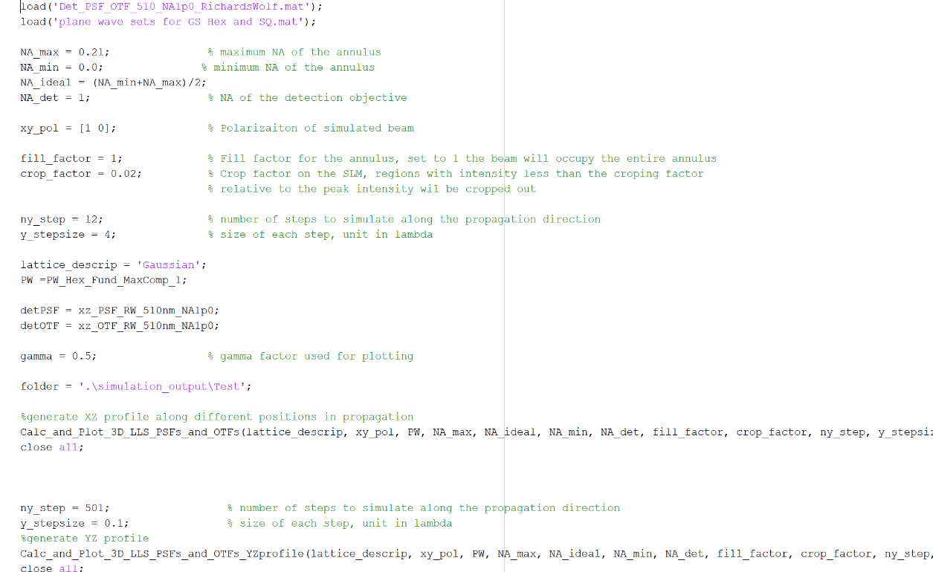

You can simply run the script to generate PSF used in the manuscript for Gaussian, Hex and MB square lattices. You can also try with different combination of NA_max and NA_min for the outer and inner annulus NA as described in the manuscript. The script will simulate a series of XZ slices along the propagation direction as well as a YZ profile.

Results will be saved in the path as indicated in “folder” in the script. This includes:

* Dithered_exOTF_XXX: z profile for the dithered excitation OTF at different locations along the propagation direction
* Dithered_overallOTF_XXX: XZ slice of the overall OTF at different locations along the propagation direction
* Dithered_OTFlinecut_XXX: linecuts of the overall OTF at different locations along the propagation direction
* OverallPSF_XXX: XZ slice of the overall PSF at different locations along the propagation direction
* PSF_linecutXXX: z profile of the detection PSF, excitation PSF and the overall PSF at different locations along the propagation direction
* Still_xzPSF_XXX: XZ slice of the excitation PSF before dithering at different locations along the propagation direction.
* Dithered_xzPSF_linecutXXX: intensity profile (red) and cumulative intensity (blue) along z in the excitation PSF at different locations along the propagation direction

# Multi-Bead simulation

Prerequisite:

1. Source code for calculating Fourier plane correlation are from Nieuwenhuizen et al(2013),
2. Install matlab toolbox dipimage, which can be downloaded at [www.diplib.org](http://www.diplib.org).
3. 3D Detection PSF, here we use <http://bigwww.epfl.ch/algorithms/psfgenerator/> to generate the detection PSF. We used the Richards & Wolf 3D optical model. We have NA = 1.0, RI = 1.3 and λ=560nm. We simulated a PSF with size of 1001x1001x1001 pixels, with pixel size = 0.1 λ, as shown below in the screenshot.

1. Make sure you have finished running the simulation for PSF in the previous section.

To run the simulation, open the script file “multibead3D_simulation.m”, which looks like the following:

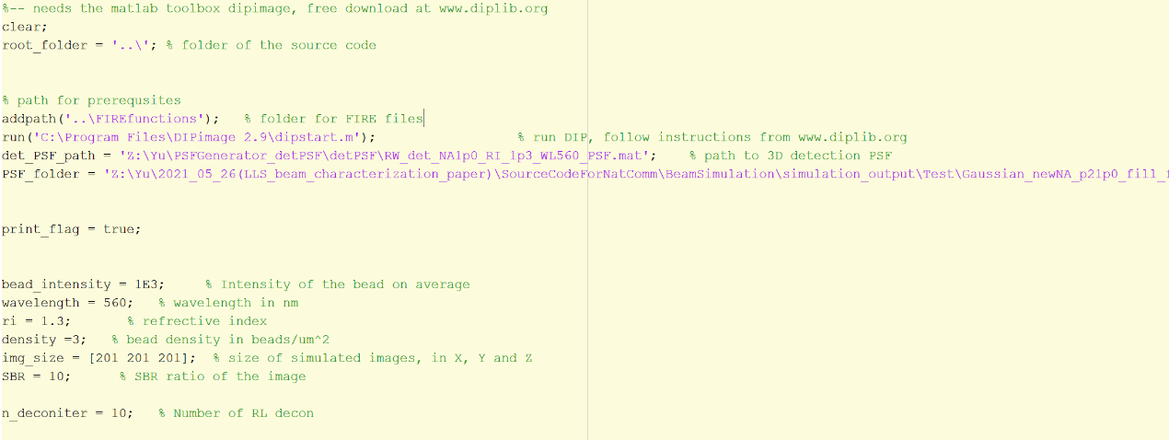

Before running the script, make sure you provide the path for dipimage, the detection PSF path, and the path for simulated lattice light sheet PSF. You can also change the other parameters for simulations such as bead density, image size, signal to background ratio, bead intensity etc.

Output of the scripts will be saved in the folder called “multibead3D” under the folder for PSF simulation. It will include the raw simulated images, FPC results on the raw simulated images, and RL deconvolved images.