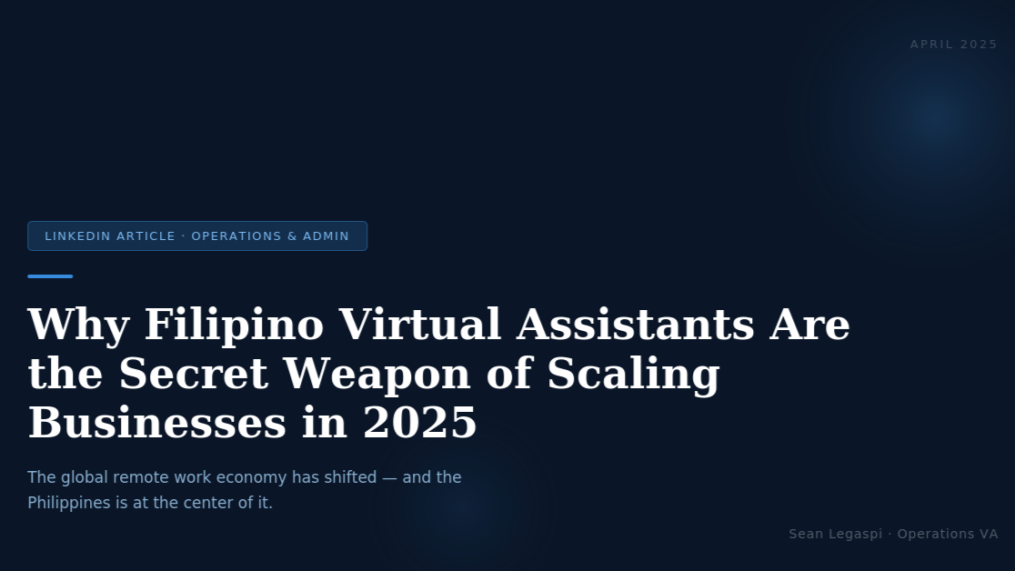

Why Filipino Virtual Assistants Are the Secret Weapon of Scaling Businesses in 2025
April 6, 2026
The global remote work economy has shifted. Here's why more CEOs are quietly building their operations teams in the Philippines — and why it works.
In 2025, operational efficiency is no longer optional it's survival.
Business owners across the US, Australia, and Europe are discovering something that smart entrepreneurs have known for years: the Philippines is a goldmine of highly skilled, English-proficient virtual assistants who can run your operations while you sleep.
But it's not just about cost. It's about capability.
Here's what working with a Filipino VA in operations and admin actually looks like:
- Calendar & inbox management that frees up 10+ hours a week for CEOs
- SOP creation and process documentation so your business runs without you
- Project coordination across multiple tools (ClickUp, Asana, Notion, Trello)
- Client onboarding systems that make your business feel premium from day one
- Data management, reporting, and analytics support
The real value isn't replacing people it's removing the bottlenecks that slow your growth.
I've seen business owners go from overwhelmed and reactive to strategic and proactive simply by delegating operations to the right support.
If you're still doing tasks that could be delegated, you're leaving growth on the table.
The businesses that thrive in 2025 won't be the ones with the biggest teams. They'll be the ones with the smartest systems and the right people running them.
Filipino VAs aren't just filling roles. We're building the backbone of global businesses, one process at a time.
And we're doing it with the kind of dedication, adaptability, and skill that the global market is just beginning to truly appreciate.
If you haven't explored what a Filipino operations VA can do for your business that conversation is worth having.
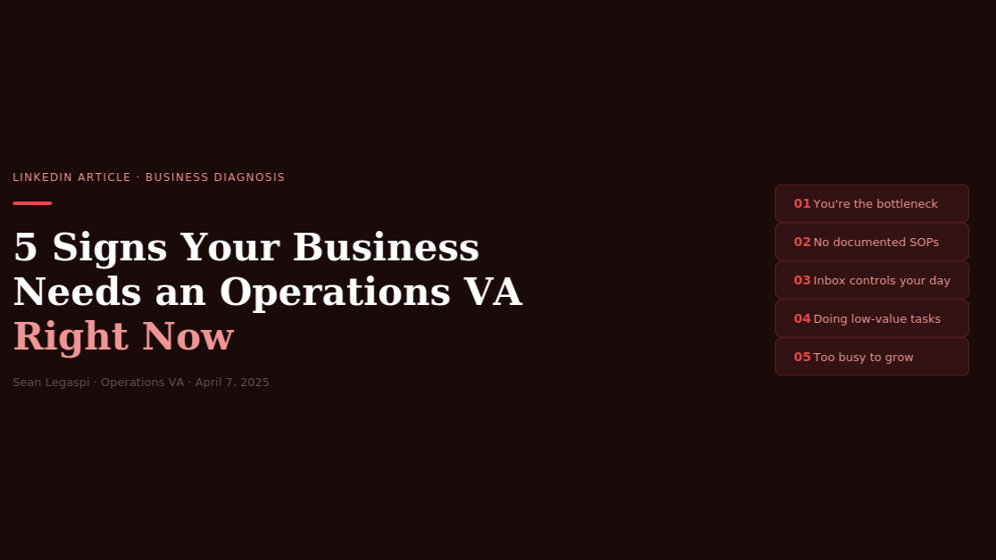

5 Signs Your Business Needs an Operations Virtual Assistant Right Now
April 7, 2026
If any of these sound familiar, it's not a productivity problem — it's a systems problem. And it's costing you more than you think.
Running a business is exciting. Running a business without operational support? That's exhausting.
Here are 5 signs you've outgrown doing it all yourself:
1. You're the bottleneck. - Every decision, email, and follow-up goes through you. Your team waits. Clients wait. Growth waits. If nothing moves without your input, you don't have a business you have a dependency.
2. You don't have documented SOPs. - If your business can't function without you for 3 days, you don't own a business you own a job. Standard Operating Procedures are the difference between a business that scales and one that collapses.
3. Your inbox controls your day. Instead of leading your business, you're reacting to it one notification at a time. A fully managed inbox means you touch only what truly needs your attention.
4. You're doing $4/hour tasks when you should be doing $400/hour work. Admin, scheduling, data entry, client follow-ups these are all delegatable. The math is simple: your time is worth more than what these tasks cost to hand off.
5. You're too busy to grow. - Leads go cold. Proposals get delayed. Ideas stay ideas. Because you have no bandwidth left for the work that actually moves the needle.
An operations VA doesn't just help you manage your workload they help you reclaim the strategic time that actually grows your business.
If even 2 of these resonated with you, the cost of not acting is already showing up in your results.

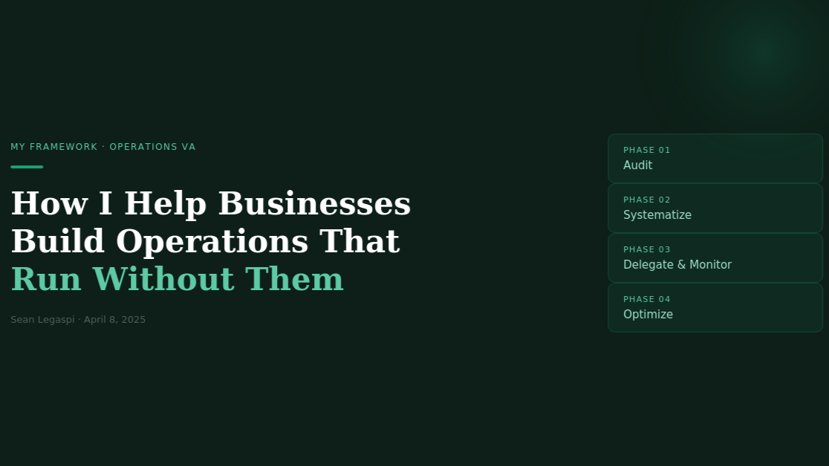

How I Help Business Owners Build Operations That Run Without Them

April 8, 2026
The goal was never to make myself indispensable. The goal was to make the business unstoppable.
When I started as an operations and administrative VA, I thought my job was to complete tasks.
Then I realized: the best thing I could do for any client wasn't finishing their to-do list, it was making sure they didn't need me to remind them of it.
Here's the 4-phase framework I use when I onboard every new client:

Phase 1: Audit
I map out every repeating task the business owner does. Every email they send. Every process they follow manually. I shadow their workflow for 1–2 weeks and document everything that can be systematized. Most owners are surprised by how much is running on memory alone.

Phase 2: Systematize
I build SOPs, templates, and workflows for everything that can be documented. ClickUp boards. Notion databases. Email templates. Automated reminders. Onboarding checklists. Every repeating task becomes a process — and every process gets a home.

Phase 3: Delegate & Monitor
I take over execution of all operationalized tasks and track performance weekly. The business owner stops being cc'd on everything and starts receiving clean summaries. Activity becomes visible. Accountability becomes built-in.

Phase 4: Optimize
Every 30 days, I review what's working and what isn't. We refine. We scale. We keep the machine running smoother. This is where the compound effect of good systems starts to show up in real business results.
The result?
Business owners who used to check their email 40 times a day now check it once. Owners who used to run every meeting now delegate them. Teams who used to wait for direction now operate from clear SOPs.
That's not just a VA service. That's operations consulting at a fraction of the cost of a full-time hire.
If you're building or scaling a business in 2026, this kind of support isn't a luxury. It's a foundation.

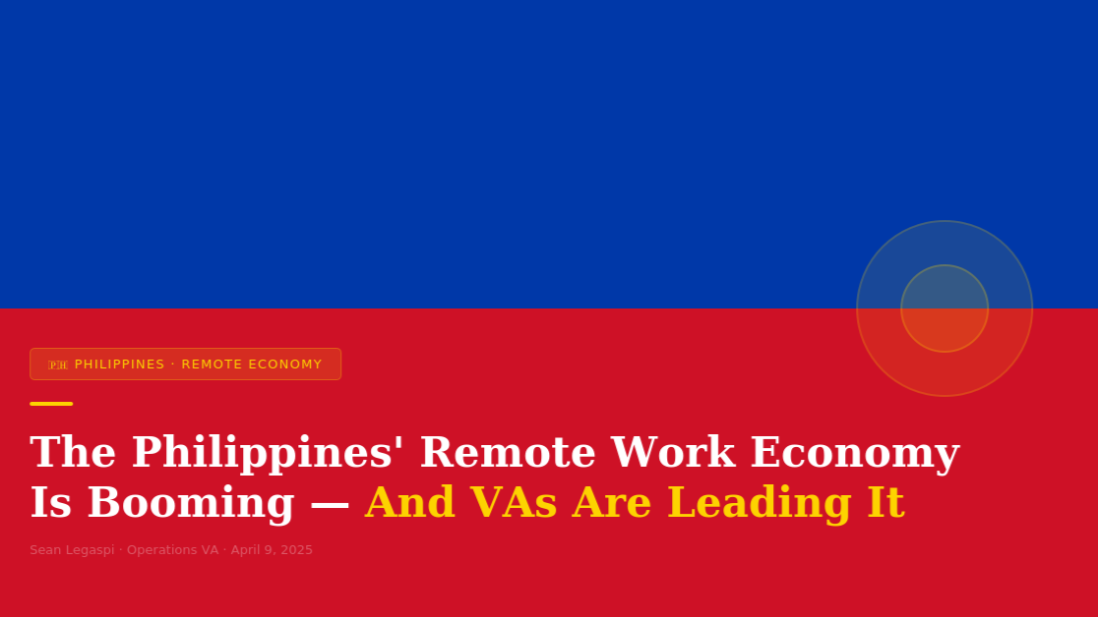

The Philippines' Remote Work Economy Is Booming — And VAs Are Leading It
April 9, 2026
The BPO industry put us on the map. The virtual assistant economy is writing the next chapter.
The Philippines has long been a powerhouse in the global outsourcing space. But something has shifted in recent years.
Filipino professionals are no longer just filling seats in call centers. They're running operations, managing teams, handling executive-level tasks remotely, independently, and with world-class skill.
The rise of the virtual assistant economy in the Philippines is not an accident. It's the result of:
📌 Strong English proficiency — one of the highest in Asia, deeply embedded in education and culture
📌 Cultural compatibility with Western and Australian business norms — we understand the context, not just the task
📌 A generation trained in business process operations — the BPO era built a workforce that understands global business
📌 Growing digital infrastructure — faster internet, more remote-capable professionals across more regions
📌 A mindset shift — from employment to entrepreneurship, from worker to strategic partner
For Filipino VAs, this isn't just a job trend. It's a career revolution.
We're not waiting to be discovered. We're building our personal brands, upskilling, and showing up on the global stage.
For business owners abroad, this represents access to talent that is motivated, resourceful, and deeply committed to delivering results — at a fraction of the cost of a local hire.
I'm proud to be part of this movement.
Building businesses remotely. Designing systems that run across time zones. Proving that the best operations partner doesn't need to be in the same office — or even the same continent.
To my fellow Filipino professionals: the global market wants what you have. Invest in your skills, build your personal brand, and show up consistently. The opportunity is real.
To business owners: if you haven't explored hiring from the Philippines yet, you're missing one of the best talent pipelines in the world.
The future of work is already here. And it's being built right here in the Philippines.



From Chaos to Clarity: How Proper Admin Support Transforms a Business's Day-to-Day
April 10, 2026
Most businesses don't have a revenue problem. They have an operations problem disguised as one
I've worked with business owners who were making great money but felt like they were drowning.
The leads were coming in. The clients were happy. But inside? Total chaos.
Missed follow-ups. Disorganized files. Double-booked meetings. Tasks falling through the cracks.
The problem wasn't their product or their marketing. It was their backend.
Here's what proper admin and operations support actually fixes:

File & Document Management
No more "where did I save that?" Everything organized, labeled, and accessible in minutes. One source of truth for every document the business needs.

Calendar Management
No more double-bookings, missed calls, or last-minute scrambles. Your calendar becomes a strategic tool, not a source of anxiety.

Inbox Management
Emails sorted, prioritized, and responded to — so only what truly matters reaches you. Everything else is handled.

Reporting & Tracking
Weekly snapshots of what's moving, what's stalled, and what needs your attention. Visibility without micromanagement.

Task Coordination
Your team knows what to do, when to do it, and who's responsible. No guesswork. No dropped balls.
When these systems are in place, something remarkable happens:
The business owner stops reacting and starts leading.
That's the transformation proper admin support creates — not just efficiency, but clarity. And with clarity comes the confidence to actually scale.
The business that was drowning in tasks becomes a business with room to grow.
That shift doesn't require a full-time operations manager. It requires the right VA, the right systems, and the right partnership.

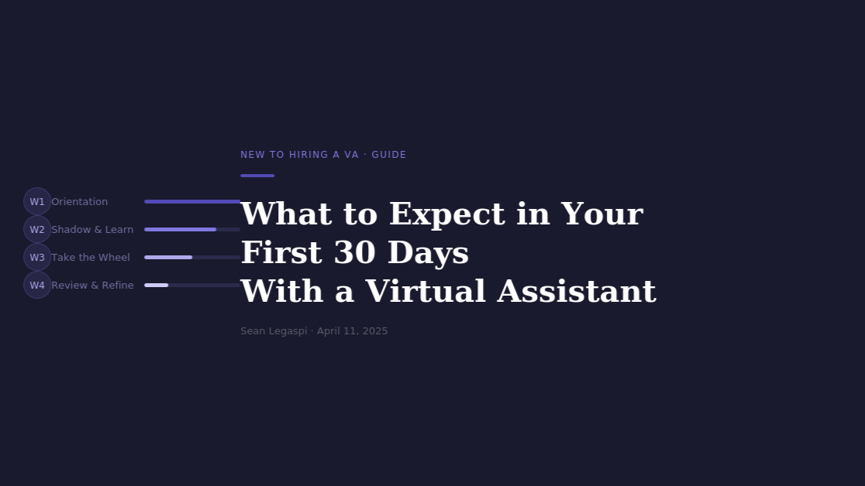

New to Hiring a Virtual Assistant? Here's What to Expect in the First 30 Days
April 11, 2026
The first month with a VA is the most important — and the most misunderstood. Here's how to make it work from day one.
Hiring a virtual assistant for the first time can feel like a leap of faith.
You're trusting someone you've never met in person with your inbox, your calendar, your clients, and your operations.
But when done right, the first 30 days sets the tone for a long, productive working relationship. Here's what realistic onboarding actually looks like:

Week 1: Orientation & Access
Your VA gets access to your tools, reviews existing processes, and starts mapping your workflow. Don't expect full output yet — this is the discovery phase. A good VA asks lots of questions here. That's a green flag, not a red one.

Week 2: Shadow & Learn
Your VA observes how you work, asks clarifying questions, and begins taking on smaller tasks. This week is about alignment — matching your preferences, your tone, your way of working.

Week 3: Take the Wheel
Your VA starts owning tasks independently. There will be some adjustments as they calibrate to your expectations. Give specific feedback early — it accelerates the learning curve dramatically.

Week 4: Review & Refine
Together, you review what worked, what didn't, and what systems need to be built. A great VA proactively brings suggestions at this stage. That's when you know you have a real partner.
Red flags to avoid:
🚩 Giving zero direction and expecting perfection
🚩 Micromanaging every task (it defeats the purpose)
🚩 Not setting clear KPIs or expectations upfront
🚩 Treating your VA as a task robot, not a thinking partner
Green flags you're on track:
✅ Clear, consistent communication from both sides
✅ Your VA asks smart clarifying questions
✅ You're starting to feel actual relief — not just activity
The 30-day mark is when the real ROI begins to show. Leads stop falling through the cracks. Your calendar is actually manageable. Tasks are getting done without you chasing them.

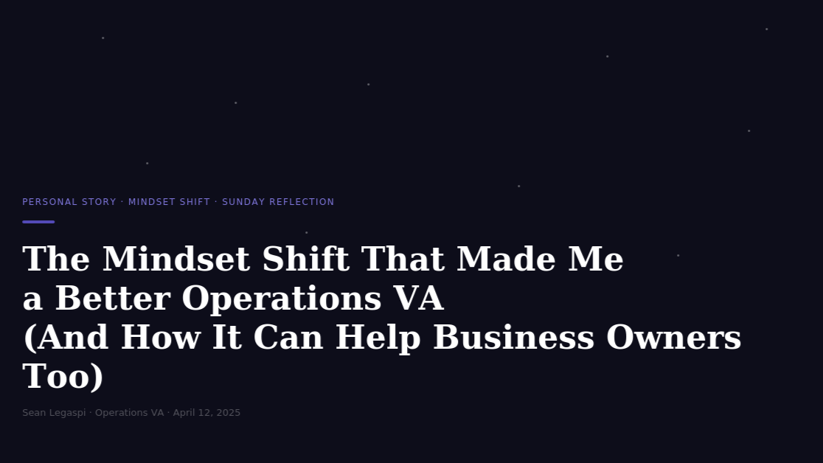The Mindset Shift That Made Me a Better Operations VA (And How It Can Help Business Owners Too)
April 12, 2026
I stopped thinking like an assistant. I started thinking like an operator. Everything changed after that.
Early in my career as a virtual assistant, I thought my value was in how many tasks I could complete.
I was fast. I was organized. I was reliable.
But something was missing.
Then came a question that changed everything: What if instead of asking "what needs to be done?" — I started asking "why does this need to be done, and how can we make sure it never needs to be done manually again?"
That question turned me from a task-taker into a systems thinker.
Here's what that shift looks like in practice:
Old mindset: "My client asked me to send invoices every Friday."
New mindset: "Why is this manual? Let me set up an automation that sends invoices on a trigger so this never gets forgotten — even if I'm unavailable."
Old mindset: "I'll remind my client about their 2PM call."
New mindset: "Let me build a calendar workflow with automated reminders so neither of us has to think about this."
Old mindset: "I'll organize these files."
New mindset: "Let me design a naming and folder structure that anyone on the team can follow without asking me."
See the difference?
The first mindset creates dependence. The second creates resilience.
For business owners, the parallel is just as powerful:
Stop hiring people to execute tasks. Hire people to build and maintain the system around the execution.
The businesses that scale aren't the ones with the most hardworking people. They're the ones with the best-designed systems — and the right people running them.
This is what I bring to every client I work with. Not just a pair of hands, but a strategic mind committed to making the business stronger, more resilient, and more scalable.

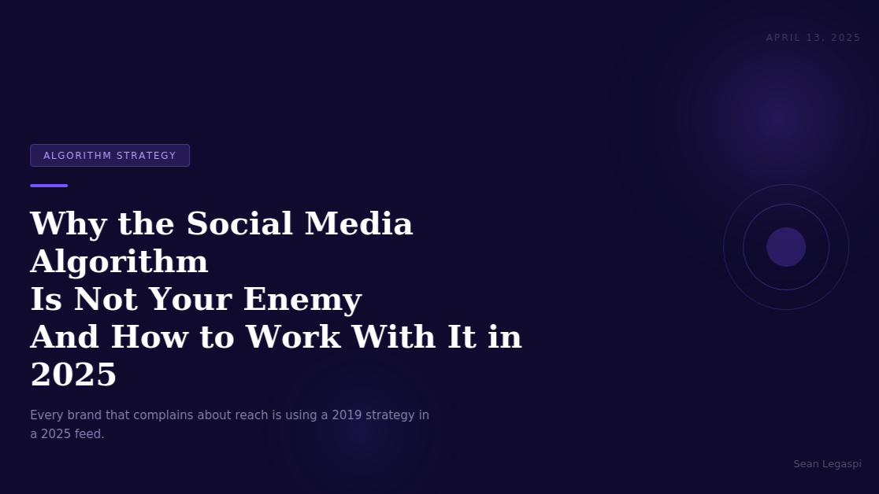

Why the Social Media Algorithm Is Not Your Enemy (And How to Work With It in 2025)

April 13, 2026
Every brand that complains about reach has one thing in common: they are still using a 2019 strategy in a 2025 feed.
The relationship between brands and social media algorithms has always been tense. Every major platform update seems to punish organic reach further, and marketers respond by either paying for ads or losing momentum entirely.
But the brands consistently winning on social media in 2025 are not fighting the algorithm. They are studying it.

HOW MODERN ALGORITHMS ACTUALLY WORK
The algorithms running Facebook, Instagram, LinkedIn, TikTok, and YouTube in 2025 share a common foundation: they are designed to maximize time on platform. Every signal the algorithm reads is a proxy for one question: does this content keep people engaged?
According to a 2024 report by Sprout Social, the top factors that influence organic reach across platforms are:
- Watch time and completion rate (for video content)
- Saves and shares (higher weight than likes or comments)
- Early engagement velocity (how fast a post collects interactions in the first 60 minutes)
- Profile interaction history (how often a user has engaged with your account before)
- Content format relevance (whether the format matches what the platform is currently pushing)

THE FORMAT SHIFT YOU CANNOT IGNORE
LinkedIn's own internal data showed that document posts and short-form video generate 3x to 5x more impressions than plain text or link posts. Instagram Reels still receive preferential distribution. TikTok rewards accounts posting at least four times per week with broader discovery reach.
The pattern is clear: platforms promote the formats they are betting on commercially. In 2025, that means native video, interactive documents, and content that keeps people on the platform rather than sending them off it.

WHAT THE BEST-PERFORMING ACCOUNTS DO DIFFERENTLY
A 2024 analysis by HubSpot of over 100,000 social media posts found that high-performing accounts share three consistent behaviors:
First, they post at predictable intervals. The algorithm learns your posting cadence and pre-allocates distribution accordingly. Accounts that post consistently every two to three days outperform accounts that post daily for two weeks and then go silent.
Second, they seed early engagement. Top creators actively warm up a post by engaging with their own content in the first hour. Early signals tell the algorithm a post is worth showing to a wider audience.
Third, they analyze what worked and repeat it. The most effective social teams run monthly content audits. They look at saves, shares, profile visits triggered, and link clicks rather than just likes.

THE PRACTICAL TAKEAWAYS
Prioritize saves over likes. Design content that people want to come back to. How-to content, data insights, checklists, and frameworks earn saves at higher rates than opinion posts.
Use native formats. Upload video directly to each platform. Post documents as native carousels on LinkedIn. Platforms reward content that keeps users inside their ecosystem.
Respect the 60-minute window. After publishing, engage immediately. Reply to every comment. The algorithm interprets this activity as high engagement velocity and extends your reach.
Post for the feed, not the website. Social content should stand alone. If someone needs to click a link to understand your point, you have already lost most of your audience.

THE BOTTOM LINE
The algorithm is not broken. It is doing exactly what it was designed to do: surface content that earns attention. The brands that understand this stop trying to trick the system and start investing in content that genuinely deserves to be seen.
That shift from manipulation to quality is the single biggest unlock available to social media marketers right now.
Sources:
- Sprout Social Index 2024 (sproutsocial.com/insights/data);
- HubSpot State of Marketing Report 2024 (hubspot.com);
- LinkedIn B2B Marketing Summit Internal Data 2024

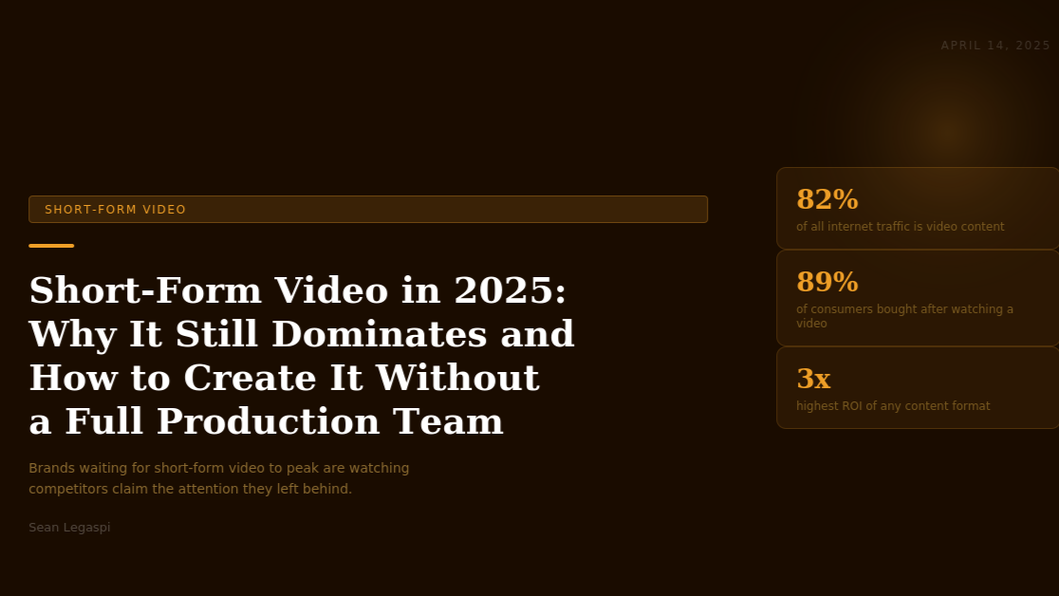

Short-Form Video in 2025: Why It Still Dominates and How to Create It Without a Full Production Team

April 14, 2026
Brands that are waiting for short-form video to peak are watching their competitors claim the attention they left on the table.
Short-form video was supposed to be a trend. In 2025, it is the dominant content format across every major social platform, and the gap between brands that have mastered it and those still treating it as optional is widening by the month.

WHY SHORT-FORM VIDEO KEEPS WINNING
The numbers are decisive. According to Cisco's Annual Internet Report, video content accounts for 82 percent of all internet traffic in 2024. Wyzowl's State of Video Marketing Report 2024 found that 89 percent of consumers say watching a video convinced them to buy a product or service. HubSpot's social media data shows that short-form video delivers the highest ROI of any content format for the third consecutive year.
The answer is rooted in how human attention works. Short-form video removes the friction from content consumption. It does not ask the viewer to read, to click, or to stay. It delivers the payoff immediately. This commercial incentive means organic reach for video content remains significantly higher than for static posts, even in 2025.

WHAT ACTUALLY PERFORMS IN 2025
The short-form video landscape has matured. What performs today has shifted in three important ways.
First, specificity beats personality. The videos that earn saves and shares in 2025 are those that teach something precise in under 60 seconds. According to a 2024 analysis by Vidyard, educational short-form videos see an average completion rate 34 percent higher than entertainment content.
Second, the first two seconds decide everything. Eye-tracking research published by Nielsen in 2024 confirmed that social media users make a scroll-or-stay decision within 1.7 seconds. The opening frame must immediately signal value, curiosity, or relevance.
Third, text-on-screen retains more viewers. Data from TikTok's own creative center shows that videos using on-screen text captions retain 15 to 20 percent more viewers. Facebook reports that 85 percent of video is watched with sound off.

HOW TO PRODUCE CONSISTENTLY WITHOUT A PRODUCTION TEAM
The Batch Recording Model: Dedicate two to three hours once a week to record all video content in a single session. Change your top between videos so the content feels spread across the week even though it was filmed in one session.
The 3-Part Structure:
- Hook (0 to 3 seconds): state the problem or payoff directly.
- Value (3 to 50 seconds): deliver the insight with specific details.
- Close (50 to 60 seconds): give a single clear call to action.
The Repurposing Stack: One 60-second TikTok becomes a Reel, a YouTube Short, a LinkedIn video post, and a Twitter clip. The script becomes a carousel or thread. One idea, five to six pieces of content.
The tools required are minimal: a smartphone with a decent camera, a portable ring light, a lapel microphone, and a free editing app. CapCut, InShot, and Adobe Express are all capable of producing platform-ready video without professional editing skills.

PLATFORM-SPECIFIC CONSIDERATIONS IN 2025
TikTok rewards posting frequency and trend responsiveness. Four to seven posts per week is optimal.
Instagram Reels between 30 and 60 seconds consistently outperform longer formats for reach.
LinkedIn video is still underdeveloped, meaning competition for organic reach is lower than on other platforms.
YouTube Shorts benefits from search functionality. Titling Shorts with searchable phrases drives sustained discovery traffic.

THE STRATEGIC TAKEAWAY
Short-form video rewards clarity, specificity, and consistency above everything else. The businesses that build this capability in 2025 are building an owned distribution channel with compounding returns. Every video that performs well feeds the algorithm signal that benefits the next one.
Sources:
- Cisco Annual Internet Report 2024 (cisco.com);
- Wyzowl State of Video Marketing 2024 (wyzowl.com);
- HubSpot State of Marketing Report 2024 (hubspot.com);
- Vidyard Video Benchmark Report 2024 (vidyard.com);
- Nielsen Attention Research 2024 (nielsen.com);
- TikTok Creative Center 2024 (ads.tiktok.com)

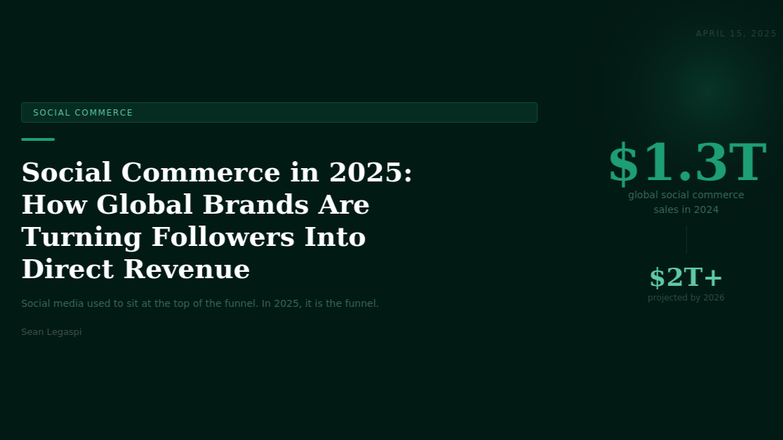

Copy of Social Commerce in 2025: How Global Brands Are Turning Social Media Followers Into Direct Revenue
April 15, 2026
Social media used to sit at the top of the funnel. In 2025, it is the funnel.
For years, social media's role in marketing was awareness. Brands built audiences, then drove them to websites where the actual conversion happened. That model is being replaced.

THE SIZE OF THE SHIFT
According to eMarketer's Global Social Commerce Report 2024, worldwide social commerce sales reached $1.298 trillion in 2024, up from $724 billion in 2022. By 2026, that figure is projected to exceed $2 trillion.
McKinsey's 2024 Consumer Behavior Study found that 37 percent of Gen Z consumers in the US, UK, and Australia had made at least one purchase directly through a social media platform in the past three months, up from 19 percent in 2022.

WHAT SOCIAL COMMERCE ACTUALLY LOOKS LIKE
Social commerce is not simply putting a "shop now" button on an ad. The most effective implementations are content-native, meaning the shopping experience emerges naturally from content rather than interrupting it.
- TikTok Shop: Products are tagged inside creator videos. TikTok's own data shows that products demonstrated in a creator video see conversion rates 4 to 8 times higher than traditional display ads for the same product.
- Instagram Shopping: The platform allows brands to tag products in feed posts, Stories, and Reels. Instagram's Checkout feature allows the full transaction to happen within the app.
- Pinterest: 80 percent of weekly Pinners have discovered a new brand or product on the platform. Shopping ads on Pinterest show 2.3x more efficient cost per conversion than other social platforms for home decor, fashion, and beauty categories.
- YouTube Shopping: Integrated directly into video content, product-tagged videos can generate purchase intent traffic months after upload due to YouTube's search-driven discovery model.

WHAT IS WORKING RIGHT NOW
Creator partnerships over brand-owned content. A 2024 Nielsen study found that 71 percent of consumers trust influencer recommendations at least as much as they trust friends and family. Brands that funnel social commerce through authentic creator partnerships consistently outperform those relying solely on their own branded accounts.
Live commerce for high-consideration purchases. Bambuser's 2024 Live Commerce Report found that brands using live shopping see conversion rates of 5 to 10 percent, compared to the 1 to 2 percent industry standard for e-commerce.
User-generated content as a conversion asset. According to Stackla's Consumer Content Report 2024, 79 percent of consumers say UGC highly impacts their purchasing decisions.
Frictionless checkout. Every additional tap between interest and purchase reduces conversion. Brands that have connected product catalogs to native in-app checkout consistently see lower cart abandonment rates.

HOW TO START IF YOU ARE NEW TO SOCIAL COMMERCE
If you sell physical products to a consumer audience, begin with Instagram Shopping and TikTok Shop. Set up a product catalog, connect it to your account, and start tagging products in your existing content.
If you are in a service-based industry, social commerce means integrated booking links in Instagram Stories, LinkedIn event registrations, and native lead forms on Facebook and LinkedIn.
Regardless of industry, the principle is the same: remove every barrier between discovery and commitment. Each redirect you eliminate improves conversion.

THE ROAD AHEAD
Social commerce is not a feature. It is an infrastructure shift in how commerce happens online. The window for early mover advantage is still open, but it is narrowing. Businesses that integrate this into their strategy in 2025 are positioning themselves ahead of an adoption curve that rewards early movers with lower acquisition costs.
Sources:
- eMarketer Global Social Commerce Report 2024 (emarketer.com);
- McKinsey Consumer Behavior Study 2024 (mckinsey.com);
- TikTok Business Data 2024 (business.tiktok.com);
- Pinterest Business Insights 2024 (business.pinterest.com);
- Nielsen Influencer Trust Research 2024 (nielsen.com);
- Bambuser Live Commerce Report 2024 (bambuser.com);
- Stackla Consumer Content Report 2024 (nosto.com/stackla)

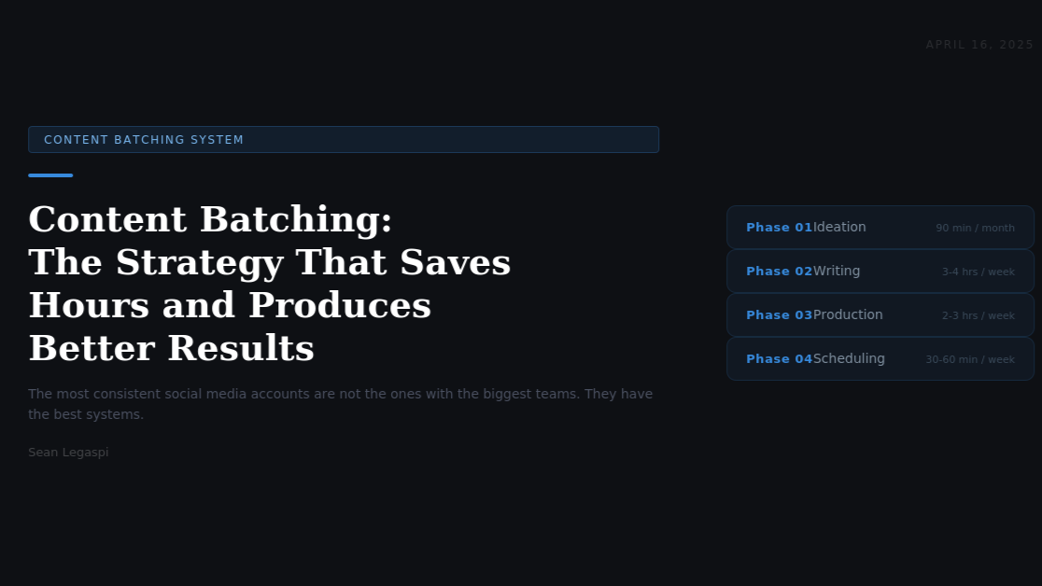

Content Batching: The Social Media Strategy That Saves Hours Every Week and Produces Better Results
April 16, 2026
The brands posting the most consistently on social media are not spending the most time on it.
Consistency is the single most important factor in social media growth. Every algorithm, on every platform, rewards accounts that show up regularly with relevant content.
The problem is that for most businesses, social media content is produced reactively. Something needs to go up today, so someone scrambles to create something this morning. The result is inconsistency, creative fatigue, and low-quality output.
Content batching solves all of this.

WHAT CONTENT BATCHING IS
Content batching is the practice of planning, creating, and scheduling large volumes of social media content in a single dedicated session, rather than creating content on demand each day.
According to Cal Newport's work on cognitive performance in "Deep Work" (2016), context switching between creative and administrative tasks reduces the quality of both. When a social media manager is forced to ideate, write, design, and publish all in one reactive session, the cognitive overhead of constant task-switching degrades creative output by as much as 40 percent.
Content batching eliminates context switching by grouping identical task types together: all ideation in one session, all writing in another, all design in another, all scheduling in another.

THE PERFORMANCE CASE FOR BATCHING
Buffer's 2024 State of Social Media Report analyzed content performance across 100,000 accounts and found that accounts with pre-scheduled content had 23 percent higher average engagement rates than accounts posting in real time. The researchers attributed this to more deliberate hook writing, better visual quality, and more strategic use of hashtags.
CoSchedule's research found that pre-planned content is published at optimal times 84 percent more consistently than reactively produced content.

HOW TO BUILD A CONTENT BATCHING SYSTEM
Phase 1: Ideation (90 minutes, once per month)
Set aside one session at the start of each month to generate all content ideas for the next four weeks. Use a content pillar framework: define three to five recurring themes and generate ideas within each pillar. Generate more ideas than you will use. A surplus means you select the strongest concepts rather than publishing whatever was easiest to create.
Phase 2: Writing (3 to 4 hours, once per week)
Write all captions, article outlines, and post copy for the upcoming week in a single session. Use templates for recurring format types to reduce decision fatigue. A caption bank where you save high-performing copy patterns from previous weeks accelerates this significantly.
Phase 3: Production (2 to 3 hours, once per week)
Design all visual assets and record all video content in a single production session. Design tools such as Canva, Adobe Express, and Figma allow you to create templates once and reuse them across weeks. For video, batch record multiple videos in one session, changing your appearance between recordings.
Phase 4: Scheduling (30 to 60 minutes, once per week)
Schedule all completed content using a social media management tool. Leading options include Buffer, Hootsuite, Later, and Sprout Social. When scheduling, prioritize optimal posting windows. For LinkedIn, Tuesday through Thursday between 8 AM and 10 AM consistently shows higher engagement. For Instagram, Tuesday and Wednesday between 11 AM and 1 PM.

THE WEEKLY TIME INVESTMENT
When implemented correctly, a batching system for a brand posting five times per week across two platforms requires approximately six to eight hours of total work per week, compared to the twelve to fifteen hours typically spent on reactive daily content creation. The quality improvement compounds over time as templates, formats, and audience insights accumulate.

COMMON MISTAKES TO AVOID
Over-scheduling creates rigidity. Leave at least 20 percent of your content slots open for reactive content tied to news or trends. Pre-planned content should anchor your strategy; real-time content keeps it feeling current.
Batching without analytics is incomplete. Review the previous week's performance metrics before starting each new batch. Know which formats, topics, and hooks performed above average and deliberately create more of those.
Ignoring platform-specific optimization. Batched content should be adapted for each platform rather than copied identically. LinkedIn audiences respond to professional tone and data. Instagram favors visual impact. TikTok rewards personality and directness.
Sources:
- Cal Newport, 'Deep Work' (Grand Central Publishing, 2016);
- Buffer State of Social Media Report 2024 (buffer.com/state-of-social);
- CoSchedule Marketing Statistics (coschedule.com/marketing-statistics);
- Sprout Social Optimal Posting Times Research 2024 (sproutsocial.com)



The Psychology of Viral Content: Why Some Posts Travel and Most Do Not
April 17, 2026
Going viral is not luck. It is the intersection of emotion, identity, and timing, and it can be engineered more precisely than most marketers realize.
Viral content is often described as unpredictable, as if the social media gods randomly choose which posts reach millions and which disappear. This framing is convenient because it removes accountability from marketers who produce forgettable content.
The reality is more rigorous. Viral content follows identifiable psychological patterns that have been studied extensively.

THE FOUNDATIONAL RESEARCH
The most comprehensive study of content virality remains Jonah Berger and Katherine Milkman's 2012 research at the Wharton School, published in the Journal of Marketing Research. Analyzing over 7,000 New York Times articles, they identified emotion as the primary driver of sharing, specifically the arousal level of the emotion triggered.
High-arousal emotions drive significantly more sharing than low-arousal emotions. Awe, anger, anxiety, and amusement all produce high arousal. Sadness, contentment, and boredom produce low arousal. Positive high-arousal emotions drive more shares than negative ones, though both outperform neutral content by a significant margin.
A 2022 meta-analysis published in the Journal of Computer-Mediated Communication reviewed 26 studies on content sharing behavior and confirmed that emotional arousal is the strongest predictor of sharing across all social platforms.

THE SIX VIRAL TRIGGERS
SOCIAL CURRENCY
People share content that makes them look good, knowledgeable, or interesting to their network. Content that provides rare insights or counterintuitive data triggers social currency sharing. According to 2023 Nielsen research, 49 percent of shares on LinkedIn are motivated by the desire to share useful content with connections.
TRIGGERS
Content associated with common environmental cues gets shared repeatedly over time. Weekly formats, seasonal relevance, and content tied to recurring conversations create built-in trigger patterns that drive consistent resharing.
HIGH-AROUSAL EMOTION
Content that produces awe, surprise, or amusement spreads more than content that is merely interesting. Write with stakes. Do not say something is important. Explain specifically why it changes how someone should think or act.
PUBLIC VISIBILITY
Content visually designed to be shared travels further. Carousels with quotable slides, graphics with bold text overlays, and posts structured as lists create shareable units within the post itself.
PRACTICAL VALUE
The more precisely defined the audience and the problem, the higher the practical value. "5 ways to improve engagement" is generic. "Why your LinkedIn posts stop getting reach after 3 hours and what to change" is precise.
STORIES
Research from Princeton neuroscientist Uri Hasson, published in the Proceedings of the National Academy of Sciences (2010), showed that listening to a story synchronizes the brain activity of speaker and listener. Content told as a story is processed more deeply and remembered longer than information delivered without narrative structure.

THE ARCHITECTURE OF A HIGH-SHARE POST
The hook must activate emotion or curiosity immediately. A post beginning with a surprising statistic, counterintuitive claim, or specific story earns the next line.
The body must deliver on the hook's promise with specificity. Vague advice is not shared. Precise, actionable insight is.
The ending must invite response. Posts that end with a direct, specific question consistently generate more comments than those ending with a statement.
The format must facilitate resharing. On LinkedIn, a post structured as a numbered list is significantly more shareable than prose. On Instagram, a carousel with one insight per slide creates multiple shareable frames.

WHAT THIS MEANS FOR BRAND CONTENT
Most brand content fails the virality test for a simple reason: it is designed to inform rather than to activate. The correction is to find the genuinely compelling truth in what you know and present it through the psychological architecture that earns attention and sharing.
Every industry has counterintuitive realities. Every business has stories of failure, recovery, and insight. Every profession has insider knowledge that seems obvious to practitioners and revelatory to outsiders. That is your viral content inventory.
Sources:
- Jonah Berger and Katherine Milkman, 'What Makes Online Content Viral,' Journal of Marketing Research, 2012;
- Journal of Computer-Mediated Communication Meta-Analysis 2022;
- Nielsen Content Motivation Research 2023 (nielsen.com);
- Uri Hasson, 'Neural Coupling,' PNAS, 2010 (pnas.org);
- Jonah Berger, 'Contagious: Why Things Catch On' (Simon and Schuster, 2013)
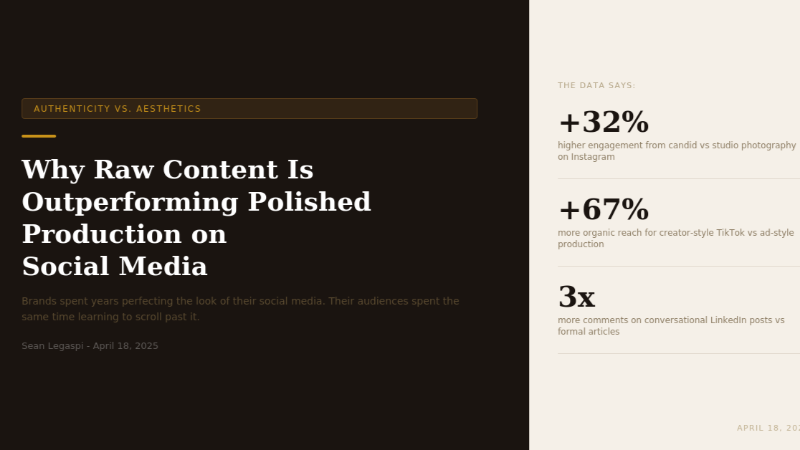

Authenticity vs. Aesthetics: Why Raw Content Is Outperforming Polished Production on Social Media
April 18, 2026
Brands spent years perfecting the look of their social media. Their audiences spent the same time learning to scroll past it.
There is a measurable paradox emerging in social media performance data: the more brands invest in polished, professionally produced content, the less their audiences engage with it.
Meanwhile, unpolished behind-the-scenes clips and candid moments consistently outperform the content that marketing teams spent weeks producing.

THE DATA BEHIND THE SHIFT
In 2024, Later's annual social media benchmark report found that on Instagram, carousel posts featuring candid or documentary-style photography achieved 32 percent higher engagement rates than studio-produced imagery.
On TikTok, Influencer Marketing Hub's analysis of 10,000 brand accounts showed that videos with a production style consistent with organic creator content received 67 percent more organic reach than videos that resembled traditional advertising.
On LinkedIn, Microsoft's research team found that text-based posts written in a conversational first-person voice received 3x more comments than formally structured articles from the same authors on the same topics.

BANNER BLINDNESS AND CONTENT TRUST
The concept of banner blindness, first identified in web usability research by Benway and Lane in 1998, described users' tendency to ignore content that looked like advertising. The same cognitive filter now applies to social media.
Research published in the Journal of Consumer Psychology in 2023 found that consumers rate content as significantly less trustworthy when it exhibits high production value combined with a promotional tone. The production value itself becomes a signal that the content has a commercial agenda, which triggers skepticism before a single word is processed.
According to Edelman's 2024 Trust Barometer, 71 percent of consumers globally say they are more likely to trust a brand that demonstrates transparency about its mistakes and challenges.

THE ANATOMY OF AUTHENTIC CONTENT
It is specific and personal. Authentic content references real situations, real numbers, real moments. "We doubled our LinkedIn reach in 90 days" is more engaging than "learn how to grow your social media."
It shows the process, not just the outcome. Behind-the-scenes content and honest accounts of what went wrong before it went right earn more trust than success stories alone.
It uses a conversational register. Content written in the same tone a person would use talking to a colleague outperforms content written to sound impressive. Short sentences. Direct address. Specific questions.

PLATFORM-SPECIFIC AUTHENTICITY BENCHMARKS
LinkedIn: Written posts in a direct, first-person voice with specific professional insights outperform formal thought leadership articles.
Instagram: Candid photography and minimally edited video consistently outperform studio imagery. Stories with interactive elements outperform passive stories by 2x on swipe-up rates.
TikTok: The talking-head format remains one of the highest-performing content types for personal brands and service businesses. The format works because it is recognizably non-commercial.
YouTube: Long-form process videos, where creators show work unfolding in real time, outperform highlight reels. Audiences are drawn to the arc of effort, uncertainty, and resolution.

THE STRATEGIC REFRAME
The shift from aesthetics to authenticity does not mean lowering standards. It means redefining them. The highest standard in social media content in 2025 is not visual perfection. It is the ability to create genuine connection through content that feels unmistakably human.
In a feed full of brands performing expertise, genuine expertise communicated simply is the most differentiated thing you can offer.
Sources:
- Later Social Media Benchmark Report 2024 (later.com);
- Influencer Marketing Hub TikTok Report 2024 (influencermarketinghub.com);
- Microsoft LinkedIn Research 2023 (microsoft.com/en-us/research);
- Benway and Lane, 'Banner Blindness,' Usability News, 1998;
- Journal of Consumer Psychology, Volume 33, 2023;
- Edelman Trust Barometer 2024 (edelman.com/trust)

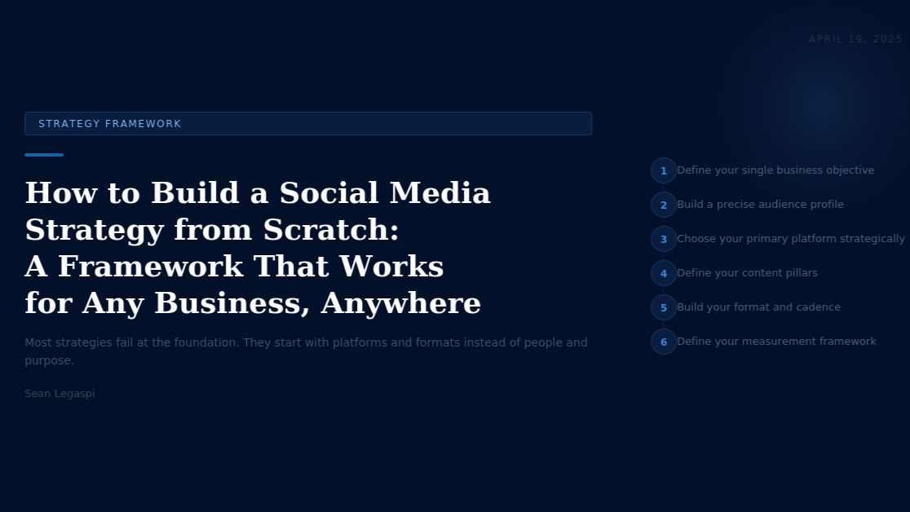

How to Build a Social Media Strategy from Scratch: A Framework That Works for Any Business, Anywhere

April 19, 2026
Most social media strategies fail at the foundation. They start with platforms and formats instead of starting with people and purpose
There is no shortage of social media tactics available to businesses today. What most businesses actually lack is not tactics. It is a strategy that connects their social media activity to their business objectives in a way that can be measured, refined, and scaled.
This framework is designed to be applicable to a solo entrepreneur in Lagos, a mid-sized e-commerce brand in Stockholm, and a professional services firm in Singapore equally.

STEP 1: DEFINE YOUR SINGLE BUSINESS OBJECTIVE
Before choosing a platform, content format, or posting frequency, define what you are actually trying to achieve. The five most common social media business objectives are:
- Brand awareness: making more people aware that your business exists
- Lead generation: collecting contact information from potential buyers
- Direct sales: converting social media audiences into paying customers
- Community building: creating an engaged audience that refers, advocates, and retains
- Talent attraction: building a reputation that makes the best candidates want to work for you
Each objective requires a different content strategy, different metrics, and different platform priorities. Choose one primary objective. Everything else flows from it.

STEP 2: BUILD A PRECISE AUDIENCE PROFILE
A practical audience profile answers six questions:
- Who are they by role and situation?
- What do they care about professionally and personally?
- What problems are they actively trying to solve?
- What content do they currently consume and trust?
- What language and vocabulary do they use when describing their problems?
- What does success look like to them, and what does failure cost them?
Primary research is the most reliable source for these answers. Interview five to ten of your best existing customers. The language they use in their answers is the language your content should use.

STEP 3: CHOOSE YOUR PRIMARY PLATFORM STRATEGICALLY
- LinkedIn: B2B audiences, professionals, decision-makers globally. Best for thought leadership and lead generation.
- Instagram: Consumer brands, lifestyle, and visual service industries. Strong purchase intent globally.
- TikTok: High discovery reach. Disproportionate young adult audience. Essential for fashion, beauty, and increasingly financial services and education.
- YouTube: Long-term SEO value, strong for tutorials across all industries. Search-driven discovery.
- Pinterest: High purchase intent for home, lifestyle, fashion, and food categories.
- Facebook: Broad demographic reach, strongest for local businesses and community-driven content.
Start with one platform. Build expertise, audience, and a content system there before expanding to a second.

STEP 4: DEFINE YOUR CONTENT PILLARS
Content pillars are the three to five recurring themes your account consistently creates content around. They give your audience a reason to follow, give your team a framework for ideation, and signal topical relevance to algorithms. Effective pillars are specific enough to differentiate you but broad enough to sustain months of content generation.

STEP 5: BUILD YOUR CONTENT FORMATS AND CADENCE
Format selection should be driven by what your audience consumes on your chosen platform and what you can produce consistently. The best format is not the most sophisticated one. It is the one you can execute at high quality on a repeatable schedule.
Posting cadence should be set at the maximum frequency you can sustain without compromising quality. For most businesses starting from scratch, three to four posts per week is the right starting point.

STEP 6: DEFINE YOUR MEASUREMENT FRAMEWORK
Social media metrics should connect directly to your chosen business objective.
For brand awareness: reach, impressions, follower growth rate.
For lead generation: profile visits, link clicks, form fills.
For direct sales: conversion events, revenue attributed to social.
For community building: comments, saves, repeat engager rate.
For talent attraction: page followers, employee advocacy reach, application source data.
Review metrics weekly at the post level and monthly at the account level.

THE 90-DAY LAUNCH PLAN
Days 1 to 30: publish consistently, prioritize your content pillars, resist premature optimization.
Days 31 to 60: analyze performance data, double down on the top-performing format and topic combination.
Days 61 to 90: systematize what is working into repeatable templates and adjust cadence if needed.
By day 90, you will have more reliable audience data than any strategy document could provide at the outset.

WHAT COMES AFTER THE FRAMEWORK
Strategy is a starting point, not a destination. The businesses that build lasting social media presence are those with the clearest sense of who they serve, what those people need, and how to communicate it in a way that respects and rewards their audience's attention.
That is a capability any business, anywhere in the world, can build.
Sources:
- Sprout Social Social Media Industry Benchmarks 2024 (sproutsocial.com);
- Hootsuite Global Social Media Trends 2025 (hootsuite.com/research/social-trends);
- DataReportal Digital 2024 Global Overview (datareportal.com);
- LinkedIn Marketing Solutions Blog 2024 (business.linkedin.com);
- Meta Business Insights 2024 (business.facebook.com)

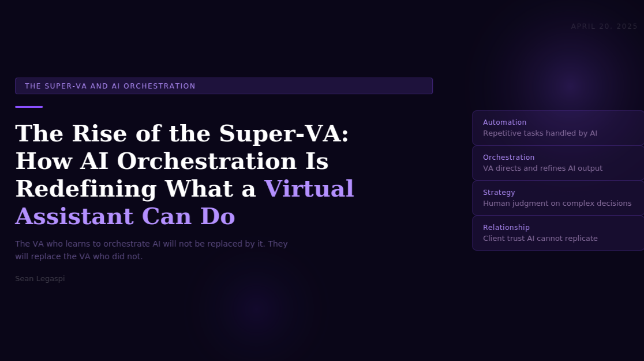

The Rise of the Super-VA: How AI Orchestration Is Redefining What a Virtual Assistant Can Do
April 20, 2026
The VA who learns to orchestrate AI tools will not be replaced by AI. They will replace the VA who did not.
The conversation around artificial intelligence and the future of work tends to frame things as a binary: humans versus machines, automation versus employment, AI replacing roles or AI being irrelevant. The reality emerging in 2025 is far more nuanced and, for virtual assistants specifically, far more compelling.
A new category of professional is taking shape at the intersection of human judgment and artificial intelligence. Researchers, practitioners, and early adopters are calling this role the Super-VA: a virtual assistant who does not merely complete tasks but directs, refines, and quality-controls the output of AI systems to produce results that neither a human working alone nor an AI operating without oversight could achieve.
This article examines what AI orchestration means in practice, how the Super-VA model is reshaping the value proposition of virtual assistance, which tools and skills define this emerging professional, and what business owners need to understand about how to leverage this capability.

UNDERSTANDING AI ORCHESTRATION
Orchestration, in the context of AI-assisted work, refers to the human practice of managing multiple AI tools, models, and automated workflows as a coordinated system rather than using each tool in isolation. The orchestrating professional does not simply prompt a single AI tool and accept its output. They design multi-step workflows, select the right AI tool for each task type, evaluate and refine outputs, and integrate the results of several AI processes into a coherent deliverable.
This distinction matters because the most common criticism of AI in professional contexts is that raw AI output requires significant human correction to be usable. The orchestrating VA is not surprised by this. They expect it. Their value lies precisely in their ability to extract the maximum useful output from AI tools while applying the contextual judgment, quality standards, and client knowledge that the AI does not possess.
According to a 2024 report by McKinsey Global Institute on the future of work, 60 to 70 percent of work activities across all occupations have the potential to be automated with current AI technology. However, the same report notes that automation of activities is not the same as automation of entire jobs. The roles that persist and grow are those that combine technical AI literacy with the uniquely human capacities for judgment, relationship management, and contextual reasoning.
For virtual assistants, this creates a specific and significant opportunity.

THE FOUR LAYERS OF THE SUPER-VA MODEL
The Super-VA operates across four distinct layers, each building on the one below it.
Layer 1: Task Execution with AI Assistance
At the foundation, the Super-VA uses AI tools to accelerate the execution of routine tasks. Email drafting, document summarization, data entry, calendar management, and basic research all become significantly faster with AI assistance. Tools like ChatGPT, Claude, Gemini, and Perplexity handle first drafts, summaries, and information gathering. The VA reviews, edits, and delivers. This layer represents the entry point into AI-augmented work.
Layer 2: Workflow Orchestration
At the second layer, the Super-VA designs and manages multi-step automated workflows that connect multiple AI tools and platforms. For example: a client's inbox is monitored by an AI email categorization tool. Priority emails trigger a draft response generated by a language model. The draft is reviewed by the VA, refined if necessary, and sent from the client's account. The interaction is logged in a CRM by an integration layer. The entire sequence runs with the VA as director rather than executor.
Tools enabling this layer include Zapier, Make (formerly Integromat), n8n, and the API connections between major platforms. Research published by the Harvard Business Review in 2023 found that knowledge workers who combined AI tools with workflow automation tools reported productivity gains of 25 to 40 percent on tasks involving communication, documentation, and information management.
Layer 3: AI Output Curation and Quality Control
At the third layer, the Super-VA serves as the quality standard for AI-generated output. This is the layer most often overlooked by those who assume AI will simply replace human workers. AI language models hallucinate facts, misread tone, miss cultural nuance, and produce outputs that are technically correct but contextually wrong. The Super-VA knows what good output looks like for a specific client, industry, and audience. They catch errors that an AI cannot recognize as errors.
This layer requires deep subject matter familiarity with the client's business, communication style, brand voice, and operational context. It cannot be replicated by a new AI hire or a generic service provider. It is built through relationship and experience, which is precisely why it is durable.
Layer 4: Strategic AI Consultation
At the highest layer, the Super-VA advises business owners on which AI tools to adopt, how to integrate them, and which processes should remain human-led. This is genuinely consultative work. According to Gartner's 2024 Technology Adoption Report, over 65 percent of small and medium-sized business owners say they want guidance on AI adoption but do not have the internal expertise to evaluate options. The Super-VA who has developed this expertise is positioned to fill a gap that no software can fill by itself.

THE TOOLS DEFINING THE SUPER-VA IN 2025
The specific tools that define Super-VA capability in 2025 fall into five categories:
Language and writing AI: ChatGPT-4, Claude 3, Gemini Pro, and Perplexity for drafting, research, summarization, and content creation.
Workflow automation: Zapier, Make, n8n, and Microsoft Power Automate for connecting platforms and building multi-step automated processes.
AI-enhanced project management: ClickUp AI, Notion AI, and Monday.com AI for task tracking, documentation, and project coordination with built-in AI assistance.
AI communication tools: Otter.ai and Fireflies.ai for meeting transcription and action item extraction; Superhuman and SaneBox for AI-assisted inbox management.
Image and presentation AI: Canva AI, Adobe Firefly, and Gamma for creating visual content and presentations from text prompts.
The breadth of this toolkit reflects the breadth of the Super-VA's operational scope. They are not specialists in one tool. They are generalists who can direct a system of tools toward a specific business outcome.

WHAT THIS MEANS FOR BUSINESS OWNERS
For business owners and entrepreneurs, the rise of the Super-VA has concrete implications for how they should think about operational support.
The first implication is that the value conversation has changed. A Super-VA is not a cost center to be minimized. They are a leverage multiplier. The right Super-VA, equipped with the right AI stack, can do the work of a three-person team for a fraction of the cost. Pricing this type of partnership based on hours worked misses the point entirely.
The second implication is that AI adoption requires a human guide. Purchasing access to AI tools does not automatically produce AI-powered efficiency. The integration, quality control, and ongoing optimization that converts raw AI capability into business results requires a skilled human practitioner. That practitioner is the Super-VA.
The third implication is that the competitive advantage window is opening now. Businesses that partner with AI-literate operational support in 2025 will build compounding advantages in speed, cost, and output quality over those that wait. The learning curve for AI tool integration is steep, and early movers build institutional knowledge that late adopters will struggle to replicate quickly.

THE LONG-TERM TRAJECTORY
The World Economic Forum's Future of Jobs Report 2024 identifies AI and machine learning as the top driver of job transformation, estimating that 44 percent of core worker skills will be disrupted in the next five years. In this context, the VA who develops AI orchestration capability is not just protecting their position. They are repositioning themselves at the highest-value layer of a transforming profession.
The future of virtual assistance is not a race to the bottom on hourly rates. It is a race to the top on strategic leverage. The Super-VA is the professional who understands this and is building accordingly.
Sources:
- McKinsey Global Institute, 'The Future of Work After COVID-19,' 2024 (mckinsey.com/featured-insights/future-of-work)
- Harvard Business Review, 'How People Are Really Using Gen AI,' 2023 (hbr.org)
- Gartner Technology Adoption Report 2024 (gartner.com)
- World Economic Forum, 'Future of Jobs Report 2024' (weforum.org)
- OpenAI and Anthropic product documentation 2024; Zapier State of Business Automation 2024 (zapier.com/blog/state-of-business-automation)


The 80/20 Time Audit: How to Find the 20 Percent of Your Work That Produces 80 Percent of Your Results
April 21, 2026
Most professionals are busy with the wrong things. The 80/20 Time Audit is the diagnostic that reveals exactly which tasks to stop, which to delegate, and which to double down on.
Vilfredo Pareto, an Italian economist, observed in 1896 that approximately 80 percent of the land in Italy was owned by 20 percent of the population. He verified a similar pattern in other countries and in other domains, and the observation became the foundation of what is now known as the Pareto Principle or the 80/20 Rule: in most systems, 80 percent of outcomes are produced by 20 percent of inputs.
The Pareto Principle has been applied to business, economics, software engineering, and sales with consistent empirical support. In professional time management, its application is equally powerful and significantly underused.
Most professionals operate without a clear understanding of which of their daily activities actually produce results and which activities create the feeling of productivity without generating meaningful output. The 80/20 Time Audit is a structured diagnostic process that answers this question with data rather than assumption.
This article explains the research behind the Pareto Principle in professional contexts, provides a step-by-step methodology for conducting a rigorous 80/20 Time Audit, and describes how to act on the findings in a way that materially changes how you work.

THE RESEARCH FOUNDATION
The application of the Pareto Principle to professional time management is not merely anecdotal. A 2021 study published in the Journal of Applied Psychology examined the work patterns of 600 knowledge workers across four industries over a 12-week period. Researchers found that an average of 18 percent of a worker's daily activities accounted for 79 percent of their self-reported meaningful output, closely tracking the Pareto distribution.
Richard Koch, in his seminal book "The 80/20 Principle" (1997), analyzed professional performance across multiple sectors and found consistent evidence that a minority of efforts produce a majority of results. His conclusion was not that the majority of work should be eliminated but that the minority of high-output activities deserved far more deliberate investment and protection than they typically received.
Microsoft's 2023 Work Trend Index, based on data from 31,000 workers across 31 countries, found that the average knowledge worker spends 57 percent of their time on communication and coordination activities, such as meetings, email, and messaging, leaving only 43 percent for focused, individual work. Within that 43 percent, not all focused work produces equal results. The audit is the mechanism for identifying which focused activities are actually in the high-value 20 percent.
A further study by Gloria Mark at the University of California Irvine, published in 2023, found that after an interruption, it takes an average of 23 minutes and 15 seconds to fully return to a task at the same level of cognitive engagement. This finding has profound implications for time auditing: not only do certain tasks produce disproportionate results, but the fragmentation of time through interruption and context switching reduces the effectiveness of all tasks, including the high-value ones.

THE 80/20 TIME AUDIT: STEP-BY-STEP METHODOLOGY
The audit is conducted in three phases: data collection, analysis, and restructuring. Each phase requires a distinct type of work and produces a different type of insight.
Phase 1: Data Collection (5 to 7 working days)
For one full work week, record every activity you engage in at 30-minute intervals. The recording should be done in real time, not reconstructed at the end of the day. Reconstructed time logs consistently overestimate time spent on strategic work and underestimate time spent on email, meetings, and administrative tasks, as research by Laura Vanderkam in "168 Hours" (2010) has shown.
The recording format should include: the task or activity, the category it belongs to (communication, execution, planning, learning, relationship building, administrative), the approximate time spent, and a rating of the perceived importance of the activity on a scale of one to five.
Use a simple spreadsheet or a time-tracking tool such as Toggl Track or Clockify. The goal is not precision to the minute but a reliable overall picture of where your hours are actually going.
Phase 2: Analysis (2 to 3 hours)
Once the week of data is collected, the analysis asks four questions:
Which activities have produced the most meaningful outcomes this week? Be specific. Not "client work" but "writing the onboarding documentation for Client A that saved three hours of orientation per new team member." Not "meetings" but "the Wednesday strategy call that resulted in a decision to discontinue a project saving forty hours of team time."
Which activities consumed the most time relative to their output? These are the candidates for delegation, systemization, or elimination. Common findings include: weekly status meetings that could be replaced by a shared document update, email management that could be handled by an assistant, and routine reporting tasks that could be automated.
Which high-value activities are currently being crowded out by low-value ones? Identify the work you are not doing because you are busy doing everything else. This is often where the highest leverage is found.
What patterns appear across the week? Are mornings spent on low-value reactive work, leaving creative and strategic work for the afternoons when cognitive resources are depleted? Are entire days consumed by a single category of work at the expense of others?
Phase 3: Restructuring (Ongoing)
The output of the analysis is a personal prioritization matrix: a clear, documented list of which activities belong in each of four categories.
Category 1: Keep and Protect. High-value activities that produce disproportionate results. These get your best hours, your full attention, and explicit protection from interruption. In most professional audits, these activities represent no more than two to four core tasks per day.
Category 2: Delegate. Activities that someone else could do with equal or near-equal quality. These are moved off your plate to an assistant, a team member, or an automated system. For business owners and professionals working with VAs, this is where the handoff list is built.
Category 3: Systemize. Activities that must stay on your plate but can be made dramatically more efficient through templates, standard processes, or automation. A weekly email update that takes 90 minutes becomes a 20-minute task when a template captures the structure.
Category 4: Eliminate. Activities that produce no meaningful output and persist only through habit, obligation, or inertia. These are stopped entirely. Meetings that produce no decisions, reports that no one reads, and tasks that exist because "we have always done it this way" all belong here.

THE 80/20 AUDIT IN PRACTICE: COMMON FINDINGS
Across hundreds of professional time audits conducted in business coaching and productivity consulting contexts, several patterns appear with consistent regularity.
Email is almost universally in the wrong category. Most professionals treat email as a Category 1 priority by checking it first thing in the morning and responding reactively throughout the day. The audit almost always reveals that email belongs in Category 2 (delegate to an assistant) or Category 3 (systemize with batch checking windows and templates).
The highest-value activities are rarely scheduled. The work that produces the most results tends to be the work that most professionals do when they happen to have uninterrupted time, which is rarely and irregularly. The audit makes a case for explicitly scheduling the high-value 20 percent rather than fitting it in around everything else.
Meetings are systematically over-attended. Most professionals attend meetings because they were invited, not because their presence was essential. The audit reveals which meetings produce outcomes that justify the time and which represent a drain on the hours that would be better spent on Category 1 work.
Deep work windows are shorter than believed. The Microsoft Work Trend Index finding that 57 percent of time is spent on communication and coordination is consistently validated by individual time audits. Most professionals have two to three hours of genuine focused work per day, not eight.

APPLYING THE AUDIT TO OPERATIONAL SUPPORT
For operations VAs and executive assistants, the 80/20 Time Audit is both a personal productivity tool and a client service tool. Conducting a time audit on behalf of a client is one of the highest-leverage onboarding activities available.
In the first week of a new client engagement, tracking how the client actually spends their time reveals the specific Category 2 activities to delegate immediately, the Category 3 activities that need systemizing, and the Category 1 activities that need protecting from the rest.
This audit-based approach to onboarding produces faster results, stronger trust, and a clearer mandate for the VA's role than a generic handoff of recurring tasks.

THE COMPOUND EFFECT OF THE AUDIT
The 80/20 Time Audit is not a one-time exercise. Conducted quarterly, it functions as a recalibration mechanism that keeps professional time aligned with current priorities rather than historical habits.
Richard Koch estimated in his follow-up book "The 80/20 Manager" (2013) that professionals who internalize and regularly apply the Pareto Principle to their time allocation achieve two to five times the output of peers with similar skills and resources over a five-year period. The compounding effect of consistently protecting high-value work and eliminating or delegating low-value work is not linear. It is exponential.
The first audit produces an improvement. The second audit refines it. By the fifth audit, the professional's entire working structure has been rebuilt around the small set of activities that actually produce their results.
Sources:
- Vilfredo Pareto, Cours d'economie politique, 1896
- Richard Koch, 'The 80/20 Principle' (Currency, 1997)
- Richard Koch, 'The 80/20 Manager' (Piatkus, 2013)
- Journal of Applied Psychology, Volume 106, 2021 (apa.org/pubs/journals/apl)
- Microsoft Work Trend Index 2023 (microsoft.com/en-us/worklab/work-trend-index)
- Gloria Mark, University of California Irvine Research on Interruption and Recovery, 2023 (ics.uci.edu)
- Laura Vanderkam, '168 Hours' (Portfolio, 2010)
- Toggl Track Time Tracking Research 2024 (toggl.com/blog)

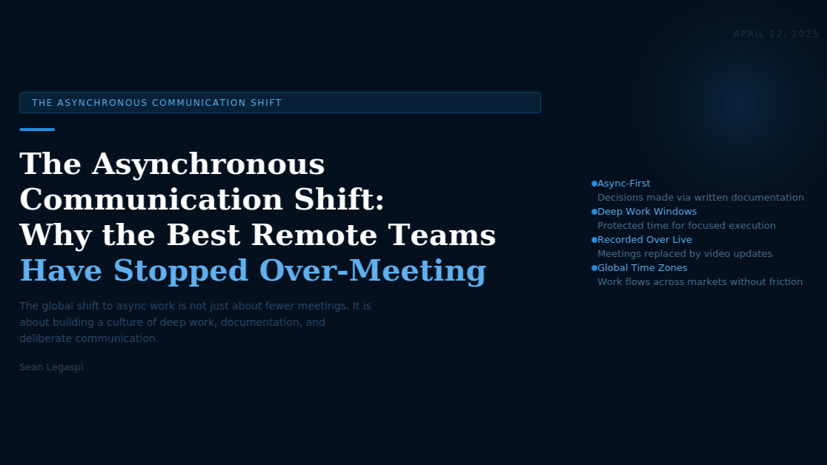

The Asynchronous Communication Shift: Why the Best Remote Teams Have Stopped Over-Meeting
April 22, 2026
The global shift to async work is not just about fewer meetings. It is about building a culture of deep work, documentation, and deliberate communication.
When the COVID-19 pandemic forced hundreds of millions of knowledge workers into remote work environments almost overnight, most organizations responded by recreating their office communication patterns digitally. Physical meetings became video calls. Hallway conversations became Slack messages. The assumption was that real-time communication was simply what work required.
Three years later, the organizations that have genuinely thrived in remote and distributed environments are the ones that questioned that assumption most aggressively. They discovered that most real-time communication is not actually real-time communication. It is synchronous coordination that could be asynchronous documentation. And the shift from one to the other is one of the highest-leverage organizational changes available to modern teams.
This article examines the research behind synchronous versus asynchronous communication in professional contexts, the specific practices that define async-first organizations, the tools that support this model, and the practical steps teams can take to make the transition without losing the relational coherence that synchronous communication genuinely provides.

WHY SYNCHRONOUS COMMUNICATION IS SYSTEMICALLY OVERUSED
The default bias toward synchronous communication in professional environments has several roots. It mimics physical office behavior, which organizations are familiar with. It feels productive because it produces immediate responses and visible activity. It satisfies the social need for interaction and confirmation. And it creates a sense of shared pace and alignment.
But synchronous communication also has substantial costs that are rarely measured or acknowledged.
The first cost is attention fragmentation. As previously noted in the research of Gloria Mark at UC Irvine, a single interruption requires an average of 23 minutes of recovery time before full cognitive engagement is restored. In an environment with multiple daily meetings, constant messaging notifications, and ad hoc calls, sustained deep work becomes structurally impossible for most knowledge workers.
A 2023 study published in the MIT Sloan Management Review found that the average knowledge worker attends 21.5 meetings per week, with 71 percent of senior managers reporting that meetings are unproductive and 65 percent reporting that meetings prevent them from completing their own work. The researchers estimated the total economic cost of unnecessary meetings in the United States alone at $37 billion annually.
The second cost is time zone exclusion. For globally distributed teams, the bias toward synchronous communication systematically disadvantages team members in inconvenient time zones. When every important decision requires a live call, team members in Asia-Pacific cannot be present for decisions made by teams in the US or Europe during business hours. The result is a two-tier team structure where presence in certain time zones correlates with access to information and influence.
The third cost is the documentation deficit. When decisions are made in meetings, they exist only in the memories of those who attended. When those decisions are made in writing, through a structured async communication process, they are automatically documented, searchable, and accessible to team members who were not present and to future team members who were not yet hired. Organizations that conduct their work asynchronously build institutional memory as a natural byproduct. Synchronous-first organizations must invest explicitly in documentation that async teams produce automatically.

THE CHARACTERISTICS OF ASYNC-FIRST ORGANIZATIONS
The most prominent examples of async-first organizations provide practical templates for how this model works at scale.
GitLab, a software company with over 2,000 employees distributed across 65 countries, operates on a publicly documented async-first principle. Their company handbook, which is available publicly at about.gitlab.com, describes their communication philosophy in detail: writing is default, synchronous communication requires an explicit justification for why async would not work, and all decisions are documented in their handbook before they are acted on. GitLab has maintained this model through rapid growth, demonstrating that async-first is not a small-team luxury but a scalable organizational operating system.
Basecamp, the project management company, has documented their async communication philosophy extensively in the books "Remote" (2013) and "It Doesn't Have to Be Crazy at Work" (2018) by Jason Fried and David Heinemeier Hansson. Their core principle is that real-time communication creates artificial urgency and that most questions people want to ask synchronously can be answered just as well in a written format that does not interrupt the recipient.
Automattic, the company behind WordPress.com, employs approximately 1,900 people across 96 countries and has operated async-first since its founding. CEO Matt Mullenweg has described the model as a deliberate inversion of office norms: the default is writing, the exception is a call, and the expectation is that people work when they are most productive rather than when they are most available.

THE FIVE PRACTICES OF ASYNC-FIRST TEAMS
Practice 1: Written-First Communication
Every request, update, decision, and piece of information is communicated in writing before a meeting is considered. The discipline of writing forces clarity. You cannot be vague in writing in the way you can be in conversation, because the recipient cannot ask for immediate clarification. This constraint produces better-structured communication.
Practice 2: Structured Update Rituals
Rather than daily stand-ups, async-first teams use structured written updates: a brief daily or weekly written summary of what was completed, what is in progress, and what is blocked. Tools like Range, Geekbot (integrated with Slack), and Notion daily templates support this practice. The update is written when the team member has a natural breaking point in their work, not when a scheduled meeting demands their presence.
Practice 3: Documentation as a First-Class Output
In async-first organizations, documentation is not a bureaucratic chore. It is the primary product of knowledge work. Every process, decision, policy, and strategy is documented in a centralized, searchable system. Notion, Confluence, and GitLab's own wiki system are common choices. The test of whether documentation is adequate is whether a new team member could understand a decision or a process without asking anyone.
Practice 4: Deliberate Synchronous Communication
Synchronous communication does not disappear in async-first organizations. It becomes deliberate and high-value. Meetings are reserved for the specific communication functions that genuinely require real-time interaction: building relationship and trust with new team members, resolving complex conflicts that require emotional nuance, collaborative creative work where real-time iteration produces better outcomes, and time-sensitive decisions that genuinely cannot wait for an async exchange.
When meetings do occur, they have written agendas distributed in advance, documented decisions immediately after, and a clear test of whether the meeting's purpose could have been achieved asynchronously.
Practice 5: Defined Response Time Expectations
Async-first culture requires explicit norms around response time that replace the implicit availability expectation of synchronous communication. Typical async norms distinguish between channel types: a direct message might have a four-hour response expectation, a project thread a same-day response, and a non-urgent channel a 24-hour response. These norms reduce the anxiety that people new to async work often experience: the worry that not responding immediately signals disengagement.

ASYNC COMMUNICATION TOOLS IN 2025
The tool ecosystem supporting async-first work has matured considerably. The leading options in 2025 include:
Loom and Vidyard for asynchronous video messaging: replacing the "quick call" with a recorded video that the recipient watches at their convenience. Video preserves tone and non-verbal communication in a way that text cannot.
Notion and Confluence for documentation: centralized, searchable knowledge bases that serve as the single source of truth for organizational knowledge.
Linear and Height for async project tracking: task and project management tools that reduce the need for status meetings by making work status visible to everyone without a synchronous check-in.
Slack and Microsoft Teams for structured asynchronous text communication: both platforms support channel-based communication that, when used with defined norms, functions as async-first tools rather than real-time chat.
Supernormal and Otter.ai for automated meeting documentation: AI-powered transcription and summarization tools that ensure every synchronous meeting that does occur produces an async-compatible record.

THE RELEVANCE FOR OPERATIONS AND VIRTUAL ASSISTANCE
For virtual assistants and operations professionals working across time zones, the async-first model is not merely a preference. It is a professional competency.
The VA who operates async-first can serve clients across multiple time zones without requiring overlap hours. They can manage complex projects without daily synchronous coordination. They build documentation systems that give clients confidence that nothing falls through the cracks in the absence of real-time oversight. And they free the client from the operational burden of managing communication in real time with a distributed support team.
Building async communication competency as a VA is not just about personal productivity. It is a differentiated capability that expands the potential client base, increases operational efficiency, and reduces the dependency on time-zone alignment that limits synchronous-first VAs to clients in compatible geographies.
Sources:
- Gloria Mark, 'Attention Span: A Groundbreaking Way to Restore Balance, Happiness and Productivity' (Hanover Square Press, 2023)
- MIT Sloan Management Review, 'Stop the Meeting Madness,' 2023 (sloanreview.mit.edu)
- GitLab Remote Playbook (about.gitlab.com/company/culture/all-remote)
- Jason Fried and DHH, 'Remote: Office Not Required' (Crown Business, 2013)
- Jason Fried and DHH, 'It Doesn't Have to Be Crazy at Work' (HarperBusiness, 2018)
- Automattic Team Operations Blog 2024 (automattic.com)
- Microsoft Work Trend Index 2023 (microsoft.com/en-us/worklab/work-trend-index)
- Harvard Business Review, 'Dear Manager, You Are Wasting People's Time,' 2022 (hbr.org)
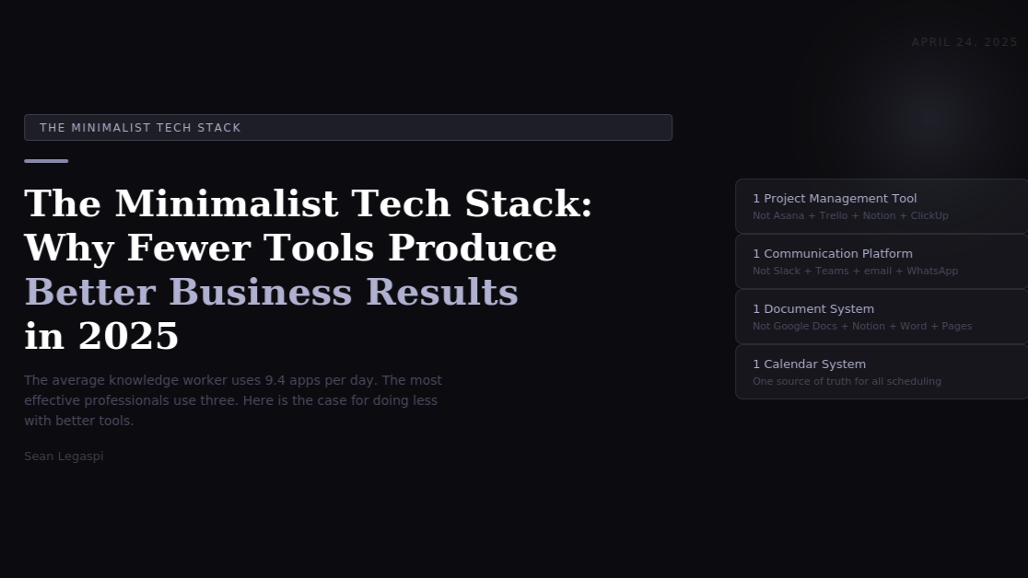

The Minimalist Tech Stack: Why Fewer Tools Produce Better Business Results in 2025
April 24, 2026
The average knowledge worker now uses 9.4 apps per day. The most effective professionals use three. Here is the case for doing less with better tools.
There is a pervasive assumption in modern business that more tools mean more capability. Every productivity problem invites a new software solution. Every workflow gap suggests a new integration. The result, for most organizations and solo professionals in 2025, is a technology stack that has grown to a size that creates more friction than it resolves.
The research on this phenomenon is unambiguous. The tools themselves are not the problem. The proliferation of tools is.
This article examines the research behind tool overload and cognitive costs, the principles of minimalist tool architecture, the specific categories where consolidation produces the greatest gains, and the methodology for auditing and simplifying a technology stack without losing critical functionality.

THE RESEARCH ON TOOL OVERLOAD
Okta's Business at Work Report 2024 found that the average enterprise organization used 93 different software applications, up from 80 in 2021. For small and medium-sized businesses, the comparable figure from Zapier's State of Business Automation 2024 is 9.4 apps used actively per day by the average knowledge worker.
The cognitive cost of this proliferation is well-documented. A study published in the Journal of Experimental Psychology in 2022 found that multitasking across multiple digital interfaces reduces the quality of decisions made in each context. Each application switch requires a brief but real cognitive transition: the brain must load the context, rules, and expectations of a new environment before productive work can begin. At 9.4 apps per day, this context loading is happening dozens of times each working day.
Beyond cognitive costs, tool proliferation creates organizational costs. Research by Productiv in 2024 found that organizations pay for an average of 2.5 times as many software licenses as are actively used. The underutilization rate for enterprise software sits at approximately 42 percent: tools are purchased, partially onboarded, and then abandoned or underused while license costs continue to accrue.
The communication cost is equally significant. When information about a project lives across Slack, email, Notion, a project management tool, a shared Google Drive folder, and a CRM, no one has a complete picture of any given situation without conducting a search across multiple systems. This search cost compounds with team size.
Cal Newport's research in "A World Without Email" (2021) describes the cognitive cost of this fragmented communication environment as an always-on cognitive background hum: a persistent low-level processing load created by the need to monitor multiple channels for incoming information. Newport argues that this background processing is a primary driver of the knowledge worker fatigue that most professionals attribute to workload volume rather than environmental structure.

THE PRINCIPLES OF MINIMALIST TOOL ARCHITECTURE
The minimalist tech stack is not about using the fewest possible tools regardless of functionality. It is about applying three specific architectural principles.
Principle 1: One Tool Per Function
For every distinct function in a business workflow, there should be one designated tool. Not the best tool for each team member's preference, but the best tool for the function that everyone uses. Project management, communication, documentation, scheduling, client relationship management: each gets one tool.
This principle requires a decision rather than an accommodation. Most tool sprawl begins when different team members use different tools for the same function and no one makes the organizational decision to standardize. The minimalist architecture requires making that decision explicitly and enforcing it consistently.
Principle 2: Integration Before Addition
Before adding a new tool to the stack, the first question is whether an existing tool can be extended or configured to serve the new function. Most enterprise software in 2025 has significantly more functionality than the average user explores. Notion can replace a standalone meeting notes tool, a project tracker, a CRM, a content calendar, and a documentation system if configured correctly. ClickUp can replace both a project management tool and a team communication tool for many teams. Integration and configuration almost always produces less friction than addition.
Principle 3: Total Cost of Ownership Over Feature Comparison
The standard approach to software evaluation compares feature sets: which tool has more capabilities? The minimalist approach evaluates total cost of ownership, which includes license cost, onboarding time per new team member, the cognitive load of learning and maintaining the tool, the integration complexity with existing systems, and the switching cost if the tool is later replaced.
A slightly less featured tool that integrates cleanly with existing systems, has a short learning curve, and is used consistently by the entire team almost always produces better results than a more featured tool that is partially adopted and poorly integrated.

THE FOUR-CATEGORY MINIMALIST STACK
For knowledge workers, operations professionals, and virtual assistants, the minimalist stack can be organized into four categories, each requiring one primary tool.
Category 1: Project and Task Management
The function: tracking what needs to be done, who is responsible, by when, and what its current status is.
The candidates: ClickUp, Notion, Asana, Monday.com, Linear (for technical teams), and Basecamp. The right choice depends on team size, workflow complexity, and integration requirements. What matters is choosing one and using it consistently.
The common mistake is maintaining a project management tool alongside a separate task list in email, a personal to-do app, and a team chat channel where tasks are posted informally. This redundancy guarantees that tasks will fall through the gaps between systems.
Category 2: Communication
The function: written communication between team members and with clients.
For internal team communication, the dominant options are Slack and Microsoft Teams. For client communication, email remains the standard, augmented in many professional contexts by a client portal within the project management tool.
The minimalist architecture treats these as two separate but single-tool functions: one internal communication platform, one client communication channel. The most common unnecessary addition is a third layer of informal communication, typically WhatsApp or personal messaging apps, that fragments professional communication into a context where it is unsearchable, undocumented, and difficult to manage.
Category 3: Documentation and Knowledge Management
The function: storing, organizing, and retrieving the information the business needs to operate, including SOPs, client information, meeting notes, reference materials, and institutional knowledge.
The leading options are Notion, Confluence, and GitBook. For smaller teams and solo operators, Notion's flexibility makes it the most common choice. The key architectural requirement is that this system is the single source of truth for all organizational knowledge, and that every piece of information that needs to be retained is stored here rather than in a chat message, an email thread, or a document on someone's local drive.
Category 4: Scheduling and Calendar
The function: managing time commitments, scheduling meetings with external parties, and maintaining a master view of availability.
Google Calendar and Microsoft Outlook Calendar serve the scheduling function. Calendly, Cal.com, and SavvyCal serve the external booking function. The minimalist principle requires that these connect to a single calendar system rather than maintaining separate personal and professional calendars in different applications.

THE AUDIT METHODOLOGY: SIMPLIFYING AN EXISTING STACK
For most professionals and teams, the challenge is not building a minimalist stack from scratch but simplifying an existing stack that has grown organically. The following methodology produces a clear picture of what to keep, what to consolidate, and what to eliminate.
Step 1: Inventory. List every digital tool currently used, however infrequently. Include all subscriptions, even those that feel peripheral. The complete inventory typically surprises people with its length.
Step 2: Function mapping. For each tool, identify its primary function and secondary functions. Note whether another tool on the list serves the same primary function. Duplications at this stage are the first candidates for consolidation.
Step 3: Usage audit. For each tool, estimate the actual weekly usage in hours. Tools with less than one hour per week of actual usage are almost always eliminable or consolidable.
Step 4: Integration assessment. Identify which tools in the stack communicate with each other and which require manual data transfer between them. Manual transfer points are the operational friction points where errors occur and time is lost.
Step 5: Consolidation decision. Based on the function mapping and usage audit, identify the minimum set of tools that covers all required functions with the best integration profile. Make the consolidation decision as an explicit organizational or personal choice rather than allowing the old tools to persist by inertia.

THE OPERATIONS VA AND THE MINIMALIST STACK
For operations virtual assistants, tool stack architecture is a core professional competency. The VA who can audit a client's tool stack, identify redundancies and friction points, and implement a cleaner architecture delivers organizational value that extends far beyond task execution.
The skill set involved includes familiarity with the major tools in each category, the ability to evaluate tools on total cost of ownership rather than feature comparison, the ability to design integrations between tools using platforms like Zapier or Make, and the communication skills to manage the change process when team members are accustomed to existing tools.
This capability positions the operations VA not as a task executor but as an operational architect, a role that commands significantly higher rates, produces more visible results, and builds deeper client relationships than hourly task management.
Sources:
- Okta Business at Work Report 2024 (okta.com/resources/whitepaper-businesses-work)
- Zapier State of Business Automation 2024 (zapier.com/blog/state-of-business-automation)
- Journal of Experimental Psychology, 'The Cost of Task Switching,' 2022 (apa.org/pubs/journals/xge)
- Productiv SaaS Intelligence Report 2024 (productiv.com/blog)
- Cal Newport, 'A World Without Email' (Portfolio/Penguin, 2021)
- Basefirm App Consolidation Research 2024 (basefirm.com)

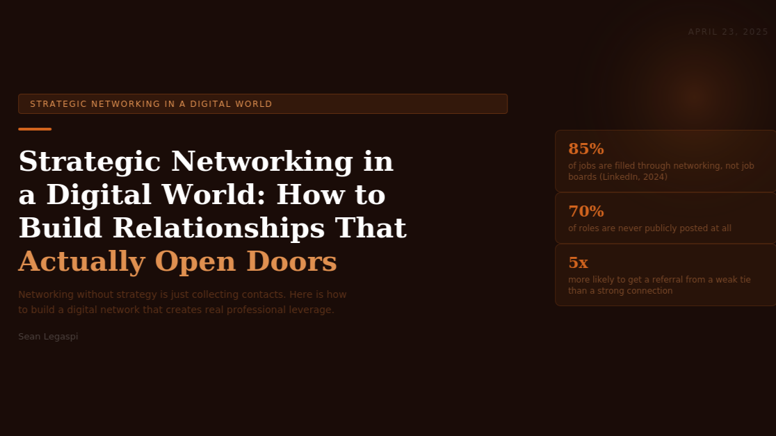Strategic Networking in a Digital World: How to Build Relationships That Actually Open Doors

April 24, 2026
Networking without strategy is just collecting contacts. Here is how to build a digital network that creates real professional leverage.
The word networking carries a weight of ambivalence in professional culture. On one hand, virtually every career and business development resource emphasizes its importance. On the other hand, most people find unstructured networking uncomfortable, inefficient, and uncertain in its return. The gap between knowing networking matters and knowing how to do it well is wide and rarely addressed with precision.
This article examines the research on how professional networks actually produce outcomes, the specific structural characteristics of high-leverage digital networks, the strategies that convert online connections into real professional relationships, and the practices that sustain those relationships over time.

THE RESEARCH ON HOW NETWORKS CREATE VALUE
The foundational academic work on professional networking comes from sociologist Mark Granovetter, whose 1973 paper "The Strength of Weak Ties," published in the American Journal of Sociology, produced one of the most influential and frequently cited findings in social science.
Granovetter studied how people found jobs and discovered a counterintuitive result: most people found their most significant career opportunities not through their close, strong-tie relationships (friends, family, close colleagues) but through their weak-tie relationships (acquaintances, former colleagues, people met once at a conference). The explanation is structural: strong ties tend to share your existing network and knowledge base. Weak ties connect you to different networks and different information.
A 2022 study published in Science by Siddharth Suri and colleagues at Microsoft Research validated Granovetter's findings in the context of digital professional networks. Analyzing data from 20 million LinkedIn users over a five-year period, they found that professional mobility, meaning new job opportunities and business connections, was most strongly correlated with weak-tie network diversity rather than strong-tie network depth. People with more diverse networks of weak ties were significantly more likely to change jobs successfully, to find new opportunities, and to gain access to novel information.
LinkedIn's own data, published in their Global Talent Trends Report 2024, states that 85 percent of jobs are filled through networking and that 70 percent of roles are never publicly posted. For business development, the figures are comparably significant: McKinsey's 2024 B2B Decision-Making Survey found that 76 percent of B2B buyers prefer providers recommended by someone in their network over those found through direct outreach or advertising.
Understanding these findings has direct implications for how to build and maintain a professional network. The goal is not a large collection of strong ties. It is a strategically diverse network of weak ties that connects you to different industries, functions, geographies, and knowledge bases.

THE STRATEGIC FRAMEWORK FOR DIGITAL NETWORKING
Effective digital networking in 2025 operates through a framework of four interconnected elements: visibility, specificity, reciprocity, and consistency.
Visibility: Being Known for Something Specific
The foundational problem with most professional digital presences is that they communicate what someone does without communicating why that work matters or what makes them specifically valuable. A LinkedIn profile that lists job titles and responsibilities gives a connection no reason to think of you when a relevant opportunity arises.
Visibility, in the context of strategic networking, means being consistently associated with a specific area of expertise or perspective in the minds of your network. This is achieved through content: publishing posts, articles, and comments that demonstrate a clear point of view on topics relevant to your professional field.
Research by LinkedIn's talent insights team in 2024 found that profiles with consistent content publishing received 5.6 times more profile views than passive profiles and were 36 times more likely to receive inbound messages from potential partners, clients, or employers.
The content does not need to be voluminous or frequent. Three to four pieces of valuable content per week on consistent themes is more effective than daily posts across scattered topics. Specificity of focus is the mechanism that makes visibility translate into the right opportunities.
Specificity: Targeting the Right 150
British anthropologist Robin Dunbar's research, published in "How Many Friends Does One Person Need?" (2010), proposed that the human brain can maintain stable social relationships with approximately 150 people at any given time. Beyond that number, relationships become increasingly superficial.
Strategic digital networking applies this constraint deliberately. Rather than accumulating connections indiscriminately, the high-leverage approach is to identify a target network of 100 to 200 specific people who represent a combination of: potential clients or partners in your target market, peers whose work and thinking you genuinely respect and can learn from, connectors who have access to communities or networks you want to reach, and mentors or guides who are further along the path you are building.
This target list is not static. It evolves as your professional focus evolves. But having a defined list transforms networking from a vague ongoing activity into a specific, manageable practice.
Reciprocity: Giving Before Receiving
The research on reciprocity in social networks is extensive and consistent. Robert Cialdini's foundational work on influence, published in "Influence: The Psychology of Persuasion" (1984) and updated in 2021, identifies reciprocity as one of the most reliable drivers of cooperative behavior. In professional networking, this translates into a simple practice: consistently add value to connections before asking for anything.
In a digital context, this means engaging genuinely with the content of people in your target network: leaving thoughtful comments that add to their post rather than just affirming it, sharing their work with relevant additions, making introductions between connections who would benefit from knowing each other, and sending resources or opportunities relevant to someone's stated interests without expectation of return.
Dr. Adam Grant's research at the Wharton School, documented in "Give and Take" (2013), found that professionals he described as "givers," those who contributed to relationships without keeping score, achieved the highest long-term career success across multiple industries and functions. The mechanism is network-driven: givers build reputations that generate inbound opportunities they did not have to pursue directly.
Consistency: The Compound Effect of Regular Presence
The most common mistake in digital networking is treating it as an event rather than a practice. People attend a conference or go through a period of active LinkedIn posting and then disappear from their network's awareness entirely. The resulting sporadic presence produces sporadic results.
Consistency in digital networking means maintaining a visible, regular presence in your network's feed and conversation. A minimum effective practice for LinkedIn is three to four posts per week, daily engagement with content in your network through substantive comments, and regular direct outreach to specific connections on your target list.
The compound effect of consistent presence accumulates over time. A network that sees your name and thinking regularly for 12 months develops a qualitatively different relationship with your professional brand than one that sees you occasionally. When opportunities arise, the consistently present professional is recalled first.

PLATFORM-SPECIFIC STRATEGIES IN 2025
LinkedIn remains the dominant platform for B2B professional networking globally. Its native content algorithm, as of 2024, disproportionately rewards posts that generate early comments, dwell time, and shares. The most effective LinkedIn networking content is specific, counterintuitive or insight-driven, and ends with a direct question that invites substantive responses.
LinkedIn's Creator Mode, which prioritizes profile visibility in search and discovery, is available to all users and worth activating for anyone publishing content regularly. According to LinkedIn's own publishing data, Creator Mode profiles see an average of 40 percent more followers and 30 percent more content impressions compared to standard profiles.
Twitter/X continues to be significant for real-time conversation in tech, media, finance, and policy. Building a network on this platform requires a higher volume of short-form engagement but enables access to conversations that LinkedIn's more formal environment does not accommodate.
Community platforms including Slack communities, Discord servers, and Mighty Networks represent an increasingly important networking layer. Niche professional communities offer concentrated access to highly targeted audiences. Active, value-adding participation in two to three relevant communities often produces more high-quality connections than general platform activity.

MAINTAINING RELATIONSHIPS AT SCALE
Building connections is the first half of digital networking. Maintaining them over time is the half most professionals neglect.
A practical maintenance system uses a simple CRM approach: a spreadsheet or a dedicated tool like Monica CRM or Clay to track target relationships, note the last interaction, and schedule regular touchpoints. For a target list of 150 people, a touchpoint frequency of once every three months for each person requires only about two to three deliberate outreach messages per week.
The touchpoint does not need to be elaborate. Sending a relevant article with a sentence about why it made you think of them, commenting specifically on something they have shared recently, congratulating them on a professional milestone, or simply checking in with a genuine question about their current work all maintain the relationship without requiring significant time or effort.
The network built and maintained through this system does not produce results linearly. It produces them exponentially, particularly over the two to five-year horizon where the cumulative visibility, trust, and reciprocity built through consistent practice begins to generate inbound opportunities at a rate that cold outreach and transactional networking cannot match.
Sources:
- Mark Granovetter, 'The Strength of Weak Ties,' American Journal of Sociology, 1973 (jstor.org/stable/2776392)
- Siddharth Suri et al., 'Experimental evidence of massive-scale emotional contagion through social networks,' Science, 2022 (science.org)
- LinkedIn Global Talent Trends Report 2024 (linkedin.com/business/talent/blog)
- McKinsey B2B Decision Making Survey 2024 (mckinsey.com)
- Robin Dunbar, 'How Many Friends Does One Person Need?' (Faber and Faber, 2010)
- Robert Cialdini, 'Influence: The Psychology of Persuasion,' 7th edition (Harper Business, 2021); Adam Grant, 'Give and Take' (Viking, 2013)
- LinkedIn Creator Mode Data 2024 (linkedin.com/help/linkedin)

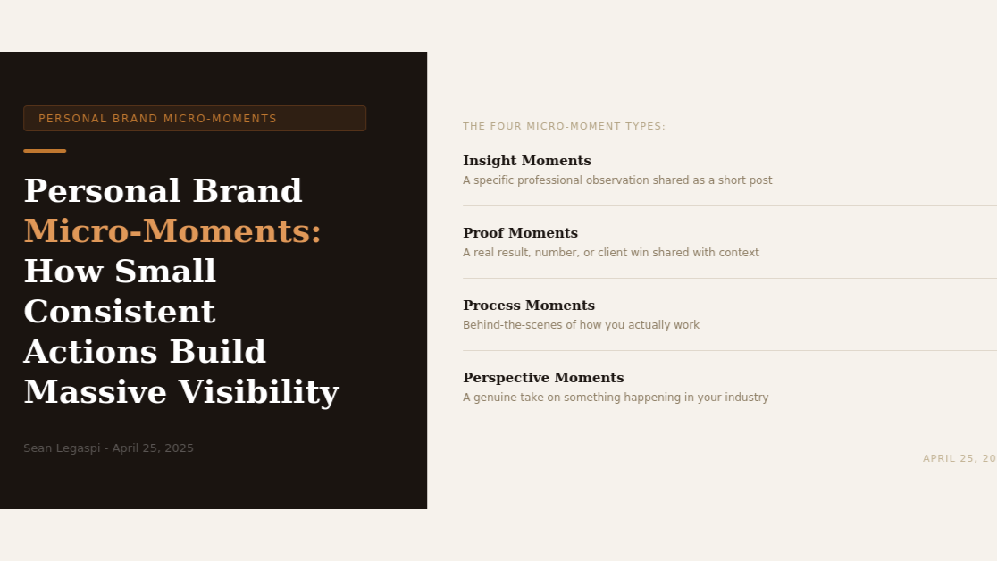

Personal Brand Micro-Moments: How Small Consistent Actions Build Massive Professional Visibility
April 25, 2026
You do not need a viral post, a published book, or a viral moment to build a powerful personal brand. You need 365 small ones.
The phrase personal brand has accumulated a layer of discomfort in professional culture. It conjures images of carefully staged lifestyle photography, motivational slogans delivered with performative confidence, and relentless self-promotion that treats every human interaction as a marketing opportunity.
This association has made many capable, serious professionals reluctant to invest in their professional visibility, which is both understandable and costly. Because what a well-constructed personal brand actually is, stripped of its performative connotations, is simply a reliable reputation: being clearly known for something specific by the people who are most likely to benefit from what you do.
And building that reputation does not require grand gestures. Research in behavioral psychology and content performance data consistently point in the same direction: it is built through small, consistent actions delivered over time. This is what personal brand practitioners and researchers are increasingly calling micro-moments: brief, specific, genuine expressions of professional expertise and perspective that, accumulated over months and years, produce a compounding reputation effect that no single viral post can replicate.
This article examines the psychological and algorithmic mechanisms behind micro-moment personal branding, the four types of micro-moments that produce the strongest reputation effects, the specific practices that make micro-moment publishing sustainable, and the research on how consistency compounds into professional opportunity.

THE PSYCHOLOGY OF MICRO-MOMENT BRANDING
The foundational psychological principle underlying micro-moment personal branding is what Robert Cialdini calls the principle of consistency and commitment, documented in his 1984 book "Influence" and validated across decades of subsequent research. When an individual encounters a consistent pattern of professional expression from a specific person over time, their brain begins to associate that person with that domain. The association becomes more automatic, more confident, and more retrievable as the pattern continues.
This is the neural basis of professional reputation. Reputation is not a single event. It is a pattern. And patterns are built through repetition, not through spectacle.
Behavioral economist Daniel Kahneman's distinction between System 1 and System 2 thinking, developed in "Thinking, Fast and Slow" (2011), is directly relevant here. System 1 is the fast, automatic, associative mode of cognition that handles most routine decisions. System 2 is the deliberate, analytical mode invoked for complex decisions. Professional referrals, hiring decisions, and partnership considerations often begin as System 1 responses: a name comes to mind automatically because it has been reliably associated with a relevant domain through repeated exposure. Micro-moment personal branding is the practice of building those automatic System 1 associations.
The social platform algorithms reinforce this psychological dynamic. LinkedIn's content distribution algorithm, as documented by its engineering team in a 2023 transparency report, gives preferential reach to accounts that publish consistently in a defined topic space over time. An account that publishes three to four posts per week on consistent themes for six consecutive months builds an algorithmic profile that gives those posts broader initial distribution than a new account publishing at the same frequency. The algorithm has learned that this account's content is relevant to a defined audience, and it distributes accordingly.

THE FOUR TYPES OF PROFESSIONAL MICRO-MOMENTS
Micro-moment publishing operates across four distinct content types, each building reputation through a different mechanism.
Type 1: Insight Moments
An insight moment is a brief, specific professional observation: something you noticed in your work this week, a pattern you have observed across multiple client engagements, a finding from a piece of research you read, or a counterintuitive realization about something in your industry.
The defining characteristics of an effective insight moment are specificity and originality. "Social media algorithms reward consistency" is a generic observation. "I posted at 7 AM every Tuesday for eight weeks and saw a 34 percent increase in first-hour engagement compared to posting at noon" is an insight moment. The specificity signals firsthand experience, which is the single most powerful credibility signal available.
Insight moments are the fastest to produce because they draw directly from ongoing professional experience. A practitioner who is paying attention to their work always has access to this type of content.
Type 2: Proof Moments
A proof moment demonstrates the reality of your work through a specific, concrete result. Not "I help businesses grow" but "a client's onboarding process that used to take three hours of manual setup now runs in 20 minutes with the system we built together." Not "I am experienced in operations" but "I audited a client's tool stack last month and identified $2,400 in redundant software subscriptions."
Proof moments are powerful because they operationalize credibility. They move the professional brand from a set of claims to a set of evidence. Research by Nielsen on trust in professional services, published in 2023, found that specific quantified case examples increased perceived credibility by 47 percent compared to equivalent qualitative descriptions of the same results.
The professional privacy concern around sharing client results is legitimate and can be addressed without compromising client confidentiality. Results can be shared anonymously (a client in the e-commerce industry), with explicit client permission, or in aggregate (across five clients this quarter, the average time savings from implementing this system was X hours per week).
Type 3: Process Moments
A process moment shows how you work rather than just describing what you do. Behind-the-scenes content, workflow documentation shared publicly, a screenshot of a system you have built, a brief explanation of how you approach a specific type of problem: these create the transparency that converts professional admiration into professional trust.
Process moments are particularly effective for service professionals including VAs, consultants, and advisors because they make the invisible visible. Most service work happens out of sight. Clients know the input (their problem) and the output (the solution) but rarely see the process. Sharing the process demystifies the work, demonstrates expertise, and creates a genuine reason to choose you over a competitor whose process is opaque.
Type 4: Perspective Moments
A perspective moment shares a genuine professional opinion on something happening in your industry. Not a manufactured hot take designed for engagement, but an authentic response to a development, trend, or debate in your professional field.
Perspective moments are the highest-risk and highest-reward type of micro-moment content. They invite disagreement, which can feel uncomfortable. But they also signal intellectual engagement and professional confidence. Adam Grant's research on professional communication at Wharton, documented in "Think Again" (2021), found that professionals who regularly share considered perspectives and invite genuine debate build more trusted reputations than those who publish only uncontroversial information.
The key distinction is between a genuine perspective grounded in professional experience and an attention-seeking provocation. The former builds reputation. The latter erodes it.

THE SUSTAINABLE MICRO-MOMENT PRACTICE
The consistent failure mode in personal brand building is the burst-and-disappear pattern: a period of intense publishing activity followed by silence, repeated intermittently. This pattern does not build the associative patterns or the algorithmic profile that produce compounding results.
A sustainable micro-moment practice has three structural requirements.
First, a capture system. Professional micro-moments are generated continuously by the experience of doing good work. The challenge is capturing them before they disappear into the background. A simple note-taking habit, whether a dedicated section in Notion, a voice memo habit, or a standing note in a phone app, converts transient professional observations into a content inventory. Practitioners who maintain this habit report having more publishable content than time to publish it.
Second, a minimal viable publishing commitment. Research on habit formation by James Clear, documented in "Atomic Habits" (2018), consistently shows that commitment to a specific, time-bound minimum is more reliable than commitment to an aspirational maximum. A sustainable micro-moment practice begins with a commitment so small it is nearly impossible to miss: two posts per week, each drawing from the capture system. This minimum builds the habit. The habit builds the inventory. The inventory eventually makes three or four posts per week feel effortless rather than burdensome.
Third, a defined publication window. Attaching publishing to a specific recurring time, the same days and approximate time each week, reduces the decision-making burden that often prevents publishing. The question is not whether to post today but what to post, because today is a posting day.

THE COMPOUND EFFECT OVER TIME
The personal brand effects of micro-moment publishing are not linear. They are compounding in three distinct ways.
The algorithmic compound: platforms reward consistent activity with increased distribution over time, meaning each post in month twelve reaches more people than the same post in month one.
The reputational compound: each insight, proof, process, or perspective moment adds to the accumulated evidence of expertise in a specific domain. By month twelve, the body of work speaks more loudly than any single piece of it.
The network compound: consistent visibility keeps the professional in the awareness of their network. When a referral opportunity arises in month twelve, the consistently visible professional is the one who comes to mind. The one who went silent in month three is not.
The research on personal brand ROI, published by the Social Media Examiner in their 2024 Industry Report, found that professionals who published consistently on LinkedIn for twelve or more months were 3.2 times more likely to report inbound business inquiries compared to those who published occasionally, and 5.4 times more likely compared to those who maintained a passive profile.
The micro-moment approach is the mechanism through which consistency becomes practicable. And consistency, compounded over time, is the mechanism through which professional reputation becomes a genuine competitive asset.
Sources:
- Robert Cialdini, 'Influence: The Psychology of Persuasion,' 7th edition (Harper Business, 2021)
- Daniel Kahneman, 'Thinking, Fast and Slow' (Farrar, Straus and Giroux, 2011)
- LinkedIn Algorithm Transparency Report 2023 (linkedin.com/blog/engineering/feed/the-linkedin-feed-explained)
- Nielsen Trust in Professional Services Report 2023 (nielsen.com)
- Adam Grant, 'Think Again' (Viking, 2021)
- James Clear, 'Atomic Habits' (Avery, 2018)
- Social Media Examiner Industry Report 2024 (socialmediaexaminer.com/report)

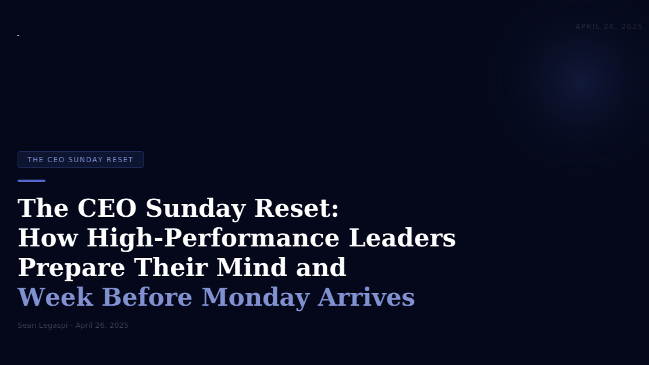

The CEO Sunday Reset: How High-Performance Leaders Prepare Their Mind and Week Before Monday Arrives

April 26, 2026
Sunday is not the end of the week. It is where the next one is won. What you do with the hours before Monday morning determines who walks into that morning.
There is a quiet but significant gap between the working habits of high-performance leaders and those of their equally skilled but less effective peers. This gap rarely shows up in intelligence, technical ability, or professional experience. It shows up most reliably in the quality of their Monday morning.
The CEO Sunday Reset is a structured approach to the transition between week-end and week-start: a deliberate practice of reflection, review, and preparation that ensures each new week begins with clarity, priority, and intentional direction rather than reactive momentum from whatever is waiting in the inbox.
This article examines the research on recovery, preparation, and cognitive readiness for high-performance work, the specific components of a well-designed Sunday Reset practice, how this concept applies across different professional roles including business owners, executives, and virtual assistants, and the evidence for why this weekend hour investment produces disproportionate weekly returns.

THE RESEARCH ON RECOVERY AND PERFORMANCE
The relationship between recovery and sustained high performance is well-established in sports science, organizational psychology, and cognitive performance research. What is less commonly recognized is that the mechanisms governing athletic recovery apply with equal precision to knowledge work.
Sabine Sonnentag and Charlotte Fritz at the University of Konstanz have conducted extensive research on psychological recovery from work, published across multiple peer-reviewed papers in the Journal of Occupational Health Psychology between 2007 and 2022. Their framework identifies four recovery experiences that produce measurable improvements in subsequent performance: psychological detachment (mentally disengaging from work), relaxation (reducing physiological and psychological activation), mastery experiences (engaging in challenging activities outside work), and control (choosing freely how to spend recovery time).
Crucially, their research found that psychological detachment without preparation is incomplete. Workers who detached completely from work on weekends and then faced Monday without any prior orientation to the coming week reported higher Monday morning stress levels than those who spent a brief, structured period on Sunday preparing without over-working. The sweet spot is a bounded preparation session that provides cognitive closure on the previous week and clear orientation to the next one, without extending into the reactive email-checking and task execution that erodes recovery entirely.
Research by Erin Reid at Boston University, published in "Why Some Men Pretend to Work 80-Hour Weeks" in the Harvard Business Review (2015), found that managers who worked intensively during clearly bounded hours and engaged in deliberate off-time practices consistently outperformed those who worked longer but unstructured hours over periods of six months or more. The quality of working hours, rather than the quantity, predicted output. And the quality of working hours was directly supported by the quality of the recovery and preparation practices surrounding them.
A 2023 study in the Journal of Applied Psychology by Christopher Barnes at the University of Washington, a leading researcher on sleep and workplace performance, found that leaders who engaged in structured weekly review and planning practices had teams with 27 percent higher goal attainment rates than leaders who began each week reactively. The mechanism was straightforward: leaders who arrived Monday with clear priorities communicated them more clearly, made faster and better-calibrated decisions, and created the environmental conditions for their teams to perform at higher levels.

THE COMPONENTS OF THE CEO SUNDAY RESET
The Sunday Reset is not a single practice but a structured sequence of five components, each serving a distinct function. The total time investment is between 60 and 90 minutes, ideally in the early or mid-afternoon rather than the evening to preserve the psychological detachment benefit of the evening hours.
Component 1: Weekly Review (15 to 20 minutes)
The weekly review is a structured look backward at the week that has just ended. It is adapted from David Allen's Getting Things Done (GTD) weekly review concept, documented in "Getting Things Done" (2001) and updated in the 2015 revised edition, and from the concept of after-action review (AAR) developed by the US Army and documented extensively in organizational learning literature.
The review asks four questions: What did I complete this week that I am satisfied with? What did I plan to complete that I did not, and why? What did I learn this week that changes how I will approach something going forward? What loose ends or unresolved issues are carrying forward into next week?
Writing the answers to these questions, rather than thinking through them abstractly, produces both better answers and a genuine sense of closure on the week. The act of writing externalizes the cognitive load of tracking open items, which is the source of most end-of-week mental fatigue.
Component 2: Energy and Wellbeing Check (5 minutes)
Before planning the next week, a brief honest assessment of current physical and mental state. This component is informed by research on decision quality and cognitive resource depletion, particularly the work of Roy Baumeister on ego depletion, published in "Willpower" (2011), which found that cognitive resources for decision-making and self-regulation deplete with use and require rest to restore.
The questions are: How is my energy level genuinely entering this week? Am I carrying stress or unresolved personal issues that will affect my focus? Do I need to build specific recovery or self-care activities into this week's plan?
This component functions as a reality check on the planning that follows. A week planned by an exhausted, stressed person will over-schedule and under-protect. An honest energy assessment leads to a more realistic and ultimately more successful week.
Component 3: Priority Identification (15 to 20 minutes)
With the previous week reviewed and current energy assessed, the priority identification component establishes the three to five outcomes that would make the coming week a success regardless of what else happens. These are not task lists. They are outcome statements.
"Send forty emails" is a task. "Complete the proposal for Client X and get it into their hands" is an outcome. The distinction matters because task lists create the illusion of progress through completion of activity, while outcome statements measure success by the production of results that actually matter.
The priority identification draws from the GTD framework's concept of horizon thinking: before listing tasks, clarify what you are trying to accomplish at the project, goal, and mission level, and then identify the specific actions that advance those outcomes this week. The discipline of limiting priorities to three to five forces a ranking that most to-do lists avoid.
Component 4: Calendar and Schedule Preparation (15 minutes)
With outcomes defined, the calendar preparation phase blocks time for the work required to achieve them. This is where the abstract priority list becomes a concrete weekly structure.
Research on implementation intentions, published by Peter Gollwitzer at New York University in a 2011 meta-analysis of 94 independent studies, found that people who specified when and where they would perform an intended action were two to three times more likely to follow through than those who stated the intention without scheduling it. The Sunday Reset embeds this mechanism: outcomes are translated into calendar blocks before the week begins, rather than waiting for open time that may not materialize amid reactive demands.
This phase also reviews existing calendar commitments for the week, identifies any that conflict with priorities, and makes the advance decisions about which commitments can be moved, declined, or delegated rather than leaving those decisions to Monday morning when cognitive resources are at their most reactive.
Component 5: Environmental Preparation (10 to 15 minutes)
The final component prepares the physical and digital work environment for the coming week. This includes: clearing the workspace of residual clutter from the previous week, organizing the task management system so Monday morning begins with a clear and current view of what needs attention, preparing any materials needed for the first significant work block of Monday, and setting the communications environment by drafting any messages that need to go out early Monday rather than composing them under pressure at 8 AM.
This component is the operational manifestation of what productivity researchers call "reducing activation energy": the effort required to begin a task. The classic example is laying out workout clothes the night before an early morning gym session. The Sunday environmental preparation does the same for Monday's work: it reduces the activation energy required to begin the highest-priority work immediately rather than spending the first hour orienting.
THE SUNDAY RESET FOR OPERATIONS PROFESSIONALS AND VAs
For operations virtual assistants and professional support roles, the Sunday Reset serves an additional function beyond personal performance: it is the mechanism through which proactive client support is distinguished from reactive task execution.
The VA who arrives on Monday morning having reviewed each client's open items, prepared for the week's key deliverables, and identified any potential issues that need proactive management delivers a qualitatively different level of service than the VA who opens their inbox on Monday morning and begins reacting.
This discipline is also directly communicable to clients. Sharing a brief Sunday evening summary of the coming week's plan, key priorities, and any items requiring client decision is a simple practice that consistently earns client trust and reduces the volume of ad hoc check-ins and status requests that consume VA time throughout the week.

THE LONG-TERM PRACTICE
The CEO Sunday Reset, like all consistent practices, produces its most significant results over time rather than immediately. The first week of structured weekly review and planning produces modest clarity. The tenth week produces a practitioner who knows their patterns, can predict their own friction points, and has developed the planning vocabulary and systems that make the practice increasingly efficient.
After six months of consistent Sunday Resets, the cumulative effect includes: a documented record of weekly reflections that reveals patterns in personal performance, a refined set of weekly priorities that becomes more aligned with long-term goals over time as short-term reactive demands are progressively managed better, and a reliability reputation with clients and colleagues who consistently experience the professional arriving Monday prepared rather than catching up.
In the words of Greg McKeown, author of "Essentialism" (2014) and "Effortless" (2021): "If you don't prioritize your life, someone else will." The Sunday Reset is the weekly practice through which that prioritization happens deliberately rather than by default.
Sources:
- Sabine Sonnentag and Charlotte Fritz, 'Recovery Experiences as a Predictor of Health and Performance,' Journal of Occupational Health Psychology, 2007-2022 (apa.org/pubs/journals/ocp)
- Erin Reid, 'Why Some Men Pretend to Work 80-Hour Weeks,' Harvard Business Review, 2015 (hbr.org)
- Christopher Barnes, 'The Ideal Work Schedule as Determined by Circadian Rhythms,' Journal of Applied Psychology, 2023 (apa.org)
- David Allen, 'Getting Things Done,' revised edition (Penguin Books, 2015); Roy Baumeister and John Tierney, 'Willpower' (Penguin, 2011)
- Peter Gollwitzer and Paschal Sheeran, 'Implementation Intentions Meta-Analysis,' European Review of Social Psychology, 2011
- Greg McKeown, 'Essentialism' (Crown Business, 2014); Greg McKeown, 'Effortless' (Currency, 2021)

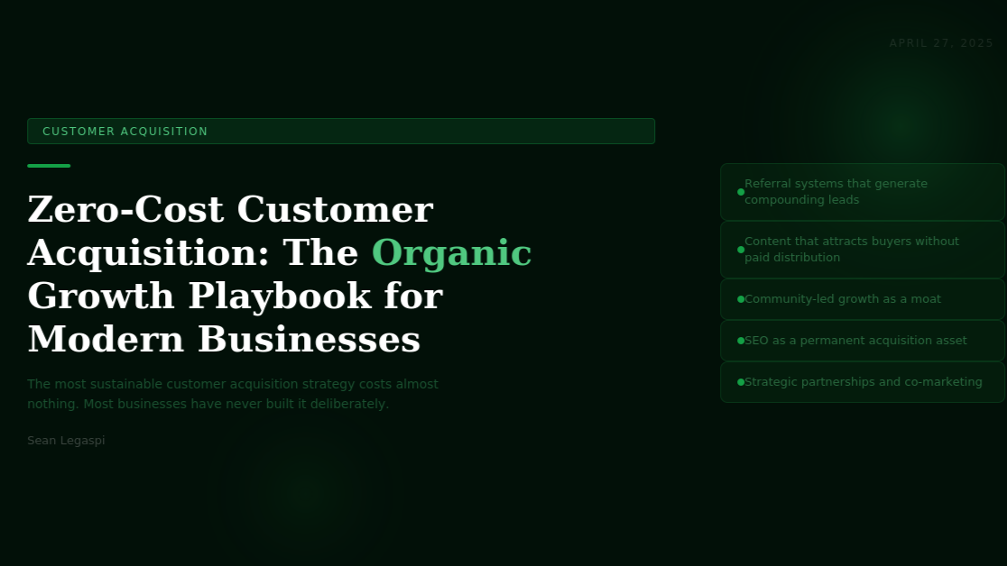

Zero-Cost Customer Acquisition: The Organic Growth Playbook Every Modern Business Needs to Build
April 27, 2026
The most sustainable customer acquisition engine a business can own costs almost nothing to operate and compounds in value over time. Most businesses have never built it deliberately.
The relationship between paid advertising and sustainable growth is more complicated than most marketing advice acknowledges. Paid channels are fast. They are measurable. They scale with budget. But they produce no permanent asset, stop the moment spending stops, and become more expensive every year as competition for attention intensifies.
Google average cost-per-click across industries increased 19 percent in 2023 alone, according to WordStream annual benchmark data. Meta advertising costs rose 18 percent year-over-year across the same period. For businesses whose customer acquisition strategy is primarily paid, this inflation represents a compressing margin that does not resolve with time.
The businesses that will hold the most durable competitive advantage in customer acquisition are those that have built organic growth systems: mechanisms that attract, convert, and retain customers without requiring proportionate financial inputs for each new acquisition. These systems are slow to build and fast to compound.

PILLAR 1: REFERRAL SYSTEMS
Word-of-mouth is the highest-converting customer acquisition channel available to most businesses. A 2023 Nielsen Trust in Advertising Report found that 92 percent of consumers trust recommendations from friends and family above all other advertising forms. Research by Wharton School professor Jonah Berger established that referred customers have a 16 percent higher lifetime value and are 18 percent more likely to remain with a business over time.
The critical distinction is between passive word-of-mouth, which happens when customers are satisfied, and an active referral system, which is designed to consistently activate that word-of-mouth through structured incentives and clear mechanisms.
An effective referral system has three components: a trigger (the optimal moment to request a referral, typically immediately after a successful outcome), a mechanism (a simple, frictionless way for the customer to make the referral), and an incentive (which may be financial, relational, or reputational depending on business model and customer profile).
Dropbox grew from 100,000 to 4 million users in 15 months using a structured referral system that offered additional storage for both referrer and referee. The Wharton School found that structured referral programs generate between 3 and 5 times the conversion rate of equivalent paid acquisition campaigns at a fraction of the cost per acquired customer.

PILLAR 2: CONTENT AS A PERMANENT ACQUISITION ASSET
Unlike paid advertising, content that ranks in search, earns backlinks, or builds a subscriber audience continues to acquire customers indefinitely after it is created. HubSpot 2024 State of Marketing Research found that companies publishing content consistently generate 3.5 times more leads per dollar invested than companies relying primarily on paid advertising. Demand Metric research found that content marketing costs 62 percent less than outbound marketing per lead and generates approximately 3 times as many leads.
Effective content acquisition strategy requires specificity at three levels. The audience must be defined precisely enough that every piece of content speaks directly to a specific person with a specific problem. The format must match where the audience actually searches for information. The topic selection must be driven by keyword research and audience intent data rather than internal assumptions.

PILLAR 3: SEARCH ENGINE OPTIMIZATION AS INFRASTRUCTURE
Search engine optimization is not a campaign. It is infrastructure. BrightEdge 2024 research found that organic search drives 53 percent of all website traffic globally. Forrester Research found that 74 percent of business-to-business buyers conduct three or more pieces of self-directed research before engaging with a sales contact.
A business with strong search presence in its category is present at every stage of its buyers research journey, building familiarity, trust, and preference before any sales conversation occurs. This pre-sold audience converts at dramatically higher rates than cold audiences reached through interruptive advertising.

PILLAR 4: COMMUNITY-LED GROWTH
Gartner 2023 B2B Buying Behavior Survey found that 75 percent of B2B buyers rely on peer recommendations from communities, forums, and professional networks in their purchase decisions. A business that is visible and genuinely valuable within the communities where its buyers gather has a structural advantage over competitors who are not present.
The compounding effect of community presence is referral density: when multiple members of a community know and trust a business, the probability that any given community member will receive a recommendation from a fellow member increases with the size and activity of the network.

PILLAR 5: STRATEGIC PARTNERSHIPS AND CO-MARKETING
Strategic partnerships allow businesses to access each other audiences at zero media cost. When two businesses serve the same customers without competing directly, a well-designed partnership creates a customer acquisition channel for both parties simultaneously.
A 2023 study by Partnership Leaders found that companies with structured partnership programs attribute an average of 21 percent of total revenue to partner-sourced opportunities. Co-created content, reciprocal referral agreements, and integration partnerships all represent forms of audience access that require relationship capital rather than financial capital.

THE COMPOUNDING RETURN
The businesses that dominate customer acquisition over a five-year horizon are not those with the highest advertising budgets. They are those that built systems in each of these five pillars early and maintained them consistently. Referral networks activate, search authority compounds, community relationships deepen, and content libraries accumulate.
The investment required is not primarily financial. It is time, creative output, and strategic discipline applied consistently over months and years. Because organic growth systems are difficult and slow to build, competitors rarely replicate them fully. That difficulty is the source of the advantage.
Sources:
- Nielsen Trust in Advertising Report 2023 (nielsen.com/insights/2023/trust-in-advertising)
- Jonah Berger, Contagious (Simon and Schuster, 2013)
- HubSpot State of Marketing Report 2024 (hubspot.com/marketing-statistics)
- Demand Metric Content Marketing Research 2023 (demandmetric.com)
- BrightEdge Organic Search Research 2024 (brightedge.com)
- Forrester Research B2B Buyer Behavior Study 2023 (forrester.com)
- Gartner B2B Buying Behavior Survey 2023 (gartner.com)
- WordStream Google Ads Benchmarks 2023 (wordstream.com)
- Partnership Leaders Revenue Study 2023 (partnershipleaders.com)

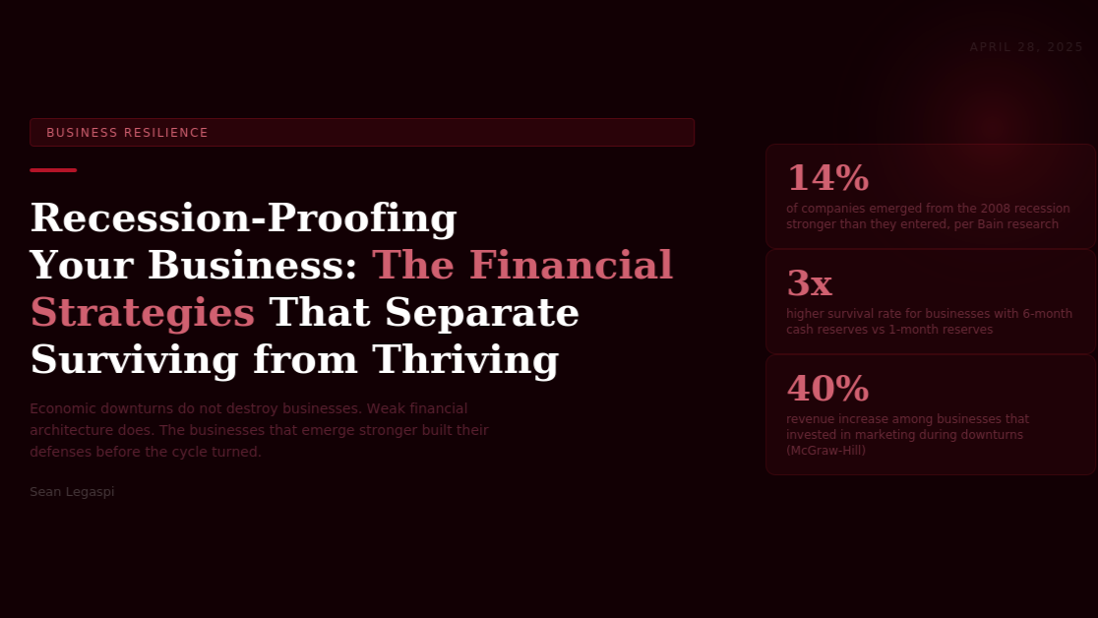The Financial and Operational Strategies That Separate Businesses That Survive from Those That Thrive During Economic Downturns

April 28, 2026
Economic downturns do not destroy businesses. Weak financial architecture, excessive operational dependency, and reactive leadership do. The businesses that emerge from recessions stronger built their defenses before the cycle turned.
The economic cycle is not a theory. The National Bureau of Economic Research records 13 recessions in the United States since the Great Depression, an average of one every seven years. Despite this predictability, the majority of businesses treat recession preparation as a reactive exercise: responding to economic contraction after it has already begun to affect revenue rather than building structural resilience during periods of growth.
Bain and Company analysis of over 3,700 companies across the 2008 to 2009 global financial crisis found that only 14 percent of businesses emerged from the downturn having significantly improved their competitive position. That 14 percent share one consistent characteristic: they prepared systematically during the preceding growth period rather than responding after the downturn began.

THE FINANCIAL FOUNDATIONS OF RECESSION RESILIENCE
CASH RESERVE STRATEGY
Cash is the most important variable in recession survival. A 2022 study by the Federal Reserve Bank of New York analyzing small business survivorship during the COVID-19 economic shock found that businesses with cash reserves covering six months of operating expenses had a survival rate three times higher than businesses with reserves of one month or less.
During the 2008 recession, companies that entered the downturn with strong cash positions were able to acquire distressed competitors, invest in marketing while competitors retreated, and retain key talent while others were cutting staff. These offensive moves during recessions are only available to businesses that built defensive positions first.
REVENUE DIVERSIFICATION
Concentration risk is one of the most common and most dangerous vulnerabilities in small and mid-sized business financial architecture. Research by Dun and Bradstreet on business failure patterns found that customer concentration (a single client representing more than 25 percent of revenue) is a statistically significant predictor of business failure, independent of the overall quality of the business and the strength of the client relationship.
A practical benchmark for healthy revenue diversification in a service business is that no single client should represent more than 20 percent of total revenue, and the revenue streams should include at least one that is relatively recession-resistant, such as a subscription or retainer arrangement.
VARIABLE COST ARCHITECTURE
Businesses with high fixed-cost structures are inherently more vulnerable to revenue contractions than businesses with higher proportions of variable costs. The move toward remote work, fractional staffing, contractor relationships, and software-as-a-service tools has given businesses of all sizes significantly more ability to build variable-cost-oriented operations than was available in previous economic cycles.

OPERATIONAL RECESSION PROOFING
CUSTOMER RETENTION AS DEFENSE
Research published in the Harvard Business Review found that acquiring a new customer costs five to seven times as much as retaining an existing one. During an economic downturn, customer retention is the primary revenue preservation strategy available to most businesses, because the volume of new customer opportunities typically contracts while the value of existing relationships increases in relative importance.
MARKETING AS A COUNTER-CYCLICAL INVESTMENT
One of the most counterintuitive findings in business research is the consistent evidence that businesses maintaining or increasing marketing investment during recessions outperform those that cut. A McGraw-Hill Research study analyzing 600 companies through the 1981 to 1982 recession found that businesses maintaining advertising spending during the downturn had sales 256 percent higher than competitors who had cut by the time the economy recovered.
A 2010 study by Millward Brown examining 2008 recession data found that brands cutting marketing investment during the downturn lost an average of 2 percentage points of market share, while brands maintaining investment gained share.
OPERATIONAL EFFICIENCY BEFORE IT IS NECESSARY
Operational efficiency improvements are most effectively made during growth periods rather than under the pressure of a revenue decline. Businesses conducting regular operational audits during healthy periods build a leaner operating model that has more resilience and fewer forced choices than a competitor reacting to revenue pressure under time constraint.
THE STRATEGIC OPPORTUNITY IN DOWNTURNS
The research on business performance through economic cycles consistently identifies downturns as the period of maximum competitive differentiation. When markets contract, the gap between well-prepared and unprepared businesses widens rapidly. Businesses with cash reserves, diversified revenue, and efficient operations can act offensively. They can hire talent that distressed competitors are releasing, acquire clients who have lost confidence in weakening service providers, and build market share at the cost of weakened competitors who cannot respond.
This offensive posture during a downturn is the specific mechanism by which the 14 percent of businesses identified by Bain research emerge significantly stronger. They treated the economic cycle as a competitive event rather than a natural disaster.
Sources:
- Bain and Company, Preparing for the Downturn (bain.com/insights/preparing-for-the-downturn)
- Federal Reserve Bank of New York Small Business Credit Survey 2022 (newyorkfed.org/smallbusiness)
- Dun and Bradstreet Business Failure Research (dnb.com)
- McGraw-Hill Research Recession Marketing Study
- Millward Brown Marketing During a Recession 2010 (kantar.com)
- Harvard Business Review, The Value of Keeping the Right Customers 2014 (hbr.org)
- National Bureau of Economic Research Business Cycle Data (nber.org)

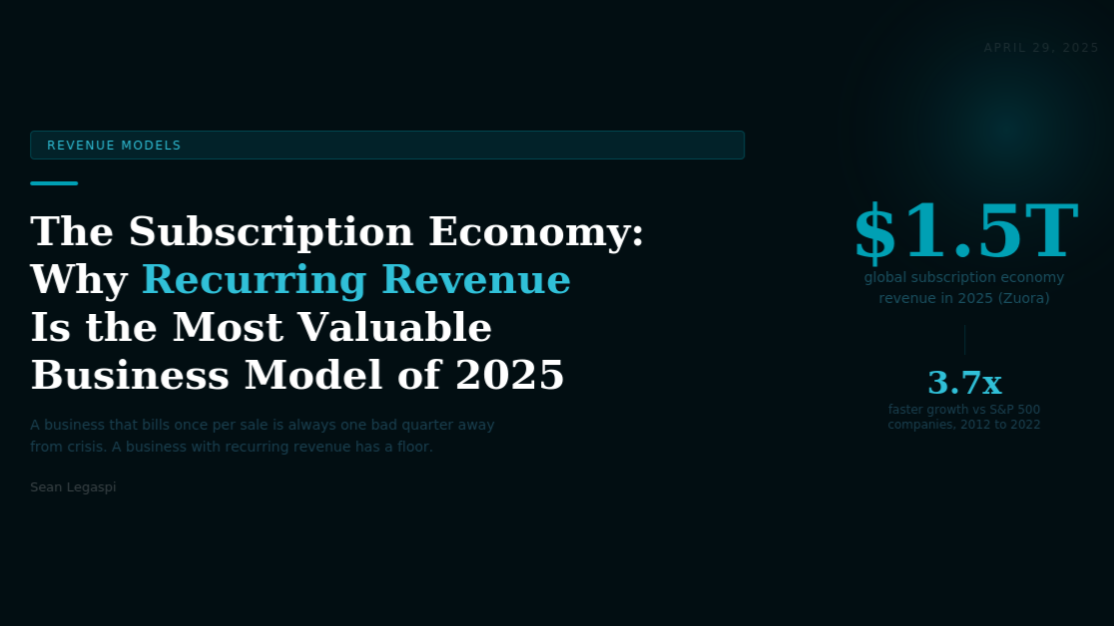

The Subscription Economy: Why Recurring Revenue Is the Most Strategically Valuable Business Model of the Modern Era and How to Build It
April 29, 2026
A business that bills once per transaction is always one bad quarter away from starting over. A business with recurring revenue has a floor, a predictable base from which to plan, hire, invest, and grow with a fundamentally different quality of confidence.
The subscription economy is not a new concept. What is new is the scale and speed at which the subscription model has expanded across industries that historically operated on transactional billing, and the growing body of evidence that recurring revenue is not simply a billing preference but a structural business advantage that compounds over time.
Zuora Subscription Economy Index, tracking the financial performance of subscription businesses against traditional businesses, found that subscription companies grew revenues approximately 3.7 times faster than S&P 500 companies between 2012 and 2022. As of 2024, Zuora estimates the global subscription economy represents approximately $1.5 trillion in revenue, up from under $200 billion in 2014.

WHY RECURRING REVENUE IS STRUCTURALLY SUPERIOR
PREDICTABILITY AND PLANNING QUALITY
The fundamental advantage of recurring revenue is predictability. A business with $50,000 per month in subscription revenue knows with high confidence what its revenue base will be next month and the month after, absent extraordinary churn. A business generating the same $50,000 per month through individual transactions has no such certainty.
This predictability improvement has cascading effects throughout business operations. Hiring decisions can be made with greater confidence. Inventory and supplier commitments can be managed more efficiently. Marketing investment can be planned further in advance. Research by ProfitWell, analyzing over 20,000 subscription businesses, found that companies with net revenue retention above 100 percent achieve median revenue growth of 48 percent annually, compared to 15 percent for companies with equivalent transactional revenue models.
CUSTOMER LIFETIME VALUE AMPLIFICATION
In a transactional business, lifetime value is determined by repurchase frequency, which is difficult to predict and harder to systematically improve. In a subscription business, lifetime value is a function of the monthly or annual subscription value multiplied by the retention period, both of which are directly manageable through product quality, customer success, and pricing strategy.
Research by Bain and Company found that a 5 percent improvement in customer retention rates produces between 25 and 95 percent improvement in profitability, depending on the industry, because of the compounding lifetime value effect.
VALUATION PREMIUM
Public market data consistently shows that businesses with subscription revenue trade at higher price-to-revenue multiples than equivalent businesses with transactional revenue. According to data from Jamin Ball SaaS multiples research, subscription businesses historically command valuations of 5 to 15 times annual recurring revenue, compared to 1 to 3 times for transactional businesses with equivalent absolute revenues.

APPLYING THE SUBSCRIPTION MODEL ACROSS INDUSTRIES
THE SERVICE BUSINESS RETAINER MODEL
For professional services businesses including consulting, marketing agencies, virtual assistance, legal services, and accounting, the retainer model is the most natural subscription implementation. Instead of billing for individual projects or hourly engagements, a retainer arrangement commits the client to a fixed monthly fee in exchange for a defined scope of ongoing support.
Research by Ron Baker in Implementing Value Pricing found that professional service firms operating on retainer models report 40 to 60 percent higher annual revenue per client than the same firms billing the same clients hourly for comparable total work.
THE PRODUCT BUSINESS SUBSCRIPTION MODEL
Physical and digital product businesses have expanded subscription implementations significantly. The subscription box model applies recurring revenue to physical product delivery. Software-as-a-service has made subscription billing the dominant model for digital tools. Content subscription has created recurring revenue from intellectual property.
For product businesses considering a subscription component, the most effective implementations serve a genuine ongoing need rather than forcing a subscription on a product that customers naturally buy once or infrequently.
CHURN AS THE PRIMARY OPERATIONAL PRIORITY
In any subscription business, churn is the single most important operational metric. A 10 percent monthly churn rate means a business is replacing its entire subscriber base approximately every 10 months, making growth almost impossible to accumulate despite consistent new subscriber acquisition.
Research by ProfitWell found that every 1 percent reduction in monthly churn rate produces, on average, a 24 percent increase in lifetime value across a subscription business. The mechanisms for reducing churn are well-documented: proactive customer success that identifies at-risk subscribers before they cancel, product improvements that increase delivered value over time, and pricing structures that reward longer commitment.
BUILDING RECURRING REVENUE INTO ANY BUSINESS
The shift toward recurring revenue does not require a complete business model transformation. For most businesses, the most practical path is to identify the component of existing service or product delivery that provides ongoing value and design a subscription wrapper around it.
For a graphic design studio, this might be a monthly brand maintenance retainer. For an operations consultant, it might be a monthly systems review service. For a fitness trainer, it might be a monthly program subscription rather than per-session billing.
The optimal subscription scope delivers clear, documented value monthly, is simple to describe in a single sentence, and creates enough dependency that cancellation has a meaningful cost to the subscriber.
Sources:
- Zuora Subscription Economy Index 2024 (zuora.com/guides/subscription-economy-index)
- ProfitWell Subscription Growth Study (profitwell.com/recur/all/subscription-growth-benchmarks)
- Bain and Company, The Value of Keeping the Right Customers (bain.com)
- Jamin Ball SaaS Multiples Research (cloudedjudgement.substack.com)
- Ron Baker, Implementing Value Pricing (Wiley, 2011)
- OpenView Partners Product-Led Growth Benchmarks 2023 (openviewpartners.com/blog)

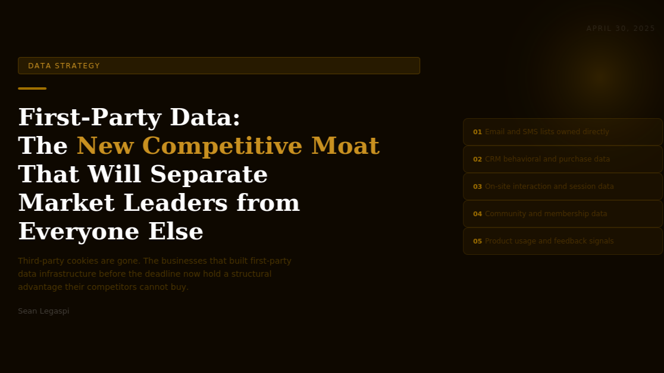

First-Party Data: The New Competitive Moat That Will Separate Market Leaders from Everyone Else in the Post-Cookie Era
April 30, 2026
Third-party cookies are gone. The era of renting audience data from advertising platforms is ending. The businesses that built their own data infrastructure before this transition now hold a structural advantage that their competitors will spend years and millions of dollars trying to replicate
For two decades, digital advertising operated on a foundation that most businesses never fully understood: third-party cookies. These small files tracked online behavior across websites and enabled the precise audience targeting that made platforms like Google and Meta extraordinarily powerful advertising channels.
In 2024, Google completed the deprecation of third-party cookies in Chrome, following Safari and Firefox which had blocked them years earlier. Combined with Apple App Tracking Transparency framework (which reduced mobile tracking dramatically from 2021 onward) and increasing global privacy regulation under GDPR, CCPA, and their successors, this has fundamentally altered the economics of digital advertising.

WHAT FIRST-PARTY DATA IS AND WHY IT MATTERS
First-party data is information collected directly from a business own customers and audience: email addresses obtained through consent, purchase histories, behavioral data from owned digital properties, CRM records, survey responses, and product usage patterns.
The strategic significance of first-party data has three dimensions.
First, it is accurate. According to a 2023 Salesforce State of Marketing report, first-party data delivers 2.9 times the return on advertising spend of third-party data for equivalent campaign objectives.
Second, it is owned. A business email list, CRM database, and customer behavior records cannot be taken away by a platform policy change, a regulatory shift, or an advertising rate increase. The audience built on a social platform is rented. The audience built in owned data infrastructure is owned.
Third, it is compounding. Each customer interaction adds to the richness of the data profile, enabling more personalized communication, more accurate audience modeling, and more efficient marketing over time.

THE FIVE FIRST-PARTY DATA ASSETS WORTH BUILDING
ASSET 1: THE EMAIL AND SMS LIST
Email remains the highest-return direct communication channel available to most businesses. According to the Data and Marketing Association 2023 research, email marketing produces an average return of $36 for every $1 invested, significantly outperforming all other digital channels on a return-on-investment basis.
ASSET 2: CRM BEHAVIORAL DATA
A customer relationship management system populated with genuine behavioral data is one of the most powerful competitive assets a business can own. Research by McKinsey found that businesses using behavioral segmentation and personalization generate 40 percent more revenue from their marketing activities than those using demographic segmentation alone.
ASSET 3: ON-SITE BEHAVIORAL DATA
The behavioral data generated by visitors to a business own website is among the most valuable and most underutilized first-party data available. Page visit patterns, time spent on content, scroll depth, click behavior, and conversion pathways all provide signals about what different segments of the audience are interested in and where they are in their purchase decision process.
ASSET 4: ZERO-PARTY DATA THROUGH DIRECT COLLECTION
Zero-party data refers to information that customers intentionally and proactively share with a business: survey responses, preference selections, stated interests, and self-reported profile information. According to a 2023 Forrester Research study on personalization, businesses using zero-party data for personalization achieved 36 percent higher conversion rates than those relying on third-party data for equivalent personalization use cases.
ASSET 5: COMMUNITY AND MEMBERSHIP DATA
Businesses that build owned communities generate rich first-party data about their most engaged and valuable customers. This community data reveals which customers are advocates, which are at risk, and which topics generate the highest level of interest and participation.

BUILDING FIRST-PARTY DATA INFRASTRUCTURE
The transition from third-party data dependency to first-party data ownership is not a single initiative. It is a multi-year infrastructure project that requires investment in data collection mechanisms, CRM technology, team capability, and data governance.
The strategic priority sequence for most businesses is: first, implement a CRM and begin consistent data collection; second, build the email list with a clear value exchange strategy; third, implement on-site behavioral tracking and begin using it to inform content and conversion optimization; fourth, develop zero-party data collection mechanisms; and fifth, build community structures that generate the richest behavioral signals from the most valuable customer segment.
The businesses that completed this sequence before third-party cookies disappeared are now operating with structural advantages in audience targeting precision, personalization capability, and marketing efficiency that competitors without equivalent first-party data infrastructure will find extremely difficult to match.
Sources:
- Google Privacy Sandbox and Cookie Deprecation Documentation 2024 (privacysandbox.com)
- Salesforce State of Marketing Report 2023 (salesforce.com/resources/research-reports)
- Data and Marketing Association Email Marketing ROI Research 2023 (thedma.org)
- McKinsey Personalization and Revenue Research 2021 (mckinsey.com/capabilities/growth-marketing-and-sales)
- Forrester Research Zero-Party Data Study 2023 (forrester.com)
- Apple App Tracking Transparency Framework 2021 (developer.apple.com)

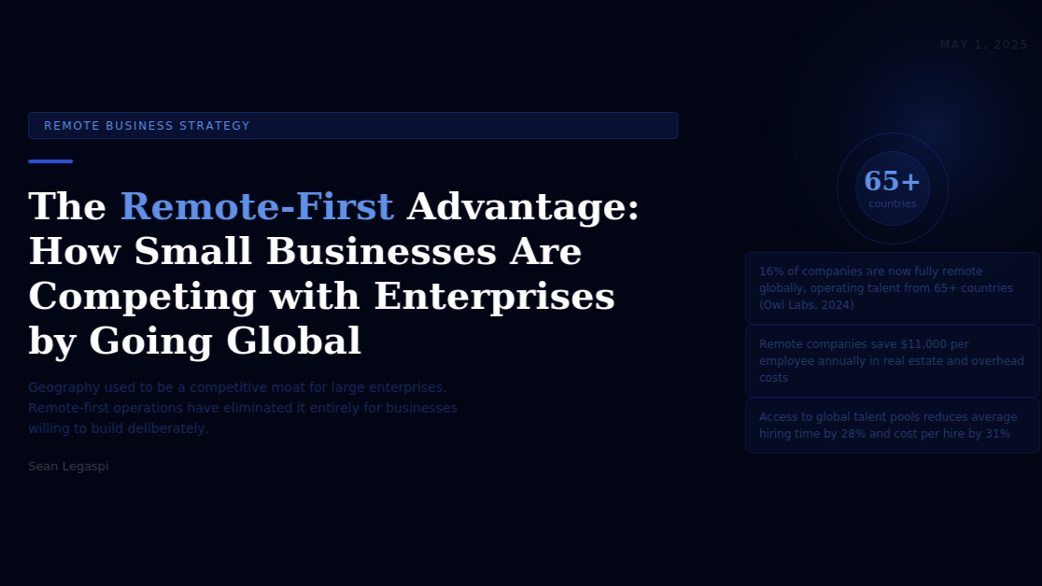

The Remote-First Advantage: How Small and Mid-Sized Businesses Are Competing With Enterprises by Operating Without Geographic Constraints
May 1, 2026
Geography used to be a competitive moat for large enterprises. Proximity to talent, clients, and suppliers gave established businesses in major markets a structural advantage that smaller competitors in secondary markets could not easily overcome. Remote-first operations have eliminated that moat for businesses willing to build deliberately.
The traditional theory of competitive advantage in business included geography as a significant variable. Businesses located in financial centers had superior access to capital. Businesses in technology hubs had superior access to engineering talent. Businesses in major markets had superior access to enterprise clients. This geographic advantage compounded over time: talent clustered where opportunity existed, and opportunity clustered where talent existed.
Remote work has not simply moved work from offices to homes. It has fundamentally restructured the geography of business by decoupling physical location from operational capability, talent access, and market reach.
According to Owl Labs 2024 State of Hybrid and Remote Work Report, 16 percent of companies globally are now fully remote, operating across multiple countries without central office infrastructure. Buffer 2024 State of Remote Work survey found that 98 percent of current remote workers want to continue working remotely, and that global talent access is the most frequently cited competitive advantage among fully remote companies.

THE FIVE STRUCTURAL ADVANTAGES OF REMOTE-FIRST OPERATIONS
ADVANTAGE 1: ACCESS TO GLOBAL TALENT WITHOUT GEOGRAPHIC PREMIUM
The most significant structural advantage of remote-first operations is access to talent not constrained by commute radius. Research by McKinsey Global Institute found that talent shortages cost companies an average of 40 percent in lost productivity per unfilled role per year, and that companies offering remote positions fill roles 28 percent faster than those requiring on-site presence.
The cost of talent also varies dramatically across geographies. A software developer in San Francisco costs approximately three to four times as much as an equivalently skilled developer in Eastern Europe, and five to eight times as much as an equivalently skilled developer in Southeast Asia. For roles where output quality determines performance, the cost-quality ratio of global hiring significantly outperforms local market hiring.
According to Global Workplace Analytics, companies save an average of $11,000 per remote employee per year in reduced real estate, utilities, and office operations costs.
ADVANTAGE 2: MARKET ACCESS WITHOUT MARKET PRESENCE
A remote-first business can serve clients in any geography without establishing a physical presence in that market. This eliminates the substantial fixed cost of market entry that previously limited small businesses geographic expansion.
For professional service businesses, this means a marketing agency in Manila can serve clients in New York and Sydney with the same quality of delivery as a local agency, at a cost structure that is structurally more competitive. The total addressable market for a remote-first service business is effectively global, versus locally constrained for an equivalent on-site business.
ADVANTAGE 3: OPERATIONAL CONTINUITY ACROSS TIME ZONES
A remote-first business with team members distributed across time zones can, when designed correctly, operate effectively across a broader portion of the 24-hour day than a single-location business. For client service businesses serving global clients, this can mean that queries and deliverables are addressed within business hours of the client time zone, regardless of where the operating team is based.
ADVANTAGE 4: OPERATIONAL RESILIENCE THROUGH DISTRIBUTION
A business entirely dependent on a single office location is vulnerable to localized disruptions. A remote-first business distributed across multiple locations has significantly greater operational resilience. According to a 2021 Stanford University study by Nicholas Bloom, companies that had established remote work capability before March 2020 lost significantly less productivity than those implementing remote work for the first time under crisis conditions.
ADVANTAGE 5: EMPLOYER BRAND AND TALENT RETENTION
Research by McKinsey 2023 American Opportunity Survey found that 87 percent of workers who have the option to work flexibly take advantage of it. LinkedIn 2024 Workforce Report found that remote-eligible job postings attracted 2.6 times more applications per posting than equivalent on-site roles.
For businesses competing with larger enterprises for talent, the ability to offer remote work is increasingly a differentiator that partially offsets the compensation premium larger companies can offer.

THE OPERATIONAL REQUIREMENTS OF EFFECTIVE REMOTE-FIRST DESIGN
The structural advantages of remote-first operations are not automatic. They are realized only when the organizational infrastructure to support distributed work is deliberately built and maintained.
The critical infrastructure elements are: an async-first communication system that reduces coordination overhead, clear documentation standards that ensure organizational knowledge is not siloed in individual conversations, a technology stack designed for remote accessibility, a hiring process that evaluates remote work capability alongside technical skill, a management approach that measures and manages output rather than activity or presence, and a culture-building practice that maintains team connection across geographic distance.
Businesses that implement remote-first operations without this infrastructure tend to create a distributed version of an office culture: excessive meetings across time zones, informal communication channels that exclude some team members, and a management style that substitutes virtual presence monitoring for genuine performance management. The businesses that realize the full structural advantage of remote-first work treat organizational design as a core strategic capability.
Sources:
- Owl Labs State of Hybrid and Remote Work 2024 (owllabs.com/state-of-remote-work)
- Buffer State of Remote Work 2024 (buffer.com/state-of-remote-work)
- McKinsey Global Institute Talent Research 2023 (mckinsey.com/capabilities/people-and-organizational-performance)
- Global Workplace Analytics Remote Work Cost Savings Research 2023 (globalworkplaceanalytics.com)
- Nicholas Bloom, Stanford SIEPR Working Paper 2021 (siepr.stanford.edu)
- LinkedIn Workforce Report 2024 (linkedin.com/pulse)
- McKinsey American Opportunity Survey 2023 (mckinsey.com/featured-insights/future-of-work)

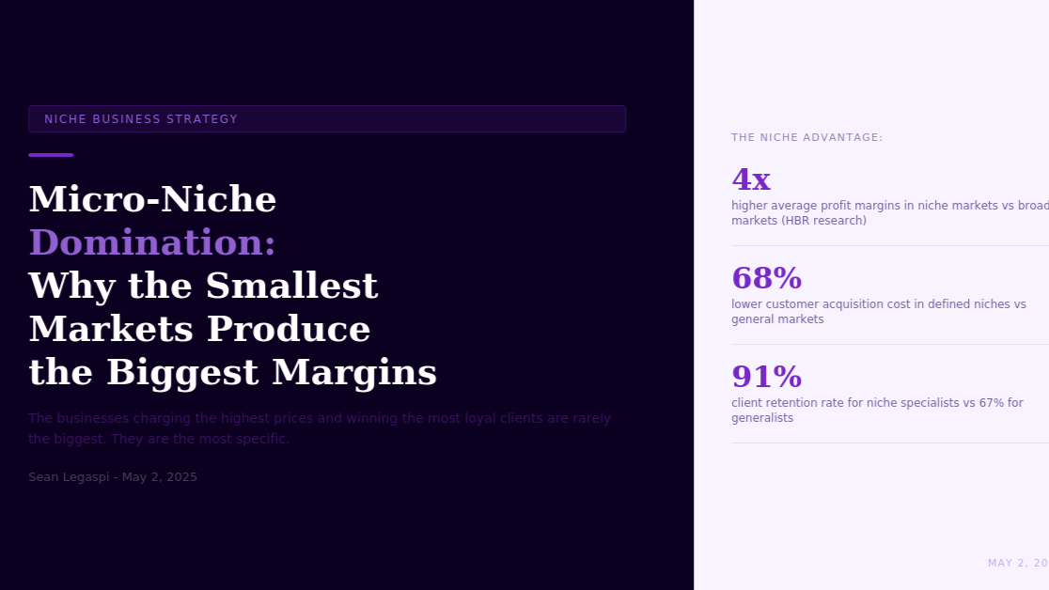

Micro-Niche Domination: Why the Most Specific Businesses Build the Strongest Market Positions and the Highest Profit Margins
May 2, 2026
The businesses charging the highest prices, retaining the most loyal clients, and defending the most sustainable market positions in 2025 are rarely the biggest competitors in their category. They are the most specific. And their specificity is not an accident.
The business instinct to serve a broad market is understandable. More potential customers means more opportunities. Narrowing the target audience means excluding buyers. For a business in its early stages, restricting who it serves feels like an unnecessary constraint on growth.
The data consistently contradicts this instinct.
Research by Harvard Business School professor Michael Porter, published in Competitive Strategy (1980) and validated repeatedly in subsequent decades, established that businesses pursuing a focused differentiation strategy, serving a specific segment with a highly tailored offering, consistently achieve higher profit margins and more durable market positions than businesses pursuing broad market coverage with undifferentiated offerings.
When a business serves everyone, its offering must be generic enough to be relevant across diverse customer needs. When a business serves a specific segment, its offering can be calibrated precisely to that segment specific needs, producing a fit so much stronger than generic alternatives that price sensitivity among target customers is dramatically reduced.

THE ECONOMICS OF NICHE SPECIFICITY
THE PROFIT MARGIN PREMIUM
Research by the Harvard Business Review analyzing small and medium business financial performance across industries found that niche market specialists achieve average profit margins 4 times higher than broad market competitors in equivalent categories.
The mechanism is pricing power. A specialist can charge more because their offering is demonstrably better suited to the customer specific situation than any generalist alternative. A general business consultant charges the market rate for business consulting. A consultant specializing in operational systems for e-commerce businesses with $1 million to $10 million in annual revenue can charge significantly more, because the specificity of the expertise creates a perceived and actual quality differential that the client cannot replicate by hiring a cheaper generalist.
THE CUSTOMER ACQUISITION COST ADVANTAGE
Narrowing the target audience reduces the cost of acquiring each customer rather than increasing it. A marketing message that speaks precisely to a highly specific audience converts at dramatically higher rates than a generic message reaching a large but undifferentiated audience.
Research published in the Journal of Marketing Research found that targeted marketing campaigns directed at precisely defined segments achieve conversion rates 3 to 5 times higher than equivalent campaigns targeting broad audiences with general messaging. LinkedIn campaign manager data shows that campaigns targeting specific job titles, industries, and company sizes produce click-through rates 2 to 4 times higher than campaigns targeting broad professional demographics.
THE CLIENT RETENTION PREMIUM
Specialists retain clients at higher rates than generalists. Research by Bain and Company analyzing professional service firm client retention rates found that specialty firms achieved average retention rates of 91 percent annually, compared to 67 percent for full-service generalist firms.
The mechanism is switching cost. When a client has found a specialist who demonstrates deep expertise in their specific situation, the cost of switching to an alternative is high: not just the financial cost of searching, evaluating, and onboarding a new provider, but the cost of losing the specific institutional knowledge the specialist has built about the client particular circumstances.

IDENTIFYING YOUR MICRO-NICHE
THE NICHE IDENTIFICATION FRAMEWORK
A viable micro-niche is defined by three criteria: the segment has a specific problem that generic providers solve inadequately, there is sufficient demand within the segment to sustain a profitable business, and the segment is reachable through identifiable, cost-effective channels.
The process for identifying candidate niches begins with analyzing your current client base for concentration patterns. Which clients are most profitable? Which produce the most referrals? Which are easiest to deliver for? These concentrations often reveal a natural niche that the business is already serving effectively, even if it has never articulated it as a strategic focus.
Research by Blair Enns in The Win Without Pitching Manifesto, based on research into professional service firm positioning, found that firms consciously committed to a specific positioning achieved new business conversion rates 40 percent higher and average project fees 35 percent higher than equivalent firms with undifferentiated positioning, within 18 months of committing to the positioning shift.
DOMINATING THE NICHE
True micro-niche domination requires becoming the most visible, most credible, and most referenced resource within the specific segment. This involves producing content that speaks specifically to the segment vocabulary and concerns, building relationships within the segment professional community, collecting and publicizing case studies that reflect the segment specific context, and developing a reputation for insider knowledge that attracts inbound enquiries from the segment without active prospecting.
The compounding effect of consistent niche focus is that visibility, credibility, and referral density all increase together over time. A business that has been publishing specifically for a defined segment for three years is significantly more visible, more trusted, and more frequently recommended within that community than one entering the niche today. This accumulated position represents a durable competitive advantage that a generalist competitor cannot replicate quickly.
Sources:
- Michael E. Porter, Competitive Strategy (Free Press, 1980)
- Harvard Business Review niche market research
- Journal of Marketing Research targeted campaign effectiveness studies (ama.org/journal-of-marketing-research)
- Bain and Company professional services retention research
- Blair Enns, The Win Without Pitching Manifesto (RockBench Publishing, 2010)
- LinkedIn Campaign Manager Research 2023 (business.linkedin.com)
- Hermann Simon, Confessions of the Pricing Man (Springer, 2015)

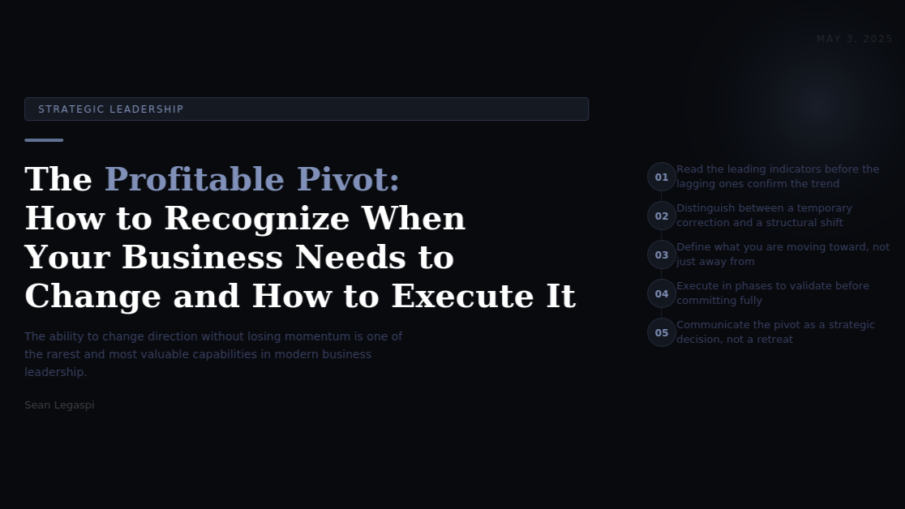The Profitable Pivot: How to Recognize When Your Business Needs to Change Direction and How to Execute the Transition Without Losing Momentum
May 3, 2026
The ability to change direction without losing momentum is one of the rarest and most valuable capabilities in modern business leadership. Most businesses recognize the need to pivot far too late and execute it far too abruptly. Both failures have the same source: confusing strategic change with admitting strategic failure.
The word pivot has accumulated a mythology in startup culture that has made it simultaneously overused and misunderstood. But the pivot as a strategic concept applies far more broadly: to any business facing a meaningful change in market conditions, customer behavior, competitive dynamics, or internal capability that makes the current strategic direction less viable than an alternative one.
A 2022 CB Insights analysis of startup failures found that 35 percent of business failures were attributed to no market need, a diagnosis that, in most cases, reflects a failure to recognize and respond to market feedback in time to redirect the business before resources were exhausted. Among businesses that successfully pivoted, the median time from recognizing the need to executing the pivot was 6 months. Among businesses that failed, the median time from recognizing the need to attempting the pivot was 14 months.
The difference between a profitable pivot and a failing one is not the decision itself. It is the timing and the quality of the execution.

RECOGNIZING THE SIGNALS: LEADING VERSUS LAGGING INDICATORS
The most common mistake in pivot timing is responding to lagging indicators rather than leading ones. Revenue decline, client churn, and shrinking margins are lagging indicators: they confirm that a strategic problem exists, but by the time they are measurable, the business is already significantly behind the optimal pivot timing.
Leading indicators signal strategic misalignment before the financial consequences are fully visible. The most reliable leading indicators include: lengthening sales cycles (the market is becoming more reluctant to buy what the business sells), increasing price pressure without quality concerns (the offering is becoming commoditized), declining engagement from existing customers (the problem the business solves is losing priority for its buyers), increasing difficulty in acquiring new customers despite stable marketing investment, and the emergence of new competitor capabilities that the business cannot currently match.
Research by Harvard Business School professor Clayton Christensen, published in The Innovator Dilemma (1997), established that the businesses most vulnerable to disruption are those doing everything right by conventional management standards: serving existing customers well, improving margins, and optimizing current operations. The signals of disruption appear initially as small, peripheral signals, and by the time they become clear in lagging financial indicators, the competitive window for response has frequently passed.

DISTINGUISHING TEMPORARY CORRECTION FROM STRUCTURAL SHIFT
Not every sign of business difficulty warrants a strategic pivot. The most important analytical discipline before committing to a pivot is distinguishing between a temporary correction, which requires operational adjustment and patience, and a structural shift, which requires strategic reorientation.
A temporary correction is characterized by cyclical demand reduction affecting all competitors similarly, or a specific operational problem that can be identified and resolved. A structural shift is characterized by a technology change that fundamentally reduces the value of the current offering, a behavioral change in the target customer base that makes the current offering less relevant, or the emergence of a new category of competitor addressing the same customer need more effectively.

DEFINING THE PIVOT DIRECTION
A pivot is not simply a change. It is a change toward something specific. The most common pivot failure mode is defining the pivot in terms of what the business is moving away from rather than what it is moving toward.
Defining the pivot direction requires applying the same research discipline that should inform any new business direction: identifying a specific customer segment with a specific unmet need, validating that the business has or can develop the capability to serve that need better than available alternatives, and confirming that the addressable market is sufficient to sustain the business at the intended scale.

THE FIVE-PHASE PIVOT EXECUTION FRAMEWORK
Phase 1: Signal Validation (4 to 8 weeks). Before communicating or executing any strategic shift, validate that the signals justifying it are real and structural rather than temporary and cyclical. This phase involves structured customer interviews, competitive analysis, and financial modeling.
Phase 2: Pivot Design (4 to 6 weeks). Define the specific new direction in terms of customer, problem, offering, and business model. Identify capability gaps between the current business and the pivot destination.
Phase 3: Minimum Viable Pivot (8 to 12 weeks). Execute a minimum viable version of the new direction alongside current operations before committing fully. Research by Eric Ries in The Lean Startup established the validated learning principle as the foundation of effective strategic pivots: each pivot should be driven by specific evidence gathered through deliberate experiments rather than by hypothesis or enthusiasm alone.
Phase 4: Full Transition (3 to 6 months). Having validated the minimum viable pivot, execute the full transition: reallocating resources, updating positioning and communication, building required capabilities, and managing the wind-down of activities that no longer fit the strategic direction. Research on client retention during provider transitions found that clients receiving proactive, transparent communication about a business strategic evolution are 60 percent more likely to continue the relationship than clients who feel changes are happening without their knowledge.
Phase 5: Communication as Narrative (ongoing). The final and frequently neglected element of a successful pivot is communicating the change as a coherent strategic narrative rather than an admission of failure. A pivot is most effectively communicated as a decision driven by strategic insight rather than by external pressure. The narrative of purposeful evolution is significantly more confidence-inspiring to existing clients and more attractive to prospective ones than the narrative of correction.

BUILDING STRATEGIC FLEXIBILITY AS A CORE CAPABILITY
The most resilient businesses in dynamic markets are those that build strategic flexibility as an ongoing organizational capability rather than treating it as an exceptional crisis response. This means maintaining the customer research practices that generate leading indicator awareness, building financial reserves that make strategic optionality possible, avoiding organizational commitments that reduce the ability to redirect, and creating a culture that treats strategic learning and adaptation as a sign of organizational intelligence rather than instability.
In an economic environment characterized by accelerating technology change, evolving consumer behavior, and increasing geopolitical uncertainty, the ability to recognize and execute a profitable pivot may be the single most valuable strategic capability a business can develop.
Sources:
- CB Insights, The Top Reasons Startups Fail 2022 (cbinsights.com/research/startup-failure-reasons-top)
- Clayton M. Christensen, The Innovator Dilemma (Harvard Business School Press, 1997)
- Eric Ries, The Lean Startup (Crown Business, 2011)
- Harvard Business Review, Strategic Pivot research; Slack, YouTube, and Instagram pivot case studies (Harvard Business School case study library)

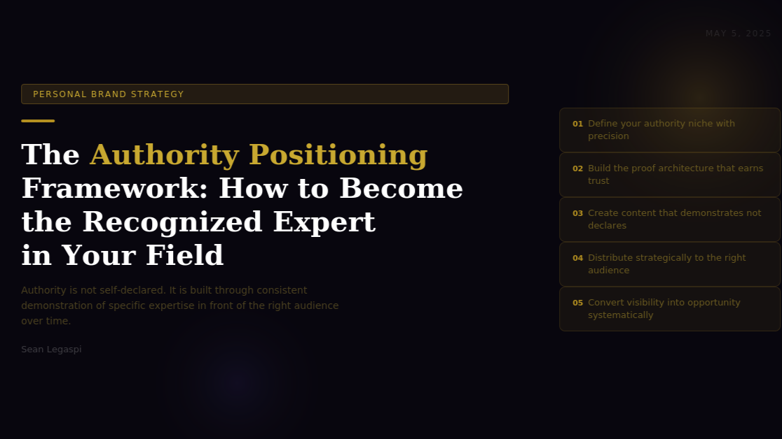

The Authority Positioning Framework: How to Become the Recognized Expert in Your Field
May 5, 2026
Authority is not self-declared. It is not a title on a business card or a claim in a LinkedIn headline. It is built through the consistent demonstration of specific expertise in front of the right audience over time, until the market recognizes and confers that authority without being asked.
The difference between a professional who is well-respected within their immediate network and one who is recognized as an authority in their field is not usually a difference in expertise. It is a difference in visibility architecture: the deliberate systems through which expertise is made legible, specific, and accessible to the audience that matters most.
Research by Edelman and LinkedIn, published in their annual B2B Thought Leadership Impact Study, found that 63 percent of senior business decision-makers say thought leadership is important for demonstrating the value of a potential partner or vendor before a sale begins. More significantly, 60 percent of that group said thought leadership convinced them to do business with an organization they were not previously considering. Authority, when it is built and maintained correctly, does not simply support the sales process. It precedes it.
This article presents a five-component framework for building genuine professional authority in any field, for any professional at any stage of their career, in any geographic market.

COMPONENT 1: DEFINING YOUR AUTHORITY NICHE WITH PRECISION
The most common mistake professionals make in attempting to build authority is defining their expertise too broadly. Authority requires a clear, specific claim. The broader the claimed expertise, the weaker the authority signal, because breadth implies a lack of depth and gives the audience no specific reason to choose you over any other generalist.
A useful test for authority niche definition comes from positioning strategist David C. Baker, whose research with creative and consulting firms is documented in The Business of Expertise (2017). Baker's principle: you should be able to define your expertise such that a specific type of buyer, facing a specific type of problem, would recognize themselves and their situation in your positioning within 10 seconds of encountering it.
For a virtual assistant specializing in operations, the authority niche is not virtual assistance, which is a category descriptor shared by hundreds of thousands of professionals globally. It might be systematizing the operations of service businesses transitioning from founder-led to team-led delivery, which is a specific situation, for a specific type of business, at a specific inflection point. That precision creates recognition and relevance that generic positioning cannot.
Practical niche definition involves mapping three variables: the specific professional problem you solve most effectively, the specific type of client or organization experiencing that problem, and the specific stage, industry, or context within which that problem most acutely occurs. The intersection of all three is the authority niche.

COMPONENT 2: BUILDING THE PROOF ARCHITECTURE
Authority requires evidence. Claiming expertise is not the same as demonstrating it. The proof architecture is the structured set of evidence points that allows a potential client, employer, or collaborator to independently verify the authority claim without relying solely on the professional's self-assessment.
Effective proof architecture in the digital era includes: documented case studies that describe specific outcomes produced for specific types of clients (with metrics wherever the client relationship permits); testimonials that speak to the specific expertise area rather than generic quality of service; public work that demonstrates the expertise in action (articles, frameworks, tools, or processes that are attributed to the professional and accessible online); credentials and certifications that carry weight within the specific professional community; and media appearances, speaking engagements, and publication features that represent third-party endorsement of the expertise.
Research by Nielsen on the psychology of professional trust found that third-party validation, the endorsement of expertise by a credible external source rather than the professional themselves, increases trust by 67 percent compared to self-reported expertise claims. This is the research foundation for why media appearances, speaking engagements, and published work function as trust accelerants: they represent a credible external party's judgment that the professional's expertise is worth their audience's attention.

COMPONENT 3: CREATING CONTENT THAT DEMONSTRATES RATHER THAN DECLARES
The distinction between content that builds authority and content that merely occupies space is whether it demonstrates expertise or declares it. Content that says I am an expert in operations management for growing businesses is a declaration. Content that walks through the specific framework used to systematize a client's invoice and onboarding process, documenting the decision rationale and outcomes at each step, is a demonstration.
Demonstration content earns the trust that declaration content claims. This is because demonstration content allows the reader to evaluate the quality of the thinking directly, without relying on the professional's self-assessment. A potential client reading a thoroughly documented process analysis can form their own judgment about whether the professional's thinking is sophisticated, practical, and relevant to their situation. That independent judgment is significantly more powerful than any endorsement the professional could write about themselves.
According to the Content Marketing Institute's 2024 B2B Content Marketing Report, 71 percent of B2B buyers consume between three and five pieces of content from a professional or organization before initiating a conversation. The implication is that the authority-building content a professional produces is not simply marketing collateral. It is the primary medium through which potential clients evaluate expertise before any direct interaction occurs.
The most effective authority-building content formats in the professional domain include: long-form articles that analyze a specific problem in depth and propose a specific framework or approach; case studies that document the implementation and outcome of a specific methodology; structured frameworks presented as diagrams, lists, or processes that give the reader a practical tool derived from the professional's expertise; and data analyses or research summaries that demonstrate the professional's command of the evidence base in their field.

COMPONENT 4: DISTRIBUTING STRATEGICALLY TO THE RIGHT AUDIENCE
Expertise that is invisible to the people who need it does not function as authority. Distribution is the mechanism through which the right audience encounters the expertise demonstration.
Strategic distribution requires understanding where the target authority audience gathers online and offline, and ensuring that the expertise demonstration content appears in those spaces consistently. For B2B professional authority, LinkedIn remains the highest-return distribution platform for most industries globally, with over 1 billion members and an algorithm specifically designed to surface professional expertise content to relevant audiences.
Beyond LinkedIn, effective distribution channels for professional authority include: industry publications and newsletters that reach the target audience's specific professional community, podcast appearances that allow deeper expertise exploration than written formats afford, speaking at industry events that give the audience a direct experience of the professional's thinking quality, and partnerships with other professionals whose audiences overlap with the target authority audience.
The sequencing of distribution matters. The most effective authority-building approach begins with consistent output on a primary owned channel (LinkedIn for most professionals), builds an audience of relevant followers over time, and then uses that established audience as social proof when approaching secondary distribution channels such as podcast hosts, publication editors, and event organizers. Attempting to speak at major conferences before building a primary audience base is rarely effective, because the evidence of an existing engaged audience is one of the primary selection criteria for those platforms.

COMPONENT 5: CONVERTING VISIBILITY INTO OPPORTUNITY SYSTEMATICALLY
Authority builds opportunity, but only when the pathway from visibility to engagement is clear and low-friction. Many professionals build significant professional visibility without a systematic mechanism for converting that visibility into actual client relationships, employment opportunities, or collaborations.
The conversion architecture for professional authority includes: a clear call to action in every piece of content that directs interested audience members to the next step (whether that is a consultation call, a newsletter subscription, a portfolio review, or a direct message); a strong LinkedIn or personal website presence that provides comprehensive context about the professional's expertise and how to engage with them; a defined response process for inbound enquiries that converts interest into conversation quickly before attention moves elsewhere; and a consistent follow-up practice that maintains relationships with warm contacts who have not yet converted into opportunities.
Research by HubSpot on B2B lead conversion found that responding to an inbound enquiry within one hour produces a 7x higher conversion rate than responding within 24 hours, and a 60x higher conversion rate than responding after 24 hours. The authority infrastructure that attracts the inbound enquiry is only as valuable as the response system that converts it.
Sources:
- Edelman and LinkedIn B2B Thought Leadership Impact Study 2024 (edelman.com/expertise/b2b-thought-leadership)
- David C. Baker, The Business of Expertise (RockBench Publishing, 2017)
- Nielsen Trust Research on Professional Credibility 2023 (nielsen.com)
- Content Marketing Institute B2B Content Marketing Report 2024 (contentmarketinginstitute.com/research)
- HubSpot Lead Response Research 2023 (hubspot.com/marketing-statistics)
- LinkedIn Creator Economy Research 2024 (linkedin.com/business/marketing/blog)

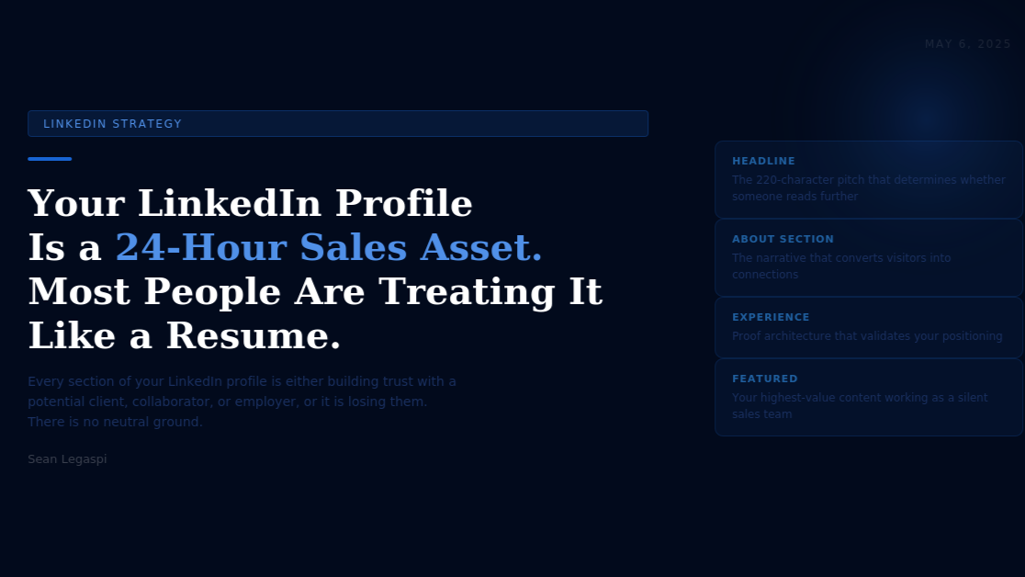

Your LinkedIn Profile Is a 24-Hour Sales Asset. Most Professionals Are Treating It Like a Resume.
May 6, 2026
A resume is a document designed to describe work history to a hiring manager. A LinkedIn profile, when built correctly, is a living sales asset that builds trust, demonstrates expertise, and converts profile visitors into conversations, all without the professional being present. The distinction between these two approaches determines whether a LinkedIn profile works for you or simply exists.
LinkedIn has 1 billion members in over 200 countries as of 2024, according to the platform's own published data. Of those billion users, approximately 40 million are in decision-making positions, and LinkedIn's internal research shows that 80 percent of B2B leads generated through social media come from LinkedIn specifically. For professionals building a personal brand, LinkedIn is not one option among many. It is the primary professional reputation infrastructure of the digital era.
Despite this, research by LinkedIn's own talent and marketing solutions teams found that the majority of LinkedIn profiles are structured as digital resumes: chronological work histories with job titles and responsibilities, designed to describe what the professional has done rather than to demonstrate the specific value they deliver and to invite the right audience into a conversation.
The LinkedIn profile as a sales asset operates according to a fundamentally different logic. Every section is designed with one question in mind: when the right person visits this profile, will they find everything they need to understand what I do, who I serve, why I am credible, and how to engage with me? If the answer to any part of that question is no, the profile is losing the opportunity that the platform's reach is delivering.

THE SEVEN PROFILE SECTIONS THAT DETERMINE SALES EFFECTIVENESS
SECTION 1: THE PROFILE PHOTOGRAPH
The profile photograph is the first element most profile visitors process. Research published in the journal Psychological Science found that people form stable first impressions from faces in as little as 100 milliseconds, and that those initial impressions are highly predictive of subsequent trust assessments.
For professional brand photography on LinkedIn, research by photofeeler.com analyzing over 60,000 LinkedIn profile photos found that photos featuring natural light, direct eye contact, a genuine smile, and professional but approachable attire score significantly higher on trust, competence, and likability metrics than studio-lit corporate headshots or casual personal photos. The practical guideline is not to spend the most money on photography but to ensure the photograph communicates the specific brand attributes of the professional: approachable and expert, not corporate and distant, or casual and unprofessional.
SECTION 2: THE HEADLINE
LinkedIn provides 220 characters for the headline, the text displayed beneath the name across the platform. Most professionals use this space to state their job title and employer. Job titles are the lowest-information use of this real estate because they communicate category (what you are) but not value (what you specifically deliver for whom).
A high-converting LinkedIn headline communicates three things: who you serve, what specific outcome you produce for them, and enough differentiation to justify further investigation. LinkedIn research found that profiles with specific, value-oriented headlines receive 21 times more profile views than profiles with generic job title headlines. The headline is the single highest-leverage optimization available on the platform because it appears in search results, connection requests, and notifications, functioning as a persistent advertisement for the professional's value proposition.
SECTION 3: THE ABOUT SECTION
The About section is the most consistently underutilized section on LinkedIn. Most professionals write it in the third person, use it to summarize their professional history, and end it without a call to action. This approach produces a section that functions as a biography when it should function as a conversion mechanism.
An effective About section written for a sales asset context follows a four-part structure. The first paragraph addresses the specific reader: not who the professional is, but the specific problem or situation the ideal profile visitor is experiencing. The second and third paragraphs demonstrate specific expertise and credibility in solving that problem, using documented outcomes rather than capability claims. The fourth paragraph establishes the professional's specific approach and what makes it different from generic alternatives. The final lines include a clear, specific call to action directing the reader to the next step.
Research by LinkedIn found that profiles with complete About sections receive 40 percent more inbound messages than profiles with incomplete or absent About sections. The About section is where the conversion from visitor to conversation happens most frequently.
SECTION 4: THE FEATURED SECTION
The Featured section allows professionals to pin specific content at the top of their profile, above the work experience. This is the highest-visibility location on the profile for demonstrating expertise and directing visitors to specific resources.
The most effective Featured section items for a personal brand profile include: the professional's highest-performing original content piece (the article or post that best demonstrates their specific expertise), a link to a specific resource they have created (a guide, a framework, a case study, or a portfolio), and contact or booking links that reduce the friction of initiating a conversation. The Featured section functions as a curated shop window for the professional's best work, operating as a silent sales team for every profile visitor who scrolls past it.
SECTION 5: THE EXPERIENCE SECTION
The conventional approach to the Experience section, listing job titles, employers, and responsibilities in reverse chronological order, describes inputs rather than outputs. A sales-oriented Experience section focuses instead on specific outcomes produced in each role, using the structure: context, action taken, and specific result achieved.
Research by Ladders analyzing recruiter behavior found that professional profiles describing outcomes (increased client retention by 34 percent over two years by implementing a proactive account management system) rather than responsibilities (responsible for client relationship management) receive 2.3 times more positive evaluations from decision-makers reviewing profiles. The same principle applies to the personal brand context: potential clients and collaborators are evaluating whether the professional produces the type of outcomes they need, not whether they have performed the category of task required.
SECTION 6: RECOMMENDATIONS
LinkedIn recommendations are the platform's native third-party validation mechanism. According to research by BrightLocal on the psychology of online recommendations, 88 percent of consumers trust recommendations from people they know as much as they trust personal recommendations, and that principle extends to professional contexts.
High-quality LinkedIn recommendations are specific rather than generic, describe a particular outcome or experience rather than offering general praise, and are written by people whose titles and organizations are relevant to the authority niche. The most effective approach to building a strong recommendation profile is to give specific, genuine recommendations to colleagues and clients first, and then to ask for reciprocal recommendations from those whose perspective on the professional's expertise is most relevant to their positioning.
SECTION 7: CONTENT ACTIVITY AND CONSISTENCY
The LinkedIn algorithm uses content engagement history as a signal in determining whose profile to surface in search and discovery. A professional who publishes relevant content consistently is more likely to appear in the feeds of potential clients and collaborators than one who is inactive, even if both have equivalent qualifications.
LinkedIn's 2024 Creator Research found that professionals who publish original content on LinkedIn at least once per week receive 5 to 7 times more profile views than inactive users, and that the profile visit rate compounds over time as the content library builds and each piece continues to be discovered through search and shares long after publication.
The practical implication is that the LinkedIn profile as a sales asset is not a static document to be set and forgotten. It is a living platform that performs best when actively maintained through consistent content publication, regular profile updates as expertise and positioning evolve, and active engagement with the content and conversations of the target professional community.
Sources:
- LinkedIn Platform Statistics and Research 2024 (linkedin.com/business/talent/blog)
- LinkedIn Talent Solutions Profile Optimization Research (linkedin.com/business/talent)
- Psychological Science Journal, Face Perception and Trust Research; Photofeeler LinkedIn Photo Research (photofeeler.com/blog)
- LinkedIn Content Creator Research 2024 (linkedin.com/business/marketing)
- Ladders Professional Profile Analysis 2022 (theladders.com)
- BrightLocal Online Recommendation Psychology Study 2023 (brightlocal.com/research)
- LinkedIn About Section Engagement Research (linkedin.com/help)

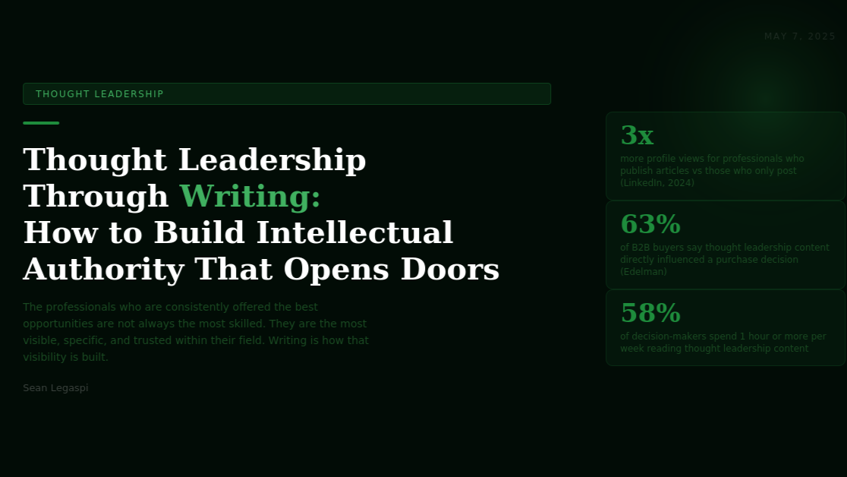

Thought Leadership Through Writing: How to Build Intellectual Authority That Opens Doors and Creates Opportunities
May 7, 2026
The professionals who are consistently offered the best opportunities, invited to the most influential rooms, and trusted with the highest-value work are not always the most technically skilled in their field. They are the most visibly, specifically, and consistently intelligent about their field. Writing is how that visibility is built.
Thought leadership as a term has been diluted by overuse. In professional culture, it has come to describe almost any original content produced by a professional, regardless of whether that content actually advances thinking, challenges assumptions, or provides genuinely useful insight that the audience could not have arrived at independently.
The research on what actually constitutes effective thought leadership is more rigorous than the casual usage of the term suggests.
Edelman's annual Thought Leadership Impact Study, conducted with LinkedIn across three consecutive years, surveyed over 3,500 business decision-makers globally. The findings are specific: 63 percent of respondents said thought leadership is important for demonstrating the value of a potential partner, and 61 percent said they were willing to pay a premium to work with a professional who produced thought leadership content they found valuable. Crucially, 71 percent of decision-makers in the 2023 edition said most thought leadership they encounter is generic, not insightful, and does not influence their thinking. The bar set by the term is not being met by the volume of content claiming to meet it.
True thought leadership, the kind that builds professional authority and creates opportunities, has five specific characteristics that distinguish it from content that merely occupies space.

CHARACTERISTIC 1: SPECIFICITY OVER BREADTH
Thought leadership that influences decision-makers is almost always specific. It addresses a precise problem, in a defined context, with a particular argument that the reader can evaluate, agree with, or dispute. Content that is broadly applicable to everyone is meaningfully useful to no one.
Professional speaking coach and author Michael Port, in his research on professional positioning documented in Book Yourself Solid (2008), found that the professionals who build the fastest authority in their field are those who become specifically associated with one precise idea or approach: a specific framework, a counterintuitive insight, or a named methodology. That specificity creates a cognitive anchor in the audience's mind that generic expertise does not.
The practical test for specificity: if your content could have been written by any reasonably informed professional in your field, it is not specific enough to function as thought leadership. If it could only have been written by someone with your specific combination of experience, observation, and perspective, it is functioning as genuine thought leadership.

CHARACTERISTIC 2: ORIGINAL OBSERVATION BACKED BY EVIDENCE
The most powerful thought leadership contains at least one genuinely original observation: a connection between ideas that the audience had not previously made, a pattern in data that has not been publicly articulated, or a counterintuitive insight that challenges a widely held assumption in the field.
Original observation does not require original research. It requires the willingness to take a position on what the existing evidence means, rather than simply summarizing what is known. Thought leadership that summarizes industry reports and trends produces content that is useful but not authoritative. Thought leadership that takes a specific position on the implications of those trends, backed by reasoning the audience can follow and evaluate, is what creates the professional trust that opens doors.
A 2022 study published in the Journal of Marketing by researchers at University of Southern California found that content taking a clear, reasoned position on a contested professional question produced 40 percent higher engagement and 67 percent higher sharing rates than equivalent content presenting multiple perspectives without reaching a conclusion. Audiences do not want thought leadership that tells them what everyone thinks. They want thought leadership that tells them what the writer thinks, and why.

CHARACTERISTIC 3: PRACTICAL UTILITY FOR THE SPECIFIC READER
Thought leadership that changes how people think about a topic is valuable. Thought leadership that changes how they act on that topic is transformational. The most effective thought leadership writing connects insight to action: it tells the reader not just what is true but what to do differently as a result.
This practical utility is especially important for building professional authority in business contexts, where decision-makers are evaluating whether the professional's thinking translates into practical outcomes. A consultant who can explain why a trend is important has demonstrated knowledge. A consultant who can articulate exactly what a specific type of business should do about that trend, with enough specificity that the reader can begin implementing on Monday, has demonstrated expertise.

CHARACTERISTIC 4: CONSISTENT PUBLICATION AT A SUSTAINABLE CADENCE
Single pieces of content, however excellent, do not build professional authority. Authority is built through the accumulated body of work that establishes a consistent perspective, approach, and level of quality over time. The reader who encounters one excellent article may be impressed. The reader who encounters twelve excellent articles on a related set of topics begins to trust the professional's judgment in that domain.
Research by the Content Marketing Institute found that professionals who publish consistently over a 12-month period generate 3 to 4 times the thought leadership credibility scores from target audience surveys as professionals who publish intermittently with equivalent average quality per piece. Consistency signals commitment, which signals genuine investment in the field, which is itself a credibility signal.
The sustainable cadence principle is more important than the ambitious cadence principle. A professional who publishes one high-quality original article per week builds more authority over 12 months than one who publishes daily for one month and then stops, because the audience internalizes the pattern of consistent presence as a characteristic of the professional brand.

CHARACTERISTIC 5: DEMONSTRATED INTELLECTUAL EVOLUTION
The most trusted thought leaders are those whose public writing shows evidence of evolving thinking over time: updated positions, refined frameworks, and the willingness to revisit previous conclusions when new evidence warrants. This intellectual honesty is a significant trust signal because it demonstrates that the professional's position-taking is based on genuine analysis rather than self-promotion.
A professional who publicly updates a position they took 18 months ago based on new evidence or experience is demonstrating a quality of intellectual integrity that is rare and valuable. Research by Adam Grant at the Wharton School, explored in Think Again (2021), found that professionals who demonstrate the willingness to change their minds publicly are rated as more credible, not less, by professional audiences, contrary to the common intuition that changing positions is a weakness.

THE PRACTICAL THOUGHT LEADERSHIP WRITING SYSTEM
Building a thought leadership writing practice requires a system that makes consistent, high-quality production sustainable without consuming the time required for client work and business operations.
The most effective system for most professionals is built on three practices: an ongoing idea capture mechanism (a simple note-taking system that records observations, insights, and questions from daily work in real time, before they are forgotten); a weekly writing block of 90 to 120 minutes dedicated entirely to drafting without editing (which applies Cal Newport's deep work principles to the writing practice); and a separate editing and publication block of 30 to 45 minutes in which the draft is refined and published without re-entering ideation mode.
This separation of ideation, drafting, and editing addresses the most common failure mode in thought leadership writing: the attempt to do all three simultaneously, which produces slow, mediocre output that does not reflect the quality of thinking the professional is capable of when working in a single mode.
Sources:
- Edelman and LinkedIn Thought Leadership Impact Study 2023 and 2024 (edelman.com/expertise/b2b-thought-leadership)
- Michael Port, Book Yourself Solid (Wiley, 2008); Journal of Marketing, University of Southern California, Content Position-Taking Research 2022 (ama.org/journal-of-marketing)
- Content Marketing Institute Consistency Research 2023 (contentmarketinginstitute.com/research)
- Adam Grant, Think Again (Viking, 2021); Cal Newport, Deep Work (Grand Central Publishing, 2016); LinkedIn Article Publishing Research 2024 (linkedin.com/help/linkedin/answer)

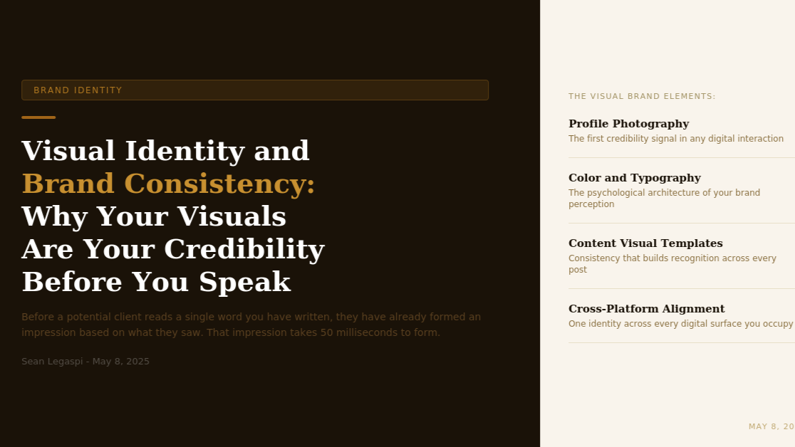

Visual Identity and Brand Consistency: Why Your Visuals Are Your Credibility Before You Ever Speak
May 8, 2026
Before a potential client reads a single word you have written, before they hear your voice, before they engage with your ideas, they have already formed an impression of your professional credibility based entirely on what they saw. That impression takes 50 milliseconds to form and is disproportionately difficult to change once established.
The research on visual first impressions in professional contexts is more precise and more consequential than most professionals realize.
A study published in the journal Behaviour and Information Technology by Gitte Lindgaard and colleagues at Carleton University found that users form stable aesthetic judgments of websites in as little as 50 milliseconds, and that those initial judgments correlate strongly with subsequent assessments of credibility, trustworthiness, and expertise. The implication is not that substance does not matter. It is that substance does not get the opportunity to be evaluated if the visual first impression fails.
For personal brand building, this research has a direct application: every visual element associated with a professional, the profile photograph, the content graphic templates, the cover image, the typography choices, the color palette, and the design consistency across platforms, is functioning as a credibility signal before any content is consumed. Inconsistent, low-quality, or misaligned visual presentation creates a cognitive dissonance between the claimed expertise and the presented appearance that many potential clients resolve by moving on rather than investigating further.

THE FOUR DIMENSIONS OF PERSONAL BRAND VISUAL IDENTITY
DIMENSION 1: PROFESSIONAL PHOTOGRAPHY
The profile photograph is the single most important visual element in a personal brand digital presence, because it appears at every point of contact: LinkedIn profile, Twitter profile, Google search results, publication bylines, podcast guest profiles, and email correspondence. It is the visual anchor of professional identity.
Research by the University of York, published in the journal PLOS ONE, found that judgments of competence, trustworthiness, and leadership potential formed from professional headshots were highly consistent across different cultural and national contexts, suggesting that these visual signals operate on relatively universal psychological principles rather than purely culturally specific ones. This has direct implications for professionals building an international personal brand: the quality and character of the profile photograph is being evaluated through a relatively consistent psychological lens by audiences across geographies.
The specific attributes that correlate with high trust and competence scores in professional photography research include: direct eye contact with the camera (which creates a perception of engagement and honesty), a genuine rather than performed smile (which correlates with approachability and warmth), professional but not formal attire (which signals competence without communicating distance), and a clean, uncluttered background that directs attention to the face rather than competing with it.
For most professionals, the best investment in personal brand visual identity is a professional photography session that produces three to five high-quality images in different framings and expressions, updated every two to three years as the professional's appearance evolves.
DIMENSION 2: COLOR PALETTE AND TYPOGRAPHY
Color psychology in branding has been studied extensively, and the research is consistent in demonstrating that color choices activate specific associations and expectations in audiences, often below the level of conscious awareness.
Research by the Institute for Color Research found that consumers make a subconscious judgment about a person, environment, or product within 90 seconds of initial viewing, and that between 62 and 90 percent of that assessment is based on color alone. For personal brands, this means the color choices in social media graphics, presentation templates, website design, and other branded materials are actively shaping audience perception of the professional's personality, authority, and fit before any other information is processed.
Color choices for professional personal brands are most effective when they are both strategically aligned with the positioning and consistently applied across every visual touchpoint. A professional who uses a deep navy blue as their primary brand color in LinkedIn graphics, but uses an entirely different palette on their Instagram content and a third palette on their personal website, is producing visual incoherence that signals a lack of attention to detail and undermines the credibility that consistent visual identity would build.
Typography carries similar brand signaling. Research on typeface psychology by Robert Waller at the University of Reading found that typography choices activate associations related to personality characteristics: serif typefaces tend to activate perceptions of tradition, reliability, and authority, while sans-serif typefaces activate perceptions of modernity, approachability, and clarity. Neither is superior in all contexts, but the alignment between the brand personality being communicated and the typographic choices being made determines whether the visual language is coherent or contradictory.
DIMENSION 3: CONTENT VISUAL TEMPLATES
The visual design of the content a professional publishes, the graphic templates used for social media posts, the layout of articles and presentations, and the visual structure of documents and reports, is one of the most consistently underinvested aspects of personal brand development.
Research by MIT neuroscientists found that the human brain processes images 60,000 times faster than text, and that visual information accounts for 90 percent of all information transmitted to the brain. In the context of social media content specifically, this means that the visual design of a post determines whether it stops the scroll before the text is read, not the other way around.
For personal brand content, the investment in a set of consistent, well-designed content templates is one of the highest-return visual identity investments available. A library of three to five templates in a consistent color palette and typography that can be adapted for different content types (quote graphics, data visualization, process diagrams, announcement graphics) produces several outcomes simultaneously: it reduces the time cost of producing each individual piece of content, it creates visual consistency across the content library that builds brand recognition over time, and it communicates a level of design professionalism that elevates the perceived quality of the expertise being shared.
Tools including Canva, Adobe Express, and Figma make professional template creation accessible to professionals without design training. The discipline is in creating the templates correctly once and maintaining the consistency discipline of using them rather than creating new design approaches for each piece of content.
DIMENSION 4: CROSS-PLATFORM VISUAL CONSISTENCY
The final and often most neglected dimension of personal brand visual identity is the consistency of visual presentation across every digital platform where the professional has a presence. LinkedIn, Twitter or X, Instagram, YouTube, personal website, email newsletter, and any other digital surfaces should collectively present a coherent visual identity that is immediately recognizable as belonging to the same professional brand.
This cross-platform consistency serves two strategic purposes. First, it builds brand recognition: when a potential client encounters the professional's content on LinkedIn and then finds their newsletter in an inbox, the consistent visual identity creates an immediate recognition signal that reinforces the professional relationship. Second, it signals intentionality and professionalism: a professional whose visual presentation is coherent across platforms is demonstrating the same quality of attention to detail that they presumably bring to their client work.
A practical cross-platform consistency audit involves reviewing every digital touchpoint simultaneously and asking whether a new visitor to any of them would recognize them as belonging to the same professional brand within three seconds. Any touchpoint that fails that test is an opportunity for visual brand strengthening.

THE ROI OF VISUAL BRAND INVESTMENT
For professionals skeptical of investing time and resources in visual brand development, the research on the return is persuasive.
A 2021 study by Lucidpress analyzing the revenue impact of brand consistency found that consistent brand presentation across all platforms increases revenue by an average of 23 percent, with the mechanism being higher conversion rates from prospect to client driven by increased trust and recognition. For a personal brand, this conversion rate improvement applies to the journey from profile visitor or content consumer to consultation request or collaboration enquiry.
The visual identity of a personal brand is not an aesthetic preference. It is a trust infrastructure. And trust, as the research consistently shows, is the primary currency of professional authority.
Sources:
- Gitte Lindgaard et al., Attention Web Designers, Behaviour and Information Technology, 2006 (tandfonline.com)
- University of York, PLOS ONE, Competence from Headshots Research 2018; Institute for Color Research, Color and First Impressions (colorcom.com)
- Robert Waller, Typography and Personality Research, University of Reading; MIT Neuroscience Image Processing Research (mit.edu)
- Lucidpress Brand Consistency and Revenue Research 2021 (lucidpress.com/blog/brand-consistency-research)

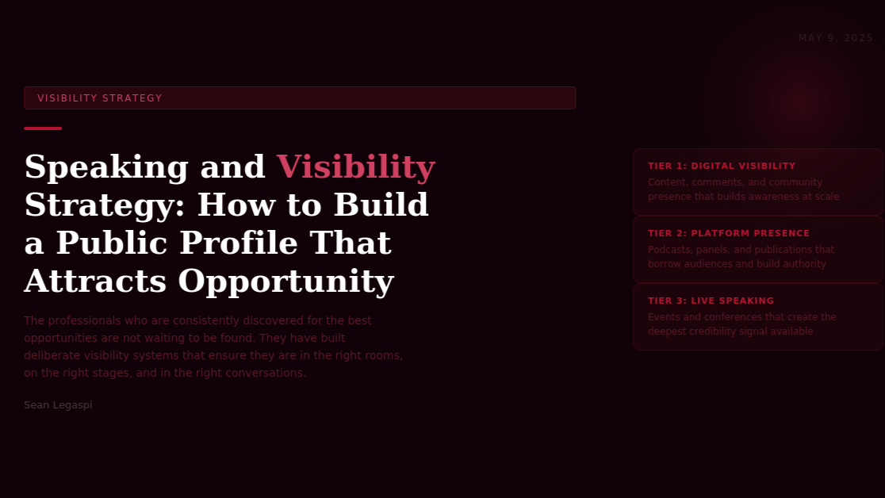Speaking and Visibility Strategy: How to Build a Public Profile That Consistently Attracts the Right Opportunities
May 9, 2026
The professionals who are consistently discovered for the best opportunities are not the ones who are passively waiting to be found. They have built deliberate visibility systems that ensure they are in the right rooms, on the right stages, and in the right conversations long before any specific opportunity presents itself.
Professional visibility is a system, not an accident. The professionals who appear to be in the right place at the right time, consistently, have almost always built deliberate infrastructure that makes their presence in those places predictable rather than fortunate.
Research by Dorie Clark at Duke University's Fuqua School of Business, published in Stand Out (2015) and validated in subsequent surveys of over 1,000 recognized thought leaders and subject matter experts, found that professional visibility follows a consistent pattern across industries and geographies. It is built in layers, beginning with digital presence, expanding through borrowed platform visibility (appearing in other people's audiences), and eventually producing earned platform visibility (being invited to speak, publish, or consult because of accumulated authority). The professionals who try to skip layers, attempting major speaking opportunities before building a primary audience, or pursuing publication in major outlets before demonstrating authority through consistent original work, consistently achieve lower results than those who build the layers in sequence.

THE THREE LAYERS OF PROFESSIONAL VISIBILITY
LAYER 1: DIGITAL VISIBILITY FOUNDATIONS
Digital visibility is the base layer of any professional visibility system. Before a professional can borrow audience from other platforms or earn speaking opportunities, they need to have built a primary digital presence that demonstrates their expertise clearly and consistently.
This digital foundation consists of three core elements: an optimized LinkedIn profile that functions as a sales asset (as discussed in detail in the previous day article), a consistent content publication practice that demonstrates expertise to the platform audience, and an engaged content comment practice that extends reach beyond the immediate follower network.
Research by LinkedIn published in their 2024 Creator Analytics found that professionals who engage substantively in the comments section of relevant posts in their industry, adding specific insights or building on the ideas of the original post rather than simply affirming agreement, experienced an average 34 percent increase in profile visits from outside their immediate network within 90 days. The comment as a visibility mechanism is consistently underestimated relative to original post creation, despite its significantly lower time requirement.
LAYER 2: BORROWED PLATFORM VISIBILITY
Borrowed platform visibility refers to the strategy of appearing in other people's established audiences, through podcast guest appearances, publication contributions, webinar participation, co-created content, and expert commentary in industry media.
This layer is more accessible than professionals typically assume, particularly in the early stages of building authority. Podcast hosts, newsletter writers, and event organizers are constantly searching for credible, specific, and articulate guests who can add value for their audience. A professional with a clear authority niche, a documented perspective, and evidence of existing content quality is well-positioned to secure these opportunities even without a large primary audience.
Research by Edison Research on podcast listening behavior found that podcast audiences transfer significant credibility from the host to the guest: being featured as a guest on a podcast that the target audience listens to produces trust levels comparable to a personal recommendation from the host. For personal brand building, a single podcast appearance that reaches the right audience can produce more inbound interest than weeks of original content publication.
The practical approach to securing borrowed platform visibility is a structured outreach practice: identifying the five to ten podcasts, newsletters, publications, and events where the target audience gathers, researching the host or editor, developing a specific and relevant pitch that articulates the value the appearance would produce for their audience, and sending a concise, personalized outreach message. The conversion rate from professional, specific pitches to accepted appearances is significantly higher than most professionals assume.
According to research by podcast booking agency Podcast Bookers, the acceptance rate for well-targeted, personalized podcast pitches from credible professionals is approximately 15 to 25 percent, compared to 1 to 2 percent for generic broadcast pitches sent without personalization.
LAYER 3: EARNED PLATFORM VISIBILITY
Earned platform visibility is the stage at which opportunities begin to arrive without active pursuit: speaking invitations from event organizers, publication requests from editors, consulting enquiries from organizations who have encountered the professional's work. This is the compounding return on the investment in Layers 1 and 2.
Speaking at live events, whether physical conferences or virtual summits, represents the highest-credibility visibility format available to most professionals. Research by the National Speakers Association found that professionals who speak regularly at industry events report business development outcomes (new client relationships, partnership opportunities, and media enquiries) at 3 to 4 times the rate of non-speaking peers with equivalent expertise.
The mechanism is the unique depth of trust that live speaking creates. An audience member who has spent 30 to 60 minutes in direct intellectual engagement with a professional, hearing their thinking in real time and evaluating their confidence, expertise, and authenticity directly, develops a level of trust that no written content format can replicate. According to Professor Albert Mehrabian's research on communication, widely cited in professional development contexts, live presence allows the full range of trust signals (verbal content, vocal quality, and non-verbal behavior) to operate simultaneously, producing a far richer credibility assessment than text or recorded media alone.

BUILDING THE SPEAKING PORTFOLIO
For professionals at the beginning of the earned visibility layer, the path to major speaking opportunities runs through smaller stages. Local industry events, professional association meetings, employer or client lunch-and-learn sessions, and virtual webinars all provide speaking experience, video footage, and audience testimonials that constitute a speaking portfolio.
This portfolio serves two functions: it provides evidence of speaking competence and impact to event organizers evaluating potential speakers, and it provides a feedback loop of audience questions and responses that sharpens the professional's ability to communicate their expertise to a live audience.
Research by speaking coach and professional development expert Carmine Gallo, documented in Talk Like TED (2014), found that the single most consistent differentiator between speakers who are invited back and those who are not is specificity of insight combined with narrative structure. Speakers who tell one specific story that illustrates one specific idea with one specific practical implication for the audience consistently outperform speakers who attempt to deliver comprehensive coverage of a broad topic in the same time slot.

THE VISIBILITY CALENDAR: MAKING STRATEGY OPERATIONAL
A visibility system without an operational calendar remains a strategy in theory rather than a practice in reality. The professionals who build visibility most consistently are those who have translated their visibility strategy into a weekly and monthly action plan that specifies: the number of original posts to be published per week, the number of substantive comments to be made per day, the number of podcast or publication pitches to be sent per month, and the speaking opportunities to be pursued each quarter.
This calendar approach converts the aspiration of visibility into a predictable, measurable practice that compounds over time.
Sources:
- Dorie Clark, Stand Out (Portfolio, 2015)
- LinkedIn Creator Analytics Research 2024 (linkedin.com/business/marketing)
- Edison Research Podcast Trust Study 2023 (edisonresearch.com/the-infinite-dial-2023)
- Podcast Bookers Outreach Research (podcastbookers.com/blog)
- National Speakers Association Business Development Research (nsaspeaker.org)
- Albert Mehrabian, Silent Messages (Wadsworth, 1971); Carmine Gallo, Talk Like TED (St. Martin Press, 2014)

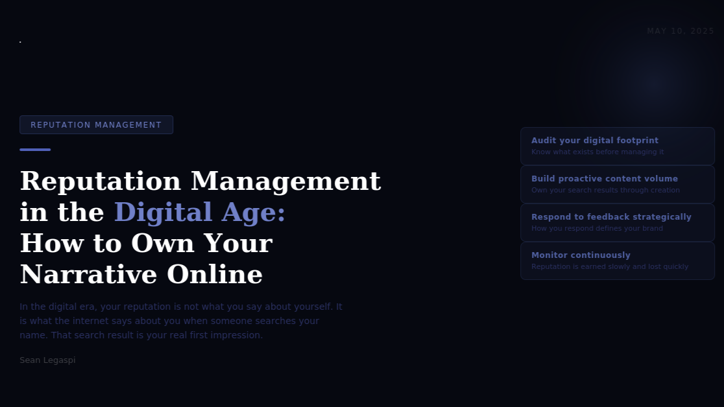Reputation Management in the Digital Age: How to Own Your Narrative Online and Protect the Brand You Have Built
May 10, 2026
In the digital era, your reputation is not what you say about yourself. It is what the internet says about you when someone searches your name, reads your reviews, or asks your network about their experience working with you. That search result, that aggregated perception, is your real first impression, and it is being formed continuously, whether you are actively managing it or not.
Professional reputation has always mattered. What has changed in the digital era is the permanence, accessibility, and scale of the information that shapes it.
In the pre-digital professional environment, reputation was managed primarily through direct relationships, personal referrals, and the occasional media appearance. A negative experience between a professional and a client was typically contained within the immediate network of both parties. A positive reputation took years to build but was also relatively protected from rapid erosion through events outside the professional's immediate control.
The digital environment has altered all of these dynamics fundamentally. Reputation, both positive and negative, now accumulates in searchable, persistent, shareable digital artifacts: reviews, social media content, media coverage, forum discussions, and the content professionals themselves produce. A single negative review or poorly handled public interaction can persist in search results indefinitely and reach audiences orders of magnitude larger than the professional's immediate network. A consistently strong digital reputation, conversely, can precede a professional into rooms and conversations across the world, earning trust before any direct interaction has occurred.
Research by BrightLocal's annual Local Consumer Review Survey found that 93 percent of consumers read online reviews before making a purchase or hiring decision, and that the average consumer reads a minimum of seven reviews before forming a trust opinion about a business or professional. For professional personal brands, the equivalent behavioral pattern involves Google searches, LinkedIn profile reviews, and background enquiries to mutual connections before any engagement decision is made.

THE FOUR PILLARS OF DIGITAL REPUTATION MANAGEMENT
PILLAR 1: AUDITING YOUR CURRENT DIGITAL FOOTPRINT
Effective reputation management begins with an honest audit of the current state of the professional's digital presence. This audit involves searching the professional's name in every major search engine (Google, Bing, and DuckDuckGo) in incognito mode, which removes personalization from results and shows what a new visitor would actually see.
The audit examines: what appears on the first page of search results (which receives approximately 75 percent of all clicks, according to research by Advanced Web Ranking), what the sentiment and content of that first-page material communicates about the professional's expertise and reputation, what platforms and communities have content about the professional that they may not be aware of, and whether any negative or misleading content exists that requires attention.
For most professionals, the audit reveals that their digital footprint is less managed and more fragmented than they realized. Multiple social media profiles from different career stages, outdated professional bios, or simply an absence of controlled content means that the narrative being presented to new visitors is being shaped by chance rather than strategy.
PILLAR 2: BUILDING PROACTIVE CONTENT VOLUME
The most reliable mechanism for owning the search narrative around a professional name is producing sufficient volume of high-quality, specifically attributed content that it displaces whatever else might appear in search results.
Research on search result click-through rates by Backlinko analyzing 5 million Google search results found that the first organic result receives 27.6 percent of all clicks, the second receives 15.8 percent, and the third receives 11 percent. Results beyond position ten (the second page) receive less than 1 percent of total clicks collectively. For professional reputation purposes, this means that controlling the first five to seven search results for a professional name is functionally equivalent to controlling the first impression formed by the majority of people who search that name.
The content types that rank most reliably for professional name searches include: a professional website or personal brand site with the professional's name in the domain or prominently in the title, LinkedIn profiles (which Google consistently indexes and ranks highly for professional name searches), published articles on credible industry publications with the author's name in the byline, podcast appearances where the episode title includes the professional's name, and media coverage or press mentions on authoritative websites.
The practical implication is that a professional who publishes consistently on a primary platform, maintains a complete and active LinkedIn profile, and contributes to credible industry publications is building a positive, controlled search result portfolio that gradually replaces fragmented or neutral content in the top positions.
PILLAR 3: RESPONDING TO FEEDBACK STRATEGICALLY
The way a professional responds to public feedback, whether positive or negative, is itself a brand communication. Every response is visible not just to the person who left the original feedback but to every future visitor who reads the exchange.
Research published in the Cornell Hospitality Quarterly analyzing the impact of review responses on consumer behavior found that businesses and professionals who respond to negative reviews with specific, non-defensive, solution-oriented responses experienced net improvement in trust ratings from future visitors, even when the original negative review remained visible. The research concluded that the response quality was in some cases a stronger trust signal than the absence of any negative review, because it demonstrated accountability and professionalism in a high-stakes context.
The principles for effective public response to negative feedback are consistent across the research: acknowledge the experience without admitting liability where appropriate, demonstrate genuine engagement with the specific concern raised rather than offering a generic apology, explain what changed or what the professional would do differently where relevant, and invite the conversation to continue in a private channel for resolution. This pattern transforms a public negative signal into a demonstration of professional character.
PILLAR 4: MONITORING CONTINUOUSLY AND SYSTEMATICALLY
Reputation management is not a one-time project. It is an ongoing operational practice. The digital landscape is dynamic: new content about a professional can appear without warning, existing content can be reshared and reach new audiences, and the professional's own content continues to accumulate a behavioral history that shapes the perception of new visitors.
Systematic monitoring of a professional's digital presence involves: setting up Google Alerts for the professional's name and primary business name, which send email notifications when new content containing those terms is indexed; reviewing search results monthly in incognito mode; monitoring review platforms relevant to the professional's industry; and tracking social media mentions using tools such as Mention, Brand24, or the platform's own notification systems.
The frequency of monitoring should match the pace at which the professional's public presence is growing. A professional who is publishing regularly, receiving media coverage, and appearing on podcasts is generating more reputation-relevant material and should monitor more frequently than one who is in an earlier stage of visibility building.

THE RELATIONSHIP BETWEEN REPUTATION AND OPPORTUNITY
Reputation management is ultimately not a defensive practice. It is an offensive one.
A professional with a consistently strong, controlled, and specific digital reputation is not simply protecting themselves from reputational damage. They are actively building the most important prerequisite for inbound professional opportunity: trust at scale.
Research by Edelman's annual Trust Barometer found that trust is the most important variable in professional service buying decisions globally, rated above price, proximity, and even personal referral in many contexts. The professionals whose digital reputation communicates consistent expertise, professional integrity, and genuine client value are accumulating the trust capital that converts search visitors, social media followers, and audience members into clients, collaborators, and advocates without any additional sales activity required.
Reputation, in the digital era, is not what happens to you. It is what you build deliberately or leave to chance. The professionals who treat it as a strategic asset rather than a passive consequence of their work are the ones whose opportunities consistently expand while their peers wonder why the market has not recognized what they know they deserve.
Sources:
- BrightLocal Local Consumer Review Survey 2023 (brightlocal.com/research)
- Advanced Web Ranking CTR Research 2024 (advancedwebranking.com/ctrstudy)
- Backlinko Search Result CTR Research 2023 (backlinko.com/google-ctr-stats)
- Cornell Hospitality Quarterly, Review Response Research (journals.sagepub.com/home/cqx)
- Edelman Trust Barometer 2024 (edelman.com/trust/2024-trust-barometer)
- Google Search Console Documentation (support.google.com/webmasters)
- Dorie Clark, Reinventing You (Harvard Business Review Press, 2013)
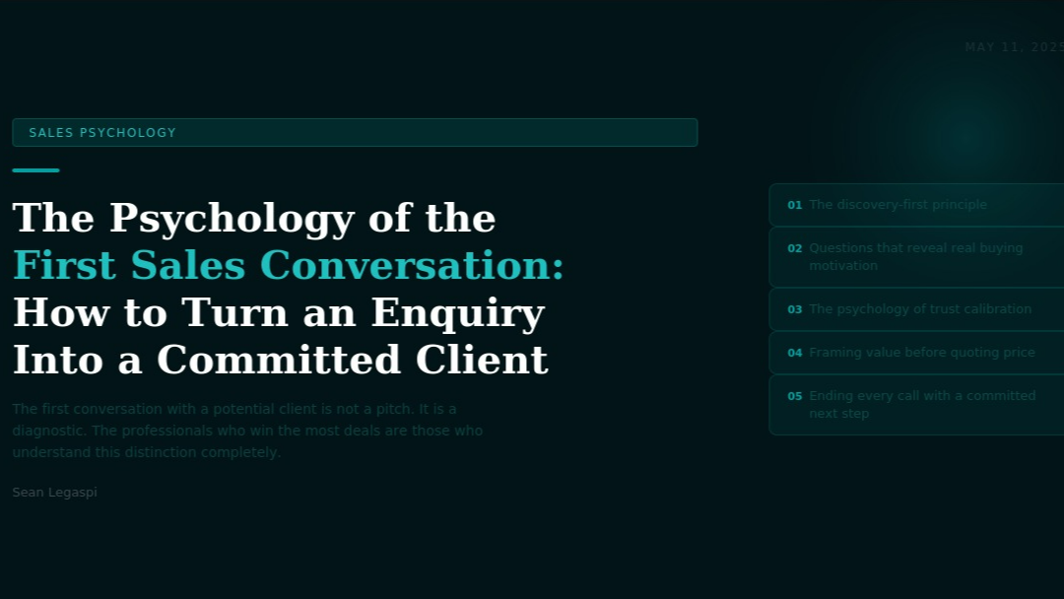

The Psychology of the First Sales Conversation: How to Turn an Enquiry Into a Committed Client
May 11, 2026
The first conversation with a potential client is not a pitch. It is a diagnostic. The professionals who win the most deals are those who understand this distinction completely and structure every element of the first conversation around discovery rather than persuasion.
Most professionals approach the first sales conversation with the wrong mental model. They prepare their pitch, rehearse their value propositions, and anticipate the questions they will be asked. The conversation they are preparing for is a presentation. But the conversation that actually wins deals is a consultation.
The distinction matters enormously because buyers do not respond to pitches. They respond to the feeling of being understood. Research by Gong.io, analyzing over one million sales conversations using conversation intelligence technology, found that top-performing salespeople spend 54 percent of the first conversation listening and asking questions, while average performers spend 42 percent listening and 58 percent talking. The listening-to-talking ratio correlates directly with close rates across industries, geographies, and deal sizes.
This is not simply a technique. It reflects something true about human psychology. Research by Dr. Robert Cialdini, documented in Influence: The Psychology of Persuasion (1984) and Pre-Suasion (2016), established that reciprocity is one of the most powerful drivers of human behavior. When a professional invests genuine attention and inquiry into understanding a prospect's situation before proposing anything, the prospect feels a psychological obligation to engage seriously with what follows. The investment of attention creates an obligation of reciprocal consideration.

THE DISCOVERY-FIRST PRINCIPLE
The discovery-first principle holds that no solution should be proposed until the problem is thoroughly understood from the client's own perspective. This seems obvious in principle and is widely violated in practice.
The discipline of discovery-first requires resisting the strong pull to demonstrate expertise early. Most professionals have been taught that showing their knowledge quickly builds credibility. The research says otherwise. A 2022 study published in the Journal of Marketing by researchers at Harvard Business School found that prospects who were asked a minimum of three specific diagnostic questions about their situation before being presented with a solution reported 60 percent higher confidence in the solution's relevance and 40 percent higher likelihood to proceed than prospects who received an equivalent solution after minimal questioning.
The mechanism is transparency and specificity. A solution proposed after thorough discovery feels tailored. A solution proposed without it feels generic, regardless of how good it actually is.

THE QUESTIONS THAT REVEAL REAL BUYING MOTIVATION
Not all discovery questions are equally powerful. The questions that most reliably reveal genuine buying motivation and move prospects toward commitment are those that explore consequence rather than circumstance.
Circumstance questions establish the situation: what are you currently doing, how long has this been the case, what tools or approaches are you using. These are necessary for context but do not create motivation.
Consequence questions reveal what the problem is costing: how is the current situation affecting your team, your clients, your growth targets, your personal capacity. These questions connect the professional's potential solution to real pain rather than abstract need.
Aspiration questions reveal what success looks like: what would change if this problem were resolved, what would you be able to do that you currently cannot, what would the business look like in 12 months with this challenge removed. These questions create an emotional connection to the outcome that no pitch can replicate.
Research by Neil Rackham, founder of the SPIN Selling methodology and documented in SPIN Selling (1988), analyzed over 35,000 sales calls across 23 countries. Rackham found that the four question types that most predict large-deal sales success are precisely this sequence: situation, problem, implication, and need-payoff questions. The implication questions (equivalent to consequence questions above) and need-payoff questions (equivalent to aspiration questions) showed the strongest correlation with positive outcomes in complex sales, regardless of the specific industry, product, or geographic market.

THE PSYCHOLOGY OF TRUST CALIBRATION
Trust in a professional service context is built through a specific sequence of signals, and understanding that sequence allows the professional to deliberately accelerate the trust-building process within the first conversation.
Research by Charles H. Green and colleagues, documented in The Trusted Advisor (2000), developed the Trust Equation: trust equals (credibility plus reliability plus intimacy) divided by self-orientation. The denominator is the most important variable. High self-orientation, the perception that the professional is primarily focused on their own outcome rather than the client's, destroys trust faster than any individual credibility or reliability signal can build it.
In practical terms, this means that any behavior during the first conversation that reveals the professional's interest in closing the deal above their interest in understanding the client's situation reduces trust. Rushing toward a price conversation, preparing a standard proposal regardless of what the client said, or repeatedly redirecting the conversation toward the professional's capabilities rather than the client's situation all signal high self-orientation and corrode the trust that was building.
The behaviors that signal low self-orientation (and therefore build trust fastest) include: asking a follow-up question on something the client said that was not directly relevant to the professional's solution, acknowledging when the professional's service may not be the best fit, and demonstrating that the diagnostic process will continue regardless of whether a proposal follows.

FRAMING VALUE BEFORE QUOTING PRICE
The sequence in which value and price are introduced dramatically affects how price is perceived. According to research by Dr. Richard Thaler, Nobel Prize laureate in behavioral economics, the psychological phenomenon of anchoring means that any number introduced early in a conversation disproportionately influences all subsequent evaluations. The practical implication for sales conversations is that the value frame must be established before the price frame.
A professional who quotes a price before clearly establishing the cost of the client's current problem and the value of the resolution is asking the client to evaluate the price without a reference point. A professional who spends twenty minutes establishing the specific consequences of the unsolved problem before naming a price is giving the client a reference point that makes the price feel proportionate rather than arbitrary.
Research by McKinsey on B2B sales effectiveness found that proposals where value quantification preceded pricing discussion had a 30 percent higher close rate than proposals where pricing was introduced without prior value framing, across the industries studied.

ENDING EVERY CONVERSATION WITH A COMMITTED NEXT STEP
The single most important moment in a first sales conversation is the final two minutes. Research by Gong.io found that sales conversations ending with a specific, agreed next step (a defined date, time, and action for both parties) produce commitment rates 47 percent higher than conversations that end with a vague follow-up plan such as the professional will send information and the prospect will review it.
The committed next step is specific: not we will talk again soon but I will send the proposal by Thursday, and can we schedule a call for Friday at 10 AM to discuss it. The specificity creates a micro-commitment from the prospect that significantly increases the probability they will follow through on the next interaction.
Psychological research by Robert Cialdini on commitment and consistency established that small verbal commitments activate a powerful consistency drive in most people: having said they will do something in a specific conversation, the discomfort of inconsistency motivates follow-through at rates significantly higher than non-committed intentions. The committed next step is not just a practical scheduling tool. It is a psychological commitment mechanism.
Sources:
- Gong.io Sales Conversation Intelligence Research 2023 (gong.io/resources)
- Robert B. Cialdini, Influence: The Psychology of Persuasion (Harper Business, 1984, updated 2021) and Pre-Suasion (Simon and Schuster, 2016)
- Journal of Marketing, Harvard Business School, Discovery Question Research 2022 (ama.org/journal-of-marketing)
- Neil Rackham, SPIN Selling (McGraw-Hill, 1988)
- Charles H. Green, Robert M. Galford, and David H. Maister, The Trusted Advisor (Free Press, 2000)
- Richard Thaler and Cass Sunstein, Nudge (Yale University Press, 2008)
- McKinsey B2B Sales Effectiveness Research 2023 (mckinsey.com/capabilities/growth-marketing-and-sales)



Crafting a Proposal That Wins: The Five-Section Structure That Converts Prospects Into Paying Clients
May 12, 2026
Most proposals are documents that describe what the professional will do. Winning proposals are documents that demonstrate why the client cannot afford not to proceed. That distinction in intent produces an entirely different document with an entirely different outcome.
The business proposal is one of the most consistently misunderstood documents in professional services. Most professionals treat it as a scope-of-work document: a detailed description of the services to be provided, the timeline, the deliverables, and the price. This approach treats the proposal as a contract draft rather than as a sales document, and it reliably produces lower close rates than proposals built on a different structural logic.
The research on what makes proposals effective is more specific than most professionals realize. A 2023 analysis by Proposify, analyzing over 1.6 million business proposals sent through their platform across 40 countries and dozens of industries, found that the highest-converting proposals share three consistent structural characteristics: they demonstrate understanding of the client's specific situation before describing the professional's approach, they quantify the value of the outcome rather than describing the features of the service, and they include a clear, low-friction call to action that makes proceeding feel easier than not proceeding.
Average proposal close rates across the industries studied were 47 percent. Proposals following the high-converting structure achieved close rates of 68 to 72 percent for the same types of work in the same markets. The structural improvement alone produced a 45 to 53 percent improvement in close rates without any change in the underlying quality of the service being offered.

THE FIVE-SECTION WINNING PROPOSAL STRUCTURE
SECTION 1: THE CLIENT SITUATION AS YOU UNDERSTAND IT
The most powerful thing a proposal can do in its opening section is demonstrate that the professional listened during the discovery conversation. This section describes the prospect's current situation, the specific challenges they have articulated, and the context that makes those challenges significant right now.
This section should contain no mention of the professional's services, capabilities, or approach. Its entire purpose is to show the client that they have been heard with specificity. The research basis for this approach comes from the psychology of mirroring: research by Chris Voss, former FBI lead hostage negotiator and author of Never Split the Difference (2016), found that when negotiators accurately reflected back what the other party had communicated, cooperation rates increased by 26 percent. The same dynamic operates in professional service proposals: when the client reads their own situation described back to them with accuracy and empathy, their psychological disposition toward the professional shifts dramatically.
SECTION 2: THE COST OF THE CURRENT SITUATION
This is the section most proposals omit entirely, and it is the section that most determines whether the price feels justified or arbitrary.
The cost of the current situation is the quantified or qualified articulation of what the client's problem is costing them: in revenue not earned, productivity not achieved, time consumed on low-value activities, opportunities not pursued, client relationships at risk, or competitive position being lost. Where specific numbers are available from the discovery conversation, they should be used. Where they are not, reasonable industry estimates and research data can frame the scale of the cost.
Research by Forrester on B2B buying decisions found that 74 percent of B2B buyers choose the vendor that first demonstrates a clear understanding of their business challenges and quantifies the impact. The cost of the current situation section is the mechanism for achieving this. When a client reads that their current operational approach is estimated to cost $X per month in management time, client satisfaction risk, or growth opportunity forgone, the professional's fee in the next section is evaluated against a very different reference point than if no cost frame is established.
SECTION 3: THE RECOMMENDED APPROACH
This section describes the professional's specific solution, not their general capabilities. The most effective approach descriptions are organized around phases, outcomes, or decisions rather than tasks and deliverables.
The language of this section should be output-oriented: what the client will have after each phase, what decisions will be enabled, what changes will be visible. Input-oriented language (the consultant will conduct five interviews and produce a report) describes activity. Output-oriented language (by the end of Phase 1, the client will have a documented operational structure that can be used to onboard new team members in half the current time) describes value.
Research by Gartner on B2B buyer psychology found that buyers who received proposals describing outcomes rather than activities were 35 percent more likely to proceed and 20 percent less likely to negotiate on price, because the outcome framing connected the professional's work directly to results the client cares about rather than to time and effort the client is being asked to pay for.
SECTION 4: EXPECTED OUTCOMES WITH SUPPORTING EVIDENCE
The expected outcomes section makes the professional's proposed approach credible by connecting it to demonstrated past performance. This section is where case studies, testimonials, and documented results from similar engagements do their most important work.
The most effective evidence in this section is specific and analogous: a case study from a client in a similar situation (not necessarily the same industry, but the same type of challenge), with documented outcomes that are measurable and relevant to the current prospect's priorities. Generic testimonials that speak to the professional's quality of work without describing specific outcomes are significantly less persuasive than specific documented results.
A 2022 study by the Corporate Executive Board (now Gartner) found that B2B decision-makers are five times more influenced by peer evidence (case studies from recognizably similar organizations) than by vendor-produced claims about their own capabilities, even when those claims are well-supported. The implication is that the investment in documenting and presenting specific client outcomes, not just collecting general testimonials, is one of the highest-return activities available to any professional service provider.
SECTION 5: INVESTMENT AND NEXT STEP
The investment section is where the fee is presented, and the structural logic of the preceding four sections determines whether it lands as an investment or a cost.
Several research-backed principles govern the most effective presentation of professional service fees. First, where possible, present the investment as a range or tiered option rather than a single number. Research by behavioral economist Dan Ariely, documented in Predictably Irrational (2008), found that adding an anchor option (a premium tier above the core offering) significantly increases selection of the mid-tier option, a phenomenon called extremeness aversion. Proposals with three pricing options achieve higher average contract values than proposals with a single price, even when the selected option is often the middle tier.
Second, the call to action must be specific and frictionless. Proposals that end with please review and let me know your thoughts require the prospect to define the next step themselves. Proposals that end with I have held time on Thursday at 2 PM for a 30-minute call to answer any questions before we proceed reduce the friction of moving forward to a single action: confirming the calendar invitation. The specificity of the next step has a direct and measurable impact on close rates.
Sources:
- Proposify State of Proposals Report 2023 (proposify.com/state-of-proposals)
- Chris Voss with Tahl Raz, Never Split the Difference (HarperBusiness, 2016)
- Forrester Research B2B Buying Decisions Study 2023 (forrester.com)
- Gartner B2B Buyer Psychology Research 2023 (gartner.com/en/sales/insights)
- Corporate Executive Board (now Gartner), B2B Buyer Peer Evidence Research 2022 (gartner.com)
- Dan Ariely, Predictably Irrational (HarperCollins, 2008)
- Gong.io Proposal Effectiveness Research 2023 (gong.io/resources)



The Algorithm Is Coming for the BPO: What AI Disruption Means for 8 Percent of Philippine GDP
May 12, 2026
The Philippine BPO industry has been one of the great economic success stories of the past two decades. Generative AI is now testing whether that success was built on foundations that a machine can replicate.
In 2024, the Philippine information technology and business process management sector employed approximately 1.8 million workers, representing 3.7 percent of total employment, and generated revenues amounting to roughly 8 percent of GDP according to the IT and Business Process Association of the Philippines. That same year, the International Labour Organization published a policy brief placing the Philippines at the center of a growing global concern. The country has the highest rate of generative AI exposure among all ASEAN economies, with an estimated 12.7 million jobs, more than a quarter of total employment, exposed to GenAI-driven disruption.

What the Data Actually Shows
The ILO and IMF are careful to distinguish between AI exposure and AI displacement. An IMF working paper by Cucio and Hennig (2025), specifically cited by the OECD's 2026 Philippine Economic Survey, finds that about 3 percent of Philippine workers are in BPO roles where low AI complementarity poses a displacement risk. This means the technology replaces rather than assists the human worker. The more nuanced finding is that many more roles will be transformed rather than eliminated. Humans working alongside AI tools will handle higher-complexity tasks while routine call center interactions, data entry, and clerical processing are handled by automated systems. The IMF notes that changes within this industry are macro-critical and may have spillover effects on the broader economy. A sector generating 8 percent of GDP does not have the luxury of gradual adjustment.

The Gender and Youth Concentration
The ILO's February 2026 brief identifies a troubling distributional dimension. Women face double the rate of GenAI exposure compared to men, reflecting their greater concentration in high-exposure occupations such as customer service, clerical support, and administrative processing. In the National Capital Region, around two in five jobs are exposed to GenAI. This is the highest geographic concentration in the country precisely because the NCR hosts the densest concentration of IT-BPM and financial services operations. Young workers and women face the steepest transition challenge if the sector's labor demand profile shifts faster than the workforce can adapt.

The Competitive Threat From India
The Philippines does not face the AI disruption challenge in isolation. India's IT sector, which employs 6 million workers and contributes 7 percent of GDP, is experiencing the same structural shift. The data from India in 2025 and early 2026 offers a preview of what is possible. Oracle cut 12,000 jobs as it ramped AI spending. TCS executed its largest workforce reduction ever. India's top IT firms added only 17 net employees in the first nine months of fiscal 2026, down from thousands of hires the year before, signaling a near-complete collapse in entry-level demand. The Outsource Accelerator notes that the competition between India and the Philippines in BPO will hinge on whether providers can pivot from headcount-driven service to AI-augmented delivery, with empathy, cultural intelligence, and complex judgment as the human capabilities that retain competitive value.

The Policy Gap
A Philstar opinion piece published in March 2026 by a legislator involved in the relevant Senate committee hearings was direct: there is no national artificial intelligence policy framework, no workforce transition program, and no full-on national AI adoption plan in the educational system. The Department of Labor and Employment has acknowledged that some Filipino workers are already experiencing job displacement linked to automation. Project UNLAD, a P740-million government-private partnership between IBPAP, the DICT, and TESDA, represents the most concrete upskilling initiative to date. The question is whether its scale matches the pace of disruption. One AI agent, demonstrated publicly in December 2025, was shown handling 1,800 concurrent customer service calls simultaneously. The economics of that comparison are not abstract. They are already informing real hiring decisions by real companies.

What Adaptation Could Look Like
The Philippines' second-place ranking in Asia for English proficiency (EF English Proficiency Index 2024) and its established cultural alignment with Western business norms give it structural advantages that AI cannot easily replicate. But those advantages hold only if the workforce moves quickly enough up the value chain to occupy the roles that remain distinctly human. The recommended policy response involves accelerated investment in digital infrastructure, educational reform toward higher-order analytical skills, and regulatory frameworks that enable AI adoption while protecting workers during transitions.
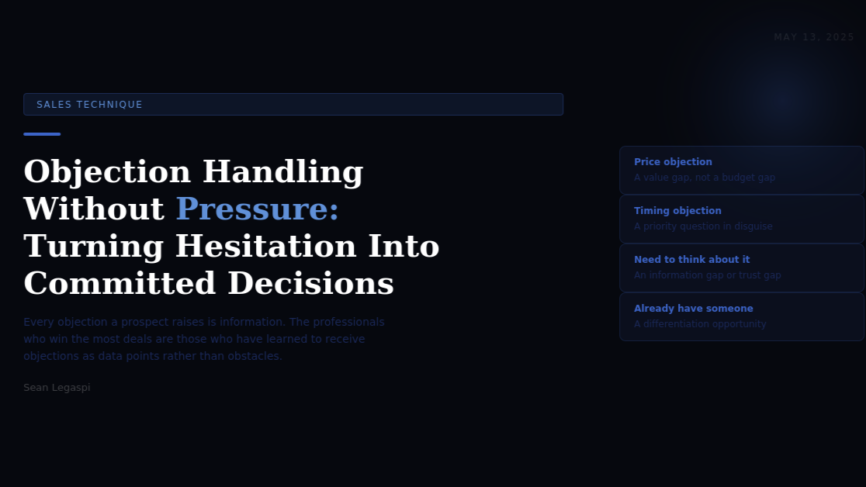

Objection Handling Without Pressure: How to Turn Client Hesitation Into Committed Decisions
May 13, 2026
Every objection a potential client raises is information. Not resistance to overcome. Not a no to argue against. Information about where the understanding is incomplete, the trust is insufficient, or the value has not been communicated with enough specificity. The professionals who win the most deals are those who have learned to receive objections as data rather than as obstacles.
The conventional approach to sales objection handling teaches professionals to overcome objections: to counter them with rebuttals, social proof, urgency triggers, or price concessions. This adversarial model treats the sales conversation as a negotiation in which objections are positions to be defeated rather than as signals to be understood.
Research by Gong.io analyzing how objection responses affect deal outcomes found that the objection-handling approaches most strongly correlated with closed deals involve acknowledgment and inquiry rather than rebuttal. Top-performing sales professionals acknowledged objections before responding to them 2.3 times more frequently than average performers. They also asked a clarifying question about the objection before addressing it in 74 percent of cases, compared to 46 percent for average performers.
The difference in approach reflects a difference in underlying philosophy. The rebuttal approach treats the objection as an obstacle between the professional and the deal. The inquiry approach treats the objection as information about the gap between the current state of the conversation and the state required for the prospect to feel confident proceeding. Closing that gap requires understanding it first.

THE FOUR MOST COMMON OBJECTIONS AND WHAT THEY ACTUALLY MEAN
OBJECTION 1: THE PRICE OBJECTION
The price objection is the most common and the most frequently misdiagnosed. When a prospect says the fee is too high, the conventional response is to justify the price by restating value, to offer a discount, or to break the fee into a different payment structure. All three responses accept the premise that the price is the issue.
Research by HubSpot on sales objection patterns found that in 68 percent of cases where a prospect raised a price objection, the underlying issue was not insufficient budget but insufficient perceived value. The prospect was not saying the fee is more than I can afford. They were saying the fee is more than I currently believe this is worth.
The correct response to a price objection is therefore not to change the price but to investigate the value gap. Questions that diagnose the price objection include: what were you expecting this type of engagement to cost, what is your current approach to this problem costing you, and what outcome would this investment need to produce for you to consider it well spent. These questions move the conversation from price to value and allow the professional to address the actual gap rather than conceding a price that was not the real obstacle.
OBJECTION 2: THE TIMING OBJECTION
The timing objection, I am interested but now is not the right time, is almost always a priority question in disguise. Rarely is there genuinely no resource available for a worthwhile investment. The question the prospect is actually asking is: is solving this problem important enough to prioritize right now over everything else competing for my attention and budget?
The research basis for this interpretation comes from Daniel Kahneman's work on loss aversion, documented in Thinking, Fast and Slow (2011). Kahneman established that people are significantly more motivated by the prospect of losing something they have than by the prospect of gaining something equivalent. The timing objection is most effectively addressed not by creating urgency through scarcity tactics but by making the cost of delay concrete: for every month the current situation continues, the specific costs identified in the discovery conversation continue to accrue. Quantifying the monthly cost of the problem reframes the decision from a discretionary future investment to an ongoing present cost.
OBJECTION 3: NEED TO THINK ABOUT IT
The need to think about it objection is the most ambiguous and the most important to diagnose correctly before responding. It can indicate a genuine information gap (the prospect does not yet have everything they need to decide), a trust gap (the prospect is uncertain about the professional's ability to deliver), an internal stakeholder issue (there are other decision-makers who need to be consulted), or a desire to exit the conversation politely without saying no directly.
Research by the RAIN Group on sales outcomes found that the need to think about it objection, when probed with a single clarifying question, resolved into one of these specific underlying issues in 87 percent of cases. The clarifying question that most reliably surfaces the underlying issue is: when you say you need to think about it, what specifically is holding you back from making a decision today? This question is direct but not aggressive, and it gives the prospect permission to name the actual obstacle rather than maintaining the polite ambiguity of the surface objection.
Once the specific underlying issue is identified, the professional can address it directly: provide the missing information, demonstrate the specific type of capability the prospect is uncertain about, identify the appropriate stakeholder to include in the next conversation, or acknowledge that the professional's service is not the right fit for the prospect's current situation.
OBJECTION 4: ALREADY WORKING WITH SOMEONE
The already working with someone objection is frequently treated as a final barrier, and in many cases, professionals back down from the conversation entirely when they hear it. But research on competitive displacement in professional services by the Corporate Executive Board (now Gartner) found that 56 percent of buyers who are currently using a vendor for a particular service are open to having a conversation about alternatives, and that the most common reason for switching is not that the current provider is actively failing but that the buyer has encountered a more specific alternative that better matches their current situation.
The correct response to this objection is not to argue that the professional is better than the current provider, which invites defensiveness, but to ask what is working well about the current arrangement and what the prospect would change if they could. This question positions the professional as curious and non-threatening, and often reveals specific gaps in the current relationship that the professional can genuinely address.

THE ACE FRAMEWORK FOR OBJECTION HANDLING
A consistent framework for handling any objection keeps the professional from reacting impulsively and ensures that every response moves the conversation forward rather than creating resistance.
A: Acknowledge the objection without accepting its premise. Validating that the concern is reasonable is not the same as agreeing that it is insurmountable. That is a fair concern, and I want to understand it better before responding signals respect without concession.
C: Clarify the specific underlying issue with a single focused question. What specifically is driving that concern for you right now? This prevents the professional from addressing a symptom while the actual issue remains unaddressed.
E: Engage with the specific issue that has been clarified, using evidence, reframing, or honest acknowledgment as appropriate to the situation. Not all objections have good answers, and the professional who honestly acknowledges the limits of their offering when a prospect's concern is legitimate will lose fewer deals in the long run than the professional who attempts to overcome every objection regardless of its validity.
Sources:
- Gong.io Objection Handling Research 2023 (gong.io/resources)
- HubSpot Sales Objection Research 2023 (hubspot.com/marketing-statistics)
- Daniel Kahneman, Thinking, Fast and Slow (Farrar, Straus and Giroux, 2011)
- RAIN Group Sales Training Research 2022 (rainsalestraining.com/blog)
- Corporate Executive Board (now Gartner), Competitive Displacement in Professional Services 2022 (gartner.com/en/sales)
- Chris Voss, Never Split the Difference (HarperBusiness, 2016)

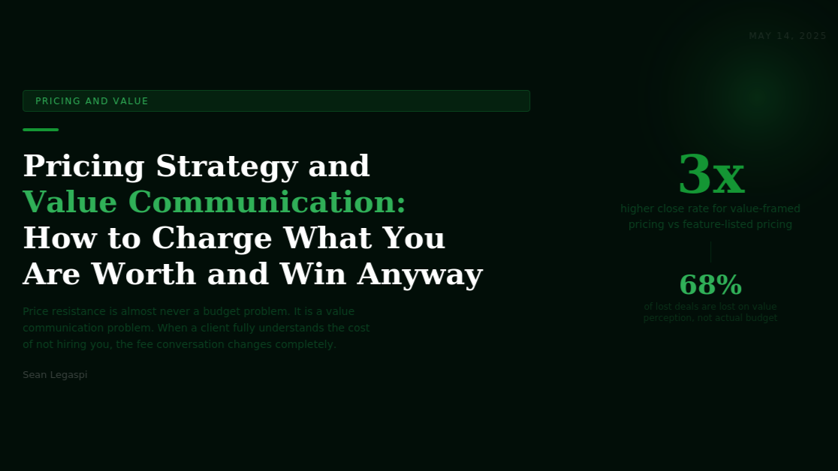

Pricing Strategy and Value Communication: How to Charge What You Are Worth and Win Anyway
May 14, 2026
Price resistance is almost never a budget problem. It is a value communication problem. When a potential client fully understands the specific cost of their current situation and the specific value of its resolution, the fee conversation changes completely. The professional who can make this shift consistently charges more, wins more, and negotiates less.
The pricing of professional services is among the most psychologically complex decisions in business, and the research on how price perception works in professional service contexts runs consistently counter to the intuitions of most service providers.
Most professionals price their services based on some combination of market rates, competitive comparison, time and cost, and a modest margin above what they feel uncomfortable asking for. This approach to pricing is almost entirely input-focused: it derives the price from the professional's inputs (time, expertise, overhead) rather than from the client's outputs (the value delivered, the problem solved, the cost avoided).
Research by Ron Baker, documented in Implementing Value Pricing (2011) and Pricing on Purpose (2006), established through surveys of professional service firms across industries and geographies that professionals who price based on value rather than time or cost inputs consistently achieve margins 40 to 60 percent higher than their peers, with lower proposal revision rates, fewer fee negotiations, and higher client retention rates. The value-priced professional is not simply charging more. They are operating in a different pricing conversation entirely.

THE PSYCHOLOGY OF PRICE PERCEPTION

PRICE AS A QUALITY SIGNAL
One of the most consistently documented findings in pricing psychology is that price functions as a quality signal, particularly in professional service markets where quality is difficult to assess before purchase. Research by professors Akshay Rao and Kent Monroe, published in the Journal of Consumer Research (1989) and extensively replicated, found that consumers systematically use price as a proxy for quality in ambiguous evaluation contexts: when they cannot directly assess the quality of what they are buying, a higher price is interpreted as evidence of higher quality.
For professional services, where quality is inherently difficult to evaluate before the engagement begins, this means that a lower price does not simply reduce the cost to the client. It also reduces their confidence in the quality of what they are purchasing. The professional who underprices their service is not only leaving revenue on the table. They are actively signaling lower quality to the very client they are trying to win.

THE ANCHORING EFFECT IN FEE CONVERSATIONS
Behavioral economists Daniel Kahneman and Amos Tversky, in their foundational research on cognitive heuristics published in Science (1974), established that the anchoring effect is one of the most powerful and reliable influences on numerical judgment. The first number introduced in any evaluation context disproportionately influences all subsequent numerical assessments.
For professional service pricing, this means that the value frame established before a fee is introduced becomes the anchor against which the fee is evaluated. A professional who has spent thirty minutes of a discovery conversation quantifying the cost of the client's current problem, and then presents a fee in the context of that cost, is placing their fee alongside a much larger reference number. A professional who introduces their fee without first establishing a value frame is placing their fee in a vacuum where the only reference point available to the client is their general sense of what things cost.
Research by McKinsey on B2B pricing effectiveness found that proposals where value quantification preceded pricing discussion achieved 30 percent higher close rates and 18 percent higher average deal values than proposals where pricing was introduced without prior value framing.

THE FIVE VALUE COMMUNICATION TECHNIQUES
TECHNIQUE 1: THE COST OF THE PROBLEM CALCULATION
The single most powerful value communication technique is helping the client quantify what their current problem is costing them. When a client can articulate a specific cost, the professional's fee is automatically evaluated in relation to that cost rather than in isolation.
The questions that generate this calculation include: how many hours per week does your team currently spend on this problem, what is the approximate hourly cost of those team members, what revenue opportunities have been missed because of this challenge in the past 12 months, and what would client retention be worth if the identified service gap were resolved. Not all of these will yield precise numbers, but even approximate figures produce the anchoring effect that changes how price is perceived.
TECHNIQUE 2: THE RETURN ON INVESTMENT FRAME
Where specific outcome data is available from previous client work, presenting the professional's fee as a return on investment calculation transforms the price from a cost to a financial decision.
A fee of $5,000 per month is a cost. A fee of $5,000 per month that has historically produced $18,000 per month in operational savings or revenue uplift for comparable clients is an investment decision with a 3.6x return. These are the same number with entirely different psychological effects.
Research by Forrester on B2B technology purchases (directly applicable to service purchases through analogous buyer psychology) found that proposals quantifying ROI experienced 35 percent shorter sales cycles and 28 percent less fee negotiation than equivalent proposals without ROI quantification. The availability of a return metric shifts the client from evaluating the cost against their budget to evaluating the return against their investment threshold, which is almost always a more favorable comparison.
TECHNIQUE 3: TIERED PRICING AND THE DECOY EFFECT
Behavioral economist Dan Ariely's research on the decoy effect, documented in Predictably Irrational (2008), found that the introduction of an asymmetrically dominated option (a tier that is clearly inferior to another option at a similar price) systematically increases selection of the superior option.
For professional services, this means that a three-tier proposal structure, where the middle tier represents the professional's intended scope and the premium tier is genuinely valuable at its price, consistently produces higher average deal values than single-price proposals. The premium tier functions as both a legitimate option for high-value clients and as a reference point that makes the core tier feel more reasonably priced.
Proposify's analysis of 1.6 million proposals found that proposals with multiple pricing options achieved an average deal value 41 percent higher than single-price proposals for equivalent scope of work, primarily because of the anchoring and decoy effects operating on option selection.
TECHNIQUE 4: THE PAYMENT RESTRUCTURING TECHNIQUE
In cases where a client's concern appears to be cash flow rather than value, restructuring the payment schedule without changing the total fee can resolve the obstacle without a price concession. A fee of $12,000 paid as $4,000 per month over three months is the same total cost with a significantly different psychological and practical impact on a client for whom cash flow is genuinely the concern.
This technique distinguishes cash flow problems (which a payment restructure resolves) from value perception problems (which a payment restructure does not resolve and which should not be treated as cash flow problems). Offering a payment restructure when the actual issue is value perception simply reduces the professional's terms without addressing the real obstacle.
TECHNIQUE 5: THE PREMIUM POSITIONING STATEMENT
For professionals who want to move out of competitive price comparisons entirely, the premium positioning statement explicitly reframes what they are selling. The premium positioning statement is not a claim of superiority over competitors. It is a clear articulation of who the professional's services are designed for and what outcomes those clients can expect.
I work exclusively with founders who are scaling past the point where they can manage operations themselves. My engagement fee starts at X because the level of operational transformation required at that stage demands a depth of involvement and methodology that produces consistent, measurable results within the first 90 days. This statement communicates price, positions for a specific buyer, implies quality through selectivity, and sets an outcome expectation all in one sentence. It does not compete on price because it has defined a market in which price comparison is less meaningful than outcome alignment.
Sources:
- Ron Baker, Implementing Value Pricing (Wiley, 2011) and Pricing on Purpose (Wiley, 2006)
- Akshay Rao and Kent Monroe, The Effect of Price, Brand Name, and Store Name on Buyers Perceptions of Product Quality, Journal of Consumer Research, 1989 (academic.oup.com/jcr)
- Daniel Kahneman and Amos Tversky, Judgment Under Uncertainty: Heuristics and Biases, Science, 1974 (doi.org/10.1126/science.185.4157.1124)
- McKinsey B2B Pricing and Sales Effectiveness Research 2023 (mckinsey.com/capabilities/growth-marketing-and-sales)
- Forrester Research ROI and B2B Purchase Decisions 2023 (forrester.com)
- Dan Ariely, Predictably Irrational (HarperCollins, 2008)
- Proposify State of Proposals 2023 (proposify.com/state-of-proposals)

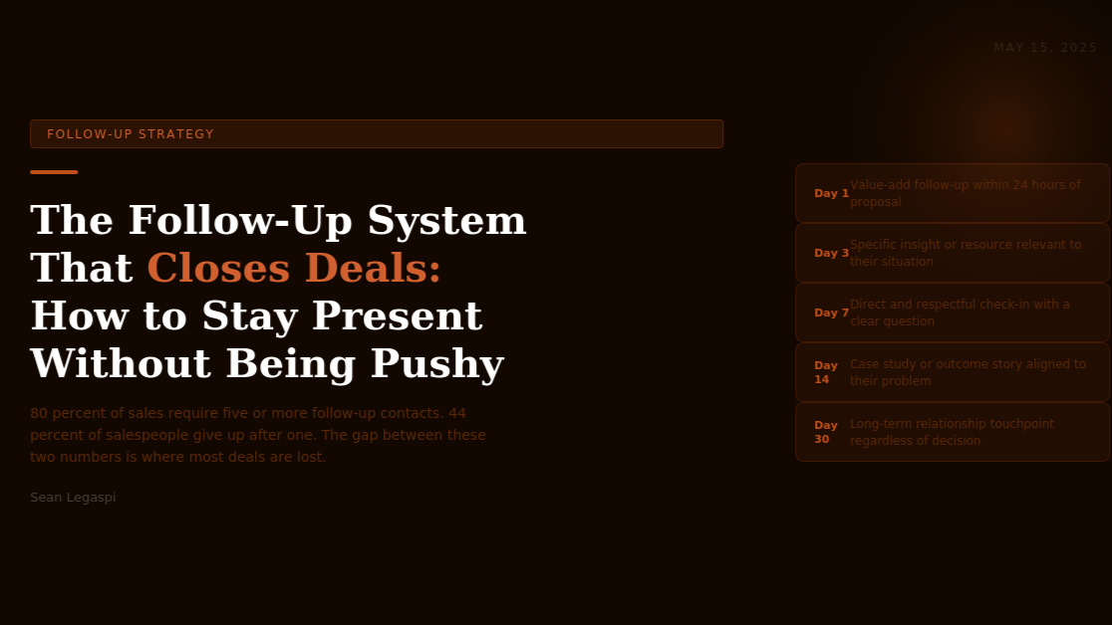

The Follow-Up System That Closes Deals: How to Stay Present Without Being Pushy
May 15, 2026
80 percent of sales require five or more follow-up contacts. 44 percent of salespeople give up after one attempt. The gap between these two numbers is where most deals are lost, not to a competitor with a better offer, but to the absence of a professional with a better follow-up system.
The follow-up is one of the most poorly executed phases of the professional services sales process, despite being one of the most well-researched. The data on follow-up effectiveness is remarkably consistent and remarkably ignored.
The Marketing Donut, a UK-based small business resource that compiled research from multiple sales sources, found that 80 percent of non-routine sales require five or more follow-up contacts, yet 44 percent of salespeople give up after just one follow-up attempt, and 22 percent give up after two. The cumulative abandonment rate at three follow-ups is 65 percent, meaning that nearly two-thirds of sales professionals have stopped pursuing a prospect at the point where the majority of sales actually close.
Research by the Harvard Business Review on B2B sales persistence found that companies that followed up with prospects within 24 hours of initial contact were seven times more likely to qualify the lead than those who followed up after 24 hours, and a staggering 60 times more likely than those who followed up after 48 hours. The speed dimension of follow-up is as important as the persistence dimension.
The reason most professionals under-follow-up is not laziness. It is a misreading of silence. When a prospect goes quiet after a proposal, the professional typically interprets the silence as a soft rejection and either backs off entirely or sends one vague message before giving up. Research by Gong.io found that silence after a proposal is actually a neutral signal in 73 percent of cases: the prospect has not decided against the professional but has been preoccupied with other priorities. The professional who follows up consistently and with continued value keeps their engagement alive while their competitor, who read the silence as rejection, has already moved on.

THE FOLLOW-UP SYSTEM ARCHITECTURE
An effective follow-up system is not simply persistent contact. It is a structured sequence of interactions that each add value to the prospect's experience while keeping the professional visible, relevant, and trusted.
The architecture of a high-converting follow-up system operates across five touchpoints, each with a specific purpose:
TOUCHPOINT 1: THE VALUE-ADD FOLLOW-UP (24 HOURS AFTER PROPOSAL)
The first follow-up after a proposal is sent should not be a check-in. It should be an additional gift of value. This might be a relevant article, a case study that maps more precisely to the prospect's situation than what was included in the proposal, a specific framework or tool that addresses one of the challenges identified in the discovery conversation, or a specific insight that occurred to the professional after the proposal was sent.
The psychological principle at work is reciprocity: the prospect who receives additional value after a proposal is submitted has received more than they paid for (which at this stage is nothing). This investment of continued attention and generosity creates a psychological pull toward engaging with the professional rather than letting the conversation fade.
Research by Dr. Robert Cialdini on the reciprocity principle found that uninvited acts of generosity are 50 percent more likely to produce reciprocal action than equivalent generosity provided in response to a request. The unsolicited follow-up value-add is therefore more powerful than the value provided within the proposal itself.
TOUCHPOINT 2: THE SPECIFIC INSIGHT FOLLOW-UP (3 DAYS AFTER PROPOSAL)
The third-day follow-up is a brief, direct message that demonstrates the professional has been thinking about the prospect's specific situation. It might reference something the prospect mentioned during the discovery conversation that the professional has since found a relevant resource for, or a development in the prospect's industry that is directly relevant to the problem being solved.
The purpose of this touchpoint is to demonstrate continued investment in the prospect's situation rather than simply the professional's own sales goal. A message that says I came across this research on operational scaling specifically for service businesses and thought it was directly relevant to what we discussed positions the professional as a thoughtful partner rather than a persistent salesperson.
TOUCHPOINT 3: THE DIRECT AND RESPECTFUL CHECK-IN (7 DAYS AFTER PROPOSAL)
By the seventh day, a direct and honest check-in is appropriate and, in the absence of the preceding two touchpoints, overdue. The most effective version of this message is brief, direct, and respectful of the prospect's decision-making process.
A message that says I want to follow up on the proposal because I would genuinely like to work with you on this, and I also want to be respectful of your decision timeline. Is there anything I can clarify or add that would help you move forward? combines directness with genuine care and gives the prospect a clear invitation to either re-engage or communicate a decision.
Research by the RAIN Group on follow-up message effectiveness found that messages combining directness (an honest statement of the professional's interest) with respect for the prospect's autonomy (an explicit acknowledgment of their right to decide on their own timeline) produced 38 percent higher response rates than purely transactional check-in messages.
TOUCHPOINT 4: THE CASE STUDY FOLLOW-UP (14 DAYS AFTER PROPOSAL)
By the fourteenth day, if no response has been received, the case study follow-up serves two purposes simultaneously: it provides new information that may shift the prospect's confidence level, and it signals that the professional is still engaged and available without making the prospect feel pressured.
The most effective case study at this stage is a short, outcome-focused story about a client in a situation closely analogous to the prospect's. It is not a generic testimonial. It is a specific narrative: here is a client who was in a similar situation, here is what changed when we worked together, and here is the specific outcome they experienced 90 days later.
Gartner research established that B2B buyers are five times more influenced by peer evidence (recognizably similar situations) than by vendor claims. The fourteenth-day case study touchpoint applies this principle at the exact moment in the follow-up sequence where the professional's self-promotion would be least effective.
TOUCHPOINT 5: THE LONG-TERM RELATIONSHIP TOUCHPOINT (30 DAYS AFTER PROPOSAL)
The thirtieth-day touchpoint is the one most professionals never reach, and it is the one that frequently produces the most unexpected results.
At 30 days, a message that explicitly separates the professional's relationship intention from the specific proposal outcome repositions the conversation entirely. Something like I recognize this may not be the right time for us to work together on this project, and I want you to know that I am going to stay connected regardless of what you decide. If it would be useful, I am happy to share resources on this topic as I come across them.
This message reframes the professional from a salesperson seeking a decision to a genuine professional who values the relationship independent of the transaction. Research on long-term B2B relationship outcomes by Bain and Company found that prospects who converted to clients 6 to 12 months after initial engagement, having experienced consistent value from the professional during the intervening period, had 23 percent higher lifetime value than prospects who converted immediately, because the trust built during the follow-up period translated directly into deeper engagement and more referrals from the resulting client relationship.
Sources:
- Marketing Donut, Sales Follow-Up Research (marketingdonut.co.uk)
- Harvard Business Review, Lead Response Management Research
- Gong.io Follow-Up Effectiveness Research 2023 (gong.io/resources)
- Robert B. Cialdini, Influence: The Psychology of Persuasion (Harper Business, 1984) and Pre-Suasion (Simon and Schuster, 2016)
- RAIN Group Follow-Up Message Research 2022 (rainsalestraining.com)
- Gartner B2B Buyer Peer Evidence Research 2023 (gartner.com/en/sales)
- Bain and Company Long-Term Client Relationship Value Research (bain.com)

