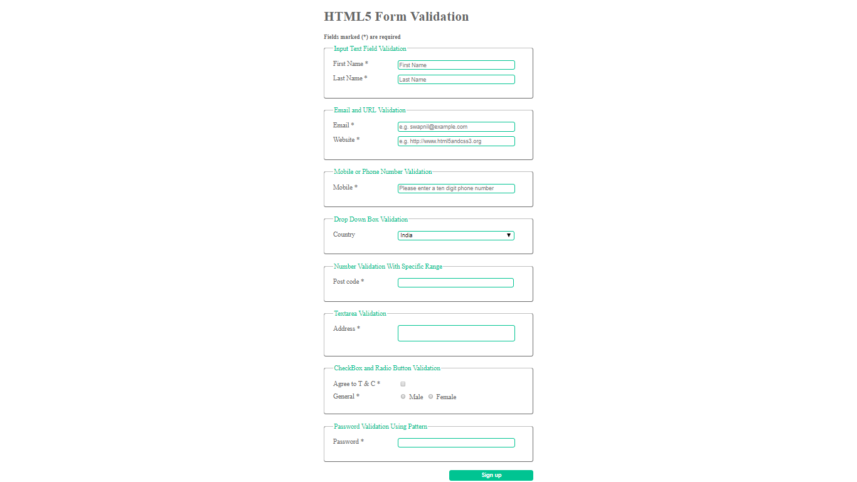

1. Design the HTML Form with reference to above image.
2. Take the fields as per specification.
3. **Don’t consider beautification of page.**