Test Cases

1. Test Case1 : Order ID : first

Quantity : 20

In setOrder

Then we setAcceptedStatus

Price set to 20

Then we get Order complete status with price 400

Then we set payment done

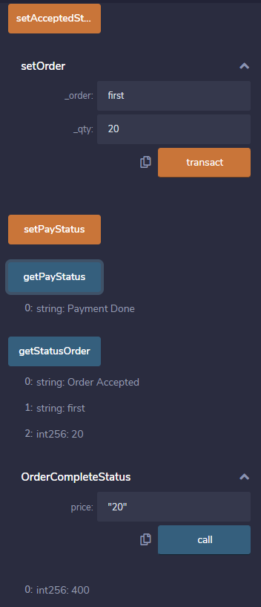

1. Order ID : second

Quantity : 25

Price 10

Result 250

1. Order ID : third

Quantity : 30

Price 5

Result 150

1. Order ID : fourth

Quantity : 40

Price 25

Result 1000

1. Order ID : fifth

Quantity : 100

Price 10

Result 1000

1. Order ID : sixth

Quantity : 250

Price 10

Result 2500

1. Order ID : seventh

Quantity : 10

Price 100

Result 1000

1. Order ID : eight

Quantity : 18

Price 5

Result 90

1. Order ID : nint

Quantity : 2

Price 4

Result 8

1. Order ID : tenth

Quantity : 10

Price 23

Result 230