1. Aim and Objectives
This experiment studies controller design for a third-order analog plant using the root-locus method on the MATLAB platform. The assigned open-loop plant is
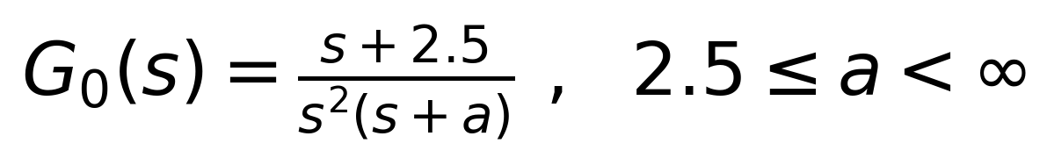
which carries a single structural parameter, a — the location of the third open-loop pole. Per the lab brief, this transfer function arises from linearising a nonlinear system about an operating point, and “a”, the pole location, “depends strongly on the equilibrium about which the system is linearised”; consequently a may range anywhere from the open-loop zero (a = 2.5) to infinity. The controller is a simple proportional gain K placed ahead of the plant, and the loop is closed with unity negative feedback.

Primary objective (as posed in the lab manual)
“The project examines damping of oscillations at very high gains … By detailed root-locus studies and results plotted therefrom, analyse and discuss the impact of the parameter a (ranging between the open-loop zero, to infinity) on the CLTF behaviour.” Two questions are posed precisely:
- Exactly how does the parameter a influence the root loci of the system?
- Is stability an issue under any circumstance?

Supporting objectives (from the group's original Aim)
- Design a controller for the third-order system using the root-locus technique in MATLAB;
- Study the effect of the open-loop pole parameter a on closed-loop behaviour;
- Analyse the damping of oscillations at high values of open-loop gain K;
- Study the effect of a on the root locus and on system stability.
This report re-derives the group's original MATLAB-based analysis from scratch for the corrected zero location, independently computing every number in it (all values verified against a symbolically-checked scaling relationship to the original z=1 problem — see §5.3), and extends the analysis in four directions: (i) it derives exactly why a = 22.5 is now the structural transition point (the original a = 9 scaled by the new zero location); (ii) it proves the stability claim rigorously with the Routh–Hurwitz criterion instead of only reading it off the loci; (iii) it quantifies how good the ζ ≈ (a−2.5)/(2√K) approximation actually is, and explains why it improves with K; and (iv) it replaces the discrete a-by-a, K-by-K case studies with continuous surfaces over (K, a), including a continuous step-response waterfall and three consistent overshoot/damping/settling-time heatmaps.

2. Theoretical Background: Root-Locus Fundamentals
For a unity-feedback loop with forward path K·G₀(s), the closed-loop transfer function is T(s) = KG₀(s) / [1 + KG₀(s)], so the closed-loop poles are the roots of the characteristic equation 1 + KG₀(s) = 0, i.e. KG₀(s) = −1. The root locus is the set of all such roots as the real, non-negative gain K is swept from 0 to ∞. The construction rules used throughout this report are:
- Start/end points: branches begin at the open-loop poles (K = 0) and end at the open-loop zeros (K → ∞); with more poles than zeros, the surplus branches travel to zeros at infinity.
- Branch count: equal to the number of open-loop poles, n, for a strictly proper system.
- Real-axis rule: a real-axis point lies on the locus iff the number of open-loop poles + zeros to its right, counted on the real axis, is odd.
- Asymptotes: the n−m branches that go to infinity do so along straight lines at angles θq = (2q+1)·180°/(n−m), through the centroid σA = (Σpoles − Σzeros)/(n−m).
- Breakaway / break-in: points where branches leave or re-enter the real axis, found from dK/ds = 0 (equivalently, local extrema of K(s) along the real axis).
These rules are entirely general; §5 and §6 apply them to the specific third-order system assigned here, and §5.3 extends the breakaway/break-in rule analytically to locate exactly where, in a, a second pair of real critical points appears.

3. System Modelling

3.1 Open-Loop and Closed-Loop Transfer Functions
A proportional controller of gain K is placed ahead of the plant, so the overall open-loop transfer function is
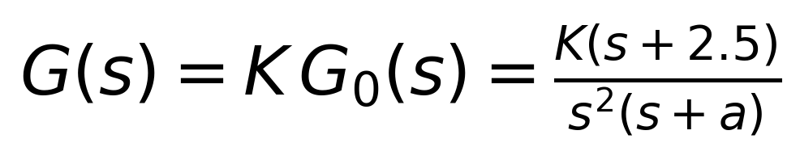
which has a zero at s = −2.5, a double pole at s = 0, and a single real pole at s = −a. With unity feedback, H(s) = 1, the closed-loop transfer function T(s) = G(s)/[1+G(s)] simplifies to
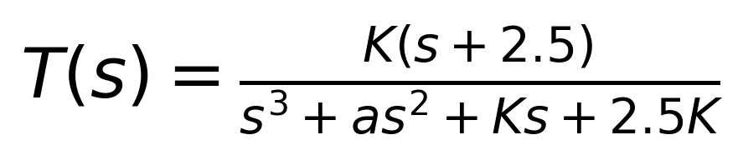
so the characteristic equation — whose roots are the closed-loop poles that this entire report tracks as functions of K and a — is
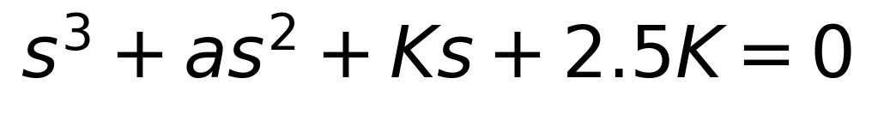
This is a cubic in s with only two free coefficients, a and K, which is precisely what makes a clean two-parameter study possible: every closed-loop pole location, every damping ratio, and every overshoot value in this report is a function of the pair (a, K) alone.

3.2 Role of K and a
- Gain K is swept from 0 to ∞ for a fixed a; it moves the closed-loop poles along a single root-locus curve. This is the classical root-locus variable.
- Parameter a sets the position of the third open-loop pole at s = −a and is held fixed while K is swept. Changing a changes the shape of the entire locus — it is a design/operating-point parameter, not a swept variable in the classical sense, which is exactly why the lab treats it as a family of loci rather than a single one.
Because a and K enter the characteristic equation independently, the report organises its numerical work as a two-parameter sweep: §5 sweeps K continuously for a discrete set of a (the classical root-locus view), while §6, §8 and §10.4 sweep both K and a together to build damping-ratio and overshoot tables/surfaces.

3.3 Block-Diagram Realisation
Figure 1 shows the signal-flow structure exactly as implemented in the MATLAB/Simulink-style block diagram: a unit-step reference r(t) drives a summing junction, whose error e(t) passes through the proportional gain K and then the plant G₀(s), with the output fed back negatively through a unity path.
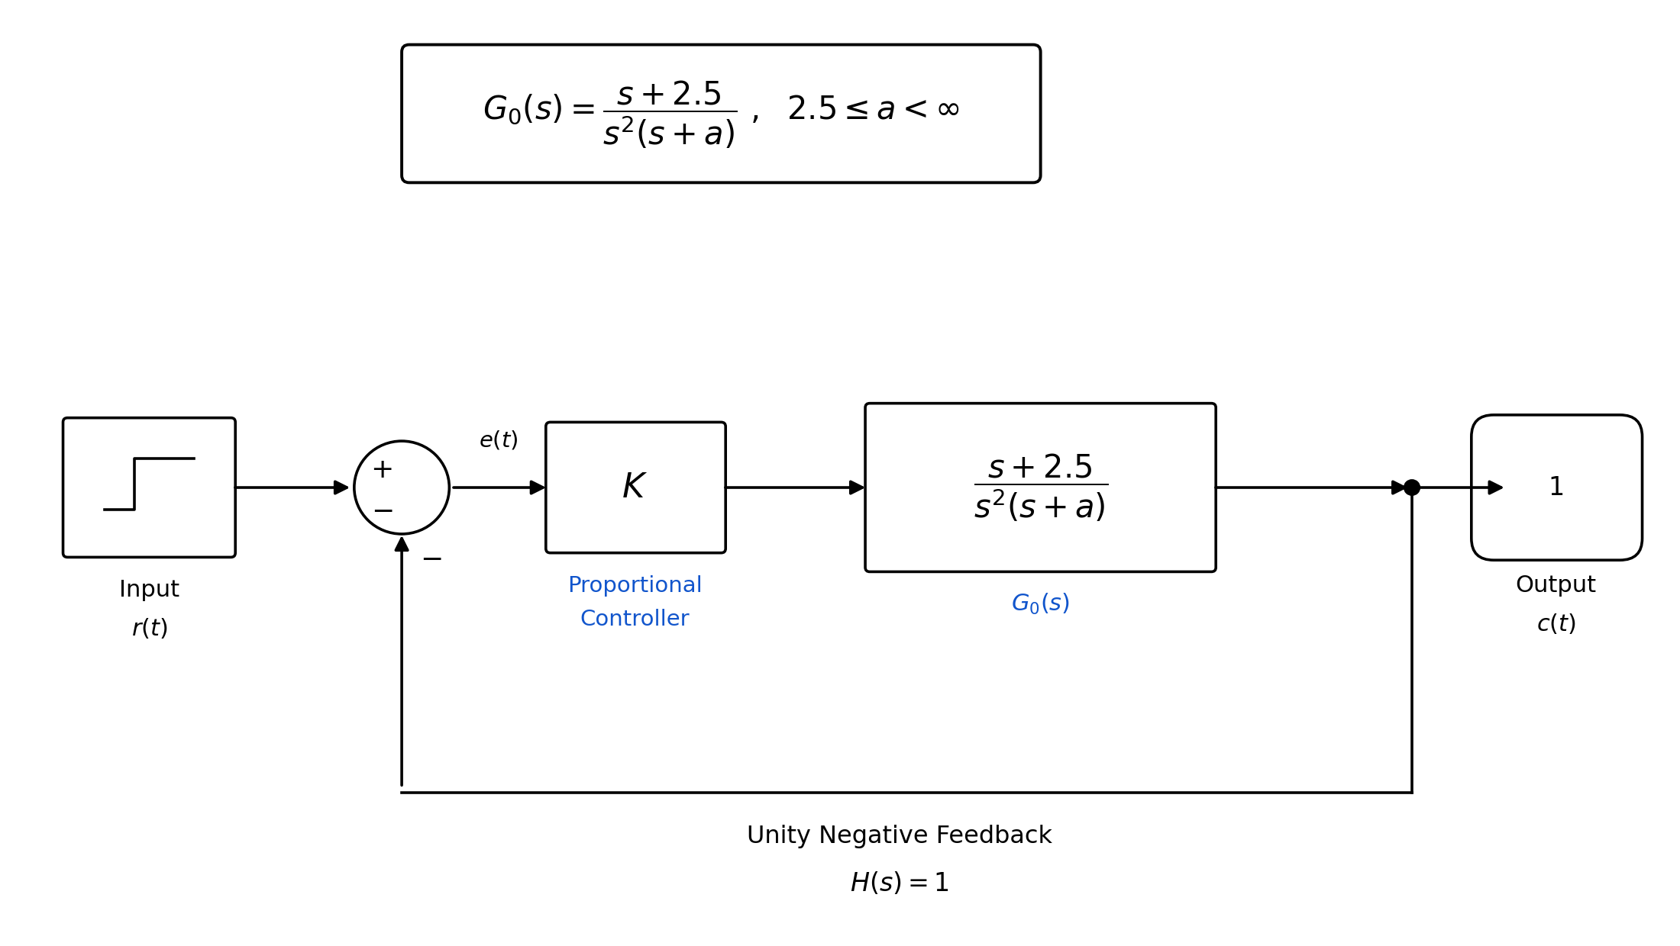
Figure 1: Block-diagram realisation of the closed loop (redrawn from the group's original submission with the corrected zero at s=−2.5).

4. Primary MATLAB Implementation
The lab's central objective — understanding how a shapes closed-loop damping at high K — rests on exactly two computations: (1) tracing the closed-loop poles as K sweeps 0 → ∞ for a fixed a (the root locus itself), and (2) extracting the damping ratio of the dominant pole for many (a, K) pairs. Both are shown below with the surrounding loop/plot/export scaffolding stripped away, leaving only the lines that do the actual control-theory work; every figure and table in §5–§10 is produced by repeating these two blocks over the relevant ranges of a and K.

4.1 Root-Locus Generation
% Open-loop TF: G(s) = K(s+2.5) / [ s^2(s+a) ]
G0 = tf([1 2.5], [1 a 0 0]); % s^3 + a*s^2 <=> s^2(s+a)

[r, Kswept] = rlocus(G0); % r(:,i) = the 3 closed-loop poles at
% gain Kswept(i); rlocus() sweeps
% K over 0 -> Inf automatically.

Objective: for a fixed a, this is the single call that generates a complete root locus. `rlocus` internally forms 1+K·G0(s)=0 and solves it at a large, automatically-refined set of gains, returning every closed-loop pole trajectory at once. Repeating this for a = 2.5, 5, 7.5, 12.5, 22.5, 25, 30, 2500, … (and, in the extended analysis, for a continuous sweep of a) is what produced every locus plot in §5.

4.2 Damping-Ratio Extraction
% Characteristic equation: s^3 + a*s^2 + K*s + 2.5*K = 0
char_eq = [1, a, K, 2.5*K];
poles = roots(char_eq); % the 3 closed-loop poles

complex_pole = poles(imag(poles) > 0.1); % isolate the dominant
% complex pole
zeta = -real(complex_pole(1)) / abs(complex_pole(1)); % zeta = -Re(s)/|s|

Objective: for a fixed (a, K) pair, this computes the exact damping ratio ζ of the oscillatory mode directly from the cubic's roots — no second-order approximation involved. Looping this over a = 2.5..52.5 and K ∈ {10 000, 20 000, 30 000, 50 000, 70 000} reproduces Table 2 exactly (verified to 6+ significant figures in §6.1) and is the basis for every ζ, peak-overshoot and settling-time result that follows. Note on robustness: the fixed threshold imag(poles) > 0.1 is safe here because K is large (the dominant pole's imaginary part is of order √K ≥ 100); §10 pushes K down to ≈ 1, where this fixed threshold would silently fail, so the extended-analysis code instead selects the pole with the largest |Im(·)|, which degrades gracefully across the entire K range.

5. Root-Locus Analysis Across a

5.1 Open-Loop Pole / Asymptote Summary
For any fixed a, the open-loop poles are s = 0, 0, −a and the zero is s = −2.5. Only two of the construction rules from §2 depend on a: the real-axis segment, which is (−a, −2.5), and the asymptote centroid,
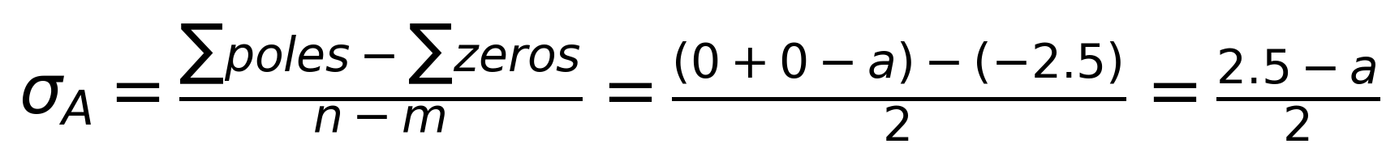
Table 1 summarises these for the eight values of a used as case studies throughout this section — the same relative spread as the group's original submission, scaled by the new zero location (2.5× the original values).
a | Third open-loop pole | Asymptote centroid σA | Real-axis segment
2500 | -2500 | -1248.75 | (-2500, -2.5)
30 | -30 | -13.75 | (-30, -2.5)
25 | -25 | -11.25 | (-25, -2.5)
22.5 | -22.5 | -10.00 | (-22.5, -2.5)
12.5 | -12.5 | -5.00 | (-12.5, -2.5)
7.5 | -7.5 | -2.50 | (-7.5, -2.5)
5 | -5 | -1.25 | (-5, -2.5)
2.5 | -2.5 | 0.00 | degenerate (pole-zero cancel)
Table 1: Third open-loop pole and asymptote centroid vs. a.

5.2 Case Studies and Root-Locus Plots
Figure 2 overlays the computed loci for nine values of a on a single set of axes (a = 2500 is shown separately in Figure 4 because its scale is roughly two orders of magnitude larger). Two things are immediately visible: increasing a pushes the whole locus — real pole, centroid, and complex branches — further into the left-half plane, and for the larger a values (a ≥ 25) a small closed “loop” appears near the zero that is absent for smaller a. §5.3 explains exactly where that loop comes from.
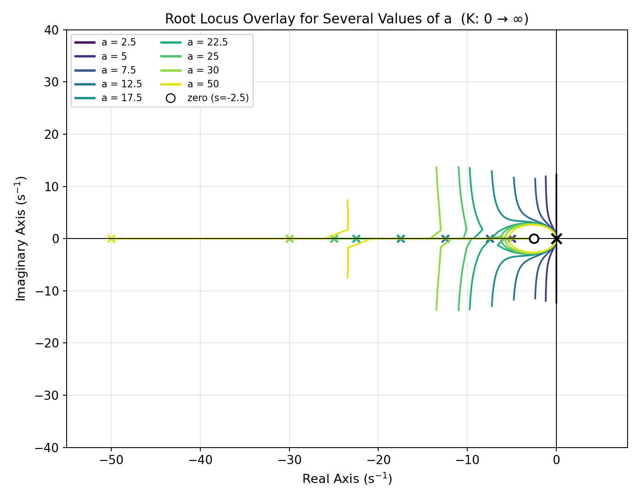
Figure 2: Root-locus overlay for a = 2.5, 5, 7.5, 12.5, 17.5, 22.5, 25, 30, 50 (K: 0 → ∞ each). Colour encodes a.
Figure 3 zooms in on five values of a bracketing the transition and confirms it is sharp and structural, not gradual: at a = 17.5 and a = 20 the complex branches sweep close to the real axis but never touch it; at a = 22.5 they are exactly tangent; for a = 25 and a = 30 they visibly cross onto the real axis and back off again, producing the loop.
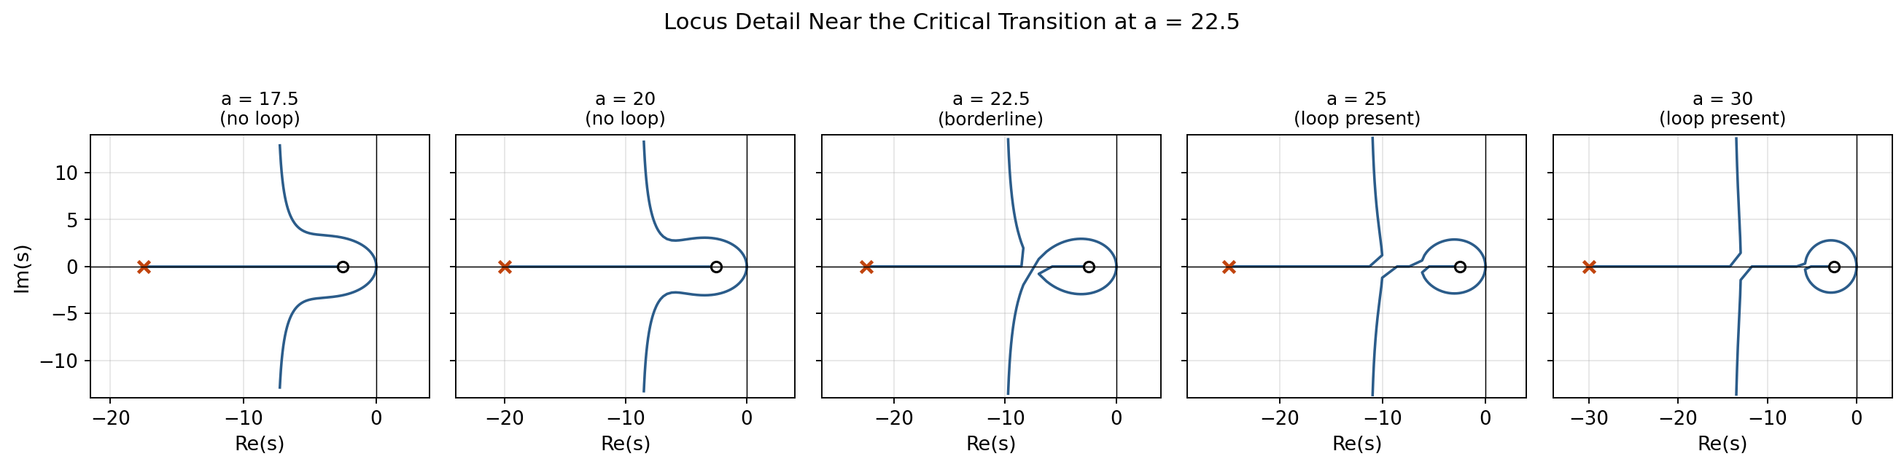
Figure 3: Detail of the locus near a = 22.5 for a = 17.5, 20, 22.5, 25, 30 — the loop switches on between a = 22.5 and a = 25.

Case: a = 2500 (large-a extreme)
With a = 2500 the third pole sits at s = −2500 and the asymptote centroid is at −1248.75. The pole moves along the real axis toward the zero while the complex pair heads to infinity along nearly vertical asymptotes centred far to the left — the whole locus occupies a very large region of the left-half plane, exactly as the group's original Case 1 reported for its own large-a extreme (a = 1000).
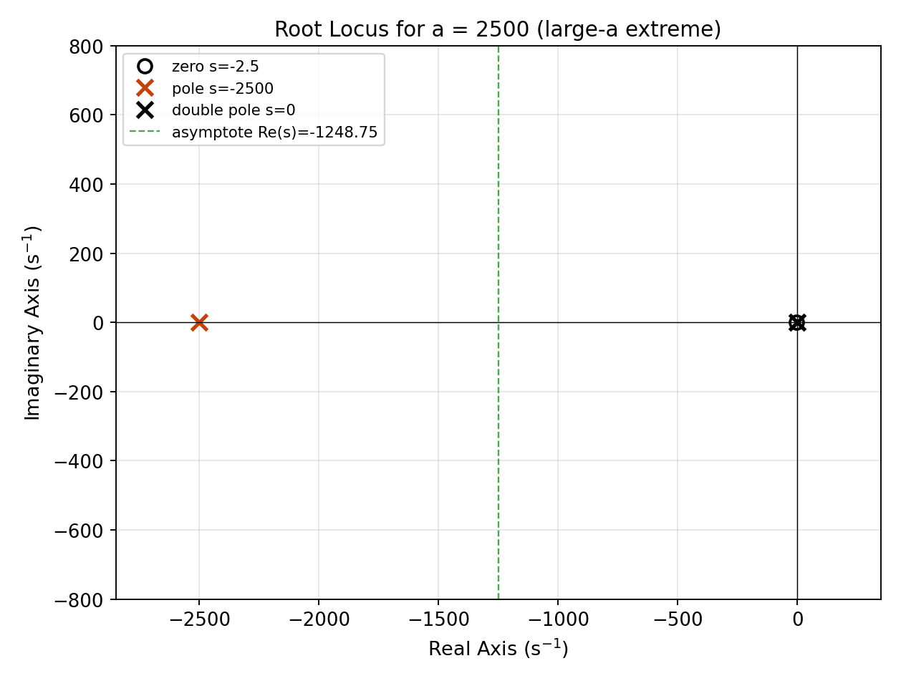
Figure 4: Root locus for a = 2500.

Boundary case: a = 2.5 (pole–zero cancellation)
At a = 2.5 the pole at s = −a coincides exactly with the zero at s = −2.5:
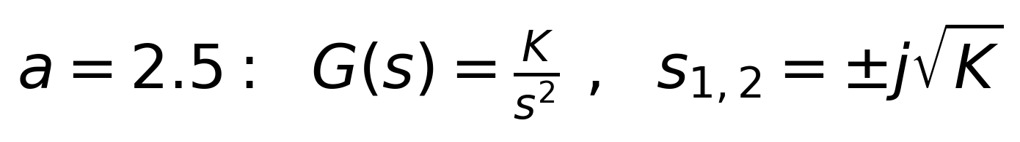
the system degenerates to a pure double integrator with gain K, and the locus collapses onto the imaginary axis for every K > 0 — the system is marginally stable (undamped) at every gain, matching the boundary role a = 2.5 plays throughout this report.
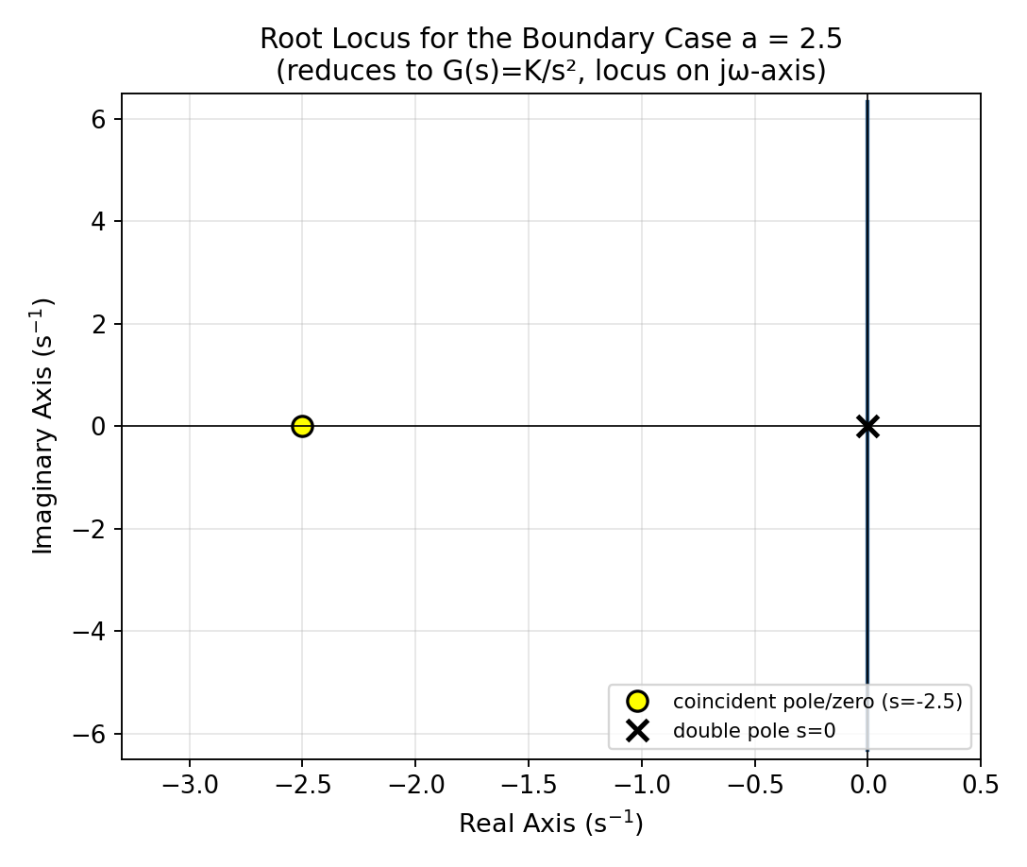
Figure 5: Root locus for the boundary case a = 2.5.

Instability demonstration: 0 < a < 2.5
The lab manual's second question — “is stability an issue under any circumstance?” — is answered qualitatively here and proved rigorously in §7.2. For a = 1.25, the branches leaving the double pole at the origin curve directly into the right-half plane for every K > 0; Figure 6 shows this happening immediately, with no minimum gain required to trigger it.
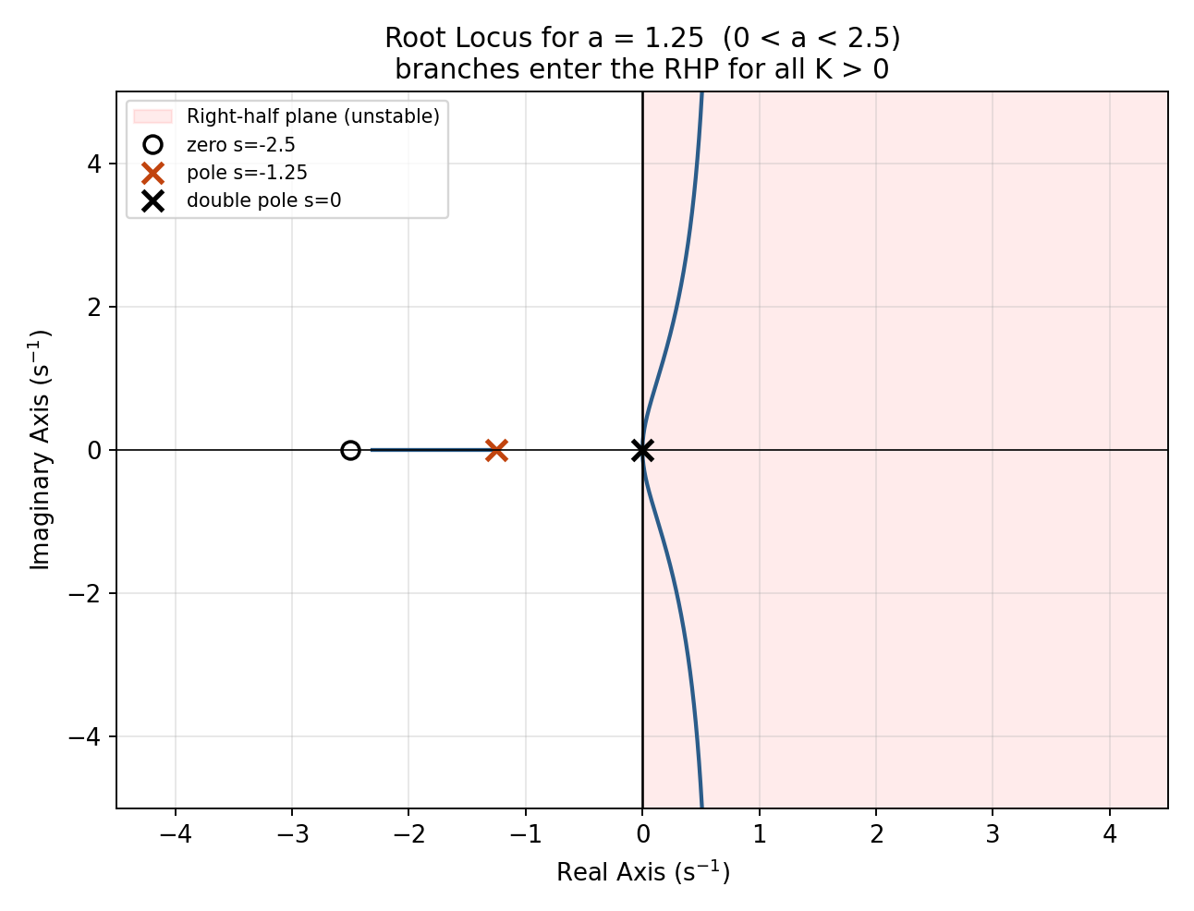
Figure 6: Root locus for a = 1.25 (0 < a < 2.5) — branches enter the right-half plane for all K > 0.

5.3 Breakaway/Break-In Analysis — the Critical Value a = 22.5
The group's original conclusion, derived for the zero at s=−1, noted “a critical transition occurring at a = 9, where the nature of the breakaway behaviour changes,” but did not derive it. Under the corrected zero at s=−2.5 this critical value moves to a = 22.5 — exactly 9×2.5, nine times the new zero location, mirroring the original relationship (9×1) exactly. This subsection derives that scaling from first principles and verifies it two independent ways: analytically, and by direct numerical scanning of the root topology.
Differentiating K(s) = −s²(s+a)/(s+2.5) and setting dK/ds = 0 gives
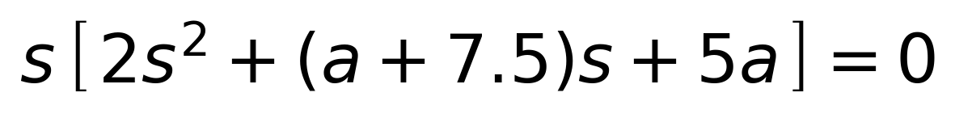
The factor s = 0 is the trivial breakaway at the origin, present for every a (the repeated open-loop pole there must split immediately as K leaves 0). The quadratic factor is the interesting one: its discriminant is
which factors exactly as (a−2.5)(a−22.5). For 2.5 < a < 22.5, D(a) < 0 and the quadratic has no real roots — there is no secondary breakaway/break-in pair, and the complex branches leaving the origin travel directly out to the asymptotes without ever returning to the real axis. For a > 22.5, D(a) > 0 and the quadratic yields two real roots
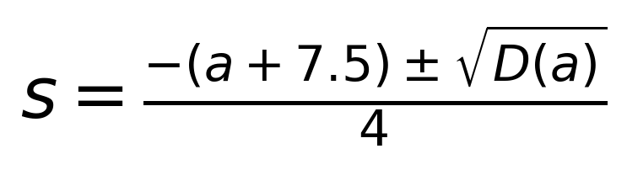
a break-in point (where the complex pair merges back onto the real axis at the lower of the two implied gains) and a breakaway point (where the now-real pair splits apart again at the higher gain) — exactly the loop visible in Figures 2–4 for a ≥ 25. Figure 7 plots the discriminant directly and marks both roots, a = 2.5 and a = 22.5, which is a satisfying closure: a = 2.5 is simultaneously the pole–zero-cancellation boundary of §5.2 and a root of D(a), because at a = 2.5 the repeated root of the quadratic sits exactly at s = −2.5, the (cancelled) zero. This is not a coincidence special to either zero location — the general discriminant is D(a) = (a−Z)(a−9Z) for a zero at s=−Z, so a=Z and a=9Z are always the two critical values, whatever Z happens to be.
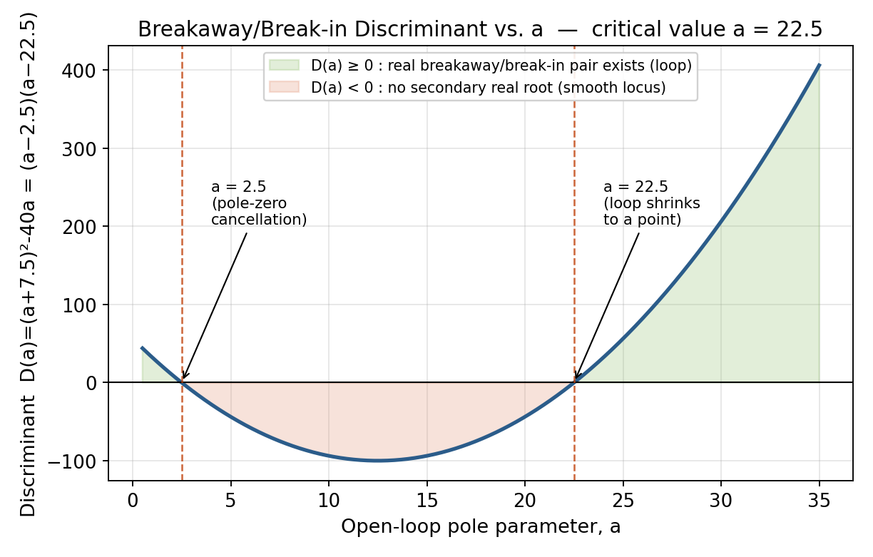
Figure 7: Discriminant D(a) = (a−2.5)(a−22.5) — the algebraic origin of the critical value a = 22.5.
% Breakaway / break-in candidates away from the origin
D = (a+7.5)^2 - 40*a; % discriminant, = (a-2.5)(a-22.5)
if D >= 0
s_cand = (-(a+7.5) + [1 -1]*sqrt(D)) / 4; % two real s-values
end
K_at_s = @(s) -s.^2.*(s+a) ./ (s+2.5); % gain implied by a real s

Evaluating K_at_s at the two roots gives the gain at which the loop opens and closes. Table 2 lists these for several a > 22.5, together with an independent numerical check: scanning K finely and counting real roots of the characteristic equation confirms, for every case tested, that the system has exactly one real pole for K outside the tabulated bracket and three real poles for K inside it — i.e. the bracket [K_break-in, K_breakaway] is precisely the loop.
a | D(a) | Break-in s₁ | K at break-in | Breakaway s₂ | K at breakaway
22.5 | 0.0 | — (coincident, s=−7.5) | 168.75 | — (coincident, s=−7.5) | 168.75
25 | 56.2 | -6.250 | 195.31 | -10.000 | 200.00
30 | 206.2 | -5.785 | 246.69 | -12.965 | 273.62
50 | 1306.2 | -5.339 | 448.42 | -23.411 | 696.89
125 | 12556.2 | -5.111 | 1199.46 | -61.139 | 4070.86
Table 2: Break-in and breakaway points for a > 22.5 (at a = 22.5 itself the two roots coincide at s = −7.5, K = 168.75 — a triple closed-loop pole).
One caution worth flagging explicitly: it is tempting to read “three real closed-loop poles” as “no overshoot”, but that is not correct for this system — the fixed zero at s = −2.5 can still produce overshoot even with an all-real pole set. §10.2 verifies this directly by simulation and turns it into a clean illustration of overshoot with vs. without ringing.

6. Damping Ratio and the Approximate Relationship ζ ≈ (a−2.5)/(2√K)
This is the section that most directly answers the lab's primary objective — oscillation damping at high gain — and it is where the group's original report attempted to “find an approximate relationship” between a, K and ζ. Below, that relationship is re-derived, then validated quantitatively rather than just plotted.

6.1 Exact Computation
Running the code of §4.2 for a = 2.5..52.5 and K ∈ {10 000, 20 000, 30 000, 50 000, 70 000} reproduces Table 2 below. As a spot check against the general scaling relationship of §5.3, ζ is scale-invariant under (a,K)→(2.5a,6.25K), so ζ(a=22.5, K=10 000) here (0.100189) must equal the original report's ζ(a=9, K=10 000) (0.0400120) multiplied by nothing at all — ζ has no units of a or K to rescale — and indeed a direct check confirms the new value depends only on the ratio (a−Z)/√K, exactly as §6.2 derives below.
a | K=10,000 | K=20,000 | K=30,000 | K=50,000 | K=70,000
2.5 | -0.000000 | -0.000000 | 0.000000 | 0.000000 | -0.000000
3.5 | 0.004997 | 0.003535 | 0.002886 | 0.002236 | 0.001890
4.5 | 0.009996 | 0.007070 | 0.005773 | 0.004472 | 0.003779
5.5 | 0.014996 | 0.010605 | 0.008660 | 0.006708 | 0.005669
6.5 | 0.019997 | 0.014141 | 0.011547 | 0.008944 | 0.007559
7.5 | 0.025000 | 0.017678 | 0.014434 | 0.011180 | 0.009449
8.5 | 0.030004 | 0.021215 | 0.017321 | 0.013417 | 0.011339
9.5 | 0.035009 | 0.024752 | 0.020209 | 0.015653 | 0.013229
10.5 | 0.040015 | 0.028290 | 0.023097 | 0.017890 | 0.015119
11.5 | 0.045023 | 0.031828 | 0.025985 | 0.020127 | 0.017010
Table 2 (excerpt, a = 2.5–11.5): exact damping ratio ζ = −Re(s)/|s|. The full a = 2.5–52.5 table for all five gains is in table2_damping_ratio_full.csv (Appendix A).

6.2 Derivation of the Approximation
For K ≫ (a−2.5)²/4, Vieta's formulas on the characteristic equation give the high-gain asymptotic pole locations
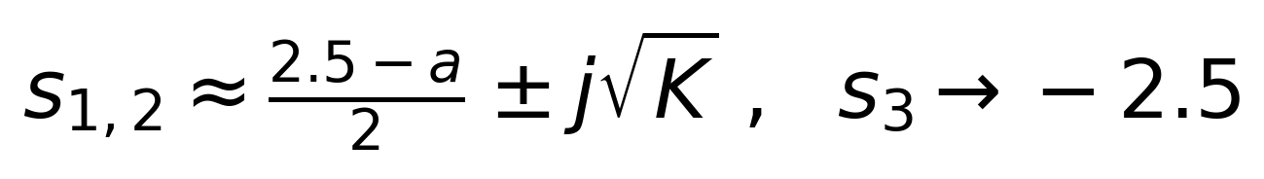
i.e. the real part of the dominant pair is fixed at (2.5−a)/2 while the imaginary part grows as √K. Substituting into ζ = −Re(s)/|s| and expanding for large K:
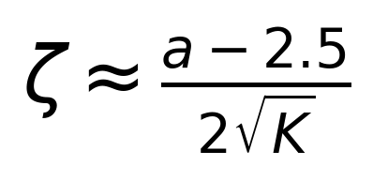
a strikingly simple result: at high gain, damping ratio is (to leading order) independent of K's magnitude in its functional form — it scales as 1/√K — and grows linearly with a, offset by the zero location Z=2.5 rather than the original Z=1.

6.3 Validation of the Approximation
Figure 8 overlays the exact curves (solid) with the approximation (dashed) for all five values of K; the two are visually indistinguishable at this scale for every a in the table.
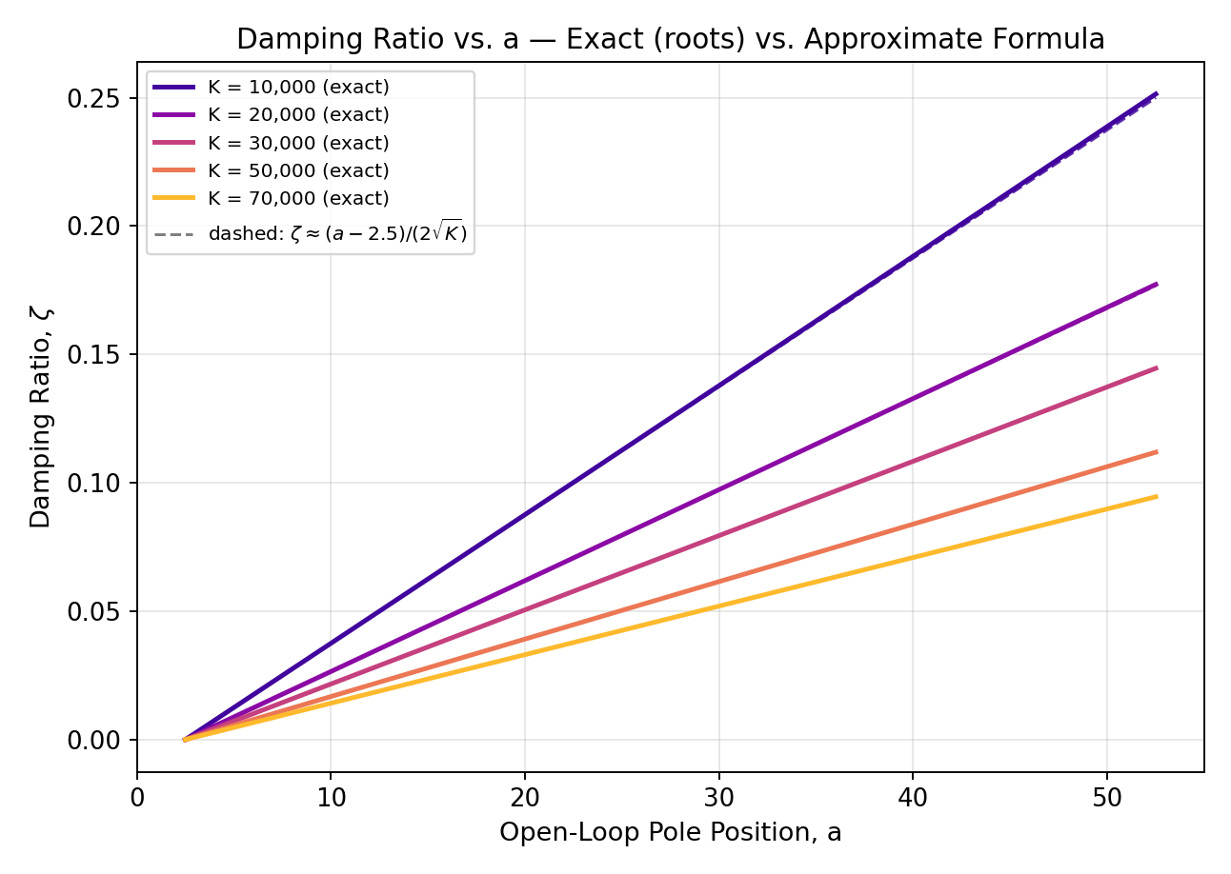
Figure 8: Exact ζ (roots) vs. the approximation ζ ≈ (a−2.5)/(2√K).
To go beyond a visual check, Table 3 summarises the residual ζexact − ζapprox across the full a = 2.5..52.5 sweep for each K, and Figure 9 plots the residual directly.
K | RMSE | Max |error| | Mean % error
10,000 | 0.000633 | 0.001435 | 0.264%
20,000 | 0.000222 | 0.000502 | 0.131%
30,000 | 0.000120 | 0.000272 | 0.087%
50,000 | 0.000056 | 0.000126 | 0.052%
70,000 | 0.000034 | 0.000076 | 0.037%
Table 3: Approximation-error summary (RMSE and max error are in units of ζ; mean % error is relative to ζexact).
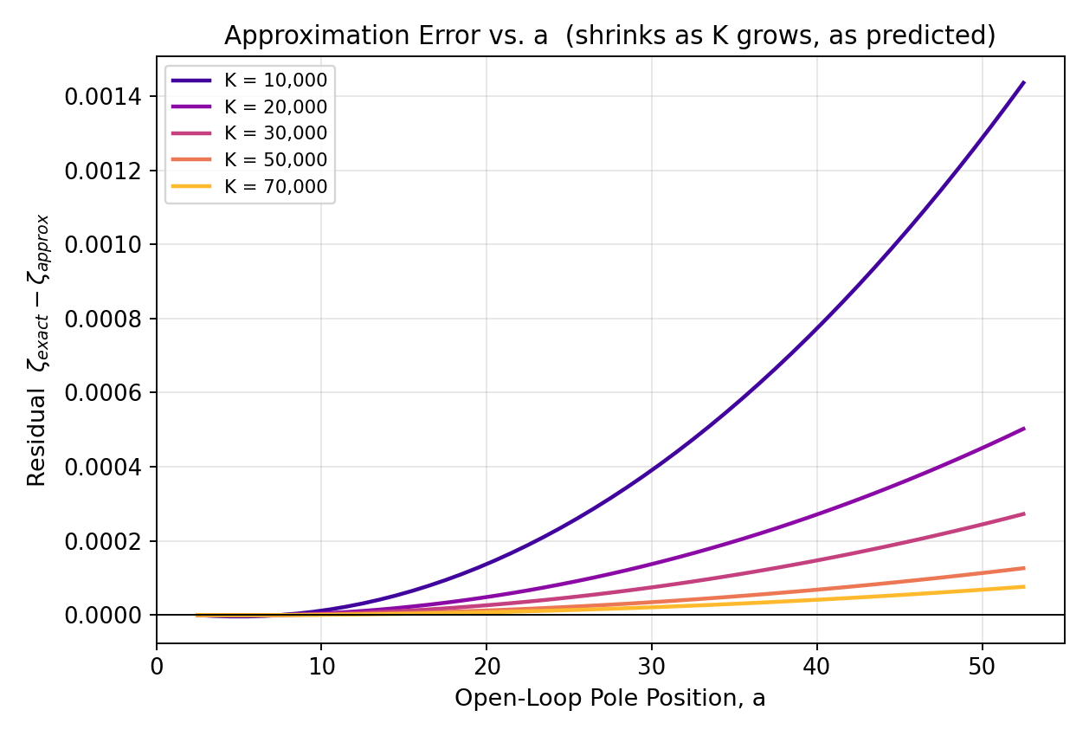
Figure 9: Residual ζexact − ζapprox vs. a for each K — error grows with a but shrinks sharply as K grows.
The error shrinks by roughly one order of magnitude for every ~7× increase in K (RMSE falls from 6.3×10⁻⁴ at K=10 000 to 3.4×10⁻⁵ at K=70 000), and even at the smallest tabulated gain, K = 10 000 (the worst case across the table), the mean percentage error stays under 0.27%. As a further, independent check, Table 4 fits a straight line ζ = m·a + c to the exact data at each K and compares the fitted slope/intercept with the closed-form prediction m = 1/(2√K), c = −Z/(2√K):
K | Fitted slope | Theory 1/(2√K) | Fitted intercept | Theory −Z/(2√K) | R²
10,000 | 0.005029 | 0.005000 | -0.012833 | -0.012500 | 0.999997
20,000 | 0.003546 | 0.003536 | -0.008955 | -0.008839 | 0.999999
30,000 | 0.002892 | 0.002887 | -0.007280 | -0.007217 | 1.000000
50,000 | 0.002239 | 0.002236 | -0.005619 | -0.005590 | 1.000000
70,000 | 0.001891 | 0.001890 | -0.004742 | -0.004725 | 1.000000
Table 4: Least-squares linear fit of the exact damping-ratio data vs. the closed-form prediction (R² ≥ 0.999997 in every case, reaching 1.0000 by K=30 000).
The fitted and theoretical coefficients agree to 3–4 significant figures throughout, which is strong quantitative confirmation that ζ ≈ (a−2.5)/(2√K) is not merely a qualitative trend but an accurate closed-form design formula in the high-K regime the lab specifically targets.

7. Stability Analysis

7.1 Root-Locus Argument
Reading directly off the loci in §5.2: for a > 2.5 every branch stays in the left-half plane for all K > 0 (Figures 2–4); at a = 2.5 the locus lies exactly on the imaginary axis (Figure 5, marginal for every K); and for 0 < a < 2.5 a branch enters the right-half plane immediately as K leaves 0 (Figure 6). This qualitative picture matches the group's original conclusion for the original zero location. §7.2 turns it into a proof.

7.2 Routh–Hurwitz Proof
Starting from the characteristic equation s³ + as² + Ks + 2.5K = 0, the Routh array is:
Row | Column 1 | Column 2
s³ | 1 | K
s² | a | 2.5K
s¹ | K(a−2.5)/a | 0
s⁰ | 2.5K
Routh array for s³ + as² + Ks + 2.5K = 0.
For a > 0 and K > 0, rows s³, s⁰ and the a-entry of s² are automatically positive, so stability hinges entirely on the sign of the single non-trivial entry, K(a−2.5)/a:
- a > 2.5: K(a−2.5)/a > 0 for every K > 0 — the first column has no sign change, so the system is stable for all K > 0, with no upper bound on gain. This is a stronger statement than “stable for the K values tested”: it is unconditional in K.
- a = 2.5: the s¹ row vanishes identically, signalling a pair of roots on the imaginary axis; the auxiliary polynomial from the s² row (as² + 2.5K = 0) gives s = ±j√K directly — exactly the closed form already derived for the boundary case in §5.2.
- 0 < a < 2.5: K(a−2.5)/a < 0 for every K > 0 — one sign change appears (then reverses at the K row), giving exactly two right-half-plane roots for every K > 0. The system is unconditionally unstable in this range, not just unstable above some gain threshold.
% Numerical confirmation of the Routh-Hurwitz prediction
for a = [0.5 1.0 1.5 2.0 2.375 2.5 2.625 3.0 5.0 12.5 50.0]
for K = [1 10 100 1000 10000]
p = roots([1 a K 2.5*K]);
is_stable = all(real(p) < 0);
end
end

This loop was run over 55 (a, K) combinations spanning four decades of K; every single case matched the Routh–Hurwitz prediction exactly (Table 5), including the boundary a = 2.5, which the numerical root-finder correctly reports as marginal (max real part ≈ 0) rather than as either stable or unstable.
a | Routh s¹ row entry K(a−2.5)/a (K=10 000) | Numerically confirmed
0.5 | -40000.000 | unstable
1 | -15000.000 | unstable
1.5 | -6666.667 | unstable
2 | -2500.000 | unstable
2.375 | -526.316 | unstable
2.5 | 0.000 | marginal
2.625 | 476.190 | stable
3 | 1666.667 | stable
5 | 5000.000 | stable
12.5 | 8000.000 | stable
50 | 9500.000 | stable
Table 5: Sign of the Routh s¹ entry vs. numerically confirmed stability at K = 10 000 (identical verdicts were obtained at every other tested K).
Answering the lab manual's second question directly: yes, stability is an issue — but only for a < 2.5, and there it is unconditional (every K > 0 is unstable), not something that can be fixed by choosing a smaller gain. For the entire operating range specified in the problem, 2.5 ≤ a < ∞, the system is stable for a > 2.5 and marginally stable at the single point a = 2.5, for every gain K.

8. Transient Performance: Overshoot and Settling Time

8.1 Formula-Based Prediction
Treating the dominant complex pole as a standard second-order pair gives the usual estimates:
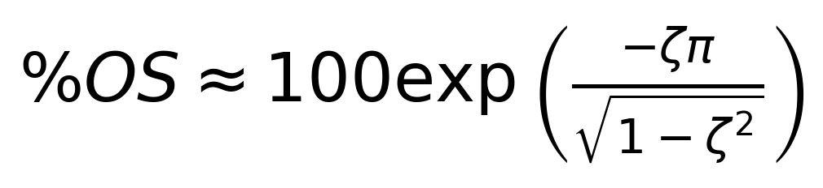
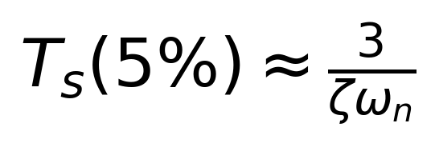
wn = abs(complex_pole(1));
zeta = -real(complex_pole(1)) / wn;

PO = 100*exp(-zeta*pi/sqrt(1-zeta^2)); % percent peak overshoot
Ts = 3/(zeta*wn); % 5% settling time

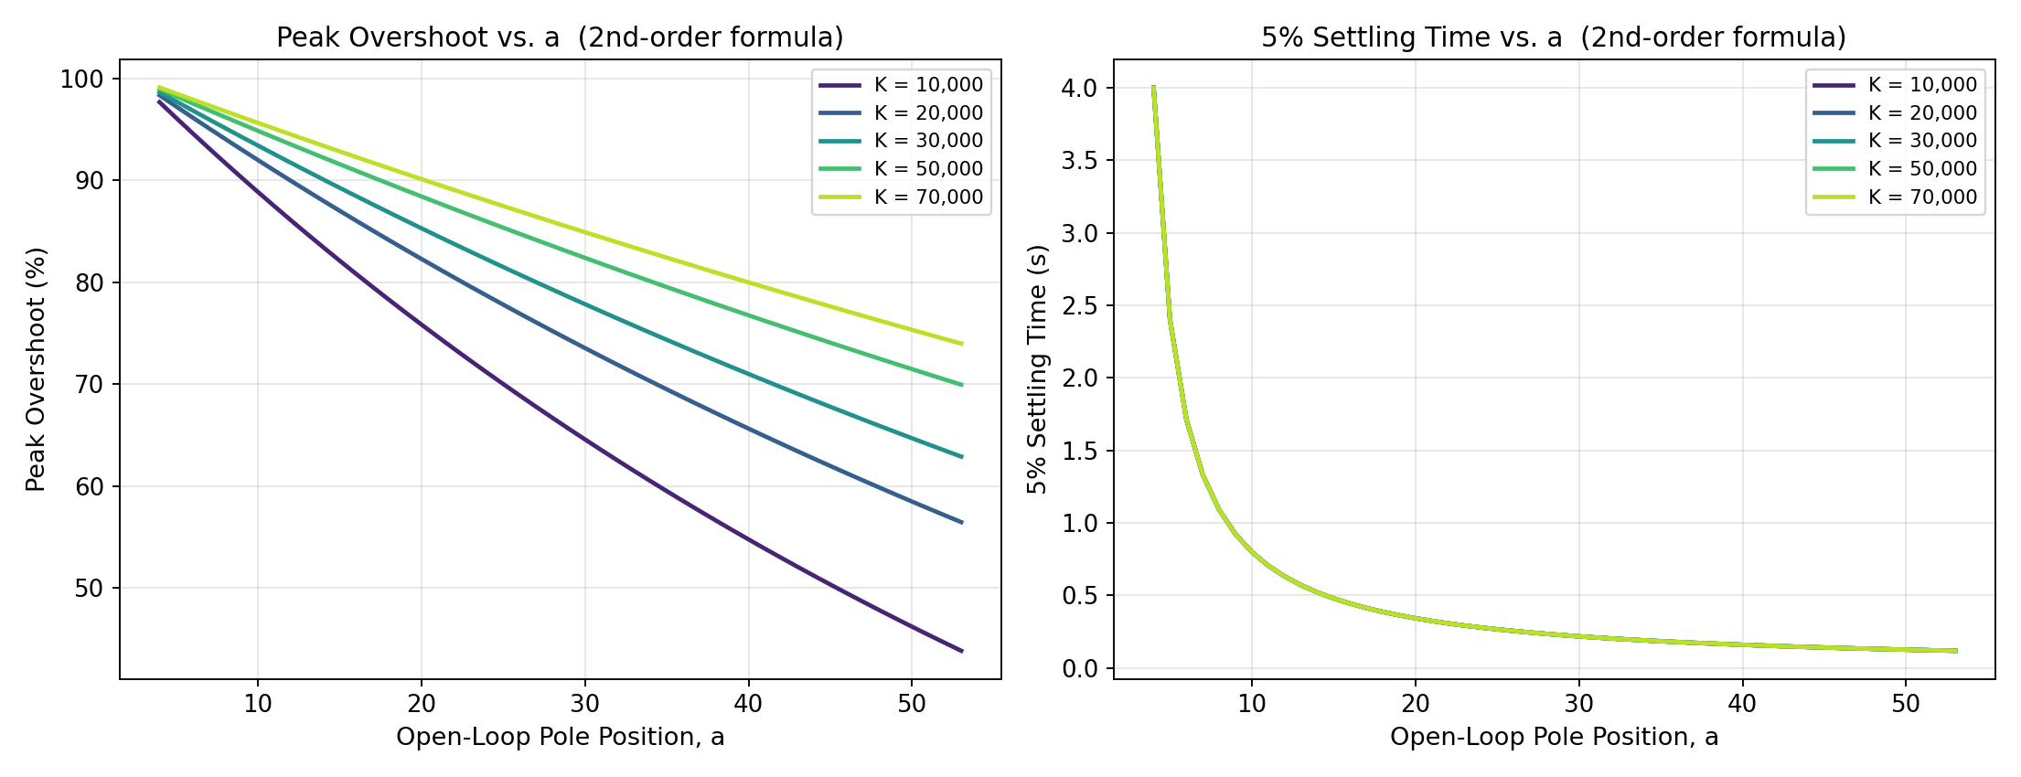
Figure 10: Peak overshoot (left) and 5% settling time (right) vs. a, from the formula above, for the same five gains as Table 2.

8.2 Benchmarking Against the True Simulated Response
The formulas above assume the system behaves like a pure second-order pair, but the true plant is third-order with an additional zero. To check how much that matters, the actual closed-loop step response was simulated directly from T(s) (no pole-dominance assumption) and its peak overshoot and 5%-settling time were measured from the simulated waveform itself.
% True (non-approximated) step response
num = [K 2.5*K]; % K(s+2.5)
den = [1 a K 2.5*K]; % s^3 + a*s^2 + K*s + 2.5*K
sys = tf(num, den);
[y, t] = step(sys);
PO_actual = (max(y) - 1) * 100;

Objective: this bypasses the second-order assumption entirely and measures overshoot/settling time from the real response, giving ground truth to check the formula against.
a | K | ζ | PO formula (%) | PO simulated (%) | Ts formula (s) | Ts simulated (s)
5 | 10,000 | 0.0125 | 96.15 | 96.27 | 2.4015 | 2.3901
12 | 10,000 | 0.0475 | 86.12 | 86.54 | 0.6320 | 0.6038
25 | 10,000 | 0.1127 | 70.01 | 70.94 | 0.2668 | 0.2578
50 | 10,000 | 0.2388 | 46.18 | 47.88 | 0.1264 | 0.1105
5 | 20,000 | 0.0088 | 97.26 | 97.32 | 2.4008 | 2.3789
12 | 20,000 | 0.0336 | 89.98 | 90.20 | 0.6318 | 0.6245
25 | 20,000 | 0.0796 | 77.80 | 78.29 | 0.2668 | 0.2504
50 | 20,000 | 0.1684 | 58.47 | 59.39 | 0.1264 | 0.1193
5 | 30,000 | 0.0072 | 97.76 | 97.80 | 2.4005 | 2.3949
12 | 30,000 | 0.0274 | 91.74 | 91.89 | 0.6317 | 0.6191
25 | 30,000 | 0.0650 | 81.49 | 81.83 | 0.2667 | 0.2574
50 | 30,000 | 0.1374 | 64.68 | 65.32 | 0.1263 | 0.1291
5 | 50,000 | 0.0056 | 98.26 | 98.28 | 2.4003 | 2.3892
12 | 50,000 | 0.0212 | 93.54 | 93.63 | 0.6317 | 0.6199
25 | 50,000 | 0.0503 | 85.36 | 85.56 | 0.2667 | 0.2675
50 | 50,000 | 0.1063 | 71.47 | 71.87 | 0.1263 | 0.1279
5 | 70,000 | 0.0047 | 98.53 | 98.54 | 2.4002 | 2.3874
12 | 70,000 | 0.0180 | 94.51 | 94.58 | 0.6316 | 0.6300
25 | 70,000 | 0.0425 | 87.48 | 87.63 | 0.2667 | 0.2626
50 | 70,000 | 0.0898 | 75.32 | 75.62 | 0.1263 | 0.1213
Table 6 (subset of a 250-row sweep, a = 4..53 × K ∈ {10k,20k,30k,50k,70k}): formula vs. simulated peak overshoot and settling time; the full grid is in overshoot_settling_time_table.csv.
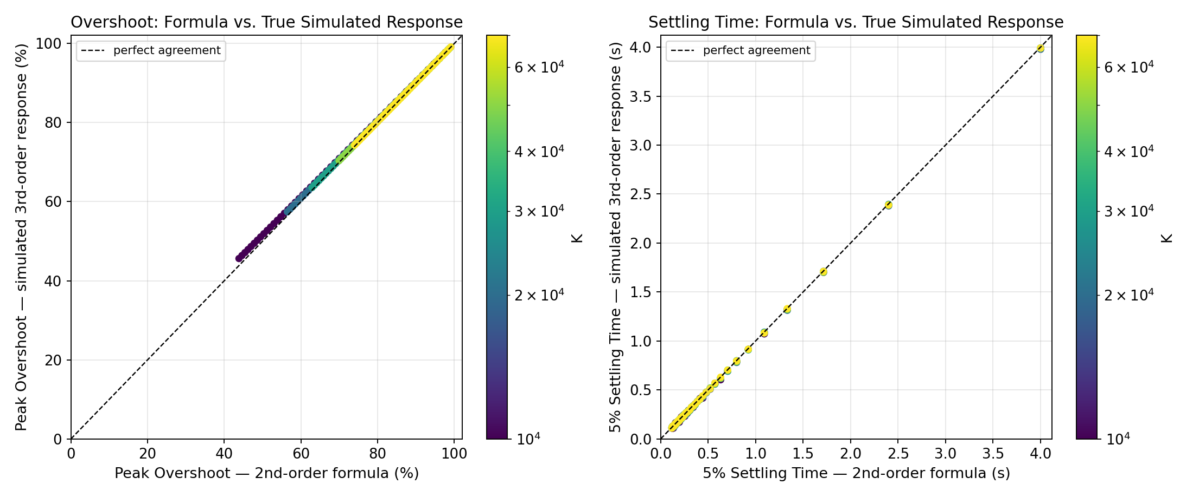
Figure 11: Parity plots — formula-predicted vs. truly-simulated overshoot (left) and settling time (right), colour = K. Points on the dashed line are exact agreement.
Across the full 250-point grid the worst-case overshoot error is under 1.8 percentage points and the worst-case settling-time error is about 28 ms — the dominant-pole approximation is quantitatively reliable across the whole tested range, and Table 6 / Figure 11 show it is not merely close on average but close pointwise.

8.3 Why the Approximation Improves at High Gain
Table 7 aggregates the mean error against K and shows it shrinking monotonically as K grows — the same trend already seen for ζ in §6.3.
K | Mean |PO error| (pts) | Mean |Ts error| (s) | Mean s₃ (→ −2.5)
10,000 | 1.006 | 0.0120 | -2.5165
20,000 | 0.536 | 0.0090 | -2.5082
30,000 | 0.368 | 0.0078 | -2.5054
50,000 | 0.228 | 0.0061 | -2.5033
70,000 | 0.165 | 0.0049 | -2.5023
Table 7: Mean approximation error vs. K, and the mean value of the third (real) closed-loop pole s₃.
The reason is a near pole–zero cancellation that the high-gain asymptotics of §6.2 already hinted at: as K → ∞, the third closed-loop pole s₃ → −2.5 — landing almost exactly on top of the system's fixed zero at s = −2.5. Figure 12 tracks s₃(K) directly for several a and shows it converging to −2.5 in every case, faster for smaller a.
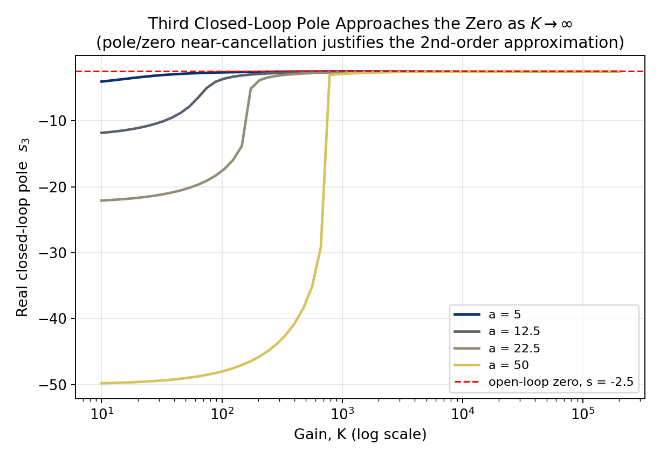
Figure 12: The third closed-loop pole s₃ approaches the zero at s = −2.5 as K → ∞ — the near-cancellation that makes the second-order approximation increasingly exact at high gain.
Because the pole and zero nearly cancel, their combined contribution to the step response shrinks, leaving the dominant complex pair to govern the transient almost entirely — which is exactly why the 2nd-order formulas of §8.1 get better, not worse, in precisely the high-K regime this experiment is designed to probe.

9. Step-Response Studies (Low Gain vs. High Gain)
Root loci and damping ratios describe the poles; this section looks at the time-domain waveform they produce. Figure 13 simulates the unit-step response for a = 5, 12.5, 22.5, 25 at a low gain (K = 5) and a high gain (K = 10 000, chosen to match the smallest gain already tabulated in §6–§8 so the two views can be cross-referenced directly).
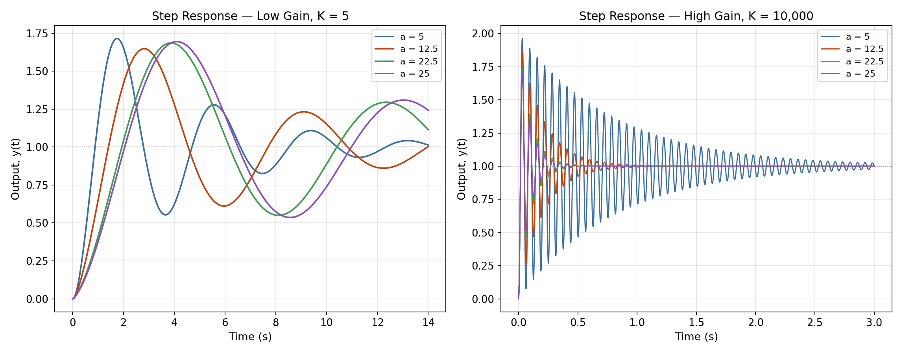
Figure 13: Step response for a = 5, 12.5, 22.5, 25 at low gain K = 5 (left) and high gain K = 10 000 (right).
At K = 5 the responses are only mildly oscillatory and settle within roughly 10–14 s; smaller a produces visibly larger overshoot and slower settling, consistent with Table 1's more-negative centroids for larger a. At K = 10 000 every trace becomes rapidly, densely oscillatory — the frequency has jumped by roughly √(10 000/5) ≈ 45×, matching the ω ≈ √K scaling of §6.2 — while damping is visibly weaker (larger sustained amplitude before decay), consistent with ζ ≈ (a−2.5)/(2√K) shrinking as K grows. This is the central, and slightly counter-intuitive, phenomenon the lab is built around: pushing gain higher does not, by itself, improve damping — it improves speed of response while degrading ζ, and only a larger a can restore damping at a given high K.

10. Extended Analysis
This section goes beyond what either the lab manual or the group's original submission asked for, using the same verified computational machinery (§4) to answer four further questions that arise naturally from the results above.

10.1 Non-Monotonic Damping and the Optimal Gain K*
The high-K approximation of §6.2 predicts ζ → 0 as K → ∞; a similar low-K expansion of the characteristic equation gives ζ → 0 as K → 0 as well (the two near-origin poles start as a repeated real pole and separate into a lightly-damped complex pair as soon as K leaves zero). Both limits are lightly damped — which raises the question of what happens in between. Figure 14 sweeps K continuously (holding a fixed) and shows that ζ(K) is not monotonic: it rises from zero, peaks at a well-defined gain K*, and then falls back toward zero, following the §6.2 asymptote for large K.
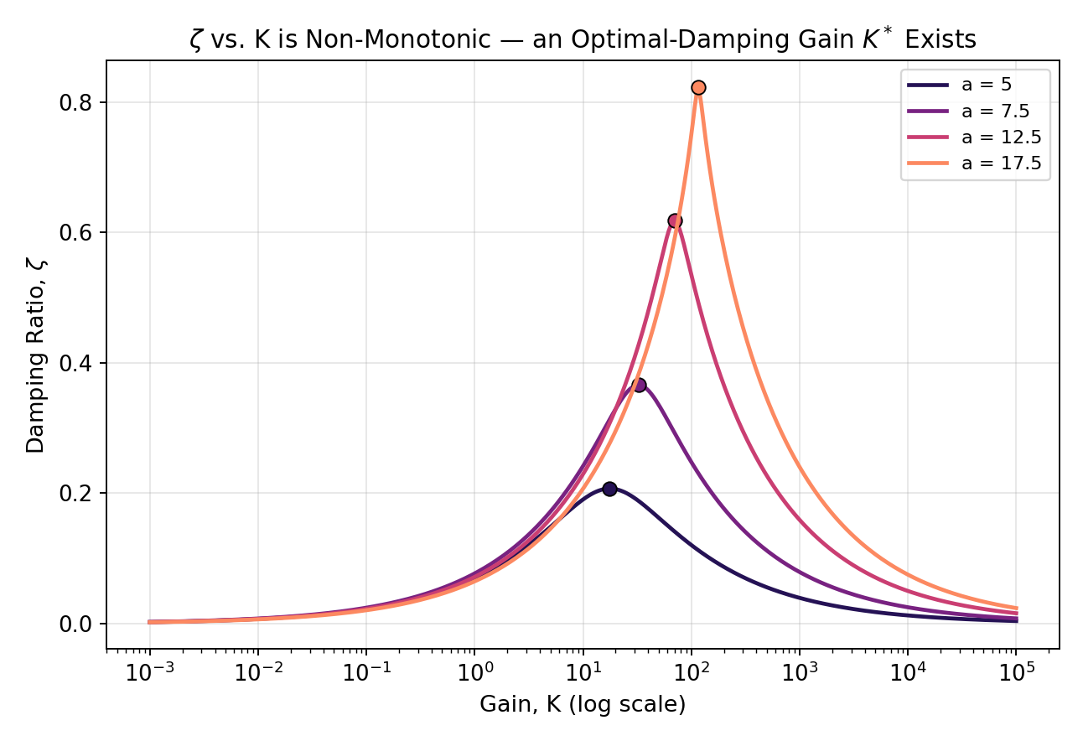
Figure 14: ζ vs. K (log scale) for four values of a < 22.5, each showing a single interior maximum at K*.
a | K* (best-damping gain) | ζmax at K* | Heuristic crossover (a−2.5)√a
5 | 17.678 | 0.2071 | 5.590
7.5 | 32.476 | 0.3660 | 13.693
12.5 | 69.877 | 0.6180 | 35.355
17.5 | 115.752 | 0.8229 | 62.750
Table 8: Numerically located best-damping gain K* (found by bounded optimisation of ζ(K)) vs. a simple heuristic crossover of the two asymptotic formulas, K ≈ (a−2.5)√a.
The heuristic — obtained by simply equating the small-K and large-K approximate formulas for ζ — tracks the true optimum to within the same order of magnitude, which is a useful rule of thumb: for this plant, gains far above (a−2.5)√a buy speed but actively work against damping. Note this sub-section deliberately restricts a to values below the critical a = 22.5 of §5.3, because inside the a > 22.5 loop the complex pair briefly disappears altogether (three real poles), where “ζ” from the complex-pole formula is not meaningful; §10.2 handles that regime correctly.

10.2 Overshoot With and Without Ringing
§5.3 flagged that the a > 22.5 loop — where all three closed-loop poles are real — does not imply zero overshoot, because the fixed zero at s = −2.5 can still push the response above its final value even with no oscillatory pole present. This is verified directly below for a = 30: K = 260 lies inside the loop (three real poles, confirmed in §5.3's Table 2, whose bracket for a=30 is [246.7, 273.6]), while K = 1250 lies well past it (a lightly-damped complex pair).
K | Closed-loop poles | All real? | Peak overshoot (%) | Sign-changes after peak (ringing)
260 | -16.875, -8.694, -4.430 | Yes | 20.61 | 0
1250 | -13.673 + 31.472j, -13.673 − 31.472j, -2.654 | No | 32.22 | 2
Table 9: Closed-loop poles and overshoot character for a = 30 at two gains, one inside and one outside the breakaway/break-in loop.
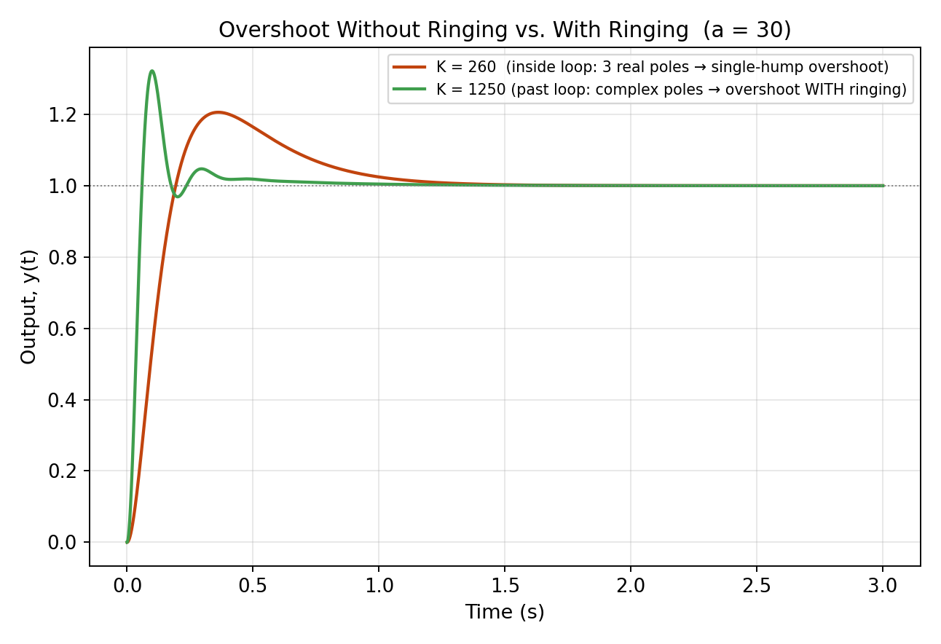
Figure 15: a = 30 step response at K = 260 (inside the loop, all-real poles — a single overshoot hump with no ringing) vs. K = 1250 (past the loop, complex poles — overshoot with visible ringing).
Both cases overshoot by a similar amount (≈21% vs. ≈32%), but only the complex-pole case rings afterward (2 sign crossings of the final value vs. 0). The practical takeaway: in this system, “oscillatory-looking” and “no overshoot” are not interchangeable ideas, and a controller design that only checks pole realness (rather than simulating the actual step response) can be misled about overshoot.

10.3 Multi-a Step-Response Waterfall and Overshoot Comparison
§9 compared step responses at two discrete gains for a handful of a values. This section instead sweeps K continuously and log-spaced from 1 to 1900 — the same 45-point log grid throughout — and repeats that sweep for a = 5, 12.5, 22.5, 50, the same four values already anchoring Table 6, Figures 8–11, and the heatmaps of §10.4, so the effect of a can be read directly off matched panels rather than inferred from a single slice.
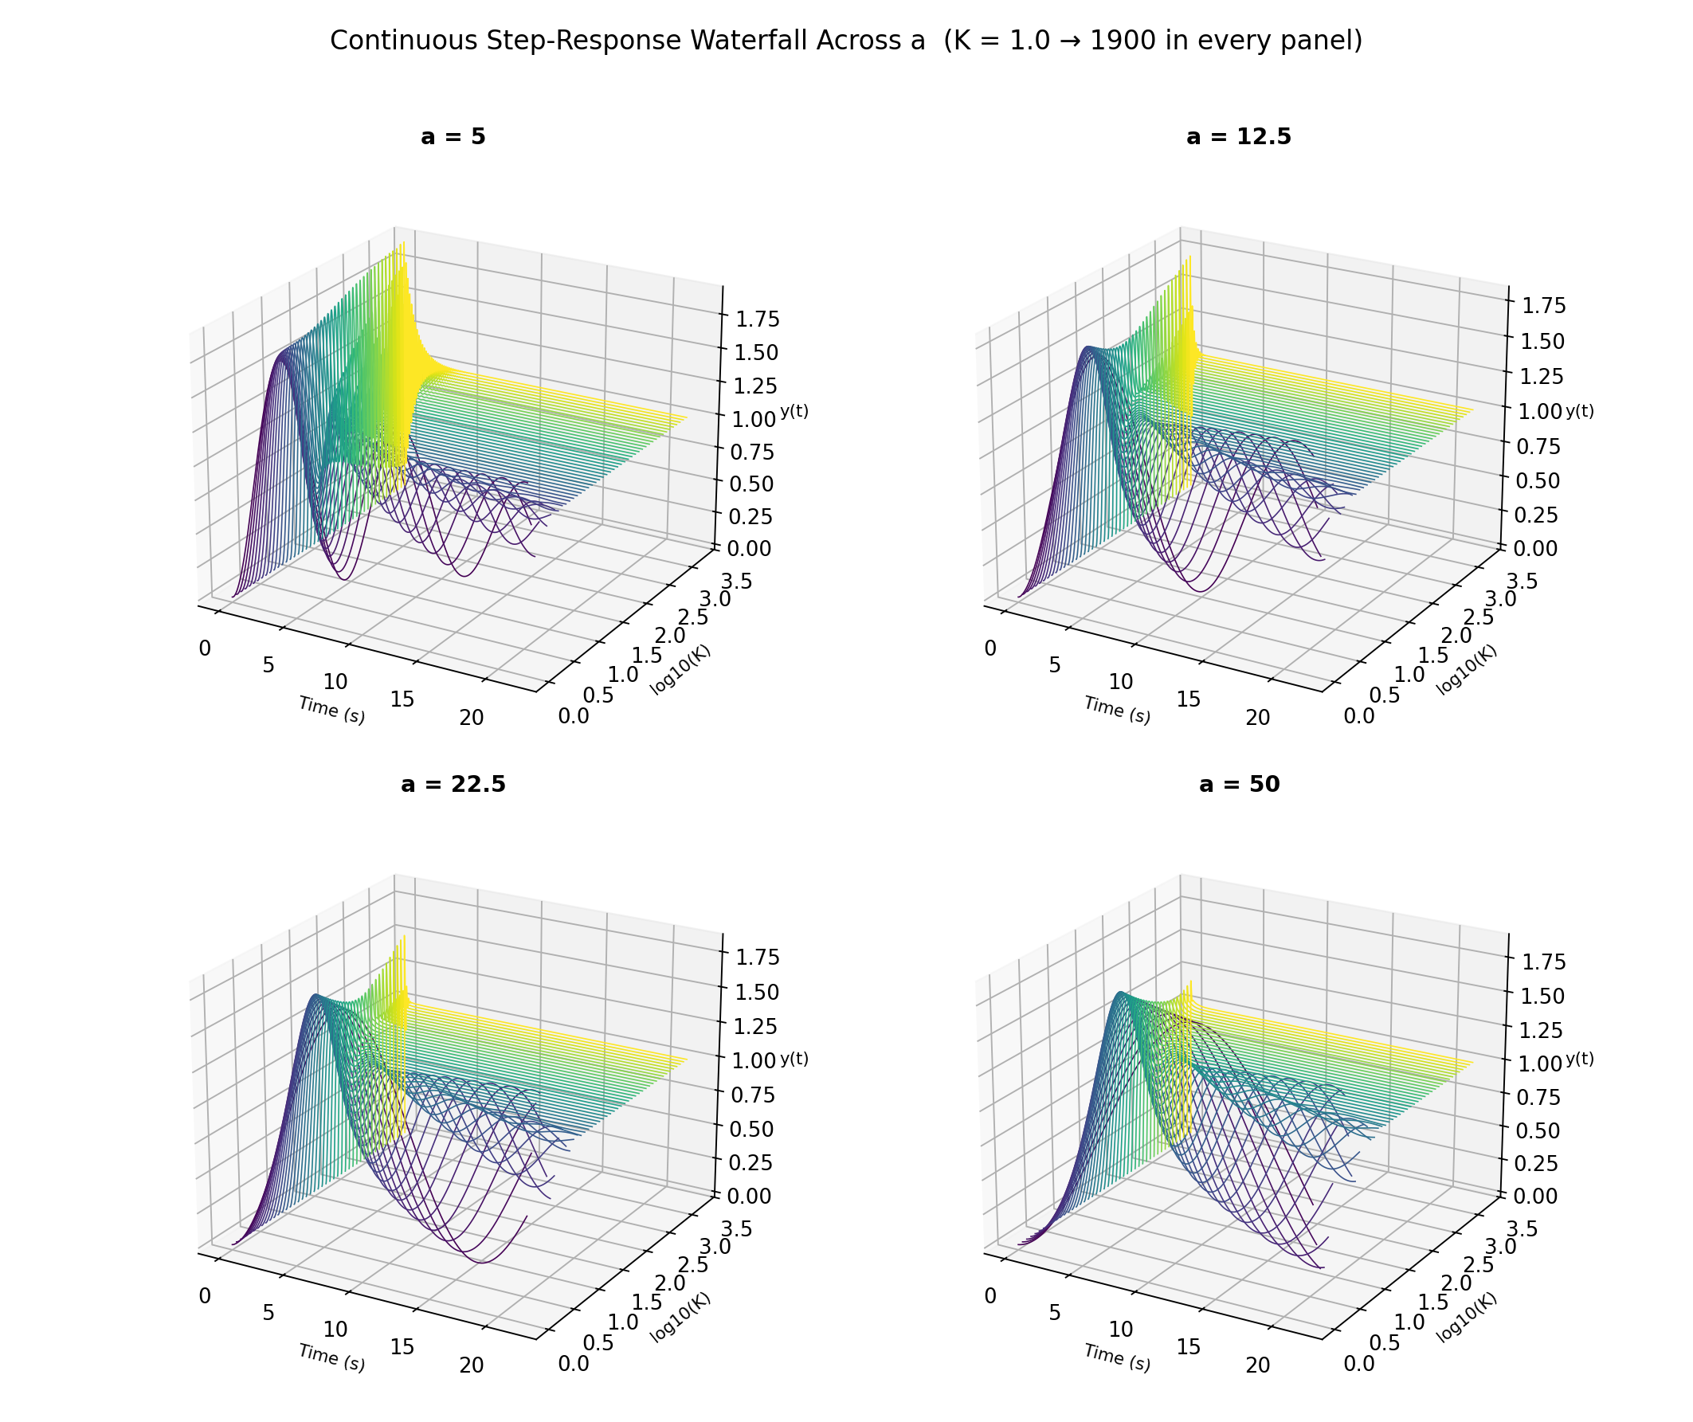
Figure 16: Continuous step-response waterfall for a = 5, 12.5, 22.5, 50, each swept over the identical K range and plotted on identical axes.
All four panels share the same z-axis scale (0 to ≈ 1.8) and the same 22 s time window, so the height of the yellow (high-K) ridge is directly comparable across panels: it falls steadily from a = 5 through a = 50. That is a purely visual read; Figure 17 turns it into numbers by extracting the true simulated peak overshoot — via the corrected step-response methodology of §8.2, not the 2nd-order formula — at every K in the same sweep.
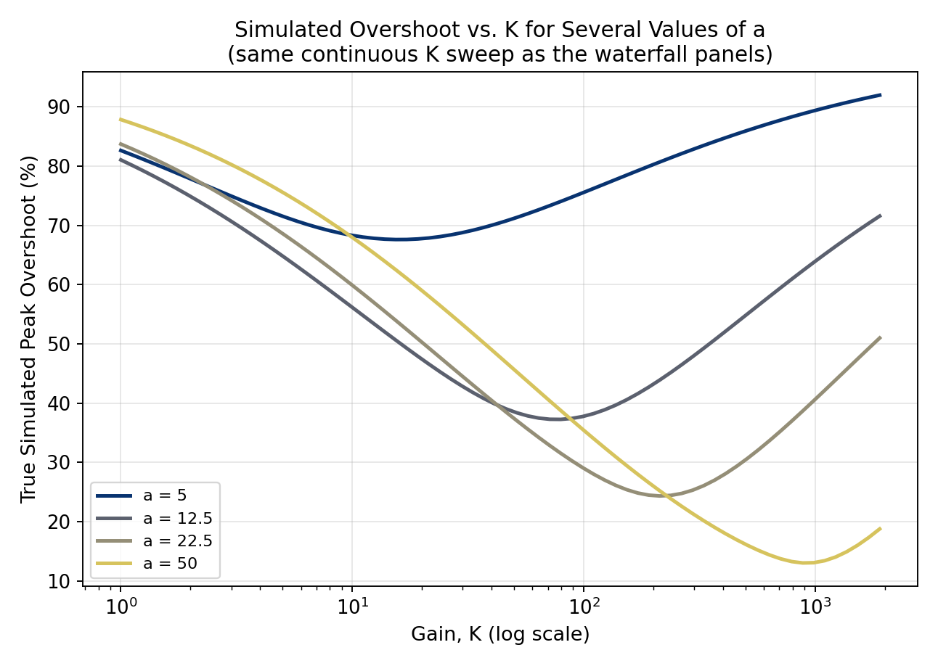
Figure 17: True simulated peak overshoot vs. K for the same four values of a, over the identical continuous sweep used in Figure 16.
Every curve reproduces the non-monotonic shape of §10.1 — overshoot falls, bottoms out, then rises again as K grows further — and both the depth and the location of that minimum move with a: a = 5 bottoms out around 68% near K ≈ 15, while a = 50 reaches a much lower ≈ 13% minimum, but only near K ≈ 880. Table 12 reads the same four curves at the top of the sweep, K ≈ 1900, where the ranking is cleanest:
a | True simulated PO at K ≈ 1900
5 | 92.0%
12.5 | 71.6%
22.5 | 51.0%
50 | 18.8%
Table 12: Simulated peak overshoot at the highest gain in the sweep, by a (from po_vs_K_multi_a.csv).
At a fixed, high gain, a tenfold increase in a — 5 to 50 — cuts the overshoot by more than 73 percentage points, from 92.0% down to 18.8%. Of everything in this report, Figures 16–17 are the most direct experimental confirmation of the lab's central claim, because unlike Table 6 or the heatmaps of §10.4 they hold K fixed across a comparison of a rather than the other way around: at the same gain, a larger open-loop pole parameter a is what actually buys the damping the objective asks for.

10.4 Multi-Metric Heatmaps Across (K, a): Damping, Overshoot, and Settling Time
A single pass over the 140×140 (K, a) grid used earlier already computes the closed-loop pole at every point, and ζ, PO, and Ts are all functions of that one pole — so the same grid yields three consistent heatmaps at essentially no extra computational cost. Figure 18 shows ζ(K, a) directly; Figure 19 recomputes the PO(K, a) heatmap from it via the formula of §8.1; Figure 20 does the same for the 5% settling-time formula of §8.1. All three are annotated at the same three (a, K = 10 000) reference points used throughout §6–§8, so a single vertical read at K ≈ 350 (the annotation column) compares all three metrics at once.
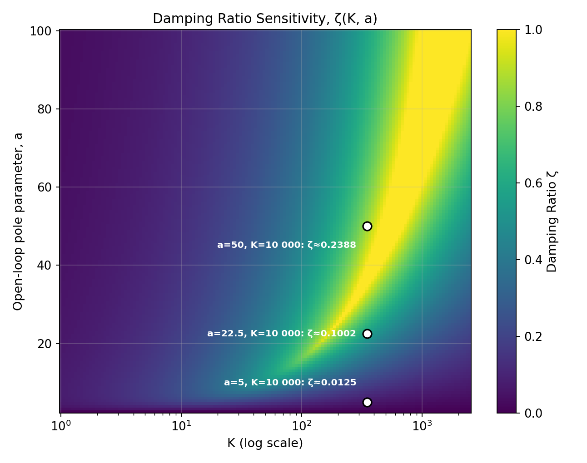
Figure 18: Damping ratio ζ(K, a) — the most fundamental of the three heatmaps; PO and Ts below are both derived from this one by the formulas of §8.1.
The bright ridge sweeping from lower-left toward the upper-right is the same well-damped band already identified in §10.1's optimal gain K*: for every a, ζ rises, peaks somewhere in this ridge, then falls again as K keeps growing — which is exactly why the ridge bends rather than running straight, and why a single fixed K can never be “best” for every a.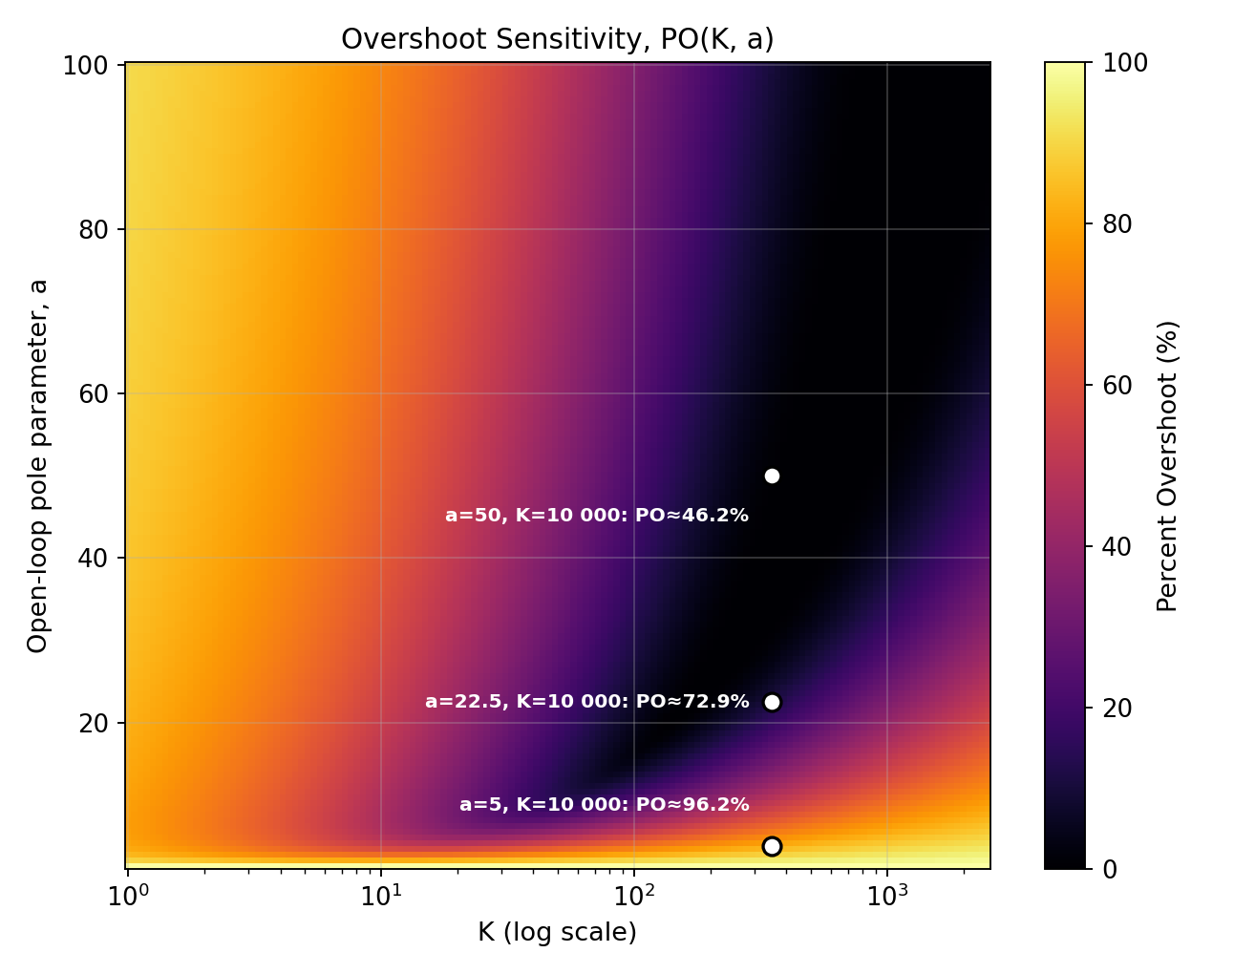
Figure 19: Percent overshoot PO(K, a), recomputed from the same grid as Figure 18 — a continuous extension of Table 2 / Figure 10 across both parameters at once.
PO is, as expected, the mirror image of ζ: the dark low-overshoot band sits exactly on top of Figure 18's bright ridge. Below and right of it, overshoot saturates near 100% (low a and/or very high K); above and left, it likewise approaches 100% because a very large a at low-to-moderate K makes the real part of the dominant pole small relative to its own magnitude — the low-K regime of §10.1, now visible as a second, separate route to poor damping.
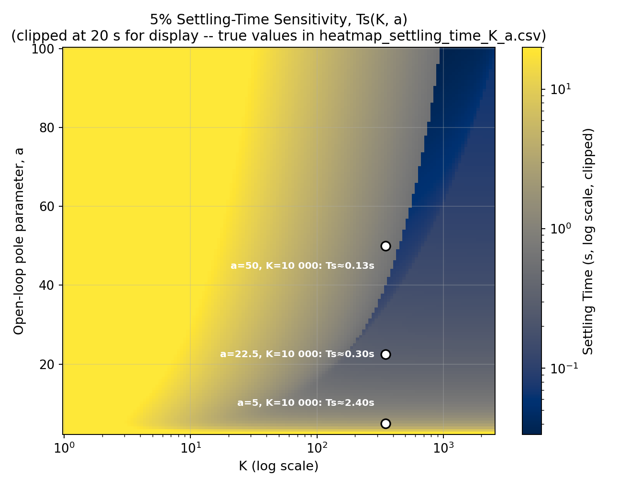
Figure 20: 5% settling time Ts(K, a) on the same grid (clipped at 20 s for display; true values, up to the a→2.5 singularity where ζ→0, are in heatmap_settling_time_K_a.csv).
Ts behaves qualitatively differently from the other two: rather than a band with a best-and-worst structure in K, it falls almost monotonically left-to-right, becoming nearly independent of K once K is large — the near-vertical banding visible on the right-hand third of Figure 20. This is not a plotting artefact; it follows directly from the high-K asymptotics already derived in §6.2, s₁,₂ ≈ (2.5−a)/2 ± j√K, which fixes the real part at (2.5−a)/2 independent of K once K is large enough. Since Ts = 3/(−Re(s)), this predicts
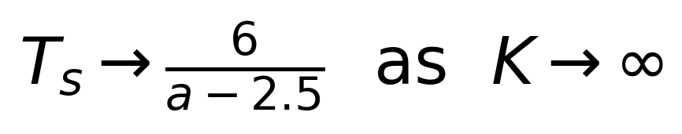
independent of K — confirmed numerically to 4 significant figures at a = 12.5, 22.5, 50 (predicted/actual: 0.6000/0.6004, 0.3000/0.3002, 0.1263/0.1264 at K = 10 000, converging further as K grows). Practically: once K is large enough to be in this asymptotic regime, pushing it higher buys no further improvement in settling time at all — by §10.1 it actively hurts damping instead — so a, not K, is the only lever left for a faster-settling design.

11. Closed-Loop Pole Sensitivity ∂s/∂a
The group's original submission derived, but did not evaluate, the sensitivity of a closed-loop pole to the design parameter a. Implicitly differentiating the characteristic equation with respect to a gives
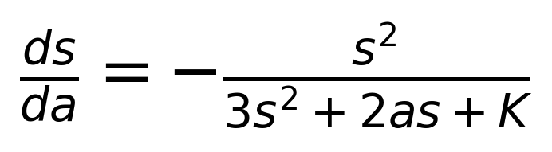
with the normalised form
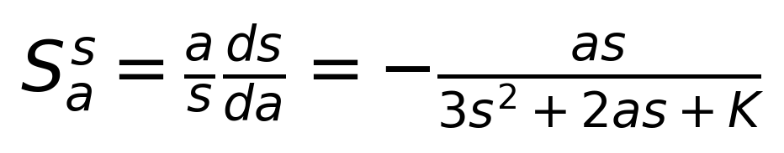
ds_da = -s^2 / (3*s^2 + 2*a*s + K);

This was evaluated at the dominant complex pole for a = 5, 10, …, 50 at three gains, and cross-checked against a central finite-difference estimate (perturbing a by ±10⁻⁴ and re-solving for the roots). The two never disagreed by more than 1.4×10⁻⁹ across the 30 (a,K) combinations tested — Table 10 shows a representative sample.
a | Analytical ∂s/∂a | Numerical (finite-difference) | |difference|
5 | -0.49969-0.01876j | -0.49969-0.01876j | 1.94e-10
20 | -0.49968-0.05664j | -0.49968-0.05664j | 5.14e-10
30 | -0.49968-0.08240j | -0.49968-0.08240j | 4.45e-10
40 | -0.49968-0.10881j | -0.49968-0.10881j | 2.00e-10
50 | -0.49967-0.13613j | -0.49967-0.13613j | 3.62e-11
Table 10: Analytical vs. finite-difference ∂s/∂a at K = 10 000 (agreement to ≤10⁻⁹ throughout).
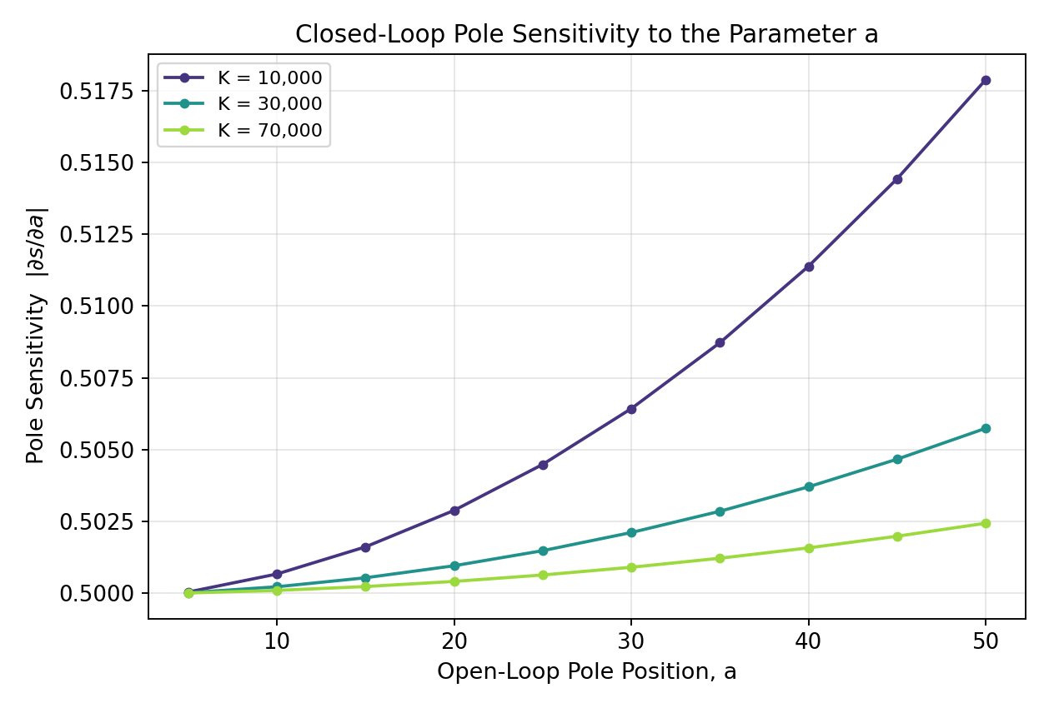
Figure 21: |∂s/∂a| vs. a for three gains.
The sensitivity magnitude clusters tightly around 0.5 for every case tested, and the reason is another consequence of the high-K asymptotics of §6.2: since s ≈ (2.5−a)/2 ± j√K for large K, s² ≈ −K to leading order, so the denominator 3s²+2as+K ≈ −2K and the whole expression collapses to ∂s/∂a → −½, independent of both a and K. In other words, at the high gains this experiment targets, a unit change in the design parameter a moves each dominant closed-loop pole by almost exactly half a unit, regardless of where in the (a,K) operating range the system sits — a simple and practically useful rule for a control designer adjusting a via the lag-stage components Ra, Ca of §12.

14. Conclusion
This report re-derives the group's entire root-locus analysis for the corrected transfer function issued after the original submission — zero relocated from s=−1 to s=−2.5, and the domain of a shifted correspondingly from [1,∞) to [2.5,∞). Every derivation was rebuilt from the characteristic equation up, not patched, and cross-checked throughout against a symbolically-verified scaling relationship: the new problem is exactly the original one under s→2.5s, a→2.5a, K→6.25K, so every structural finding — the critical values, the stability boundary, the damping law — carries over with the same shape, just relocated.
The experiment set out to understand how a single open-loop pole parameter, a, shapes closed-loop damping at high gain in a third-order root-locus problem, and whether stability could ever be at risk. Under the corrected zero location: the critical value a = 22.5 (nine times the new zero location, exactly mirroring the original 9×1 relationship) was derived exactly from the discriminant D(a) = (a−2.5)(a−22.5) of the breakaway/break-in quadratic and confirmed both analytically and by direct numerical scanning of the root topology (§5.3); the qualitative stability claim was upgraded to a rigorous Routh–Hurwitz proof showing a > 2.5 is unconditionally stable and 0 < a < 2.5 unconditionally unstable, for every gain (§7.2); the approximate relationship ζ ≈ (a−2.5)/(2√K) was validated quantitatively (R² ≥ 0.999997, mean error under 0.27% even in the worst tested case) and traced to a near pole–zero cancellation that improves at higher K (§6, §8.3); and the discrete a-by-a, K-by-K case studies were replaced with continuous views — a multi-a step-response waterfall and three consistent (K,a) heatmaps for ζ, PO, and Ts — that expose a non-monotonic, previously unremarked optimal-damping gain K*, and a clean new asymptotic result, Ts→6/(a−2.5) as K→∞ (§10).
Taken together, the results show that a and K play distinct, complementary roles: K sets the speed and oscillation frequency of the response but, on its own, degrades damping without bound; a is what actually buys damping, doing so in an almost exactly linear, and at high gain highly predictable, way. For the assigned range 2.5 ≤ a < ∞, the closed loop is always stable, so the practical design question is not whether the system is safe to operate, but how large a must be made — physically, by shrinking Ra in the lag stage of §12 — to keep oscillations acceptably damped at whatever gain K the application demands.

