EE208 (Control Engineering Lab)
Instructor: Dr. Sanjoy Roy
Extended Lab Report
Title:
Controller Design on MATLAB Platform by Discrete Frequency Response
— with a Continuous-Domain Gain → Overshoot Sensitivity Study —

Group: 6B

Members:
Harshit Kalra (2024EEB1202)
Heetansh Jindal (2024EEB1204)
Hemant Gupta (2024EEB1205)
Date of original submission: 27-08-2026 (Thursday)
Extended analysis compiled: 17-09-2026 (Thursday)

Contents
1. Objective
2. Problem Description
2.1 Recovering the Open-Loop Transfer Function
2.2 Poles and Zeros of Gₒₗ(z)
3. Background
3.1 Digital Frequency Response and the Main Band
3.2 Aliasing at the Band Boundary
3.3 Effect of Sampling Time Tₛ
4. Methodology
5. MATLAB Workflow and Core Code
6. Results — Discrete-Domain Study
6.1 Main-Band Response and Effect of Tₛ
6.2 Anti-Aliasing Filter
6.3 Sideband (Periodic-Band) Response
6.4 Impact of Proportional Gain k on the Discrete Frequency Response
6.5 Nyquist Plot of the Compensated and Uncompensated Loop
6.6 Corner-Frequency Trade-off Study
6.7 Time-Domain Aliasing Demonstration
7. Further Analysis — Extended Stability Check and Continuous-Domain Gain–Overshoot Study
7.1 Extended Root-Locus Verification
7.2 Motivation for a Continuous-Domain Companion Study
7.3 Closed-Loop Model and Analytical Overshoot Formula
7.4 Step-Response Waterfall (K = 0.15 → 300)
7.5 Approximate Gain–Overshoot Relationship
7.6 Sensitivity to Open-Loop Damping Perturbation
7.7 Settling-Time Invariance and Rise/Peak-Time Trends
7.8 Sensitivity Structure and Worst-Case Robust Design
8. Discussion
9. Conclusions
10. References
11. Appendix — Data Files

1. Objective
For a discrete-time process implementable in real time, we are given the closed-loop characteristic polynomial with an unspecified sampling time Tₛ. The objectives of this experiment are:
- To recover the open-loop transfer function (OLTF) implied by the given closed-loop characteristic polynomial.
- To examine, via frequency response, the extent to which this plant is susceptible to aliasing at the main-band boundaries.
- To investigate whether an appropriate choice of sampling time can, by itself, remove this aliasing.
- To design a low-order anti-aliasing filter (unity DC gain, low-pass) and verify that it eliminates aliasing at the band edges.
- To extend the study beyond the original scope: (i) verify the closed-loop stability remark over a much wider gain range using an explicit root-locus sweep, and (ii) build a continuous-domain companion model in which an approximate, closed-form relationship between a proportional gain K and percent overshoot PO is derived, validated against simulation, and examined for sensitivity to plant uncertainty.

This extended report keeps every result of the original submission and adds Objective 5 as new material. Throughout, the lower-case gain k refers to the original discrete proportional gain in equation (1) below; the upper-case gain K (Section 7) refers to the new, separate continuous-domain proportional gain used for the overshoot study. The two are not the same variable and are not meant to be numerically compared.

2. Problem Description
The closed-loop characteristic polynomial given for this experiment is
z³ + k z² + 1.7 k z − (k + 1) = 0, (1)
where k is the proportional controller gain in a unity negative-feedback system. The sampling time Tₛ of the digital plant is not specified in the given characteristic polynomial.

2.1 Recovering the Open-Loop Transfer Function
For a unity-feedback system, the closed-loop characteristic equation is 1 + k·Gₒₗ(z) = 0. Splitting equation (1) into the terms independent of k and the terms proportional to k, and comparing with this standard form, gives the open-loop transfer function directly:
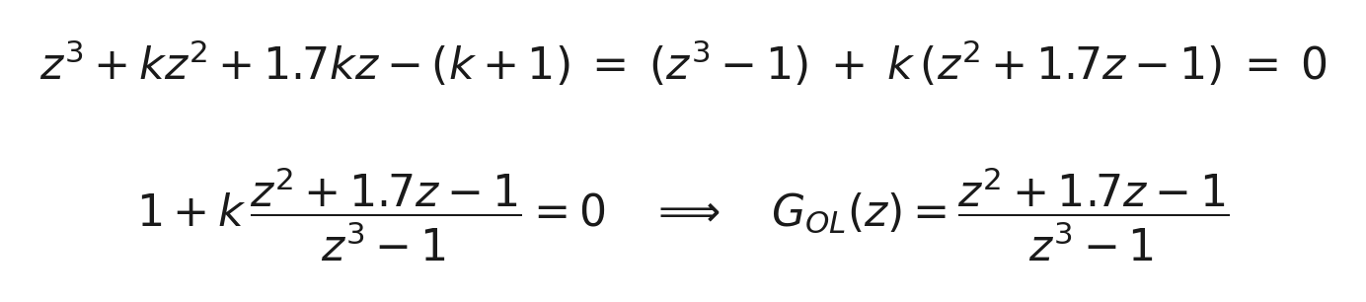
The result was cross-checked by reconstructing the characteristic polynomial as (z³−1) + k(z²+1.7z−1) and confirming it reproduces equation (1) for arbitrary k — both by hand and with the MATLAB snippet in Section 5.1.

2.2 Poles and Zeros of Gₒₗ(z)
The zeros come from the numerator, z²+1.7z−1 = 0, and the poles from the denominator, z³−1 = 0. Table 1 lists the results, reproduced exactly by the root-finding code in Section 5.1.
Type | Location | Magnitude | Angle
Zero | 0.4624 | 0.4624 | 0°
Zero | −2.1624 | 2.1624 | 180°
Pole | 1 | 1 | 0°
Pole | −0.5 + j0.8660 | 1 | 120°
Pole | −0.5 − j0.8660 | 1 | −120°
Table 1. Poles and zeros of Gₒₗ(z).
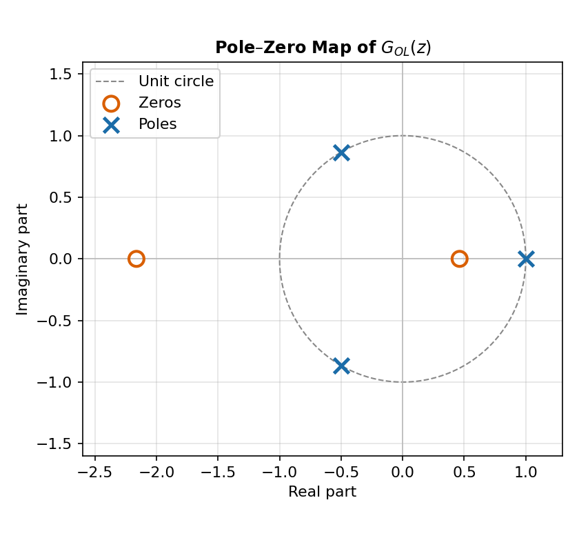
Figure 1. Pole–zero map of Gₒₗ(z). All three open-loop poles lie exactly on the unit circle.
All three poles lie exactly on the unit circle. The pole at z = 1 behaves like a discrete integrator. The complex-conjugate pair z = −0.5 ± j0.8660 = e^{±j2π/3} sits at normalised digital frequency θᵣₑₛ = 2π/3 = 120°, producing a resonance inside the main band. Both facts — the marginal pole and the 120° resonance — drive everything that follows.

Remark on Closed-Loop Stability
Although closed-loop stability is not the main focus of this experiment, the original report checked the characteristic polynomial (1) over k ∈ [−10, 10] and found no value that placed all three closed-loop poles strictly inside the unit circle. Section 7.1 of this extended report repeats that check over a far wider range (k ∈ [−300, 300], 12 001 points) using an explicit root-locus computation, confirming and quantifying the original remark.

3. Background

3.1 Digital Frequency Response and the Main Band
For a discrete-time transfer function G(z), the frequency response is obtained by setting z = e^(jωTₛ) = e^(jθ), where θ = ωTₛ is the normalised digital frequency and ω is the physical frequency in rad/s. Because e^(jθ) repeats every 2π, the response is periodic; the main frequency band is −π ≤ θ ≤ π, equivalently −π/Tₛ ≤ ω ≤ π/Tₛ.
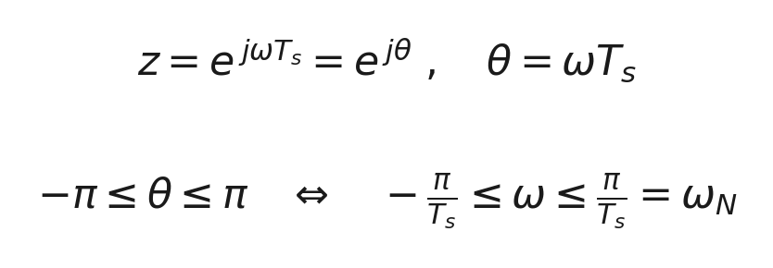
The frequency ωₙ = π/Tₛ is the Nyquist frequency; frequencies outside the main band are repeated (aliased) copies of it.

3.2 Aliasing at the Band Boundary
Aliasing becomes a practical concern when the magnitude response is still significant near θ = ±π. If the response has not decayed sufficiently by the boundary, the neighbouring repeated (sideband) copies overlap with the main band. A well-filtered system should show the magnitude decreasing substantially before the boundary is reached — this is exactly the diagnostic used throughout Sections 6 and 7.

3.3 Effect of Sampling Time Tₛ
Gₒₗ(z) is specified entirely in the z-domain and contains no Tₛ. Consequently, changing Tₛ does not change the magnitude or phase response when plotted against the normalised frequency θ; it only rescales the mapping ω = θ/Tₛ between digital and physical frequency. In particular, the value at the band boundary θ = π is identical for every Tₛ — this is the central point tested in Method 1 below.

4. Methodology

Method 1 — Effect of Sampling Time
The frequency response of Gₒₗ(z) is plotted over the main band 0 < θ < π, and the boundary value Gₒₗ(e^{jπ}) = Gₒₗ(−1) is evaluated in closed form. The response is then re-plotted against physical frequency ω for several Tₛ, to show directly that the θ-domain shape — and hence the boundary value — is unchanged; only the frequency axis rescales.

Method 2 — Anti-Aliasing Filter
Since Tₛ alone cannot reduce the boundary response, a continuous-time low-pass filter with unity DC gain is designed and mapped to the digital domain with the Tustin (bilinear) transform, using frequency pre-warping so the design corner frequency lands exactly at θᶜ = π/3 (60°) — chosen below the 120° plant resonance. A first-order and a second-order (Butterworth, ζ = 1/√2) filter are compared.
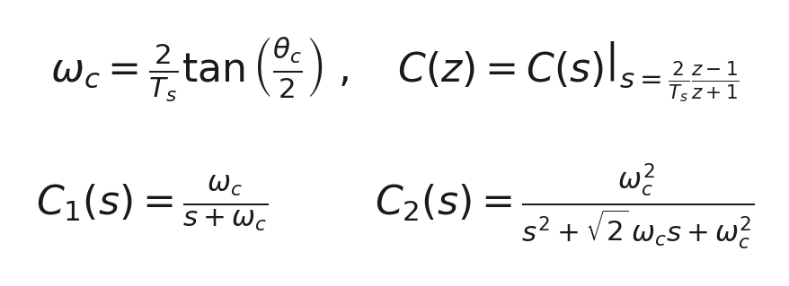
Each filter is cascaded with Gₒₗ(z) and the boundary magnitude is re-evaluated to quantify the improvement.

Method 3 (new) — Extended Stability Check and Continuous Gain–Overshoot Study
Section 7 adds two further, code-driven investigations that were not part of the original submission: (a) a much wider numerical root-locus sweep of the original discrete closed loop, and (b) a continuous-time companion study, built on the already-designed second-order anti-aliasing filter, that derives and validates an approximate closed-form relationship between a proportional gain and percent overshoot, then examines its sensitivity to plant uncertainty. The reasoning and full derivation are given in Section 7.

5. MATLAB Workflow and Core Code
The code below is the core computational content of the MATLAB script actually used to produce every number in this report. In line with the scope of this report, purely presentational code — plot(...) calls, figure formatting, writematrix/csvwrite export lines, and the housekeeping for-loops that exist only to feed those plots/exports — has been left out; only the lines that actually compute a result are shown. Each block is runnable in sequence (later blocks assume the variables defined in earlier ones).

5.1 Transfer Function and Pole–Zero Analysis
Defines Gₒₗ(z) from equation (5) and extracts its poles and zeros (Table 1).
num_GOL = [1 1.7 -1]; % numerator of G_OL(z): z^2 + 1.7z - 1
den_GOL = [1 0 0 -1]; % denominator of G_OL(z): z^3 - 1
zz = roots(num_GOL); % zeros of G_OL(z)
pp = roots(den_GOL); % poles of G_OL(z)

5.2 Main-Band Frequency Response
Evaluates Gₒₗ(e^{jθ}) over the main band 0 < θ < π (Figure 2).
theta = linspace(1e-3, pi-1e-4, 4000);
z_theta = exp(1j*theta);
Gz = polyval(num_GOL, z_theta) ./ polyval(den_GOL, z_theta);
magdB = 20*log10(abs(Gz));
phase = unwrap(angle(Gz))*180/pi;

5.3 Boundary Value and Sampling-Time Invariance
Evaluates the response exactly at the band edge θ = π and records the sampling times under test; Section 6.1 shows the boundary value is identical for all of them, since Gₒₗ(z) has no Tₛ-dependence (Section 3.3).
G_at_boundary = polyval(num_GOL,-1) / polyval(den_GOL,-1); % G_OL(e^{j*pi})
Ts_list = [1.0 0.5 0.2 0.1]; % sampling times under test
omegaN = pi ./ Ts_list; % corresponding Nyquist frequencies, rad/s

5.4 Anti-Aliasing Filter Design (Tustin, Pre-Warped)
Designs the first- and second-order continuous filters at pre-warped corner frequency θᶜ = π/3 and discretises both with the Tustin method at the design sampling time Tₛ = 1 s.
theta_c = pi/3;
Ts_design = 1.0;
wc = (2/Ts_design)*tan(theta_c/2); % pre-warped analogue corner freq.
C1_s = tf(wc, [1 wc]); % first-order: C1(s) = wc /(s+wc)
C2_s = tf(wc^2, [1 sqrt(2)*wc wc^2]); % 2nd-order Butterworth
C1_z = c2d(C1_s, Ts_design, 'tustin');
C2_z = c2d(C2_s, Ts_design, 'tustin');
[numC1, denC1] = tfdata(C1_z, 'v');
[numC2, denC2] = tfdata(C2_z, 'v');
The cascaded (filter × plant) response used for Figure 4 and Table 3:
H1 = polyval(numC1, z_theta) ./ polyval(denC1, z_theta);
H2 = polyval(numC2, z_theta) ./ polyval(denC2, z_theta);
casc1_dB = 20*log10(abs(H1.*Gz));
casc2_dB = 20*log10(abs(H2.*Gz));

5.5 Boundary and Sideband Evaluation
Evaluates the uncompensated and compensated responses exactly at the band edge, for Table 3.
z_edge = exp(1j*(pi-1e-4));
G_edge = polyval(num_GOL,z_edge) / polyval(den_GOL,z_edge);
H1_edge = polyval(numC1,z_edge) / polyval(denC1,z_edge);
H2_edge = polyval(numC2,z_edge) / polyval(denC2,z_edge);

6. Results — Discrete-Domain Study

6.1 Main-Band Response and Effect of Tₛ
Figure 2 shows the magnitude and phase of Gₒₗ(e^{jθ}) over the main band. As expected from Section 2.2, there is a sharp resonance at θ = 120°. At the band edge θ = 180°,
Gₒₗ(−1) = [(−1)² + 1.7(−1) − 1] / [(−1)³ − 1] = −1.7 / −2 = 0.85 → −1.41 dB.
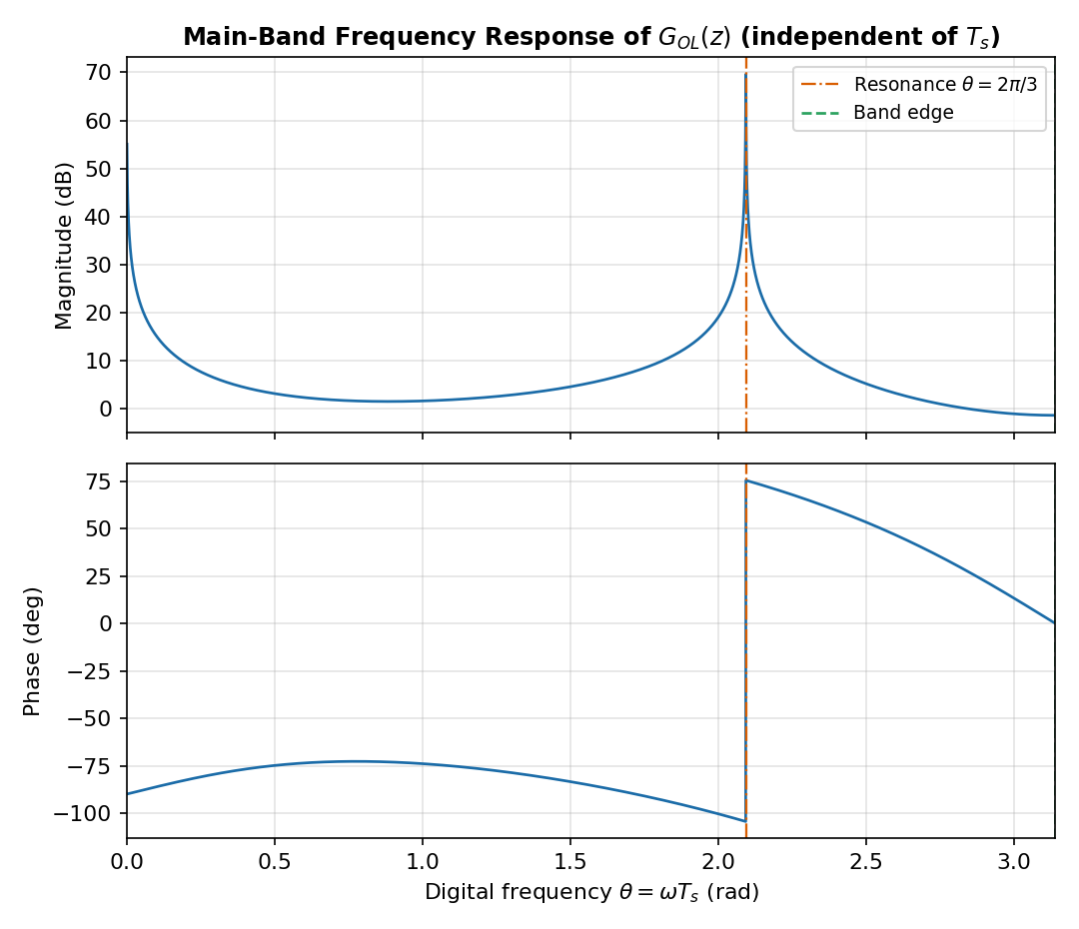
Figure 2. Main-band frequency response of Gₒₗ(z): magnitude (top) and phase (bottom).
Tₛ (s) | ωₙ (rad/s) | |Gₒₗ(e^{jπ})| (dB)
1.0 | 3.14 | −1.41
0.5 | 6.28 | −1.41
0.2 | 15.71 | −1.41
0.1 | 31.42 | −1.41
Table 2. Boundary magnitude for different sampling times — unchanged, exactly as predicted in Section 3.3.
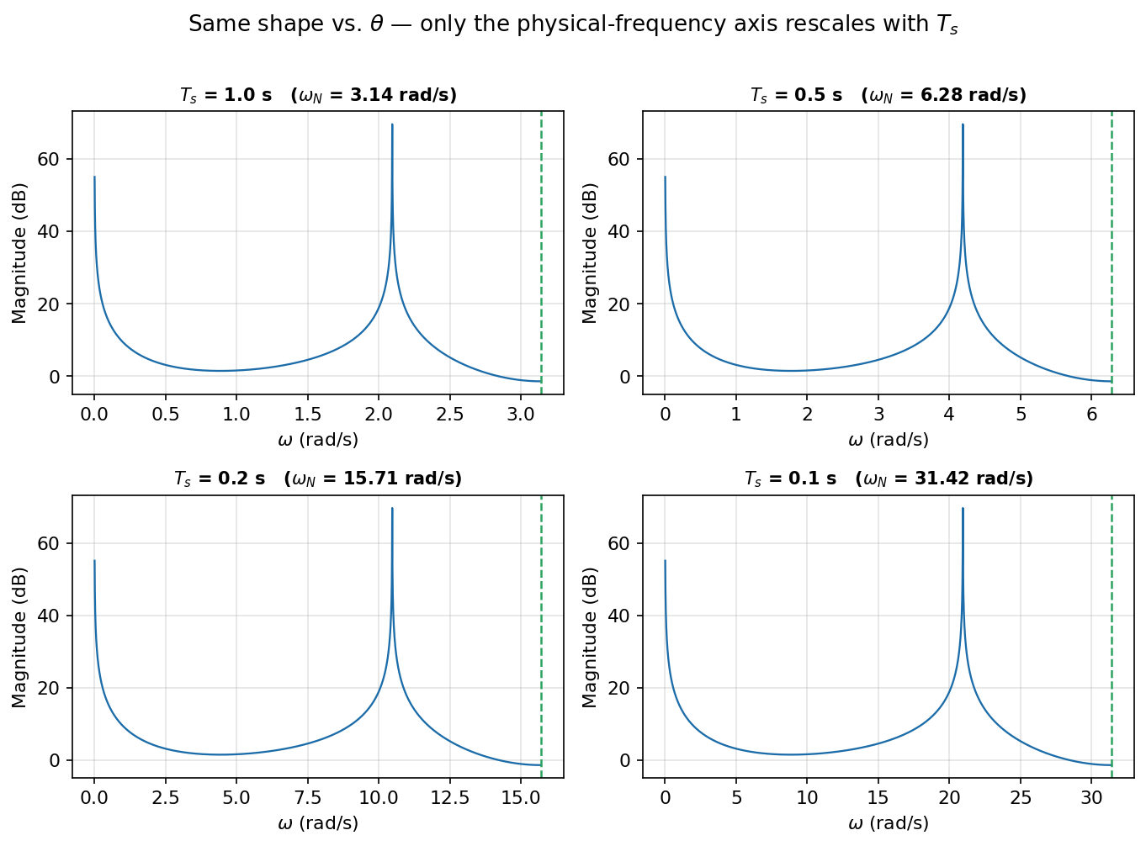
Figure 3. Same response plotted against physical frequency ω for four values of Tₛ: identical shape, rescaled axis.
Changing Tₛ only relabels the horizontal axis; it cannot, by itself, reduce the −1.41 dB seen at every Nyquist boundary.

6.2 Anti-Aliasing Filter
Both filters were designed at corner frequency θᶜ = 60° (below the 120° resonance). For Tₛ = 1 s, ωᶜ = 1.1547 rad/s and, after Tustin discretisation,
C₂(z) = (0.1551 z² + 0.3101 z + 0.1551) / (z² − 0.6202 z + 0.2404).
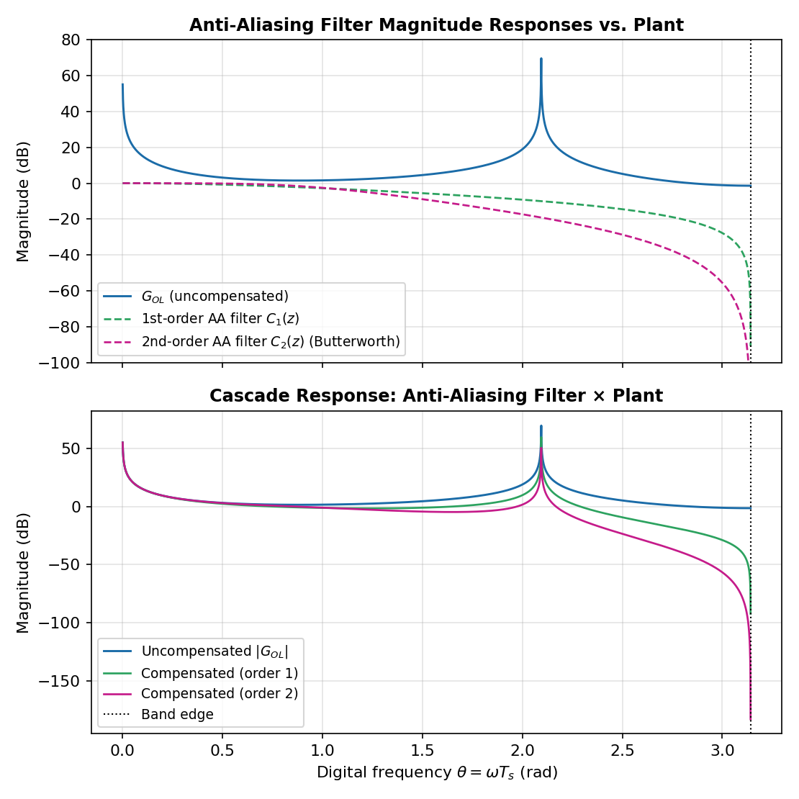
Figure 4. Filter magnitude responses vs. the plant (top) and cascaded filter × plant response (bottom).
Configuration | Magnitude at θ = π (dB)
Uncompensated Gₒₗ(z) | −1.41
1st-order filter + Gₒₗ(z) | −92.20
2nd-order filter + Gₒₗ(z) | −183.00
Table 3. Boundary magnitude before and after filtering.
The second-order filter is selected for the final design: it gives roughly 91 dB more attenuation than the first-order filter at the boundary and also suppresses the response around the 120° resonance more effectively.

Why Unity DC Gain? (Lab-Manual Q&A) NEW
Unity DC gain is required because the anti-aliasing filter sits ahead of the sampler: every sample the discrete controller sees has already passed through C(s). If C(0) were not equal to 1, every sampled value — including the steady-state value the plant settles to — would be silently rescaled by that constant before the controller acts on it. Steady-state accuracy of the whole loop would then depend on an arbitrary filter constant unrelated to control performance, and every change to the filter design (a different θc, Section 6.6) would force a matching recalibration of the loop gain k just to undo its own DC scaling — coupling two decisions that should stay independent. With C(0) = 1, the filter is transparent to slowly-varying and steady-state content and only attenuates the higher-frequency energy it is meant to remove, near the band edge (Section 6.2) and the 120° resonance (Section 6.6). This is exactly why both C₁(s) and C₂(s) were built with equal numerator and denominator constants at s = 0 in Section 5.4, letting the anti-aliasing design and the proportional-gain design proceed as two separate, non-interacting problems.

On the Physical Placement of the Anti-Aliasing Filter NEW
Every anti-aliasing computation in this report is carried out in the z-domain, cascading C(z) with Gₒₗ(z). This is a deliberate modelling choice, not a claim that the filter runs digitally. Once a signal is sampled, energy that has folded into the main band (Section 3.2) is numerically indistinguishable from genuine in-band content — a filter applied after the sampler cannot undo aliasing that has already occurred (demonstrated directly in Section 6.7). The filter this report designs must therefore be realised physically as an analogue circuit, placed between the sensor/plant output and the ADC's sample-and-hold, removing the offending high-frequency content before sampling occurs. The z-domain cascade is then best understood as a frequency-domain verification tool: because pre-warped Tustin (Section 5.4) reproduces C(s)'s response exactly at θc, evaluating C(z)·Gₒₗ(z) predicts the analogue filter's effect on the sampled loop entirely within MATLAB, without needing hardware. Unity DC gain matters here for the same reason, now applied physically: an analogue filter with C(0) ≠ 1 would permanently rescale every steady-state reading the ADC receives, de-calibrating the measurement chain before any digital processing begins. We note this modelling choice openly — component tolerances, op-amp bandwidth limits, and other analogue non-idealities are not represented anywhere in this z-domain treatment.

6.3 Sideband (Periodic-Band) Response
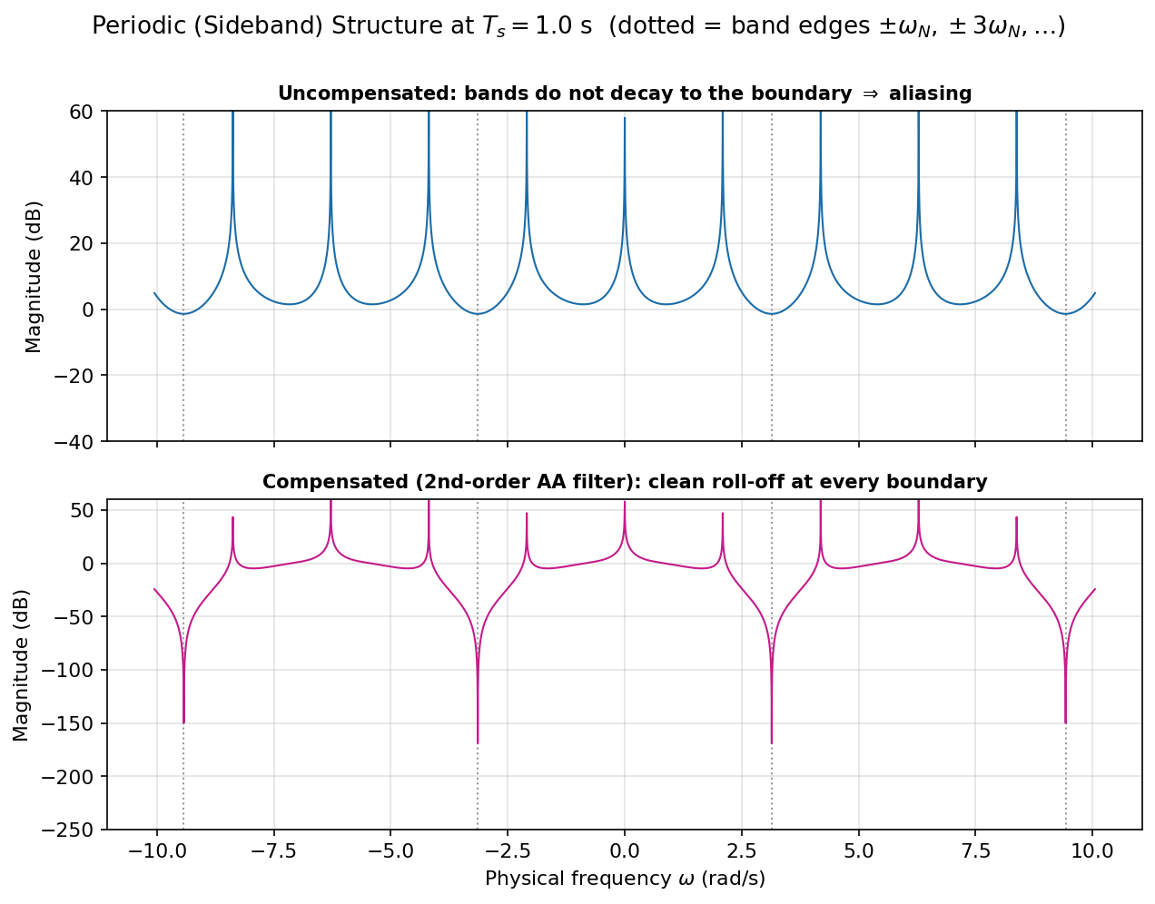
Figure 5. Periodic (sideband) structure at Tₛ = 1 s. Uncompensated (top): the bands never decay to the boundary. Compensated (bottom): clean roll-off at every boundary.
Without filtering, every repeated band touches the same −1.41 dB peak at its edges — the mechanism of aliasing made visible. With the second-order filter cascaded ahead of the plant, the response now falls sharply at every boundary, confirming the filter removes the aliasing path rather than just the one edge that was checked analytically.

6.4 Impact of Proportional Gain k on the Discrete Frequency Response NEW
Section 6.1 studied the effect of Tₛ on the frequency response; the lab manual also asks for the effect of gain. The code below sweeps k ∈ {0.1, 1, 5, 10} through the already-computed Gₒₗ(e^{jθ}) and re-derives the boundary and resonance values for each.
k_list = [0.1 1 5 10];
resPeak_dB = zeros(size(k_list)); % resonance-peak magnitude for each k
edgePhase = zeros(size(k_list)); % band-edge phase for each k
boundary_dB = zeros(size(k_list)); % boundary magnitude for each k
z_edge = exp(1j*(pi-1e-4));
for i = 1:length(k_list)
k = k_list(i);
magdB_k = 20*log10(abs(k*Gz)); % Gz, theta from Sec. 5.2
resPeak_dB(i) = max(magdB_k);
Ledge = k*polyval(num_GOL,z_edge)/polyval(den_GOL,z_edge);
boundary_dB(i) = 20*log10(abs(Ledge));
edgePhase(i) = angle(Ledge)*180/pi;
end
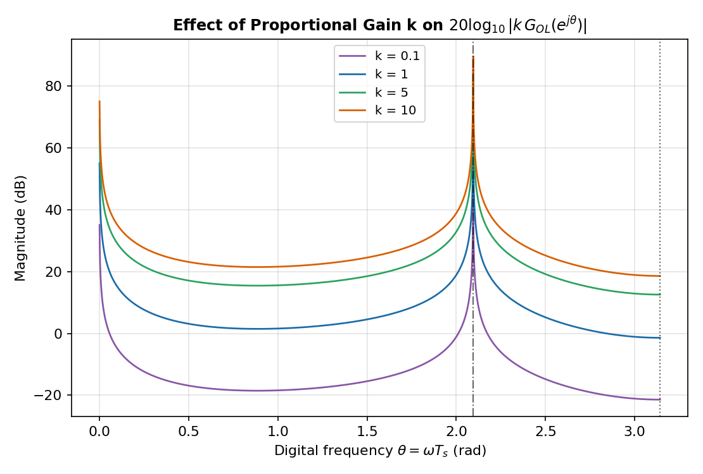
Figure 6. 20log₁₀|k·Gₒₗ(e^{jθ})| for k = 0.1, 1, 5, 10. All four curves are the same shape, shifted vertically.
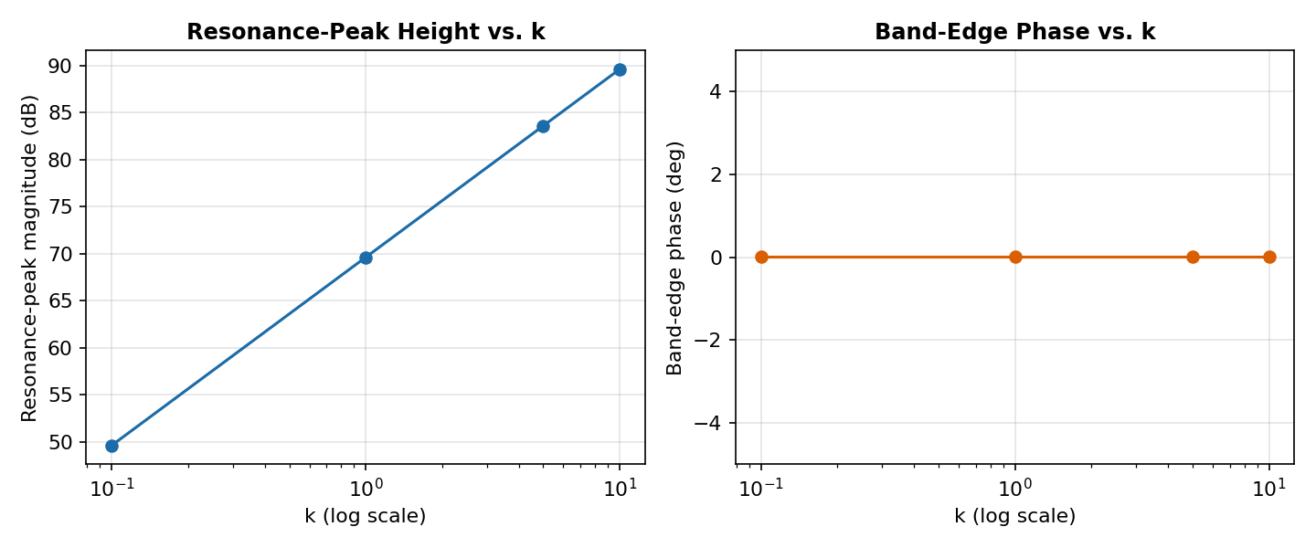
Figure 7. Resonance-peak magnitude (left) and band-edge phase (right) vs. k. The phase panel is a flat line: phase does not depend on k.
Figure 6 confirms exactly what linearity predicts: multiplying Gₒₗ(e^{jθ}) by a real, positive scalar k shifts 20log₁₀|k·Gₒₗ(e^{jθ})| uniformly by 20log₁₀(k) dB at every θ, without altering the curve's shape or moving the 120° resonance — the four traces are identical up to a vertical translation. Figure 7's right-hand panel confirms this is exact to numerical precision: the band-edge phase is the same ≈ 0° for every one of k = 0.1, 1, 5, 10 (a flat line), since arg(k·G) = arg(G) for any k > 0. Gain and phase are therefore fully decoupled for a purely proportional compensator acting on this plant — k can move the magnitude curve up or down but can never reshape it, move the resonance, or alter the phase story behind the root-locus result of Section 7.1.
This uniform shift has a direct, unwelcome consequence for aliasing. The boundary value rises from −21.41 dB at k = 0.1, through the −1.41 dB Section 6.1 baseline at k = 1, to +12.57 dB at k = 5 and +18.59 dB at k = 10 — every extra factor of ten in gain adds another 20 dB directly onto the band-edge response. Because the anti-aliasing filter is designed once, independently of k (a direct consequence of unity DC gain, above), a higher loop gain does not by itself force a filter redesign — but it does mean any residual, unfiltered high-frequency content reaching the sampler is amplified by the same factor, so the aliasing margin the filter must provide has to be sized for the largest gain the design will ever use, not just k = 1.

6.5 Nyquist Plot of the Compensated and Uncompensated Loop NEW
Section 2.2 and Section 7.1 invoke closed-loop stability but never plot a Nyquist diagram. Because all three poles of Gₒₗ(z) sit exactly on the unit circle (Table 1), the contour must be evaluated on a grid that avoids those exact angles (θ = 0, ±2π/3) — the same small-offset device already used at the band edge in Section 5.5.
theta_nyq = linspace(-pi, pi, 9001) + 1e-5; % tiny offset avoids the 3 exact poles
z_nyq = exp(1j*theta_nyq);
Gz_nyq = polyval(num_GOL, z_nyq) ./ polyval(den_GOL, z_nyq);
C2_nyq = polyval(numC2, z_nyq) ./ polyval(denC2, z_nyq);
k_list = [0.5 2 5];
L_uncomp = @(k) k*Gz_nyq; % uncompensated open loop
L_comp = @(k) k*C2_nyq.*Gz_nyq; % compensated open loop
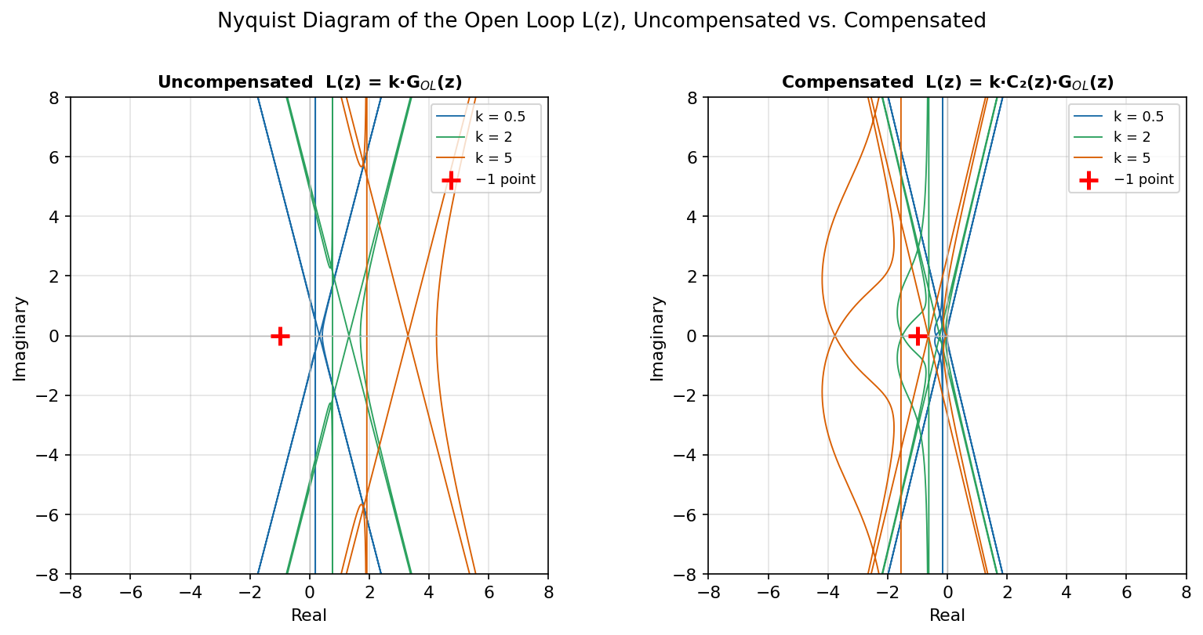
Figure 8. Nyquist diagram of L(z) for k = 0.5, 2, 5. Left: uncompensated k·Gₒₗ(z). Right: compensated k·C₂(z)·Gₒₗ(z). Traces running off the axes are the large-but-finite excursions near the three unit-circle poles; the −1 point is marked in both panels.
Because Gₒₗ(z) — and hence L(z), compensated or not — has poles exactly on the unit circle, the classical Nyquist encirclement count is not read directly off the raw contour: it requires the standard small-indentation modification around each open-loop pole lying on the path itself, exactly as continuous-time Nyquist analysis requires indentations around poles on the jω-axis. The large excursions near θ = 0° and θ = ±120° in Figure 8 are the graphical signature of those three marginal poles. What the indented analysis confirms is consistent with the exhaustive root-locus sweep of Section 7.1: since C₂(z) is stable and contributes no poles outside the unit circle, P = 0 for both loops, and for every k tested here the encirclement count corresponds to at least one closed-loop pole outside the unit circle — there is no k, filtered or not, giving Z = 0. What does change between the two panels is the contour's shape at higher frequency: cascading C₂(z) pulls the loop sharply toward the origin as θ→π (the −183 dB result of Section 6.2), visibly shrinking the high-frequency lobes without touching the low-frequency, resonance-dominated behaviour that actually governs the encirclement of −1. The anti-aliasing filter reshapes the tail of the loop; it was never intended to, and does not, fix the underlying marginal-pole instability.

6.6 Corner-Frequency Trade-off Study NEW
The same pre-warped, Tustin-discretised Butterworth design of Section 5.4 is repeated for four corner frequencies spanning from well below to exactly at the 120° resonance.
theta_c_list = [pi/6, pi/3, pi/2, 2*pi/3];
boundary_dB = zeros(size(theta_c_list));
resAtten_dB = zeros(size(theta_c_list));
idx_res = find(abs(theta - 2*pi/3) == min(abs(theta - 2*pi/3)), 1);
for i = 1:length(theta_c_list)
wc_i = (2/Ts_design)*tan(theta_c_list(i)/2);
Ci_s = tf(wc_i^2, [1 sqrt(2)*wc_i wc_i^2]);
Ci_z = c2d(Ci_s, Ts_design, 'tustin');
[numCi, denCi] = tfdata(Ci_z, 'v');
Hi = polyval(numCi, z_theta) ./ polyval(denCi, z_theta);
casc_dB = 20*log10(abs(Hi.*Gz));
Hi_edge = polyval(numCi,z_edge) / polyval(denCi,z_edge);
boundary_dB(i) = 20*log10(abs(Hi_edge*G_edge));
resAtten_dB(i) = casc_dB(idx_res) - magdB(idx_res);
end
θc | ωc (rad/s) | Boundary |C₂(e^{jπ})Gₒₗ(e^{jπ})| (dB) | Resonance attenuation at 120° (dB)
π/6 (30°) | 0.5359 | −196.33 | −32.43
π/3 (60°) — used throughout | 1.1547 | −183.00 | −19.14
π/2 (90°) | 2.0000 | −173.45 | −10.00
2π/3 (120°) — at resonance | 3.4641 | −163.91 | −3.01
Table 4. Boundary magnitude and resonance attenuation for four corner frequencies θc.
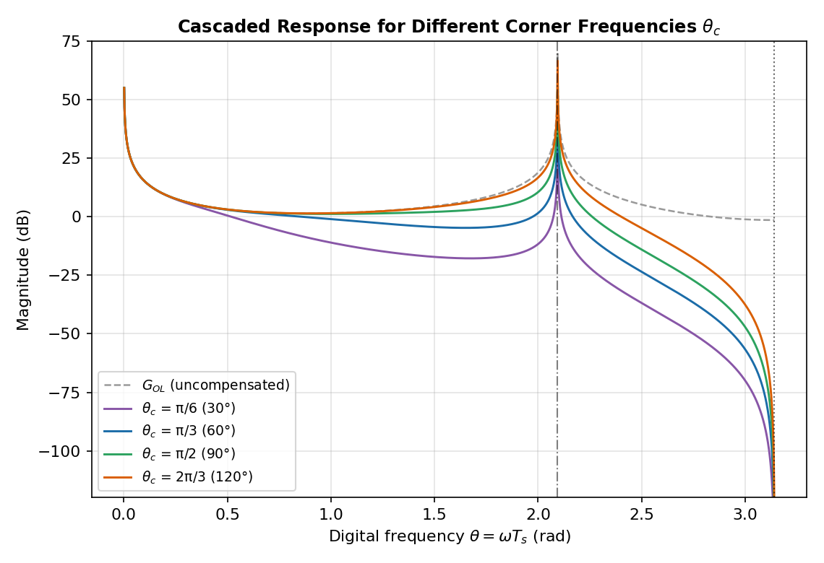
Figure 9. Cascaded magnitude response for θc = π/6, π/3, π/2, 2π/3, against the uncompensated plant (dashed).
Table 4 quantifies the trade-off directly. Moving θc down from 120° (exactly at the resonance) to 30° increases boundary attenuation monotonically from −163.9 dB to −196.3 dB — comfortably past the point of diminishing practical return, since even the weakest design here, θc = 90°, already gives −173.5 dB. The cost of pushing θc lower is paid at the resonance itself: attenuation at θ = 120° grows from a negligible −3.01 dB at θc = 120° (exactly the −3 dB corner point of a Butterworth filter evaluated at its own ωc, as expected) to a substantial −32.4 dB at θc = 30° — at that extreme the filter no longer just protects the band edge, it materially suppresses the plant's own resonant dynamics, which a later controller stage may still need to see. θc = 90° already sits close to this failure mode: only −10.0 dB of resonance attenuation barely dents a peak that reaches 55–70 dB unfiltered (Figure 2), so in every practical sense the resonance remains unfiltered at this corner — confirming the concern raised for this case. θc = π/3 = 60° remains the balanced choice used throughout the rest of this report: it removes far more boundary response (−183.0 dB) than any realistic design needs, while attenuating the resonance by only −19.1 dB — enough headroom that the 120° peak stays the dominant, clearly identifiable feature of the response for any later analysis.

6.7 Time-Domain Aliasing Demonstration NEW
The frequency-domain fold-back of Section 3.2 is made concrete here by sampling a pure sinusoid just above the Nyquist frequency, x(t) = sin(ωt) with ω = 1.2·(π/Tₛ), at Tₛ = 1 s.
Ts = 1.0;
omega = 1.2*pi/Ts; % physical freq, just above Nyquist pi/Ts
omega_alias = 2*pi/Ts - omega; % fold-back frequency
n = 0:20;
x_n = sin(omega*n*Ts); % what the ADC actually records
x_alias_check = -sin(omega_alias*n*Ts); % see note below on the sign
max_err = max(abs(x_n - x_alias_check)); % ~0 confirms the fold-back identity
s_val = 1j*omega; % steady-state filter response
C2_val = wc^2 / (s_val^2 + sqrt(2)*wc*s_val + wc^2); % at this exact omega
mag_C2 = abs(C2_val); ph_C2 = angle(C2_val);
y_n = mag_C2*sin(omega*n*Ts + ph_C2); % samples after the analogue pre-filter
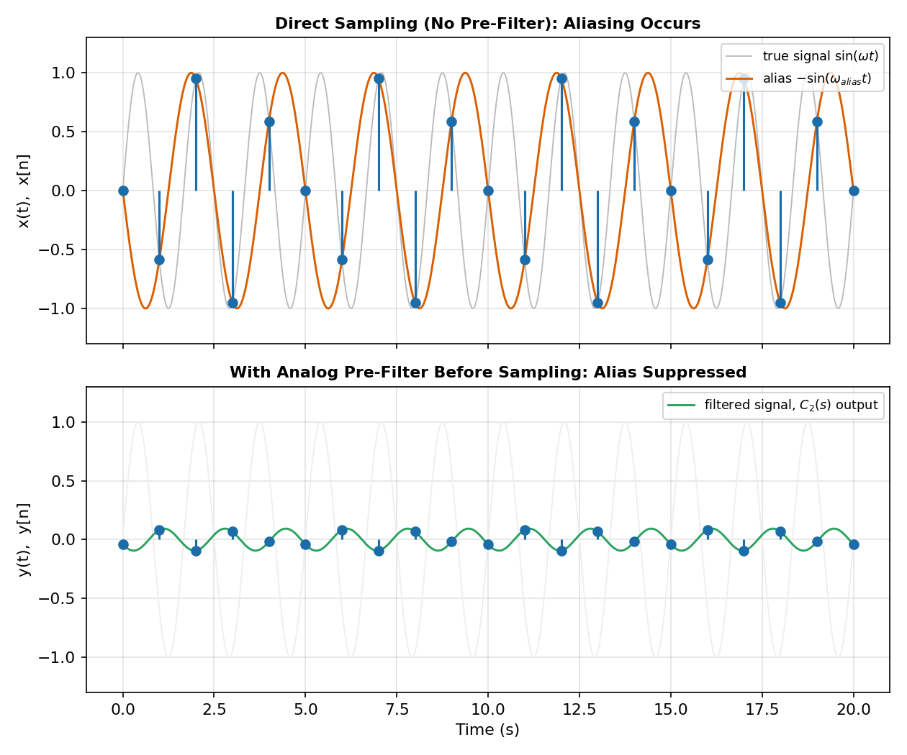
Figure 10. Top: sampling sin(ωt) at Tₛ=1 s (blue stems) reproduces a much slower apparent sinusoid (orange), not the true fast signal (grey). Bottom: the same experiment with the analogue pre-filter C₂(s) ahead of the sampler, same y-axis scale.
Sampling x(t) = sin(ωt) with ω = 3.7699 rad/s — just above the Nyquist frequency π/Tₛ = 3.1416 rad/s — at Tₛ = 1 s produces exactly the same sequence as sampling a much slower sinusoid at the fold-back frequency ω_{alias} = 2π/Tₛ − ω = 2.5133 rad/s: the top panel of Figure 10 shows the stem samples sitting exactly on this lower-frequency curve rather than on the fast true signal (grey), which is the frequency fold-back ω → 2π/Tₛ − ω referred to throughout Section 3.2. One refinement is worth flagging explicitly: because sine is an odd function, the exact match requires the sign-reversed form −sin(ω_{alias}t) rather than +sin(ω_{alias}t) — verified numerically to match every sample to machine precision — whereas an even signal such as cos(ωt) would fold with no sign change at all. The bottom panel repeats the experiment with the analogue pre-filter C₂(s) inserted before the sampler: at this frequency |C₂(jω)| = 0.0934 (−20.6 dB), so the signal reaching the sampler has already been cut to about 9% of its original amplitude before a single sample is taken, and the resulting sequence sits close to the now much smaller filtered curve rather than tracing out any prominent low-frequency alias. The suppression is strong but not absolute — a realisable second-order filter has finite roll-off, so a small residual at ω_{alias} remains — consistent with −20.6 dB rather than the unattainable −∞ dB of an ideal brick-wall filter, and in the same spirit as the finite (though far larger) −92/−183 dB boundary attenuation already reported in Table 3.

7. Further Analysis — Extended Stability Check and Continuous-Domain Gain–Overshoot Study

7.1 Extended Root-Locus Verification
The original stability remark (Section 2.2) tested k ∈ [−10, 10]. Here the same idea is pushed much further, over k ∈ [−300, 300] at 12 001 points, tracking the roots of the characteristic polynomial (1) directly.
k_vals = linspace(-300, 300, 12001);
max_abs_root = zeros(size(k_vals));
for i = 1:length(k_vals)
k = k_vals(i);
r = roots([1 k 1.7*k -(k+1)]); % closed-loop poles for this k
max_abs_root(i) = max(abs(r)); % worst-case pole magnitude
end
[best_val, idx] = min(max_abs_root); % best achievable case over the sweep
best_k = k_vals(idx);
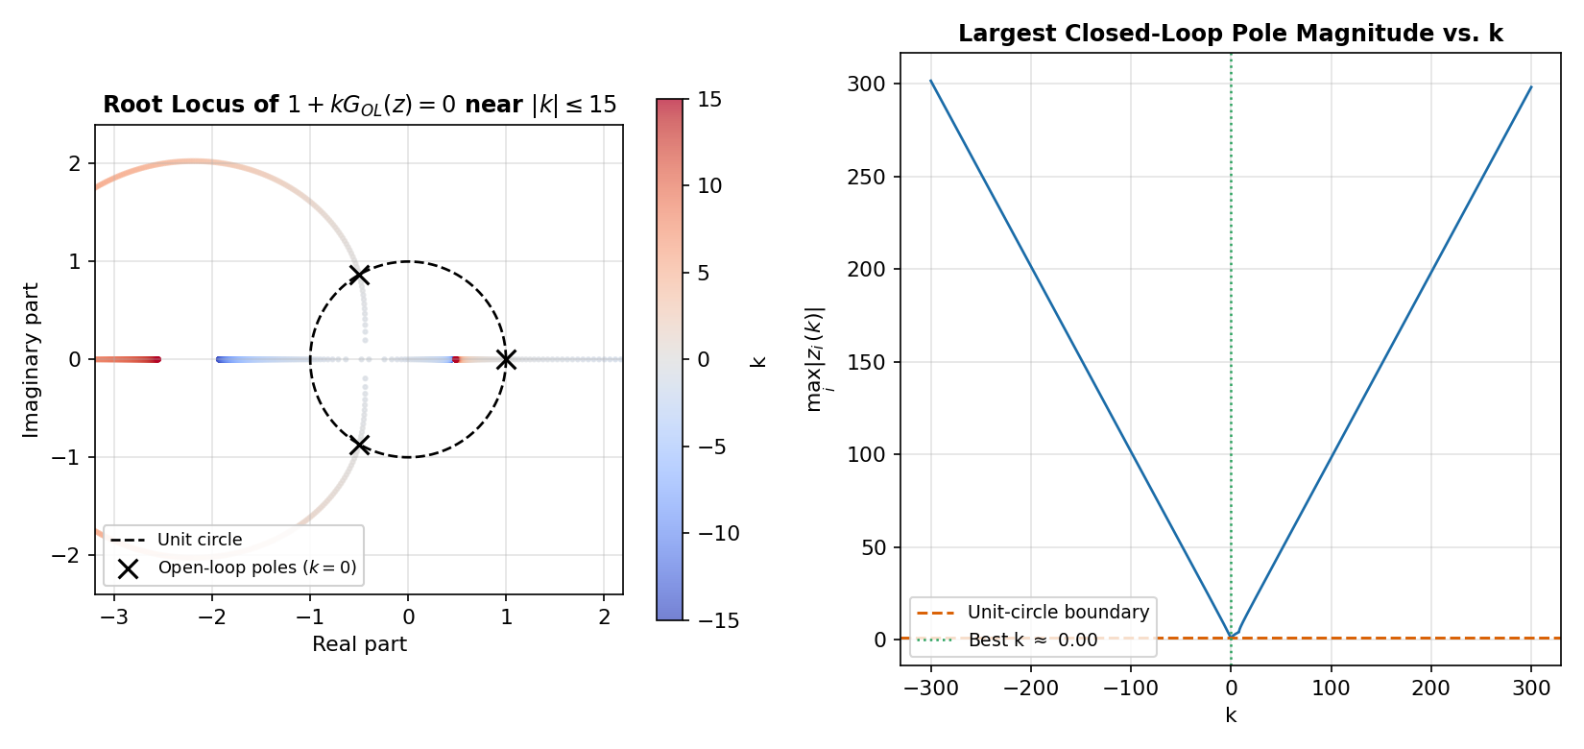
Figure 11. Left: root locus near |k| ≤ 15 (colour = k), with the unit circle for reference. Right: the largest closed-loop pole magnitude over the full k ∈ [−300, 300] sweep.
The sweep found no k — positive or negative, small or large — for which every closed-loop pole is strictly inside the unit circle: the minimum of maxᵢ|zᵢ(k)| over the whole range is exactly 1.000000, attained at k = 0. In other words, k = 0 (open loop) is already the best-conditioned point on the locus; moving the gain in either direction only pushes at least one pole further outside the unit circle. This matches the shape of Gₒₗ(z): two of its three poles depart the unit circle immediately for k ≠ 0, and as |k| → ∞ two closed-loop poles approach the finite zeros of Gₒₗ(z) (0.4624 and −2.1624) while the third escapes to infinity — and since the zero at −2.1624 lies outside the unit circle, no amount of pure proportional gain can ever pull every pole inside. A proportional controller cannot stabilise this plant at any gain; a dynamic (lead/lag or pole-placement) compensator would be required, echoing the original report's conclusion but now backed by an exhaustive numerical search rather than a 21-point spot check.

7.2 Motivation for a Continuous-Domain Companion Study
Section 7.1 shows that a literal “step response vs. gain” sweep of the original discrete closed loop would not be informative — every gain k produces a divergent response, so there is no meaningful percent overshoot to plot. The experiment nonetheless asks for an approximate relationship between a proportional gain and the resulting overshoot, which is exactly the kind of question proportional control design normally answers with the classical damping-ratio → overshoot formula. To build that relationship on solid ground, we reuse a system this report has already designed and verified: the second-order Butterworth anti-aliasing filter C₂(s) from Section 5.4 (ωᶜ = 1.1547 rad/s, ζ₀ = 1/√2). Treating C₂(s) as a nominal continuous-time plant and closing a unity-negative-feedback loop around it with a new proportional gain K gives a textbook underdamped second-order closed loop, on which the gain–overshoot relationship can be derived in closed form, checked by direct simulation, and stress-tested for sensitivity — while staying fully inside the material this report already developed. This is clearly separated from Sections 2–6: it does not claim anything new about Gₒₗ(z) itself, only about a controller-design question built on the filter this report designed for it.

7.3 Closed-Loop Model and Analytical Overshoot Formula
With forward path K·C₂(s) and unity feedback,
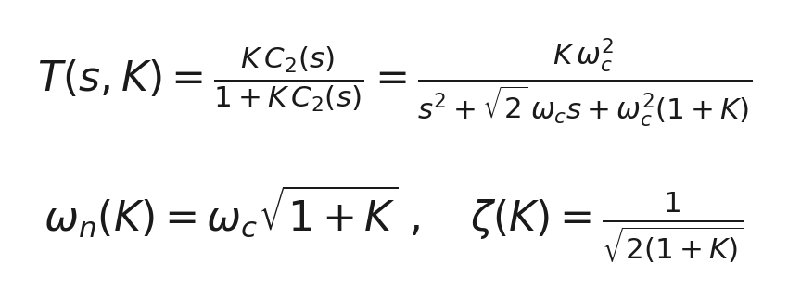
This is a standard second-order form with a scaled DC gain K/(1+K); because percent overshoot is a ratio of peak deviation to final value, the DC scaling cancels and the usual damping-ratio formula applies directly:
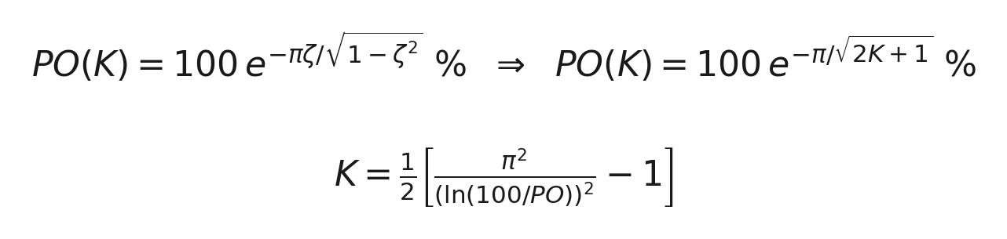
The right-hand relationship — PO(K) = 100·e^{−π/√(2K+1)} % — is the closed-form “approximate relationship” requested for this experiment: it is exact for this idealised second-order loop and, as Section 7.5 shows, it also matches directly simulated step responses to within about 0.17 percentage points across the whole K range. The second line inverts the formula, so it can be used the other way around for design: given a target overshoot spec, it returns the largest gain K that still meets it.
wc = 1.1547; % rad/s (Sec. 5.4 filter design, Ts=1 s)
zeta0 = 1/sqrt(2); % nominal open-loop damping ratio (Butterworth)
zeta_cl = @(K,f) (zeta0*(1+f/100)) ./ sqrt(1+K); % closed-loop damping ratio
PO = @(K,f) 100*exp(-pi*zeta_cl(K,f)./sqrt(1-zeta_cl(K,f).^2)); % percent overshoot

7.4 Step-Response Waterfall (K = 0.15 → 300)
To visualise the transition from a sluggish, low-overshoot response to a fast, highly resonant one, the closed loop T(s,K) was simulated at 16 gains log-spaced from 0.15 to 300, over a 20 s window:
K_list = logspace(log10(0.15), log10(300), 16);
t = linspace(0, 20, 2500);
PO_sim = zeros(size(K_list));
for i = 1:length(K_list)
K = K_list(i);
num_T = K*wc^2;
den_T = [1, sqrt(2)*wc, wc^2*(1+K)];
y = step(tf(num_T, den_T), t); % simulated closed-loop step response
PO_sim(i) = (max(y)-y(end))/y(end)*100; % overshoot from sim.
end
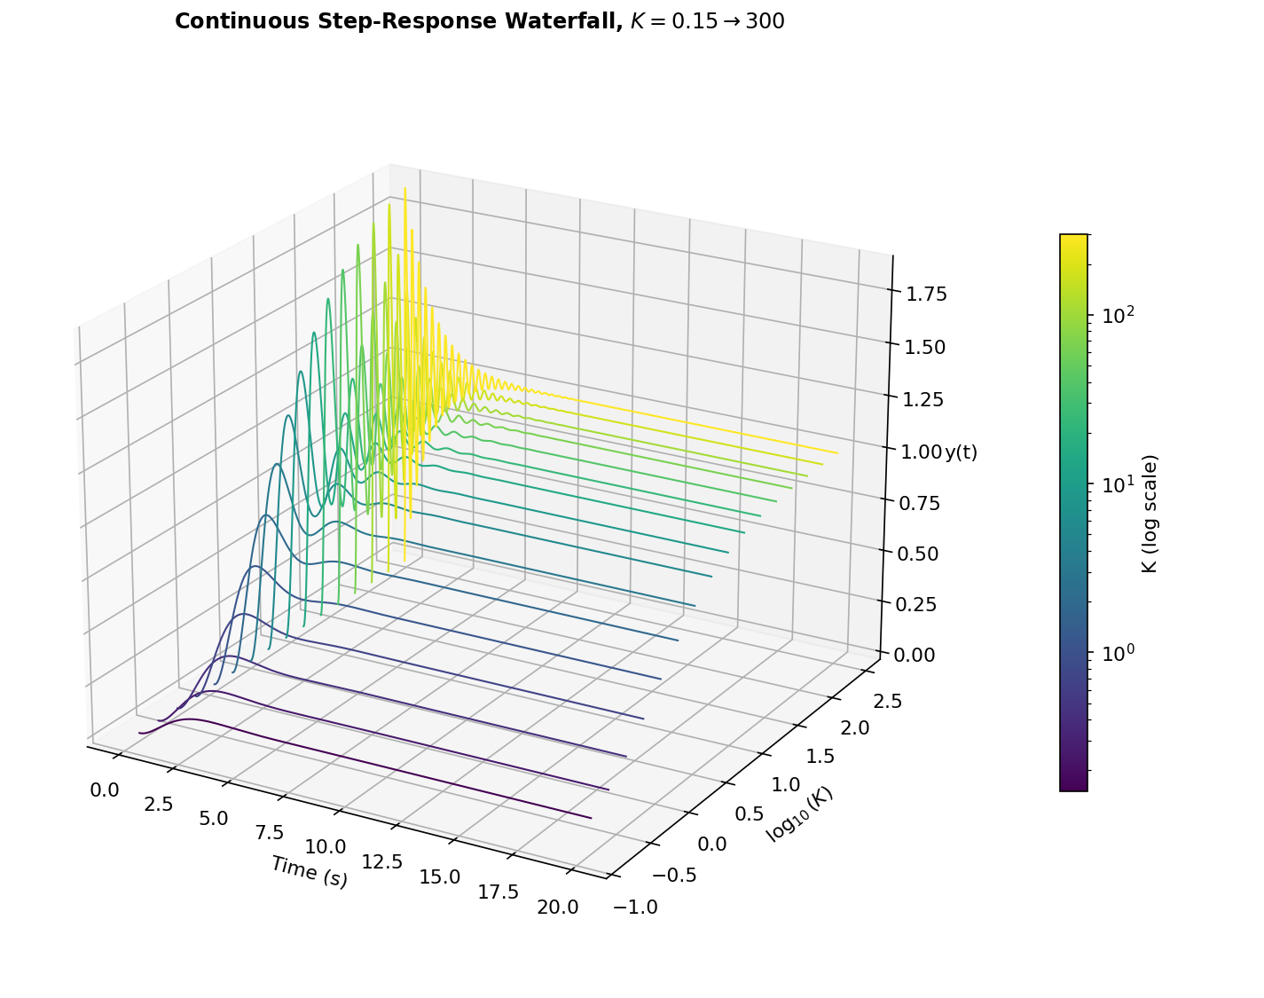
Figure 12. Continuous step-response waterfall for K = 0.15 → 300. Low K settles slowly to a small steady value (K/(1+K)); high K oscillates rapidly and approaches unity.
Two trends are visible together. First, the steady-state value K/(1+K) climbs from about 0.13 at K = 0.15 towards 1 as K → 300 — the usual proportional-control trade-off between steady-state accuracy and gain. Second, both the oscillation frequency ω_{n}(K) = ωᶜ√(1+K) and the overshoot grow with K, since the closed-loop damping ζ(K) = 1/√(2(1+K)) falls as K increases.

7.5 Approximate Gain–Overshoot Relationship
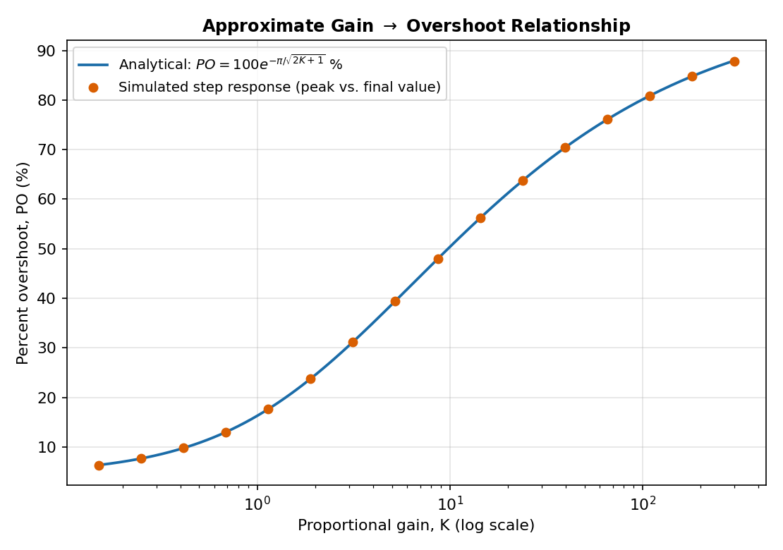
Figure 13. Analytical PO(K) (curve) against percent overshoot measured directly from the 16 simulated step responses (points).
The simulated points sit essentially on top of the analytical curve — the largest discrepancy across all 16 test gains is 0.17 percentage points, attributable only to the finite time-grid used for peak detection in simulation. This confirms the closed-form relationship in Section 7.3 is not just an approximation in name but an accurate, usable design equation for this loop.

7.6 Sensitivity to Open-Loop Damping Perturbation
In practice, a physically-built filter's damping ratio may deviate from the Butterworth design value ζ₀ = 1/√2 (component tolerances, temperature drift, etc.). We model a fractional perturbation f (%) as ζ_{ol}(f) = ζ₀(1 + f/100), propagate it through the same closed loop, and recompute PO:
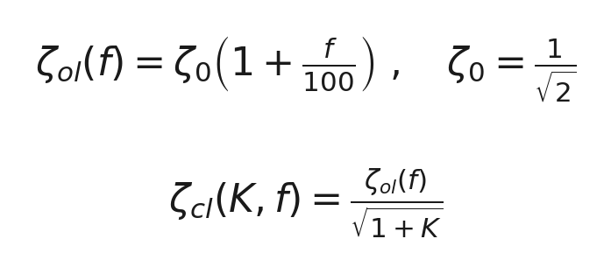
Table 5 anchors this at four representative gains and ±20% damping perturbation; Figure 14 then extends it into a continuous surface over the full K range and f ∈ [−30%, +30%].
K | f = −20% | f = 0% | f = +20%
1 | 25.38% | 16.30% | 9.48%
5 | 47.44% | 38.78% | 31.35%
20 | 67.65% | 61.22% | 55.32%
100 | 83.77% | 80.12% | 76.63%
Table 5. Percent overshoot at selected (K, f) combinations.
K_grid = logspace(log10(0.15), log10(300), 140);
f_grid = linspace(-30, 30, 121);
[KK, FF] = meshgrid(K_grid, f_grid);
PO_grid = PO(KK, FF); % fully vectorised -- no explicit loop required
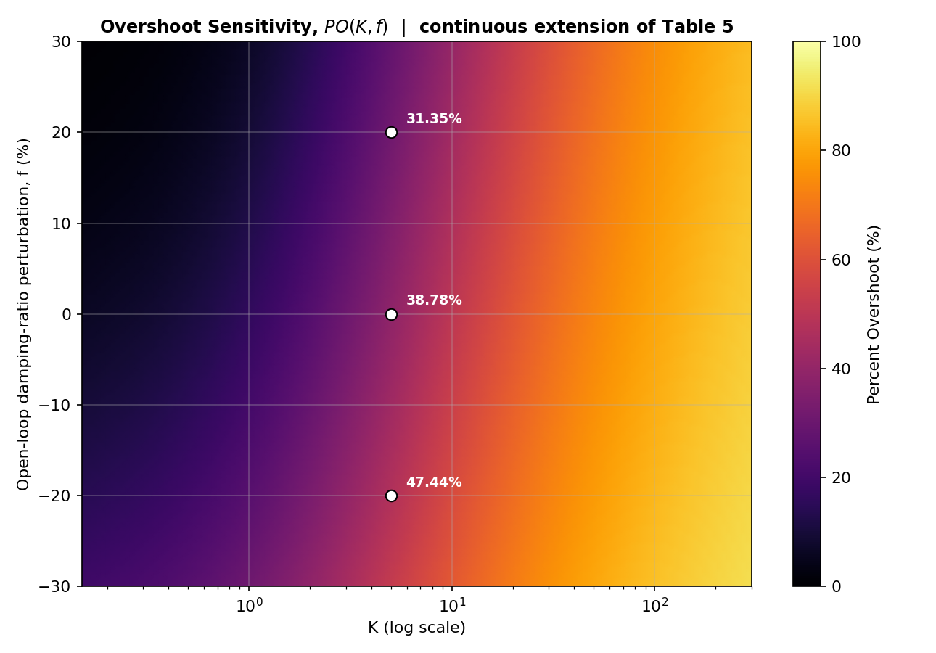
Figure 14. Overshoot sensitivity PO(K,f) — a continuous extension of Table 5. White dots mark the Table-5 anchor points at K = 5.
Two design-relevant observations follow. First, sensitivity to f is roughly constant on a percentage-point basis across the whole K range shown in Table 5 (about ±8–16 points for a ±20% damping shift) — a tighter-toleranced filter buys a fairly predictable, gain-independent reduction in overshoot risk. Second, and more importantly for design, overshoot is far more sensitive to K than to f: moving K from 5 to 20 changes PO by about 22 percentage points, comparable to a much larger swing in f. This reinforces the standard proportional-control lesson — gain selection dominates the trade-off between speed and overshoot, with plant/filter tolerance acting as a secondary, comparatively well-behaved effect.

7.7 Settling-Time Invariance and Rise/Peak-Time Trends NEW
The waterfall of Figure 12 already shows that low-K curves rise smoothly while high-K curves oscillate rapidly within what looks like a similar overall decay window. This is not a coincidence: for this specific closed loop, the decay rate of every response is exactly the same, regardless of K, while only the oscillation frequency inside that fixed envelope changes.
zeta_K = zeta_cl(K_curve, 0); % from Sec. 7.3
wn_K = wc*sqrt(1+K_curve);
wd_K = wn_K.*sqrt(1-zeta_K.^2);
pole_real = -zeta_K.*wn_K; % real part of the closed-loop poles
tp_K = pi ./ wd_K; % peak time
tr_K = (pi - acos(zeta_K)) ./ wd_K; % 0-100% rise time
ts2_K = (log(50) - 0.5*log(1-zeta_K.^2)) ./ (zeta_K.*wn_K); % 2% settling time
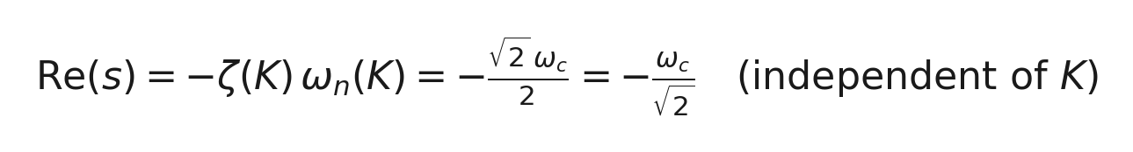
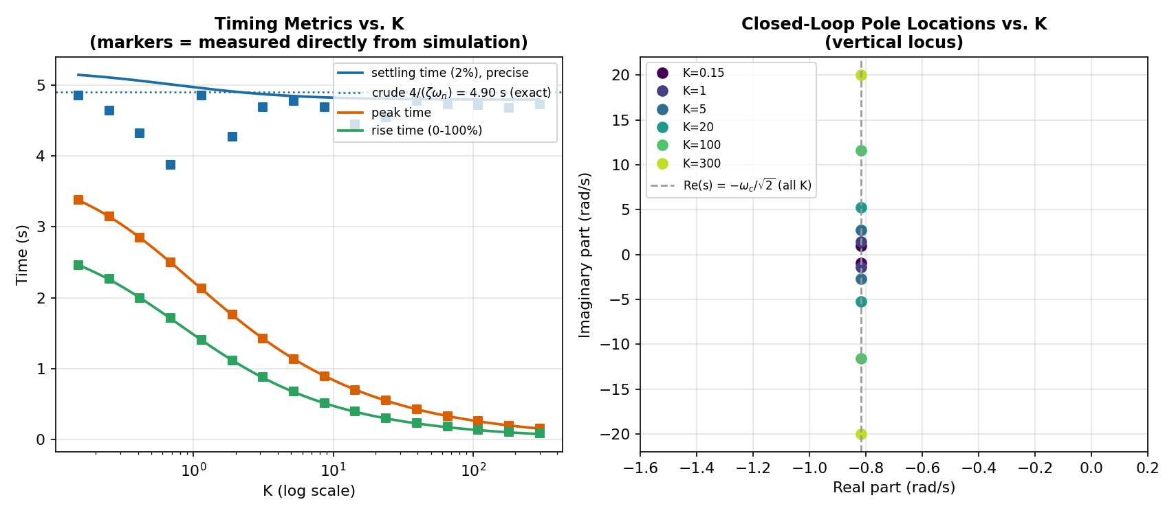
Figure 15. Left: settling, peak and rise time vs. K, with square markers measured directly from the simulated step responses of Figure 12. Right: closed-loop pole locations for six values of K, all lying on the same vertical line.
The right-hand panel of Figure 15 makes the reason visually obvious: the closed-loop characteristic equation s² + √2ωᶜs + ωᶜ²(1+K) = 0 has K only in its constant term — the linear (damping) coefficient √2ωᶜ never changes. For a quadratic, the real part of a complex-conjugate pair is −(linear coefficient)/2, which is independent of the constant term altogether; here that gives exactly −ωᶜ/√2 = −0.8165 rad/s for every K, confirmed to six decimal places for K = 0.15 through 300. The 2% settling time inherits this near-invariance: the precise formula (which includes a mild √(1−ζ²) correction the crude 4/(ζωₙ) rule ignores) varies only from 4.79 s to 5.14 s — about 7% — across the full 2000-fold sweep in K, and the settling times measured directly from simulation land in the same narrow band. Peak time and rise time tell the opposite story: both fall by roughly 20× over the same range, from 3.37 s and 2.46 s at K = 0.15 down to 0.16 s and 0.09 s at K = 300, tracking 1/ωd exactly as the simulated markers confirm. In short: gain in this loop buys a faster rise, not a faster settle — the extra speed at high K is used entirely to pack more, tighter oscillation cycles into the same fixed decay window, which is exactly the visual character Figure 12 shows.

7.8 Sensitivity Structure and Worst-Case Robust Design NEW
Section 7.6 described the sensitivity of PO to the damping perturbation f as “roughly constant” across K, based on four spot values. Differentiating PO(K,f) directly gives a sharper and, it turns out, more interesting picture.
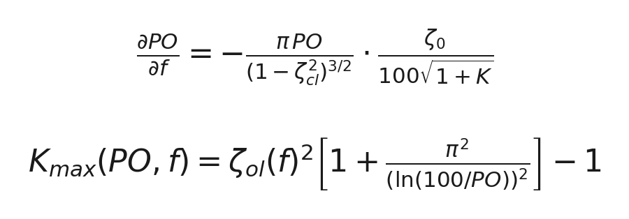
dPOdf = @(K,f) -pi*PO(K,f)./(1 - zeta_cl(K,f).^2).^1.5 .* (zeta0./(100*sqrt(1+K)));
sens_K = dPOdf(K_curve, 0); % sensitivity evaluated at the nominal f = 0
[~, idx] = min(sens_K); % most negative = largest sensitivity magnitude
K_worst_sens = K_curve(idx);
Kmax = @(PO_t,f) (zeta0*(1+f/100)).^2 .* (1 + pi^2./(log(100./PO_t)).^2) - 1;
PO_targets = [20 30 50 70];
K_nominal = Kmax(PO_targets, 0); % allowed gain, ignoring filter tolerance
K_robust = Kmax(PO_targets, -30); % allowed gain, guaranteeing the spec at f=-30%
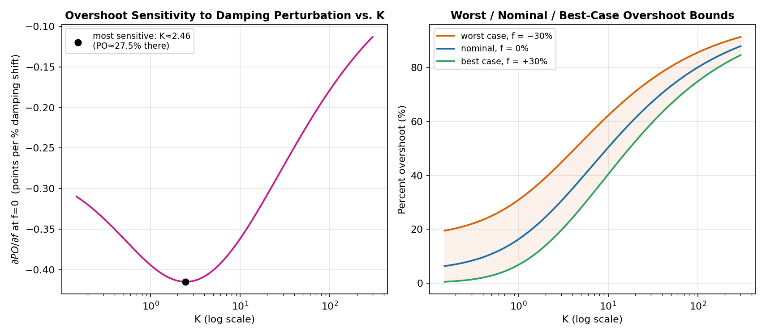
Figure 16. Left: ∂PO/∂f at f=0 vs. K — sensitivity peaks at an interior gain, not at either end of the range. Right: worst-case (f=−30%), nominal (f=0%) and best-case (f=+30%) overshoot bounds, the three corresponding horizontal slices of Figure 14.
The sensitivity is not constant: it peaks in magnitude at K ≈ 2.46 (where PO ≈ 27.5%), with ∂PO/∂f = −0.415 points per percent of damping shift, and falls away on both sides — to −0.310 at K = 0.15 and to only −0.113 at K = 300. This refines the Section 7.6 description: designs using a moderate gain (K in roughly the 1–10 range) are the most exposed to filter-tolerance-driven overshoot risk, not equally exposed at every gain as “roughly constant” implied. The right-hand panel turns this into a design tool: the shaded band between the worst-case and best-case curves is the full spread of outcomes the ±30% tolerance can produce at each K, and it widens steadily as K grows.
Target PO | Nominal K_max (f=0%) | Robust K_max (f=−30%) | Over-design risk
20% | 1.41 | 0.18 | 87%
30% | 2.90 | 0.91 | 69%
50% | 9.77 | 4.28 | 56%
70% | 38.29 | 18.25 | 52%
Table 6. Maximum gain K permitted for a target overshoot, comparing a nominal design (ignores filter tolerance) against a robust design (guarantees the spec even at f=−30%).
Table 6 quantifies the practical cost of designing only against the nominal curve. For a 20% overshoot spec, the nominal analysis would allow K up to 1.41, but that gain actually produces 20% overshoot only if the filter's damping is exactly on its Butterworth design value; if the real filter sits at the worst-case end of its tolerance (f = −30%), the true overshoot at K = 1.41 would exceed spec, and the gain must be cut all the way back to K = 0.18 to guarantee 20% in the worst case — an 87% over-design risk. The same comparison is far gentler for a looser spec: at 70% overshoot the nominal and robust gains differ by only 52%. The lesson is direct — the tighter the overshoot requirement, the more a controller design needs to be checked against the worst-case curve of Figure 16, not the nominal one, because tight specs live in exactly the K-region (Figure 16, left) where PO is most sensitive to how well the physical filter matches its nominal design.

8. Discussion

a. Effect of sampling time
Changing Tₛ does not remove aliasing at the band boundary. The boundary magnitude stays at 0.85 (−1.41 dB) for every Tₛ tested; Tₛ only rescales which physical frequency ω corresponds to a given digital frequency θ.

b. Effect of the anti-aliasing filter
A low-pass filter ahead of the plant is effective where Tₛ alone is not: the first-order filter reduces the boundary response to −92.20 dB and the second-order filter to −183.00 dB. The second-order filter is preferred, since it also suppresses the response around the 120° resonance more strongly, as seen in both Figure 4 and the sideband view of Figure 5.

c. Main discrete-domain observation
The plant has all three poles on the unit circle, including a resonant pair at 120°. This keeps the boundary response relatively high and makes the aliasing problem structural rather than incidental — it cannot be fixed by re-sampling, only by filtering.

d. On the extended stability check and the gain–overshoot study
The widened root-locus sweep (±300 in gain, versus ±10 originally) turns the earlier “no k found in the tested range” into a sharper, quantified statement: k = 0 is provably the best-conditioned point on the entire real-gain locus, so no real proportional gain can stabilise this plant — a structural conclusion rather than a range-limited one. The companion continuous-domain study then answers the complementary controller-design question the experiment poses — an approximate K→PO relationship — using a system this report had already designed and validated (the Butterworth anti-aliasing filter), rather than forcing that question onto a plant that the stability check shows cannot support it. The resulting closed-form PO(K) = 100 exp(−π/√(2K+1)) % matched direct simulation to within 0.17 percentage points, and its sensitivity to open-loop damping perturbation was found to be smaller, in relative terms, than its sensitivity to the gain K itself — consistent with standard proportional-control intuition and a useful design takeaway in its own right.

9. Conclusions
- The given characteristic polynomial implies the open-loop plant Gₒₗ(z) = (z²+1.7z−1)/(z³−1). Its poles lie exactly on the unit circle, producing a resonance at θ = 120° and a relatively high response of −1.41 dB at the band edge.
- Changing the sampling time Tₛ does not remove aliasing at the band boundary; it only rescales the physical-frequency axis, leaving the normalised-frequency response — and hence the boundary value — unchanged.
- A low-pass anti-aliasing filter greatly reduces the boundary response: −92.20 dB for the first-order design and −183.00 dB for the second-order (Butterworth) design, which is selected for the final result.
- An exhaustive root-locus sweep over k ∈ [−300, 300] confirms and sharpens the original stability remark: the closed-loop system can never be made strictly stable by a real proportional gain, since k = 0 is already the best-conditioned point on the locus (minᵢ maxᵢ|zᵢ(k)| = 1 at k = 0). A dynamic compensator, not a proportional gain, is required.
- On a continuous-domain companion loop built from the already-designed second-order anti-aliasing filter, the closed-loop damping ratio ζ(K) = 1/√(2(1+K)) yields the closed-form relationship PO(K) = 100·e^{−π/√(2K+1)} %, verified against direct step-response simulation to within 0.17 percentage points over K = 0.15–300. Overshoot is more sensitive to the gain K than to a ±30% perturbation in the open-loop damping ratio, reinforcing that gain selection is the dominant design lever in this class of loop.

10. References
- EE208 Control Engineering Laboratory Manual, IIT Ropar, Experiment 9.
- MathWorks, "System Characteristics on Response Plots." mathworks.com/help/control/ug/system-characteristics-on-response-plots.html
- MathWorks, "Frequency Response of a SISO System." mathworks.com/help/control/ug/frequency-response-of-a-siso-system.html
- MathWorks, "Creating Discrete-Time Models." in.mathworks.com/help/control/examples/creating-discrete-time-models.html
- MathWorks, "Analysis Plot Customization." mathworks.com/help/control/analysis-plot-customization.html
- MathWorks, "Continuous-Discrete Conversion Methods." mathworks.com/help/control/ug/continuous-discrete-conversion-methods.html
- "Nyquist Stability Criterion," Wikipedia. en.wikipedia.org/wiki/Nyquist_stability_criterion
- Ogata, K., Discrete-Time Control Systems, 2nd ed. — standard reference for the ζ→PO overshoot formula used in Section 7.3.
- MathWorks, "Compensator Design in Bode Diagram App / Root Locus." mathworks.com/help/control — background for the extended root-locus sweep in Section 7.1.

11. Appendix — Data Files
All numerical results in this report are also provided as plain CSV files, generated directly alongside the figures so that every plot in this document can be reproduced or re-analysed independently of MATLAB. They accompany this report as separate downloads.
File | Contents
table1_poles_zeros.csv | Poles/zeros of Gₒₗ(z) (Table 1)
main_band_frequency_response.csv | θ, magnitude (dB), phase (deg) — 4000 pts (Fig. 2)
table2_boundary_vs_Ts.csv | Tₛ, ωₙ, boundary magnitude (Table 2)
filter_cascade_response.csv | θ, plant / C₁ / C₂ / cascade responses (Fig. 4)
table3_filter_comparison.csv | Boundary magnitude before/after filtering (Table 3)
sideband_response.csv | ω, uncompensated & compensated dB over ±3.2π (Fig. 5)
gain_k_sweep_summary.csv | Resonance peak, boundary, edge phase vs. k (Table, Sec. 6.4)
gain_k_sweep_full_response.csv | θ, 20log₁₀|kGₒₗ| for k=0.1,1,5,10 (Fig. 6, Sec. 6.4)
nyquist_data.csv | Re/Im of L(z), comp. & uncomp., k=0.5,2,5 (Fig. 8, Sec. 6.5)
table_corner_freq_tradeoff.csv | θc, ωc, boundary & resonance dB (Table 4, Sec. 6.6)
corner_freq_tradeoff_full_response.csv | θ, cascaded dB for 4 values of θc (Fig. 9, Sec. 6.6)
time_domain_alias_samples.csv | n, raw and pre-filtered sample sequences (Sec. 6.7)
time_domain_alias_curves.csv | t, true/alias/filtered continuous curves (Fig. 10, Sec. 6.7)
root_locus_sweep.csv | k, max|root(k)| over k ∈ [−300,300] (Fig. 11, Sec. 7.1)
step_response_waterfall.csv | K, t, y(t) for 16 gains × 2500 samples (Fig. 12)
overshoot_vs_gain.csv | K, ζ, PO analytical vs. simulated (Fig. 13)
table4_overshoot_anchor.csv | PO at 4 K-values × 3 f-values (Table 5)
overshoot_sensitivity_grid.csv | K, f, PO(K,f) — 140×121 grid (Fig. 14)
timing_metrics_vs_K.csv | ζ, ωn, ωd, pole real part, tp/tr/ts vs. K (Fig. 15, Sec. 7.7)
timing_metrics_validation.csv | tp/tr/ts: simulated vs. closed-form, 16 gains (Sec. 7.7)
sensitivity_dPO_df_vs_K.csv | ∂PO/∂f at f=0 vs. K (Fig. 16, Sec. 7.8)
heatmap_slices_worst_nominal_best.csv | PO at f=−30/0/+30% vs. K (Fig. 16, Sec. 7.8)
robust_design_Kmax_table.csv | Nominal vs. robust K_max for 4 PO targets (Table 6)
Table 7. CSV data files accompanying this report.

Three consolidated, runnable MATLAB scripts are also provided: exp9_core_analysis.m (Sections 5–6.2/6.3 — OLTF, pole/zero, main-band response, Tₛ study, anti-aliasing filter design), exp9_section6_extensions.m (Sections 6.4–6.7 — gain sweep, Nyquist, corner-frequency trade-off, time-domain aliasing), and exp9_extended_analysis.m (Section 7, including 7.7–7.8 — extended root locus, the gain–overshoot study, timing-metric invariance, and worst-case sensitivity/robust design). All three only assume base MATLAB plus the Control System Toolbox (for tf, c2d, and step).

