1. Objective
This experiment designs a cascade proportional digital controller K_{p} for the given digitised plant so that the closed-loop unit-step response meets analog-style requirements (%OS ≤ 5%, t_{s} ≤ 9 s), using discrete root loci and constant-damping-ratio (ζ) contours in the z-plane. Five objectives are each paired with the MATLAB code that carries them out in §4:
- Recover the continuous-time plant G(s) implied by the digitised G(z) at T = 1 s.
- Convert %OS ≤ 5% into a minimum damping ratio and find the analog proportional-gain range for 0.69 ≤ ζ ≤ 1.
- Redesign K_{p} directly in the z-domain, using the discrete root locus and ζ contours, for T = 0.1 s … 1.0 s in 0.1 s steps.
- Find the admissible digital gain interval [K_{p,min}, K_{p,max}] at each T and evaluate the resulting overshoot and settling time.
- Study how the gain varies with sampling time, compare with the analog design, and fit an approximate K_{p}(T) relationship.
Beyond these, §6 adds a sixth strand: how close each design sits to true instability and how well the simplified textbook formulas hold up against a full discrete-time simulation. Part II (§9–§14) adds graphical cross-checks, margins, Nyquist, bandwidth, zero migration, sensitivity/robustness, a lead compensator, a nomograph and an intersample study.

2. Problem Statement
The digitised open-loop transfer function supplied for this experiment (handwritten lab sheet), at T = 1 s, is
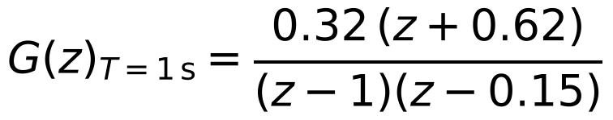
in a unity-negative-feedback loop with a proportional digital controller K_{p}, giving the characteristic equation
where p is the finite open-loop pole and b₁, b₀ the ZOH numerator coefficients at the sampling time in question (§3.3). The requirements are %OS ≤ 5% and a 2%-criterion settling time t_{s} ≤ 9 s. T is then varied from 0.1 s to 1.0 s; for each T the ZOH-equivalent plant is recomputed from the recovered continuous plant and K_{p} is redesigned from scratch.

3. Theory

3.1 Recovering the analog plant
The pole at z = 1 is a free integrator, so the continuous plant is modelled as K/[s(s+a)]. The finite discrete pole obeys the sampling relation
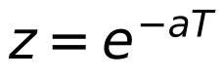
so the sheet’s pole z = 0.15 at T = 1 s fixes a = −ln(0.15) = 1.8971 rad/s. The plant gain K follows by matching the leading ZOH numerator coefficient b₁ = 0.32 (§4.1), giving K = 1.0999.

3.2 From %OS ≤ 5% to a minimum damping ratio
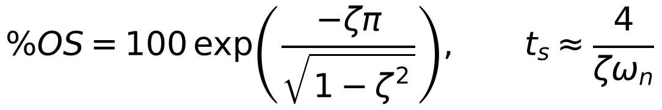
Setting %OS = 5% and solving for ζ gives the minimum admissible damping ratio
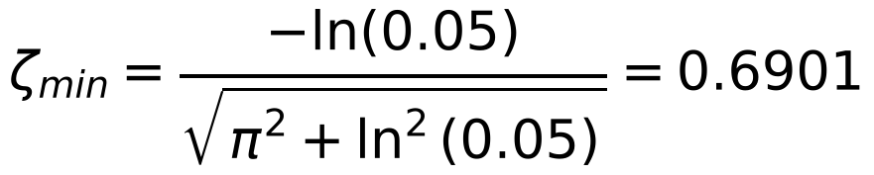
so the admissible region is 0.69 ≤ ζ ≤ 1: ζ = 0.6901 is exactly 5% overshoot and ζ = 1 is the critically damped (0% overshoot) boundary.

3.3 The z-plane picture: ZOH re-discretisation and constant-ζ contours
For the recovered analog plant with proportional gain K_{p} the characteristic equation is the first expression below, which gives the analog design directly (§4.2). To repeat the design digitally the plant is re-discretised by ZOH at each T, with the exact closed-form coefficients (equivalent to MATLAB’s c2d)
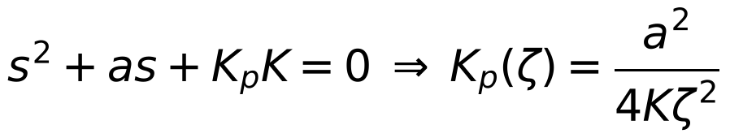
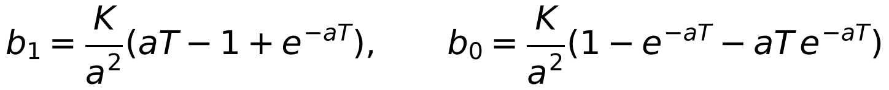
A constant-ζ line in the s-plane maps through z = e^{sT} to a logarithmic spiral in the z-plane. The effective damping ratio of a z-domain pole,
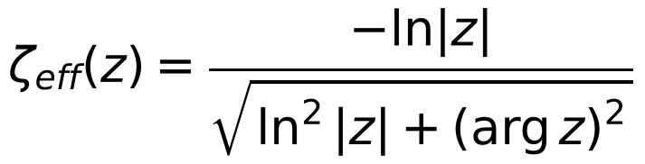
does not depend on T, because s = ln(z)/T and changing T only rescales |s|, never its angle. The same contour-crossing routine (§4.5) therefore works unchanged at every sampling time.

3.4 Marginal stability and the ZOH “half-sample delay” heuristic
The base design only asks how much gain is needed to just reach 5% overshoot; it never asks how much the loop can tolerate before going unstable. Because the characteristic equation is a monic quadratic, the product of the closed-loop pole pair equals its constant term, so the exact marginal-stability gain (a pole pair first reaching the unit circle) is closed-form:
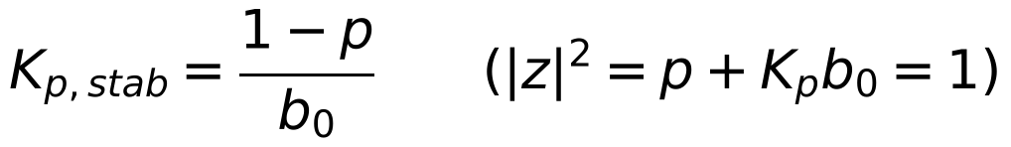
(used in §4.7 and §6.1). Separately, a ZOH behaves roughly like a T/2 pure delay, which should erode the admissible gain as 1/(1+aT/2) relative to the analog value, i.e. c_{theory} = a/2 in the empirical model of §6.3, which tests that heuristic directly.

4. MATLAB Implementation
*Note on reproducibility. Every function below was also re-implemented independently in Python/NumPy/SciPy as a numerical cross-check (same closed-form equations, agreement to ≥ 4 significant figures). The tables, CSVs and figures were generated from that cross-check; the MATLAB code is the documented implementation, supplied in full (nine function files, a verification script and the main script) in the accompanying package. The code could not be run inside MATLAB while preparing this report, so run verify_report_numbers first. Plotting, CSV-export and filtering loops are described in prose, not reproduced.*

4.1 Recovering G(s) and verifying by discretisation (Objective 1)
Objective: Recover a and K from the supplied G(z) at T = 1 s, build the continuous plant, and check it against the supplied G(z) when re-discretised.

% --- Recover the analog plant from the sampled model at T = 1 s ---
T1 = 1; pz = 0.15; b1_target = 0.32; zero_given = 0.62; % lab-sheet values
a = -log(pz)/T1; % z = exp(-aT) -> a = 1.8971 rad/s
p1 = exp(-a*T1);
K = b1_target*a^2/(a*T1 - 1 + p1); % match leading ZOH coefficient -> K = 1.0999
Gs = tf(K,[1 a 0]); % recovered plant K/[s(s+a)]
Gz_check = c2d(Gs, T1, 'zoh'); % ZOH model: 0.32 z + 0.1728 over (z-1)(z-0.15)
nz = Gz_check.Numerator{1}; % [0 b1 b0]
fprintf('model zero %.4f vs sheet zero %.4f\n', -nz(3)/nz(2), -zero_given);

Running this gives a = 1.8971 rad/s and K = 1.0999. The re-discretised plant reproduces the sheet’s pole (0.15) and leading coefficient (0.32) by construction, but gives b₀ = 0.1728, i.e. a zero at −0.5400 rather than the sheet’s −0.62 (b₀ = 0.1984). This 14.8% mismatch is analysed in §5.1.

4.2 Analog proportional-gain range (Objective 2)
Objective: Convert the 5% overshoot spec to ζ_{min}, then use K_{p}(ζ) = a²/(4Kζ²) for the analog K_{p} interval and the (constant) ideal settling time.

OS_spec = 5; % percent overshoot limit
zeta_min = -log(OS_spec/100)/sqrt(pi^2+log(OS_spec/100)^2); % 0.6901
Kp_max_analog = a^2/(4*K*zeta_min^2); % = 1.7177
Kp_min_analog = a^2/(4*K*1^2); % = 0.8181
ts_analog = 8/a; % 4/(zeta*wn), zeta*wn = a/2 -> 4.2169 s

4.3 ZOH re-discretisation for a general T (Objective 3, part 1)
Objective: Provide the plant’s ZOH numerator coefficients at any sampling time so the same design procedure runs for every T of the sweep.

function [b1,b0,p] = zoh_coeffs(T,a,K)
% ZOH-equivalent coefficients of K/[s(s+a)] (same as c2d(...,'zoh'), closed form)
p = exp(-a*T);
b1 = (K/a^2).*(a*T - 1 + p);
b0 = (K/a^2).*(1 - p - a*p.*T);
end

4.4 Locating the ζ = 1 boundary exactly (Objective 3, part 2)
Objective: Find the breakaway gain, where the two real closed-loop poles meet and turn complex, without plotting the locus.

The locus leaves the real axis where the discriminant of z² + [K_{p}b₁−(1+p)]z + [p+K_{p}b₀] vanishes:
function [Kp_min,Kp_breakin] = breakaway_gain(b1,b0,p)
A = b1^2; B = -(2*b1*(1+p) + 4*b0); C = (1-p)^2;
r = sort(roots([A B C])); % two real roots: breakaway, break-in
Kp_min = r(1); Kp_breakin = r(2); % smaller one is the zeta = 1 boundary
end

4.5 Locating the ζ = 0.69 boundary (Objective 3, part 3)
Objective: Find the gain at which the complex-pole branch crosses the 5%-overshoot contour, using the T-independent ζ_{eff} of §3.3.

function Kp_max = zeta_crossing_gain(b1,b0,p,target_zeta,Kp_lo,Kp_hi)
Kp_max = fzero(@(Kp) zeta_error(Kp,b1,b0,p,target_zeta), [Kp_lo Kp_hi]);
end
function e = zeta_error(Kp,b1,b0,p,target)
r = roots([1, Kp*b1-(1+p), p+Kp*b0]);
zc = r(imag(r) > 0); % upper complex pole
e = -log(abs(zc))/abs(log(zc)) - target; % zeta_eff(z) - target
end

4.6 Performance evaluation (Objective 4)
Objective: Given a design point (K_{p}, T), build the closed-loop discrete transfer function and read off the true overshoot and settling time.

function [OS,ts] = evaluate_design(b1,b0,p,Kp,T)
Gz = tf([b1 b0],[1 -(1+p) p], T); % open-loop ZOH plant
Gcl = feedback(Kp*Gz, 1); % unity feedback
info = stepinfo(Gcl,'SettlingTimeThreshold',0.02);
OS = info.Overshoot; ts = info.SettlingTime;
end

4.7 Marginal-stability gain (further analysis, §6.1)
Objective: Compute the exact upper stability limit on K_{p} from the closed-form result of §3.4.

function Kp_stab = marginal_stability_gain(b0,p)
% On the complex branch |z|^2 = C = p + Kp*b0; instability begins when it reaches 1
Kp_stab = (1 - p)/b0;
end

4.8 Empirical K_{p}(T) relationship (Objective 5, further analysis)
Objective: Fit a closed-form approximation to how K_{p,min} and K_{p,max} fall with sampling time, and report the goodness of fit.

function [Kp0,c,R2] = fit_inverse_law(Tvec,Kpvec)
% Fit Kp(T) ~= Kp0/(1+c*T) by nonlinear least squares (fminsearch: base MATLAB)
model = @(par,T) par(1)./(1+par(2).*T);
sse = @(par) sum((Kpvec(:) - model(par,Tvec(:))).^2);
par = fminsearch(sse,[Kpvec(1),1],optimset('TolX',1e-12,'TolFun',1e-14,'MaxIter',5000));
Kp0 = par(1); c = par(2);
R2 = 1 - sum((Kpvec(:)-model(par,Tvec(:))).^2)/sum((Kpvec(:)-mean(Kpvec)).^2);
end

5. Results

5.1 Recovered plant, analog design, and the consistency of the supplied G(z)
§4.1 gives a = 1.8971 rad/s and K = 1.0999, so G(s) = 1.0999/[s(s+1.8971)]. §4.2 gives ζ_{min} = 0.6901, an analog gain range 0.8181 ≤ K_{p} ≤ 1.7177 and a constant ideal settling time 8/a = 4.2169 s across that range (ζω_{n} = a/2 is fixed by construction).
Consistency of the supplied G(z) (new finding). For a plant K/[s(s+a)] the ZOH numerator coefficients b₁ and b₀ and the pole p are tied together by a single pair (a, K). The sheet gives three numbers (p = 0.15, b₁ = 0.32, zero −0.62), so one of them is redundant, and it is inconsistent: p and b₁ fix a and K, which then force the zero to
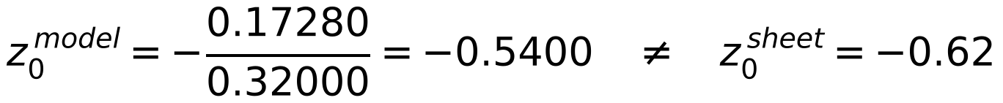
a 14.8% difference. The effect on the design is not negligible (Table 0). The sheet’s own coefficients are used for every T = 1 s analysis (§5.2, §6.4–6.8, §10.2, §12.1, §13) because that is the plant the lab specifies, while the T-sweep necessarily uses the recovered continuous model. A zero of 0.54 on the sheet would make the two descriptions coincide exactly, so it is worth re-checking the handwritten value; the MATLAB switch USE_GIVEN_AT_T1 (or editing zero_given) re-runs everything either way.
T = 1 s | Zero z₀ | K_{p,min} (ζ=1) | K_{p,max} (ζ=0.69) | K_{p,stab} | K_{p,stab}/K_{p,max} | OS / t_{s} at K_{p,max}
Sheet G(z) [0.32(z+0.62)] | −0.6200 | 0.4883 | 0.7845 | 4.284 | 5.46× | 5.00% / 7 s
ZOH model [0.32(z+0.540)] | −0.5400 | 0.5261 | 0.8524 | 4.919 | 5.77× | 4.98% / 7 s
Difference (sheet vs model) | +14.8% | -7.2% | -8.0% | -12.9%
Table 0. The same design procedure applied to the sheet’s G(z) and to the exact ZOH model of the recovered plant, at T = 1 s. Both reach t_{s} = 9.0 s at K_{p,min} and 7 s at K_{p,max}, so the conclusions are unchanged; the gains shift by 7–13%.
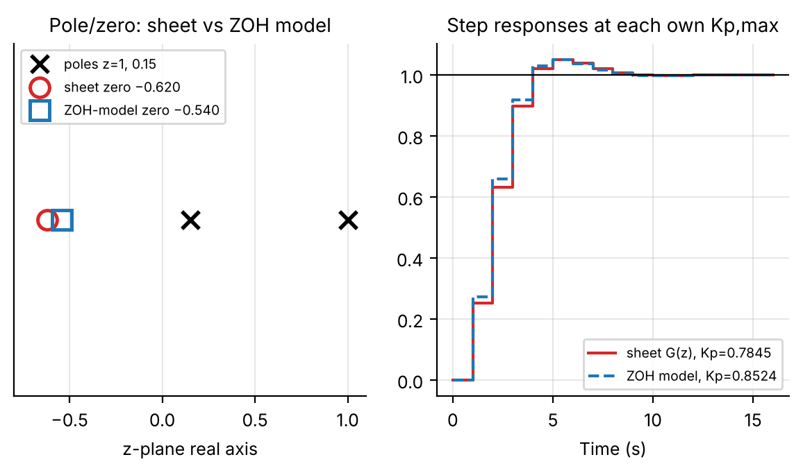
Figure 1. Left: the sheet’s zero (−0.62) and the zero of the exact ZOH model (−0.540). Right: step responses, each at its own K_{p,max}: the two are almost indistinguishable at the sample instants.

5.2 Digital design table
Table 1 gives the digital design at each sampling time: the two gain boundaries (§4.4–4.5), the true marginal-stability gain (§4.7) and the resulting gain margin, all on the recovered continuous model. At T = 0.1 s the lower boundary lies about 4.6% below the analog K_{p,min} and the upper about 9% below the analog K_{p,max}, and both converge to the analog values as T → 0.
T (s) | K_{p,min} (ζ=1) | K_{p,max} (ζ=0.69) | K_{p,stability} | Margin K_{p,stab}/K_{p,max} | OS at K_{p,max} | t_{s} at K_{p,min} (s) | t_{s} at K_{p,max} (s)
0.1 | 0.7803 | 1.5613 | 35.623 | 22.82× | 5.00% | 6.4 | 4.6
0.2 | 0.7447 | 1.4299 | 18.410 | 12.88× | 4.97% | 6.6 | 5.0
0.3 | 0.7111 | 1.3182 | 12.697 | 9.63× | 4.99% | 6.9 | 5.1
0.4 | 0.6794 | 1.2224 | 9.859 | 8.07× | 4.90% | 7.2 | 5.6
0.5 | 0.6497 | 1.1395 | 8.172 | 7.17× | 5.00% | 7.5 | 6.0
0.6 | 0.6217 | 1.0671 | 7.061 | 6.62× | 5.00% | 7.8 | 6.0
0.7 | 0.5955 | 1.0035 | 6.279 | 6.26× | 4.95% | 7.7 | 6.3
0.8 | 0.5709 | 0.9473 | 5.702 | 6.02× | 4.85% | 8.0 | 6.4
0.9 | 0.5478 | 0.8972 | 5.262 | 5.87× | 4.91% | 8.1 | 7.2
1.0 | 0.5261 | 0.8524 | 4.919 | 5.77× | 4.98% | 9.0 | 7.0
Table 1. Digital design boundaries and true stability limit, T = 0.1–1.0 s (recovered ZOH model, csv_new_plant/table1_digital_design.csv). Overshoot at K_{p,min} is 0.0% at every T (real breakaway poles). At T = 1 s the sheet’s own G(z) gives 0.4883 / 0.7845 / 4.284 (Table 0).
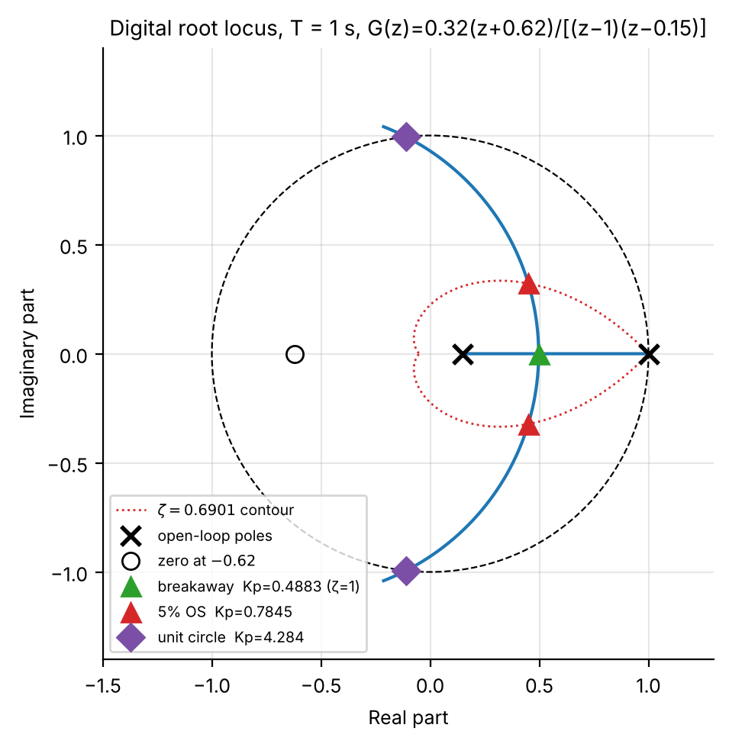
Figure 2. Digital root locus at T = 1 s for the sheet’s G(z): breakaway (ζ = 1, K_{p} = 0.4883, double pole at z = 0.4969), 5%-overshoot crossing (K_{p} = 0.7845, z = 0.4495 ± 0.3219j) and exact marginal-stability point (K_{p} = 4.284, z = −0.1105 ± 0.9939j) on the same locus; dotted: ζ = 0.6901 contour.

5.3 K_{p} and settling time vs sampling time
Figure 3 plots the three gain boundaries against T on a log axis with the fitted laws of §4.8 (discussed in §6.3). Figure 4 compares the simulated settling time with the idealised formulas; the idealised 4/σ estimate and the simulation are close at the K_{p,max} boundary but diverge at K_{p,min} (§6.2).
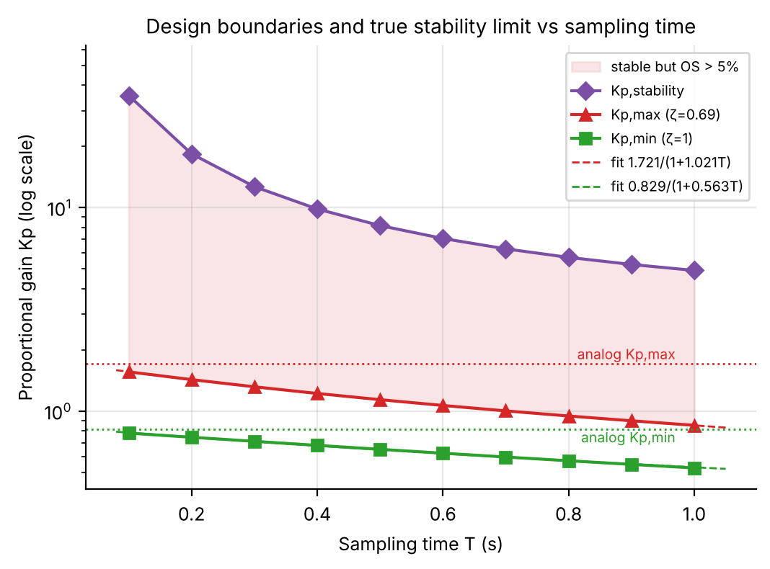
Figure 3. K_{p,min}, K_{p,max} and K_{p,stability} vs T (log axis) with the fitted inverse laws overlaid; dotted lines are the analog values. The shaded band is stable but violates the 5% overshoot spec.
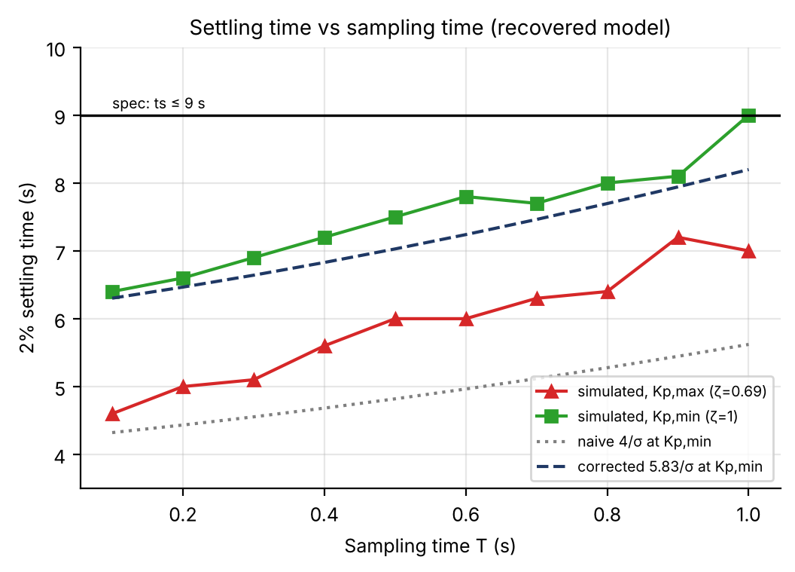
Figure 4. Simulated 2% settling time at both boundaries, with the naive (4/σ) and repeated-pole-corrected (5.83/σ) estimates at K_{p,min}. At T = 1 s the simulated t_{s} at K_{p,min} reaches the 9 s spec exactly.

6. Further Analysis
This section goes beyond the base experiment in four directions: how much gain margin actually exists before instability, why the idealised settling-time formula misleads at critical damping, how well a simple empirical law captures K_{p}(T), and continuous-parameter visualisations (waterfall and heatmaps) that make the whole design space visible at once.

6.1 How close is the design to instability?
The open-loop model has one more pole than zero, so the root locus has a single asymptote and, as K_{p} grows, one closed-loop pole heads to −∞ while the other approaches the open-loop zero. In between, the complex pair crosses the unit circle at a single exact gain K_{p,stab} = (1−p)/b₀ (§4.7). For the sheet’s plant at T = 1 s this is K_{p} = 4.284: 5.46× the gain that already gives 5% overshoot (0.7845). On the recovered model the margin ratio grows from 5.77× at T = 1 s to 22.8× at T = 0.1 s (Table 1, Figure 3).
This is an important, slightly counter-intuitive digital-control fact. The analog plant K/[s(s+a)] under proportional feedback is unconditionally stable for every K_{p} > 0 (s² + as + K_{p}K has positive coefficients). Sampling destroys this: ZOH sampling of a type-1 plant introduces a finite zero, giving a real asymptote and a finite stability limit, so gains harmless in continuous time can destabilise the sampled loop. The 5% overshoot limit lies well inside the stability boundary over the whole tested range, but a designer relying on continuous-time intuition would be caught out at higher gains.

6.2 The critical-damping settling-time correction
The usual t_{s} ≈ 4/(ζω_{n}) comes from the 1/√(1−ζ²) envelope of an underdamped second-order response and is only valid away from ζ = 1. At the K_{p,min} boundary the closed-loop poles are real and repeated, the natural mode is n·rⁿ, and the 2%-settling constant becomes the root of
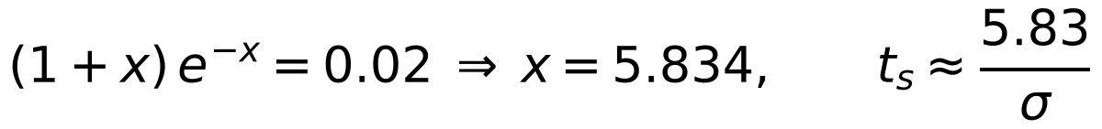
T (s) | t_{s} naive (4/σ) | t_{s} corrected (5.83/σ) | t_{s} full simulation
0.1 | 4.321 | 6.302 | 6.4
0.4 | 4.682 | 6.828 | 7.2
0.7 | 5.117 | 7.463 | 7.7
1.0 | 5.621 | 8.198 | 9.0
Table 2. Settling time at the K_{p,min} (ζ = 1) boundary (all ten T in csv_new_plant/table2_ts_at_Kpmin.csv). The corrected formula tracks the simulation (to within the one-sample quantisation); at T = 1 s the true settling time (9.0 s) sits exactly on the 9 s limit, not comfortably inside it as the naive 5.62 s suggests.
Practical takeaway: near ζ = 1 use 5.83/σ (or a full simulation). The gap is small at fine sampling but is the difference between comfortably meeting the specification and sitting exactly on its boundary once T approaches 1 s. The same 9.0 s result holds for the sheet’s own G(z) (Table 0).

6.3 Empirical K_{p}(T) relationship
Fitting K_{p}(T) ≈ K_{p0}/(1+cT) by nonlinear least squares (§4.8) to the two design boundaries gives
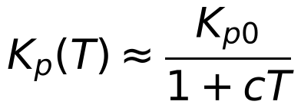
Quantity | Fitted model | R²
K_{p,max}(T) (ζ = 0.69) | 1.7212 / (1 + 1.0205·T) | 1.00000
K_{p,min}(T) (ζ = 1, breakaway) | 0.8288 / (1 + 0.5631·T) | 0.99895
t_{s,max}(T) (linear, simulated) | 2.764·T + 4.400 | 0.9611
t_{s,min}(T) (linear, simulated) | 2.497·T + 6.147 | 0.9428
Table 3. Empirical curve fits. Both K_{p} fits are excellent, and their zero-sampling intercepts K_{p0} (1.721 and 0.829) land almost exactly on the analog values (1.718 and 0.818) of §5.1, so the digital design converges to the analog design as T → 0.
Does the ZOH “half-sample-delay” heuristic (c = a/2 = 0.9486) explain this? Using that single, physically motivated constant instead of the fitted one gives R² = 0.9881 at the K_{p,max} boundary (a good approximation) but R² = -0.230 at K_{p,min}, worse than a constant. The delay picture explains how sampling erodes the overshoot-limited gain (a phase-lag mechanism) but not the breakaway boundary, which is a purely real-axis condition (the discriminant of the characteristic equation). This is a genuine limit of the heuristic, not a fitting artefact: the free two-parameter fit for K_{p,min} remains excellent (R² = 0.9990).

6.4 Continuous step-response waterfall (T = 1 s)
Table 1 samples only two K_{p} values per sampling time. Figure 5 fills in the space between and beyond them: the discrete closed-loop step response of the sheet’s plant at T = 1 s, swept continuously in K_{p} (70 values, log-spaced, 0.0488 → 5.78, the upper end 1.35× the instability gain). It shows the whole story of §5–6 in one picture: a slow overdamped climb at low K_{p}, overshoot appearing past breakaway, the response crossing 5% overshoot, and finally growing oscillation beyond the marginal-stability gain.
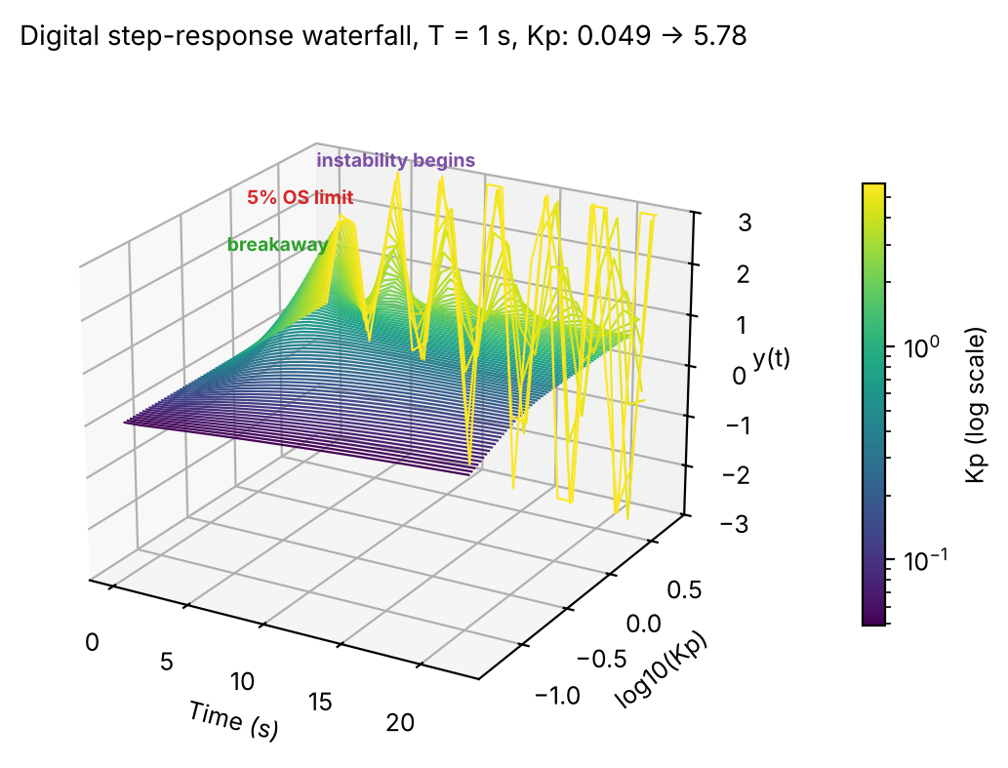
Figure 5. Digital step-response waterfall at T = 1 s, K_{p} swept 0.0488 → 5.78 (log scale; y clipped to ±3). The three labelled bands correspond to the three marked points on the root locus of Figure 2.

6.5 Overshoot sensitivity heatmap
Figure 6 evaluates %OS(K_{p}, T) over a dense grid (240 × 220 points) from the pole location, as a continuous extension of Table 1. Table 1’s (K_{p,max}, T) points fall on the dashed 5% contour, and its (K_{p,min}, T) points lie just left of the dashed 0.2% contour, as they must since overshoot is exactly zero up to breakaway: a visual cross-check of the whole table at once. The bright band on the right is the >90% overshoot / near-instability region approached in §6.1.
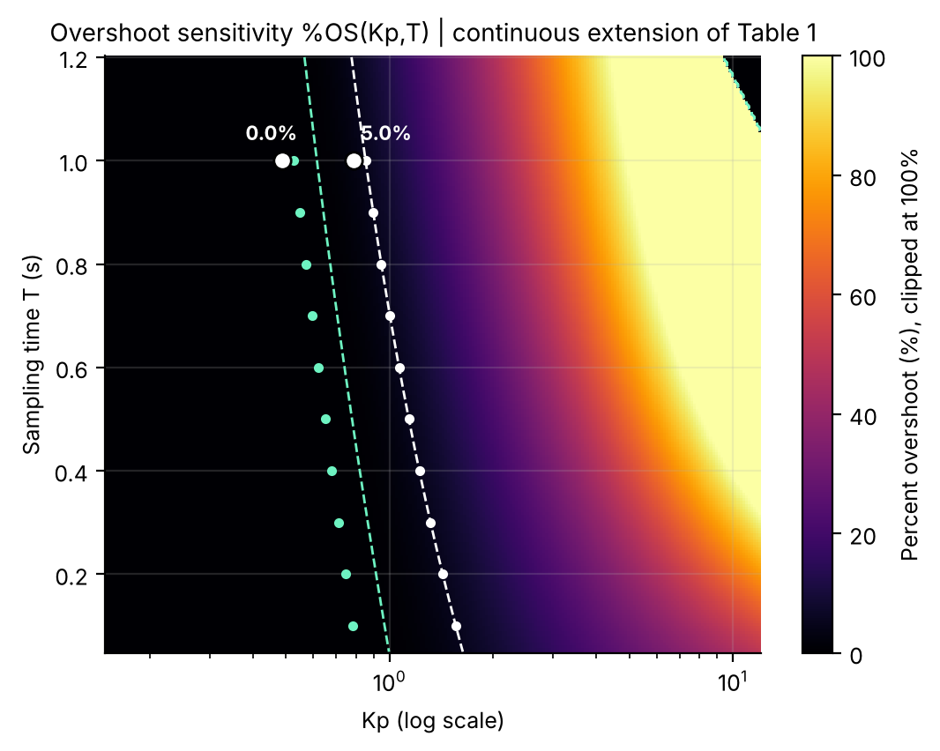
Figure 6. Overshoot %OS(K_{p}, T) of the recovered model with the Table 1 boundary points (small dots) and the 5% / 0.2% contours (dashed). The two large dots at T = 1 s are the sheet’s G(z) boundary gains (0.4883, 0.7845); they sit left of the model’s small dots because of the §5.1 mismatch.

6.6 Why simulated overshoot isn’t exactly 5.00%
Simulated overshoot at K_{p,max} ranges from 4.85% (T = 0.8 s) to 5.00% (T = 0.1, 0.5, 0.6 s) rather than sitting at exactly 5.00%. The design places the closed-loop pole exactly on the ζ = 0.6901 contour, which fixes the peak of the continuous envelope, but a simulation reports values only at sample instants and can miss the true peak between two samples. This is the discrete-time analogue of intersample ripple (quantified directly in §14.2): a sampled step response can look slightly better than it truly is.

6.7 Mining the waterfall further: the full %OS(K_{p}) and t_{s}(K_{p}) curves
Figure 5’s underlying data already contains 70 simulated responses, which can be re-mined sample by sample into continuous %OS(K_{p}) and t_{s}(K_{p}) curves without further simulation. In MATLAB this is the same peak and 2%-band logic as evaluate_design (§4.6) applied to the cached wf_y/wf_t cells of the main script (section 6.7).
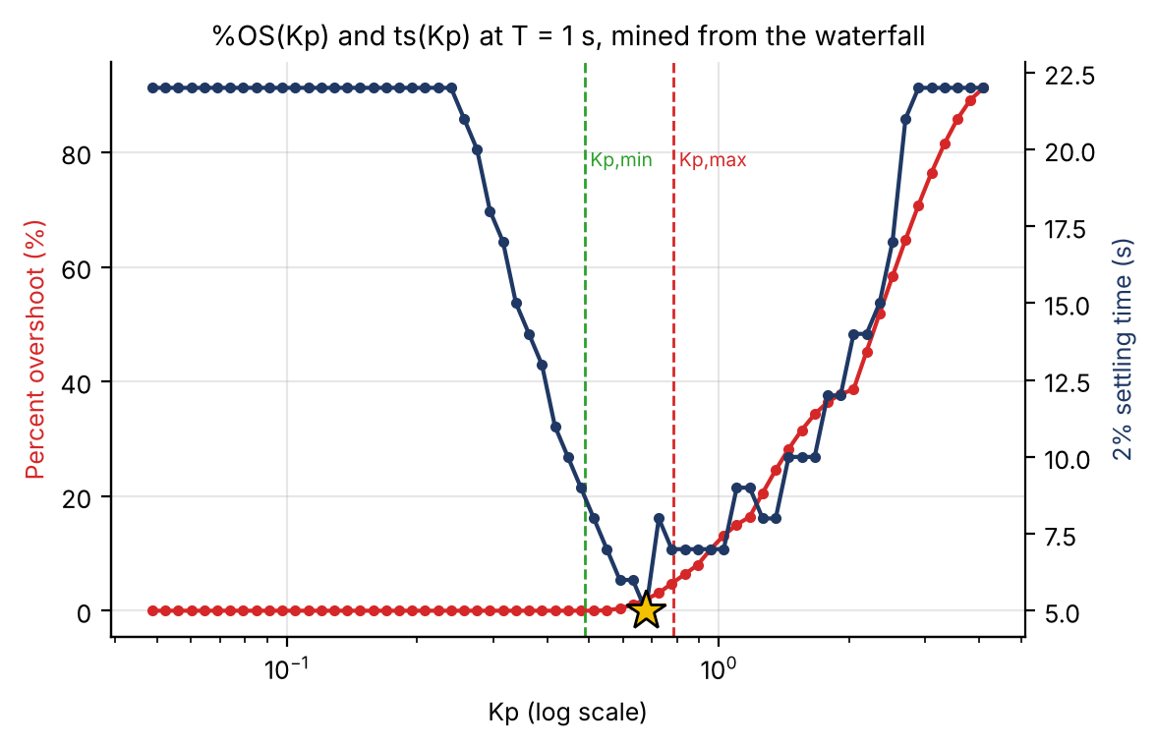
Figure 7. %OS (red, left) and 2% settling time (navy, right) vs K_{p} at T = 1 s, mined from Figure 5’s data; the gold star is the minimum of t_{s}. A plateau at 22 s means “not settled within the 22 s record”.
Interpretation. %OS(K_{p}) is exactly the monotonic curve the design method assumes: flat at 0% until breakaway, then rising smoothly. t_{s}(K_{p}) is not monotonic; it is U-shaped, and its minimum (t_{s} = 5 s at K_{p} ≈ 0.68, OS 1.97%) lies inside the design window, below K_{p,max} = 0.7845, not at either boundary. A 400-point scan of the window shows that t_{s} = 5 s holds for 0.635 ≲ K_{p} ≲ 0.678 (mid-band K_{p} = 0.656, OS 1.45%). A designer who only needs %OS ≤ 5% and the fastest settling should therefore not pick K_{p,max} (7 s, 5.0% OS) but a gain near 0.66, which settles in 5 s with a quarter of the overshoot. The two slow ends of the U have different causes: as K_{p} → 0 the dominant pole barely leaves z = 1; as K_{p} → K_{p,stab} the decay rate σ → 0 as the pole nears the unit circle, so the response is sluggish for the opposite reason (too little damping, not too little gain).

6.8 Validating the waterfall against theory: decay rate and frequency
The waterfall is a simulation of the same model used throughout, but its raw samples can be checked independently against the theoretical pole location using only peak-finding on y(t) (the find_local_extrema helper in the main script): the log decrement gives σ and the peak spacing gives ω_{d}, compared with s = ln(z)/T.
K_{p} (nearest waterfall) | σ, theory | σ, empirical | ω_{d}, theory | ω_{d}, empirical
0.339 | real poles (below breakaway) | — | — | —
0.778 | 0.5949 | 3.065 (unreliable) | 0.6148 | 0.6283 (2.2% off)
2.521 | 0.2152 | 0.500 (unreliable) | 1.3563 | 1.3228 (2.5% off)
4.092 | 0.0194 | 0.076 (unreliable) | 1.6522 | 1.6535 (0.1% off)
Table 4. Empirical vs theoretical decay rate and damped frequency from the simulated waterfall (csv_new_plant/waterfall_theory_validation.csv).
Interpretation. Oscillation frequency validates well, within 0.1–2.5% of theory, confirming the predicted pole angle independently of the analytic pipeline. Decay-rate estimates are off by 2–5×. This is a data-quantity problem, not a modelling error: at T = 1 s the record holds only a few cycles in 22 s, and the first “cycle” is contaminated by the initial transient. Peak timing needs only roughly even sampling; amplitude decay needs several clean cycles, a standard limitation of log-decrement estimation from short records.

6.9 A companion heatmap: the full t_{s}(K_{p}, T) landscape
Figure 8 shows the same domain coloured by settling time, from a full discrete simulation at every grid point (140 × 170 points).
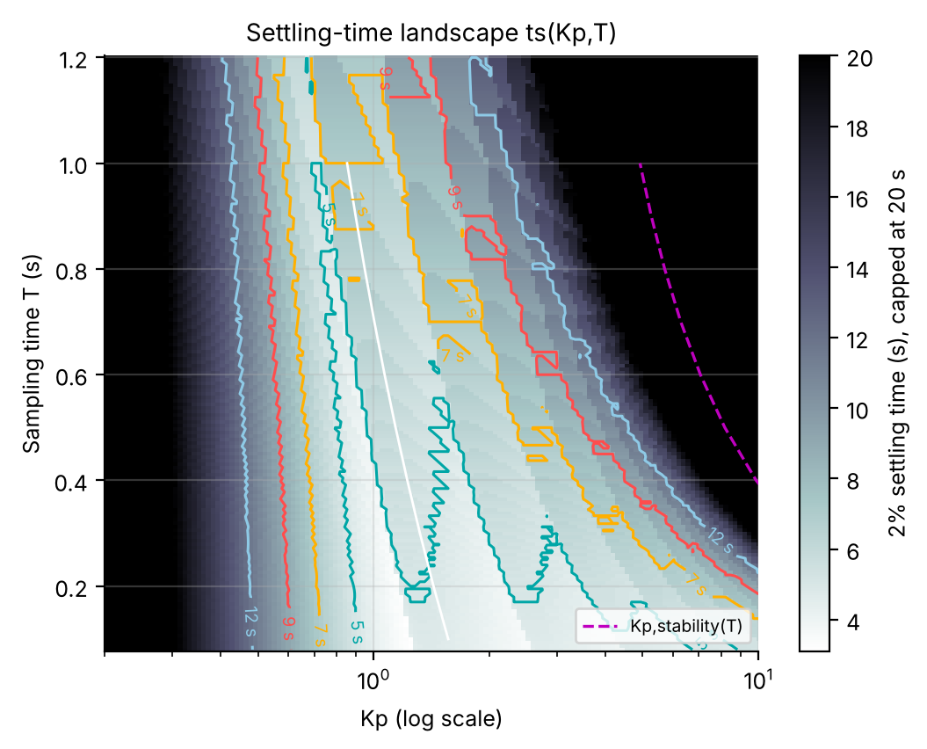
Figure 8. 2% settling time over (K_{p}, T), capped at 20 s; black is “does not settle” (at or beyond marginal stability). Contours: 5, 7, 9, 12 s. The dashed magenta curve is K_{p,stab}(T).
Interpretation. The dark band on the right is the marginal-stability boundary K_{p,stab}(T) of §6.1, seen here as where t_{s} diverges rather than where a pole crosses the unit circle: two different computations land on the same curve. The contours are jagged, almost sawtooth, especially at large T. This is not noise: t_{s} can only take values that are integer multiples of T (the finding of §6.2 generalised), so a “t_{s} = 7 s” contour is a staircase whose step width is T at that row. The heatmap is, among other things, a picture of quantisation error.

6.10 Where is overshoot most gain-sensitive? A 2-D sensitivity field
§12.1 computes the pole sensitivity |dz/dK_{p}| at two points. The same idea extends to the whole Figure 6 domain: differentiating the cached %OS(K_{p}, T) grid along K_{p} gives the field d(%OS)/dK_{p} with no new simulation (MATLAB: gradient(OS_grid(i,:), Kp_grid) row by row).
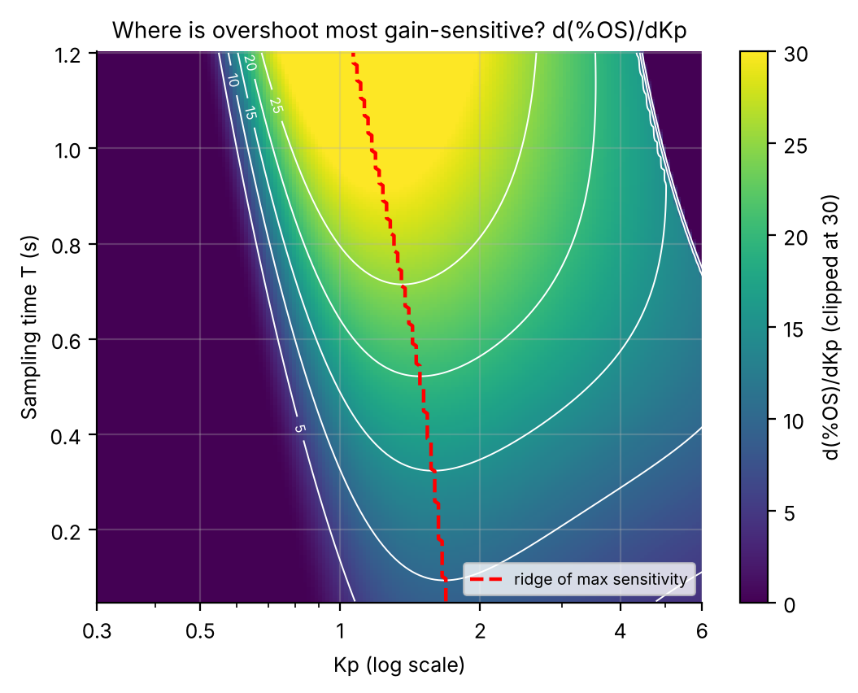
Figure 9. d(%OS)/dK_{p} over the Figure 6 domain (clipped at 30). The dashed ridge traces the K_{p} of maximum sensitivity at each T.
Interpretation. The ridge lies somewhat beyond breakaway (K_{p} ≈ 1.2–1.7 depending on T) because %OS is flat at and before breakaway and climbs steeply only once the pole is well into the complex plane. Notably, the 5% design boundary sits just below the ridge: at K_{p,max} the slope is already 10.1 %OS per unit K_{p} at T = 0.1 s, 17.9 at T = 0.5 s and 28.1 at T = 1.0 s. A 10% gain error at T = 1 s moves the overshoot from 5.0% to about 7.5%. The ridge peak grows from 10.2 (T = 0.1 s) to 32.0 (T = 1.0 s), so the same absolute gain error is about 3× more consequential at the coarsest tested sampling time, one more entry in this report’s running theme that coarse sampling degrades the design on every axis measured. (This overshoot sensitivity is distinct from |dz/dK_{p}|, which peaks exactly at breakaway.)

7. Discussion
a. Can the analog performance requirements be met digitally? Yes: for every T from 0.1 to 1.0 s there is a non-empty admissible K_{p} interval and the overshoot requirement is met by construction throughout it. Settling time is also met, but only just at the coarse end: the simulated t_{s} at the ζ = 1 boundary reaches exactly 9.0 s at T = 1 s (§6.2, Table 2), against 5.62 s from the naive formula. The correct conclusion is a qualified yes: the specification is met, with zero margin at T = 1 s if the critical-damping point is chosen. Choosing a gain inside the window (K_{p} ≈ 0.66 at T = 1 s, §6.7) gives 5 s and 1.5% overshoot.
b. Effect of damping ratio on gain and transient response. Moving from ζ = 0.69 to ζ = 1 trades overshoot (5% → 0%) for gain (down to the lower K_{p} boundary) at every T, mirroring the analog case. In the analog design the trade is free in settling time (t_{s} = 8/a is constant); digitally it is not: the ζ = 1 choice settles more slowly (9.0 s vs 7.0 s at T = 1 s), the opposite of the usual intuition that more damping always settles faster.
c. Effect of sampling time. Coarser sampling shrinks both K_{p} boundaries (captured by K_{p0}/(1+cT) with R² ≈ 1.000 and 0.999), pushes settling time up roughly linearly (R² ≈ 0.96 and 0.94), and shrinks the gain margin to instability from 22.8× at T = 0.1 s to 5.8× at T = 1 s. All trends point the same way: finer sampling brings the digital loop closer to the analog design in every respect checked.
d. How much stability margin exists? The base experiment designs only to the 5% overshoot boundary. §4.7 and §6.1 show the true stability limit is 5.5×–22.8× beyond it, so the specified design is nowhere near instability, but the cliff edge is much closer at coarse sampling.
e. Restrictions and limitations.
- Conclusions are drawn over T = 0.1–1.0 s; the discriminant/contour-crossing procedure is general, but heatmaps were evaluated only to T ≈ 1.2 s and should not be extrapolated without re-running the functions.
- The %OS and ζ formulas of §3.2 assume a zero-free second-order response; §6.2 shows they fail at ζ = 1, and §6.6/§14.2 show the finite ZOH zero causes deviations of order 0.1–0.2 percentage points even away from that boundary.
- Settling time is evaluated on the sample sequence, the standard definition for a digital loop, so it quantises to multiples of T and ignores intersample behaviour.
- The sheet’s G(z) is not an exact ZOH of K/[s(s+a)] (§5.1). The T-sweep rests on the recovered continuous model; the T = 1 s analyses use the sheet coefficients. Absolute gains therefore differ by 7–13% between the two descriptions at T = 1 s, though every qualitative conclusion is identical.
f. Overall interpretation. Using both damping boundaries gives the complete admissible K_{p} interval and exposes the trade-off between gain, damping, sampling time and settling time. Adding the exact stability limit, a full discrete simulation in place of the idealised formula alone, and an explicit empirical K_{p}(T) law turns the experiment into a considerably more complete design study, consistent with and numerically validating the base procedure wherever the two overlap.

8. Conclusions
- The sheet’s G(z) at T = 1 s corresponds to the continuous type-1 plant K/[s(s+a)] with a = 1.8971 rad/s and K = 1.0999 (from the pole and leading coefficient); its zero (−0.62) is 14.8% away from the exact-ZOH value (−0.540), which shifts T = 1 s gains by 7–13% but changes no conclusion.
- The 5% overshoot spec requires ζ ≥ 0.6901, giving an analog gain range 0.8181 ≤ K_{p} ≤ 1.7177 and a constant ideal settling time of 4.217 s.
- A non-empty admissible digital K_{p} interval exists at every T from 0.1 to 1.0 s; for the sheet plant at T = 1 s it is 0.4883 ≤ K_{p} ≤ 0.7845, and the intervals converge to the analog interval as T → 0 (confirmed by the fits of §6.3).
- The exact marginal-stability gain is 5.5×–22.8× the 5%-overshoot gain; the sampled loop is conditionally stable although the analog loop is unconditionally stable.
- The idealised t_{s} = 4/(ζω_{n}) is accurate at ζ = 0.69 but understates settling time at ζ = 1 (repeated pole, constant ≈ 5.83): at T = 1 s the true t_{s} is exactly 9 s, not 5.6 s.
- K_{p,min}(T) and K_{p,max}(T) follow K_{p0}/(1+cT) with R² ≈ 0.999/1.000; the half-sample-delay estimate c = a/2 explains K_{p,max} (R² = 0.988) but not K_{p,min} (R² = −0.23).
- The settling time is minimised inside the design window (5 s near K_{p} ≈ 0.66 at T = 1 s), not at its boundaries; the 5% boundary lies just below the ridge of maximum overshoot-to-gain sensitivity.
— Part II: Extended Analysis Package —

9. Lab-Manual Compliance: Graphical Cross-Checks
Sections 1–8 designed and verified the controller analytically. This section repeats the T = 1 s and T = 0.5 s designs with the graphical workflow the lab manual asks for (rlocusplot with a zgrid overlay, datatips, the Control System Designer) and cross-checks the readings against the analytic values, then answers the manual’s question on how gain varies with sampling time.

9.1 Graphical zgrid workflow, T = 1 s
Objective: Use rlocusplot with a zgrid(0.69,[]) overlay, read the gain at the ζ = 0.69 crossing via a datatip, and cross-check against the analytic K_{p,min} = 0.4883 / K_{p,max} = 0.7845.

T = 1; Gz1 = tf(0.32*[1 0.62],conv([1 -1],[1 -0.15]),T); % sheet G(z)
h = rlocusplot(Gz1); hold on; zgrid(0.69,[]); % zeta = 0.69 spiral + unit circle
opts = getoptions(h); opts.Title.String = 'Root locus, \zeta = 0.69 contour, T = 1 s'; setoptions(h,opts);
% Click the branch where it meets the dashed zeta=0.69 curve: datatip shows Gain, Damping, Overshoot.
[rl,kl] = rlocus(Gz1); % programmatic cross-check of the datatip
zeta_vec = nan(1,numel(kl));
for q = 1:numel(kl)
zc = rl(imag(rl(:,q)) > 1e-9, q); if ~isempty(zc), zeta_vec(q) = effective_zeta(zc(1)); end
end
[~,iq] = min(abs(zeta_vec - 0.6901));
fprintf('Kp,max graphical %.4f | analytic %.4f\n', kl(iq), Kp1_max);

The locus starts at z = 1 and z = 0.15, breaks away at z ≈ 0.497 and crosses the ζ = 0.69 spiral near z ≈ 0.45 + 0.32j (Figure 2). The datatip there should read about Gain 0.78, Damping 0.690, Overshoot 5.0%. A mouse reading is limited to roughly ±1%, and rlocus’s gain vector is not refined at a contour crossing the way the fzero routine of §4.5 is, so a small discrepancy is expected; the graphical workflow is a sanity check on the analytic pipeline, not the source of the final numbers. The script prints the programmatic difference when run.
Method | K_{p,max} (ζ = 0.69) | K_{p,min} (ζ = 1, breakaway)
Graphical (datatip) | ≈ 0.78 (± 1%, cursor-limited) | ≈ 0.49 (± 1%)
Analytic (§4.4–4.5) | 0.7845 | 0.4883

9.2 Control System Designer walkthrough, T = 0.5 s
Objective: Step-by-step controlSystemDesigner('rlocus',Gz) procedure at T = 0.5 s: import the plant, enable the damping grid, drag the pole onto the ζ = 0.69 contour and read the gain.

[b1c,b0c,pc] = zoh_coeffs(0.5,a,K); % recovered model at T = 0.5 s
Gz_csd = tf([b1c b0c],[1 -(1+pc) pc], 0.5);
controlSystemDesigner('rlocus', Gz_csd)

- Launch. The Root Locus Editor shows poles z = 1 and z = 0.3873 and the zero at z ≈ −0.7304. [screenshot: window on open]
- Enable the damping grid (right-click → Grid), then add a design requirement (right-click → Design Requirements → New → Damping Ratio = 0.69); a shaded exclusion wedge appears. [screenshot]
- Drag the closed-loop pole square along the locus until it sits on the ζ = 0.69 boundary; the Compensator Editor updates live and should settle near K_{p} ≈ 1.14. [screenshot]
- Repeat for ζ = 1: drag to the real-axis breakaway point; the readout should land near K_{p} ≈ 0.65. [screenshot]
These targets (K_{p,min}(0.5) = 0.6497, K_{p,max}(0.5) = 1.1395 from Table 1) let a mismatch of more than a percent or two be diagnosed as a mis-drag or a units error (Hz vs rad/s, or an un-discretised G(s)) instead of a real discrepancy.

9.3 Gain vs sampling time: quantitative answer to Q3
Objective: Use the fitted laws to tabulate the admissible-interval width and K_{p,max}, K_{p,min} as a percentage of their analog values, and answer how the gain requirement changes with sampling time.

Kp_max_fit = Kp0_max./(1+c_max*Table1.T); Kp_min_fit = Kp0_min./(1+c_min*Table1.T);
width = Kp_max_fit - Kp_min_fit;
pct_max_of_analog = Kp_max_fit/Kp_max_analog*100; pct_min_of_analog = Kp_min_fit/Kp_min_analog*100;
Table9_3 = table(Table1.T, width, pct_max_of_analog, pct_min_of_analog)

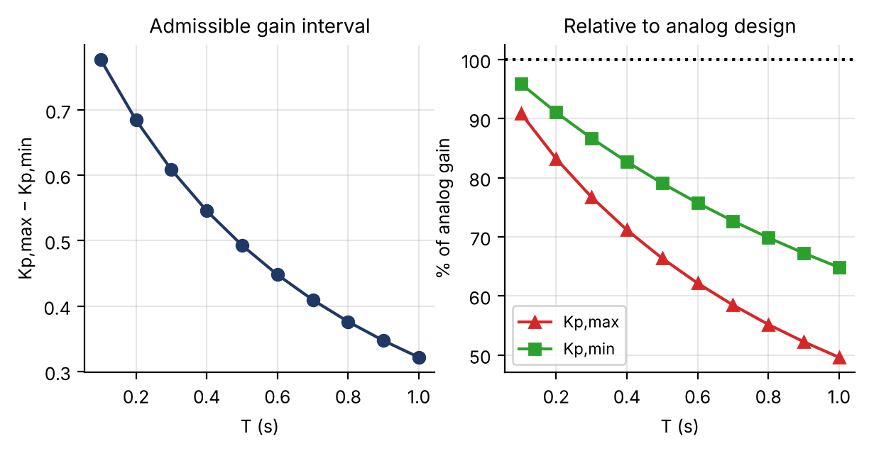
Figure 10. Left: admissible gain-interval width vs T. Right: K_{p,max}(T) and K_{p,min}(T) as a percentage of their analog counterparts.
T (s) | Interval width | K_{p,max} / analog | K_{p,min} / analog
0.1 | 0.777 | 90.9% | 95.9%
0.2 | 0.684 | 83.2% | 91.1%
0.4 | 0.546 | 71.2% | 82.7%
0.6 | 0.448 | 62.1% | 75.7%
0.8 | 0.376 | 55.2% | 69.8%
1.0 | 0.322 | 49.6% | 64.8%
(Every-other-row excerpt; full table in A3_interval_width.csv.)
Interpretation. The admissible window narrows from 0.777 at T = 0.1 s to 0.322 at T = 1.0 s (−59%), and it narrows from the top down: K_{p,max} erodes to 49.6% of its analog value by T = 1 s, K_{p,min} only to 64.8%. This reflects §6.3: K_{p,max} is governed largely by phase lag, well captured by the half-sample-delay picture, whereas K_{p,min} is a real-axis breakaway condition that erodes more slowly.

10. Frequency-Domain Robustness
This section re-derives the stability picture from the frequency domain (gain margin, phase margin, Nyquist) and checks that it agrees exactly with the z-plane picture, not just qualitatively.

10.1 Gain margin, phase margin and crossover frequency vs T
Objective: For L(z) = K_{p}G(z) at both Table 1 boundaries and every T, compute GM, PM and the gain-crossover frequency; connect the trend to §6.1.

for i = 1:n % loop over Ts (data loop, not shown in full)
[b1,b0,p] = zoh_coeffs(Table1.T(i),a,K); Gz = tf([b1 b0],[1 -(1+p) p],Table1.T(i));
[GM,PM,Wcg,Wcp] = margin(Table1.Kp_max(i)*Gz); % GM linear, PM deg
% Wcg: frequency of the gain margin (phase = -180); Wcp: gain-crossover frequency (|L| = 1)
GMdB = 20*log10(GM); wgc = Wcp;
end
allmargin(Table1.Kp_max(end)*Gz) % full set of crossings and delay margin

T (s) | K_{p,max} | PM (°) | GM (dB) | GM (lin) | ω_{gc} (rad/s) | K_{p,min} | PM (°) | GM (lin)
0.1 | 1.5613 | 64.02 | 27.16 | 22.815 | 0.829 | 0.7803 | 75.66 | 45.650
0.2 | 1.4299 | 63.57 | 22.20 | 12.875 | 0.768 | 0.7447 | 75.06 | 24.721
0.3 | 1.3182 | 63.24 | 19.67 | 9.632 | 0.714 | 0.7111 | 74.54 | 17.856
0.4 | 1.2224 | 63.00 | 18.13 | 8.066 | 0.667 | 0.6794 | 74.09 | 14.511
0.5 | 1.1395 | 62.82 | 17.11 | 7.172 | 0.625 | 0.6497 | 73.70 | 12.579
0.6 | 1.0671 | 62.69 | 16.41 | 6.617 | 0.588 | 0.6217 | 73.36 | 11.357
0.7 | 1.0035 | 62.59 | 15.93 | 6.257 | 0.555 | 0.5955 | 73.07 | 10.544
0.8 | 0.9473 | 62.50 | 15.59 | 6.019 | 0.526 | 0.5709 | 72.82 | 9.988
0.9 | 0.8972 | 62.44 | 15.37 | 5.865 | 0.499 | 0.5478 | 72.61 | 9.607
1.0 | 0.8524 | 62.38 | 15.22 | 5.771 | 0.475 | 0.5261 | 72.42 | 9.350
Table 5. Phase and gain margin at both boundaries (csv_new_plant/B1_margins.csv).
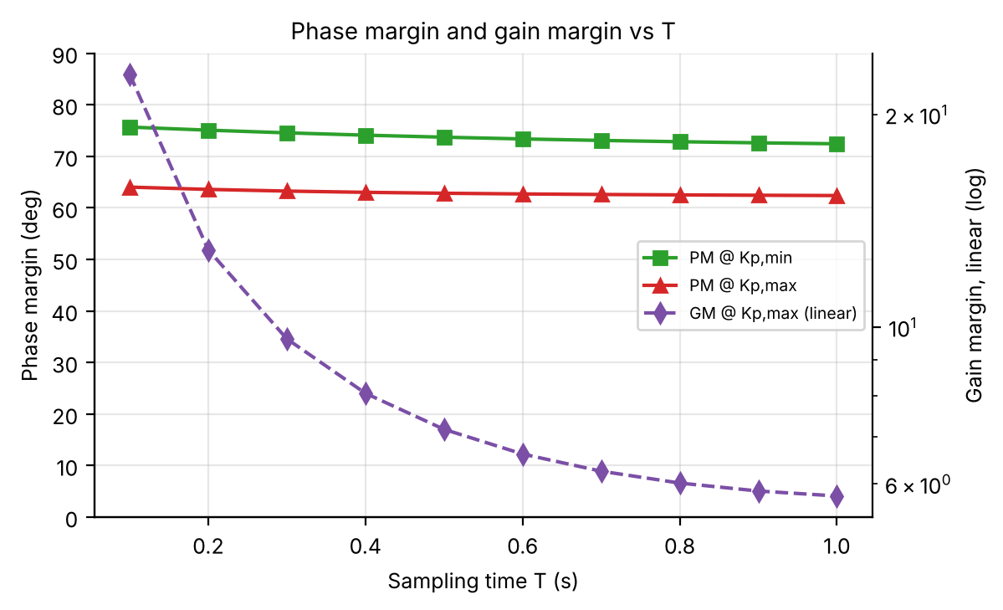
Figure 11. Phase margin at both boundaries (left axis) and linear gain margin at K_{p,max} (right axis, log) vs T.
Interpretation. Phase margin barely moves across the whole range: 62.4°–64.0° at K_{p,max} and 72.4°–75.7° at K_{p,min}, because the design always places the dominant pole at the same ζ, and PM is tied to that damping ratio. Gain margin is the metric that erodes with T, from 22.8× (27.2 dB) at T = 0.1 s to 5.77× (15.2 dB) at T = 1.0 s at K_{p,max}. Multiplying GM(lin) by K_{p} reproduces K_{p,stab} from the root-locus analysis at every T (e.g. T = 1 s: 5.7709 × 0.8524 = 4.919), so the §6.1 gain-margin ratios are precisely the classical gain margins.

10.2 Nyquist analysis at T = 1 s
Objective: Plot the Nyquist diagram of L(z) at K_{p} = 0.7845, 2.534 and 4.284 (the marginal-stability gain); mark −1; count encirclements; connect the marginal case to the unit-circle crossing of Figure 2.

Kps_nyq = [Kp1_max, Kp1_mid, Kp1_stab]; % Kp1_mid = mean of Kp1_max and Kp1_stab
figure; nyquistplot(Kps_nyq(1)*Gz1, Kps_nyq(2)*Gz1, Kps_nyq(3)*Gz1); % auto-indents around z = 1
zz = exp(1j*linspace(1e-4,pi,6000));
for Kp = Kps_nyq
L = Kp*(b1T*zz+b0T)./((zz-1).*(zz-pT)); % P = 0 -> N = #unstable closed-loop poles
rc = roots([1, Kp*b1T-(1+pT), pT+Kp*b0T]); N = sum(abs(rc) > 1+1e-6);
fprintf('Kp=%.4f: closest approach to -1 = %.5f, N = %d\n', Kp, min(abs(L+1)), N);
end

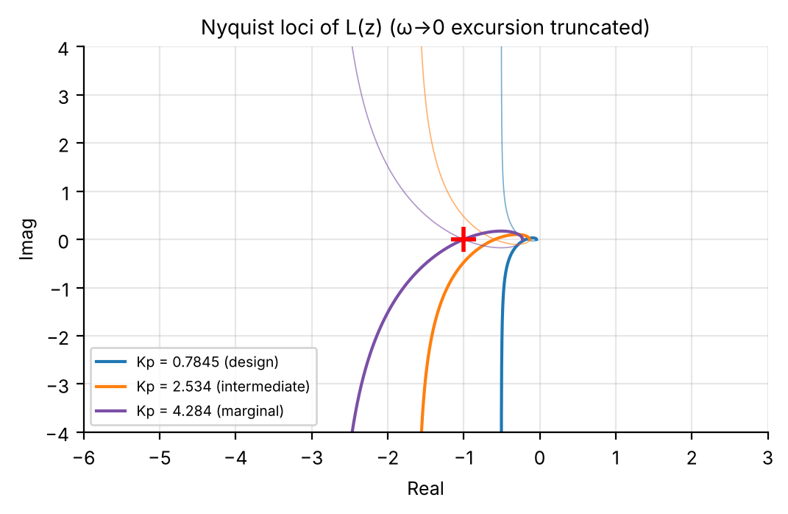
Figure 12. Nyquist loci of L(z) at the three gains (the large excursion as ω → 0, from the pole at z = 1, is truncated by the axis limits).
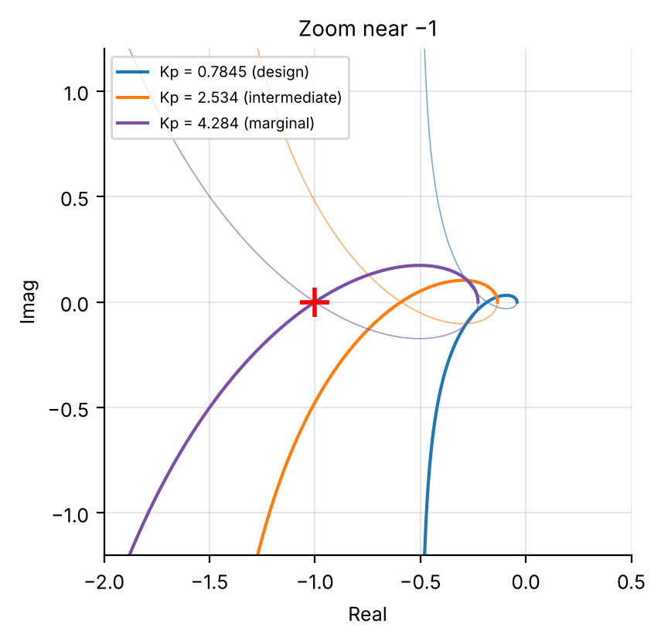
Figure 13. Zoom near −1: the closest approach shrinks from 0.691 (K_{p} = 0.7845) to 0.273 (2.534) to ≈ 10⁻⁶ (4.284), passing through −1.
K_{p} | Closest approach to −1 | N (clockwise encirclements) | Status
0.7845 (design) | 0.691 | 0 | stable, healthy margin
2.5344 (intermediate) | 0.273 | 0 | stable, reduced margin
4.2843 (marginal) | 1.3e-06 | 0 (locus passes through −1) | marginally stable

Interpretation. The open loop has no poles outside the unit disk (P = 0; the pole at z = 0.15 is inside, the pole at z = 1 is handled by the small-radius indentation), so stability needs zero net clockwise encirclements of −1. At K_{p} = 4.284 the locus passes through −1 to within 10⁻⁶: exactly the marginal gain (1−p)/b₀ from the root-locus discriminant argument. This is the frequency-domain restatement of Figure 2: the purple diamond where the locus crosses the unit circle and the point where the Nyquist curve crosses −1 are the same event seen in two planes.

11. Sampling Physics, Continued

11.1 Closed-loop bandwidth vs Nyquist frequency
Objective: Compute the closed-loop bandwidth ω_{b} at K_{p,max} for each T and compare it with the Nyquist frequency π/T; state where sampling becomes marginal by the 6–10× rule of thumb.

Gcl = feedback(Table1.Kp_max(i)*Gz, 1); % per T, with Gz = tf([b1 b0],[1 -(1+p) p],T)
bw(i) = bandwidth(Gcl); % -3 dB bandwidth, rad/s
wnyq(i) = pi/Table1.T(i); ratio(i) = wnyq(i)/bw(i);

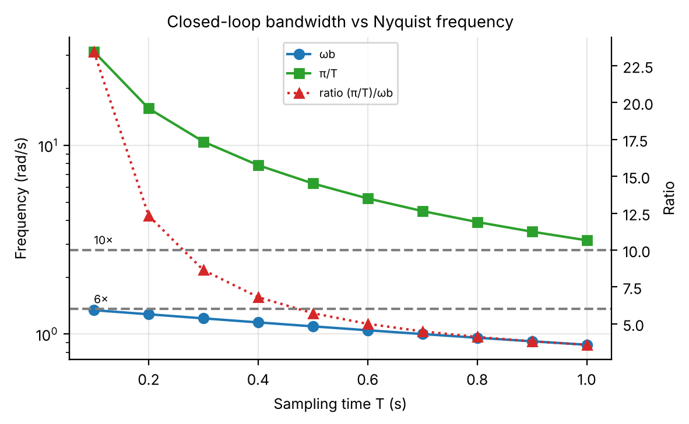
Figure 14. Closed-loop bandwidth ω_{b} and Nyquist frequency π/T (log scale, left) and their ratio (right axis) against the 6× and 10× guidelines.
T (s) | K_{p,max} | ω_{b} (rad/s) | π/T (rad/s) | Ratio
0.1 | 1.5613 | 1.339 | 31.416 | 23.46×
0.2 | 1.4299 | 1.274 | 15.708 | 12.33×
0.3 | 1.3182 | 1.212 | 10.472 | 8.64×
0.4 | 1.2224 | 1.154 | 7.854 | 6.81×
0.5 | 1.1395 | 1.099 | 6.283 | 5.72×
0.6 | 1.0671 | 1.048 | 5.236 | 5.00×
1.0 | 0.8524 | 0.878 | 3.142 | 3.58×
(Excerpt; all ten rows in C1_bandwidth.csv.)
Interpretation. The ratio falls below the conservative 10× guideline between T = 0.2 s (12.3×) and 0.3 s (8.6×), and below the lenient 6× guideline between 0.4 s (6.8×) and 0.5 s (5.7×). At T = 1 s the sampling rate is only 3.6× the closed-loop bandwidth, inside the region where visible sampling artefacts are expected: exactly what appears independently as the intersample deviation of §14.2 and the settling-time discrepancies of §6.2 and §6.6.

11.2 ZOH zero migration
Objective: Derive and plot z₀(T) = −b₀(T)/b₁(T); explain how the zero’s migration reshapes the locus and why it explains the delay heuristic fitting K_{p,max}(T) but not K_{p,min}(T).

Tg = linspace(0.05,1.2,400);
[b1g,b0g,pg] = zoh_coeffs(Tg,a,K); % vectorised: zoh_coeffs uses elementwise operators
plot(Tg,-b0g./b1g,'LineWidth',2); hold on; plot(Tg,pg,'r--'); yline(-1,':k');
plot(T1,-zero_given,'ko','MarkerFaceColor','y'); % the zero written on the lab sheet

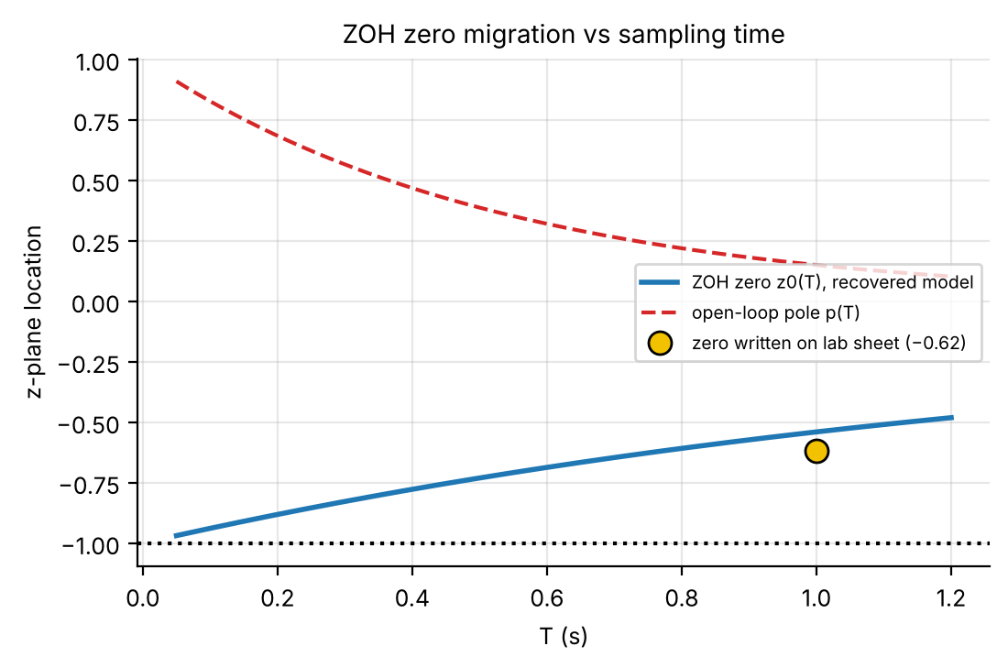
Figure 15. The ZOH zero z₀(T) of the recovered model (solid), the open-loop pole p(T) (dashed) and the zero written on the lab sheet (yellow marker, −0.62 at T = 1 s).
T (s) | 0.05 | 0.34 | 0.63 | 0.91 | 1.00 | 1.20
z₀(T) | -0.969 | -0.807 | -0.674 | -0.569 | -0.540 | -0.481
p(T) | 0.910 | 0.525 | 0.303 | 0.178 | 0.150 | 0.103

Interpretation. As T → 0 the ZOH zero migrates toward z = −1 (the classical ZOH sampling zero for a relative-degree-2 plant) while the pole p(T) moves to z = 1 more slowly. This asymmetric migration is the geometric reason the delay heuristic works for K_{p,max}(T) (R² = 0.988) but fails for K_{p,min}(T) (R² = −0.23): the ζ = 0.69 crossing is dominated by phase contributions a pure delay captures, whereas the breakaway point is a real-axis algebraic condition that depends on where the fast-moving zero sits relative to the slow-moving pole, a geometric fact a delay approximation (which encodes only phase lag) cannot see. The yellow marker also shows the §5.1 mismatch: the sheet’s zero lies off the model curve, at the position the model would have for T ≈ 0.77 s.

12. Sensitivity and Robustness to Plant Uncertainty
Every result so far assumes the recovered plant parameters exact. This section asks how sensitive the closed-loop pole is to a small gain error, and how much the design degrades if a and K are themselves off by ±10%.

12.1 Pole sensitivity |dz/dK_{p}| at T = 1 s
Objective: By implicit differentiation of the characteristic equation, compute |dz/dK_{p}| at K_{p} = 0.7845 (5% overshoot boundary) and K_{p} = 4.284 (stability boundary) and interpret the ratio.

With F(z,K_{p}) = z² + [K_{p}b₁−(1+p)]z + [p+K_{p}b₀] = 0, implicit differentiation gives
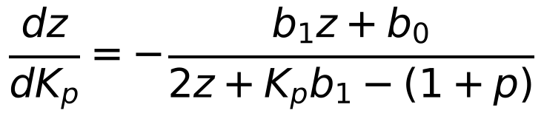
The denominator is the breakaway discriminant condition of §4.4: sensitivity diverges at breakaway and shrinks farther along the locus.
function [dzdKp,zc] = pole_sensitivity(Kp,b1,b0,p)
B = Kp*b1-(1+p); r = roots([1 B p+Kp*b0]);
if any(abs(imag(r)) > 1e-9), zc = r(imag(r) > 0); zc = zc(1); else, zc = max(r); end
dzdKp = -(b1*zc + b0)/(2*zc + B);
end

K_{p} | Closed-loop pole z | |dz/dK_{p}|
0.7845 (design point) | 0.4495 + 0.3219j | 0.555
4.2843 (marginal stability) | -0.1105 + 0.9939j | 0.180
Ratio |  | 3.09×

Interpretation. The pole is about 3× more sensitive to gain error at the design point than near marginal stability, because the design point sits on the tightly curved part of the locus near breakaway, while K_{p} = 4.284 sits on the flatter part near the unit circle. Despite the large absolute gain margin (5.5×–22.8×), a 1% error in K_{p} at the design point moves the dominant pole about 3× further than the same error near marginal stability: pushing gain “for a snappier response” moves toward a region that is less stable in absolute terms and mechanically more sensitive.

12.2 Robustness to ±10% errors in a and K, T = 1 s
Objective: Redo the design with a and K perturbed ±10% in all four sign combinations, apply the nominal K_{p,max}, simulate %OS/t_{s}, and state whether the specs survive or K_{p} must be detuned.

Kp_nom = Table1.Kp_max(iT1); % nominal gain of the continuous-model design (0.8524)
combos = [1.1 1.1; 1.1 0.9; 0.9 1.1; 0.9 0.9];
for i = 1:4
[b1_,b0_,p_] = zoh_coeffs(1.0, a*combos(i,1), K*combos(i,2));
[OSr(i),tsr(i)] = evaluate_design(b1_,b0_,p_,Kp_nom,1.0);
fprintf('a%+.0f%% K%+.0f%%: OS = %6.2f%% ts = %.1f s\n',(combos(i,1)-1)*100,(combos(i,2)-1)*100,OSr(i),tsr(i));
end

Perturbation (a / K) | a | K | %OS | t_{s} | Spec (%OS ≤ 5, t_{s} ≤ 9)
+10% / +10% | 2.0868 | 1.2099 | 3.90% | 7.0 s | meets
+10% / -10% | 2.0868 | 0.9899 | 0.71% | 5.0 s | meets
-10% / +10% | 1.7074 | 1.2099 | 12.39% | 7.0 s | VIOLATES (overshoot)
-10% / -10% | 1.7074 | 0.9899 | 6.32% | 8.0 s | VIOLATES (overshoot)
nominal (0 / 0) | 1.8971 | 1.0999 | 4.98% | 7.0 s | meets
Table 6. Robustness with nominal K_{p} = 0.8524 held fixed (csv_new_plant/D2_robustness.csv).
Interpretation. With K_{p} fixed, the design tolerates a plant that is 10% faster (a high) in both K cases (OS ≤ 3.9%), but a plant that is 10% slower (a low) violates the overshoot spec for both K values (12.4% with K high, 6.3% with K low), while t_{s} stays ≤ 8 s throughout. The design has essentially no robustness against unfavourable errors in a: a real implementation needs either plant identification well under ±10% or a detuned K_{p} (e.g. the mid-window 0.66 of §6.7) that buys overshoot margin.

13. Beyond Proportional Control: Lead Compensator Design
Objective: Design C(z) = K(z − z_{lead})/(z − p_{lead}) at T = 1 s keeping %OS ≤ 5% while settling faster than the best proportional-only design, with a one-sample margin under a 5 s target; verify by full discrete simulation.

Fairness first. The proportional design is not stuck at 9 s: that figure belongs to the K_{p,min} end of the window. As §6.7 showed, K_{p} ≈ 0.635–0.678 already settles in 5 s (OS 1.45% at the mid-band gain 0.656). A lead compensator is therefore only worthwhile if it beats 5 s, so the target here is t_{s} ≤ 5 − 1 = 4 s.
Design approach. Set z_{lead} = p = 0.15 to cancel the slow plant pole. The remaining loop L(z) = K(b₁z+b₀)/[(z−1)(z−p_{lead})] has the same form as the proportional design with the fixed pole p replaced by a free p_{lead}, so the breakaway and ζ-crossing functions of §4.4–4.5 are reused with p_{lead} and swept to find the least aggressive pole that meets the target in a full simulation.
z_lead = pT; cand = 0.15:-0.05:-0.40; % cancel the plant pole; sweep p_lead
for q = 1:numel(cand)
try
[km,kb] = breakaway_gain(b1T,b0T,cand(q));
Kc(q) = zeta_crossing_gain(b1T,b0T,cand(q),zeta_min,km*1.0005,kb*0.999);
Cq = tf(Kc(q)*[1 -z_lead],[1 -cand(q)],T1);
i2 = stepinfo(feedback(Cq*Gz1,1),'SettlingTimeThreshold',0.02);
OSc(q) = i2.Overshoot; tsc(q) = i2.SettlingTime;
catch, end % bracket fails for very negative p_lead
end
ok = find(OSc <= OS_spec+OS_tol & tsc <= ts_lead-lead_margin, 1, 'first'); % ts_lead = 5, margin = 1
p_lead = cand(ok); K_lead = Kc(ok); C = tf(K_lead*[1 -z_lead],[1 -p_lead],T1);

p_{lead} | K | %OS (simulated) | t_{s} (simulated)
+0.15 (baseline: original pole) | 0.7845 | 5.00% | 7 s
0.00 | 1.0955 | 4.99% | 6 s
−0.10 | 1.3323 | 4.34% | 5 s
−0.20 (chosen) | 1.5922 | 4.91% | 4 s
−0.30 | 1.8734 | 3.19% | 4 s
−0.40 | 2.1657 | 5.82% | 3 s
Table 7. Lead search excerpt (all candidates in lead_search.csv). p_{lead} = 0.15 reproduces the proportional K_{p,max} design. The −0.10 candidate (5 s) only equals the best proportional design, so it is rejected; −0.20 is the first candidate that is strictly faster with a one-sample margin.
Final compensator: C(z) = 1.5922 (z − 0.15) / (z + 0.20), with closed-loop poles 0.1452 ± 0.3079j.
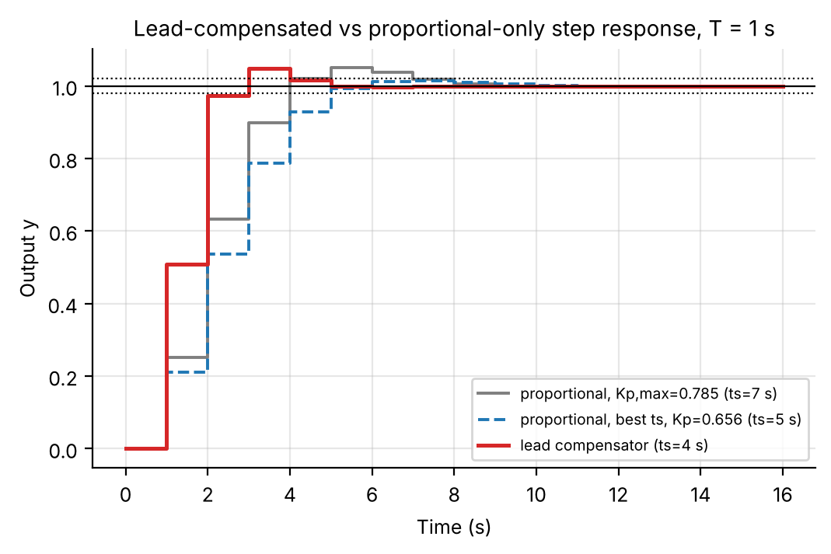
Figure 16. Full discrete step response at T = 1 s: lead-compensated design (red, t_{s} = 4 s), proportional at the best-t_{s} gain (blue dashed, 5 s) and proportional at K_{p,max} (grey, 7 s).
Metric | Proportional, K_{p,max} | Proportional, best t_{s} (K_{p} = 0.656) | Lead compensator (this design)
%OS | 5.00% | 1.45% | 4.91%
t_{s} (2%) | 7 s | 5 s | 4 s (1 s margin under the 5 s target)
Controller gain | 0.7845 | 0.656 | 1.5922 (≈ 2× larger)

Interpretation. Cancelling the slow plant pole and adding a faster negative-real pole at z = −0.20 roughly doubles the usable gain (0.78 → 1.59) while keeping the dominant pole pair on the ζ = 0.69 contour, so overshoot stays at the 5% limit (4.91%) and t_{s} drops from the proportional best of 5 s to 4 s (and from 9 s at the K_{p,min} end). The gain is modest, one sample, because settling time is already quantised to whole sampling periods, and it is paid for with the full overshoot budget and a controller gain twice as large (more noise amplification), whereas the best proportional design keeps 3.5 percentage points of overshoot margin. The lead is thus justified only if the 4 s target matters. The pole at −0.20 decays within a sample or two and does not affect the dominant response.

14. Presentation: Nomograph and Intersample Analysis

14.1 Design nomograph
Objective: One figure: T on x, K_{p} on y, the %OS ≤ 5% region shaded, the t_{s} ≤ 9 s bound overlaid and their intersection shaded as the spec-compliant region, with the Table 1 points labelled.

Tg14 = linspace(0.1,1.0,19); Kpg14 = linspace(0.6*min(Table1.Kp_min), 1.7*max(Table1.Kp_max), 85);
for i = 1:numel(Tg14) % grid simulation, same machinery as 6.5
[b1,b0,p] = zoh_coeffs(Tg14(i),a,K);
for j = 1:numel(Kpg14), [OS14(j,i),ts14(j,i)] = evaluate_design(b1,b0,p,Kpg14(j),Tg14(i)); end
end
ok14 = double((OS14 <= OS_spec) & (ts14 <= ts_spec));
contourf(Tg14,Kpg14,ok14,[0.5 1.5]); hold on;
contour(Tg14,Kpg14,OS14,[OS_spec OS_spec],'r','LineWidth',2); contour(Tg14,Kpg14,ts14,[ts_spec ts_spec],'b','LineWidth',2);

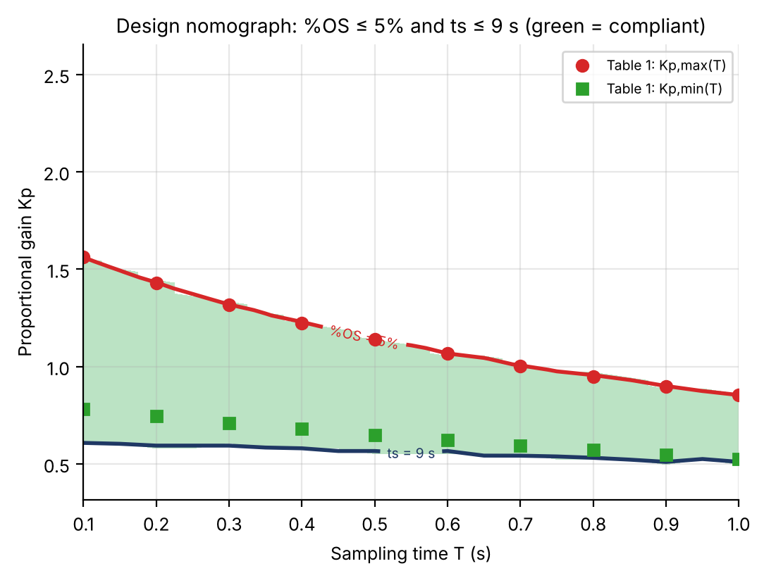
Figure 17. Green: both specs satisfied. Red: %OS = 5% boundary (= K_{p,max}(T)). Navy: t_{s} = 9 s boundary (drawn only below K_{p,max}). Table 1 points overlaid.
Interpretation. The compliant region’s upper boundary is always the 5% overshoot line, so K_{p,max}(T) binds from above at every T. Its lower boundary is the t_{s} = 9 s line, which lies below K_{p,min}(T) for every T < 1 s (the window extends below breakaway at 0% overshoot, only slower) and meets K_{p,min}(T) as T → 1 s. This independently confirms from a full-grid simulation that the settling-time constraint becomes binding only at the coarsest sampling, where the ζ = 1 gain itself sits at 9 s.

14.2 Intersample peak quantification
Objective: At T = 1 s with K_{p} = K_{p,max}, simulate the step response and evaluate the peak both on the sample sequence and on the true continuous response; report the gap across all T.

Ac = [0 1; 0 -a]; Bc = [0; K]; Cc = [1 0]; Nsub = 60; Kp14 = Table1.Kp_max(iT1);
sd = c2d(ss(Ac,Bc,Cc,0), T1/Nsub, 'zoh'); % fine ZOH sub-stepping of the continuous plant
x = [0;0]; t_h = 0; y_h = 0;
for m = 0:21
u = Kp14*(1 - Cc*x); % sampled error, held for one period
for k = 1:Nsub, x = sd.A*x + sd.B*u; t_h(end+1) = t_h(end)+T1/Nsub; y_h(end+1) = Cc*x; end
end
y_s = y_h(1:Nsub:end); OS_s = max(0,(max(y_s)-1)*100); [pk,ipk] = max(y_h); OS_c = max(0,(pk-1)*100);

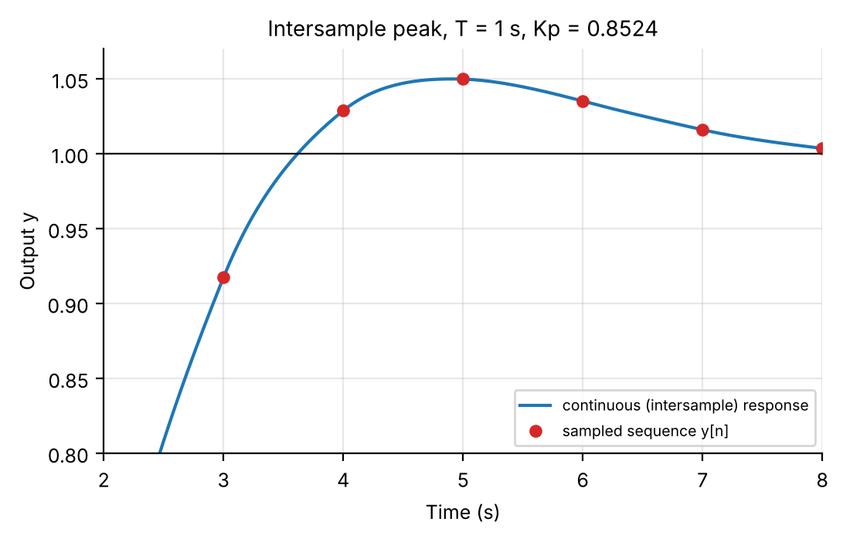
Figure 18. True continuous intersample response (blue) vs the sampled sequence y[n] (red), zoomed on the peak (T = 1 s, K_{p} = 0.8524).
At T = 1 s: 4.981% overshoot on the sample sequence (peak at t = 5 s, a sample instant) versus 4.994% true continuous overshoot (peak at t = 4.90 s, between samples), a gap of 0.012 percentage points. Repeating this at each T with its own K_{p,max}:
T (s) | 0.1 | 0.2 | 0.3 | 0.4 | 0.5 | 0.6 | 0.7 | 0.8 | 0.9 | 1.0
OS on samples (%) | 4.999 | 4.974 | 4.992 | 4.902 | 5.000 | 4.997 | 4.946 | 4.848 | 4.908 | 4.981
OS continuous (%) | 5.000 | 5.000 | 5.001 | 5.002 | 5.000 | 4.999 | 5.014 | 5.010 | 5.032 | 4.994
Gap (points) | 0.001 | 0.027 | 0.009 | 0.099 | 0.000 | 0.001 | 0.067 | 0.162 | 0.124 | 0.012
Table 8. Sampled vs continuous overshoot at K_{p,max} for each T (csv_new_plant/E_intersample_vs_T.csv).
Interpretation. The sampled sequence can understate the true peak by up to 0.16 points (T = 0.8 s), and at T = 0.7–0.9 s the true continuous overshoot reaches 5.01–5.03%, i.e. fractionally above the 5% target even though the sampled response reports 4.85–4.95%. The gap is negligible at fine sampling and tends to grow, non-monotonically (it depends on where the peak falls relative to the sample instants), as π/T falls toward 4× the bandwidth (§11.1). The bar to watch is the upper end of the interval [OS_{samples}, OS_{continuous}]; the continuous response can only reveal a peak the samples missed, never hide one that is there.

