
INDIAN INSTITUTE OF TECHNOLOGY ROPAR
Department of Electrical Engineering
Control Engineering Laboratory
PROJECT / EXPERIMENT
Position Control by a Servomotor Actuator
Group No. ____________
GROUP MEMBERS
S. No. | Name of Group Member | Entry No.
1
2
3
4
Date of Experiment: ____________

1. Aim
To study the closed-loop speed and position control of a Mitsubishi 230 V AC servomotor driven by an MR-JE-40AS servo amplifier under a bang-bang (relay) control law, and to determine, from measurement, the range of reference speed and commanded angular displacement over which the actuator positions itself reliably.

2. Objectives
- To operate the servomotor in speed-control mode over the full rated range up to 2000 rpm and to measure the steady-state speed error in both the forward and reverse directions using the photoelectric feedback readout.
- To operate the servomotor in position-control mode at three fixed speeds — 1500 rpm, 800 rpm and 100 rpm — and to measure the angle actually attained for a range of commanded angles.
- To use the number of forward switching actions recorded for each command as a direct measure of bang-bang chattering, and to relate it to the resulting positioning error.
- To identify the operating limits of the actuator, including the minimum attainable speed, any speed band over which the drive fails to behave normally, and the smallest angular command that can be executed reliably at each speed.
- To explain the observed behaviour in terms of the relay control law, the controller deadband, sensor resolution, rotor inertia and friction.

3. Apparatus
- Mitsubishi 230 V AC servomotor with integral encoder.
- Mitsubishi MR-JE-40AS servo amplifier / controller.
- Photoelectric (opto-interrupter) position and speed sensing unit with digital readout.
- Control console with speed and angular-position setting screens (Screen 2 for speed, Screen 3 for position).
- Single-phase AC supply and interconnection cabling.

4. Theory

4.1 The bang-bang control law
A bang-bang controller, also called a relay or on–off controller, does not scale its output in proportion to the error. It selects one of a small number of fixed output levels according to the sign of the error alone. Writing the position error as
e_{θ} = θ_{ref} − θ_{actual}
the ideal relay law drives the actuator at full command in whichever direction reduces the error:
u = +U_{max} for e_{θ} > 0, u = −U_{max} for e_{θ} < 0
The attraction of this scheme is that it needs no tuning and no plant model, and it applies maximum available torque throughout the move, so the transient is as fast as the hardware allows. Its weakness is that it has no notion of "almost there": the command remains at full value until the error changes sign, at which point it reverses completely.

4.2 Deadband and chattering
Because the ideal law switches on the instant the error crosses zero, measurement noise and finite sensor resolution cause it to switch repeatedly about the target. This rapid reversal is called chattering, and it produces audible vibration, mechanical wear and switching losses without improving accuracy. The standard remedy is to introduce a deadband ε about zero error:
u = +U_{max} for e_{θ} > ε; u = 0 for |e_{θ}| ≤ ε; u = −U_{max} for e_{θ} < −ε
Inside the deadband the controller is passive: it applies no restoring torque at all. The deadband therefore sets a floor on achievable accuracy and, more importantly for this experiment, it means that any commanded displacement comparable in size to ε cannot be resolved by the controller. The choice of ε is a compromise — too small and the drive chatters, too large and the actuator stops short of its target.

4.3 Closed-loop structure with photoelectric feedback
The commanded angle is compared with the angle reported by the photoelectric sensor, the relay block converts the resulting error into a discrete speed or torque command, and the servo amplifier drives the motor accordingly. The sensor consists of a slotted disc mounted on the shaft which alternately blocks and passes a light beam falling on a phototransistor. Each interruption generates a pulse, and the pulse count gives the angular displacement while the pulse rate gives the speed.
Two properties of this feedback path matter for the results that follow. First, its resolution is finite: displacements smaller than one slot pitch cannot be distinguished. Second, it is sampled: the controller updates its estimate only once per sampling interval Ts, during which the shaft advances by approximately
Δθ ≈ ω T_{s}
so the effective feedback delay in angular terms grows in direct proportion to speed.

4.4 Mechanical behaviour during stopping
Neglecting compliance, the rotor obeys
J (dω/dt) + Bω = T_{m} − T_{L}, dθ/dt = ω
where J is the moment of inertia and B the viscous friction coefficient. When the relay removes its command, the stored rotational kinetic energy
E_{k} = ½ J ω²
must be dissipated before the shaft comes to rest, so the motor overtravels. Since Ek varies as the square of speed, a doubling of operating speed quadruples the energy that has to be removed. At the opposite extreme, when the speed is very low the available torque may be insufficient to overcome static friction (stiction), and the shaft stops short of the target instead.

4.5 Error definitions used in this report
The signed position error is taken as the observed forward angle minus the commanded angle, so that a negative value denotes undertravel and a positive value overtravel:
e_{θ} = θ_{FW,obs} − θ_{set}, %Error = |e_{θ}| / θ_{set} × 100
The speed error is defined in the same way, with the worst-case value taken where the readout fluctuated over a range:
e_{N} = N_{meas} − N_{ref}, %Error = |e_{N}| / N_{ref} × 100

5. Procedure
The supply to the servo amplifier was switched on and the drive was allowed to initialise. The console was then set to Screen 2 for the speed-control tests. Reference speeds were entered in ascending order and, for each setting, the speed reported by the photoelectric readout was noted in both the forward and reverse directions. Where the readout fluctuated, the extremes of the observed range were recorded. The lowest speed at which the shaft would turn continuously was found by reducing the reference until rotation ceased.
The console was then set to Screen 3 for the position-control tests. The operating speed was fixed at 1500 rpm and a series of angular commands from 5° to 330° was entered. For each command the angle reached in the forward direction, the angle registered in the reverse direction and the number of forward switching actions taken by the controller were recorded. The shaft was returned to its home position between readings. The procedure was repeated with the speed fixed at 800 rpm and again at 100 rpm.

6. Observations

6.1 Speed control
Table 1 lists the speed-control readings. Where the display was not steady, the range over which it varied is given and the error is computed from whichever end of that range lies further from the reference.
Table 1 — Forward and reverse speed control results
Sr. | Ref. speed (rpm) | FWD observed (rpm) | REV observed (rpm) | Worst error (rpm) | Error (%) | Remark
1 | 27 | 27 | 27 | 0 | 0.00 | Servo minimum speed
2 | 30 | 30 | 30 | 0 | 0.00 | Exact
3 | 90 | 90 | 90 | 0 | 0.00 | Exact
4 | 120 | 120 | 120 | 0 | 0.00 | Exact
5 | 140 | 140 | 140 | 0 | 0.00 | Exact
6 | 150 – 300 | — | — | — | — | Misbehaving; no stable reading
7 | 310 | 309 – 310 | 305 – 310 | −1 | 0.32 | Rev. spread 5 rpm
8 | 420 | 419 – 420 | — | −1 | 0.24
9 | 500 | 498 – 500 | — | −2 | 0.40
10 | 600 | 598 – 600 | — | −2 | 0.33
11 | 800 | 795 – 800 | — | −5 | 0.62 | Largest error observed
12 | 1000 | 997 – 1000 | — | −3 | 0.30
13 | 1200 | 1196 – 1200 | — | −4 | 0.33
14 | 1400 | 1403 | — | +3 | 0.21
15 | 1600 | 1601 | — | +1 | 0.06 | Smallest error observed
16 | 1800 | 1804 | — | +4 | 0.22
17 | 2000 | 1994 – 1995 | — | −6 | 0.30 | Rated limit
The lowest speed at which the shaft rotated continuously was 27 rpm; below this the motor did not turn. Readings between 150 rpm and 300 rpm could not be taken because the drive did not behave normally in that band.

6.2 Position control at 1500 rpm
Table 2 — Position control at 1500 rpm
Set angle θset (°) | FW obs. (°) | BW obs. (°) | FW steps | FW error eθ (°) | Error (%)
5 | 1 | 4 | 5 | −4 | 80.00
20 | 1 | 19 | 18 | −19 | 95.00
35 | 35 | 0 | 1 | 0 | 0.00
90 | 90 | 0 | 1 | 0 | 0.00
120 | 120 | 0 | 1 | 0 | 0.00
200 | 200 | 0 | 1 | 0 | 0.00
250 | 250 | 0 | 1 | 0 | 0.00
330 | 330 | 0 | 1 | 0 | 0.00

6.3 Position control at 800 rpm
Table 3 — Position control at 800 rpm
Set angle θset (°) | FW obs. (°) | BW obs. (°) | FW steps | FW error eθ (°) | Error (%)
15 | 1 | 14 | 12 | −14 | 93.33
30 | 28 | 0 | 2 | −2 | 6.67
50 | 50 | 0 | 1 | 0 | 0.00
100 | 100 | 0 | 1 | 0 | 0.00
150 | 150 | 0 | 1 | 0 | 0.00
200 | 200 | 0 | 1 | 0 | 0.00
300 | 300 | 0 | 1 | 0 | 0.00
330 | 330 | 148 | 1 | 0 | 0.00

6.4 Position control at 100 rpm
Table 4 — Position control at 100 rpm
Set angle θset (°) | FW obs. (°) | BW obs. (°) | FW steps | FW error eθ (°) | Error (%)
30 | 30 | 0 | 1 | 0 | 0.00
120 | 116 | 66 | 4 | −4 | 3.33
130 | 116 | 19 | 2 | −14 | 10.77
180 | 115 | 64 | 3 | −65 | 36.11
240 | 116 | 124 | 3 | −124 | 51.67
300 | 116 | 185 | 3 | −184 | 61.33
355 | 116 | 240 | 8 | −239 | 67.32
Rows shaded in red are those exceeding the 5% error criterion adopted in Section 8. "FW steps" is the number of forward switching actions the controller took before settling.

7. Results and Analysis

7.1 Speed-tracking performance
Outside one anomalous band the drive tracks its speed reference very closely. Every reading from 27 rpm to 2000 rpm lies within 6 rpm of the commanded value, and the largest percentage error anywhere in the table is 0.62%, recorded at 800 rpm. At the five lowest settings tested — 27, 30, 90, 120 and 140 rpm — the readout matched the reference exactly in both directions, and at the rated limit of 2000 rpm the measured speed was 1994–1995 rpm, an error of 0.30%.
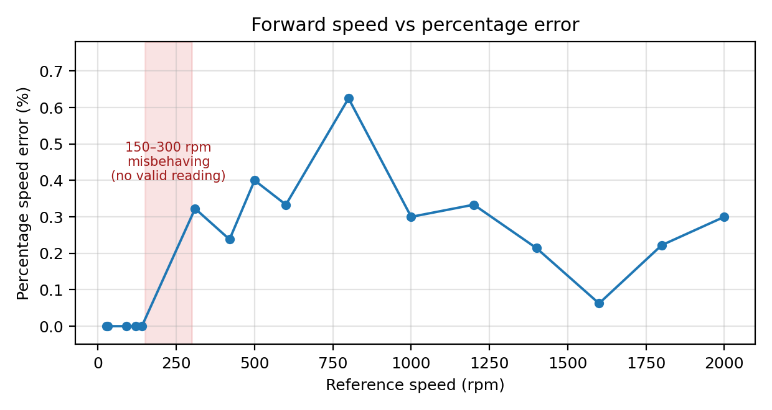
Figure 1 — Percentage speed error against reference speed. The shaded band marks the 150–300 rpm region in which no valid reading could be obtained.
The errors are not biased in one direction: the readings run low at 310, 500, 800, 1000, 1200 and 2000 rpm but high at 1400, 1600 and 1800 rpm. This scatter about the reference, rather than a consistent offset, indicates that what is being measured is quantisation and refresh behaviour of the photoelectric readout together with small ripple in the speed loop, not a calibration error in the drive.
It is worth noting that the minimum speed of 27 rpm achieved here is considerably lower than the figure usually quoted for this rig. The inner speed loop of the MR-JE amplifier is evidently able to hold rotation at a small fraction of rated speed, so the low-speed limitations that appear later in the position results are not caused by an inability to turn slowly.

7.2 The 150–300 rpm anomaly
The single break in an otherwise clean speed characteristic is the band from 150 rpm to 300 rpm, over which the drive misbehaved and no stable reading could be recorded. This is a mid-range band, with correct operation both below it (up to 140 rpm) and above it (from 310 rpm), so it cannot be explained by a torque or stiction limit — those would affect the low end only.
Two explanations are consistent with the observation. The first is an interaction between the pulse rate from the encoder disc and the update rate of the digital readout: at intermediate speeds the two can become commensurate, so that the number of pulses captured in each display window alternates and the reading will not settle. The second is a mechanical resonance of the shaft, coupling and load disc excited in that speed range, which would produce a genuine fluctuation in shaft speed rather than merely a fluctuating display. The two can be distinguished by listening to the rig and by watching whether the amplifier's own speed monitor is also unsteady; that check was not performed during this experiment and is recommended if the rig is revisited.
For the purpose of specifying a usable operating envelope, the practical consequence is the same either way: the band 150–300 rpm should be avoided.

7.3 Position control at high speed — small angles fail, large angles are exact
At 1500 rpm the results divide sharply into two groups. Commands of 35° and above — 35°, 90°, 120°, 200°, 250° and 330° — were all executed with zero error in a single switching action. Commands of 20° and below failed almost completely: the 5° command produced 1° of forward travel (80% error) after 5 switchings, and the 20° command also produced 1° of forward travel (95% error) after 18 switchings.
At 800 rpm the same pattern appears with the boundary shifted slightly downward. Commands from 50° to 330° were all exact in a single step; the 30° command reached 28°, a 2° shortfall corresponding to 6.67% error, in two steps; and the 15° command collapsed to 1° of forward travel, 93.33% error, after 12 switchings.
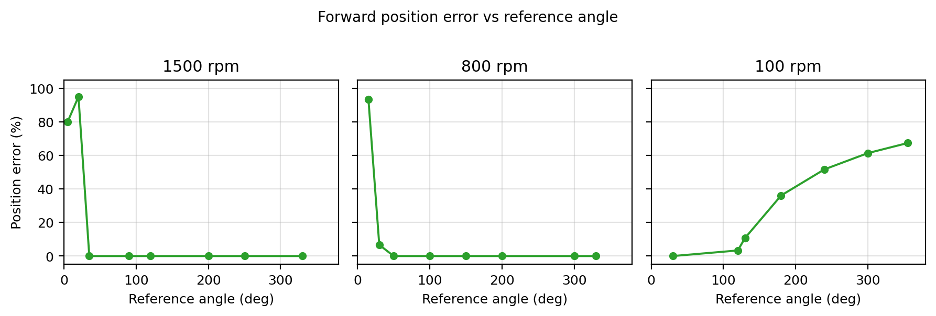
Figure 2 — Forward position error against reference angle at the three tested speeds. Note the reversal of the trend at 100 rpm.

7.4 The failure mechanism is the deadband, not rotor inertia
It is tempting to attribute the small-angle failures to the kinetic energy of the rotor, since that is the usual textbook explanation. The present data argue against it. If overtravel from stored energy set the smallest workable angle, that angle would scale with the stopping distance, which for braking at constant torque varies as ω². Between 800 rpm and 1500 rpm the speed ratio is 1.875, so the threshold angle should rise by a factor of about 3.5. The measured threshold moves only from somewhere between 15° and 30° at 800 rpm to somewhere between 20° and 35° at 1500 rpm — a change of roughly 1.2 times, nowhere near the predicted factor.
Two further observations point the same way. First, in all three failure cases — 5° and 20° at 1500 rpm, 15° at 800 rpm — the final forward reading was exactly 1°, the smallest non-zero value the readout can show, irrespective of both the commanded angle and the speed. A genuine inertial overshoot would leave the shaft at a position depending on how fast it was travelling, not parked at the resolution limit. Second, the 30° command at 800 rpm fell short by 2°, a small fixed offset of the order of the sensor resolution rather than a speed-dependent distance.
The consistent reading is that the controller deadband together with the finite resolution of the photoelectric sensor sets a minimum executable displacement of the order of 20–30° on this rig. When the command is smaller than this, the error is inside or barely outside the deadband from the outset, the relay has no proportional action available, and the drive simply hunts back and forth about the origin — which is exactly what the switching counts show.

7.5 Switching count as a direct measure of chattering
The "FW steps" column is the most informative single quantity recorded in this experiment, because it counts the relay switchings directly rather than inferring them. Every command that was executed accurately took exactly one step. Every command that failed took many: 18 steps for the 20° command at 1500 rpm, 12 for the 15° command at 800 rpm, 8 for the 355° command at 100 rpm.
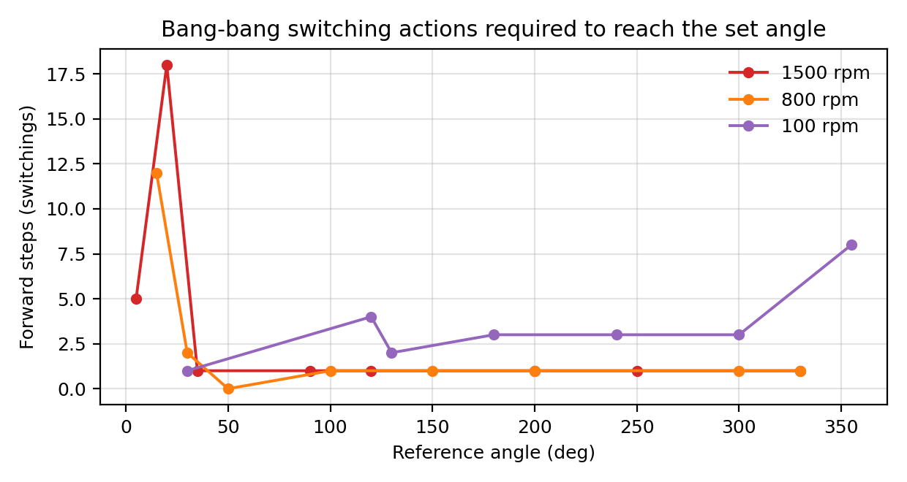
Figure 3 — Number of forward switching actions required at each commanded angle.
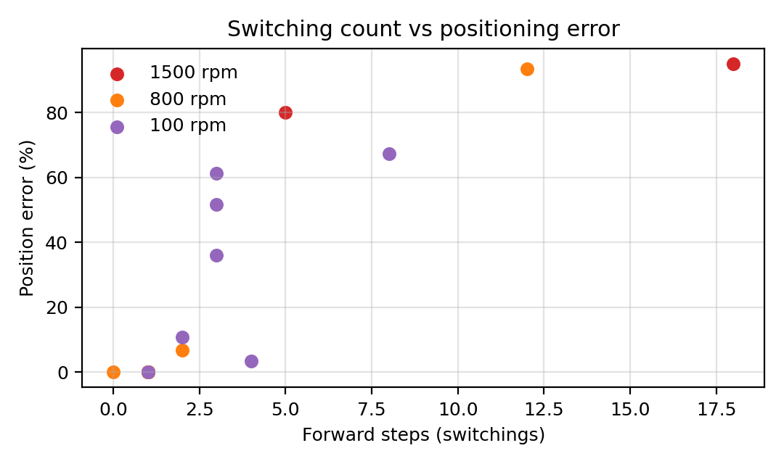
Figure 4 — Positioning error plotted against the number of switching actions. The two quantities rise together across all three speeds.
Figure 4 shows that error and switching count rise together across all three speeds. This is the signature of chattering predicted in Section 4.2: once the relay begins to reverse about the target it does not converge, and each additional reversal leaves the shaft no closer than the last. A single-step response, by contrast, means the error left the deadband once, the drive ran at full command, and the shaft entered the deadband and stayed there.

7.6 Position control at low speed — the trend reverses
The 100 rpm results behave in the opposite way to the high-speed results, and this is the most striking finding of the experiment. Here the small command succeeds and the large commands fail: 30° was reached exactly, while 355° reached only 116°, an error of 67.32%.
The forward observed angle in Table 4 does not simply degrade with increasing command — it saturates. For every command of 120° and above the forward reading is 115° or 116°, whatever the target: 116° for a 130° command, 115° for 180°, and 116° again for 240°, 300° and 355°. The shaft is evidently unable to complete more than about 116° of forward travel in one pass at this speed.
This is consistent with a torque and momentum limitation rather than a control-law limitation. At 100 rpm the speed reference passed to the inner loop is small, so the accelerating torque available is correspondingly small and the rotor carries very little momentum to carry it through friction in the bearings and coupling. Once motion stops, the relay is still calling for forward travel, but with the shaft stationary the breakaway torque needed to restart it exceeds what the reduced command can supply. The residual travel then appears in the reverse register, which is why the backward readings grow steadily — 19°, 64°, 124°, 185°, 240° — as the forward reading stays pinned near 116°.
The percentage error therefore climbs monotonically with commanded angle at 100 rpm, from 0% at 30° to 67.32% at 355°, in direct contrast to the high-speed behaviour where percentage error falls monotonically with angle.

7.7 Consistency of the forward and reverse readings
A useful internal check on the data is that in most rows the forward and reverse readings sum to approximately the commanded angle. This holds exactly for all eight rows at 1500 rpm, including the two failures (1 + 4 = 5 and 1 + 19 = 20), for six of the eight rows at 800 rpm, and for five of the seven rows at 100 rpm (115 + 64 = 179 against a 180° command, 116 + 124 = 240, 116 + 185 = 301 against 300°, and 116 + 240 = 356 against 355°).
This supports the interpretation given above: the two registers are recording how the total commanded travel was divided between motion in the intended direction and motion recovered in the opposite direction. A row with all its travel in the forward register is a clean single-pass move; a row with travel split between the two is one in which the drive hunted.
Two rows do not fit the pattern and should be flagged. The 330° command at 800 rpm gave a reverse reading of 148° despite an exact forward result, giving a total of 478°; and the 120° command at 100 rpm gave a reverse reading of 66°, a total of 182°. Both may be genuine, since a command near a full revolution can cause the readout to wrap, but both should be repeated before being relied on. They do not affect the forward-error analysis, which is the basis of all conclusions drawn here.

8. Determination of the Good Working Range
Following the usual laboratory convention, an operating point is taken to be acceptable if its percentage error does not exceed 5%. Applying this criterion to Tables 1 to 4 gives the summary below.
Table 5 — Operating points meeting the 5% error criterion
Mode / speed | Acceptable settings tested | Best error observed | Comment
Speed, 27–140 rpm | 27, 30, 90, 120, 140 rpm | 0.00% | Exact in both directions
Speed, 150–300 rpm | None | — | Band unusable
Speed, 310–2000 rpm | All settings tested | 0.06% at 1600 rpm | Worst case 0.62% at 800 rpm
Position, 1500 rpm | 35°, 90°, 120°, 200°, 250°, 330° | 0.00% | Fails at 20° and below
Position, 800 rpm | 30°, 50°, 100°, 150°, 200°, 300°, 330° | 0.00% | Widest usable angular range
Position, 100 rpm | 30°, 120° | 0.00% at 30° | Fails above ~130°

8.1 Recommended operating envelope
Combining the two sets of results gives the following practical envelope for this rig.
Table 6 — Recommended operating envelope
Quantity | Recommended range | Basis
Speed reference | 27–140 rpm and 310–2000 rpm | All errors ≤ 0.62%; 150–300 rpm excluded as unusable
Positioning speed | 800 rpm | Only speed at which every angle from 30° to 330° met the criterion
Commanded angle at 800 rpm | 30°–330° | Zero error at all points except 30°, which gave 6.67%
Commanded angle at 1500 rpm | 35°–330° | Zero error throughout; 20° and below unusable
Commanded angle at 100 rpm | ≤ 120° | Forward travel saturates near 116°
Minimum executable angle | ≈ 30° | Set by deadband and sensor resolution, not by speed
The best overall operating point is 800 rpm. It is the only speed tested at which every angular command from 30° to 330° met the 5% criterion, and it lies comfortably clear of both the 150–300 rpm anomaly and the low-speed region where forward travel saturates. Since only discrete angles were tested, these should be read as tested regions rather than as guaranteed continuous ranges.

9. Sources of Error and Limitations
- Controller deadband. Inside the deadband the relay applies no corrective torque, so any command comparable in size to it cannot be executed. This is the dominant limitation at small angles and is the principal finding of Section 7.4.
- Finite sensor resolution. The photoelectric disc cannot resolve displacements below one slot pitch. The recurrence of a 1° forward reading in every failed command suggests that the resolution limit and the deadband are of similar magnitude here.
- Sampled feedback. The controller sees the shaft position only once per sampling interval, so the angle travelled between updates grows in proportion to speed. This contributes to detection delay at 1500 rpm, though the evidence indicates it is not the limiting factor.
- Static friction. At 100 rpm the reduced torque command leaves too little margin over breakaway friction, producing the saturation of forward travel near 116°.
- Readout instability in the 150–300 rpm band. Whether this originates in the display electronics or in a genuine mechanical resonance was not established and remains an open point.
- Single-trial measurements. Each operating point was recorded once. Repeat readings would allow the scatter to be separated from systematic effects, particularly for the two anomalous reverse readings noted in Section 7.7.

10. Applications of Servomotor Position Control
The trade-off examined in this experiment — speed against positioning fidelity — is precisely the trade-off that governs how servo actuators are specified in practice.
- CNC machining and additive manufacturing. Servo drives position the tool or print head along each axis through ball screws. Fine finishing passes involve exactly the small incremental moves that this experiment shows a relay controller cannot execute, which is why production machines use proportional or full PID inner loops with high-resolution encoders.
- Robotic joints and manipulators. Each joint of an industrial arm is a position servo. End-effector accuracy depends on the smallest reliable increment at every joint, and errors accumulate along the kinematic chain — so a joint-level deadband of the kind observed here would be unacceptable.
- Automated flow-control valves. A valve actuator must hold a commanded fractional opening against fluid reaction forces. The low-speed stiction effect of Section 7.6 is the mechanism behind valve stiction, a well-known cause of limit cycling in process control loops.
- Aerospace and defence actuation. Flight-control surfaces, radar antenna drives and thrust-vectoring mechanisms demand small, fast, repeatable angular corrections under load, and are designed with substantial margin above the minimum executable displacement.
- Gimballed antenna pointing. A satellite communication antenna tracks a ground station in azimuth and elevation through corrections far smaller than the smallest angle executed reliably here, which is why such systems use continuous rather than relay control.

11. Conclusion
The speed and position control performance of a Mitsubishi AC servomotor under bang-bang control was measured and analysed. In speed-control mode the drive tracked its reference to within 0.62% at every setting from 27 rpm to 2000 rpm, with exact agreement at the five lowest speeds tested. The single exception was the band from 150 rpm to 300 rpm, in which the drive did not behave normally and no stable reading could be obtained; whether the cause is a display artefact or a mechanical resonance was not resolved.
In position-control mode the accuracy depended on the commanded angle far more strongly than on the speed, and the direction of that dependence reversed between high and low speed. At 1500 rpm and 800 rpm every command above roughly 30° was executed exactly in a single switching action, while commands of 20° and below failed almost entirely, returning 1° of travel after as many as 18 switchings. At 100 rpm the opposite held: the 30° command was exact, but forward travel saturated near 116° so that larger commands produced errors rising to 67.32% at 355°.
Comparing the two high-speed cases shows that the small-angle failures are not caused by rotor inertia. The minimum workable angle changed by a factor of about 1.2 between 800 rpm and 1500 rpm, whereas an inertia-limited stopping distance would have changed it by about 3.5. Together with the observation that every failed command returned exactly 1° regardless of speed, this identifies the controller deadband and the sensor resolution as the binding constraint, with a minimum executable displacement of roughly 30° on this rig. The low-speed saturation is a separate effect, caused by insufficient torque margin over static friction.
The number of switching actions recorded for each command proved to be a direct and reliable measure of chattering: accurate commands took one step, failed commands took between 5 and 18. Taken together, the results place the best operating point at 800 rpm with commanded angles between 30° and 330°, and demonstrate that good speed regulation is no guarantee of good positioning, since the two are limited by entirely different mechanisms.

