1. Objective
To design a proportional controller for a given digital transfer function using discrete root-locus analysis and to determine the controller gain required to meet the closed-loop specifications %OS ≤ 5 % and t_{s} ≤ 9 s. The effect of sampling time is studied by repeating the design for T = 0.1 s to 1 s in steps of 0.1 s.

2. Theory
With a proportional controller C(z) = K_{p} and unity negative feedback, the open-loop function is L(z) = K_{p}G(z) and the closed-loop poles are the roots of 1 + K_{p}G(z) = 0; as K_{p} varies they trace the discrete root locus. The s- and z-planes are related by z = e^{sT}: for s = σ + jω, |z| = e^{σT} and ∠z = ωT, so pole locations in the z-plane depend on T, and the stable region is the interior of the unit circle. zgrid shows constant-ζ and constant-ω_{n} curves in this plane.
The 5 % overshoot limit corresponds to the minimum damping ratio
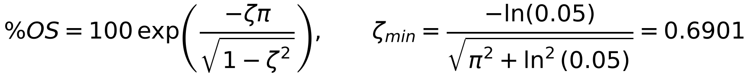
and, for the digital loop, the damping of a z-plane pole is measured by the effective damping ratio (independent of T, because s = ln z / T only rescales |s|):
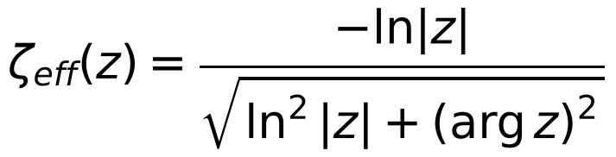

3. Given Digital Transfer Function
At T = 1 s the given plant is G(z) = 0.32(z + 0.62)/(z² − 1.15z + 0.15), defined in MATLAB as
z = tf('z',1);
Gz_1 = 0.32*(z + 0.62)/((z - 1)*(z - 0.15));

4. Continuous-Time Equivalent of the Plant
The digital plant is converted to a continuous equivalent with the zero-order-hold inverse (Gs = d2c(Gz_1,’zoh’)). The MATLAB result — reproduced here exactly in closed form (§17) — is
The poles are s = 0 and s = −1.897; the zero is at s = +31.18 (non-minimum phase, far above the sampling frequency for every T used, so it affects the discrete zero but not the dominant dynamics). The required damping ratio is ζ_{req} = 0.6901.
Analog gain window. Closing the loop around the continuous plant and applying the same specifications gives, by an exact search of the continuous step response, 0.582 ≤ K_{p} ≤ 1.536. ◆ Your report quotes ≈ 0.678 and ≈ 1.845. Those two numbers do not satisfy your own specification for this plant: at K_{p} = 0.678 the continuous t_{s} is already 7.33 s (the 9 s boundary is at 0.582), and at K_{p} = 1.845 the overshoot is 8.05 % (the 5 % boundary is at 1.536). The corrected values are also the ones towards which the digital limits converge as T → 0 (the ζ-crossing gain is 1.522 at T = 0.01 s), so they are the right reference for §11 and for the discussion of “analog vs digital” gains. Figure 1 shows the continuous step responses at the two corrected limits.
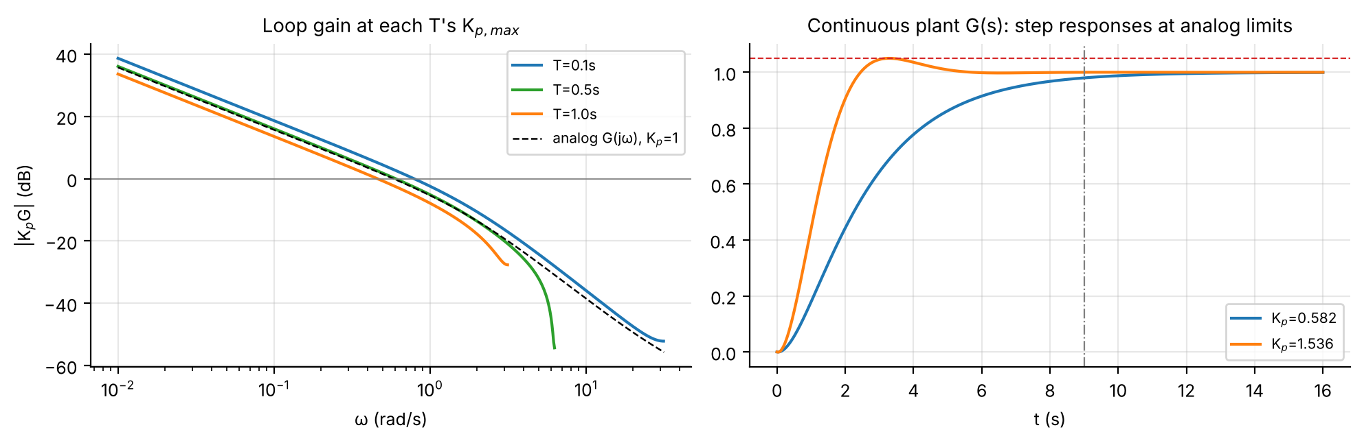
Figure 1. Left: loop gain at each T’s K_{p,max} against the analog G(jω) (K_{p} = 1): the sampled loop follows the analog one up to ≈ π/T and then rolls off. Right: continuous-plant step responses at the corrected analog limits.

5. Discretisation for Different Sampling Times
For T = 0.1, 0.2, …, 1.0 s the continuous plant is discretised by ZOH, Gd = c2d(Gs,T,’zoh’). Writing G_{s} = c₀/s + c₁/(s+a) (a = 1.8971, c₀ = 0.6099, c₁ = −0.6470), every plant has the form (b₁z + b₀)/[(z−1)(z−p)] with
T (s) | b₁ | b₀ | z coefficient: −(1+p) | p = e^{−aT} | zero −b₀/b₁
0.1 | 0.002056 | 0.008483 | -1.82720 | 0.82720 | -4.126
0.2 | 0.014296 | 0.024218 | -1.68426 | 0.68426 | -1.694
0.3 | 0.034959 | 0.044445 | -1.56601 | 0.56601 | -1.271
0.4 | 0.062591 | 0.067142 | -1.46821 | 0.46821 | -1.073
0.5 | 0.095987 | 0.090851 | -1.38730 | 0.38730 | -0.947
0.6 | 0.134150 | 0.114545 | -1.32037 | 0.32037 | -0.854
0.7 | 0.176258 | 0.137521 | -1.26501 | 0.26501 | -0.780
0.8 | 0.221629 | 0.159320 | -1.21922 | 0.21922 | -0.719
0.9 | 0.269698 | 0.179662 | -1.18134 | 0.18134 | -0.666
1.0 | 0.320000 | 0.198400 | -1.15000 | 0.15000 | -0.620
Table 1. Sampling time versus discrete-time plant G_{d}(z) = (b₁z + b₀)/(z² − (1+p)z + p). At T = 1 s this returns the given 0.32z + 0.1984 over z² − 1.15z + 0.15 exactly.
The finite zero moves from −4.13 at T = 0.1 s (outside the unit circle) to −0.62 at T = 1 s; it crosses the unit circle at T_{c} = 0.453 s (§15).

6. Discrete Root-Locus Analysis
For each T the root locus of K_{p}G_{d}(z) is obtained by varying K_{p}; the unit circle is the stability boundary. Figure 2 shows all ten loci with the ζ = 0.6901 contour and the two gain boundaries of §7 marked (▲ K_{p,min}, ■ K_{p,max}). At every T the lower-gain pair of poles is real (▲, between the two open-loop poles), meets and leaves the real axis at breakaway, and the complex branch crosses the ζ = 0.6901 contour at K_{p,max} (■) on its way to the unit circle.
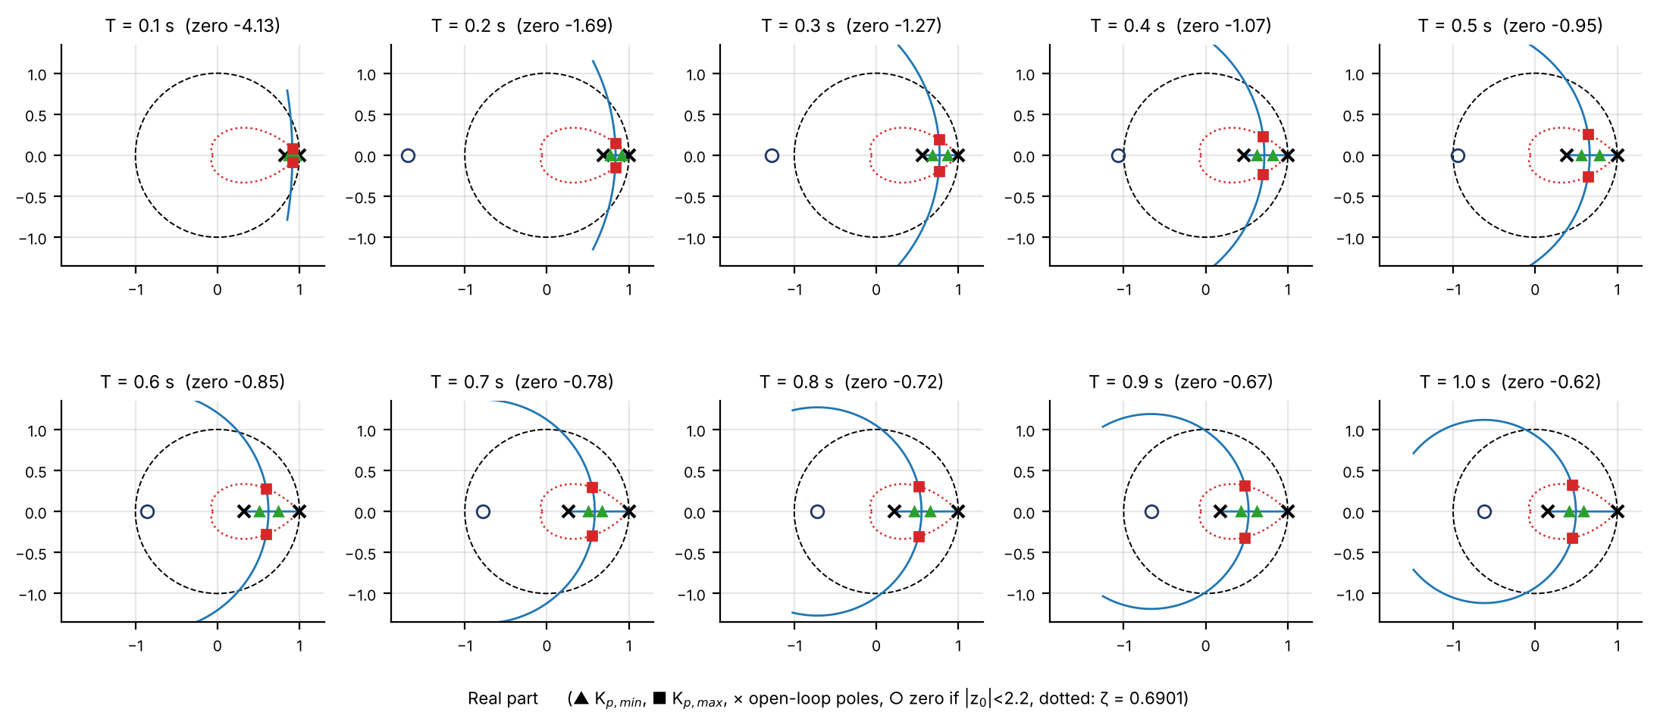
Figure 2. Discrete root loci for T = 0.1 … 1.0 s with the ζ = 0.6901 contour (dotted) and the unit circle (dashed).

7. Proportional Controller Design and Gain Results
For each T the gain is swept; for every K_{p} the closed-loop transfer function T_{cl}(z) = K_{p}G_{d}(z)/(1 + K_{p}G_{d}(z)) is built and stepinfo supplies the 2 % settling time and the peak overshoot. A gain is acceptable only if %OS ≤ 5 and t_{s} ≤ 9 s, so for every T
(the settling-time limit fixes the lower edge and the overshoot limit the upper edge). Your sweep, with the detailed values at both edges, is reproduced in Table 2. Because a stepinfo sweep has a finite gain step (0.01 in your table) and settling time is quantised in multiples of T, the edges were also located exactly by a 0.001 scan followed by bisection (Table 3). The two agree within 0.01 everywhere except the lower edge at T = 0.3 s (0.016), where the quantised t_{s} makes the edge jump (§10).
T (s) | K_{p,min} | t_{s} (s) | M_{p} (%) | K_{p,max} | t_{s} (s) | M_{p} (%)
0.1 | 0.571 | 9 | 0 | 1.401 | 4.8 | 4.961
0.2 | 0.561 | 9 | 0 | 1.291 | 5 | 4.996
0.3 | 0.561 | 8.7 | 0 | 1.191 | 5.4 | 4.902
0.4 | 0.551 | 8.8 | 0 | 1.111 | 5.6 | 4.981
0.5 | 0.531 | 9 | 0 | 1.041 | 6 | 4.997
0.6 | 0.511 | 9 | 0 | 0.971 | 6 | 4.857
0.7 | 0.531 | 8.4 | 0 | 0.921 | 6.3 | 4.843
0.8 | 0.501 | 8.8 | 0 | 0.861 | 7.2 | 4.766
0.9 | 0.481 | 9 | 0 | 0.831 | 7.2 | 4.966
1.0 | 0.471 | 9 | 0 | 0.781 | 7 | 4.884
Table 2. Your sweep results (lab report), reproduced unchanged.
T (s) | K_{p,min} (yours) | K_{p,min} exact | t_{s} | OS % | K_{p,max} (yours) | K_{p,max} exact | t_{s} | OS % | ΔK_{p} exact
0.1 | 0.571 | 0.5694 | 9.0 | 0.0 | 1.401 | 1.4043 | 4.8 | 5.000 | 0.835
0.2 | 0.561 | 0.5571 | 9.0 | 0.0 | 1.291 | 1.2913 | 5.0 | 5.000 | 0.734
0.3 | 0.561 | 0.5451 | 9.0 | 0.0 | 1.191 | 1.1984 | 5.4 | 5.000 | 0.653
0.4 | 0.551 | 0.5415 | 8.8 | 0.0 | 1.111 | 1.1121 | 5.6 | 5.000 | 0.571
0.5 | 0.531 | 0.5218 | 9.0 | 0.0 | 1.041 | 1.0411 | 6.0 | 5.000 | 0.519
0.6 | 0.511 | 0.5105 | 9.0 | 0.0 | 0.971 | 0.9766 | 6.0 | 5.000 | 0.466
0.7 | 0.531 | 0.5210 | 8.4 | 0.0 | 0.921 | 0.9259 | 6.3 | 5.000 | 0.405
0.8 | 0.501 | 0.4954 | 8.8 | 0.0 | 0.861 | 0.8709 | 7.2 | 5.000 | 0.375
0.9 | 0.481 | 0.4783 | 9.0 | 0.0 | 0.831 | 0.8319 | 7.2 | 5.000 | 0.354
1.0 | 0.471 | 0.4681 | 9.0 | 0.0 | 0.781 | 0.7846 | 7.0 | 5.000 | 0.316
Table 3. Exact gain window for your plant (csv_user_plant/table1_digital_design.csv). Your values are conservative by ≤ 0.01 at the upper edge; the exact upper edge reaches OS = 5.000 % and the exact lower edge t_{s} = 9 s (8.8 s at T = 0.4 and 0.8 s, 8.4 s at 0.7 s because t_{s} moves in steps of T).
Figure 3 shows the closed-loop step responses at both edges for T = 0.1, 0.5 and 1 s; the staircase is the sampled output. Figure 4 plots the window against T, with the exact edges, your tabulated values, the fitted laws of §11 and the continuous-plant limits.
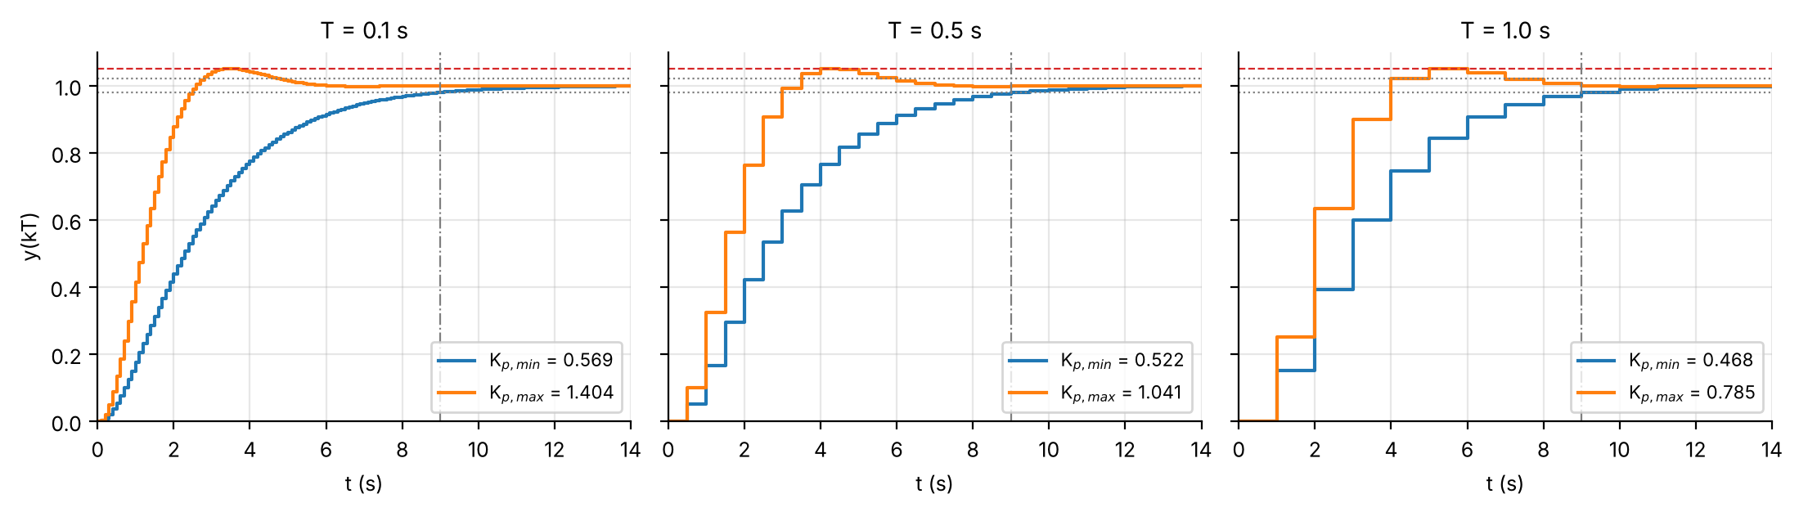
Figure 3. Step responses at K_{p,min} and K_{p,max} (T = 0.1, 0.5, 1.0 s). Dotted: ±2 % band; dashed red: +5 %; dash-dot: 9 s.
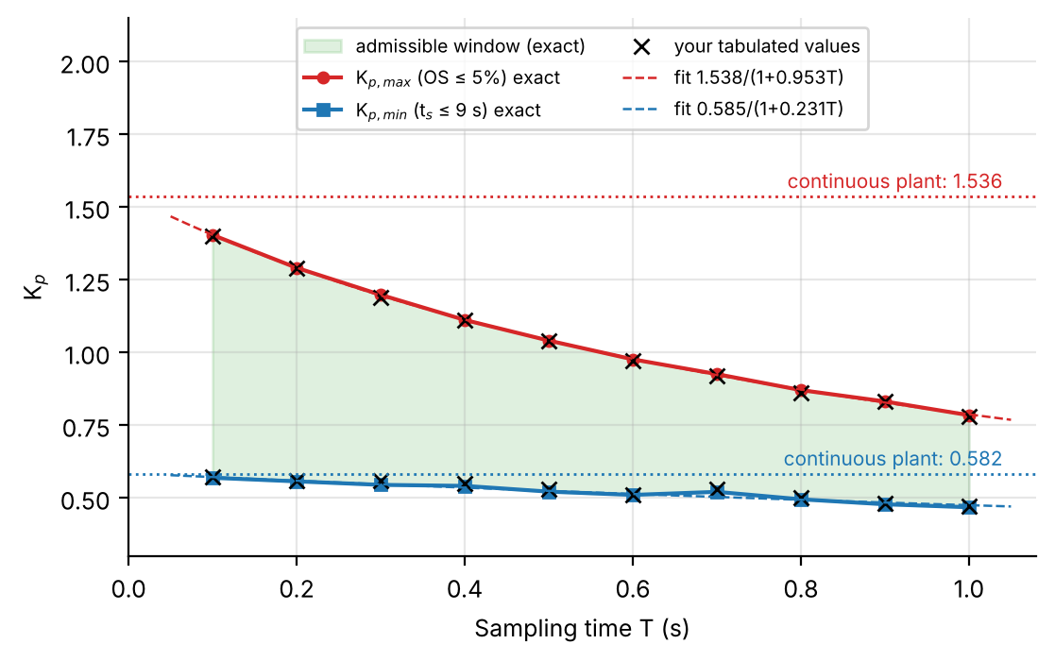
Figure 4. Admissible gain window versus sampling time. Crosses are the values of your table; the dotted lines are the continuous-plant limits.

8. Analysis of the Gain Results
The specifications can be met at every sampling time. At T = 0.1 s the acceptable range is 0.571 ≤ K_{p} ≤ 1.401 (exact 0.569 ≤ K_{p} ≤ 1.404); at T = 1.0 s it is 0.471 ≤ K_{p} ≤ 0.781 (exact 0.468 ≤ K_{p} ≤ 0.785). The width ΔK_{p} = K_{p,max} − K_{p,min} falls from 0.830 to 0.310 in your table (exact 0.835 → 0.316, a 62 % reduction), so the controller-gain margin is much smaller at the larger sampling time.
Settling time. At the minimum acceptable gains t_{s} sits at the 9 s limit (8.4–9 s); at the maximum gains it stays below 9 s and increases with T, from 4.8 s at T = 0.1 s to 7.0 s at T = 1 s (linear fit t_{s} ≈ 2.81T + 4.51, R² = 0.94, Figure 5, left): the fastest-allowed response gets slower as sampling gets coarser. Overshoot. The overshoot is 0 % at K_{p,min} for all T and 4.7–5.0 % at K_{p,max} (Figure 5, right); your tabulated K_{p,max} values give 4.77–4.996 % because the sweep stops at the last gain below 5 %.
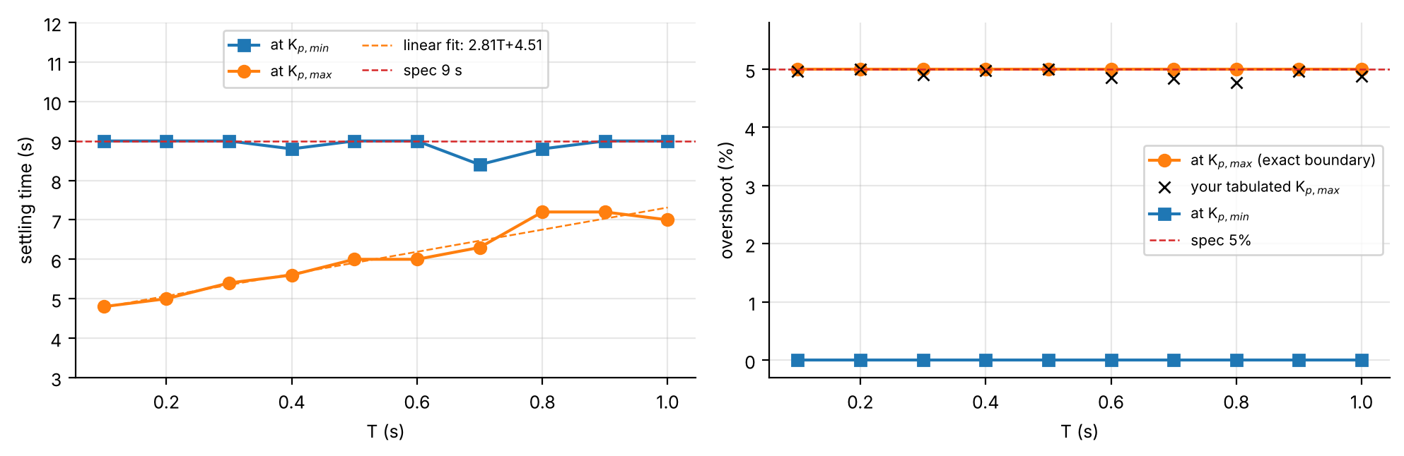
Figure 5. Left: settling time at both gain edges. Right: overshoot at both edges (crosses: your tabulated overshoot at your K_{p,max}).
— Part II: Added Analysis for Your Plant —

9. Exact Gain Window and Stability Limits
Beyond the two specification edges, the root-locus equations of the plant give three more gains in closed form. The characteristic equation is z² + [K_{p}b₁ − (1+p)]z + [p + K_{p}b₀] = 0, so the breakaway gain (poles turn complex, ζ = 1) is the smaller root of the discriminant equation, the ζ = 0.6901 crossing follows from ζ_{eff}(z) = 0.6901 on the complex branch, and — because the product of the pole pair is the constant term — the exact stability limit is
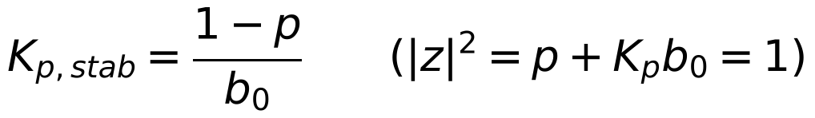
T (s) | K_{p,min} (t_{s}=9) | Breakaway (ζ=1) | K_{p,max} (OS=5%) | ζ=0.69 crossing | true OS at crossing (%) | K_{p,stab} | K_{p,stab}/K_{p,max}
0.1 | 0.5694 | 0.7205 | 1.4043 | 1.4039 | 4.99 | 20.371 | 14.51×
0.2 | 0.5571 | 0.6881 | 1.2913 | 1.2915 | 5.00 | 13.038 | 10.10×
0.3 | 0.5451 | 0.6575 | 1.1984 | 1.1951 | 4.96 | 9.765 | 8.15×
0.4 | 0.5415 | 0.6286 | 1.1121 | 1.1118 | 4.99 | 7.920 | 7.12×
0.5 | 0.5218 | 0.6014 | 1.0411 | 1.0392 | 4.95 | 6.744 | 6.48×
0.6 | 0.5105 | 0.5759 | 0.9766 | 0.9755 | 4.97 | 5.933 | 6.08×
0.7 | 0.5210 | 0.5519 | 0.9259 | 0.9193 | 4.79 | 5.345 | 5.77×
0.8 | 0.4954 | 0.5293 | 0.8709 | 0.8693 | 4.96 | 4.901 | 5.63×
0.9 | 0.4783 | 0.5082 | 0.8319 | 0.8246 | 4.72 | 4.557 | 5.48×
1.0 | 0.4681 | 0.4883 | 0.7846 | 0.7845 | 5.00 | 4.284 | 5.46×
Table 4. All gain boundaries for your plant. csv_user_plant/table1_digital_design.csv.
Three results stand out. (i) The lower edge lies below the breakaway gain at every T (0.468 against 0.488 at T = 1 s; 0.569 against 0.721 at T = 0.1 s): the gain that just meets t_{s} ≤ 9 s still has two real poles, which is why the overshoot there is exactly 0 % and why your “mainly governed by settling time” statement is precisely right. (ii) The ζ = 0.6901 crossing reproduces the exact 5 % overshoot gain to within 1 % at all ten T (true overshoot 4.72–5.00 %), even though the plant has a zero; the crossing is therefore a closed-form way to find K_{p,max} without any step sweep. (iii) The stability limit is 5.5× to 14.5× above K_{p,max} (4.284 against 0.785 at T = 1 s, 20.37 against 1.404 at T = 0.1 s), so the design is nowhere near instability, but the cliff is much closer at coarse sampling. At T = 1 s the closed-loop poles are 0.585 and 0.415 at K_{p,min}, a double pole at 0.497 at breakaway, 0.4495 ± 0.3219j at K_{p,max}, and −0.1105 ± 0.9939j (on the unit circle) at K_{p,stab}. A gain 10 % above K_{p,max} gives 6.7–7.7 % overshoot at every T, so the overshoot edge is a hard one in practice.

10. Settling Time at the Lower Gain Boundary
T (s) | slow real pole | σ = −ln|z|/T (1/s) | τ = 1/σ (s) | ln 50 / σ (s) | simulated t_{s} (s)
0.1 | 0.953 | 0.486 | 2.06 | 8.05 | 9.0
0.2 | 0.907 | 0.488 | 2.05 | 8.02 | 9.0
0.3 | 0.863 | 0.491 | 2.04 | 7.97 | 9.0
0.4 | 0.816 | 0.509 | 1.97 | 7.69 | 8.8
0.5 | 0.780 | 0.498 | 2.01 | 7.86 | 9.0
0.6 | 0.740 | 0.502 | 1.99 | 7.79 | 9.0
0.7 | 0.673 | 0.566 | 1.77 | 6.91 | 8.4
0.8 | 0.652 | 0.534 | 1.87 | 7.33 | 8.8
0.9 | 0.624 | 0.524 | 1.91 | 7.47 | 9.0
1.0 | 0.585 | 0.536 | 1.87 | 7.30 | 9.0
Table 5. Dominant (slow) pole at K_{p,min} and the single-exponential settling-time estimate.
At K_{p,min} the closed loop has two real poles and the response is dominated by the slow one. Its decay rate σ ≈ 0.49–0.57 s⁻¹ is almost independent of T and equals the slow pole of the continuous loop at its own lower limit (0.484 s⁻¹): the lower edge is a property of the plant’s slow mode, not of the sampling. The single-exponential estimate ln 50/σ ≈ 7–8 s underestimates the simulated 8.4–9 s because the fast pole’s residue and the 2 % band add roughly one more time constant. The simulated t_{s} is a multiple of T, so the lower edge moves in jumps — at T = 0.7 s the response settles at t = 8.4 s for K_{p} ≥ 0.521 but at 9.1 s just below it, which is why your sweep shows the non-monotone sequence 0.561, 0.561, 0.551, 0.531, 0.511, 0.531, 0.501 and why the exact edge is also irregular (Figure 4).

11. Empirical K_{p}(T) Relationships
Both boundaries fall with T roughly like a delayed analog design. A two-parameter law
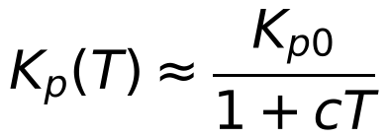
was fitted by least squares to the exact edges. Upper edge: K_{p0} = 1.5382, c = 0.9531, R² = 0.99987. K_{p0} equals the analog limit 1.536 to 0.2 %, and c equals a/2 = 0.949 to 0.5 %: the zero-order hold acts as a half-sample delay, K_{p,max}(T) ≈ K_{p,max,analog}/(1 + aT/2), and this parameter-free prediction already gives R² = 0.99985. Lower edge: K_{p0} = 0.5850 (analog 0.582), c = 0.2310, R² = 0.954; the delay law does not apply (R² < 0) because this edge is fixed by the slow pole (§10), not by phase lag, and the fit is only descriptive (scatter ±0.02 from the T-quantisation). Extrapolating the two fits, the window would close near T ≈ 4.7 s — an extrapolation far outside the tested range that should be confirmed before use. The width follows ΔK_{p} ≈ 1.538/(1+0.953T) − 0.585/(1+0.231T) (from 0.83 to 0.32).

12. Waterfall Analysis at T = 1 s
Seventy closed-loop step responses were generated for K_{p} from 0.1·K_{p,min} to 1.35·K_{p,stab} (csv_user_plant/waterfall_*.csv). Figure 6 (left) stacks them; the right panel plots the resulting overshoot and settling time against K_{p}.
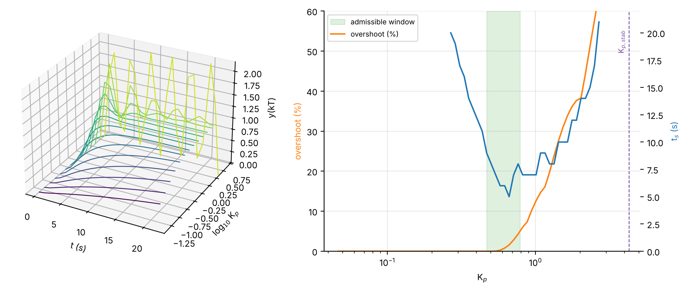
Figure 6. Left: waterfall of step responses at T = 1 s (clipped at y = 2.2). Right: overshoot and settling time against K_{p}; shaded: admissible window; dashed: stability limit.
The picture shows three regimes. Below K_{p,min} the response is overdamped and slow (t_{s} > 9 s). Inside the window t_{s} is not monotone: it falls from 9 s at 0.468 to a minimum of 5 s near K_{p} ≈ 0.63–0.68 (overshoot ≈ 1.4–1.6 %), then rises again to 7 s at K_{p,max} as the oscillation starts to ring across the 2 % band. Above K_{p,max} overshoot grows steeply and t_{s} becomes irregular (the staircase in the right panel is the 2 % band being re-crossed by successive peaks) until the loop reaches sustained oscillation at K_{p,stab} = 4.284. The decay rate σ and damped frequency of the ringing agree with the closed-form pole location (Table 6), confirming the z-plane picture; the gap near K_{p,stab} is the coarse sample grid (about four samples per cycle).
Gain | K_{p} | σ theory (1/s) | σ from simulation | ω_{d} theory (rad/s) | ω_{d} from simulation
Kp,max | 0.785 | 0.593 | 0.601 | 0.622 | 0.634
2.0 | 2.000 | 0.302 | 0.312 | 1.219 | 1.273
3.0 | 3.000 | 0.147 | 0.149 | 1.461 | 1.605
0.95 Kp,stab | 4.070 | 0.022 | 0.047 | 1.649 | 1.723
Table 6. Pole-based prediction against measured ringing in the simulated step responses (T = 1 s).

13. Heat Maps and Feasible Region
Evaluating the simulated overshoot and settling time on a 120 × 150 grid in (T, K_{p}) gives Figure 7 (csv_user_plant/feasibility_heatmap_grid.csv). The white 5 % contour in the overshoot map and the cyan 9 s contour in the settling-time map are the upper and lower edges of the window; the 9 s contour is ragged at high gain because settling time there depends on which peak last leaves the 2 % band.
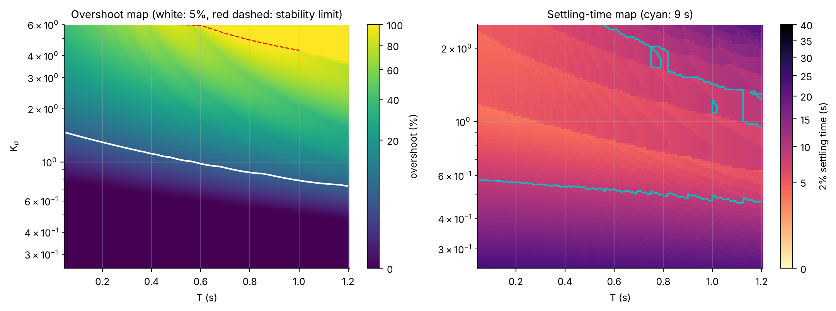
Figure 7. Left: overshoot over the (T, K_{p}) plane; white: 5 % contour; red dashed: stability limit. Right: settling time; cyan: 9 s contour (restricted to K_{p} ≤ 2.5).
Figure 8 (left) intersects the two conditions: the feasible region is a single connected band at every T tested (no holes), with a nearly flat lower edge (0.47–0.57) and an upper edge that falls steadily — so the window narrows from the top. Figure 8 (right) shows the overshoot sensitivity dOS/d ln K_{p}: the K_{p,max} boundary sits on the steep part just above the flat 0 % plateau (≈ 20 percentage points of overshoot per unit of ln K_{p}), which is why a 10 % gain increase costs 2 points of overshoot. The stripes at higher gain are the sampled oscillation peaks changing sample.
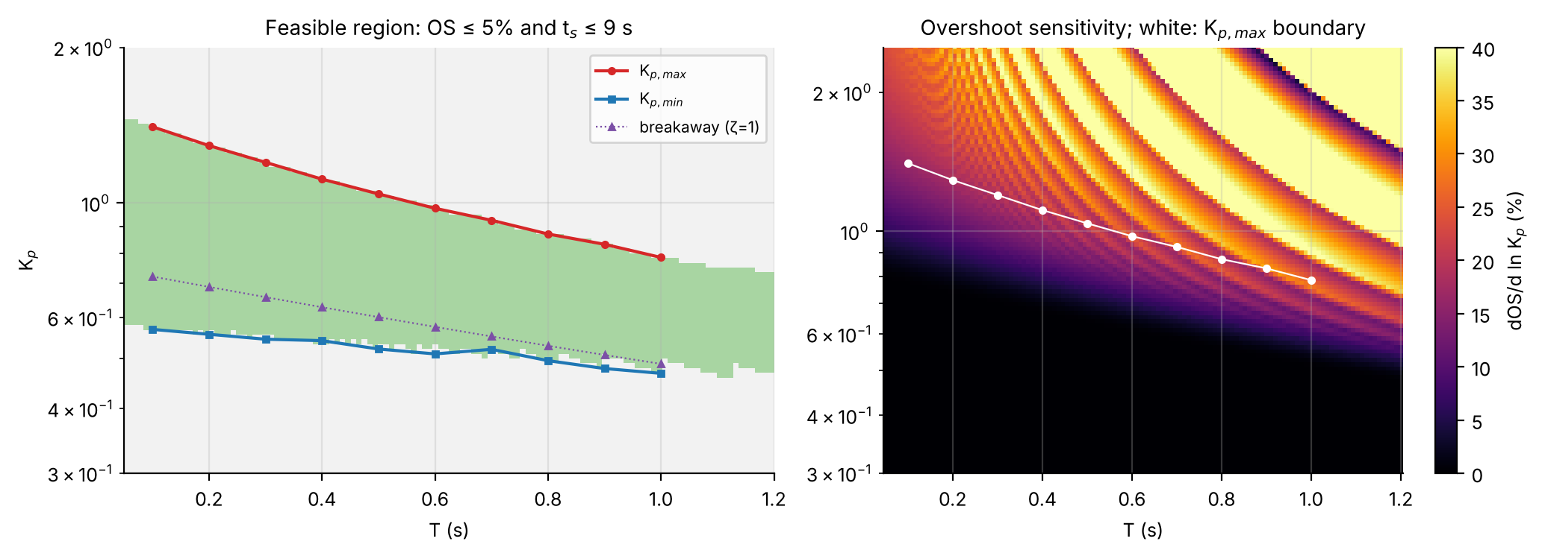
Figure 8. Left: feasible region (green) for OS ≤ 5 % and t_{s} ≤ 9 s with the exact edges. Right: overshoot sensitivity.

14. Frequency-Domain Checks
T (s) | GM at K_{p,max} (dB) | PM at K_{p,max} (°) | GM at K_{p,min} (dB) | PM at K_{p,min} (°) | ω_{b} (rad/s) | π/T (rad/s) | (π/T)/ω_{b}
0.1 | 23.2 | 63.7 | 31.1 | 78.2 | 1.302 | 31.42 | 24.1
0.2 | 20.1 | 63.3 | 27.4 | 77.5 | 1.239 | 15.71 | 12.7
0.3 | 18.2 | 63.0 | 25.1 | 76.8 | 1.184 | 10.47 | 8.8
0.4 | 17.1 | 62.8 | 23.3 | 75.9 | 1.124 | 7.85 | 7.0
0.5 | 16.2 | 62.6 | 22.2 | 75.5 | 1.073 | 6.28 | 5.9
0.6 | 15.7 | 62.5 | 21.3 | 75.0 | 1.023 | 5.24 | 5.1
0.7 | 15.2 | 62.3 | 20.2 | 73.8 | 0.984 | 4.49 | 4.6
0.8 | 15.0 | 62.4 | 19.9 | 73.7 | 0.935 | 3.93 | 4.2
0.9 | 14.8 | 62.2 | 19.6 | 73.4 | 0.902 | 3.49 | 3.9
1.0 | 14.7 | 62.3 | 19.2 | 73.0 | 0.856 | 3.14 | 3.7
Table 7. Gain/phase margins at both edges and closed-loop −3 dB bandwidth at K_{p,max} (csv_user_plant/B1_margins.csv, C1_bandwidth.csv).
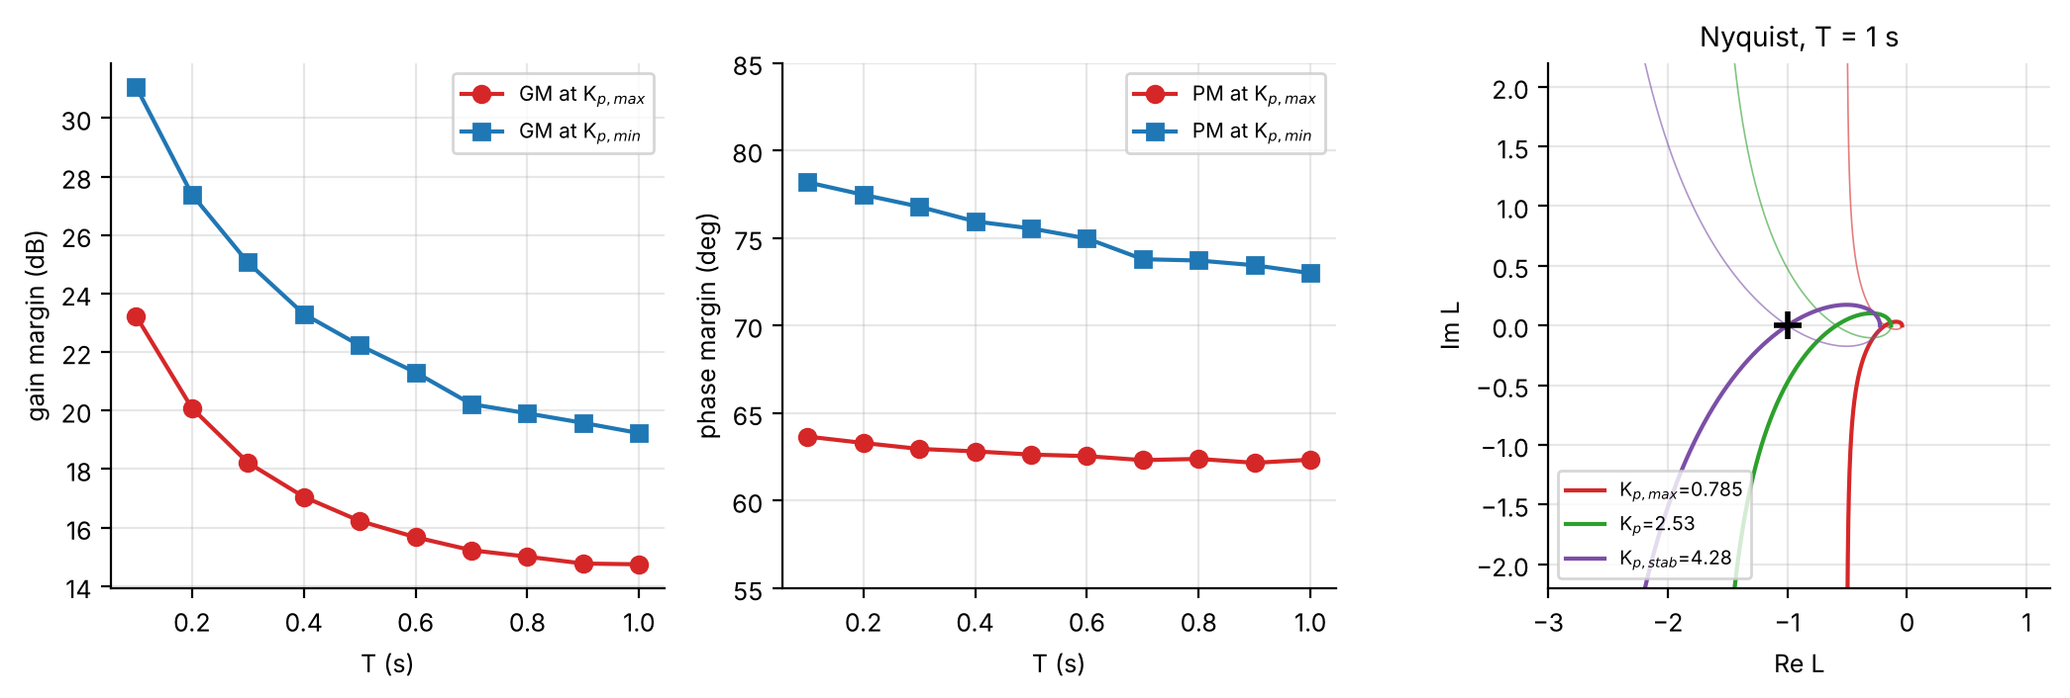
Figure 9. Gain margin and phase margin at both edges against T, and the Nyquist plot at T = 1 s for K_{p,max}, a mid gain and K_{p,stab} (the last passes through −1; no encirclements for the first two).
The phase margin at K_{p,max} is almost independent of T (62–64°, the 5 % overshoot signature) while at K_{p,min} it is 73–78°; the gain margin falls from 23 dB to 14.7 dB (T = 0.1 → 1 s) at K_{p,max} and equals 20 log10(Kp,stab/Kp) by construction. At T = 1 s the Nyquist curve for K_{p,max} stays 0.69 from −1 with no encirclement, while the K_{p,stab} curve touches −1. The closed-loop bandwidth falls from 1.30 to 0.86 rad/s, whereas the Nyquist frequency π/T falls from 31 to 3.1 rad/s: the ratio drops from 24 to 3.7, so at T = 1 s the loop is sampled only about 3.7× faster than its bandwidth — far short of the usual 10–20×, which is why the digital limits differ so much from the analog ones at this T.

15. Sampling Physics: Zero, Sensitivity, Intersample
Zero migration. The single finite zero of G_{d}(z) is −b₀/b₁. For your plant it is −4.13 at T = 0.1 s, −1.69 at 0.2 s, crosses z = −1 at T_{c} = 0.453 s and ends at −0.62 at T = 1 s (Figure 10, right): for T < T_{c} the discrete plant is non-minimum-phase, reflecting the continuous zero at s = +31.18. It does not limit the design (K_{p,stab} ≫ K_{p,max}) but it is why the loci of Figure 2 bend towards a zero outside the unit circle at fine sampling and why the exact upper edge differs slightly from a zero-free second-order prediction.
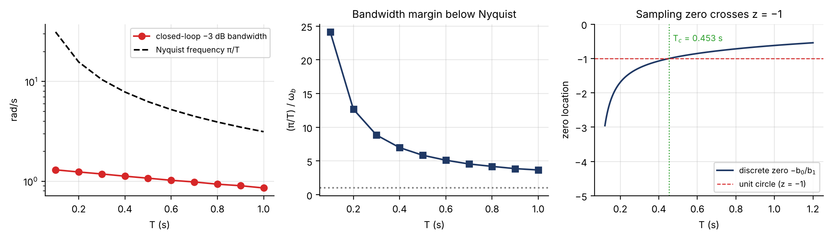
Figure 10. Closed-loop bandwidth against the Nyquist frequency, bandwidth margin, and migration of the discrete zero with T.
Pole sensitivity. Implicit differentiation of the characteristic equation gives dz/dK_{p} = −(b₁z + b₀)/[2z + K_{p}b₁ − (1+p)]. At T = 1 s the dominant pole moves 0.555 per unit gain at K_{p,max} and 0.180 at K_{p,stab} (ratio 3.1): the pole is most sensitive to gain near the design edge and less so near instability, where it simply slides along the unit circle.
Intersample behaviour. stepinfo sees only the samples. Simulating the continuous plant under the held control with 60 sub-steps per sample (it reproduces the c2d response at the samples to 1e-14) gives, at K_{p,max}, a true continuous-time peak of 5.001–5.251 % against exactly 5.000 % at the samples — an excess of at most 0.25 percentage points (T = 0.9 s). The non-minimum-phase zero produces an initial undershoot of only 0.04–0.08 %. The sampled evaluation is therefore a sound basis for the specification.
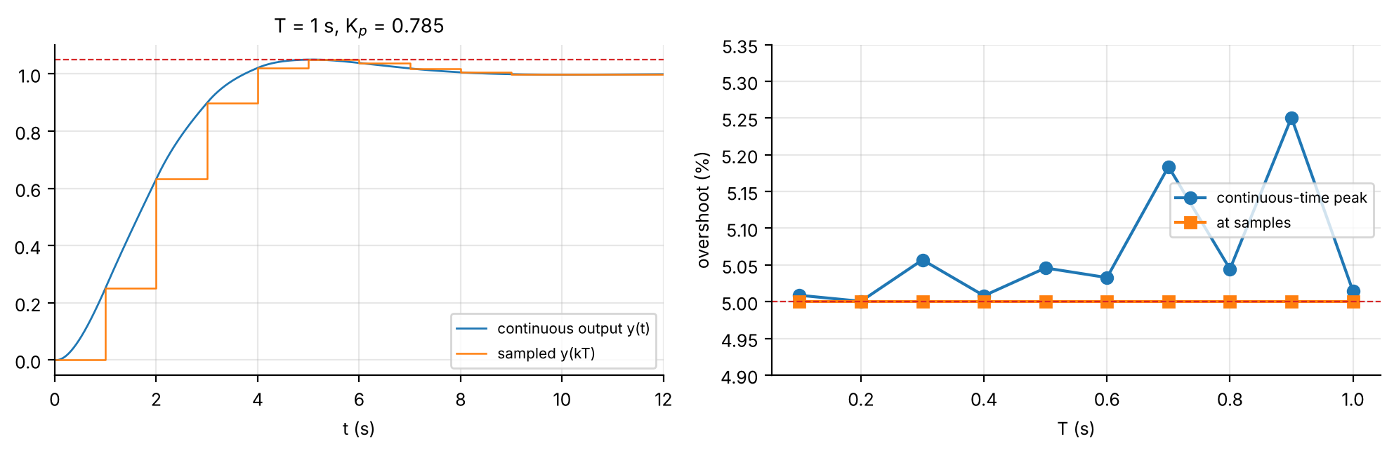
Figure 11. Left: continuous output and sampled output at T = 1 s, K_{p,max}. Right: continuous-time vs sampled overshoot against T.

16. Robustness and Lead Compensation
Robustness. With the gain placed mid-window (K_{p} = 0.626 at T = 1 s, 0.987 at T = 0.1 s) the plant was perturbed by ±10 % in gain (c₀, c₁) and in the pole a, in all eight corners plus the single-parameter cases, and re-discretised. Every case still meets both specifications; the worst case is a −10 % pole with +10 % gain: overshoot 3.36 %, t_{s} 8 s at T = 1 s (2.66 %, 5.4 s at T = 0.1 s). Choosing K_{p} at K_{p,max} instead would violate the 5 % limit for any positive gain error (+10 % → 6.7–7.7 %), so the mid-window gain is the sensible design point.
Lead compensator (T = 1 s). Because the plant pole p = 0.15 is known, a lead C(z) = K(z − 0.15)/(z − p_{c}) cancels it, leaving L = K b₁(z + 0.62)/[(z − 1)(z − p_{c})]. The best proportional design reaches t_{s} = 5 s (K_{p} ≈ 0.635–0.678, overshoot ≈ 1.4 %). Moving the compensator pole to the left shortens t_{s} at higher gain (Table 8): p_{c} = 0.05 gives 4 s at K = 0.84 (OS 1.4 %), p_{c} = −0.10 gives 3 s and p_{c} ≤ −0.30 gives 2 s, at the price of a loop gain 2–3× larger (more control effort and noise gain, and a smaller stability reserve). The first design that meets 4 s with ≤ 5 % overshoot (p_{c} = 0.05) is shown in Figure 12.
p_{c} (lead pole) | K | OS (%) | t_{s} (s)
+0.15 | 0.64 | 1.19 | 5
+0.05 | 0.84 | 1.38 | 4
-0.10 | 1.18 | 1.71 | 3
-0.20 | 1.33 | 0.22 | 3
-0.30 | 1.74 | 1.74 | 2
-0.40 | 1.90 | 0.00 | 2
Table 8. Lead designs at T = 1 s (zero at 0.15; K chosen for minimum t_{s} with OS ≤ 5 %; full list in lead_search.csv). p_{c} = 0.15 is the plain proportional controller.
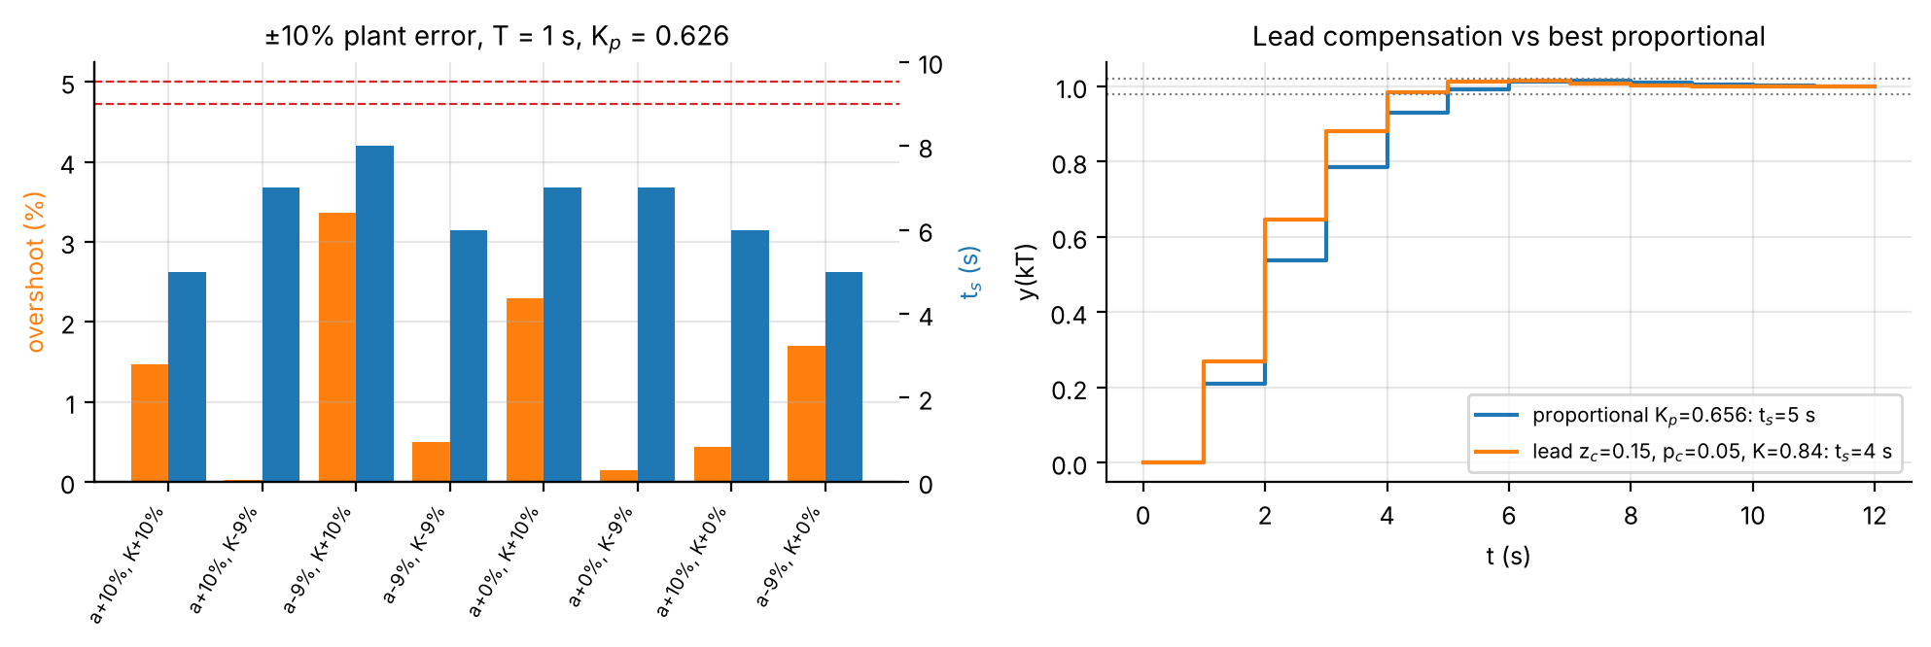
Figure 12. Left: overshoot and settling time for the eight ±10 % plant-error corners at T = 1 s (mid-window gain). Right: best proportional response against the lead design.

17. MATLAB Implementation of the Added Analysis
The complete code is in the accompanying package (matlab_user_method, 15 files; run verify_user_method first, then main_experiment7_user). It was cross-checked against an independent Python implementation but could not be run in MATLAB where it was prepared. Plotting, CSV export and bookkeeping loops are not reproduced; the four routines that carry the analysis are.
(a) Plant chain. Closed-form equivalent of your d2c / c2d steps (the main script asserts agreement with c2d at every T):
[a,c0,c1,N1,N0] = plant_from_sheet(0.32, 0.32*0.62, 0.15, 1); % Gs = (N1 s+N0)/(s^2+a s)
[b1,b0,p] = zoh_from_Gs(T,a,c0,c1); % p=exp(-aT); g=c1(1-p)/a; b1=c0T+g; b0=-c0Tp-g

(b) Fast step metrics (same definitions as stepinfo, base MATLAB only; evaluate_design gives the stepinfo version for cross-checking):
den = [1, Kp*b1-(1+p), p+Kp*b0];
if any(abs(roots(den))>=1), OS=Inf; ts=NaN; return, end % unstable
y = filter([0 Kp*b1 Kp*b0], den, ones(n,1)); t = (0:n-1)'*T;
OS = max(0,(max(y)-1)*100);
k = find(abs(y-1)>0.02,1,'last'); ts = t(k+1); % last sample outside 2% band

(c) Exact gain window (fine scan, then bisection on each edge):
ok_fun = @(K) test_ok(b1,b0,p,K,T,OS_spec,ts_spec); % OS<=5 && ts<=9
Ks = 0.2:0.001:2.4; idx = find(arrayfun(ok_fun,Ks));
Kmin = bisect_edge(ok_fun, Ks(idx(1)-1), Ks(idx(1))); % bad -> good
Kmax = bisect_edge(ok_fun, Ks(idx(end)+1), Ks(idx(end)));

(d) Boundaries and stability limit (closed form; fzero on the T-independent ζ_{eff}):
[Kbrk,Kbi] = breakaway_gain(b1,b0,p); % discriminant roots
Kz = zeta_crossing_gain(b1,b0,p,zeta_min,Kbrk*1.0005,min(Kbi,1e3)*0.999);
Kst = marginal_stability_gain(b0,p); % (1-p)/b0
[K0,c,R2] = fit_inverse_law(Tvec,Kmax); % Kp(T) = K0/(1+cT)

18. Data and Code Availability
All numbers in Part II come from the CSV files in csv_user_plant/: table1_digital_design (all gain edges, boundaries, your values alongside), table2_ts_at_Kpmin, A3_interval_width, B1_margins, C1_bandwidth, C2_zero_migration, D2_robustness, E_intersample_vs_T, lead_search, waterfall_stepresponse_T1s, waterfall_OS_ts_vs_Kp, waterfall_theory_validation and feasibility_heatmap_grid. The Python cross-check reproduces your sweep: every one of your twenty Kp values lies within 0.016 of the exact edge.
— Part III: Companion Study with the Analytic Model K/[s(s+a)] —
This part reproduces selected material of the earlier report, which modelled the plant analytically as K/[s(s+a)] (a = 1.8971, K = 1.0999 fitted from the pole and leading coefficient of the sheet) and used the sheet’s own coefficients at T = 1 s. It differs from Parts I–II only in the plant used for T ≠ 1 s. Its tables and figures are labelled with a C prefix (Table C1, Figure C2, §C4.3) so they cannot be confused with those of Parts I–II; references to “§14–§16” and “§19–§21” point back into Parts II and IV.

C1. Theory of the Analytic Model

C1.1 Recovering the analog plant
The pole at z = 1 is a free integrator, so the continuous plant is modelled as K/[s(s+a)]. The finite discrete pole obeys the sampling relation
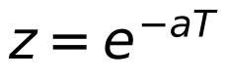
so the sheet’s pole z = 0.15 at T = 1 s fixes a = −ln(0.15) = 1.8971 rad/s. The plant gain K follows by matching the leading ZOH numerator coefficient b₁ = 0.32 (§C2.1), giving K = 1.0999.

C1.3 The z-plane picture: ZOH re-discretisation and constant-ζ contours
For the recovered analog plant with proportional gain K_{p} the characteristic equation is the first expression below, which gives the analog design directly (§C2.2). To repeat the design digitally the plant is re-discretised by ZOH at each T, with the exact closed-form coefficients (equivalent to MATLAB’s c2d)
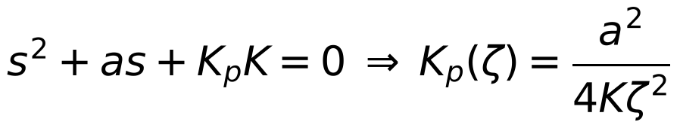
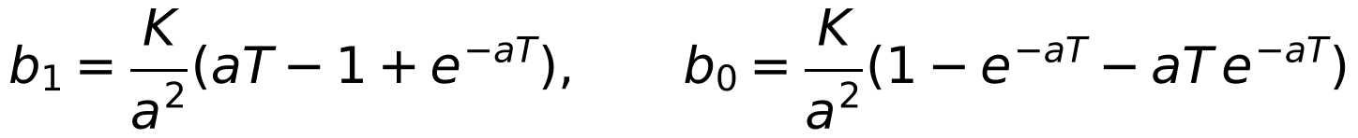
A constant-ζ line in the s-plane maps through z = e^{sT} to a logarithmic spiral in the z-plane. The effective damping ratio of a z-domain pole,
does not depend on T, because s = ln(z)/T and changing T only rescales |s|, never its angle. The same contour-crossing routine (§C2.5) therefore works unchanged at every sampling time.

C1.4 Marginal stability and the ZOH “half-sample delay” heuristic
The base design only asks how much gain is needed to just reach 5% overshoot; it never asks how much the loop can tolerate before going unstable. Because the characteristic equation is a monic quadratic, the product of the closed-loop pole pair equals its constant term, so the exact marginal-stability gain (a pole pair first reaching the unit circle) is closed-form:
(used in §C2.7 and §C4.1). Separately, a ZOH behaves roughly like a T/2 pure delay, which should erode the admissible gain as 1/(1+aT/2) relative to the analog value, i.e. c_{theory} = a/2 in the empirical model of §C4.3, which tests that heuristic directly.

C2. MATLAB Implementation of the Analytic Model

C2.1 Recovering G(s) and verifying by discretisation (Objective 1)
Objective: Recover a and K from the supplied G(z) at T = 1 s, build the continuous plant, and check it against the supplied G(z) when re-discretised.

% --- Recover the analog plant from the sampled model at T = 1 s ---
T1 = 1; pz = 0.15; b1_target = 0.32; zero_given = 0.62; % lab-sheet values
a = -log(pz)/T1; % z = exp(-aT) -> a = 1.8971 rad/s
p1 = exp(-a*T1);
K = b1_target*a^2/(a*T1 - 1 + p1); % match leading ZOH coefficient -> K = 1.0999
Gs = tf(K,[1 a 0]); % recovered plant K/[s(s+a)]
Gz_check = c2d(Gs, T1, 'zoh'); % ZOH model: 0.32 z + 0.1728 over (z-1)(z-0.15)
nz = Gz_check.Numerator{1}; % [0 b1 b0]
fprintf('model zero %.4f vs sheet zero %.4f\n', -nz(3)/nz(2), -zero_given);

Running this gives a = 1.8971 rad/s and K = 1.0999. The re-discretised plant reproduces the sheet’s pole (0.15) and leading coefficient (0.32) by construction, but gives b₀ = 0.1728, i.e. a zero at −0.5400 rather than the sheet’s −0.62 (b₀ = 0.1984). This 14.8% mismatch is analysed in §C3.1.

C2.2 Analog proportional-gain range (Objective 2)
Objective: Convert the 5% overshoot spec to ζ_{min}, then use K_{p}(ζ) = a²/(4Kζ²) for the analog K_{p} interval and the (constant) ideal settling time.

OS_spec = 5; % percent overshoot limit
zeta_min = -log(OS_spec/100)/sqrt(pi^2+log(OS_spec/100)^2); % 0.6901
Kp_max_analog = a^2/(4*K*zeta_min^2); % = 1.7177
Kp_min_analog = a^2/(4*K*1^2); % = 0.8181
ts_analog = 8/a; % 4/(zeta*wn), zeta*wn = a/2 -> 4.2169 s

C2.3 ZOH re-discretisation for a general T (Objective 3, part 1)
Objective: Provide the plant’s ZOH numerator coefficients at any sampling time so the same design procedure runs for every T of the sweep.

function [b1,b0,p] = zoh_coeffs(T,a,K)
% ZOH-equivalent coefficients of K/[s(s+a)] (same as c2d(...,'zoh'), closed form)
p = exp(-a*T);
b1 = (K/a^2).*(a*T - 1 + p);
b0 = (K/a^2).*(1 - p - a*p.*T);
end

C2.4 Locating the ζ = 1 boundary exactly (Objective 3, part 2)
Objective: Find the breakaway gain, where the two real closed-loop poles meet and turn complex, without plotting the locus.

The locus leaves the real axis where the discriminant of z² + [K_{p}b₁−(1+p)]z + [p+K_{p}b₀] vanishes:
function [Kp_min,Kp_breakin] = breakaway_gain(b1,b0,p)
A = b1^2; B = -(2*b1*(1+p) + 4*b0); C = (1-p)^2;
r = sort(roots([A B C])); % two real roots: breakaway, break-in
Kp_min = r(1); Kp_breakin = r(2); % smaller one is the zeta = 1 boundary
end

C2.5 Locating the ζ = 0.69 boundary (Objective 3, part 3)
Objective: Find the gain at which the complex-pole branch crosses the 5%-overshoot contour, using the T-independent ζ_{eff} of §C1.3.

function Kp_max = zeta_crossing_gain(b1,b0,p,target_zeta,Kp_lo,Kp_hi)
Kp_max = fzero(@(Kp) zeta_error(Kp,b1,b0,p,target_zeta), [Kp_lo Kp_hi]);
end
function e = zeta_error(Kp,b1,b0,p,target)
r = roots([1, Kp*b1-(1+p), p+Kp*b0]);
zc = r(imag(r) > 0); % upper complex pole
e = -log(abs(zc))/abs(log(zc)) - target; % zeta_eff(z) - target
end

C2.6 Performance evaluation (Objective 4)
Objective: Given a design point (K_{p}, T), build the closed-loop discrete transfer function and read off the true overshoot and settling time.

function [OS,ts] = evaluate_design(b1,b0,p,Kp,T)
Gz = tf([b1 b0],[1 -(1+p) p], T); % open-loop ZOH plant
Gcl = feedback(Kp*Gz, 1); % unity feedback
info = stepinfo(Gcl,'SettlingTimeThreshold',0.02);
OS = info.Overshoot; ts = info.SettlingTime;
end

C2.7 Marginal-stability gain (further analysis, §C4.1)
Objective: Compute the exact upper stability limit on K_{p} from the closed-form result of §C1.4.

function Kp_stab = marginal_stability_gain(b0,p)
% On the complex branch |z|^2 = C = p + Kp*b0; instability begins when it reaches 1
Kp_stab = (1 - p)/b0;
end

C2.8 Empirical K_{p}(T) relationship (Objective 5, further analysis)
Objective: Fit a closed-form approximation to how K_{p,min} and K_{p,max} fall with sampling time, and report the goodness of fit.

function [Kp0,c,R2] = fit_inverse_law(Tvec,Kpvec)
% Fit Kp(T) ~= Kp0/(1+c*T) by nonlinear least squares (fminsearch: base MATLAB)
model = @(par,T) par(1)./(1+par(2).*T);
sse = @(par) sum((Kpvec(:) - model(par,Tvec(:))).^2);
par = fminsearch(sse,[Kpvec(1),1],optimset('TolX',1e-12,'TolFun',1e-14,'MaxIter',5000));
Kp0 = par(1); c = par(2);
R2 = 1 - sum((Kpvec(:)-model(par,Tvec(:))).^2)/sum((Kpvec(:)-mean(Kpvec)).^2);
end

C3. Sheet versus Analytic Model: Consistency and Comparison

C3.1 Recovered plant, analog design, and the consistency of the supplied G(z)
§C2.1 gives a = 1.8971 rad/s and K = 1.0999, so G(s) = 1.0999/[s(s+1.8971)]. §C2.2 gives ζ_{min} = 0.6901, an analog gain range 0.8181 ≤ K_{p} ≤ 1.7177 and a constant ideal settling time 8/a = 4.2169 s across that range (ζω_{n} = a/2 is fixed by construction).
Consistency of the supplied G(z) (new finding). For a plant K/[s(s+a)] the ZOH numerator coefficients b₁ and b₀ and the pole p are tied together by a single pair (a, K). The sheet gives three numbers (p = 0.15, b₁ = 0.32, zero −0.62), so one of them is redundant, and it is inconsistent: p and b₁ fix a and K, which then force the zero to
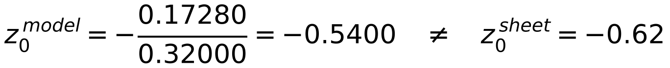
a 14.8% difference. The effect on the design is not negligible (Table C0). The sheet’s own coefficients are used for every T = 1 s analysis (§C3.2, §C4.4–6.8, §14, §15, §C6) because that is the plant the lab specifies, while the T-sweep necessarily uses the recovered continuous model. A zero of 0.54 on the sheet would make the two descriptions coincide exactly, so it is worth re-checking the handwritten value; the MATLAB switch USE_GIVEN_AT_T1 (or editing zero_given) re-runs everything either way.
T = 1 s | Zero z₀ | K_{p,min} (ζ=1) | K_{p,max} (ζ=0.69) | K_{p,stab} | K_{p,stab}/K_{p,max} | OS / t_{s} at K_{p,max}
Sheet G(z) [0.32(z+0.62)] | −0.6200 | 0.4883 | 0.7845 | 4.284 | 5.46× | 5.00% / 7 s
ZOH model [0.32(z+0.540)] | −0.5400 | 0.5261 | 0.8524 | 4.919 | 5.77× | 4.98% / 7 s
Difference (sheet vs model) | +14.8% | -7.2% | -8.0% | -12.9%
Table C0. The same design procedure applied to the sheet’s G(z) and to the exact ZOH model of the recovered plant, at T = 1 s. Both reach t_{s} = 9.0 s at K_{p,min} and 7 s at K_{p,max}, so the conclusions are unchanged; the gains shift by 7–13%.
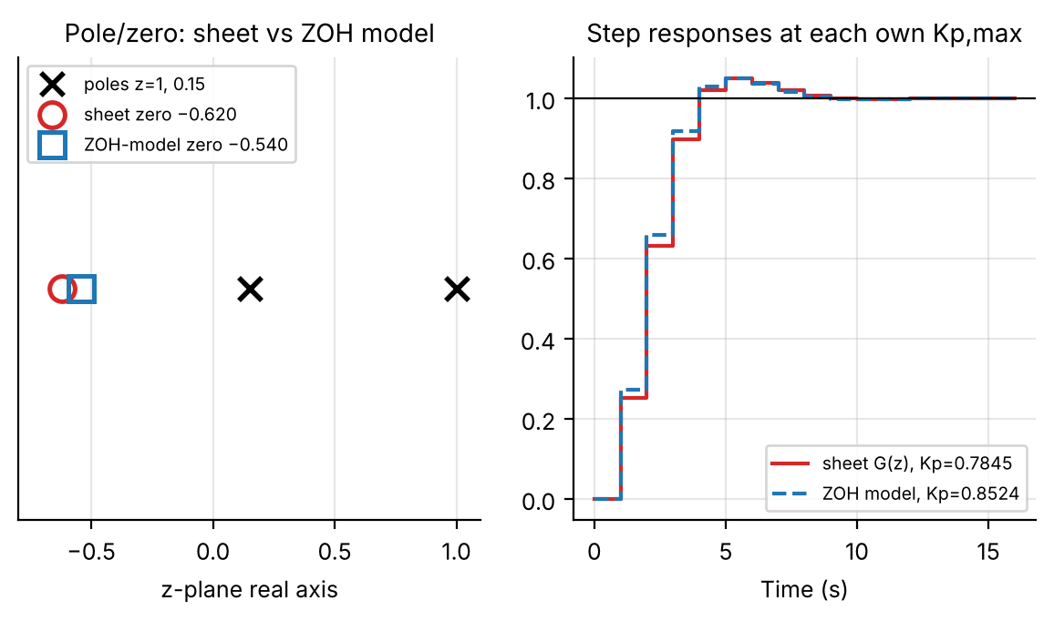
Figure C1. Left: the sheet’s zero (−0.62) and the zero of the exact ZOH model (−0.540). Right: step responses, each at its own K_{p,max}: the two are almost indistinguishable at the sample instants.

C3.2 Digital design table
Table C1 gives the digital design at each sampling time: the two gain boundaries (§C2.4–4.5), the true marginal-stability gain (§C2.7) and the resulting gain margin, all on the recovered continuous model. At T = 0.1 s the lower boundary lies about 4.6% below the analog K_{p,min} and the upper about 9% below the analog K_{p,max}, and both converge to the analog values as T → 0.
T (s) | K_{p,min} (ζ=1) | K_{p,max} (ζ=0.69) | K_{p,stability} | Margin K_{p,stab}/K_{p,max} | OS at K_{p,max} | t_{s} at K_{p,min} (s) | t_{s} at K_{p,max} (s)
0.1 | 0.7803 | 1.5613 | 35.623 | 22.82× | 5.00% | 6.4 | 4.6
0.2 | 0.7447 | 1.4299 | 18.410 | 12.88× | 4.97% | 6.6 | 5.0
0.3 | 0.7111 | 1.3182 | 12.697 | 9.63× | 4.99% | 6.9 | 5.1
0.4 | 0.6794 | 1.2224 | 9.859 | 8.07× | 4.90% | 7.2 | 5.6
0.5 | 0.6497 | 1.1395 | 8.172 | 7.17× | 5.00% | 7.5 | 6.0
0.6 | 0.6217 | 1.0671 | 7.061 | 6.62× | 5.00% | 7.8 | 6.0
0.7 | 0.5955 | 1.0035 | 6.279 | 6.26× | 4.95% | 7.7 | 6.3
0.8 | 0.5709 | 0.9473 | 5.702 | 6.02× | 4.85% | 8.0 | 6.4
0.9 | 0.5478 | 0.8972 | 5.262 | 5.87× | 4.91% | 8.1 | 7.2
1.0 | 0.5261 | 0.8524 | 4.919 | 5.77× | 4.98% | 9.0 | 7.0
Table C1. Digital design boundaries and true stability limit, T = 0.1–1.0 s (recovered ZOH model, csv_new_plant/table1_digital_design.csv). Overshoot at K_{p,min} is 0.0% at every T (real breakaway poles). At T = 1 s the sheet’s own G(z) gives 0.4883 / 0.7845 / 4.284 (Table C0).
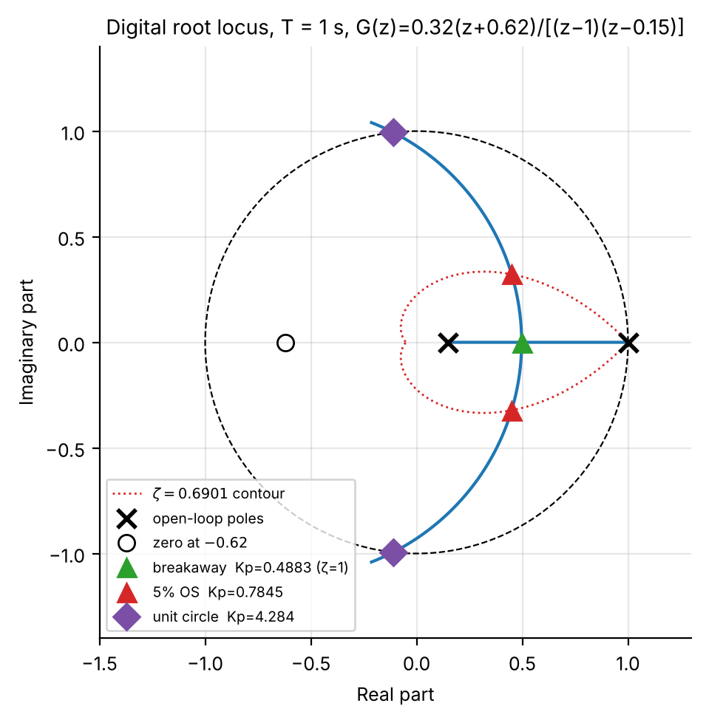
Figure C2. Digital root locus at T = 1 s for the sheet’s G(z): breakaway (ζ = 1, K_{p} = 0.4883, double pole at z = 0.4969), 5%-overshoot crossing (K_{p} = 0.7845, z = 0.4495 ± 0.3219j) and exact marginal-stability point (K_{p} = 4.284, z = −0.1105 ± 0.9939j) on the same locus; dotted: ζ = 0.6901 contour.

C3.3 K_{p} and settling time vs sampling time
Figure C3 plots the three gain boundaries against T on a log axis with the fitted laws of §C2.8 (discussed in §C4.3). Figure C4 compares the simulated settling time with the idealised formulas; the idealised 4/σ estimate and the simulation are close at the K_{p,max} boundary but diverge at K_{p,min} (§C4.2).
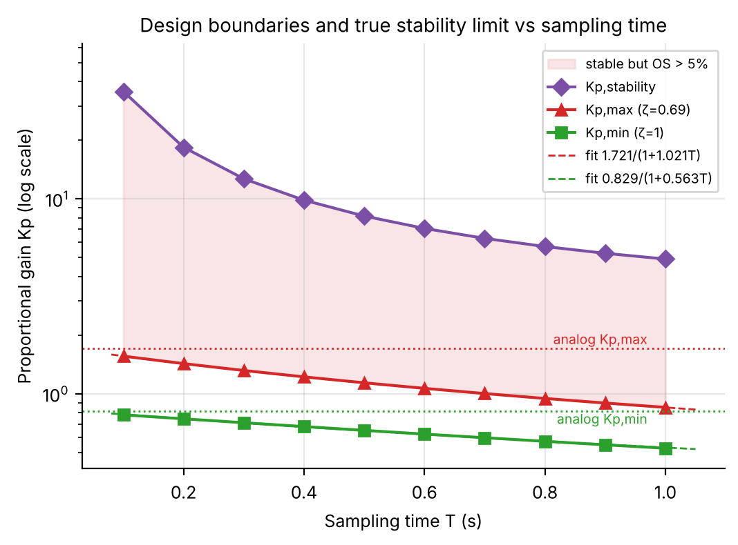
Figure C3. K_{p,min}, K_{p,max} and K_{p,stability} vs T (log axis) with the fitted inverse laws overlaid; dotted lines are the analog values. The shaded band is stable but violates the 5% overshoot spec.
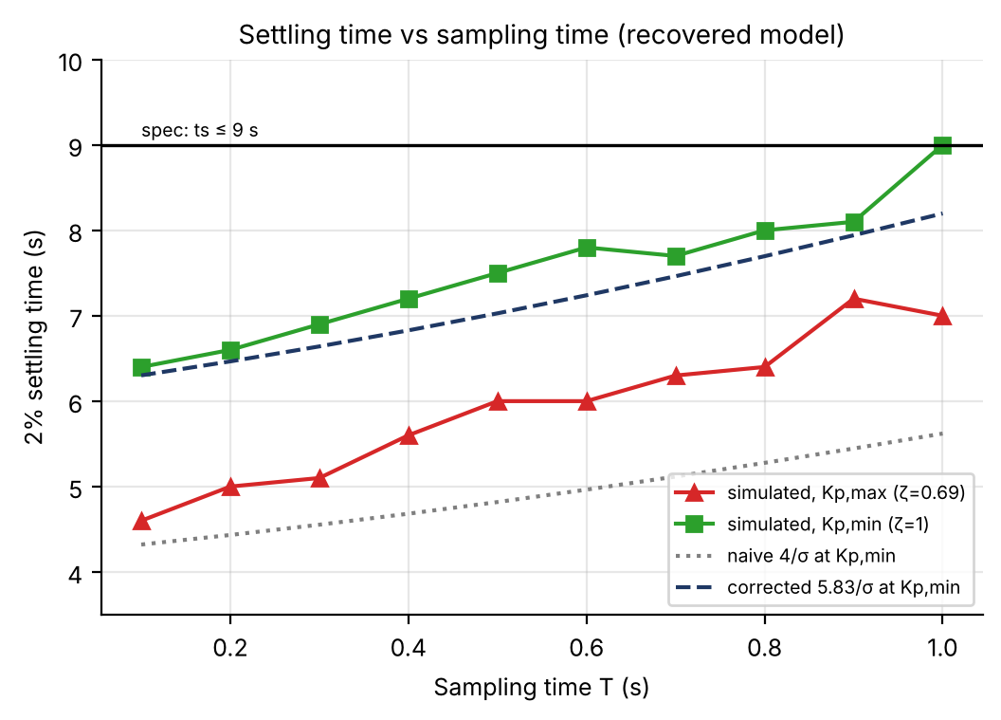
Figure C4. Simulated 2% settling time at both boundaries, with the naive (4/σ) and repeated-pole-corrected (5.83/σ) estimates at K_{p,min}. At T = 1 s the simulated t_{s} at K_{p,min} reaches the 9 s spec exactly.
T (s) | K_{p,max} d2c→c2d (Part I) | K_{p,max} analytic (§C3) | Δ | Breakaway d2c→c2d | Breakaway analytic | Δ | zero d2c→c2d | zero analytic
0.1 | 1.4043 | 1.5613 | +11.2 % | 0.7205 | 0.7803 | +8.3 % | -4.13 | -0.94
0.2 | 1.2913 | 1.4299 | +10.7 % | 0.6881 | 0.7447 | +8.2 % | -1.69 | -0.88
0.3 | 1.1984 | 1.3182 | +10.0 % | 0.6575 | 0.7111 | +8.2 % | -1.27 | -0.83
0.4 | 1.1121 | 1.2224 | +9.9 % | 0.6286 | 0.6794 | +8.1 % | -1.07 | -0.78
0.5 | 1.0411 | 1.1395 | +9.4 % | 0.6014 | 0.6497 | +8.0 % | -0.95 | -0.73
0.6 | 0.9766 | 1.0671 | +9.3 % | 0.5759 | 0.6217 | +8.0 % | -0.85 | -0.69
0.7 | 0.9259 | 1.0035 | +8.4 % | 0.5519 | 0.5955 | +7.9 % | -0.78 | -0.65
0.8 | 0.8709 | 0.9473 | +8.8 % | 0.5293 | 0.5709 | +7.8 % | -0.72 | -0.61
0.9 | 0.8319 | 0.8972 | +7.8 % | 0.5082 | 0.5478 | +7.8 % | -0.67 | -0.57
1.0 | 0.7846 | 0.8524 | +8.6 % | 0.4883 | 0.5261 | +7.7 % | -0.62 | -0.54
Table C2. The two plant descriptions side by side. They coincide in pole and leading coefficient at T = 1 s but differ in the zero (−0.62 vs −0.540), and for T < 1 s the d2c→c2d chain keeps the sheet’s non-minimum-phase zero while the analytic model has none; the K_{p,max} values differ by 8–11 %.
Which description to use. The chain used in your report reproduces the lab sheet exactly at T = 1 s (zero −0.62), so its T = 1 s numbers (0.468–0.785) are the ones to quote; the analytic model assumes a plant form the sheet does not obey exactly, and gives 0.488–0.852 at T = 1 s if its own ZOH zero is used (Table C0). The two models agree on every qualitative conclusion — gain windows that shrink with T, a half-sample-delay law for K_{p,max}, stability limits several times above the design gain — and on the closed-form tools; they differ by a roughly constant 8–11 % in K_{p,max}. The analytic model is useful because K/[s(s+a)] has closed-form analog formulas (§C2.2) and an unconditional-stability argument (§C4.1).

C4. Further Analysis with the Analytic Model

C4.1 How close is the design to instability?
The open-loop model has one more pole than zero, so the root locus has a single asymptote and, as K_{p} grows, one closed-loop pole heads to −∞ while the other approaches the open-loop zero. In between, the complex pair crosses the unit circle at a single exact gain K_{p,stab} = (1−p)/b₀ (§C2.7). For the sheet’s plant at T = 1 s this is K_{p} = 4.284: 5.46× the gain that already gives 5% overshoot (0.7845). On the recovered model the margin ratio grows from 5.77× at T = 1 s to 22.8× at T = 0.1 s (Table C1, Figure C3).
This is an important, slightly counter-intuitive digital-control fact. The analog plant K/[s(s+a)] under proportional feedback is unconditionally stable for every K_{p} > 0 (s² + as + K_{p}K has positive coefficients). Sampling destroys this: ZOH sampling of a type-1 plant introduces a finite zero, giving a real asymptote and a finite stability limit, so gains harmless in continuous time can destabilise the sampled loop. The 5% overshoot limit lies well inside the stability boundary over the whole tested range, but a designer relying on continuous-time intuition would be caught out at higher gains.

C4.2 The critical-damping settling-time correction
The usual t_{s} ≈ 4/(ζω_{n}) comes from the 1/√(1−ζ²) envelope of an underdamped second-order response and is only valid away from ζ = 1. At the K_{p,min} boundary the closed-loop poles are real and repeated, the natural mode is n·rⁿ, and the 2%-settling constant becomes the root of
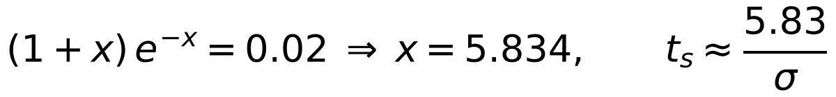
T (s) | t_{s} naive (4/σ) | t_{s} corrected (5.83/σ) | t_{s} full simulation
0.1 | 4.321 | 6.302 | 6.4
0.4 | 4.682 | 6.828 | 7.2
0.7 | 5.117 | 7.463 | 7.7
1.0 | 5.621 | 8.198 | 9.0
Table C2. Settling time at the K_{p,min} (ζ = 1) boundary (all ten T in csv_new_plant/table2_ts_at_Kpmin.csv). The corrected formula tracks the simulation (to within the one-sample quantisation); at T = 1 s the true settling time (9.0 s) sits exactly on the 9 s limit, not comfortably inside it as the naive 5.62 s suggests.
Practical takeaway: near ζ = 1 use 5.83/σ (or a full simulation). The gap is small at fine sampling but is the difference between comfortably meeting the specification and sitting exactly on its boundary once T approaches 1 s. The same 9.0 s result holds for the sheet’s own G(z) (Table C0).

C4.3 Empirical K_{p}(T) relationship
Fitting K_{p}(T) ≈ K_{p0}/(1+cT) by nonlinear least squares (§C2.8) to the two design boundaries gives
Quantity | Fitted model | R²
K_{p,max}(T) (ζ = 0.69) | 1.7212 / (1 + 1.0205·T) | 1.00000
K_{p,min}(T) (ζ = 1, breakaway) | 0.8288 / (1 + 0.5631·T) | 0.99895
t_{s,max}(T) (linear, simulated) | 2.764·T + 4.400 | 0.9611
t_{s,min}(T) (linear, simulated) | 2.497·T + 6.147 | 0.9428
Table C3. Empirical curve fits. Both K_{p} fits are excellent, and their zero-sampling intercepts K_{p0} (1.721 and 0.829) land almost exactly on the analog values (1.718 and 0.818) of §C3.1, so the digital design converges to the analog design as T → 0.
Does the ZOH “half-sample-delay” heuristic (c = a/2 = 0.9486) explain this? Using that single, physically motivated constant instead of the fitted one gives R² = 0.9881 at the K_{p,max} boundary (a good approximation) but R² = -0.230 at K_{p,min}, worse than a constant. The delay picture explains how sampling erodes the overshoot-limited gain (a phase-lag mechanism) but not the breakaway boundary, which is a purely real-axis condition (the discriminant of the characteristic equation). This is a genuine limit of the heuristic, not a fitting artefact: the free two-parameter fit for K_{p,min} remains excellent (R² = 0.9990).

C4.5 Overshoot sensitivity heatmap
Figure C6 evaluates %OS(K_{p}, T) over a dense grid (240 × 220 points) from the pole location, as a continuous extension of Table C1. Table C1’s (K_{p,max}, T) points fall on the dashed 5% contour, and its (K_{p,min}, T) points lie just left of the dashed 0.2% contour, as they must since overshoot is exactly zero up to breakaway: a visual cross-check of the whole table at once. The bright band on the right is the >90% overshoot / near-instability region approached in §C4.1.
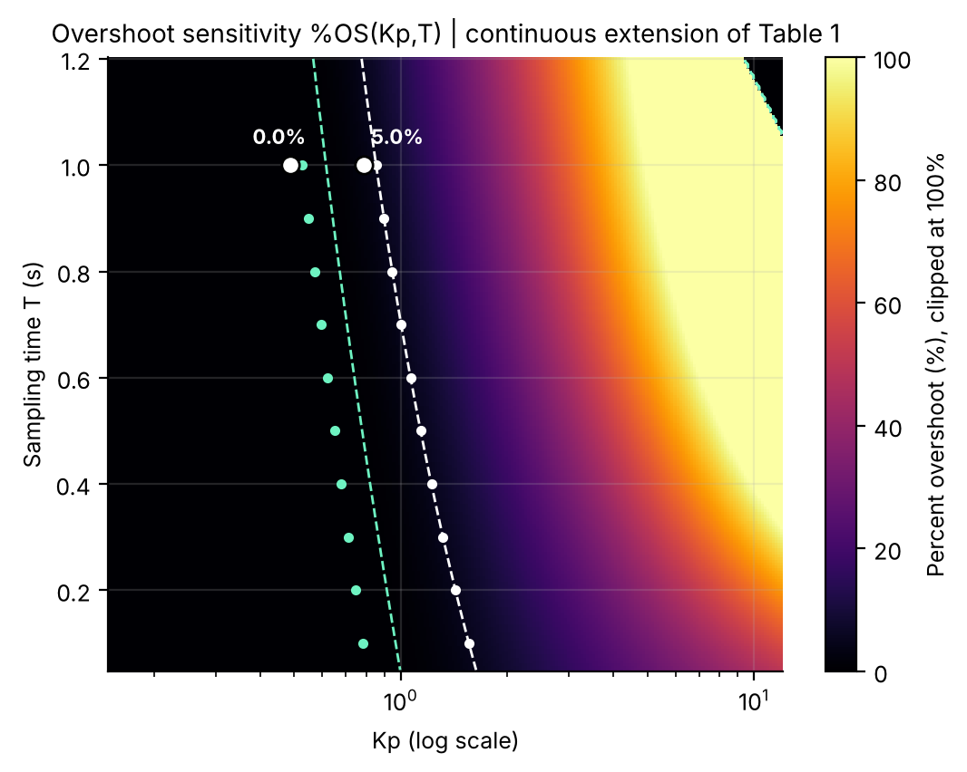
Figure C6. Overshoot %OS(K_{p}, T) of the recovered model with the Table C1 boundary points (small dots) and the 5% / 0.2% contours (dashed). The two large dots at T = 1 s are the sheet’s G(z) boundary gains (0.4883, 0.7845); they sit left of the model’s small dots because of the §C3.1 mismatch.

C4.7 Mining the waterfall further: the full %OS(K_{p}) and t_{s}(K_{p}) curves
Figure C5’s underlying data already contains 70 simulated responses, which can be re-mined sample by sample into continuous %OS(K_{p}) and t_{s}(K_{p}) curves without further simulation. In MATLAB this is the same peak and 2%-band logic as evaluate_design (§C2.6) applied to the cached wf_y/wf_t cells of the main script (section 6.7).
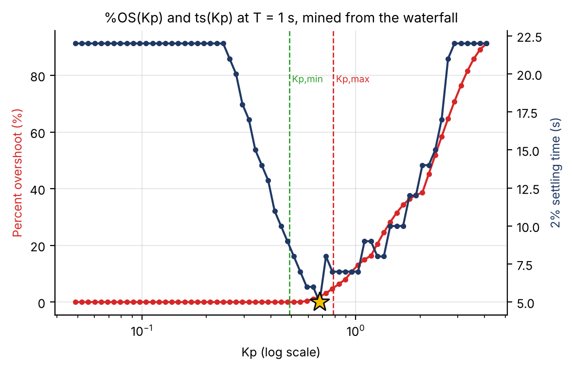
Figure C7. %OS (red, left) and 2% settling time (navy, right) vs K_{p} at T = 1 s, mined from Figure C5’s data; the gold star is the minimum of t_{s}. A plateau at 22 s means “not settled within the 22 s record”.
Interpretation. %OS(K_{p}) is exactly the monotonic curve the design method assumes: flat at 0% until breakaway, then rising smoothly. t_{s}(K_{p}) is not monotonic; it is U-shaped, and its minimum (t_{s} = 5 s at K_{p} ≈ 0.68, OS 1.97%) lies inside the design window, below K_{p,max} = 0.7845, not at either boundary. A 400-point scan of the window shows that t_{s} = 5 s holds for 0.635 ≲ K_{p} ≲ 0.678 (mid-band K_{p} = 0.656, OS 1.45%). A designer who only needs %OS ≤ 5% and the fastest settling should therefore not pick K_{p,max} (7 s, 5.0% OS) but a gain near 0.66, which settles in 5 s with a quarter of the overshoot. The two slow ends of the U have different causes: as K_{p} → 0 the dominant pole barely leaves z = 1; as K_{p} → K_{p,stab} the decay rate σ → 0 as the pole nears the unit circle, so the response is sluggish for the opposite reason (too little damping, not too little gain).

C4.10 Where is overshoot most gain-sensitive? A 2-D sensitivity field
§15 computes the pole sensitivity |dz/dK_{p}| at two points. The same idea extends to the whole Figure C6 domain: differentiating the cached %OS(K_{p}, T) grid along K_{p} gives the field d(%OS)/dK_{p} with no new simulation (MATLAB: gradient(OS_grid(i,:), Kp_grid) row by row).
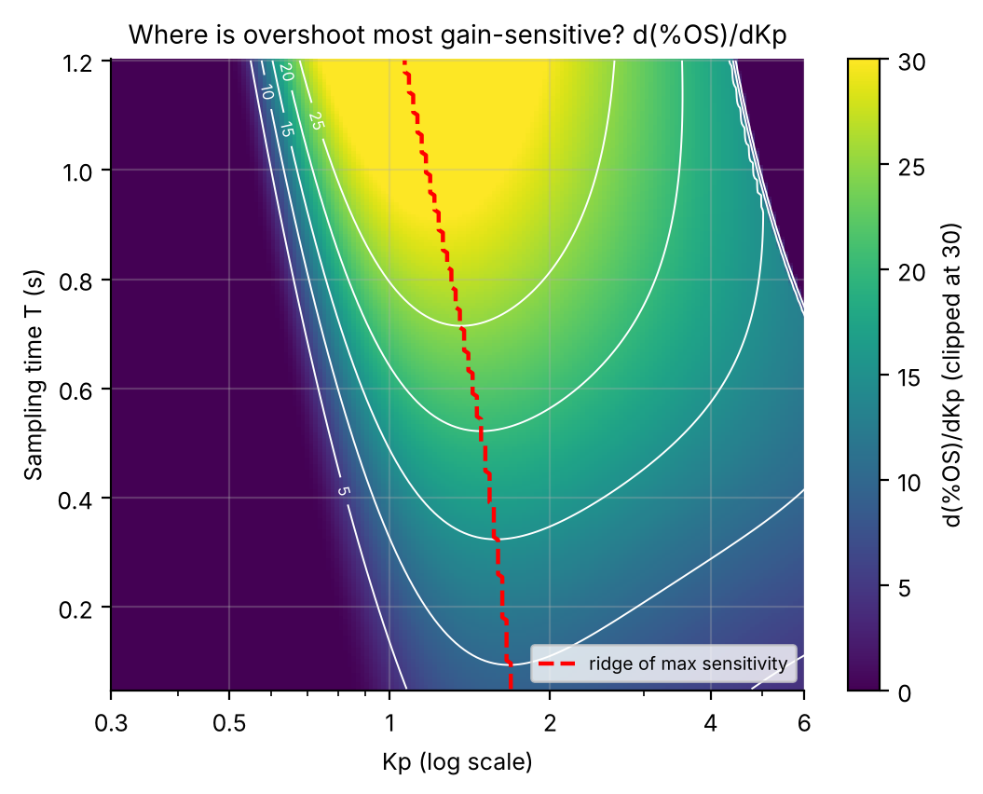
Figure C9. d(%OS)/dK_{p} over the Figure C6 domain (clipped at 30). The dashed ridge traces the K_{p} of maximum sensitivity at each T.
Interpretation. The ridge lies somewhat beyond breakaway (K_{p} ≈ 1.2–1.7 depending on T) because %OS is flat at and before breakaway and climbs steeply only once the pole is well into the complex plane. Notably, the 5% design boundary sits just below the ridge: at K_{p,max} the slope is already 10.1 %OS per unit K_{p} at T = 0.1 s, 17.9 at T = 0.5 s and 28.1 at T = 1.0 s. A 10% gain error at T = 1 s moves the overshoot from 5.0% to about 7.5%. The ridge peak grows from 10.2 (T = 0.1 s) to 32.0 (T = 1.0 s), so the same absolute gain error is about 3× more consequential at the coarsest tested sampling time, one more entry in this report’s running theme that coarse sampling degrades the design on every axis measured. (This overshoot sensitivity is distinct from |dz/dK_{p}|, which peaks exactly at breakaway.)

C5. Lab-Manual Graphical Workflow
The lab manual asks for the graphical workflow (rlocusplot with zgrid, datatips, Control System Designer) in addition to the analytic route. The steps below reproduce the T = 1 s and T = 0.5 s designs graphically and give the targets a careful user should read off.

C5.1 Graphical zgrid workflow, T = 1 s
Objective: Use rlocusplot with a zgrid(0.69,[]) overlay, read the gain at the ζ = 0.69 crossing via a datatip, and cross-check against the analytic K_{p,min} = 0.4883 / K_{p,max} = 0.7845.

T = 1; Gz1 = tf(0.32*[1 0.62],conv([1 -1],[1 -0.15]),T); % sheet G(z)
h = rlocusplot(Gz1); hold on; zgrid(0.69,[]); % zeta = 0.69 spiral + unit circle
opts = getoptions(h); opts.Title.String = 'Root locus, \zeta = 0.69 contour, T = 1 s'; setoptions(h,opts);
% Click the branch where it meets the dashed zeta=0.69 curve: datatip shows Gain, Damping, Overshoot.
[rl,kl] = rlocus(Gz1); % programmatic cross-check of the datatip
zeta_vec = nan(1,numel(kl));
for q = 1:numel(kl)
zc = rl(imag(rl(:,q)) > 1e-9, q); if ~isempty(zc), zeta_vec(q) = effective_zeta(zc(1)); end
end
[~,iq] = min(abs(zeta_vec - 0.6901));
fprintf('Kp,max graphical %.4f | analytic %.4f\n', kl(iq), Kp1_max);

The locus starts at z = 1 and z = 0.15, breaks away at z ≈ 0.497 and crosses the ζ = 0.69 spiral near z ≈ 0.45 + 0.32j (Figure C2). The datatip there should read about Gain 0.78, Damping 0.690, Overshoot 5.0%. A mouse reading is limited to roughly ±1%, and rlocus’s gain vector is not refined at a contour crossing the way the fzero routine of §C2.5 is, so a small discrepancy is expected; the graphical workflow is a sanity check on the analytic pipeline, not the source of the final numbers. The script prints the programmatic difference when run.
Method | K_{p,max} (ζ = 0.69) | K_{p,min} (ζ = 1, breakaway)
Graphical (datatip) | ≈ 0.78 (± 1%, cursor-limited) | ≈ 0.49 (± 1%)
Analytic (§C2.4–4.5) | 0.7845 | 0.4883

C5.2 Control System Designer walkthrough, T = 0.5 s
Objective: Step-by-step controlSystemDesigner('rlocus',Gz) procedure at T = 0.5 s: import the plant, enable the damping grid, drag the pole onto the ζ = 0.69 contour and read the gain.

[b1c,b0c,pc] = zoh_coeffs(0.5,a,K); % recovered model at T = 0.5 s
Gz_csd = tf([b1c b0c],[1 -(1+pc) pc], 0.5);
controlSystemDesigner('rlocus', Gz_csd)

- Launch. The Root Locus Editor shows poles z = 1 and z = 0.3873 and the zero at z ≈ −0.7304. [screenshot: window on open]
- Enable the damping grid (right-click → Grid), then add a design requirement (right-click → Design Requirements → New → Damping Ratio = 0.69); a shaded exclusion wedge appears. [screenshot]
- Drag the closed-loop pole square along the locus until it sits on the ζ = 0.69 boundary; the Compensator Editor updates live and should settle near K_{p} ≈ 1.14. [screenshot]
- Repeat for ζ = 1: drag to the real-axis breakaway point; the readout should land near K_{p} ≈ 0.65. [screenshot]
These targets (K_{p,min}(0.5) = 0.6497, K_{p,max}(0.5) = 1.1395 from Table C1) let a mismatch of more than a percent or two be diagnosed as a mis-drag or a units error (Hz vs rad/s, or an un-discretised G(s)) instead of a real discrepancy.

C5.3 Gain vs sampling time: quantitative answer to Q3
Objective: Use the fitted laws to tabulate the admissible-interval width and K_{p,max}, K_{p,min} as a percentage of their analog values, and answer how the gain requirement changes with sampling time.

Kp_max_fit = Kp0_max./(1+c_max*Table1.T); Kp_min_fit = Kp0_min./(1+c_min*Table1.T);
width = Kp_max_fit - Kp_min_fit;
pct_max_of_analog = Kp_max_fit/Kp_max_analog*100; pct_min_of_analog = Kp_min_fit/Kp_min_analog*100;
Table9_3 = table(Table1.T, width, pct_max_of_analog, pct_min_of_analog)

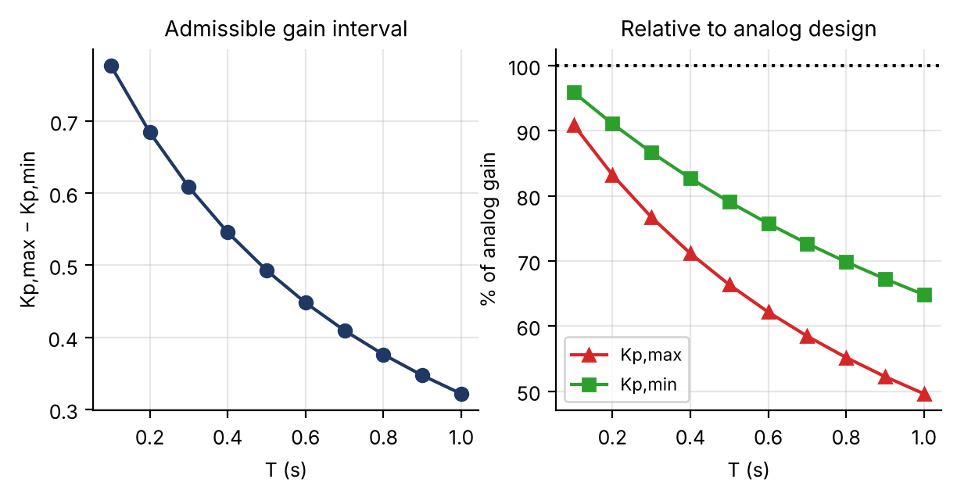
Figure C10. Left: admissible gain-interval width vs T. Right: K_{p,max}(T) and K_{p,min}(T) as a percentage of their analog counterparts.
T (s) | Interval width | K_{p,max} / analog | K_{p,min} / analog
0.1 | 0.777 | 90.9% | 95.9%
0.2 | 0.684 | 83.2% | 91.1%
0.4 | 0.546 | 71.2% | 82.7%
0.6 | 0.448 | 62.1% | 75.7%
0.8 | 0.376 | 55.2% | 69.8%
1.0 | 0.322 | 49.6% | 64.8%
(Every-other-row excerpt; full table in A3_interval_width.csv.)
Interpretation. The admissible window narrows from 0.777 at T = 0.1 s to 0.322 at T = 1.0 s (−59%), and it narrows from the top down: K_{p,max} erodes to 49.6% of its analog value by T = 1 s, K_{p,min} only to 64.8%. This reflects §C4.3: K_{p,max} is governed largely by phase lag, well captured by the half-sample-delay picture, whereas K_{p,min} is a real-axis breakaway condition that erodes more slowly.

C6. Beyond Proportional Control: Lead Compensator Design
Objective: Design C(z) = K(z − z_{lead})/(z − p_{lead}) at T = 1 s keeping %OS ≤ 5% while settling faster than the best proportional-only design, with a one-sample margin under a 5 s target; verify by full discrete simulation.

Fairness first. The proportional design is not stuck at 9 s: that figure belongs to the K_{p,min} end of the window. As §C4.7 showed, K_{p} ≈ 0.635–0.678 already settles in 5 s (OS 1.45% at the mid-band gain 0.656). A lead compensator is therefore only worthwhile if it beats 5 s, so the target here is t_{s} ≤ 5 − 1 = 4 s.
Design approach. Set z_{lead} = p = 0.15 to cancel the slow plant pole. The remaining loop L(z) = K(b₁z+b₀)/[(z−1)(z−p_{lead})] has the same form as the proportional design with the fixed pole p replaced by a free p_{lead}, so the breakaway and ζ-crossing functions of §C2.4–4.5 are reused with p_{lead} and swept to find the least aggressive pole that meets the target in a full simulation.
z_lead = pT; cand = 0.15:-0.05:-0.40; % cancel the plant pole; sweep p_lead
for q = 1:numel(cand)
try
[km,kb] = breakaway_gain(b1T,b0T,cand(q));
Kc(q) = zeta_crossing_gain(b1T,b0T,cand(q),zeta_min,km*1.0005,kb*0.999);
Cq = tf(Kc(q)*[1 -z_lead],[1 -cand(q)],T1);
i2 = stepinfo(feedback(Cq*Gz1,1),'SettlingTimeThreshold',0.02);
OSc(q) = i2.Overshoot; tsc(q) = i2.SettlingTime;
catch, end % bracket fails for very negative p_lead
end
ok = find(OSc <= OS_spec+OS_tol & tsc <= ts_lead-lead_margin, 1, 'first'); % ts_lead = 5, margin = 1
p_lead = cand(ok); K_lead = Kc(ok); C = tf(K_lead*[1 -z_lead],[1 -p_lead],T1);

p_{lead} | K | %OS (simulated) | t_{s} (simulated)
+0.15 (baseline: original pole) | 0.7845 | 5.00% | 7 s
0.00 | 1.0955 | 4.99% | 6 s
−0.10 | 1.3323 | 4.34% | 5 s
−0.20 (chosen) | 1.5922 | 4.91% | 4 s
−0.30 | 1.8734 | 3.19% | 4 s
−0.40 | 2.1657 | 5.82% | 3 s
Table C7. Lead search excerpt (all candidates in lead_search.csv). p_{lead} = 0.15 reproduces the proportional K_{p,max} design. The −0.10 candidate (5 s) only equals the best proportional design, so it is rejected; −0.20 is the first candidate that is strictly faster with a one-sample margin.
Final compensator: C(z) = 1.5922 (z − 0.15) / (z + 0.20), with closed-loop poles 0.1452 ± 0.3079j.
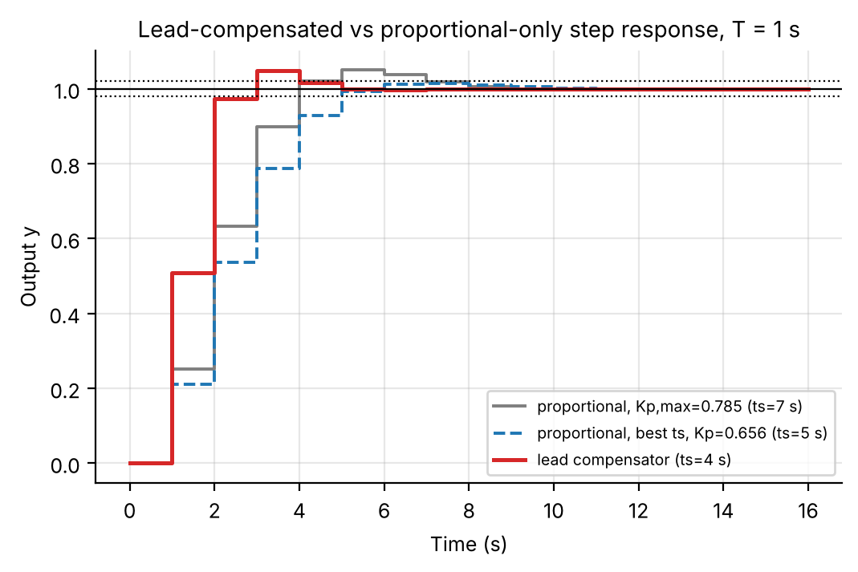
Figure C16. Full discrete step response at T = 1 s: lead-compensated design (red, t_{s} = 4 s), proportional at the best-t_{s} gain (blue dashed, 5 s) and proportional at K_{p,max} (grey, 7 s).
Metric | Proportional, K_{p,max} | Proportional, best t_{s} (K_{p} = 0.656) | Lead compensator (this design)
%OS | 5.00% | 1.45% | 4.91%
t_{s} (2%) | 7 s | 5 s | 4 s (1 s margin under the 5 s target)
Controller gain | 0.7845 | 0.656 | 1.5922 (≈ 2× larger)

Interpretation. Cancelling the slow plant pole and adding a faster negative-real pole at z = −0.20 roughly doubles the usable gain (0.78 → 1.59) while keeping the dominant pole pair on the ζ = 0.69 contour, so overshoot stays at the 5% limit (4.91%) and t_{s} drops from the proportional best of 5 s to 4 s (and from 9 s at the K_{p,min} end). The gain is modest, one sample, because settling time is already quantised to whole sampling periods, and it is paid for with the full overshoot budget and a controller gain twice as large (more noise amplification), whereas the best proportional design keeps 3.5 percentage points of overshoot margin. The lead is thus justified only if the 4 s target matters. The pole at −0.20 decays within a sample or two and does not affect the dominant response.

C7. Design Nomograph

C7.1 Design nomograph
Objective: One figure: T on x, K_{p} on y, the %OS ≤ 5% region shaded, the t_{s} ≤ 9 s bound overlaid and their intersection shaded as the spec-compliant region, with the Table C1 points labelled.

Tg14 = linspace(0.1,1.0,19); Kpg14 = linspace(0.6*min(Table1.Kp_min), 1.7*max(Table1.Kp_max), 85);
for i = 1:numel(Tg14) % grid simulation, same machinery as 6.5
[b1,b0,p] = zoh_coeffs(Tg14(i),a,K);
for j = 1:numel(Kpg14), [OS14(j,i),ts14(j,i)] = evaluate_design(b1,b0,p,Kpg14(j),Tg14(i)); end
end
ok14 = double((OS14 <= OS_spec) & (ts14 <= ts_spec));
contourf(Tg14,Kpg14,ok14,[0.5 1.5]); hold on;
contour(Tg14,Kpg14,OS14,[OS_spec OS_spec],'r','LineWidth',2); contour(Tg14,Kpg14,ts14,[ts_spec ts_spec],'b','LineWidth',2);

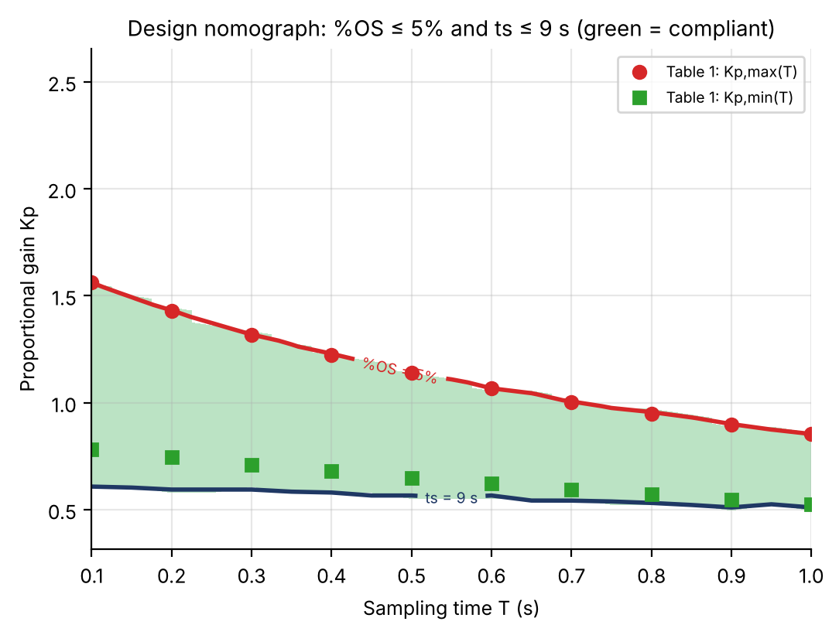
Figure C17. Green: both specs satisfied. Red: %OS = 5% boundary (= K_{p,max}(T)). Navy: t_{s} = 9 s boundary (drawn only below K_{p,max}). Table C1 points overlaid.
Interpretation. The compliant region’s upper boundary is always the 5% overshoot line, so K_{p,max}(T) binds from above at every T. Its lower boundary is the t_{s} = 9 s line, which lies below K_{p,min}(T) for every T < 1 s (the window extends below breakaway at 0% overshoot, only slower) and meets K_{p,min}(T) as T → 1 s. This independently confirms from a full-grid simulation that the settling-time constraint becomes binding only at the coarsest sampling, where the ζ = 1 gain itself sits at 9 s.
— Part IV: Closing Sections —

19. Discussion
The results demonstrate the influence of sampling time on the design of a digital proportional controller. Although the same continuous plant underlies every case, its discrete representation changes with T through z = e^{sT}, so the discrete poles and zero — and with them the root-locus trajectory — change, and the gain must be chosen for the sampling time in use.
The two specifications bound the permissible gain: t_{s} ≤ 9 s sets the lower bound and %OS ≤ 5 % the upper one. The added analysis makes this precise: the lower edge is a slow-pole effect (σ ≈ 0.5 s⁻¹ at every T, §10) that is reached while both poles are still real (below breakaway), hence 0 % overshoot there; the upper edge is where the complex branch crosses ζ = 0.6901, which the closed-form crossing reproduces to within 1 % (§9). An acceptable range exists for every T from 0.1 s to 1.0 s.
The maximum permissible gain decreases significantly with T: ◆ from 1.404 at T = 0.1 s to 0.785 at T = 1.0 s (your sweep: 1.401 → 0.781). The corresponding sentence of your report quotes 1.676134 and 0.921074, which do not match your own table or any of the exact values; the table values are used here. The decrease follows K_{p,max}(T) ≈ 1.538/(1 + 0.953T) with R² = 0.9999 — an analog limit divided by a half-sample ZOH delay (c ≈ a/2) — which also explains why larger sampling intervals leave a narrower window: the range shrinks by 62 % from T = 0.1 s to 1 s, mainly through the upper edge.
◆ Analog versus digital values. The analog limits are 0.582 ≤ K_{p} ≤ 1.536 (your quoted 0.678 / 1.845 do not satisfy the specifications for this plant, §4). The digital limits converge towards these as T → 0 (ζ-crossing gain 1.522 at T = 0.01 s), so the analog result should be compared with the T = 0.1 s case rather than the T = 1 s case, as your report notes; the apparently “extreme” difference is the sampling effect, not an error in the analog calculation.
Stability, robustness and limits of the conclusions. The true stability limit is 5.5×–14.5× above K_{p,max} (§9), the phase margin at K_{p,max} is ≈ 62°, the continuous-time overshoot exceeds the sampled one by at most 0.25 points (§15), and a mid-window gain survives ±10 % plant error at T = 1 s and T = 0.1 s (§16). Settling time is evaluated on the sample sequence and is quantised to multiples of T, which makes the lower edge irregular (T = 0.7 s). Results are for T = 0.1–1.0 s and the plant chain d2c → c2d; at T = 1 s the sheet G(z) is reproduced exactly, so no sheet-versus-model inconsistency arises. Within the window the fastest response (t_{s} = 5 s) occurs mid-window near K_{p} ≈ 0.63–0.68, and a lead compensator cancelling the plant pole can reduce this to 4 s or less at higher gain (§C6, §16).
Two plant descriptions, one set of conclusions. Part III repeats the study with the analytic plant K/[s(s+a)]. Its closed-form results complement Parts I–II: the continuous plant is unconditionally stable for every K_{p} > 0, so the finite stability limit (5.5×–22.8× the design gain in that model) is purely a sampling effect (§C4.1); near ζ = 1 the settling time must be computed with the repeated-pole constant 5.83/σ rather than 4/σ (the naive estimate gives 5.6 s where the true value is 9 s, §C4.2); the K_{p,max}(T) law K_{p0}/(1 + cT) holds in both descriptions with c ≈ a/2, and the lower edge does not follow it in either (§C4.3, §11); the lead compensator that cancels the plant pole gives 4 s against 5 s for the best proportional gain in both (§C6, §16). The two descriptions differ by 8–11 % in K_{p,max} (Table C2) because the analytic model has no sampling zero from the sheet; the d2c → c2d chain of your report matches the sheet exactly at T = 1 s and is the one whose numbers should be quoted.

20. Observations
- The damping ratio for 5 % peak overshoot is ζ = 0.6901.
- The digital transfer function changes with every sampling time (Table 1); its zero moves from −4.13 to −0.62 and crosses the unit circle at T_{c} = 0.453 s.
- The discrete root locus therefore changes with sampling time.
- An acceptable proportional gain range exists for all T from 0.1 s to 1.0 s.
- The minimum permissible gain is governed by the settling-time requirement and is reached with two real poles (below breakaway).
- The maximum permissible gain is governed by the overshoot requirement and coincides (within 1 %) with the ζ = 0.6901 crossing.
- The overshoot at the minimum gain is 0 % at every T; at the maximum gain it is 5 % (4.77–4.996 % in the coarse sweep).
- The maximum gain falls from 1.404 to 0.785; the minimum gain from 0.569 to 0.468; the window narrows from 0.835 to 0.316.
- Settling time at the maximum gain rises from 4.8 s to 7.0 s as T grows from 0.1 s to 1 s; inside the window t_{s} is smallest (5 s) near K_{p} ≈ 0.63–0.68 at T = 1 s.
- The stability limit is 5.5×–14.5× the maximum design gain; the phase margin at K_{p,max} is ≈ 62° at every T; the gain margin falls from 23 dB to 14.7 dB.
- K_{p,max}(T) follows K_{p0}/(1 + cT) with K_{p0} ≈ analog limit and c ≈ a/2 (R² = 0.9999); the lower edge does not follow this law.
- A ±10 % plant error at mid-window gain keeps both specifications met; a gain at the overshoot edge would not survive a +10 % gain error.
- In the analytic model the continuous loop is unconditionally stable, so every stability limit of the sampled loop (5.5×–22.8×) is created by sampling; the 2 % settling time near ζ = 1 follows 5.83/σ, not 4/σ (§C4).
- The overshoot-sensitivity ridge lies above the 5 % boundary: at the boundary a 10 % gain increase adds about 2 points of overshoot, and the sensitivity is about three times larger at T = 1 s than at T = 0.1 s (§C4.10).
- A lead compensator cancelling the plant pole (z = 0.15) reduces t_{s} from 5 s (best proportional) to 4 s with ≤ 5 % overshoot at T = 1 s, and further at higher gain (§C6).
- The graphical zgrid / Control System Designer workflow reproduces the analytic gains to the ±1 % limit of a cursor reading (§C5); both give 0.7845 and 0.4883 at T = 1 s for the exact sheet G(z).

21. Conclusion
The proportional controller design was carried out with discrete root-locus analysis for sampling times from 0.1 s to 1.0 s. For every T the digital plant was obtained by zero-order-hold discretisation of the continuous equivalent of the given G(z), and the gain was varied to find the range meeting %OS ≤ 5 % and t_{s} ≤ 9 s.
The permissible range changes from 0.571 ≤ K_{p} ≤ 1.401 at T = 0.1 s to 0.471 ≤ K_{p} ≤ 0.781 at T = 1.0 s in the lab sweep (exact limits 0.569–1.404 and 0.468–0.785). Increasing the sampling time therefore reduces the allowable gain range, mainly through the upper limit, which falls as K_{p0}/(1 + cT) with c ≈ a/2. The analysis added here shows that the design is well inside the stable region (5.5×–14.5× margin), robust to ±10 % plant error when the gain is chosen mid-window, and that a gain of about 0.63–0.68 at T = 1 s gives the fastest response (5 s) with about 1.5 % overshoot. The experiment demonstrates why sampling time must be considered when selecting a proportional gain for a digital root-locus design.
Finally, the companion study with the analytic model K/[s(s+a)] confirms the same picture (gain window narrowing with T, K_{p,max}(T) ≈ K_{p0}/(1 + cT), stability limits well above the design gain) and adds three practical points: use 5.83/σ rather than 4/σ for settling time near ζ = 1, choose a gain inside the window (about 0.66 at T = 1 s) rather than at the overshoot edge, and consider a pole-cancelling lead compensator if a settling time below 5 s is needed. Where the two descriptions differ (8–11 % in K_{p,max}), the d2c → c2d chain of your report is the one that reproduces the lab sheet exactly.

