

**Wollo University, Kombolcha Institute of Technology**

**College of Informatics (COI)**

**Software Engineering Department**

**Title🡺ATM management system**

**Projects submitted for the course 🡺software practice and tool**

PREPARED BY:

1. Misganaw Getahun………... …….0586/10

2. Ahmed Oumer……………..…0775/10

3. Tibebu Asres ……………........0621/10

4.Wondosen Tedla……………..…..0623/10

5. Segid Eyayu……………...…...0612/10

6.Ligsesse Nigat……………….....1566/10

Advisor’s name: - Ms. Bezawit E

Kombolcha, Wollo, Ethiopia

May 2011.

CHAPTER ONE: INTRODUCTION 1

1. 1 BACKGROUND 1

1.2 Statement of the problem 1

3. Objectives of the project 2

3.1 General objectives of the project 2

3.2 specific objectives of the project:- 3

4. Project scope and Limitation 3

4.1 Scope of the project 3

4.2 Limitations of the project 4

5. METHODOLOGY of the project 4

5.1. Data collection method 4

6. Development tools 4

6.1.1. Software development tools:- 4

6.1.2. Hardware development tools:- 5

7. System analysis and design methodology 5

8. Feasibility study 5

8.1 Operational feasibility 6

8.1.2 Technical feasibility 6

8.1.3 Economic feasibility 6

Table 1 hardware cost 7

8.1.4 Political feasibility 8

8. Significance of the project 9

9. Beneficiary of the project 10

The bank workers/ 10

10. Team configuration management:- 11

12 Organization of the project 12

Chapter Two: Analysis 13

2.1 Introduction of the existing systems 13

2.2 Existing system 14

2.2.1 The existing system description 14

2.3 New systems 14

2.3.1 Software requirement specification (SRS) 14

2.3.1.1 Functional requirement 14

2.3.1.2 Nonfunctional requirement 15

2.3.1.3 Actors of the system 16

2.3.2 System Use Case Diagram 16

2.3.4 Sequence Diagram 22

2.3.4 Activity diagram 25

Chapter three 31

System design 31

3.1 purpose and goals of design 31

3 32

3.5 component diagram 33

3.4.3 Deployment diagram 34

Chapter four 36

Implementation and testing 36

4.1 implementation 36

4.2 Unit testing 38

Chapter Five 41

Conclusion and Recommendation 41

5.1 Conclusion 41

5.2 Recommendation 41

5.3 Reference 42

**Acknowledgement**

First of all We would like to praise to **GOD** who initiates and gratified our project successfully.Secondly we would like to salute our course advisor Ms. .**Bezawit E** who plays an indispensable role by giving appropriate guidance system, for his useful comment on the subject matter and for the knowledge that we gained by sharing ideas with him. Thirdly we would like to express our sincere gratitude to senior students of our college whose department is specially software engineering.

**Abstract**

The ATM management system undertaken as a project is based on relevant technologies .The main aim or goal of our project is to develop ATM management systematize project has been developed to carry out the process easily and quickly which is not possible with the manual system which are overcome by this software. Our project will be developed using java programming and hence it will provide a complete solution for the current ATM management system **.**The very important feature of our project is that it allows the customer to open a bank account .Nevertheless deposits and withdrawals are the other important keys of our project.

# CHAPTER ONE: INTRODUCTION

Recent a day rapid growth of technology endorses everything fast, simple, computerized and web based, but when we investigate the former practice of banking management system, it was being practiced on a very small scale as compared to modern day banking and frame work was not systematic. Modern banks deal with banking activities on a larger scale and abide by the rules made by the government. The government plays a crucial role with its control over the banking system. This calls for bank management, which further ensures quality service to customers and a win-win situation between the customer, the banks and the government.

# 1. 1 BACKGROUND

ATM accepts deposits, pays interest on pre-defined rates, clears checks, makes loans, and often acts as an intermediary in financial transactions. It also provides other financial services to its customers. ATM is an application for maintaining a person's account in a bank. In this project we tried to show the working of an ATM management system and cover the basic functionality of ATM management system. To develop a project for solving financial applications of a customer in ATM environment in order to nurture the needs of an end banking user by providing various ways to perform banking tasks. Also to enable the user’s work space to have additional functionalities which are not provided under a conventional ATM.The ATM Management System undertaken as a project is based on relevant technologies. The main aim of this project is to develop software for ATM Management System. This project has been developed to carry out the processes easily and quickly, which is not possible with the manuals systems, which are overcome or solved by this software.

# 1.2 Statement of the problem

* It takes much time to report the problem.
* Files are exposed to loss and damage since the files are stored on a paper.
* It is difficult to search Item from mini maintenance store that applying for maintaining malfunction materials.
* Customer must come physically to report problem. This is boring and time consuming process.
* The System records documents on papers as result it needs more storage place and resources and it is difficult to manage properly.
* Data redundancy: Paper based documentation does not support integration of data, as a result similar data may be recorded redundantly. This makes modification very difficult and leaves inconsistent data here and there.
* Poor coordination with proctor in the context of proving requested information appropriately.
* Searching a specific item in mini maintenance store is difficult and it is boring and time consuming process.

# 3. Objectives of the project

## 3.1 General objectives of the project

The general objective of our project is to develop an automated online ATM management system to KIOT Campus.

## 3.2 specific objectives of the project**:-**

### Gathering requirement

### Analysis the gathered requirement

### Identifying the functional and non-functional requirementof the project

### Designing the system

### Implementing the system

### Testing the system

### Maintenance of the system

# 4. Project scope and Limitation

## 4.1 Scope of the project

The extent to which our project functional is:-

* To perform basic requirements that is performed in an online banking management system except some exceptional tasks.
* So we limit ourselves to the following areas.
* Creating customer’s account.
* Deposit money.
* Withdrawal money.
* Transfer money.
* Check balance.
* Modify customer’s account.
* Close customer’s account.
* Receive money from other.

## 4.2 Limitations of the project

On the contrary our project has some limitation’s including:-

* Language limitation (it only supports an English language).
* It cannot access foreign countries birr.

# 5. METHODOLOGY of the project

## 5.1. Data collection method

We have collected all the crucial information’s considering about our project in different manners. For instance,

* Interview:-So as to gather information we made an interview with KIOT software engineering students and lecturores.Finally we have gotten an indespensable information.
* Observation:-Inorder to get accurate information we have read different documents and disscus with them to comeup with our project system.
* Document analysis:-we have analysed different documents references that the instructo or the students use.

# 6. Development tools

## 6.1.1. Software development tools:-

* Microsoft office for documentation and presentation
* Web browsers

Enterprise architecture: for modeling UML diagram, CLASS diagram, ACTIVITY diagram, USE CASE diagram, and SEQUENCE diagram.

## 6.1.2. Hardware development tools:-

The hardware development tools are collections of input output devices which are applicable to our project such as:-

* Desktop computer processor
* Laptop
* Flash disk 16 gaga Byte

# 7. System analysis and design methodology

For the system analysis and design part there are two models. These are structured and object oriented. We have decided to use object oriented methodology because of the following reasons.

* It is known by the group member’s.
* It is Easier to maintenance.
* Ease of understanding object oriented models due to a consistent underlying representation throughout the development process.
* Ease of modification and extensibility of object oriented models.
* Easy to use.
* Reusable
* Secure
* Extensible
* Modular

# 8. Feasibility study

We can say our project which is web based application development for KOMBOLCHA INSTITUTE OF TECHNOLOGYstudent’s,blue collar workers and government administrative is feasible because it can fulfill all the requirement of good software which are economical, technical, political, legal/contractual, schedule and operational feasible.

## 8.1 Operational feasibility

As we are the project team members, the project that we are developing is to be operational feasible and the project will be or the study of how the project is organized, in order to make the system more efficient:

* Any customer can operate with the system.
* User friendly
* The proposed system will be easy and navigate the pages.

## 8.1.2 Technical feasibility

Our project is technically feasible. Because everyone can access with the system if the access privilege is given. It is also compatible with modern technology. This system is to be implemented by computers, smart phone and others. Since the system uses easy hardware and software specifications for deployment processes it can be feasible in technical issues. So that the required person to operate and use the system is not expected to be professional.

## 8.1.3 Economic feasibility

After developing this project, it has its own benefit for the university members. Since this project is going to web based application, there is an escalated habit of saving in the bank, it reduced impulsive purchase or it limits the needs and wants of the customer, save time and make comfortable environment for the user. The purpose of the economic feasibility assessment is to determine the positive economic benefits to the organization that the proposed system will provide. There are two cases for benefit analysis such as tangible and intangible as well as software cost benefit and hard ware cost. The following are the tangible and intangible benefits and we will identify in this project

Tangible benefit: - are those our project benefit that can convert into monetary values. For this project, we would identify the following tangible benefits.

* Reduction of paper and pen.
* Reduction of space needed to record data.
* Increased speed of service.

Intangible benefits: are those our project benefit that cannot convert into monetary values.

* Knowledge gain by project developer.
* Increasing the competitiveness of the individual
* Improved productivity
* Improving the morale of our team.
* Faster decision making on the team member
* Facilitating information processing of our team
* Increased customer satisfaction
* Improvement in service quality

# Table 1 hardware cost

|  |  |  |  |
| --- | --- | --- | --- |
| **Item** | **Quantity** | **Unit price** | **Total** |
| PC | 1 | 15000 | 15000 |
| Flash disk | 1 | 250 | 250 |
| Other material | e.g. paper, pen | 50 | 50 |
| Total |  |  | 15300 |

### Table 2 software cost

|  |  |
| --- | --- |
| Item | Price |
| Microsoft window 10 | 0 |
| Microsoft word 2010 | 0 |
| Enterprise architecture | 0 |
| netbeans | 0 |
| Total | 0 |

## 8.1.4 Political feasibility

In fact nobody refuse every activity on education. It is acceptable for all university employees or after developing the project there is no conflict between the employees and the university. Now a day the previous manual working environment does not satisfy customers and not comfortable for employees. But when the proposed system is implemented customers will get fast and reliable services and information as they want. Since the feature database management system will have user friendly interface and back-end system. So that it is technically feasible to implement this system.

**8.1.5 Schedule feasibility**

Our project has taken one month from requirement elicitation until the full coding of the system.

|  |  |  |  |  |  |  |
| --- | --- | --- | --- | --- | --- | --- |
| Serial No | Task name | Description | starting date | Finishing date | Duration | Advisor feed back |
| 1 | Requirement  Gathering | Gathering requirement in the bank and department office | 9/09/11 | 21/09/11 | 12 days |  |
| 3 | Design | Full documentation | 9/09/11 | 12/09/11 | 3 days |  |
| 4 | Coding | Full implementation | 19/09/11 | 20/09/11 | 1 day |  |
| 5 | Testing | Testing the code |  |  | 21/09/11 |  |

Table 3 schedule of the project

# 8. Significance of the project

Some of the significance of our project is:-

* Increasing the habit of saving to the society
* System gives fast service to the customer
* Helps to avoid incorrect placement of record money
* Unauthorized person will be out of service
* Reduce the loss of money & human resource
* Avoid data redundancy, which means extended data can be retrieved without affecting other data
* To support customer application system
* To facilitate report generation
* To allow manager to view thiere remaining amount
* Enough reliable in order to deposit money
* Escalating the per capital income of the customer
* Reducing extravagant practice and impulsive purchase
* Restricting the needs and wants of the customer

# 9. Beneficiary of the project

* Customer’s:-The target group of the bank is the client’s .There for the system plays a crucial role to the customers by giving appropriate service to them.

### **The bank workers/ Staff members**:-

Our project also reduces the labor forces of the white collar workers in the bank because the system is computer based

* Can get service easily
* Save their time
* Reduce workers load
* Decrease errors in information access of the manual system

### **Employees:**-

* Saving their time and work loads
* Reduce complexity
* Easily access information from organized and centralized database.

### Group members:-

* The project has initiated our team to get knowledge of how to develop the required system application.
* While struggling with some difficulties, the team got a lot of experiences of solving problems.
* For the country:-The project plays a commendable role to the country by increasing

The saving habits of the society at all level.

# 10. Team configuration management:-

|  |  |  |  |
| --- | --- | --- | --- |
| No | Name | Id no | Management task(issue) |
| 1 | MISGANAW GETAHUN | 0586/10 | (In all activity) Project proposal, requirement Analysis and, design, coding, Project team leader. |
| 2 | MELSO WELDIE | 1669/10 | (In all activity) Project proposal, requirement Analysis and, design, coding, Project team counselor. |
| 3 | ADINAN ALI | 0519/10 | (In all activity) Project proposal, requirement Analysis and, design, coding, Project team member. |
| 4 | AHMED OUMER | 0775/10 | (In all activity) Project proposal, requirement Analysis and, design, coding, Project team member. |

Table 3 team configuration management of the project

# 12 Organization of the project

This project documentation is organized into five chapters.

* The first chapter is about the introduction of the project
* The second chapter is about the system analysis of the project.
* The third chapter is about the design system of the project
* The fourth chapter is about the implementation of the project
* The fifth chapter is about the conclusion of the project

# Chapter Two: Analysis

# 2.1 Introduction of the existing systems

An online banking system is totally manual (data record file based on manual system).Hence there is a need to upgrade the system with a computer based banking system. All the details of the banking system are maintained in a single record. So searching and upgrading the details is a tedious task.

# 2.2 Existing system

## 2.2.1 The existing system description

The existing system description describes the current system of the organization as it is. This could be describing the activities they perform, how they handle information, and the drawback of the system.

**Constraints**

Constraint means anything that challenges to do our project properly. We expect the following. Constraint may encounter while doing the project:

* The unavailability of data source (such as shortage of internet connection ) on time may extend the project completion time
* Damage on the computers that we work on ,it is managed by using backup
* Shortage time we managed such problem by using additional time from our rest time
* Virus can attack our project .we used updated antivirus to manage this problem.
* power fluctuation problem .it using laptop that have high system power pack ups are used

# 2.3 New systems

## 2.3.1 Software requirement specification (SRS)

A requirement is a feature that the system must have or a constraint that it must satisfy to be accepted by the maintenance system .it determines the needs of everyone who are the user of the proposed system of our project user’s .generally the requirement of the new system can be viewed as:

## 2.3.1.1 Functional requirement

The functional requirement of the system describes what the system should do. Meaning

* What input the system should accept
* What output the system should produce
* What data the system should store
* What computations the system should perform

Some of the functional requirements of our projects are listed below.

|  |  |  |  |  |
| --- | --- | --- | --- | --- |
| No | Requirement Name | Priority | | Category |
| 1 | The system allows the customer to register in the system | | High | Register |
| 2 | The system allows the customer to login in the system | | High | Login |
| 3 | The system allows the customer to update his or her profile | | High | Manage |
| 4 | The system allows the customer to receive money from others | | High | Receive |
| 5 | The system allows the customer to send money to his/her intimate friends | | High | Transfer |
| 6 | The system allows the customer to deposit money in the bank | | High | Deposit |
| 7 | The system allows the customer to withdrawal of money | | Medium | Withdrawal |
| 8 | The system allows the customer to check his/her remaining amount in the bank | | High | Check balance |

Table 1 Functional requirements of the project

## 2.3.1.2 Nonfunctional requirement

The non-functional requirement of the system describes the external behaviors of the system.

Some of the non-functional requirements of our projects are also listed below.

|  |  |  |
| --- | --- | --- |
| Req.ID | Requirement/Description | Category |
| 01 | All pages should be supported with an English language | Usability |
| 02 | The system shall have a simple user interface | Usability |
| 03 | The system should support one user per minute/ The system allows an escalated the response to the customer in a prescribed period of time | Performance |
| 04 | The system shall run on window/lunix | Portability |
| 05 | The system should not fail at all | Reliability |
| 06 | The system shall have a strong password to hack/ The system allows the customer to deposit his/her money in a reliable manner in the bank | Security |
| 07 | The system allows the customer to continue at the same level, standard | Maintainability |
| 08 | The system gives service to the customer in a profound manner | Availability |
| 09 | The system the act of increasing the area of activity the customer | Extensibility |

Table 2 Nonfunctional requirements of the project

## 2.3.1.3 Actors of the system

An actor is anything that interacts with the system, so the actors of our projects are listed below.

* **The system (ATM):-**The system is one types of actor in our project because it enables the administrator and the customer with it.
* **The administrator**:-Enables the customer to perform the actions of transactions such as deposit, withdrawals, transfer and receive money to and from others and managing his/her account including creating account, modify and close account.
* The customer:-The customer is another actor that interacts with the system for the purpose of withdrawals, deposit, transferring, and receiving of money in the bank and creating of account.

# 2.3.2 System Use Case Diagram

Use case diagram is a diagram that shows Use case, Actor and their relationships. It represents the interactions between the use case and the system. Use case diagram depicts a collection of use case, actor, their association, a system boundary box and packages. It describes a sequence of actions that provide a measurable value to an actor and is drawn as horizontal ellipse. An actor is a person, an organization or external system that plays a role in one or more interaction with the system and it is drawn as stick figures. Relationships between actor and cases are indicated in use case diagram, a relationship exists whenever an actor is involved with an interaction illustrated by use case.



**2.3.2.1 Use Case Documentation**

It is a step by step description of the action performed by each use case. It should contain pre condition, post condition, main course of action, alternative course of action s it is shown in the following table.

|  |  |
| --- | --- |
| Section | Purpose |
| Author | MISGANAW GETAHUN |
| No | UC 1 |
| Name | Log in |
| Description | The customer introduce its background information to the system when he/she registered and using his/her account number the customer log in into the system but the customer must registered first . |
| Precondition | The customer must have a legal account number in the bank |
| Post condition | The customer becomes the client of the bank |
| Basic course of action | * The clerk writes the URL of the system in address bar of web browser and press enter key from the key board. * The system displays the system log in page on the user screen. * The user click on the log in button . * The system allows the customer/the user to enter their URL. * The user fills his/her personal information and clicks on the sign button. * The system displays the system home page. |
| Alternative course of action | If the customer fills wrong information :-   * The system displays error message to the customer * The system reminds to the customer to fills his/her personal information again |

|  |  |
| --- | --- |
| Section | Purpose |
| Author | AHMED OUMER |
| No | Use case 2 |
| Name | Create account |
| Description | After the customer log in to the system he/she wants to have an account in the bank. |
| Precondition | The customer should tell his/ her background information to the administrator of the bank |
| Post condition | After the customer tell his personal information to the clerk of the bank ,finally he/she have an account in the bank and also the customer can manage his or her account and perform transaction to and from his/her colleagues. |
| Basic course of action | * The system displays the system home page to theadministrator. * The administrator enters the full name of the customer/the client supplies neccesary informations to the administrator when he/she wants to have an account number in the bank. * The administrator press the enter key from the keyboard. * The system displays thefull information of the customer to the administrator. * Finally the customer has already an account in the bank/the customer becomes the client of the bank. |
| Alternative course of action | If the customer cannot fill the personal information that the administrator needs, an error message will be displayed to the customer. Finally the system intends to fill the personal information again. |

|  |  |
| --- | --- |
| Section | Purpose |
| Author | Legese nigat |
| No | Use case 3 |
| Name | Transfer money |
| Description | The customer wants to transfer money to his/her lovely friends (intimate friends), families. |
| Precondition | The customer who wants to receive money from the sender one should have a legal account in the central bank of ETHIOPIA and the receiver one should tell the exact account number that he/she has already created. |
| Post condition | After the sender enters the account number and the amount of money that he/she wants to transfer, the system sends a SMS message that tells the amount of money remaining in the bank to the sender if the sender uses a Mobile bank |
| Basic course of action | * The system displays the system home page to the administrator. * The customer tells the account number and the amount of money to the bank administrator. * The administrator press the enter key from the keyboard. * The money will resides in the hands of the reciver. |
| Alternative course of action | If the customer tells wrong account to the administrator the money will resides in the hands of the other person who have a glorious chance. |

# 2.3.4 Sequence Diagram

We have prepared a sequence diagram for some of the main use cases that we have to show how different objects interacts with each other to achieve the functionality of the use case. A sequences diagram models show how the classes of objects interacts with each other over time as the system runs.

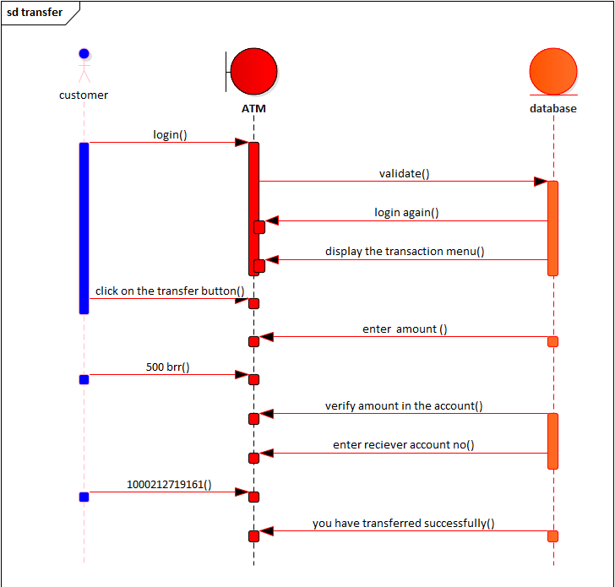





# 2.3.4 Activity diagram

Draw activity diagrams to show the operation/activity performed by use cases to achieve their functionality. Activity diagrams draw for each use cases. An activity diagram is essentially a flow chart, showing flow of control activity to activity it involves.

* modeling the sequential(and possibly concurent)steps in acomputational prosses .
* modeling the flow of an object as it moves from state to state at difffernt points in the flow of control



Activity Diagram for transfer



Activity Diagram for check_Balance



Activity Diagram for Login



Activity Diagram for Withdrawal

# Chapter three

# System design

# 3.1 purpose and goals of design

* The purpose of design is to describe how the new system is going to build and to obtain the information necessary for drive the implementation of the system.
* This focused on understanding the model how the software will be built
* It is the best input to indicate and show of easy way to implementation phase

The goals of the design are:-

* Reduce the complexity for establishment of the new system.
* Show the best way to feasible output of the project.
* Minimize the extravagancy which is occurring due to done without design.
* Locate the necessary actor to make easy clear system development way.
* Avoid in appropriate thing which will can be the obstacle of the new system .

Generally, design goals describe the qualities of the system that developer should consider.

* **Security**:-the system should authenticate it’s user by motivating them to enter user name and password in order to get access to the system.
* **Availability**:-the system should be available every time that the user needs to access it.
* **Usability**:-the system should have user friendly user interface to allow the user to interact with the system easily.
* **Portability**:-the system should be able to run on any mobile that supports android environment.
* **Performance**:-the system should give fast responses for user requests. The main performance measure for the project is that time.
* **Fault Toleranc**e:-the system should be fault tolerant to where errors happen.
* **Modifiability**:-the system should be easily modifiable for further modification and enhancement of the application.
* **Cost**:-the system should be developed with minimum cost possible.
* **End criteria**:-the system should have simple and understandable graphical interface.

All the interfaces, forms and buttons are written or designed in simple language or common language so that they can access it without any difficult.

3**.2 class modeling diagram**

Class diagram provide an over view of target system by describing the object and classes inside the systems the relationship between them. It provides a wide Varity of usages; from modeling the domain specific data structure to detailed design of the target system. With the share modeled facilities, you can re-use the class model in the interaction diagram for modeling the detailed design of dynamic behaviors .this diagram can be derived from one part of modeling is class responsibility collaboration (CRC).



3.5 component diagram

Component diagram shows how objects (classes)in our system will grouped together and form components .the component enter act with each other either in giving service to other components or requesting service from other component .component diagrams are partially useful with our system.



Component diagram of ATM management system

# 3.4.3 Deployment diagram

Deployment diagram are used to describe the static deployment view of a system. In another words, diagram show the hardware for your system. The software instilled on hardware, and the middleware used to connect disparate machines to one other.

Deployment diagram show how the system will deployed on computers. In other word it shows which component of the software will instilled on which machine and how they communicate with each other if they are on deferent machine deployment diagram can be also be created to explore the architecture of embedded systems, showing how the hard ware and software components work together



Deployment diagram of ATM management system

# Chapter four

# Implementation and testing

# 4.1 implementation

Implementation is the phase where objectives physical operations on the system turned in to reality, i.e. real working model. The crucial phases in system development life cycle are the successful implementation of the new system design. The process of converting as a new system in to an operational one is known as system implementation. This includes all those activities that take place to convert from an old system to a new system. To implement the project we use net beans language.

Coding phase of the software development life cycle is the third phase of the **SDLC** process

The objective of the coding phase is to transform the design of a system into code in a high-level language. Good software development organizations normally require their programmers to adhere to some well-defined and standard style of coding called coding standards. A coding standard gives a uniform appearance to the codes written by different engineers. It enhances code understanding. It encourages good programming practices.

🡺generated sample code

/**

* @author Ahemd

* @version 1.0

* @created 28-May-2019 7:26:38 AM

*/

public class transfer_Transaction extends atm_Transaction {

private int acc_No;

Public double amount;

Public pin Validation m_pin_Validation;

Public transfer Transaction(){

}

public void finalize() throws Throw able {

super. Finalize();

}

public void transaction(){

}

public void transaction(){

}

public void transfer Amount(){

}

Public void update(){

}

}

# 4.2 Unit testing

Each module is tested individually in an attempt to discover any error ignites code .In unit testing, each module (roughly a section of code that perform a single function) is tested individually to discover any error that may exist in the modules code.

In this level of testing process, the online banking system developers test the different sub procedures, Functions and tested by applying the black and white box testing.

Sample Tests

* Check whether the return type of the functions is correct or not.
* Check how the sub procedures or functions are called correctly.
* Check if the correct output is produced for different inputs.
* Check the efficiency of the code with respect to the memory and CPU time.

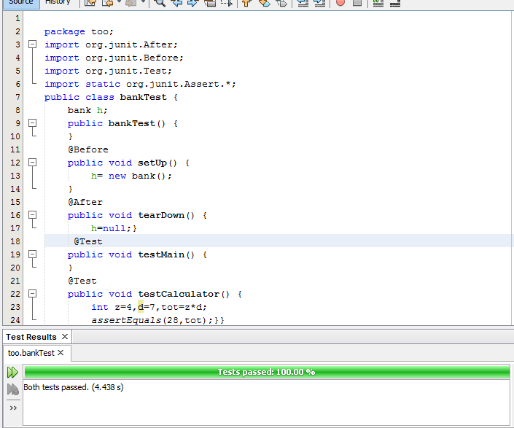

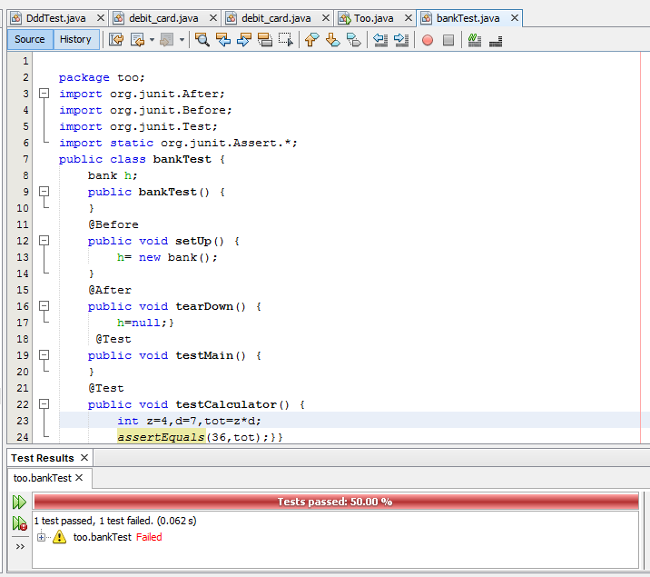

# Chapter Five

# Conclusion and Recommendation

# 5.1 Conclusion

In this project, we have developed web based ATM management system for KIOT that facilitates various activities of KIOT banking team’s work and provides for customer of KIOT gets fast services. The system we have developed stores the data in automated database system. We do this project for KIOT in order to facilitate the service that provided by banking team to provide immediate services for customer of KIOT. Our project has four actors in which those perform various tasks in order to fulfill their responsibility those are bank administrator, bank officer, and customer. This system provides online service request for customer, , online feedback, and customer receives the message for viewing his or her money, deposit money and withdraw money, manage account (create account, update account, search user account and close account). Our module contains analysis module which contains functional and Nonfunctional requirements use case, sequence, and activity, deployment, component diagrams.

As a system developing team the group member have acquired more knowledge and experience about the different phases of the software development life-cycle. As software developers, the team has worked together and assessed risks, and minimizes them.

# 5.2 Recommendation

### We recommended Wollo University to implement and use this web based system in order to give immediate and sufficient real time services for campus community. All the authenticated users of this web based system logged in to system using their username and they perform their task to fulfill their responsibility and should logout from the system when he or she finishes their task. Online banking system gives services in real work time only they do not provide services in night time

# 5.3 Reference

* [www.google.com](http://www.google.com)