# *Software Requirements Specification for FeastFreedom*

**Software Requirements**

**Specification**

**forFeastFreedom**

**Prepared by:**

Yodit Alemayehu

Sushritha Gone **22 May 2023**

# 

# *Software Requirements Specification for FeastFreedom*

INTRODUCTION

1. **Purpose**

FeastFreedom is a web- based application that aims to digitalize the process of marketing homemade food service and the demand of users. There is a huge demand for homemade food in tri-estate area especially in south Asian communities. This FeastFreedom software is developed as a platform which can be used to connect consumer who are looking for homemade food to a homemade service provider who cooks the food and provide delivery or pickup.

1. **Intended Audience and Reading Suggestions**

The purpose of this document is to give a detailed description of the requirements for the

“FeastFreedom” software. It will illustrate the purpose, scope and complete description for the

development of system. It will also explain external interface requirements and system

requirements as well as non-functional requirements.

1. **Terminology**

Kitchen and Service provider are the same, these will be used interchangeably

throughout the document.

|  |  |
| --- | --- |
|  |  |

**FUNCTIONAL SPECIFICATION**

This section will give an overview of the fistfreedom application. The basic functionality of the

system as well as its context will be explored in detail. It also describes different kinds of

Regular User and Service Provider classes associated with the system and what functionality is available for each class. At last, the assumptions and dependencies for the system are presented.

1. **Service Provider** **Perspective**

This module will allow a service provider to register his/her kitchen using a registration screen. Here are the primary functions of this module:

1. Allow a Kitchen to register on the application using a “Provider Register Now” Link at

the top section of the application. Once clicked, it will open a screen with these entry/selection options:

1. Service Provider Name (Unique varchar (50) Not NULL): This will be displayed.
2. to end user at the time of creation of an order.
3. Email (Unique varchar (50) Not NULL)
4. Password nVarchar(10) NOT NULL
5. Confirm Password nVarchar(10) NOT NULL
6. Next Button
7. Cancel Button

2. When clicked on cancel button, user will be redirected to application landing screen

without saving any data.

3. When clicked on Next button, here is what user will see:

a. Kitchen working Days: checkbox selections for Monday to Sunday

b. Kitchen working Time: two dropdown Start Time and End Time.

c. Kitchen Image: browse control to upload an image. This image will be shown at

kitchen display.

d. Kitchen Menu. One Kitchen will have more than one Menu Item and each.

Menu Item will have these attributes:

i. Item Name

ii. Veg/Non-Veg

iii. Price.

e. Save Button

f. Cancel Button

4. Once user register, they should see a success message.

**2. Regular** **User Perspective**

Users interact with our system directly in order to place order, modify order. We do not store any information related to customers in our system. The process

of order taking starts from customers placing order and then the other series of events begin.

we should have all the Kitchen data available in the database, in this phase of the

application, we will display Kitchen information to end-users so that they can place an order by

selecting a menu item from the kitchen provider’s list.

1. When user browse the application, they will see a page having listed all the

REGISTERED kitchens in this format:

2. All the Kitchen Images will be clickable and once clicked, it will redirect the user to

another screen which will show the Menu for that Kitchen along with prices.

3. Each menu item should have a checkbox next to it with “add to cart” and a button at the

bottom with the display name “Add”.

4. Once user checks the checkboxes and clicks on “Add”, all the items should be added to

the cart.

5. User should be able to register & Login himself/herself by clicking on user icon which is

available.

6. If the user is logged in, application will display his/her name.

7. User Registration screen is a standard screen with options such as first name, last name,

email, password and two security questions and answers.

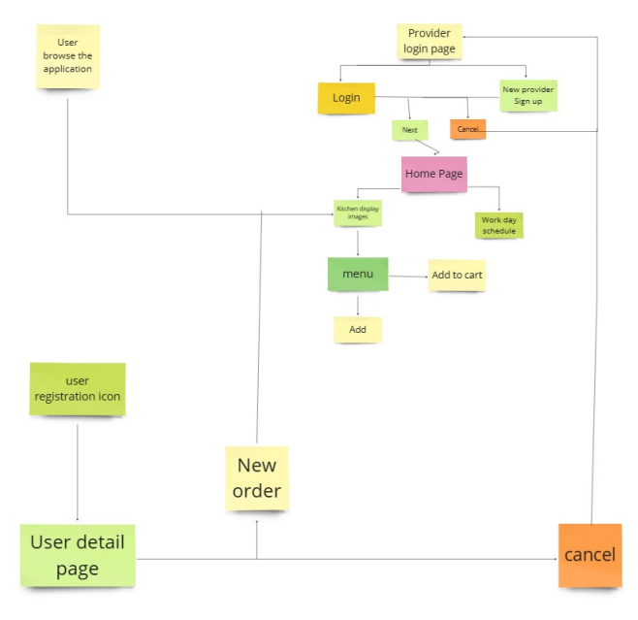

*Fig1 - System Perspective Diagram*