Local Sales ETL Pipeline
PowerShell, six stages, fully local. Documentation and operating guide.
Generated for portfolio use. No external dependencies, no network calls, no database.

1. What this pipeline does
This tool takes a raw sales CSV and turns it into a finished report: an HTML dashboard you can open in any browser, plus a set of summary CSVs ready for Excel or Power BI. It does this in six clear stages. Each stage does one job, hands its result to the next, and writes that result to disk so you can inspect it.
The design follows a principle: everything stays on the local machine. Nothing is uploaded, nothing is downloaded, no database is involved. The source file is only ever read, never changed. Every action is written to a log. This makes the whole run transparent and auditable, which matters when the data is sensitive.

2. The process at a glance
The diagram below shows the full flow. Data enters at the top as a raw CSV and moves down through the six stages. Each arrow is labelled with the file that stage produces. Stage 3 is the gate: data that passes continues down, data that fails breaks off to the left and the run stops. The bar at the bottom is not a stage; it represents the logging and progress that run alongside every stage.
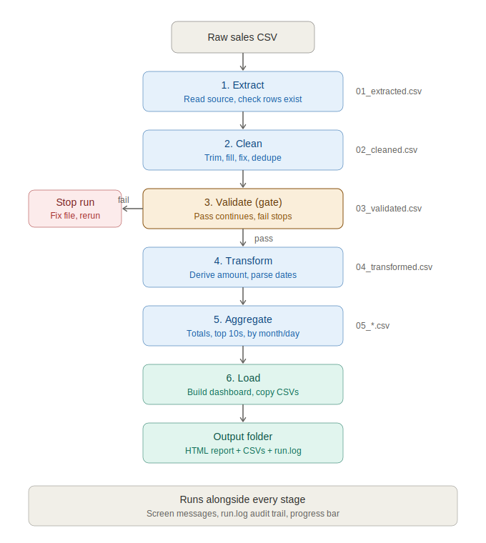

3. How the pieces fit together
There are eight files in total. One orchestrator runs the whole thing. Six stage scripts each do one job. One shared helper file holds the common logging and progress code so it is not repeated in every stage.
File | Role
run_pipeline.ps1 | The orchestrator. Runs all six stages in order and handles errors.
01_extract.ps1 | Stage 1. Reads the source file.
02_clean.ps1 | Stage 2. Tidies the data.
03_validate.ps1 | Stage 3. The quality gate.
04_transform.ps1 | Stage 4. Reshapes into clean records.
05_aggregate.ps1 | Stage 5. Calculates the numbers.
06_load.ps1 | Stage 6. Builds the dashboard and CSVs.
pipeline_common.ps1 | Shared helpers: logging, progress, number and column tools.

4. The orchestrator (run_pipeline.ps1)
This is the file you normally run. It does not do any data work itself; it sets up the run and then calls each stage in turn.

What it sets up
- An output folder, named with the date and time so each run gets its own and nothing is overwritten. You can also pass your own folder with -OutputDir.
- A pipeline_work subfolder inside it, where the numbered files from each stage are kept.
- A run.log file, the audit trail for the whole run.

What it does
It calls the six stages one after another, updating a progress bar before each. Every stage call is wrapped in a single try block. If any stage stops with an error, the orchestrator catches it, writes a clear message to the screen and the log, removes the progress bar, and exits. Because the stages run in order inside that block, a failure at stage 3 means stages 4 to 6 never run, so no half-finished report is ever produced.
try {
Show-StageProgress 1 6 'Extract'
& '01_extract.ps1' -InputPath $InputPath -WorkDir $workDir -LogPath $logPath
...
Show-StageProgress 6 6 'Load'
& '06_load.ps1' -WorkDir $workDir -OutputDir $OutputDir -LogPath $logPath ...
}
catch {
Write-Log "Pipeline stopped: $($_.Exception.Message)" 'ERROR' $logPath
exit 1
}

5. The six stages explained

Stage 1 — Extract
Reads the raw CSV into memory and confirms it is usable. It checks the file exists and that it has at least one row. If either check fails, it stops with a plain message. On success it reports how many rows and columns it found, then saves the data as 01_extracted.csv. This stage does not change any values; it only reads and confirms.
Reads: the raw CSV Writes: 01_extracted.csv

Stage 2 — Clean
Tidies the data, in a deliberate order. First it checks each row using its original values and skips any row that was completely blank. Then, for every cell, it trims stray spaces and collapses double spaces. Blank cells are filled: a zero for columns you flagged as numbers, the text N/A for everything else. Cells that had real content get their formats fixed where you asked: numbers stripped of currency symbols and commas, dates rewritten to a single yyyy-MM-dd style, names put into Title Case. Finally it removes exact duplicate rows, keeping the first copy of each.
The order matters. Empty rows are caught before filling, so a blank row cannot disguise itself as a row full of zeros. Duplicate removal runs last, so it compares fully cleaned values and correctly catches rows that differed only by spacing or casing.
Reads: 01_extracted.csv Writes: 02_cleaned.csv

Stage 3 — Validate (the gate)
This is the only stage that can stop the pipeline. Its job is to refuse bad data before it becomes a misleading report. It runs three checks.
- Can we get a sale amount at all? It looks for an amount column, or a quantity and price pair to multiply. If neither exists, it stops, because there is no way to calculate sales.
- Are the amount values actually numbers? It counts how many rows fail to read as a number. If 20 percent or more are bad, it stops, because the data is too broken to trust. If fewer than that fail, it only warns and lets those rows count as zero.
- Are any dates readable? If a date column exists but none of its values can be read, it warns that the month and day breakdowns will be empty, but it does not stop, because the totals and rankings do not need dates.
If a check triggers a hard stop, the specific reason is written to the screen and the log, you are told to fix the source file and run again, and the pipeline ends. If everything passes, the data is copied forward unchanged as 03_validated.csv so the numbered chain stays intact.
The 20 percent threshold is a deliberate judgement: a few junk rows should not block a daily report, but a mostly broken file should. It can be tightened or loosened in one line.
Reads: 02_cleaned.csv Writes: 03_validated.csv (only if it passes)

Stage 4 — Transform
Reshapes every row into a small, predictable record with just four fields: Product, Customer, Date, and Amount. The amount is either taken from the amount column or calculated as quantity times price, whichever the data supports. Dates are parsed into the yyyy-MM-dd form; unreadable ones are left blank. Missing product or customer values fall back to the word Unknown so nothing breaks later. From this point on, every later stage works off this clean four-field shape rather than the messy original, which is why the calculation code stays short.
Reads: 03_validated.csv Writes: 04_transformed.csv

Stage 5 — Aggregate
Calculates the numbers the report shows. It produces the headline figures (total sales, transaction count, average per transaction, unique customers, average per customer), the top 10 products and top 10 customers by sales, and the breakdowns of sales by month and by day. Each result set is written as its own CSV, prefixed 05_, ready for the next stage and for any tool you want to open them in.
Reads: 04_transformed.csv Writes: 05_summary.csv and four more 05_ files

Stage 6 — Load
Builds the finished outputs. It reads the five summary files and assembles one self-contained HTML dashboard: five metric cards across the top, then tables for top products, top customers, sales by month, and sales by day. All styling is inside that single file, so anyone can open it by double-clicking, with no internet and no extra files. It then copies the summary CSVs into the output folder with clean names for Excel or Power BI. The page footer states plainly that all processing ran locally and no data left the machine.
Reads: the 05_ files Writes: sales_report.html and the final CSVs

6. Running the whole pipeline
The normal way to run it is through the orchestrator. Point it at your CSV:
.\run_pipeline.ps1 -InputPath "C:\sales\raw.csv"
If the automatic column detection guesses wrong, name the columns yourself. Your choices always win over the guessing:
.\run_pipeline.ps1 -InputPath "C:\sales\raw.csv" `
-AmountColumn "Revenue" -ProductColumn "Item" `
-CustomerColumn "Client" -DateColumn "InvoiceDate" `
-DateColumns "InvoiceDate" -NumberColumns "Revenue" -NameColumns "Client"

7. Running a stage on its own
Each stage is a standalone script with its own parameters, so you can run any one of them by itself. This is useful for debugging a single step, re-running just one stage after editing its input, or rebuilding only the dashboard after a styling change.

The one rule: each stage needs the file the stage before it produced
Stages 2 to 6 read a numbered file that the previous stage writes. So a stage will only run alone if its input file already exists in the work folder. You cannot start a stage in the middle of an empty folder. Stage 1 is the exception; it takes your raw file directly.

Examples
Re-run just the cleaning step on data you already extracted:
.\02_clean.ps1 -WorkDir "C:\sales\run_folder\pipeline_work" `
-LogPath "C:\sales\run_folder\run.log" `
-NumberColumns "Amount" -DateColumns "OrderDate"
Rebuild only the HTML dashboard after changing its styling, without reprocessing anything:
.\06_load.ps1 -WorkDir "C:\sales\run_folder\pipeline_work" `
-OutputDir "C:\sales\run_folder" `
-LogPath "C:\sales\run_folder\run.log" -SourceName "raw.csv"

8. Important: keep every file in the same folder
Whether you run the whole pipeline or a single stage, all eight files must sit together in one folder. This is because every stage begins by loading the shared helper file:
. (Join-Path $PSScriptRoot 'pipeline_common.ps1')
That line pulls in the common logging, progress, and helper functions. $PSScriptRoot means the folder the script itself is in, so the stage looks for pipeline_common.ps1 right next to itself. If that file is missing or in a different folder, the stage cannot find its helpers and will fail immediately. So the rule is simple: move or copy the scripts as a set, never one on its own.
This also keeps the toolkit portable. Drop the whole folder onto any Windows machine, open PowerShell in it, and it runs. Nothing to install.

9. What a finished run produces
A timestamped output folder containing:
- sales_report.html, the dashboard you open in a browser.
- summary.csv, top_products.csv, top_customers.csv, sales_by_month.csv, sales_by_day.csv, the data for Excel or Power BI.
- run.log, the full timestamped record of the run.
- pipeline_work, the folder holding the numbered file from every stage, so the whole transformation can be inspected step by step.

10. Governance and data-handling notes
The pipeline is built so that a security-minded reviewer can trust it on sight.
- No data leaves the machine. There are no network calls anywhere in the code; all work stays inside the output folder.
- The source file is read-only to the pipeline. It is opened, never modified.
- Every step is written to disk and logged, so the entire run is auditable after the fact.
- Bad data is refused, not silently processed. If validation fails, the run stops and explains why, rather than producing a misleading report.

11. Requirements
PowerShell 5.1, which is built into Windows 10 and 11, or PowerShell 7 and above. There is nothing to install and no internet connection needed to run it.

