Technical Specification of Hivenectar
Category: Overview | Version: 1.0 | Date: June 2026 | Status: Draft

The technical contract for Hivenectar: the four hiveantennae operating modes as trigger→action→post-condition tables, the data-model component contract, the guarded recall arm, the three-daemon topology obligations, and the non-goals stated as hard exclusions.

Related Documents
- `../overview.md` (../overview.md)
- `overview-introduction-and-theory.md` (overview-introduction-and-theory.md)
- `overview-user-stories.md` (overview-user-stories.md)
- `../ai/brooding-pipeline.md` (../ai/brooding-pipeline.md)
- `../ai/enricher-and-llm-model.md` (../ai/enricher-and-llm-model.md)
- `../ai/identity-and-reassociation.md` (../ai/identity-and-reassociation.md)
- `../data/source-graph-schema.md` (../data/source-graph-schema.md)
- `../data/recall-integration.md` (../data/recall-integration.md)
- `../architecture/ADR-0003-three-daemon-topology-and-thehive-portal.md` (../architecture/ADR-0003-three-daemon-topology-and-thehive-portal.md)

Scope of this contract
This document is the engineering contract: it states what the hiveantennae daemon must do, the conditions under which each mode fires, the post-conditions that define success, and the boundaries it must not cross. It is not a concept essay (that is `overview-introduction-and-theory.md` (overview-introduction-and-theory.md)) and it is not an operator-acceptance spec (that is `overview-user-stories.md` (overview-user-stories.md)). The deep-dive docs it references hold the algorithmic and schema detail; this document holds the surface that composes them.

The hiveantennae daemon pipeline
hiveantennae is the Hivenectar daemon — an independent OS process registered with and supervised by hivedoctor, not a worker inside the Honeycomb daemon (per ADR-0002 and ADR-0003). It owns its own Deep Lake client, auth context, scoping, and observability within hivedoctor's supervised lifecycle. It is parallel to (not a phase of) the Honeycomb daemon's codebase-graph worker: the graph worker is build-triggered and on-demand; hiveantennae is watch-driven and continuous. The two write to disjoint Deep Lake tables and run without coordination. thehive, not Hivenectar or hivedoctor, hosts the unified dashboard and Source Graph page.

Figure 1. hiveantennae daemon pipeline
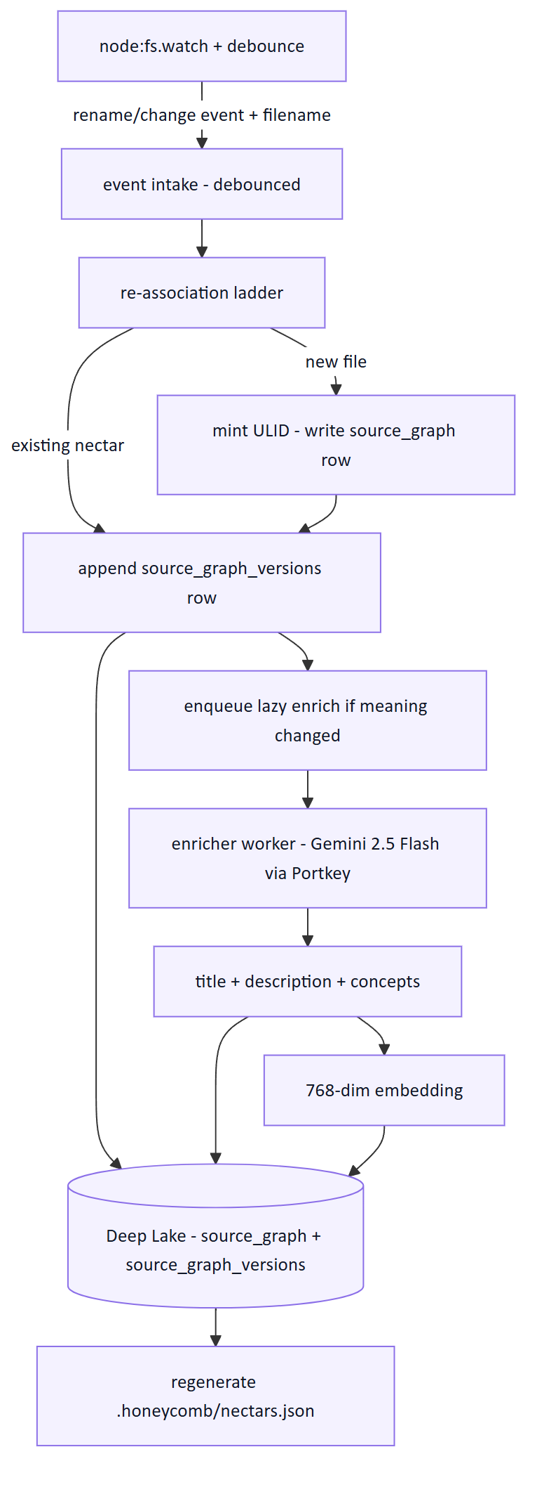

The four operating modes
hiveantennae operates in four modes. The modes are not mutually exclusive in code — they are the distinct *triggers* that select which pipeline path runs — but a given file event flows through exactly one at a time.

Brooding
The one-time-per-project full scan that takes a codebase from "no nectars exist" to "every file has a nectar and most have a description."
Trigger | First run against a project with no source_graph rows, or a fresh checkout with no .honeycomb/nectars.json. Also invokable explicitly via honeycomb hivenectar brood.
Action | Discover files via git ls-files (CodeGraph discovery reused verbatim). Pre-check each file's content hash against the portable projection; inherit on match. Bucket the rest by size/type (skip-binary, skip-too-large, batch ≤4KB, solo). Describe batches of ~40 small files per Gemini call, large files one-per-call. Embed each description at 768 dims.
Post-condition | Every non-skipped file has a nectar with describe_status ∈ {described, skipped-*}. .honeycomb/nectars.json is regenerated. Daemon switches to live-watch mode.

Brooding is resumable: every mint and description write is a committed Deep Lake write, so a crash mid-brood resumes from describe_status. It does not block daemon readiness — recall serves whatever has been described so far while brooding proceeds in the background. The cost math for a representative 2000-file repo lands under ~$3; a 10000-file monorepo broods for ~$15. See `../ai/brooding-pipeline.md` (../ai/brooding-pipeline.md).

Live watch
Steady-state operation during normal editing.
Trigger | A node:fs.watch observation (rename/change plus filename) during the daemon's normal running state.
Action | Debounce per-path. Run the re-association ladder against the debounced state. Path+mtime+size exact match → no-op. Path match, content changed → append version row, enqueue lazy enrich. Exact-hash match to a missing file → carry nectar to new path. Fuzzy match → carry with a confidence flag. Nothing matches → mint new nectar. Copy detection: a new path whose content matches an existing file's current content mints a fresh nectar with derived_from_nectar.
Post-condition | Deep Lake reflects the post-debounce disk state. Lazy enrich jobs are queued for any meaningfully-changed version. Recall never blocks on the watcher.

Live watch is easier than cold catch-up because fresh events tell the daemon where to refresh state, but node:fs.watch does not provide correlated move semantics. The ladder reconstructs moves from the debounced event stream, missing-files set, exact content hashes, and TLSH fuzzy evidence. The full ladder is in `../ai/identity-and-reassociation.md` (../ai/identity-and-reassociation.md).

Cold catch-up
The hard case: the daemon boots after the laptop was closed and the user moved and edited files offline.
Trigger | Daemon boot against a project whose on-disk state diverges from Deep Lake (files moved/edited/added while the daemon was down).
Action | Load .honeycomb/nectars.json if present and build a content-hash→nectar index; inherit on hash match. For unmatched files, walk disk and run the re-association ladder top-down per file. Exact path/mtime/size dominates (most files untouched). Exact-hash-to-missing handles renames. TLSH fuzzy handles move-and-edit, scored not binary: low-confidence matches are surfaced to the dashboard for human review rather than auto-claimed. Nothing matches → mint new. Batch-enrich any drifted pending versions.
Post-condition | Every on-disk file has a nectar; every meaningfully-changed file is queued for re-description. Low-confidence fuzzy matches are visible in the review surface, not silently committed.

Cold catch-up is where the confidence field earns its keep: the daemon cannot ask a human in real time whether a fuzzy match is a real move, so it surfaces candidates instead of guessing. A mis-association corrupts the history chain, which is worse than a fresh nectar.

Projection sync
The lockfile regeneration step that runs at the end of the other three modes.
Trigger | End of a brood, end of an enricher cycle that wrote new descriptions, or explicit honeycomb hivenectar rebuild-projection.
Action | Scan source_graph_versions (latest described version per nectar, scoped to the project), denormalize into the projection format, write atomically (temp file + rename).
Post-condition | .honeycomb/nectars.json reflects current Deep Lake state. The write is atomic so a crashed regeneration leaves the prior projection, not a partial one.

Projection writes are debounced the same way enricher calls are, so a rapid edit session produces one projection write at the end of a cycle, not one per save. See `../data/portable-registry.md` (../data/portable-registry.md).

The data-model component contract
The full DDL lives in `../data/source-graph-schema.md` (../data/source-graph-schema.md); this is the one-paragraph contract expanded into component obligations.
`source_graph` — one row per logical file, keyed by nectar (ULID primary key, immutable, never derived). Carries created_at, optional provenance (derived_from_nectar, fork_content_hash set at minting, write-once), a kind discriminator ('file' in v1, namespace reserved for 'directory'), and tenancy (org_id, workspace_id, project_id). It is identity and provenance only — no content, no description.
`source_graph_versions` — append-only, one row per observed state of a file, keyed by the composite (nectar, content_hash). Carries seq (monotonic per-nectar counter so "latest" is ORDER BY seq DESC LIMIT 1), the observed path (mutable across rows for the same nectar — this is how moves are recorded), metadata (filename, ext, size_bytes, mtime_observed), and the lazily-filled semantic fields (title, description, concepts, embedding, described_at, describe_model, describe_status). Tenancy is denormalized so the versions table is queryable in isolation for recall.
The contract invariants:
Invariant | Enforcement
nectar is immutable once written | Never updated by any code path. Re-association changes the *association* (path metadata on a new version row), never the nectar.
(nectar, content_hash) composite uniqueness | Idempotent re-observation: a no-change save is a no-op.
"Current state of file X" | Latest version row for X's nectar (MAX(seq)).
"History of file X" | All version rows for X's nectar.
Description is nullable until enriched | describe_status drives recall filtering; undescribed rows are excluded from semantic recall but not from identity.
Nectars are never deleted by re-association | Deletion is a separate, explicit honeycomb hivenectar prune --confirm with a configurable grace period (default 30 days).

The guarded recall arm contract
Hivenectar adds a fourth guarded arm to the existing hybrid recall pipeline (BM25 lexical + 768-dim vector, fused by reciprocal rank fusion). The arm queries source_graph_versions filtered to the latest described version per nectar, scoped by tenancy. If the Hivenectar table is missing, the arm returns empty and the other recall arms still answer. The full query and fusion rationale are in `../data/recall-integration.md` (../data/recall-integration.md).
The contract the arm must uphold:
- One row per current file. The latest-per-nectar subquery ensures a file edited 50 times does not dominate recall with 50 near-duplicate rows.
- Described rows only. The describe_status = 'described' filter excludes pending, failed, and skipped rows. A never-described file is absent from semantic recall but may still appear in the structural CodeGraph's find/ results.
- Equal RRF weight by default. The arm ships with a multiplier of 1.0 — a Hivenectar rank-1 hit contributes the same RRF weight as a sessions rank-1 hit. Operators can tune the multiplier via ~/.honeycomb/hivenectar.json if descriptions dominate recall.
- Silent fallback to BM25. When embeddings are off (optional dependency absent), only the lexical arm runs over title + description. No error, no quality cliff — the same degradation every other recall arm uses.
- No dedup against CodeGraph hits. If src/auth/login.ts appears in both a Hivenectar hit and a find/login structural hit, both are returned. Each carries information the other lacks.

Structural-vs-semantic complementarity
The complementarity is the reason both layers ship. The diagram makes the division of labor explicit.

Figure 2. Structural and semantic complementarity
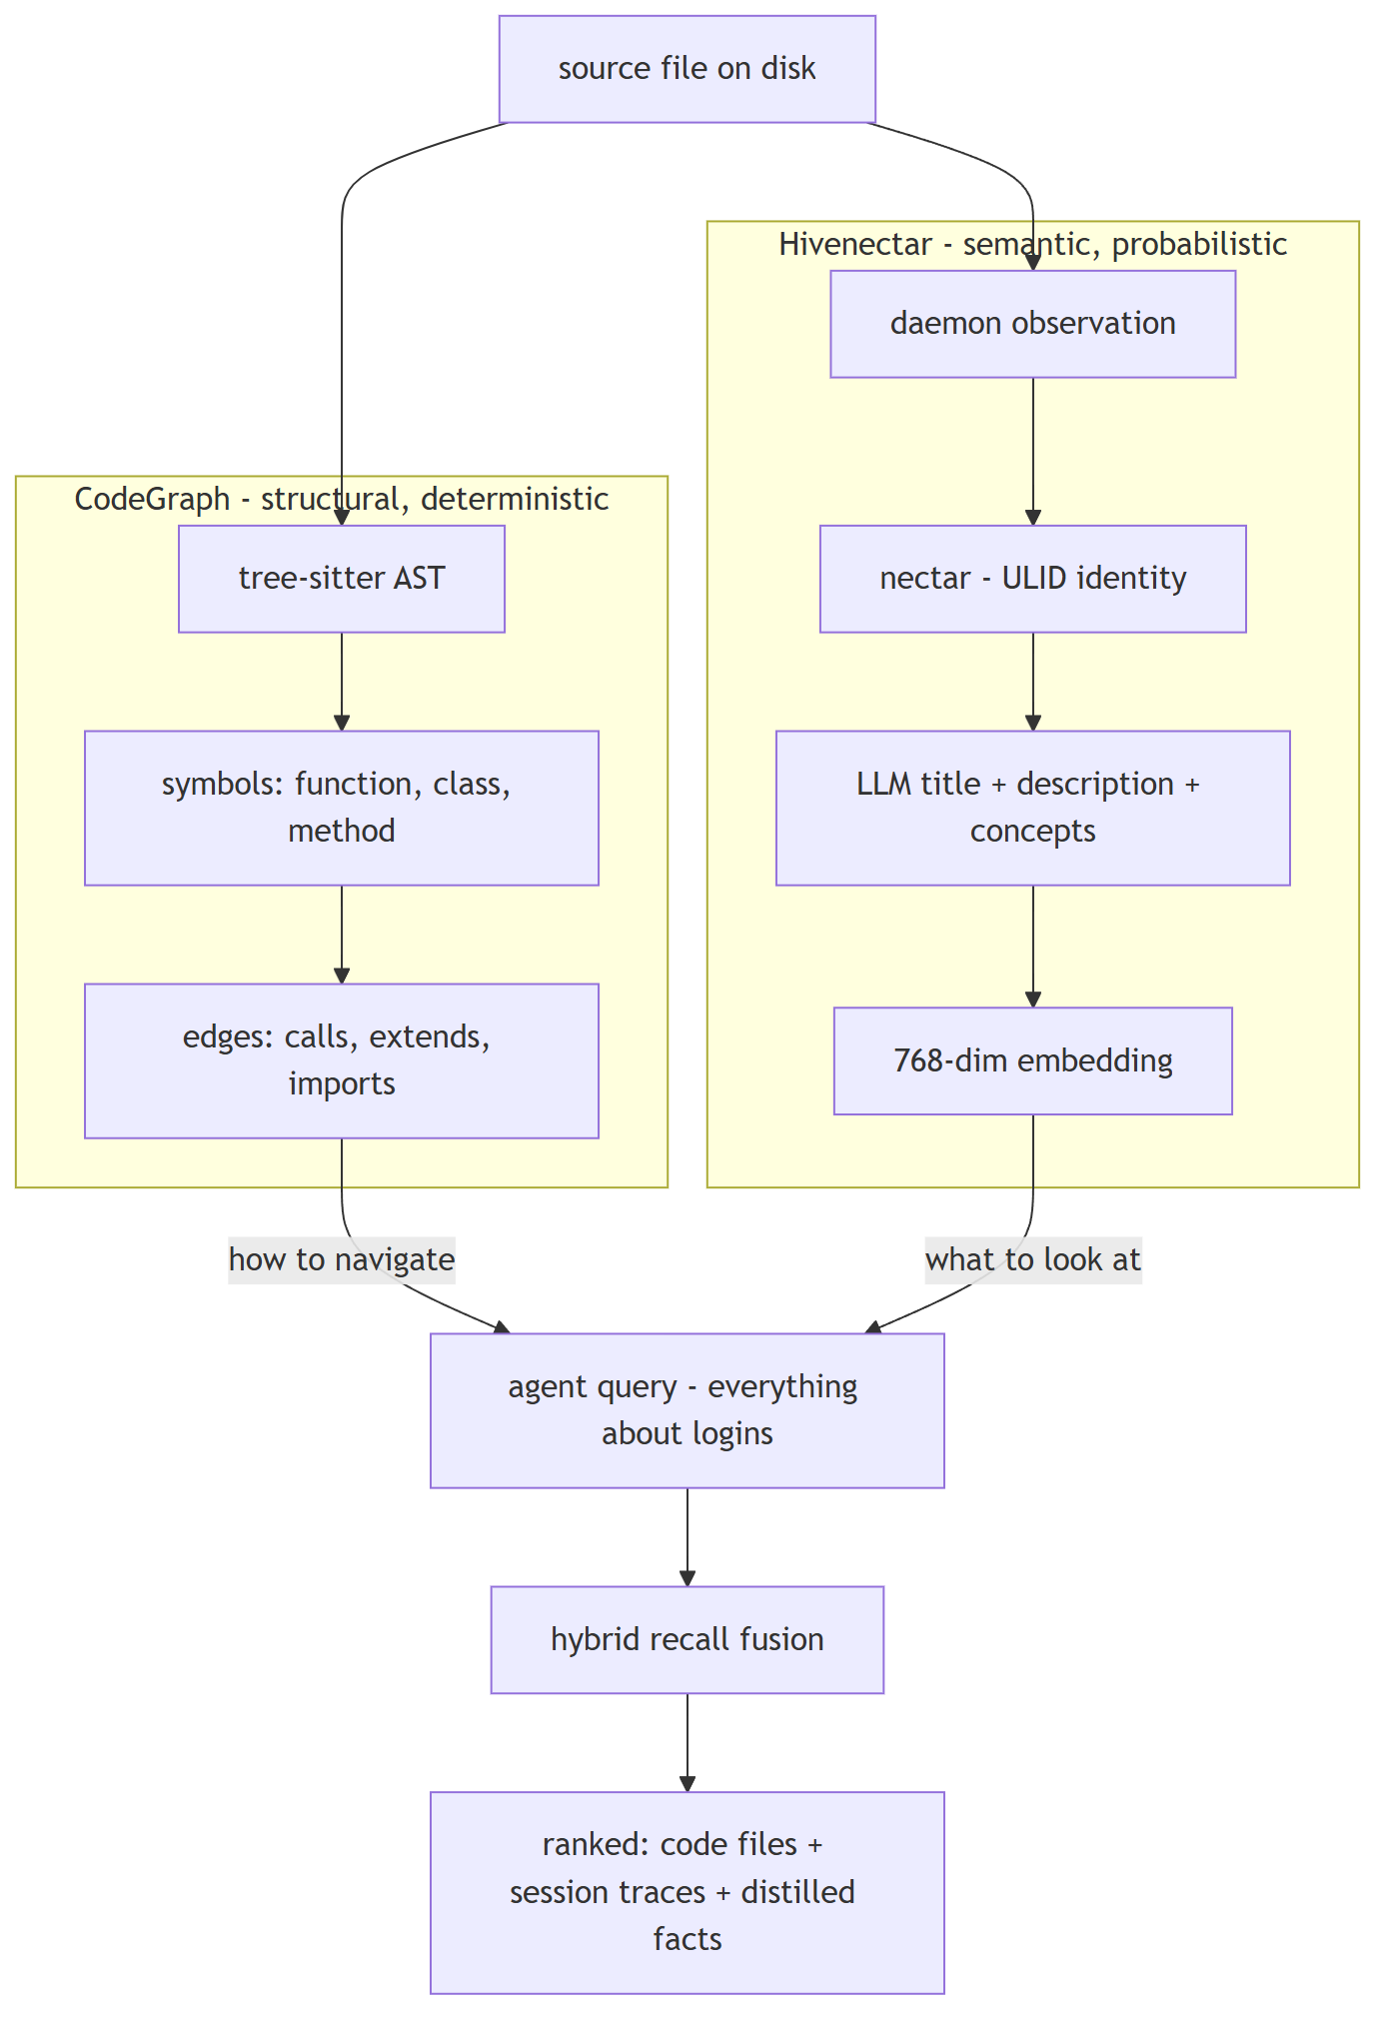
A file can be in the CodeGraph without a nectar; a file can have a nectar without being in the CodeGraph. Recall unions over both because the agent needs both.

The three-daemon topology contract
hiveantennae is not a Honeycomb worker and it is not the portal host. Its topology obligations are binding, not stylistic:
Obligation | What it means | Why it is binding
Own Deep Lake client, shared datasets | Hivenectar opens its own client but points at the same org/workspace datasets Honeycomb recall reads. | Process independence without data federation.
Registered supervision | Hivenectar has a hivedoctor registry entry with its own health URL, PID path, and probe settings. | hivedoctor supervises registered daemons rather than hardcoding one Honeycomb target.
Project scoping | Every query includes project_id as a soft column filter inside the workspace scope. Two projects in the same workspace do not share nectars. | File identity is cross-agent within a project but isolated across projects.
thehive-hosted dashboard | Enricher cycles log files described, inherited, failed, tokens consumed, estimated cost; thehive surfaces the rolling cost counter, queue-depth gauge, and Source Graph page by calling Hivenectar APIs. | hivedoctor remains a minimal supervisor; the portal stays independently updateable.
Non-blocking | Brooding and enrichment run in the background. Daemon readiness does not wait on them; recall serves partial state during a brood. | Per the daemon readiness principle: accept requests first, do background work after.

Non-goals as hard exclusions
The following are not deferred features; they are out of scope by design and the system actively does not do them.
- Not a replacement for the CodeGraph. Both layers ship. The CodeGraph answers structural questions deterministically; Hivenectar answers semantic questions probabilistically.
- Not an LSP. hiveantennae does not resolve types, run compilers, or produce compiler-accurate references. The CodeGraph and any future LSP own that.
- Not eager. A file can exist in Deep Lake with a null description indefinitely. Description is a cache.
- Not a source mutation. No file on disk is ever edited by hiveantennae. The only file it writes is the committed, regenerable .honeycomb/nectars.json.
- Not a separate database. Deep Lake is the store. The SQLite-sidecar instinct is rejected in ADR-0001 for FR-8 violation.
- Not the portal host. Hivenectar exposes APIs and status; thehive hosts the unified dashboard and Source Graph page.
- Not symbol-granular in v1. File granularity is deliberate. Symbol-level nectars would multiply row counts 10–100× and duplicate the structural CodeGraph; deferred to a possible v2.
- Not directory-granular in v1. Folders are derivable from file paths; a directory description is synthesized on demand from its files' descriptions. The kind column reserves the namespace.
- Not bidirectional projection sync. Sync is one-directional: Deep Lake → projection. The reverse (projection → Deep Lake) happens only on a fresh clone, as an inheritance write for nectars the local Deep Lake lacks.

How the modes compose
The four modes are the same pipeline with different triggers; understanding which mode owns which event is the key to reasoning about the worker.
Figure 3. Operating-mode composition
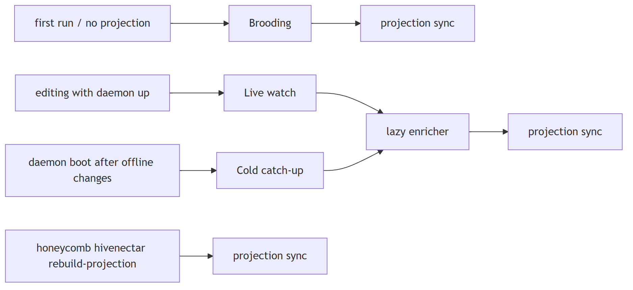
Brooding runs once per project and bootstraps the projection. After brooding, the daemon is in live-watch; cold-catch-up handles restarts; projection sync runs at the tail of any mode that produced new descriptions.

