**OS ASSIGNMENT-4**

**Name: Ishan Mishra**

**Reg No.: 209302173**

**1(a):**

Code:

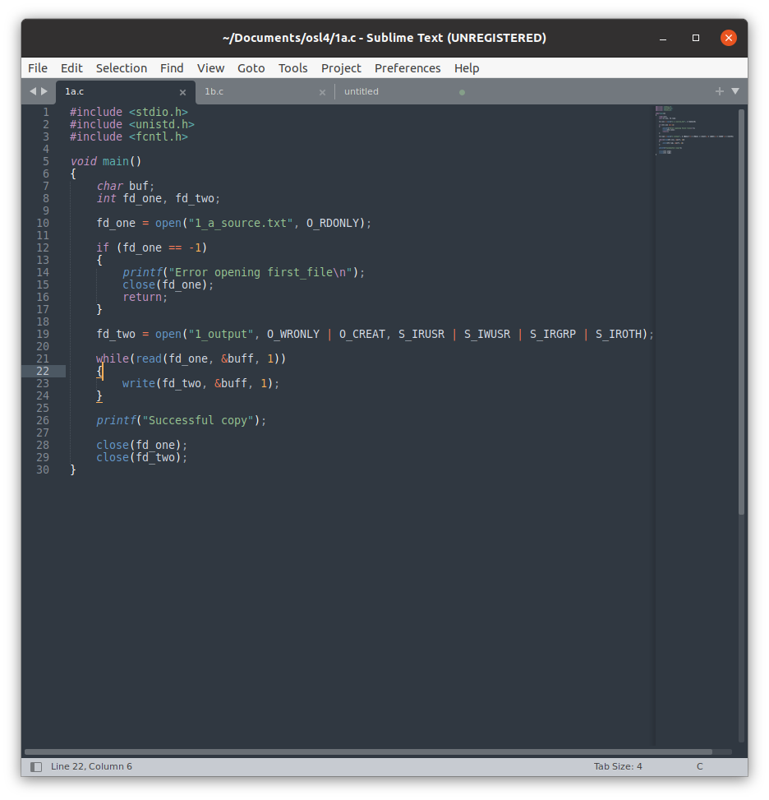

**1(b):**

Output:

**1(c):**

Code:

Output:

**1(d):**

Code:

Output:

**Ques-2:**

Code:

