S - throughput
λ - in packets per second
 | be average pacekt transmission time (srednje trajanje prostiranja signala)
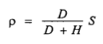 | Channel utilization is defined as the fraction of time a channel is busy transmitting packets. D is the number of data bits in the packet and H is the number of overhead bits in the packet.
ρ < 1 | Uvjet stabilnosti sustava!
 | Vjerojatnost p da je određeni bit zadnji u paketu
 | Propagacija - srednje vrijeme trajanja slanja paketa
Normalized average transfer delay is defined as the average time from the arrival of the last bit of a packet into the sending station of a network until the last bit of this packet is delivered through the network to its receiving station.
T be average transfer delay
LAN
 | Virtual transmission time
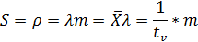 | Prometna opterećenost
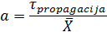
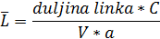 | Prosječna duljina okvira
FDMA
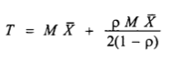 | T be average transfer delay, is equal to the sum of the packet transmission time and the average queueing delay at the station.
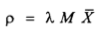 | Channel utilization
 | Throughput
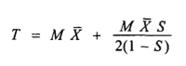  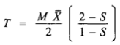 | jer je  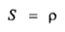
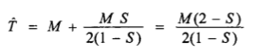 | Normalized average transfer
TDMA / STDM
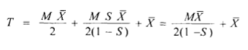
The average transfer delay T is the sum of the average synchronization delay, the average waiting time W in the buffer, and the packet transmission time.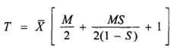
 | Average slot synchronization delay is one-half of the frame time.
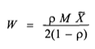  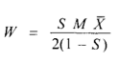 | Avarage delay in the buffer
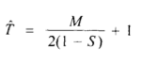 | Normalized transfer delay
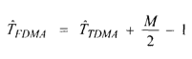
CDMA
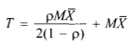  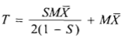 | Average packet transfer delay can be written as the sum of the mean waiting time in the queue and the mean effective packet transmission time.
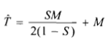 | Normalized transfer delay
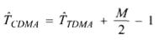 | 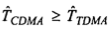
CENTRAL CONTROL ACCESS METHODS
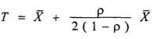  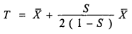 | Average transfer delay
 | Prometno opterećenje po svakoj stanici
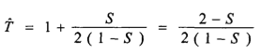 | Normalized transfer delay
POLLING NETWORKS (Roll-call Polling)
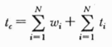 | t_{c} be cycle time (scan time)  w_{i} be station walk time  t_{i} be station transmission time, time required to transmit packets on the line (vrijeme slanja poruke po svakoj stanici)
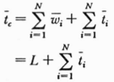  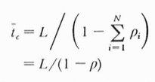 | Average scan time  L be total walk time of the complete polling system.  ρ be total traffic intensity.
 | Average frame lenght (srednje vrijeme slanja paketa na link) in units of time. C be capacity of the channel, in bps. l be average lenght of packet, l' the number of overhead bits.
 | Average number of packets (N) waiting to be transmitted when station i is polled.
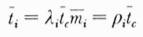 | t_{i} be station transmission time
 | Traffic intensity due to station i.
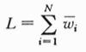 | Total system walk time
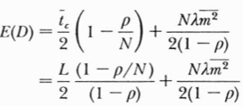  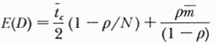 | Average access delay is the average time a apcket must wait at a station from the time it first arrives until the time transmission begins.
 | The walk time is due to the polling-message transmission time, the necessary station synchronization time (latency time) and propagation delay.
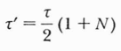 | Total propagation delay for entire N-station system
 | be round trip propagation delay
 | Poruka prozivanja
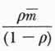 | Wait time
POLLING NETWORKS (Hub Polling)
 | Propagation time = round-trip delay (delay through a complete cycle)
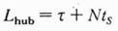 | Total walk time
FTXX
Point-to-point | Za N korisnika koji su udajeni L od centrale potrebno je 2N primopredajnika a ukupna duljina niti je NL.
Aktivna optička mreža | Ukupna duljina niti L, primopredajnici su na 2N+2.
Pasivna optička mreža PON | Ukupna duljina niti L i broj primopredajnika (N+1).
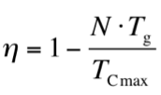  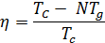 | Iskoristivost upstream kanala  T_{g} be guard time (zaštita vremena između transmisija)  T_{Cmax} be implicitno maksimalno trajanje ciklusa
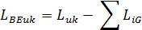
10*log₁₀(mW) [dBm] | W -> dBm
10^{dB/10} [W] | dB -> W
Power margin = ONU (izlazna snaga laserske diode) [dBm] - OLT (osjetljivost fotodetektora) [dBm] = [dB]
M, system margin | 3.0 - 4.8 dB
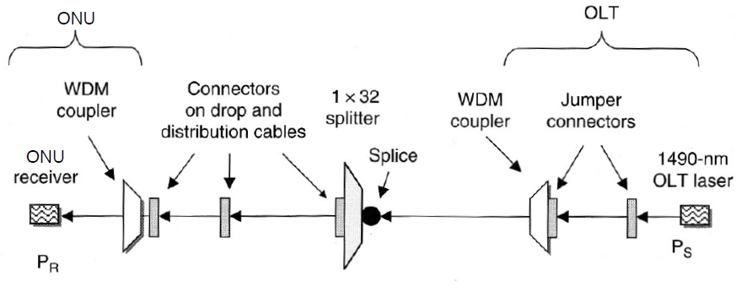
 | (downstream) 1490 nm
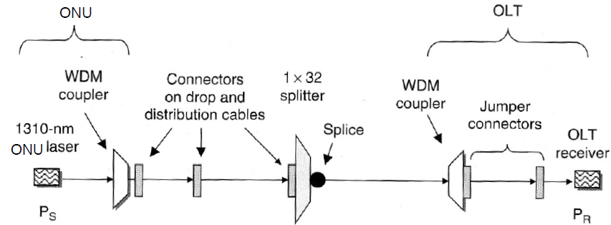
 | (upstream) 1310 nm
N_{K} = broj korisnika  K₁ = kapacitet (broj niti) kabela 1  K₂ = kapacitet (broj niti) kabela 2  Sve uzeti sa gornjim granicama!  N₁ = N_{K} / K₁ = broj velikih kabela (zjdč.)  N₂ = N_{K} / K₂ = broj malih kabela (izrav.)  N_{KAZETA} = broj spojnica niti / niti u kazeti | C₁(l)=N₁l(C₁ + C_{POLAGANJA}) + N_{K}(C_{IZRADE}+C_{ZAŠTITE}) + N_{SPOJNICA} (C_{SPOJNICE} + C_{POSTAVLJANJE SPOJNICE}) + N_{KAZETA}C_{KAZETE}  C₂(l)=N₂l(C₂ + C_{POLAGANJA})  C₁ = C₂ -> l=...

