**Zadatak 5 (2 boda)**

U programskom jeziku VHDL potrebno je implementirati sljedeću logičku funkciju na razvojon pločici Spartan-6: Preklopnici SW2-SW0 predstavljaju ulaze u logičku funkciju, dok signali LED3-LED1 predstavljaju izlaze logičke funkcije, kako je prikazano u tablici

|  |  |
| --- | --- |
| IZLAZ | FUNKCIJA |
| LED1 | SW0 or SW1 |
| LED2 | SW0 and SW2 |
| LED3 | (SW0 xor SW1) and (SW1 or SW2) |

Rješenje:

entity funkcija is

Port ( SW0: std_logic; SW1: std_logic; SW2: std_logic;

LD1: std_logic; LD2: std_logic; LD3: std_logic;

);

end funkcija;

architecture Beh of funkcija is

begin

LD1 <= SW0 or SW1;

LD2 <= SW0 and SW2;

LD3 <= (SW0 xor SW1) and (SW1 xor SW2);

end Beh;

ovo je bilo samo zagrijavanje, sad slijedi pravi zadatak :)

**Zadatak 6 (15 bodova)**

Na PicoBlaze procesor spojene su dvije ulazne vanjske jedinice (VJ1, adresa: 0x20, VJ2 , adresa: 0x40) i jedna izlazna jedinica (VJ3, adresa: 0x60). Potrebno je rješiti sljedeći zadatak: Na svaki signal s tipkala spojenog na najniži bit na adresi 0x21 treba pročitati podatak sa ulaznih jedinica (podaci su u 8-bitnom 2'k formatu). Na prvi signal čita se podatak sa VJ1, a na drugi signal sa VJ2. Na treći signal potrebno je poslati podatak na VJ3, te postupak ponavljati beskonačno. Ukoliko je podatak primljen s VJ1 paran, onda se podatak s VJ2 šalje nepromijenjen na VJ3. Ako je podatak s VJ1 neparan, onda se na VJ3 šalje negirana vrijednost podatka primljenog s VJ2. Potrebno je napisati sve procese u VHDL-u koji će obrađivati vanjske jedinice i prekidnu jedinicu, te program za procesor, cjelokupni programski kod u VHDL-u za entitet i arhitekturu te nacrtat blok-shemu povezivanja komponenti.

Za procesor i ROM koristite sljedeće deklaracije komponenti:

- - KCPSM2 processor component

component kcpsm3

Port ( address : out std_logic_vector(9 downto 0);

instruction : in std_logic_vector(17 downto 0);

port_id : out std_logic_vector(7 downto 0);

write_strobe : out std_logic;

out_port : out std_logic_vector(7 downto 0);

read_strobe : out std_logic;

in_port : in std_logic_vector(7 downto 0);

interrupt : in std_logic;

interrupt_ack : out std_logic;

reset : in std_logic;

clk : in std_logic);

end component;

- - ROM component

component prog_rom

Port ( address : in std_logic_vector(9 downto 0);

instruction : out std_logic_vector(17 downto 0);

clk : in std_logic);

end component;

Rješenje:

ADRESS 000

CONSTANT VJ1, 0x20

CONSTANT VJ2, 0x40

CONSTANT VJ3, 0x60

CONSTANT TIPKALO, 0x21

LOAD S 0,00

PETLJA: LOAD, S1, TIPKALO

COMPARE S1, 01

JUMP NZ, PETLJA

ADD S0, 01

SIGNAL1: COMPARE S0,01

JUMP NZ, SIGNAL2

INPUT S2, VJ1

JUMP PETLJA

SIGNAL2: COMPARE S0,02

JUMP NZ, SIGNAL3

INPUT S3, VJ2

JUMP PETLJA

SIGNAL3: SR0 S2 ;pomak bitova udesno, najniži bit „ispada“ u carry zastavicu

JUMP NC, PARAN

XOR S3, FF

PARAN: OUTPUT S3, VJ3

LOAD S0, 00

JUMP PETLJA

entity top_level is

Port ( data_vj1: in std_logic_vector(7 downto 0);

data_vj2: in std_logic_vector(7 downto 0);

data_vj3: out std_logic_vector(7 downto 0);

tipkalo: in std_logic;

clk: in std_logic;

);

end top_level;

------------------------------------------------------------------------------------------------------------------------------

architecture Beh of top_level is

component kcpsm3

Port ( address : out std_logic_vector(9 downto 0);

instruction : in std_logic_vector(17 downto 0);

port_id : out std_logic_vector(7 downto 0);

write_strobe : out std_logic;

out_port : out std_logic_vector(7 downto 0);

read_strobe : out std_logic;

in_port : in std_logic_vector(7 downto 0);

interrupt : in std_logic;

interrupt_ack : out std_logic;

reset : in std_logic;

clk : in std_logic);

end component;

component prog_rom

Port ( address : in std_logic_vector(9 downto 0);

instruction : out std_logic_vector(17 downto 0);

clk : in std_logic);

end component;

------------------------------------------------------------------------------------------------------------------------------

signal address : out std_logic_vector(9 downto 0);

signal instruction : in std_logic_vector(17 downto 0);

signal port_id : out std_logic_vector(7 downto 0);

signal write_strobe : out std_logic;

signal out_port : out std_logic_vector(7 downto 0);

signal read_strobe : out std_logic;

signal in_port : in std_logic_vector(7 downto 0);

signal interrupt : in std_logic;

signal interrupt_ack : out std_logic;

signal reset : in std_logic;

begin

processor: kcpsm3

port map( address => address_signal,

instruction => instruction_signal,

port_id => port_id_signal,

write_strobe => write_strobe_signal,

out_port => out_port_signal,

read_strobe => read_strobe_signal,

in_port => in_port_signal,

interrupt => interrupt_signal,

interrupt_ack => interrupt_ack_signal,

reset => reset_signal,

clk => clk_signal);

program: prog_rom

port map( address => address_signal,

instruction => instruction_signal,

clk => clk_signal);

------------------------------------------------------------------------------------------------------------------------------

ulazne_vj: process (clk)

begin

if clk' event and clk = '1' then

if port_id = '0010 0000“ then

in_port <= data_vj1;

elsif port_id = '0100 0000' then

in_port <= data_vj2;

elsif port_id = '0100 0001' then

in_port <= tipkalo;

end if

end process ulazne_vj;

izlazna_vj: process (clk)

begin

if clk' event and clk = '1' then

if write_strobe = '1' then

if port_id = '0110 0000' then

data_vj3 <= out_port;

end if

end if

end if

end process izlazna vj;

end Beh;

Blok – shema povezivanja komponenti

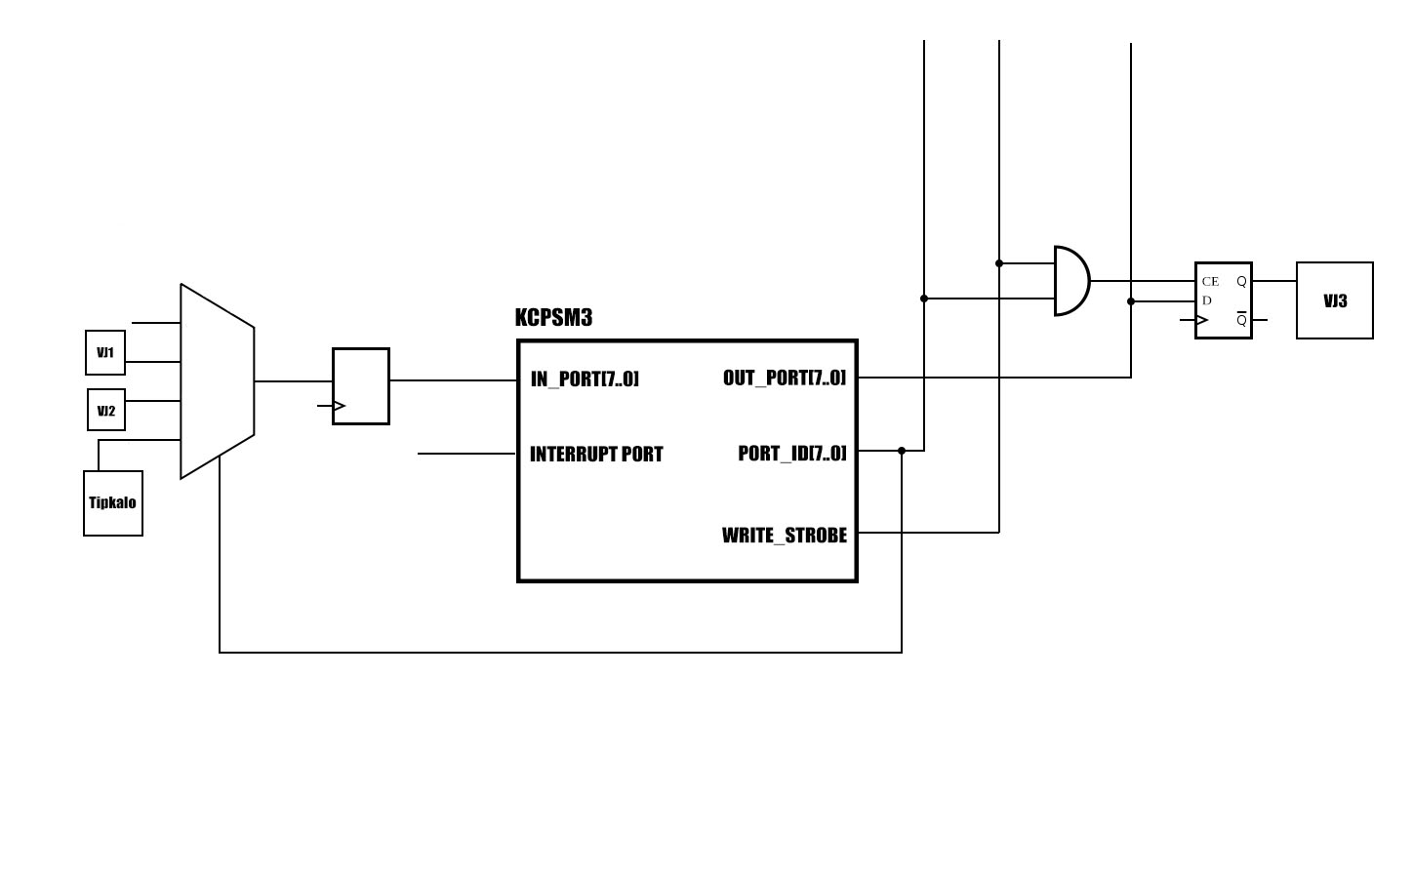

Ovo sam pisao po sjećanju na ispit na kojem sam za ove zadatke dobio sve bodove, tako da bi ovo trebalo biti sve točno.

Happy learning :)