Living Technical Note: 電控箱-PDU設計

Project: 番茄採摘載具

1. Metadata
- Owner: Lego
- Status: 進行中
- Last Updated: 2025-10-17

2. Introduction (The Mission Brief)

Problem:
發現電力系統不足Jetson AGX Orin發揮完整性能

Objective:

分配各個電壓系統(48v/24v/12v)

良好的散熱

過載斷電機制

Deliverable(s):

參考先前設計來規畫安全電路(大小電開關和繼電器)

Definition of Done (DoD):
確認規格沒問題後，等零件到齊即可開始組裝電路並測試

3. Methodology & Process Log (The "Lab Notebook")
(This is the most important, "living" section of the document. You update this as you work. It is a clean, chronological log of your investigation, making your thinking process visible.)

2025-10-05:
Hypothesis: 設計保險絲規格
Action: 參考網路上的影片和舊有的草圖來發想
Electric Cable & Fuse Sizing
What Size Fuse and Wire?
2.5代載具電力系統圖:
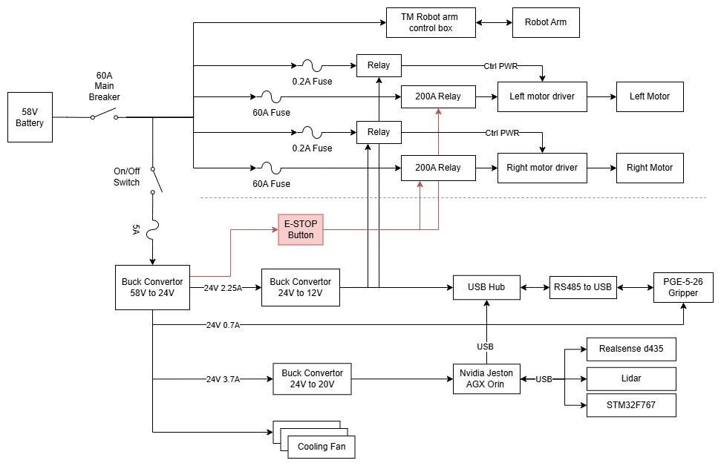
Finding: 學到新的觀念是保險絲主要是拿來保護線而非電路元件
Reasoning:為確保電線不會在高電流轉換至低電流時線俓較小的線被燒毀，

2025-10-17:
Hypothesis: 繪出完整的電力系統圖
Action: 手繪
Finding:
Reasoning:

4. Results & Analysis
(This section is for your polished, final results. You update this as you generate key data. This is the source for your presentation slides.)

Key Finding 1: 重新設計繼電器開關線路
因為現在電源分配將48v並聯出兩個24v來確保大小電能夠獨立供電，因此重新將繼電器的線路重新設計

5. Conclusion & Current Status
(A brief, final summary that you update as the task progresses.)
- Current Status: 可以測試的安全電路系統
- Next Steps:
- 待零件到齊後可開始組裝測試
- 依照cad圖設計電路元件佈局
- 等待期間可先研讀馬達驅動器說明書，確認控制線佈局
- Blockers: N/a

