Living Technical Note: **電控箱-PDU設計**

Project: 番茄採摘載具

1. Metadata

* **Owner:** Lego
* **Status:** 進行中
* **Last Updated:** 2025-0926

# 2. Introduction (The Mission Brief)

## Problem:

發現電力系統不足Jetson AGX Orin發揮完整性能

## Objective:

## *分配各個電壓系統(48v/24v/12v)*

## *良好的散熱*

## *過載斷電機制*

## Deliverable(s):

## *學習與參考網路上UDP設計方法*

## *在draw.io中呈現電路佈局*

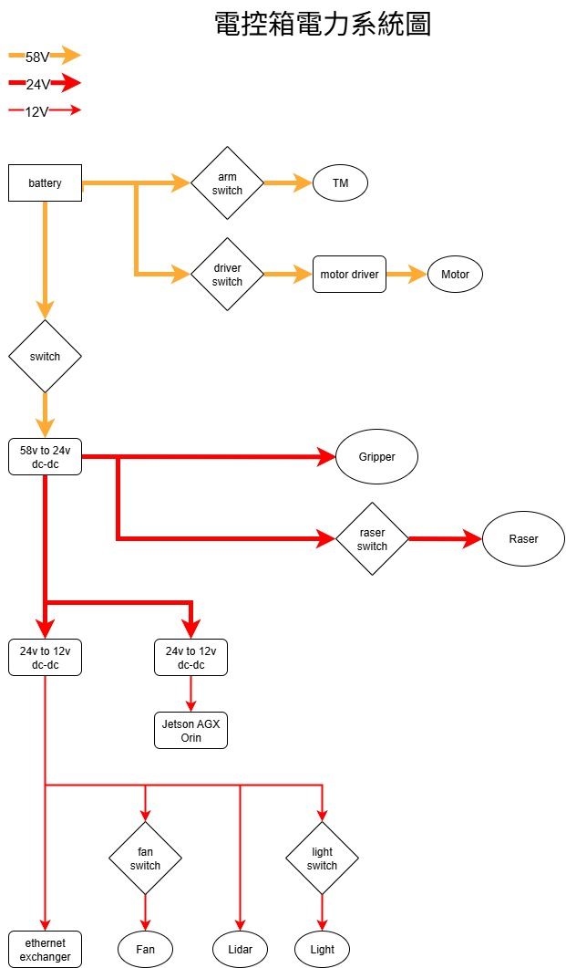

## Definition of Done (DoD):

老師和學長的肯定，下一步就是實踐

# 3. Methodology & Process Log (The "Lab Notebook")

*(This is the most important, "living" section of the document. You update this* ***as you work****. It is a clean, chronological log of your investigation, making your thinking process visible.)*

## YYYY-MM-DD:

**Hypothesis:** [What is your assumption for today's work?] **Action:** [What specific experiment or action did you take to test the hypothesis?] **Finding:** [What was the result? What new data did you generate?] **Reasoning:** [What does this finding mean? How does it inform your next step?]

# 4. Results & Analysis

*(This section is for your polished, final results. You update this as you generate key data. This is the source for your presentation slides.)*

## Key Finding 1: 發現上位機供電問題

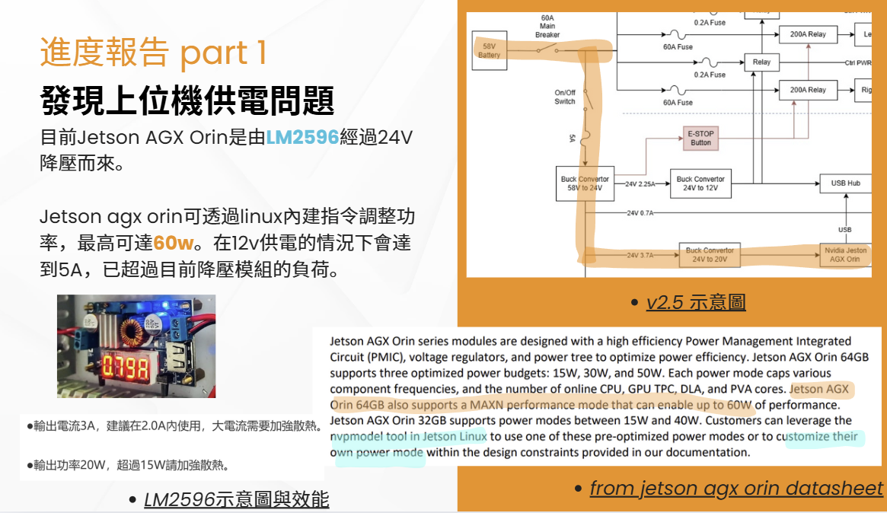

# 5. Conclusion & Current Status

*(A brief, final summary that you update as the task progresses.)*

* **Current Status:** 配置出能夠讓載具上各元件能夠正常運作的圖
* **Next Steps:**

1. 畫出更完整的電力系統規畫(fuse規格, 線徑等)
2. 依照cad圖設計電路元件佈局

* **Blockers:** N/a