**屏幕两侧黑边与绿条纹等显示问题临时措施  
Temporary measures for black borders and green stripes**

你好，很抱歉给您带来了困扰。本地IT同事已确认此会议室在使用HDMI线投屏时有些兼容性问题，主要影响戴尔 9530 等默认16:10分辨率(1920x1200)的笔记本电脑，如下图所示。

Hello, we apologize for the inconvenience. Our local IT colleagues have confirmed that this meeting room has some compatibility issues when using an HDMI cable for screen projection, mainly affecting laptops like the Dell 9530 that default to a 16:10 resolution (1920x1200), as shown in the picture below.

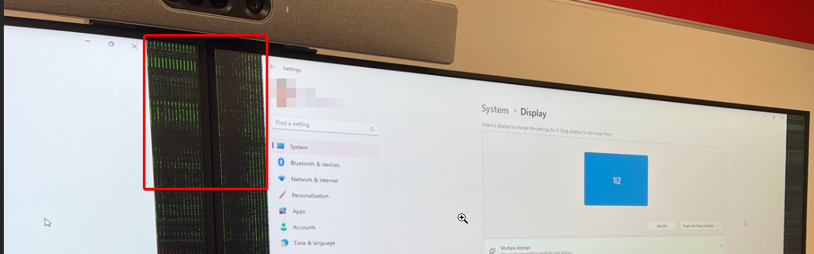

* **解决方式一：** 通过Windows徽标键+P切换到扩展显示模式
* **Solution One:** Switch to extended display mode using the Windows logo key + P.

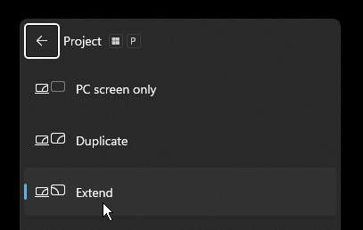

* **解决方式二：** 电脑静音加入Teams会议并分享桌面
* **Solution Two:** Join the Teams meeting with your computer on mute and share your desktop.
* **解决方式三：**
* **Solution Three:**

1. 单击桌面空白处右键，选择——>**显示设置**Right-click on an empty space on your desktop and select --> Display Settings.
2. 找到**显示器分辨率**，更改为 1920*1080  
   Locate the Display Resolution and change it to 1920*1080.

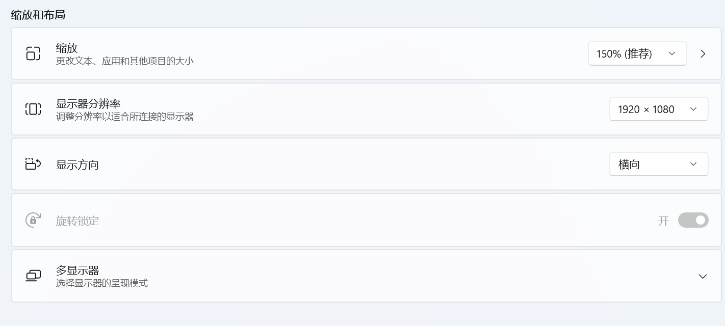

1. 点开**高级显示设置**，  
   Open Advanced Display Settings.

1. 选择 **显示器2** 以及**选择刷新率**更改为**60HZ**Select Display 2 and change the refresh rate to 60HZ.

