**Proposal for Joint Development Project on Integrated Asphaltenes Deposition Modeling**

|  |
| --- |
| A Proposal Prepared for  **ADNOC**  Submitted by:  Dr. Mohammed I. L. Abutaqiya  Director, Computational Research  Dr. Caleb J. Sisco  Director, Software Development & Support  Dr. Sanjay Misra  Chief Technology Officer  ENNOVA LLC  **CONFIDENTIAL**  August 21st, 2020 |

# Proposal Summary

Many fields in ADNOC show asphaltenes deposition in the wells. The tendency may aggravate in the event of gas/CO2 injection for the purpose of EOR. Asphaltenes deposition causes blockage in the tubing affecting production. The mitigation depends on severity of the problem. In many cases the wells can be cleaned by solvent wash. But if the deposit build up is more frequent, preventive strategy in terms of asphaltenes inhibitor treatment is called for. Special completion in terms of deployment of capillary tube along the tubing is desired for delivery of inhibitor in the wellbore. Such arrangement is CAPEX and OPEX intensive. Therefore, it is imperative to predict severity of deposition. It is known that asphaltenes starts precipitating as system pressure reduces from reservoir pressure to asphaltenes onset pressure (AOP). The peak in precipitation happens around bubble point pressure (Pb). After that a phase of redissolution starts as liberating gas makes the remaining liquid phase more asphaltenes philic. Thus, an asphaltenes precipitation envelop exists covering both sides of Pb line. Many efforts were made to predict asphaltene precipitation envelop. ADNOC developed software COPRA for prediction of asphaltene precipitation envelop using PC-SAFT equation of state (EOS). Precipitation modelling is attempted by many researchers but COPRA has a distinction of providing accuracy. The efforts are directed to accurately predict full asphaltenes precipitation envelop by PCSAFT as well as Peng Robinson EOSs. The deposition of precipitated asphaltenes on the metal surface is subject matter of research. Hydrodynamic and kinetic models are proposed for asphaltenes deposition. The kinetic model proposed by Guan et al provides a practical solution. This paper establishes that use of cubic EOS like Peng Robinson may provide good accuracy as well as fast calculations. There are some other research papers also providing kinetic models. Interestingly majority of the publications use single phase flow in their models. But the flow in the oil wells is multiphase flow, therefore, a model is desired which considers multiphase flow in the tubing. It is proposed to develop an integrated model for asphaltenes deposition.

The integrated asphaltenes deposition model will consist of three modules

1. Well module with inflow and outflow modeling
2. PVT module with solid separation capability
3. Asphaltenes deposition module

The first module will estimate pressure and temperature conditions in the conduit with the help of standard two-phase correlations. The PVT properties in this module can be estimated by black oil correlations or from the PVT module. This module will estimate changes in optimum flow from the well with the progression of deposition. The PVT module will predict thermodynamics of asphaltenes precipitation. It is proposed to adopt some important and technically sound approaches in our model. There should be the capability to switch between these approaches as and when required. Therefore, both PCSAFT and PR EOSs will be considered for this work. There are two main approaches for the asphaltenes deposition module. The one adopted by Edris is thermodynamics of particle aggregation. Deposition of the particle depends on its size and velocity of the laminar layer near the wall. The approach by Vargas is based on treating precipitation, deposition and shear erosion as mth order reactions. They propose to evaluate reaction coefficients of these reaction to explain dynamics of deposition.

# Well Module

The multiphase flow in the wells is explained by principles of Nodal AnalysisTM (Beggs 2003). In Nodal Analysis each component of the well is treated separately. Typical components are reservoir, production tubing, choke, flow line. Characteristic pressure loss curves are drawn for each component. The analysis is carried out from one end where pressure is known (e.g. reservoir, wellhead or separator). At a time two contiguous components are analyzed. The characteristic curves of these components are superimposed to obtain optimum flow condition and pressure at the junction point (node). Generally, bottom hole node is considered important in typical well analysis. Thus, the components are reservoir and production tubing which are designated as inflow and outflow.

## Inflow Performance Relationship (IPR)

Flow of fluid from reservoir to wellbore is governed by Darcy equation:

|  |  |
| --- | --- |
| $$ql=\frac{0.00708 kh \left(P_{R}-P_{wf}\right)}{μB0 ln \frac{r_{e}}{r_{w}} +S}$$ | (1) |

Where, k – permeability in mD, h – reservoir height in ft, µ - viscosity in cp, PR – average reservoir pressure in psia, Pwf – flowing bottomhole pressure in psia, re – reservoir drainage radius in ft, rw is well radius in ft and S – skin factor. A relationship of fluid rate and pressure loss, called Inflow Performance Relationship (IPR) can be generated by applying this equation. A straight-line relationship is obtained for single phase flow. In case the bottom hole flowing pressure (Pwf) reduces below the bubble point (Pb) some gas is released in the reservoir. Such gas accumulates in the reservoir up to certain pressure drop before moving towards the wellbore. The gas accumulated in the reservoir blocks the pores and causes some permeability loss. This phenomenon is best captured by Vogel equation in Eq. (2), which is applicable for Pwf below Pb:

|  |  |
| --- | --- |
|  | (2) |

where, $q_{0}$ is flow rate corresponding to Pwf while $q_{0(max)}$ is inflow rate corresponding to zero wellbore flowing pressure. It is called absolute open flow potential (AOFP).

For horizontal wells any suitable model like Joshi equation can be used. The IPR for wells can be drawn based on above equations 1 and 2 (**Figure 1**).



**Figure 1**: IPR curve

## Outflow Module

Oil, water and gas flow through the conduit. Depending on pressure and temperature the amount of gas keeps changing as the fluid travels up the pipe. Although it is a three-phase flow but oil and water are considered as fluid mixture and the problem is reduced to two phase flow of fluid and gas for the sake of engineering solution. The two-phase flow pressure loss (Δp) in the well conduit is governed by following equation having three terms, namely hydraulic, friction and acceleration,

|  |  |
| --- | --- |
| $$∆p=ρgLSinθ+\frac{fρv^{2}L}{2d}+\frac{ρ{∆v}_{m}^{2}}{2}$$ | (3) |

where, ρ is density of mixture, L is length of the conduit, ρθ is angle of inclination, f is fanning friction factor, v is velocity of the mixture and d is diameter of the conduit Δvm is change in mixture velocity in the section. In oil wells the hydraulic term dominates and accounts for up to 95% pressure losses. The friction term accounts for up to 5% of the total pressure loss while the effect of acceleration term remains negligible. Acceleration term gets more weightage as we go from high GOR to gas wells.

Gas, being light, has a tendency is to move faster which is explained by slip velocity. Different flow patterns are caused by the slip velocity depending on the amount of gas fraction. Due to this phenomenon the liquid holdup is always more than the theoretical liquid fraction. Liquid hold up is found out by one of the many available correlations and mixture density is calculated accordingly. In this integrated software we propose to providing calculation of hold up based on two correlations namely, Hagedorn & Brown and Beggs & Brill.

The friction term is calculated using theoretical mixture density and velocity and fanning friction factor, which depends on Reynold’s number, pipe roughness and pipe dia as derived from Moody’s correlation. Appropriate equations can be used for the latter.

It can be seen that physical properties like density, viscosity, gas solubility, formation volume factor and interfacial tension are required to be estimated. These properties can be estimated using the PVT module or appropriate black oil correlations. Suitable black oil correlations will be incorporated which can be tuned to experimental values in the parameter matching module.

The physical properties are dependent on pressure and temperature. Therefore, estimation of temperature along the well conduit is essential part of outflow calculations.

The temperature of fluid is at reservoir temperature when it flows in the borehole. The heat is lost while traveling upwards against the geothermal gradient. Loss of heat depends on the heat capacity of the system and heat resistivity of the conduit. Heat loss gradient can be expressed as

|  |  |
| --- | --- |
| $$\frac{dq}{dL}=\frac{U(πd)}{W_{T}} (\overline{T}-{\overline{T}}_{g})$$ | (4) |

where, $\overline{T}$ is average fluid temp over dL, ${\overline{T}}_{g}$ is average surrounding temperature over DL, U is overall heat transfer coefficient, d is inside diameter of pipe and WT is total mass flow rate.

In the wells the heat is transferred from bulk to pipe wall which is mostly convective. That is followed by conductive losses from wall to casing annulus which is filled with completion fluid, gas or cement. The heat is further transferred from annulus to casing wall by conduction (static condition, in case of gas lift different). From casing wall, the heat is transferred to cement and finally to the rock by conduction again. In general heat transfer coefficient is the reciprocal of the sums of the individual resistance to heat transfer.

|  |  |
| --- | --- |
| $$U=\frac{1}{R_{g}+R_{p}+R_{f}}$$ | (5) |

where, Rg, Rp and Rf are heat resistivity of formation, pipe and fluid respectively. In wellbore heat resistance is dominated by Rg thus U = 1/Rg. For unsteady state heat transfer Rg is given by

|  |  |
| --- | --- |
| $$R_{g}=\frac{f(t)}{2K_{g}/d }$$ | (6) |

where f(t) is a time dependent dimensionless function, Kg is thermal conductivity of earth, d is pipe ID. If t is longer than a week then f(t) is given by

|  |  |
| --- | --- |
| $$f\left(t\right)=-\ln\left[\frac{r_{c}}{2\sqrt{∞t}}\right]-0.29$$ | (7) |

where rc is outer radius of casing, ∞ is thermal diffusivity of earth and t is time since well began flow. Typical values of f(t) ranges from 0.5 – 3.0

Value of U is used for further calculations which is best represented by Ramey’s equation which allows to estimate flowing temperature TL at distance L when the temperature at entry (Ti) is provided.

|  |  |
| --- | --- |
| $$T_{L}=T_{i}+ g_{T} \left\{L-A (1-EXP(-\frac{L}{A})\right\}$$ | (8) |

where gT is geothermal gradient, A is relaxation distance, which is given by

|  |  |
| --- | --- |
| $$A=\frac{wC_{f}}{πdU}$$ | (9) |

where, w is mass flow rate, Cf is specific heat of the fluid and d is pipe OD.

The flow chart for making outflow curve is provided in **Figure 2**.

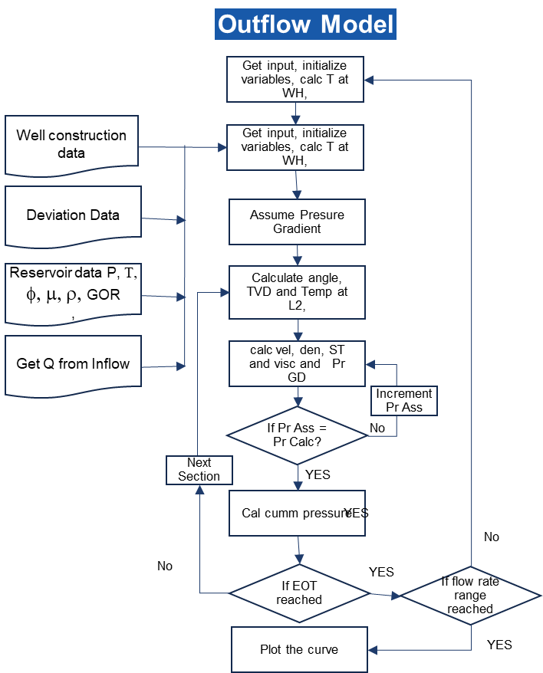

**Figure 2**: Outflow Model.

In finding out optimal flow rate from the well both inflow and outflow models can be run together with Newton Raphson regression.

# Asphaltene Precipitation Module

Asphaltene precipitation is a necessary, but not a sufficient, condition for deposition to occur on the walls of the production tubing. An accurate representation of the thermodynamics of asphaltene precipitation is a key aspect in the development of an accurate asphaltene deposition framework. Equations of state are the most popular models for capturing the thermodynamics of asphaltene precipitation as a function of pressure, temperature, and composition.

A typical asphaltene phase diagram generated from PC-SAFT EOS is shown in **Figure 3**. The color shading on **Figure 3** represents the amoutns of precipitated asphaltenes. Precipitated asphaltenes represent the primary particles that are first formed when the conditions of pressure and temperature are such that asphaltene instability occurs. Accurate prediction of the solubility of these primary particles in oil as a function of pressure and temperature is an important input to the deposition module. The calculation of asphaltene solubility requires the solution of a complex set of equations to satisfy the phase equilibrium condition (i.e. Gibbs minimization at a constant T and P) and the material balance. A robust and reliable in-house multiphase calculation engine will be used to calculate the asphaltene solubility along with other thermodynamic properties.

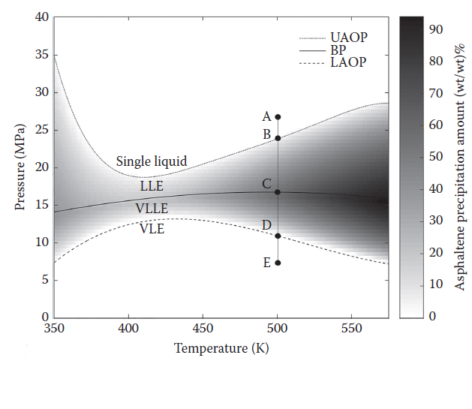

**Figure 3**: Asphaltene phase envelope generated from PC-SAFT EOS. Color shading denotes precipitated amounts in the unstable region.

To accurately model the asphaltene phase behavior, it is necessary to implement a representative crude oil characterization along with an accurate equation of state. In the proposed simulator, crude oil is characterized using an in-house SARA-based characterization methodology which is designed to work with either PC-SAFT or Peng-Robinson equation of state. The simulator automates the fluid charachterization and parameter estimation routines. The following inputs are required to run the thermodynamic module: gas/liquid composition from zero-flash experiment, zero-flash GOR, SARA analysis, STO density, bubble pressure, 2 AOP data points, n-alkane titration using the Indirect Method (required for treating asphaltenes as a polydisperse fraction).

# Asphaltene Deposition Module

A transient one-dimensional advection-diffusion-reaction equation is used to model asphaltene deposition in the wellbore. The rate of asphaltene precipitation is assumed to be proportional to the supersaturation degree of asphaltenes, which is defined as the difference between the actual concentration of asphaltenes dissolved in the oil and the solubility of asphaltenes.

Diffusion and advection are modeled using the traditional equations of mass transport, aggregation is modeled using a second order reaction mechanism, and deposition is modeled using a surface deposition reaction mechanism.

A schematic of the proposed mechanism of asphaltene deposition along with the computational structure of the asphaltene deposition model is shown in **Figure 4**.

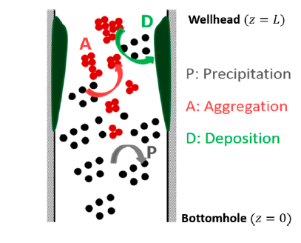 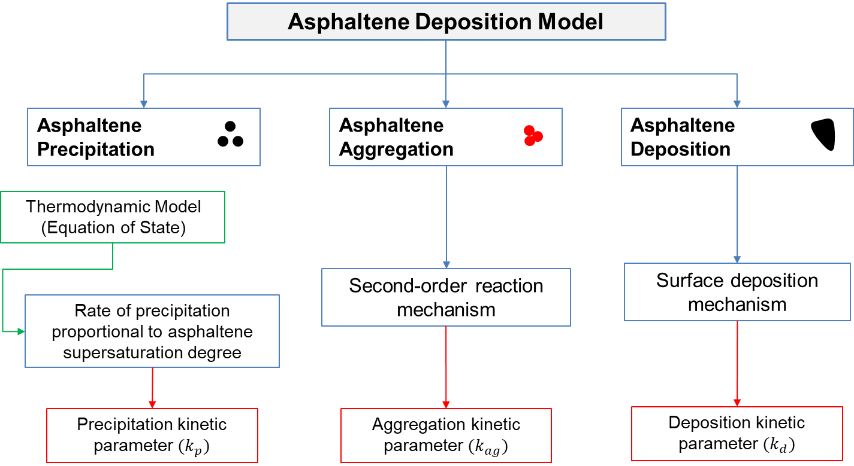

**Figure 4.** Computational structure of the asphaltene deposition model.

## Main Deposition Equation

Deposition is modeled according to the following differential equation:

|  |  |
| --- | --- |
| $$\frac{∂C}{∂t}=\frac{1}{Pe}\frac{∂^{2}C}{∂z^{2}}-\frac{∂C}{∂z}+r_{p}-r_{ag}-r_{d}$$ | (16) |

Where $C$ is dimensionless concentration of primary particles, $t$ is time, $Pe$ is Peclet number, $z$ is axial length, $r_{p}$ is rate of precipitation, $r_{ag}$ is rate of aggregation, and $r_{d}$ is rate of deposition.

## Precipitation Kinetics

The rate of asphaltene precipitation is assumed to be proportional to the supersaturation degree of asphaltenes, which is defined as the difference between the actual concentration of asphaltenes dissolved in the oil and the asphaltene solubility, which is given as:

|  |  |
| --- | --- |
| $$r_{p}=k_{p}\left(C_{f}^{'}-C_{eq}^{'}\right)$$ | (17) |

where $C_{f}^{'}$ is the dimensional concentration of dissolved asphaltene in the oil phase, and $C_{eq}^{'}$ is the dimensional thermodynamic equilibrium concentration of asphaltene, which can be regarded as the solubility of asphaltene at the given pressure, temperature and composition. $k_{p}$ is the precipitation kinetic parameter.

The greater the supersaturation degree of asphaltenes in the crude oil, the quicker the precipitation rate. When the supersaturation degree is zero, the system is right at the onset of asphaltene precipitation.

## Aggregation Kinetics

Aggregation is modeled as a second order reaction, which is given by the following equation:

|  |  |
| --- | --- |
| $$r_{ag}={-k}_{ag}{C'}^{2}$$ | (18) |

where $C'$ is the dimensional concentration of the primary particles and $k_{ag}$ is the aggregation kinetic parameter.

## Deposition Kinetics

Deposition is modeled using a surface deposition reaction mechanism, which is given by the following equation:

|  |  |
| --- | --- |
| $$r_{d}={-k}_{d}G_{ux}C'$$ | (19) |

where $C'$ is the dimensional concentration of the primary particles and $k_{d}$ is the deposition kinetic parameter, and $G_{ux}$ is the velocity gradient at the surface of the pipe.

The problem may have a numerical solution where a control volume travels through the conduit which is divided into sections of fixed length. The amount of precipitated, deposited and dissolved asphaltenes are estimated at the section boundaries. Asphaltenes deposition module the outflow module is run at optimal flow condition. Pressure and temperature are estimated for each section. Since the flow in pressure traverse is steady state, based on one time step these quantities are estimated for one day by applying suitable multiplier. After one day the amount of deposited asphaltenes is considered in all the sections and their internal diameter is accordingly changed. The process is depicted in **Figure 4** and flow chart in **Figure 5**. The well model is again run with this change in tubing ID and optimum flow from the well is determined. (we have to discuss it). This follows determination for asphaltenes deposition for the next day. The cycle thus goes on for a number of predetermined days.

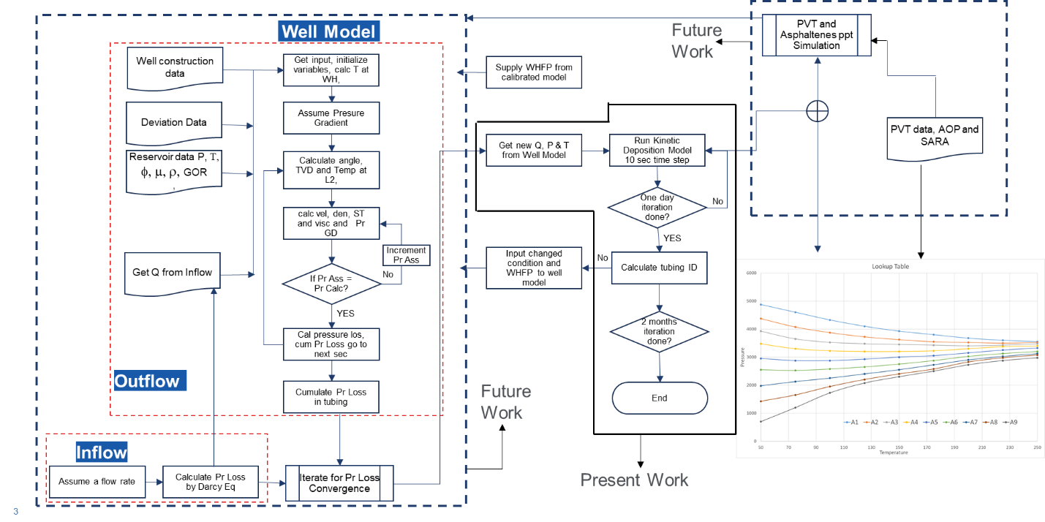

**Figure 5**: Flow Chart for Integrated Asphaltene Deposition Modeling