**Generate and distribution for a given set of states and calculating entropy:**

Code: distribution_generator.py

Inputs: number of states

Outputs: output.txt with the entropy of the distribution, the states and the associated distribution

**Generate and distribution for a given Entropy:**

Code: generates_distribution_with_desired entropy.ipynb

Inputs: size of the distribution, desired entropy

Outputs: distribution and real entropy

Principle: We start from a gaussian (or another standard distribution) and we modify it until the entropy reach the desired entropy

**Impact of isolating dominant node on the graph entropy:**

Code: entropy_graph_intervention.ipynb

Principle :

1. Create a graph with 2 cluster, one big and one small. The nodes of the small are highly linked to the nodes of the big but not very between themselves. So the nodes of the small cluster are dominant nodes of the graph

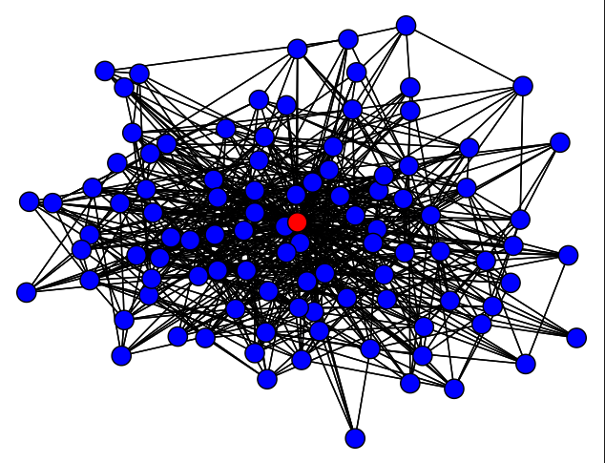

1. We run page rank to determine which are the dominant nodes (its supposed to be the nodes of small cluster. We get a static distribution, and we calculate entropy of it.

1. We cut the links of the dominant node.

avec une confiance faible

1. We run Page rank to calculate new static distribution and we calculate the new entropy.

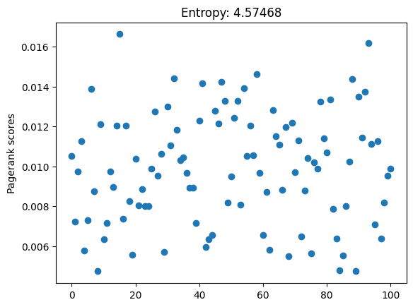

1. We have the delta entropy.

Remarks: generating the graph is a random process so we calculate many graphs of a given structure (number of nodes in each cluster and probabilities of transition intra and inter cluster) and we calculate the mean delta entropy.

**Impact of isolating dominant node on the graph entropy:**

With the previous section we can see that isolating the dominant node tend to increase the entropy of the graph. Now we will try to see if different structures of graph are sensible to this intervention.

In this figure you can see that:

1. If there are more dominant nodes, cutting only one of them conduct to a lower delta entropy than when you have only one dominant node that you cut.
2. When you have more non-dominant nodes the delta entropy is lower.